The Next Generation Swelians – A Digital Business Platform Company
Johnny Yakoub
Swiss School of Business Research

Disclaimer: Due to the sensitive nature of the information, it is not possible to identify the company specifically or share details about its current operations.
Table of Contents
Executive Summary 4
Current Operations Model 5
Pipeline (Product) Model 6
Swelians Work According to Pipeline Business Model 7
Identifying a Suitable Business Model 8
Ecosystem (Platform) Business Model 11
Swelians and The Digital Transformation Domains 12
Business Proposal 14
The Potential for a Successful Transformation 14
Unique Value Proposition to Disrupt the Market 14
Swelians Digital Business Platform – A Technical Implementation 16
Traditional Enterprise Architecture to Digital Business Architecture. 17
Self-service Customer Channels. 20
Digital Employee Channels and Marketing automation. 23
The Pathway to Realisation 24
Teams Organizing Around Value. 26
Restructuring Business Unit Teams. 29
Building the DBP Organisation 30
References 35
Figures 37
Appendices 38

Executive Summary
In recent history, organisational activities were typically classified as either projects or programs. These endeavours required comprehensive documentation outlining their execution over several years. By the time implementation began, it was apparent that the plans were already outdated.
“A business team often works on collecting requirements for a year and creates a document that is 300 pages long, The development team then discovers architectural problems that affect most of the requirements, which means that they have to be changed a lot.” (Kopta and Kopta, 2023.)
In the late 1990s and early 2000s, advancements in Internet technology significantly enhanced business communication capabilities. Improved hardware allowed for greater data storage and processing speeds. Consequently, many companies recognized the potential to streamline their applications and data storage, aiming to boost sales and deliver enhanced business value within their organisations.
Despite these improvements, the reliance on the traditional product-based business model, also described as a “pipeline” (Parker, Van Alstyne and Choudary, 2016) persisted. This model facilitated product sales and necessitated prolonged periods to introduce new products.
This business proposal aims to evaluate the current operations of Swelians, focusing on its time-to-market, organizational structure, and business model. It will identify the strengths and weaknesses of the existing framework, outline necessary actions for both business and IT improvements, and propose a strategy to enhance the delivery of the right product to the right channel, targeting the right customer needs.

Current Operations Model
Swelians encompasses various businesses, including banking, life insurance, non-life insurance, and animal insurance, each offering a range of products. This diversity is mirrored in the organizational structure, application landscape, and workflows, where product development, automation, and market launch are lengthy processes.
The company continues to operate as a pipeline in its IT landscape. This leaves the company vulnerable to being outpaced by competitors and smaller startups that offer superior customer value, speed, quality, and cost efficiency.
This organisational and architectural complexity hampers cross-selling efforts when trying to offer multiple products from different business units to a single customer. The existing systems are not equipped to handle the necessary analysis, marketing, and sales for such strategies. Attempts to address this through system development or marketing and sales improvements typically start but then drag on for years, eventually failing to produce results. This is due to the reliance on the pipeline model, which impedes agility in responding to market demands.
To grasp how Swelians functions in terms of digitization and its product offerings to customers within the framework of the pipeline business model, it's essential to first understand what the pipeline business model entails.

Pipeline (Product) Model
A pipeline model is a linear process, as shown in Figure 1, that begins with inbound logistics, followed by operations to add value to the product, and then outbound logistics, which involves placing the product on the market, afterwards, marketing and sales to promote the product, and finally, service to ensure customer satisfaction. (Parker, Van Alstyne and Choudary, 2016).
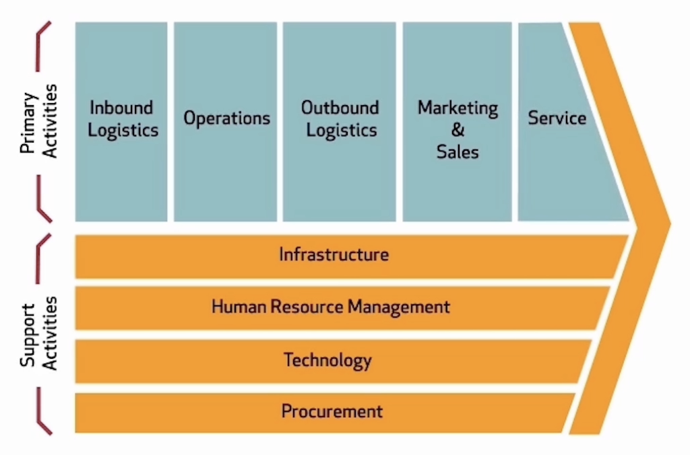
Figure 1 Traditional Pipeline Model (Parker, Van Alstyne and Choudary, 2016)
For a financial institution, the process for a new product starts with the business team creating the product conceptually. Next, the IT department develops this product within a core business application to facilitate sales. Next, begins the work on the digital channels to develop new employee interfaces for the product, then developing customer channels to assist customers in purchasing the product, CRM functionalities providing ongoing customer support, and finally, Marketing automation to launch the product into the market.
In other words, this process is sequential; each step must be completed before the next can begin, and no steps can be skipped. Consequently, from product creation to launch, the entire process can take several months or even years. This delay means that while the product might have been a good idea initially, it may no longer be relevant by the time it reaches the market. Additionally, competitors may have already captured a significant portion of the market share related to this product.
One could argue that there is no alternative for addressing the issue with individual products. While this might be true, creating new value by packaging existing products as a new offering makes this process very challenging. Therefore, it is necessary to adapt the business model—not completely overhaul it, but enhance it to develop new, unique value propositions from existing products.

Swelians Work According to Pipeline Business Model
In the modules "Leadership and Strategic Management" (see Appendix A for more information) and "Problem-Solving and Decision-Making" (see Appendix B), several problem areas were identified that complicate operations at Swelians. Various solutions were also presented to enhance operational efficiency, specifically addressing issues associated with the pipeline business model.
This model complicates the work within the IT unit because the architecture is closely tied to the organization. Even the smallest changes in the organization structure, products, or working methods directly impact the technical solution's design. The architecture's most challenging aspect is launching the product to the market—specifically in the common IT area i.e. CRM, Marketing, and customer channels. These components must provide solutions to all business units, and the lengthy backlog significantly delays the launch.
When a business is about to launch a product; it must go through all the steps in the "pipeline" before finally reaching the market, which can take several months or even years. This process applies not only to new products but also to existing products that are being repackaged as new offers.
The existing technical solutions and the IT architecture can only handle products, so the new packaging must be treated as a new product and go through the pipeline, not just from one business unit, but from several business units. As a result, CRM, Marketing, and customer channels must develop special solutions for the new packaging, which also takes time to develop and the new offer to the market will be delayed.
This does not imply that Swelians should abandon their existing business model and start anew. The product model will remain essential. However, incorporating additional strategies and exploring new business models could expedite value creation and market delivery, ensuring that products reach the market precisely when needed, rather than months or years later.
Let's explore which business model could be suitable for Swelians to streamline and accelerate their operations.

Identifying a Suitable Business Model
Various methods and processes were employed to identify the most suitable business model for Swelians successfully. The primary approach used was the digital business model (DBM) framework developed by Weill and Woerner (2018), as illustrated in Figure 2.
Step 1 involved determining the company's current position. The first question addressed whether Swelians has full control over the entire value chain or is part of an ecosystem. The answer revealed that Swelians has full control over its entire value chain.
The next question assessed how well the company understands its customers' needs. Swelians demonstrated extensive knowledge of its customers' needs and the ability to gather additional information if required. This placed Swelians in the Omnichannel quadrant.

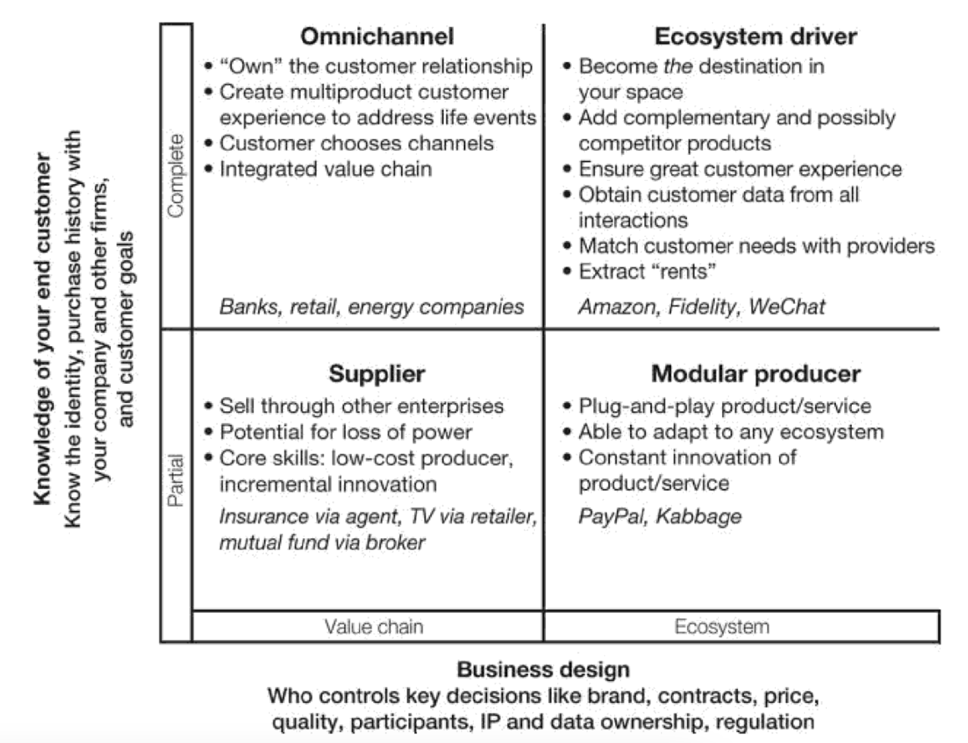
Figure 2 Business model framework (Weill and Woerner, 2018)
Step 2 involved using the DBM framework to decide whether the company should remain in its current quadrant or transition to another DBM. The analysis concluded that Swelians should move to the Ecosystem DBM, which would offer significant benefits, as indicated in Figure 3.
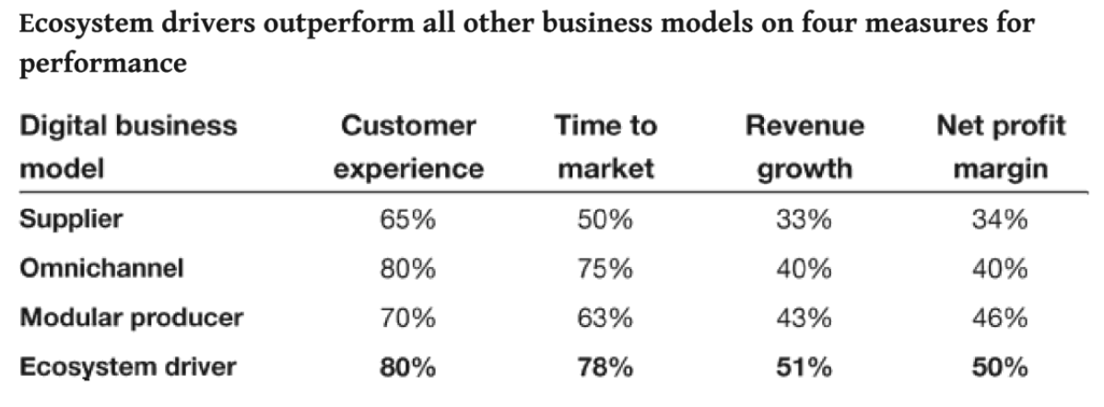
Figure 3 Measures for performance per DBM (Weill and Woerner, 2018)
The next step was to investigate whether Swelians can transition to the right in the DBM framework quadrant, i.e. to the Ecosystem model. For that, “In order to participate in a vibrant ecosystem, to move to the right a company must:
- Become the first choice in its space.
- Become great at building partnerships.
- Create service-enabled interfaces that others can use.” (Weill and Woerner, 2018)
The first two requirements are almost met, and Swelians’ management is actively working towards achieving these goals. The third requirement involves developing an IT strategy to implement a digital platform that enables the shift towards an ecosystem business model.
The result of this analysis revealed that Swelians is positioned to transition to an ecosystem model, which will accelerate achieving the initial two requirements. But what exactly is an ecosystem business model? How do we implement it? Can we implement it? These questions and more will be addressed in the following sections of this document.

Ecosystem (Platform) Business Model
To understand what an ecosystem business model is, it is important to have a general business-related definition that is not tied to a specific value proposition or specific technology implementation. Two sources mentioned below provide such definitions:
First, Mari Sako describes a business ecosystem as follows: “To define a business ecosystem, we focus on a value-creating activity, such as entrepreneurship or innovation, rather than an industrial sector. A business ecosystem therefore tends to cover a variety of industries.” (Sako, 2018)
Next, Parker, Van Alstyne and Choudary define an ecosystem as “A business based on enabling value-creating interactions between external producers and consumers. The platform provides an open, participative infrastructure for these interactions and sets governance conditions for them. The platform’s overarching purpose: to consummate matches among users and facilitate the exchange of goods, services, or social currency, thereby enabling value creation for all participants.” (Parker, Van Alstyne and Choudary, 2016)
They further explain that this business model began to emerge, characterised by its ability to accelerate the creation, marketing, and scaling of new business ideas, thereby enhancing network effects and hastening the decline of competitors. An ecosystem business model, also known as the platform model or digital business platform, presents a revolutionary approach to business operations. (Parker, Van Alstyne and Choudary, 2016)
A platform model improves the network effect which is important to survive in this digital age, a positive network effect refers to the ability of a large, well-managed platform community to produce significant value for each user of the platform, it can lead to the dominance of certain products or services in their markets, as users tend to gravitate towards the largest and most established networks due to their enhanced value, (Parker, Van Alstyne and Choudary, 2016.)
Based on the information presented so far, the question is no longer whether Swelians needs to adopt an ecosystem business model, but whether it can seize the opportunity in time. However, transitioning to a platform model is particularly challenging for a larger organisation like Swelians. This transformation requires changes in culture, business operations, organisational structure, and IT architecture. It also involves embracing innovation, optimizing marketing efforts, and implementing lean-agile practices.

Swelians and The Digital Transformation Domains
While Sako, Parker, Van Alstyne and Choudary discuss the business model, David Rogers identifies how to transform the organisation by presenting the domains of digital transformation, he articulates (Rogers, 2023):
Digital transformation domains are five, (see Figure 4):
- Customers: Who are our customers, and what do they need?
- Competitors: Who are our competitors?
- Data: Do we have the right data, and is it accessible when needed?
- Innovation: How should we approach innovation, and how should we manage the associated risks?
- Value: What value do we deliver to the market? Is it the right value for the right customer, and how do we ensure its accuracy?
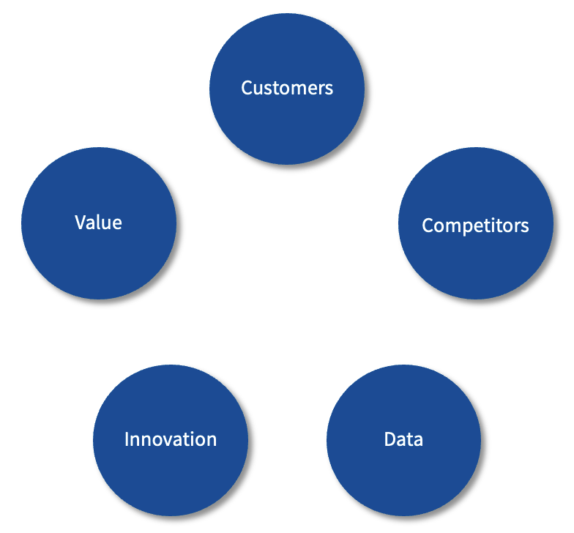
Figure 4 Digital transformations domains (Rogers, 2023)
Swelians started to consider these domains and understand their relevance. However, it's important to note that these domains typically apply to a single business, whereas Swelians comprises multiple businesses. While some customers may overlap, others have distinct needs, and the same complexity applies to competitors, data, innovation, and delivered value. This diversity makes it challenging for Swelians to adopt a one-size-fits-all solution.
Although the David Rogers model is still applicable, its implementation at Swelians looks as illustrated in Figure 5.
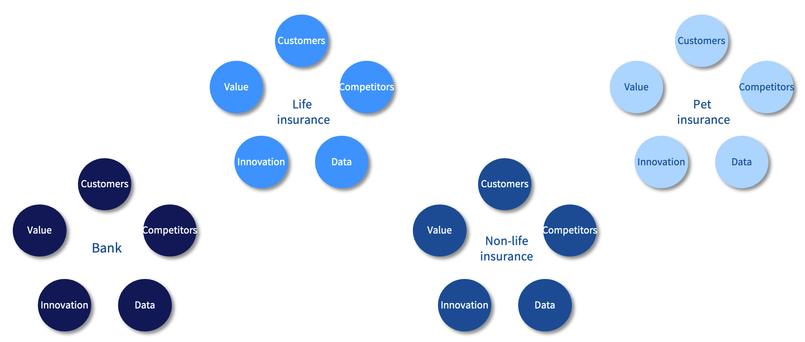
Figure 5 Digital transformation domains at Swelians (Rogers, 2023)
Another crucial aspect to consider is the varying legal requirements imposed by different authorities, which differ across the various businesses. Moreover, It cannot tackle all challenges at once; the company must be innovative while staying realistic, ensuring its daily operations continue smoothly.
Furthermore, Swelians cannot simply abandon the pipeline model for each business, as each product has its own specific rules, processes, functions, and controls. At the same time, Swelians face difficulties in completing their transformation journeys because they attempt to address all business needs as a single entity with one setup of the digital transformation domains, which leads to failed projects and transformations.
Swelians need to start adopting the platform model at the central unit, allowing all businesses and other partners to join the platform with their products. This approach will enable the business units to interact with customers under their own rules, while the platform model will present the value of all these products in a unified manner, aligning with the company's brand strategy.

Business Proposal
In this third module, our goal is to further improve the company’s efficiency and market strength. We aim to position Swelians ahead of all other financial companies in Sweden, making it resilient to rapid mergers and acquisitions, and capable of quickly innovating new value propositions to meet market needs and respond to global crises. This requires a well-thought-out plan that addresses various aspects, including ongoing transformations and market needs, the potential for a successful transformation, a new unique value proposition to disrupt the market, implementation of the IT solutions, and team structure and costs.
Let’s start.

Unique Value Proposition to Disrupt the Market
Swelians operates four distinct businesses and serves a large customer base across various segments. It collaborates with numerous companies for its insurance services, such as damage assessment and claims processes, weather warnings, and more. Most of these partner companies are not currently Swelians customers but could become so if offered unique services that enhance their operations. These opportunities can be realized through a digital business platform.
What services could such a platform offer? Consider a feature where partners, including both existing customers and non-customers like car repair shops, can market themselves to Swelians' extensive customer base of over four million on the digital business platform. These partners wouldn't pay an entry fee but would instead offer discounts to Swelians' customers. This would increase Swelians’ customer satisfaction by providing lower prices and giving partners access to a larger customer base and reduced marketing costs, along with discounts on Swelians' banking and insurance services for being part of this comprehensive platform. The company's network effect will improve as illustrated in the inner rectangle of Figure 6.
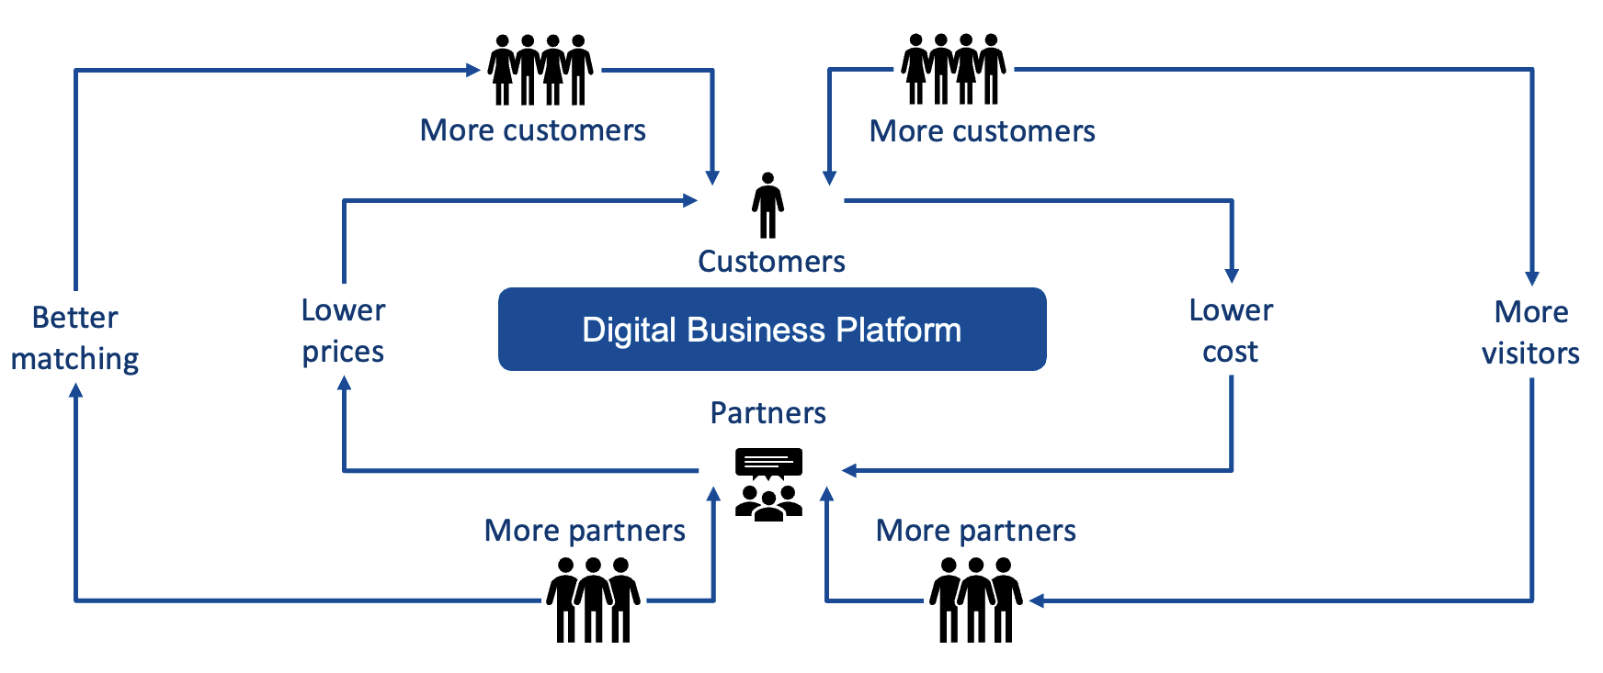
Figure 6 Network effects (Parker, Van Alstyne and Choudary, 2016)
As the network effect gains momentum, more companies will be drawn to Swelians, wanting to become customers, thereby increasing the number of corporate customers who recognize the platform's value. With more partners and customers, the matching algorithms between partners and customers will improve, leading to increased value and attracting even more customers. This will enhance Swelians' ability to offer the right banking and insurance products to the right customers at the right time via the digital business platform, while this platform does not own the product or its management.
The next unique value proposition could be attracting car parts stores to join the platform by offering access to all customer base even the new car repair shops, along with cheaper financial services. This would further amplify the network effect, boosting Swelians' market presence as customers recommend it to others.
This chain of unique values will transform Swelians into a marketplace where businesses and individuals meet and transact on the new digital business platform, Swelians will be able to continue creating new and diverse values for all partners, business units, and customers, thereby increasing its network effect without incurring additional costs for the digital platform.

Swelians Digital Business Platform – A Technical Implementation
A digital business platform is described as creating unique customer value and selling it without owning the product or service. This concept is illustrated in the book Platform Revolution, which states:
“Tom Goodwin, senior vice president of strategy for Havas Media, describes this change succinctly: “Uber, the world’s largest taxi company, owns no vehicles. Facebook, the world’s most popular media owner, creates no content. Alibaba, the most valuable retailer, has no inventory. And Airbnb, the world’s largest accommodation provider, owns no real estate.” (Parker, Van Alstyne and Choudary, 2016).
This statement fits into Swelians as an organisation with multiple business units owning their products and their management processes.
Swelians needs to maintain two different business models—the traditional product-based business model and the platform business model. These models can complement each other with their various strengths, there will be no need to partner with any external vendors to create new customer value, at least not from the beginning.
This approach aligns perfectly with Swelians' needs. The product model will be maintained within the business units, allowing them the freedom to deliver products internally within each unit. Simultaneously, the new platform business model will enable the business units to act as partners in the platform which will package different products into new value propositions.
Additionally, other partners can join the platform, contributing their products to create entirely new and unique value propositions that have never existed in the market. For example, customers could receive cheaper insurance premiums if they service their car at one of Swelians’ "approved" car shops, or gain faster access to a doctor by choosing a doctor who is also a Swelians partner.
This diverse range of products, services and new unique customer values will make Swelians a strong contender in the market, even guarding it against new aggressive startups that use regulations such as open banking, open insurance and open finance to create their digital business platform and sell it for a high price to financial institutions.
To accomplish this, the application landscape must be redesigned not only to implement a digital platform but also to ensure the platform is as generic as possible. This approach will allow for the creation of new unique values without requiring significant changes in the future.
The architectural building blocks of such a platform must include customer self-service channels, employee channels corresponding to a CRM solution, and marketing capabilities to handle analysis, matching algorithms, automated marketing, and personalisation.
These components were also highlighted in Module 1, "A New Strategic Plan," (Yakoub, 2023, p.19). However, to succeed, Swelians must make adjustments to ensure a modular, loosely coupled, and generic architecture. Additionally, it's crucial to separate the architecture of the business units from that of the digital platform to allow changes within the business units' architecture without impacting the digital platform's architecture and vice versa.

Traditional Enterprise Architecture to Digital Business Architecture.
Enterprise architecture can be a challenging subject to describe, but it becomes clearer through examples of what we aim to achieve.
Imagine we are a startup with the business idea of simplifying financial product management for customers, offering banking, life insurance, non-life insurance and pet insurance all-in-one digital business platform. We want these products to be managed and delivered by Deutsche Bank, Zurich Insurance, Allianz, and PetPlan. These large companies have their application landscapes, complete with customer channels, CRM, and marketing systems, and they will likely never change their applications just for our startup to succeed. So, what can we do?
One solution is to adapt to their systems by building new customer channels that can integrate and display their customer channels. We would also implement our own CRM solution to handle our company's customer cases, support, and complaints. Additionally, we would develop a sophisticated, automated marketing platform that uses artificial intelligence (AI) to match products to customers in the right channel, at the right time, and based on specific needs as shown in Figure 7.
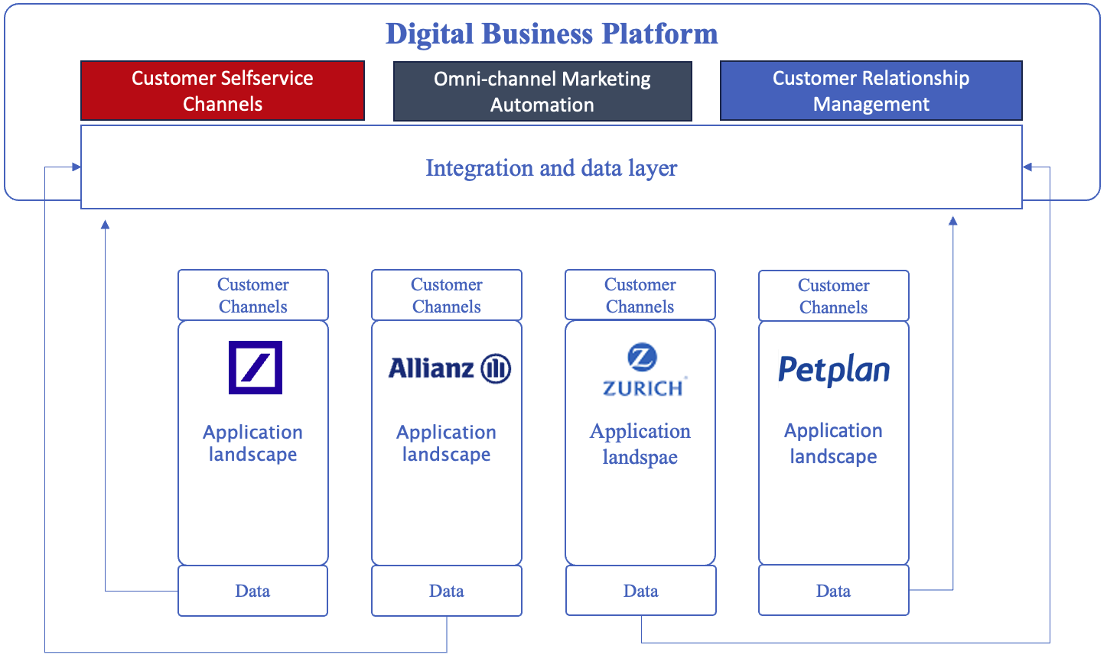
Figure 7 A hypothetical startup architecture landscape
The most crucial aspect is obtaining data from these four large companies. This data must be streamed in real time, analysed by AI, and used to make evidence-based decisions. These decisions will result in the Next-Best-Action and Next-Best-Offer being displayed in the customer and employee channels as quickly as possible.
Let's examine the current architecture at Swelians (Figure 8). The customer channels of the various business units are intertwined and dependent on each other, except for the Pet insurance unit. Consequently, if we modify the banking customer channels, we must relaunch all the business units' customer channels. Regarding data management, we still operate in silos where information in the channels is retrieved from each business unit's core system. This results in a lack of a holistic view of the customer, and analysis results based on one business data. Which is not optimal for the company’s marketing automation teams or sales force.
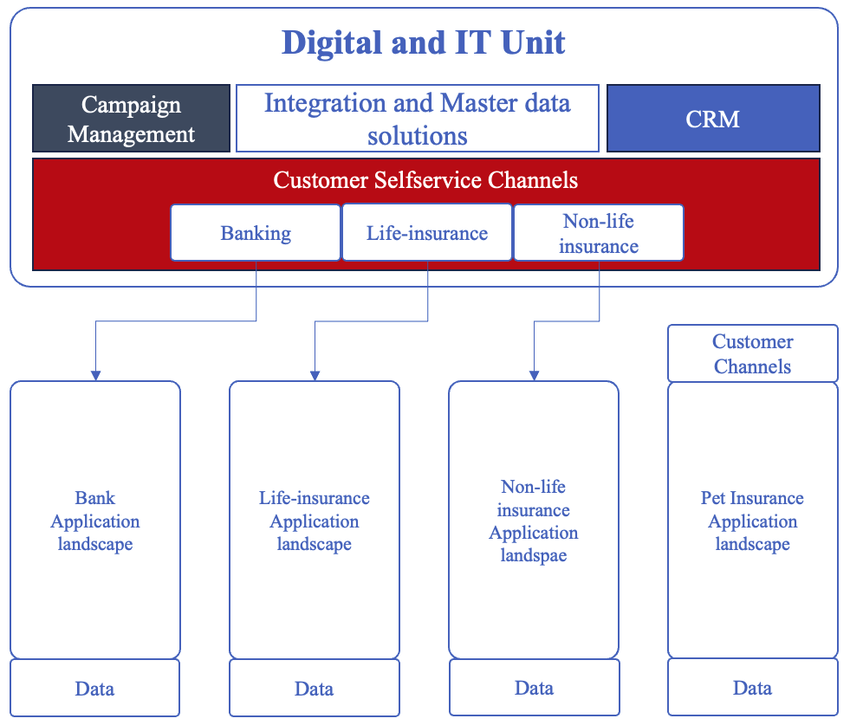
Figure 8 High-level simplified architecture view of Swelians
However, we still can maintain CRM as a common capability because the same personnel will work across both the business units and the digital platform.
A new conceptual enterprise architectural view could resemble Figure 9, which aligns closely with what we aimed to achieve with our “startup”. Appendix C contains a more detailed enterprise architecture view of the DBP.
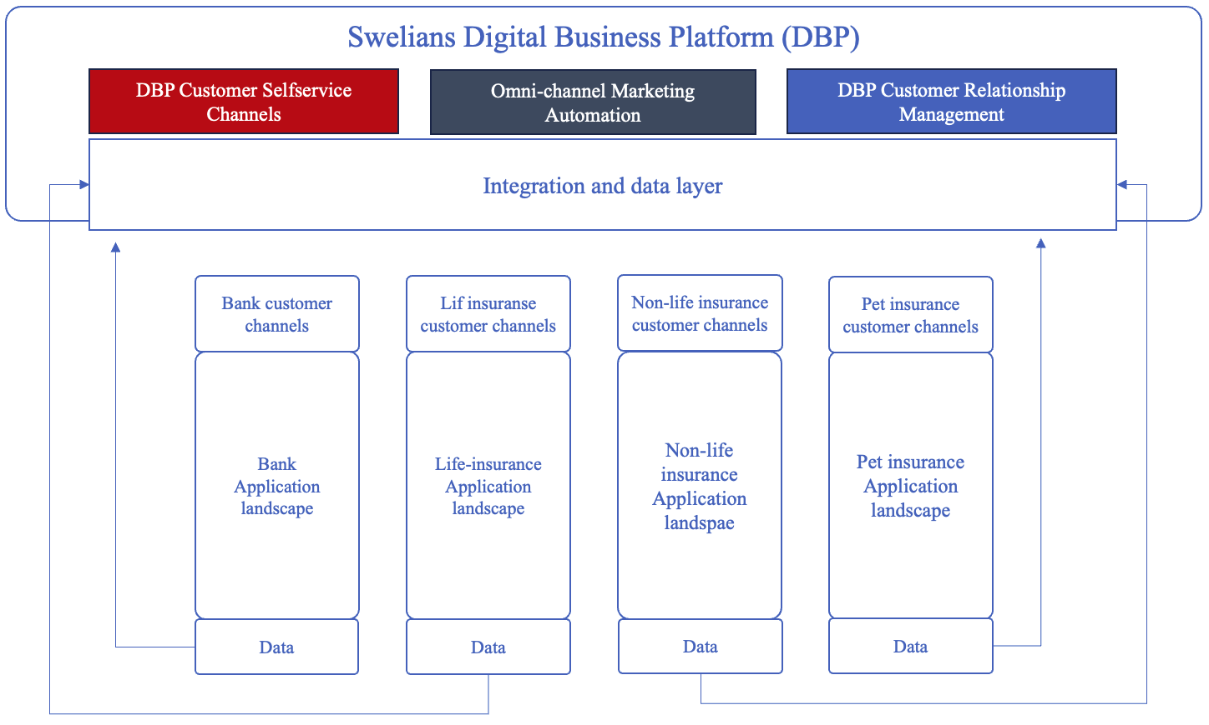
Figure 9 Swelians new digital enterprise architecture view
With this architecture, the digital business platform will serve as the central hub for customer interactions across all channels. Each business unit will independently develop, manage, and deploy its product channels without relying on others, aligning with the principles presented in Module 1, "Strengthen the Organizational and Architectural Structures." (Yakoub, 2023, p.27).
The digital business platform will host these channels and have the ability to create new channels to deliver unique values to customers quickly and easily, based on intelligent analytics from Generative AI and machine learning.

Self-service Customer Channels.
Today’s self-service customer channels are implemented as a monolith. To succeed in realizing the digital business platform, we need to shift to a new architectural model called Micro Frontend Architecture. So, what is the difference between these two architectures?
A monolithic front-end is a large, cohesive codebase where all functionality and UI components are tightly integrated. Some characteristics include:
- Common codebase: All front-end code resides in a single project.
- Centralized deployment: The entire application is deployed as a single unit.
- Tight coupling: Components and modules are highly dependent on each other, making changes or updates difficult without affecting the entire system.
- Long development cycles: The size and complexity of the application result in longer development and deployment times.
Micro frontend architecture, on the other hand, breaks down frontend functionality into smaller, independent units. Its characteristics include:
- Independent components: Each micro frontend is an independent component that can be developed, tested, and deployed separately.
- Decentralized deployment: Each component is deployed independently, allowing for faster and more frequent updates.
- Loose coupling: Components interact via well-defined interfaces or APIs, reducing the risk of changes in one part of the system affecting other parts.
The new architectural pattern is ideally designed to separate the customer channels of the business units from the rest of the digital platform, addressing both technological (Figure 10) and operational aspects. This topic will be explored in more detail in future chapters, but for now, let's simplify it with an analogy.
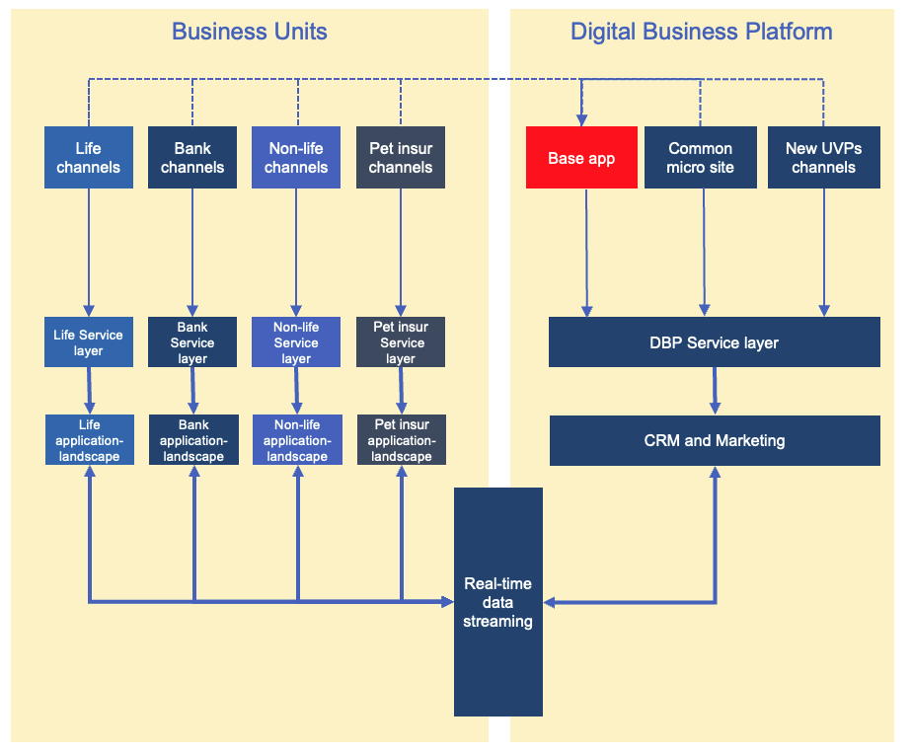
Figure 10 Swelians DBP’s customer interaction layer and business unit’s channels
Consider roads (Figures 11 and 12): you can either pave them with asphalt or lay paving stones. The choice depends on the required speed and durability against weather conditions. You wouldn't use paving stones on motorways because they would hinder high-speed driving and reduce safety. However, for a driveway, both asphalt and paving stones are viable options.
Asphalt can be laid relatively quickly using large machines while paving stones take longer period to lay due to the necessary foundational work. In the long run, paving stones are preferable for a driveway as individual stones can be easily removed and replaced by hand. If the driveway were asphalt, you would either have to do the repairs yourself, resulting in an unattractive finish, or hire a company to redo the asphalt, which is more expensive and takes longer time to fix.
  Figure 11Laying asphalt similar to Monolithic Architecture (Redaktionen, 2018) |   Figure 12 Paving stones similar to Micro Frontend Architecture (Lundin, 2021)
Similarly, monolithic architecture (asphalt) and microservices architecture (paving stones) each have their advantages and considerations. However, to ensure independence between components, opting for paving stones (Micro frontend architecture) is the preferable choice.

Digital Employee Channels and Marketing automation.
This architecture is still the same as presented in module 1 (Appendix A), the only difference is that instead of improving CRM with one platform and improving analytics and marketing with another platform, the market has started to move towards start using complete platforms that provide both of these capabilities. the advantage of such a platform is not having to implement new integrations between CRM, marketing, analysis and customer channels every time you have to introduce new market competitive values. of course, some disadvantages can be described by the fact that you will have a large platform and dependence on a supplier's new updates of the platform, and probably that they will be responsible for implementing it, training the staff and managing the technical part of it in their cloud solution.
This does not conflict at all with the overall strategy, but will of course entail costs during implementation, but lower maintenance and management costs.
So far, we have identified the following:
- Swelians currently operates with a pipeline business model.
- It can transform and incorporate an ecosystem business model.
- The new business model requires implementation through a digital business platform.
- This digital business platform aligns perfectly with ecosystem definitions and digital transformation domains.
- Swelians needs to revamp its architectural landscape to create a more modular architecture.
- Additionally, we need to update the customer channels, CRM, and marketing strategies.
The next question is: How should we approach this change? Should we renovate the old summer house into a nice villa, or should we build the villa from scratch?

The Pathway to Realisation
In February 2021, an article was published on the MIT CISR Research Briefing page, presenting research by L. Woerner and P. Weill (2021) that involved a large number of companies to investigate various transformation strategies, their advantages and disadvantages, and their relative effectiveness. The research identified four distinct pathways for transformation, as illustrated in Figure 13:
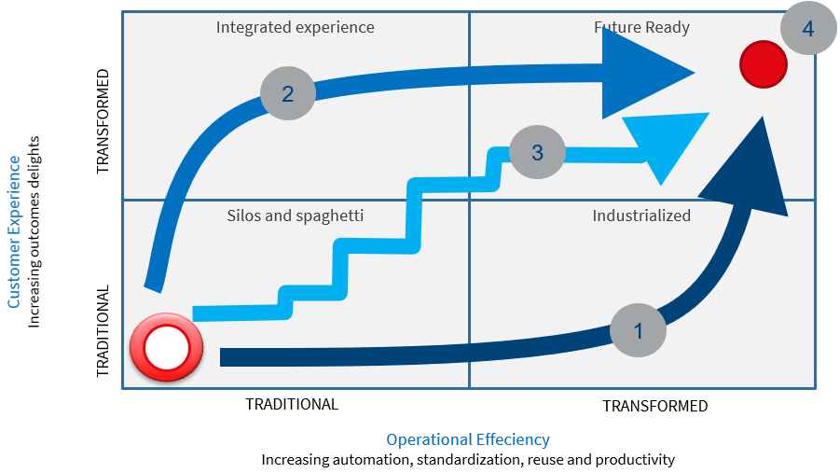
Figure 13 The four pathways to future-ready (L. Woerner and Weill, 2021)
- Reusing and Improving Current Landscape: This approach focuses on transforming by leveraging and enhancing existing data and applications.
- Investing in Customer Experience: Utilizing a Minimum Viable Product (MVP) approach, this strategy aims to develop and quickly launch small, value-delivering solutions to improve customer experience.
- Structured Improvement with MVPs: Organizing work to simultaneously utilize and enhance existing systems by creating and launching small MVPs in a structured manner.
- Make a jump and build a parallel organisation with new systems: When the first three strategies are ineffective, companies opt to build new systems, launch them to the market, and subsequently phase out obsolete components.
L. Woerner and Weill (2021) further elaborate in their article, stating, "In understanding how companies successfully get to Future Ready, we identified four significant, disruptive changes common to all of the pathways. We call these changes 'explosions' because that's what they feel like: companies are blowing up the way they used to do things to remove barriers and move faster." These "explosions" are summarized as:
“Changing decision rights”, “Developing new ways of working”, “Creating a platform mindset”, and “Performing organizational surgery.” (L. Woerner and Weill, 2021)
For Swelians, this research provided critical insights amidst their major digital transformations. The conclusions drawn include the decision to adopt cloud technologies to reduce costs, accelerate development, and minimize reliance on consultants. The new digital business platform represents a significant shift, retaining only the integration layer and the business units' IT landscape, now classified as a partner in the Digital Business Platform (DBP).
The aforementioned "explosions" are integral to Swelians' strategy, aiming to eliminate barriers through:
- New Ways of Working: Initiated with the transformation to SAFe (Scaled Agile Framework).
- Efficient Architectural Control: Enhancing architectural governance, stack, and roles (Yakoub, 2024, p.30).
- Cultural Change: Driven by company management and HR to foster a culture shift.
- Platform Mindset: The topic of this document.
Given the concurrent changes spanning business, information, security, application, and infrastructure domains, This work finds pathways one, two, and three less viable. Therefore, the best way forward is to adopt pathway four: by building a parallel unit with a new IT landscape in cloud infrastructure such as Azure, AWS or Google Cloud, allowing it to grow and stabilize before the market launch.
A potential roadmap for such a transformation could involve several parallel and independent transformation journeys:
- Customer Self-service Channels: Focusing on customer self-service channels.
- CRM and Marketing: Implementing the new Customer Relations Platform (CRP) within these domains (see Appendix C for more information).
- Integration Layer: Streaming data from business units to the DBP
Those transformation journeys will be managed by different SAFe trains that are organised around value, which will make sure we will be aligned with “Structuring around value entails ensuring that agile trains are purposefully designed with a clear mission: to deliver value directly to the customer.” (Yakoub, 2024, p.15) a topic that will be discussed in the next chapter.

Teams Organizing Around Value.
Today's design of the SAFe train is still evolving, with the company striving to enhance its lean-agile approach. Progress is slow due to the challenging transition from a PM3 model focused on projects to a SAFe framework that promotes innovation, exploration, and a willingness to make, fail, and correct mistakes quickly.
As mentioned in module 2 (Yakoub, 2024):
" Regrettably, the current problem-solving and decision-making processes have not yielded the desired outcomes. According to the author, this is attributed to the trains being structured incorrectly. Rather than adhering to SAFe's recommended value stream trains, they are organised along the lines of the traditional organisational structure."
The trains within the business units are partly structured to deliver value, but a significant issue lies in the complex architecture. This "spaghetti architecture" involves intricate dependencies between business units and a tangled IT landscape resembling a spider's web, almost as presented in Figure 14.
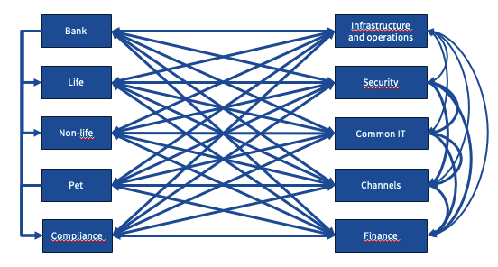
Figure 14 Spaghetti Architecture
Integrations between applications pass through multiple service layers, containing services that are tailored to fit in all business’ needs—a mindset that was effective in the late 1990s and early 2000s but is now outdated. Changing for one business affects all others, not to mention that the team who works with those services are overloaded with tasks to make all businesses happy.
Moving forward, the market’s focus has shifted from automating systems to delivering customer experiences across all channels. The goal is not just a multi-channel experience but an omni-channel experience, where a customer can start a process in one channel, continue in another, and complete it in a third, perhaps with assistance from an administrator.
All companies aim to provide a world-class customer experience. Achieving this will take years, and this goal will be outdated, so it is crucial to be proactive and forward-looking. Swelians must anticipate future trends and prepare for rapid market changes by building teams equipped for the future, which currently points towards AI, machine learning, virtual and augmented reality, and platform models that leverage ecosystems for support.
AI will transform the way we work. While we will still need teams focused on specific tasks, they will operate differently, likely utilizing AI for analysis and evidence-based decision-making. This shift requires the company to engage in data-driven activities that support this approach.
Today's computer science curricula at universities reflect this change. There is less emphasis on programming and more on teaching students how to instruct AI to generate code for applications. The traditional mindset of having complete control over the code and understanding its every detail will diminish. Instead, the new way of working will involve managing and guiding AI with the right information to perform tasks on our behalf.
A Digital Business Platform (DBP) is not a "silver bullet" or merely a technical platform; it is a business concept similar to those of Uber, Google, AirBNB, and not to forget the Swiss School of Business Research with its educational digital platform.
A DBP represents a significant step into the future, designed to enhance the customer experience by proactively addressing needs in a personalized manner. This is achieved through AI and machine learning, ensuring a consistent message, offer, and support across all channels. Therefore, it is crucial to properly configure the teams that work within this framework.
Let's explore the team structure according to SAFe to be suitable for a DBP and geared up for the future.
The team structure was discussed in both modules 1 (Yakoub, 2023) and 2 (Yakoub, 2024), as well as in this document. Now, we have the opportunity to hypothetically address this issue by proposing a potential solution for the team structure, which will, in turn, shape the trains.

Restructuring Business Unit Teams.
When businesses take ownership of their customer channels and switch to a Micro Frontend architecture, it is not merely about enhancing the technical aspects of these channels.
The transition to a Micro Frontend architecture aims to increase business efficiency, as highlighted in various articles (Cameroon, 2023), books such as "Micro Frontends in Action" (Geers, 2020), and videos like those by Wadella (2023). Consequently, the team structure must shift from horizontal teams focused on technology and development to vertical teams that understand and deliver the entire value they are responsible for, as illustrated in Figure 15 for the Bank unit.
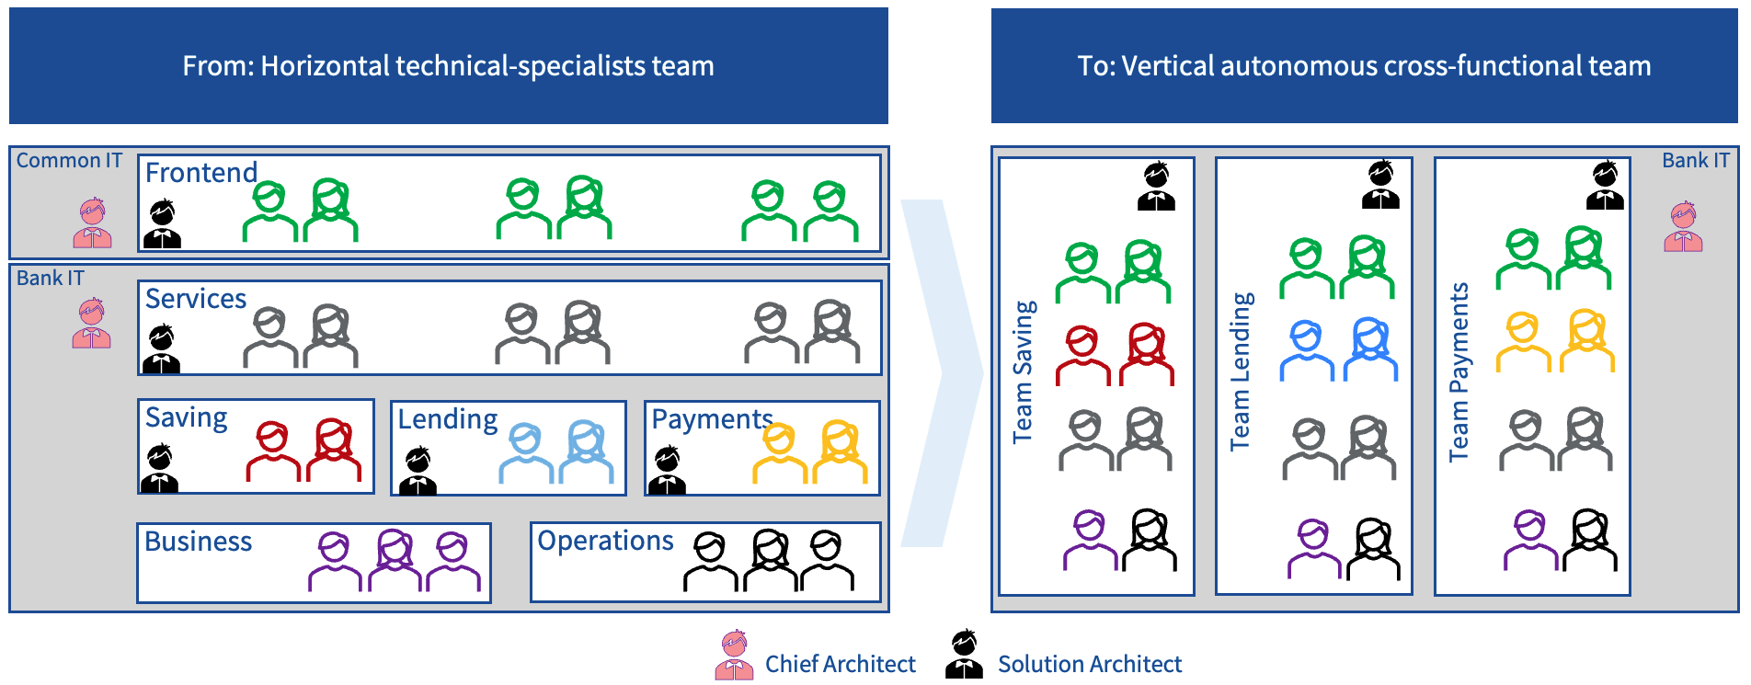
Figure 15 Moving from horizontal to vertical team structure in the Bank unit
This transition may initially cause some employees within Common IT to feel disheartened. Therefore, it is essential to guide them through this journey by raising awareness and helping them understand what this change means for them, ultimately encouraging them to work within the innovative, and modern DBP organization instead. The authority of the Enterprise architecture community and company management steering will partially help, but it is still crucial to accelerate a change management journey to have a smooth transformation, by using change management methods such as Prosci.
Another side-effect is that this transition will also result in a reduced workforce, decreased dependencies, more efficient delivery, greater autonomy, and significantly lower costs. For instance, for those personnel illustrated in Figure 15, we achieve cost savings of approximately nine million per year currently spent on consultants.

Building the DBP Organisation
Reflecting on module 2, it was mentioned: "Crafting a train involves not only creating it but also ensuring the dismantling of silos. This ensures that the train is accountable for the complete value delivery journey from inception to fruition, traversing all business areas and domains, and encompassing all necessary personnel to deliver this value." (Yakoub, 2024).
We must keep this in mind, as it applies not only to problem-solving or decision-making but is central to the entire SAFe framework. Therefore, the teams we construct must be part of a value stream delivering train. The question then becomes: what kind of values are delivered in a DBP?
By examining our current capabilities and future needs across various departments, we can identify the necessary business capabilities to address. These capabilities will be value stream-based and may provide insights into how the trains should be structured.
We have the following information:
- All core business customer channels will be moved to their respective business units for development and management. However, these channels must be integrated into a common site, known as The Base App, to create a uniform customer experience where all other microsites will be injected.
- Certain elements of the customer channels will continue to be managed within the DBP, such as customer authentication, information logging, messaging, notifications, and future functionalities like online booking and screen sharing for online meetings.
- These functionalities will require collaboration across DBP’s various components, including master data management, in-depth and real-time analysis, security, infrastructure and operations, and content management to personalize the sites based on analyses.
Following SAFe principles, we can build a new autonomous train, Common Business Train, that avoids conflicts with other trains within business units or the IT department. This train will consist of the following teams and responsibilities (Figure 16):
- Frontend and Application Programmable Interphase (APIs) services, to deliver directly to the customer.
- Data Management Team: to use customer information and analysis results, to personalize the customer experience using a Content Management System (CMS) and Data Asset Management (DAM).
- Distribution team, to transmit information from backend systems to services then to the customer.
- Teams to manage infrastructure and operations.
- Teams to ensure the security of hardware, software, and channels to prevent unauthorized access.
- Teams to ensure the quality of services delivered to the customer.
Figure 16 DBP’s first SAFe train - Common Business Train
The next train is the Customer Relations Train as illustrated in Figure 17, which will deliver value to the customer through an employee, managing customer relations and providing the same value delivered through self-service channels, such as during office visits or phone calls with a representative.
This train consists of:
- Teams with IT expertise in CRM and Contact Center
- An orchestration team, where CRM will act as the hub to launch all other core business applications. This requires a representative from each store to manage integrations.
- An analysis team utilizing Generative AI and Machine Learning (ML), composed of system managers and data scientists to build ML models.
- Teams for data management, IT security, QA, and infrastructure and operations, are needed for the same reasons as the first train.
Figure 17 DBP's second SAFe train - Customer Relations Train
The third train, the Marketing Automation Train (Figure 18), aims to enhance the customer experience proactively by leveraging intelligent insights derived from the platform via data analysis. This train will facilitate various types of analyses necessary for both DBP and all other business units, including descriptive, diagnostic, predictive, prescriptive, and cognitive analyses. These analyses will culminate in customers being met with Next Best Action (NBA) and Next Best Offer (NBO) in both self-service channels and during interactions with employees via the Contact Centre and CRM.
In addition to requiring QA, IT security, infrastructure and operations, Content, data management, and analysis teams, the following teams will be essential:
- Personalization team: Responsible for constructing and managing customer journeys within the platform to enable automated actions.
- Campaign team: Manages manual marketing activities by constructing and overseeing campaigns within the DBP.
Figure 18 DBP's third SAFe train - Marketing Automation Train
All these trains are designed to keep Swelians’ business operational and do not directly address new unique value propositions. However, we have everything we need in place in terms of a virtual organization and SAFe trains.
Let's assume we want to deliver a new unique value, such as the one previously mentioned, car repair services for private customers. This would require a new microsite to present the value, adding the new service to the central storage area in the CRP, and developing new ML models for analysis. Here are two possible approaches:
- If the new unique value, like the car repair/private customer case, requires minimal implementation, it can be managed by the existing trains. Each team would be responsible for its part while maintaining autonomy, and only a small number of new hires would be needed to support the new value without overburdening the entire DBP.
- If delivering the new value requires substantial effort involving multiple large teams, it would be more efficient to establish a new SAFe train specifically focused on this value proposition.
With a DBP in place, Swelians are no longer dependent on specific technical platforms as long as they are kept up-to-date according to vendor recommendations. The only potential need is for new teams to avoid overburdening existing ones. Everything else remains the same, ensuring efficiency, including problem-solving and decision-making processes.
The previously presented recommendations regarding the enterprise architecture organization still apply (Yakoub, 2024, p.30). If these are implemented, Swelians will become a stronger organization, excelling in its current businesses and new innovative value propositions, this will position Swelians as a leading competitive company in the Swedish financial sector.
With such a platform, innovation will become inevitable. It will enhance the company culture and help everyone adopt a creative mindset.

References
Cameroon, L. (2023) 'Blog,' Sathyalog, 31 October. https://www.luxoft.com/blog/answering-single-page-application-challenges-with-micro-front-end-architecture (Accessed: June 12, 2024).
Geers, M. (2020) Micro frontends in action. Manning Publications.
Kopta, M. and Kopta, M. (2023) 'What are the most common problems with IT projects? - leaware.com,' leaware.com - We build the right software . We build the software right. Mobile, Web & Generative AI Development Agency. Free consultation on your project., 24 October. https://leaware.com/what-are-the-most-common-problems-with-it-projects/ (Accessed: July 2, 2024).
Parker, G.G., Van Alstyne, M.W. and Choudary, S.P. (2016) Platform Revolution: How Networked Markets are Trasnforming the Economy - and How to Make Them Work For You. National Geographic Books.
Rogers, D. (2023) The Digital Transformation Roadmap: Rebuild Your Organization for Continuous Change. Columbia Business School Publishing.
Sako, M. (2018) Business Ecosystems – Communications of the ACM. https://cacm.acm.org/opinion/business-ecosystems/ (Accessed: July 5, 2024).
Wadella, J. (2023) Problems micro frontends won’t solve that no one wants to talk about | Micro Frontends Summit 2023. https://www.youtube.com/watch?v=50UBQ66xLmQ (Accessed: June 12, 2024).
Weill, P. and L. Woerner, S. (2015) AETNA: Building a healthier world via a digital ecosystem. https://cisr.mit.edu/publication/2015_1101_AetnaDigitalEcosytem_WeillWoernerSamuel (Accessed: June 10, 2024).
Weill, P. and L. Woerner, S. (2021) Update on the four Pathways to Future Ready. https://cisr.mit.edu/publication/2021_0201_PathwaysUpdate_WoernerWeill (Accessed: July 4, 2024).
Weill, P. and Woerner, S. (2018) What’s your digital business model?: Six Questions to Help You Build the Next-Generation Enterprise. Harvard Business Press.
Yakoub, J. (2023) A New Strategic Plan. PhD by Portfolio Module 1: LO4 - Develop new ideas or processes at the forefront of work. Swiss School of Business Research. Unpublished assignment
Yakoub, J. (2024) Enhancing Problem-solving and Decision-making Within Swelians. PhD by Portfolio Module 2: LO4 - Develop new ideas or processes at the forefront of work in relation to problem solving and decision making. Swiss School of Business Research. Unpublished assignment.

Figures
Lundin, P. (2021) Lägga Marksten i 5 enkla steg, Stenbolaget. https://stenbolaget.se/blogs/gor-det-sjalv/lagga-marksten-5-steg (Accessed: June 11, 2024).
Parker, G.G., Van Alstyne, M.W. and Choudary, S.P. (2016) Platform Revolution: How Networked Markets are Transforming the Economy - and How to Make Them Work For You. National Geographic Books.
Redaktionen (2018) Detta behöver du veta för att asfaltera uppfart – Villalivet.se, Villalivet.se. https://villalivet.se/om-bygg/tips-for-att-asfaltera-uppfart/ (Accessed: June 11, 2024).
Rogers, D. (2023) The Digital Transformation Roadmap: Rebuild Your Organization for Continuous Change. Columbia Business School Publishing.
Weill, P. and Woerner, S. (2018) What’s your digital business model?: Six Questions to Help You Build the Next-Generation Enterprise. Harvard Business Press.

Appendices

Appendix A

A New Strategic Plan
This appendix summarises and condenses the academic work undertaken in module 1: Leadership and Strategic Management. It outlines the existing strategy employed by Swelians and lists the suggested enhancements and the roadmap for implementation.
Swelians, based in Stockholm, is a leader in financial services, offering insurance, banking, and asset management. It combines small firms' agility with large companies' strength through 20 customer-owned regional insurance firms.
20 companies own Swelians, each with its CEO and IT department, coordinated by a central IT division consisting of Bank, Non-life insurance, Life insurance and Pet insurance as presented in Figure A1. The "Market Plan" focuses on enhancing customer and employee experiences, boosting profitability, and improving efficiency.
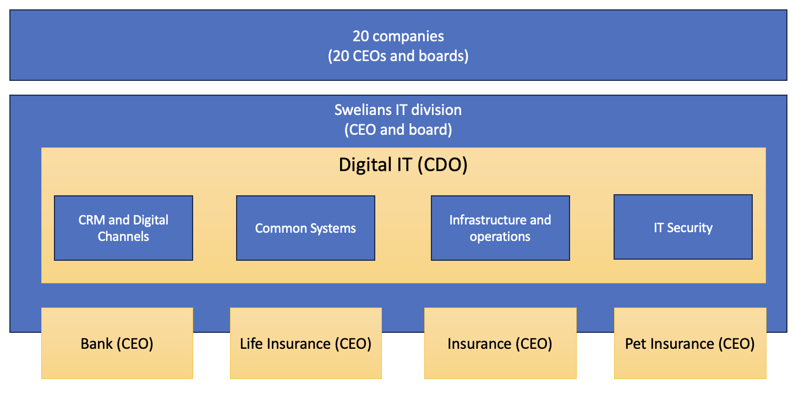
Figure A1 Swelians Organisation Model
Identified Challenges
In Module 1, which centred on Swelians' existing strategy, execution methods, and roles and responsibilities, the following challenges were pinpointed:
- Complex Strategy: Simplifying Swelians' strategy into core actions is necessary but difficult due to its diverse structure.
- Initiative Overload: Frequent new initiatives disrupt ongoing projects and misallocate resources.
- Lack of Clear Prioritization: Independent prioritization by business units causes delays and resource conflicts.
- Accountability Issues: Shared responsibility for objectives results in a lack of clear accountability.
- Problem-Focused Culture: Employees identify problems well but fail to propose solutions, hindering execution.
- High Interdependencies: Organizational structure within the SAFe framework creates dependencies that hinder efficiency.
Proposed Enhancements
The solution to overcome these challenges can be summarized in the following list:
- Streamline Actions: Focus on a few core priorities.
- Limit Initiatives: Ensure new initiatives align with overall goals.
- Prioritize Clearly: Make decisive prioritization decisions.
- Assign Accountability: Designate single managers for objectives.
- Foster Solutions: Encourage employees to propose solutions.
- Reduce Dependencies: Restructure to ensure independent value stream delivery.
Furthermore, Swelians is embarking on a new strategic plan, guided by two key perspectives: understanding customer and employee challenges and leveraging the company's unique advantages. By addressing pain points identified through customer reviews and aligning with market demands, Swelians aims to enhance its offerings and solidify its market position.
Customer and Employee Challenges: Analysing customer reviews revealed discrepancies between self-service channels and the CRM tool, leading to frustration and eroded trust. Similarly, employees faced challenges due to manual tasks and inadequate access to real-time information.
Unfair Advantages: Swelians' broad scope across financial sectors positions it as a strong competitor with the potential for market disruption. Streamlining customer experiences and targeting newer demographics are key strategies for success.
Strategic Goals and Initiatives: Addressing data fragmentation, enhancing customer channels, and improving employee channels are central to Swelians' strategic objectives. The plan also focuses on profitability and expense reduction through enhanced operational efficiency (Figure A2).
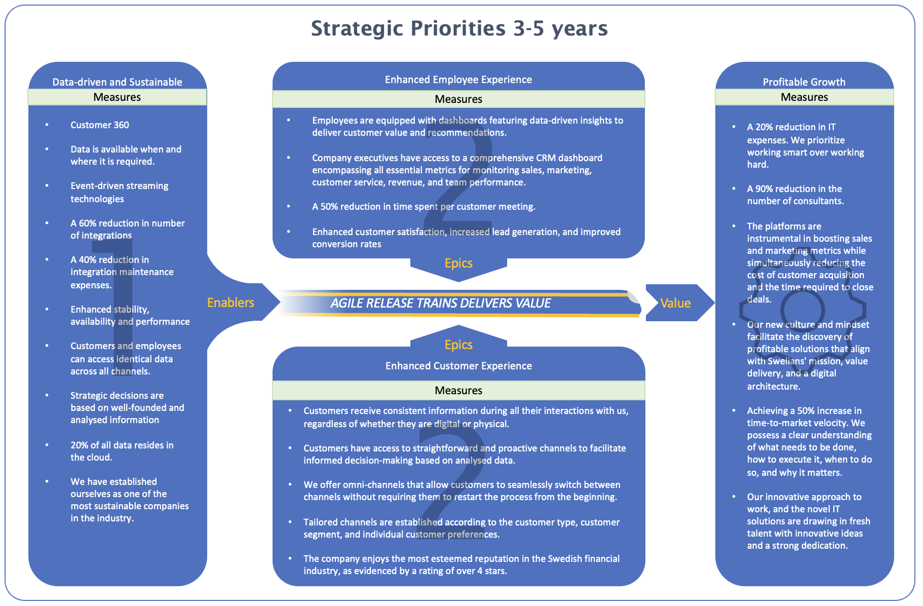
Figure A2 Swelians Strategic Priorities 3-5 Years
Key Success Factors: Balancing strategic priorities, collaborative prioritization, and clear accountability are essential for realizing Swelians' strategic objectives. Additionally, fostering a solution-oriented culture and strengthening organizational and architectural structures are crucial steps.
Implementation Plan: The author proposes implementing a CRM tool, deploying a Customer Data Platform (CDP), and enhancing self-service channels across business units. Additionally, each business unit outlines specific action points aligned with the overall strategic goals (Figure A3).
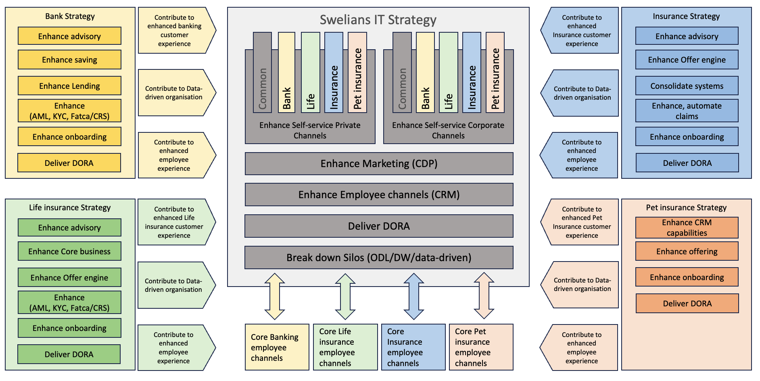
Figure A3 Swelians Action Plan
By aligning actions with strategic objectives and enhancing organizational structures, Swelians aims to drive sustainable growth and cement its position in the market.
Swelians, operating within the SAFe framework, acknowledges the importance of flexibility in long-term commitments to maintain business agility. The implementation plan, although a vision, aligns with SAFe practices and evolves over time as per changing market conditions.
Following SAFe principles, the author adopts a process outlined by Sull et al. (2017) to form a prioritized strategic action list. SAFe practices in Enterprise Portfolio Management are then utilized to generate Enterprise Epics (EEP) and Super Epics (SEP), forming a comprehensive portfolio roadmap as in Figure A4.
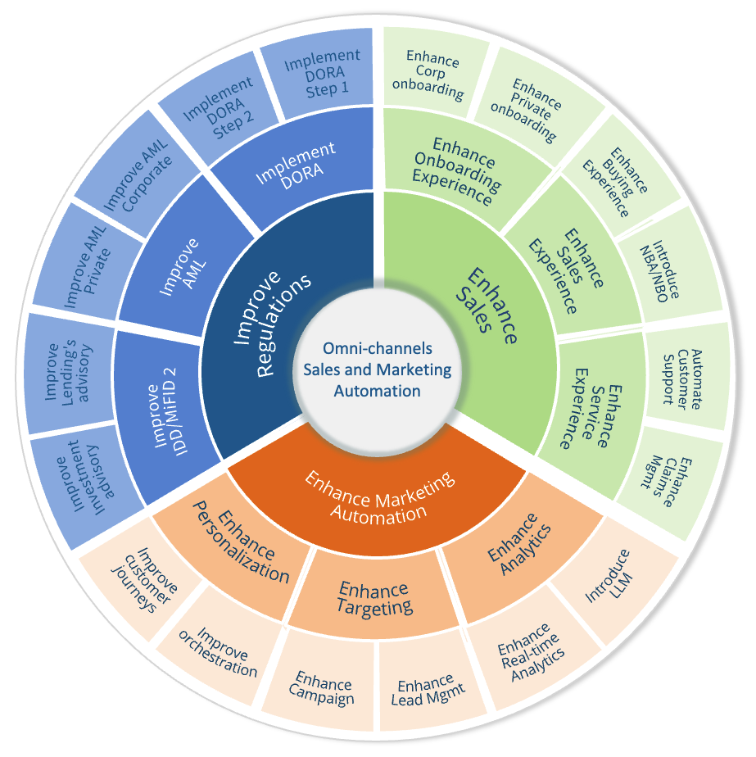
Figure A4 From Action Plan to Enterprise- and Super Epics
The action list is categorized into cross-domain value-generating actions, resulting in EEPs and SEPs focusing on enhancing various customer experiences, analytics, targeting, personalization, regulatory compliance, and implementing DORA regulations.
The approach prioritizes resolving customer and employee challenges, necessitating an outside-in perspective and comprehensive customer information tools like CRM systems. The enterprise portfolio roadmap, comprising EEPs and SEPs, ensures alignment with strategic goals and facilitates prioritization and synchronization across portfolios.
Lastly, Balancing maintenance tasks with new initiatives is crucial to prevent overwhelming teams, allowing efficient handling of deliveries. Overall, the implementation plan evolves iteratively to adapt to changing market dynamics and organizational needs.

Appendix B

Enhancing Problem-solving and Decision-making Within Swelians
This appendix presents a summarised and condensed version of the academic work conducted in Module 2: Problem-Solving and Decision-Making. It outlines the challenges associated with these processes at Swelians and enumerates the proposed enhancements to improve them.
The academic work identified several areas for improvement, particularly highlighting issues stemming from poorly designed SAFe trains. SAFe, a framework centred around teams working in value streams and implementing everything necessary to deliver value, is not being effectively utilized at Swelians.
This misalignment disrupts several SAFe ceremonies, including the problem-solving process. Teams on different trains often believe they are doing the right thing, leading to a blame-game mentality where no one takes responsibility. Consequently, problems take longer to resolve as root causes are not identified, and only the symptoms are addressed.
Decision-making is also hampered because solving a problem requires making decisions in line with SAFe principle #9, which states decisions should be made as close to the team as possible. However, uncertainty about who should make the decision complicates this process. Additionally, decision-making is hindered by the need to assess if one has enough information, which is often lacking due to poor architecture governance.
Architecture governance, which includes principles, processes, reference architectures, and best practices, is not well defined. This lack of clarity prevents teams from effectively leveraging these components. As a result, teams either make decisions based on incorrect assumptions or escalate issues to others, causing delays in delivery and conflicts between trains and team
Finally, it is problematic that the various business units within the company have different goals to fulfil. The process for developing an action plan varies across units, resulting in each portfolio having distinct objectives. This disparity can lead to a situation where solving a problem, or making a decision, in one portfolio creates a new problem in another.
The work also identified solutions to the problems, which can be summarized as follows:
- Add an Enterprise Portfolio Management Level: Introduce this level to unify all portfolios around deliveries and align them towards the same goals, ensuring simultaneous and well-coordinated efforts.
- Redesign the Trains: Transition to value stream trains to reduce dependencies between trains and portfolios, enhancing problem-solving and decision-making within each train by increasing autonomy and integrating all necessary components and team members.
- Streamline Architecture Management: Define clearer principles, target architecture, and reference architecture to outline where the company aims to be in the coming years. This will help trains become more autonomous and make decisions within the framework of the company’s architectural guidelines.
- Standardize Problem-Solving and Decision-Making Methods: Establish uniform methods to ensure teams operate autonomously and cohesively under the same principles.
- Optimize SAFe Principle #9: Incorporate McKinsey's decision categorization to expedite the decision-making process and quickly identify the appropriate escalation paths.
- Automate Processes and Implement Data-Driven Operations: Automate all processes and leverage data-driven operations to enhance decision-making based on factual information, ideally leading to more automatic decisions.
These improvements are detailed in a developed framework presented in Figure B1.
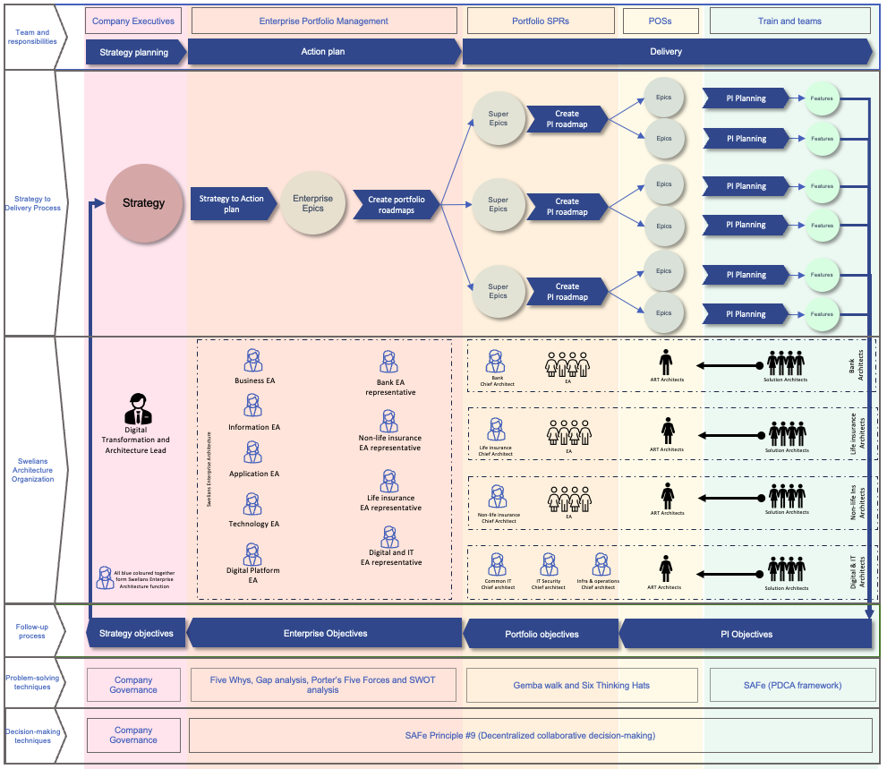
Figure B1 The new Swelians operational model.

Appendix C

Swelians Digital Business Platform Enterprise Architecture View
This appendix contains the enterprise architecture view of the Digital Business Platform to allow enterprise architects to understand how the platform will be implemented, highlighting the most important components and capabilities to be included.
A helicopter view from 10.000m
From this height, we can observe the following (see Figure C1):
Business and Partner IT Landscape
Each business unit maintains its own customer channels within decentralized IT landscapes, enabling faster development and delivery of customer channels, increasing flexibility, and facilitating the integration of multiple partners within Swelians. This approach also streamlines and accelerates mergers and acquisitions.
Digital Business Platform
This platform comprises several central components, including:
Digital Interaction Layer: This layer supports the integration and hosting of various customer channels, each with its own UX layer tailored to present a unified Swelians brand experience to customers.
Customer Relationship Platform (CRP): CRP is designed to assist our employees in proactively supporting our customers in a data-driven manner, utilizing AI and predictive real-time analysis. For CRP, it is crucial to have a modular platform where we can add and remove modules without initiating long-term projects. The goal is to have a complete platform that, while monolithic from our perspective, is composed of modules that can intelligently reuse the platform's data storage, AI capabilities, and resources, eliminating the need for new integrations each time we want to add new functionality or value
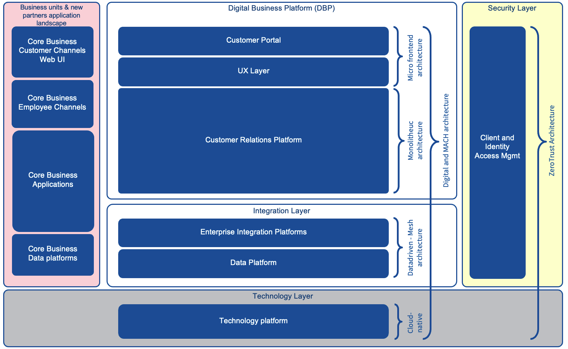
Figure C18 Swelians Enterprise architecture for DBP and architecture patterns
Integration Layer: This layer represents one of our most valuable capabilities. It facilitates both internal integration within the Digital Business Platform and external integration with the business IT landscape and external partners outside Swelians. We employ a data-driven architecture to enable near real-time interactions and a Mesh architecture to ensure data is always available where and when it is needed by the right consumer.
Technology Layer: To support the previous two layers, a stable deployment platform is essential. The cloud is the preferred solution for us at Swelians and the entire market. Therefore, the first two layers of the Digital Business Platform must be placed in the cloud to maximize efficiency and enable scalability in all directions.
These three layers – the channel layer, the integration layer, and the technology layer – will be implemented with MACH architecture (Microservices, API-first, Cloud-native, and Headless CMS). This approach ensures we can adapt quickly, remain loosely coupled, foster innovation, and prepare to develop an open innovation platform in the future.
Security Layer: In today's increasingly digital and threat-laden landscape, security has become a central component of Enterprise Architecture. A prominent security model used in this area is Zero Trust architecture. Zero Trust operates on the principle of "never trust, always verify," meaning no device – whether inside or outside the network – is automatically trusted. (Modern Cybersecurity: The Role of Resilient Networks) All devices must undergo strict authentication and authorization before accessing resources. (FortiSASE vs Microsoft Defender for Cloud Apps comparison).
By integrating Zero Trust architecture into the Digital Business Platform, we can minimize the risk of security incidents, protect sensitive data, and ensure continuous compliance with security standards. This creates a robust and dynamic IT environment well-equipped to meet modern security challenges.
A helicopter view from 5,000 m
From this height we can see the components building each layer as presented in Figure C2:
Business and Partner IT Landscape: Each business unit has its own customer channels developed according to a Micro Frontend architecture. These units also employ services that adhere to an API-first approach, ensuring that these services deliver the right amount of information—no more, no less—to the customer channels via Experience APIs.
Digital Business Platform: This platform comprises several core areas, including:
Digital Interaction Layer: This layer can include various types of channels, but we must start with three key components,
- Base App: A web implementation that hosts all other web apps from the business and partner layers.
- Micro Sites: Shared Swelians pages used to deliver common functions to customers, such as My Documents, My Cases, notifications, etc.
- Hybrid App: Swelians’ common app, capable of hosting all microsites both within the DBP and from business units and partners.
- Once these three are in place, we can start incorporating other channels into this platform, such as:
- Chatbot: Utilizes the platform's AI capabilities to answer questions with precision.
- Smart Assistant: Helps customers learn more about the financial industry and Swelians specifically.
- Open API: Enables the implementation of open finance if desired.
- Developers Portal: Opens our platform to young developers, allowing them to contribute their own ideas and solutions.
This list is extensive. With the strength of the selected architectural patterns in the different layers, we will be well-prepared to be future-ready.
In the same layer, we also see two important components:
- Experience APIs Layer: Ensures the customer channels in the DBP operate with optimal performance and security.
- UX Design: A crucial factor for presenting a unified Swelians brand experience to customers and meeting various regulations, such as accessibility directives.
Customer Relationship Platform (CRP): To avoid confusion with CRM-related terms, we use the abbreviation CRP to encompass both CRM and marketing functions.
As mentioned earlier, this layer is a complete platform composed of independent and modular components to accelerate development. The CRP includes the following capabilities:
CRM: The tool our employees will use daily, serving as the entry point to many other business systems. It does not handle business transactions or processes but can orchestrate calls to initiate other processes within each business unit or with partners if available.
Regulation Management: Ensures employees working within the CRM have the proper conditions to comply with regulations.
Storage: The shared storage in CRP, built once and used by all who need it, both in CRP, DBP, and the rest of Swelians. It also includes an ODL (Operational Data Layer) that digital customer channels can use for optimal performance, insights, and information delivery to customers.
Digital Experience Platform (DXP): This part of the platform includes intelligent features that generate insights to personalize customer experiences and target the right offer to the right customer in the right channel at the right time. It may encompass many more capabilities than shown in Figure C2.
Integration Layer: This layer comprises:
- Enterprise Integration Platforms: Manage and implement various integration mechanisms within DBP and between DBP and business units/partners.
- API Platform: Handles synchronous calls.
- Message Broker (AMP): Streams data via topics between consumers and producers.
- File Transfer: This continues to be necessary for sending large volumes of data.
- Data Storage: Acts as a shared storage area to support data-driven operations.
- Analytics Platform: Ensures various analytical mechanisms are available at all levels, from descriptive to prescriptive analytics.
- Master Data Management (MDM): Manages master data.
- Common Systems: Backend applications for the common capabilities within Swelians.
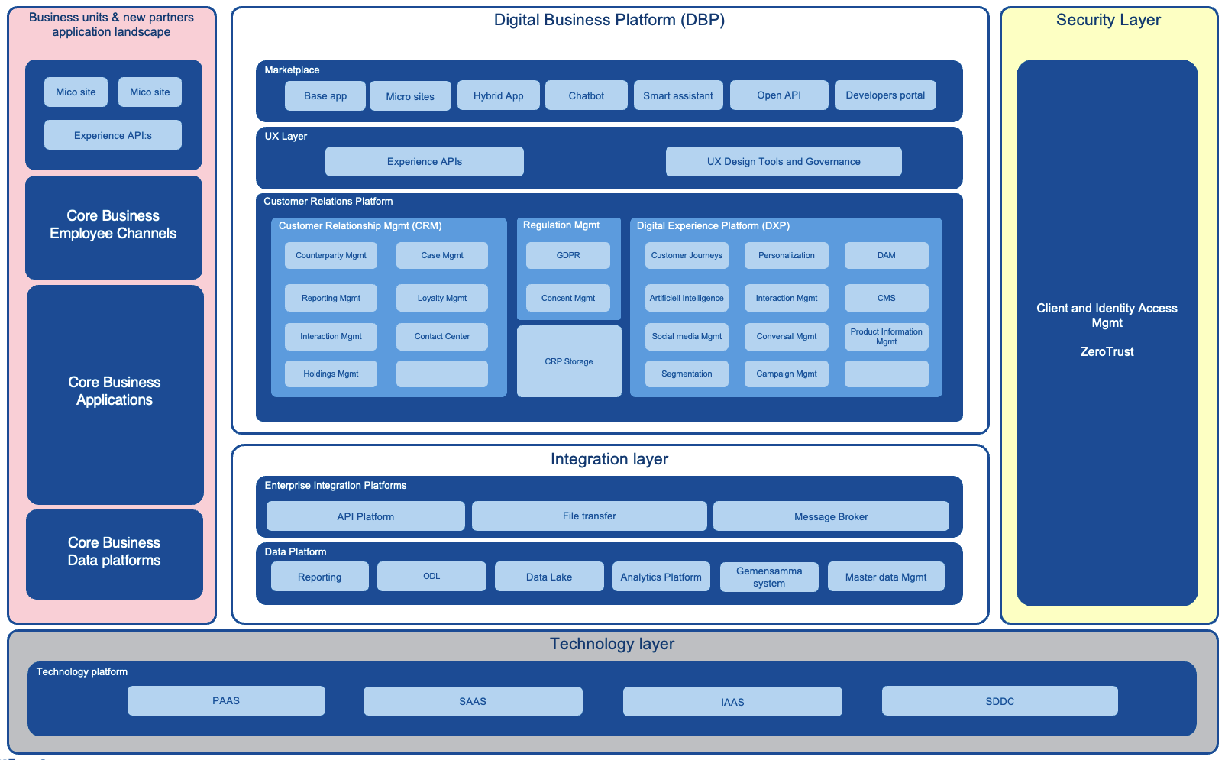
Figure C2 Swelians DBP enterprise architecture - 5,000 m

