
INFLUENCING FACTORS ON Employee SATISFACTION OF ctz pay CO., LTD, YANGON, MYANMAR

BACHELOR OF BUSINESS ADMINISTRATION
(BBA)

SU WAI PHYO
SSBR/2023/BBA/151100

MARCH 2025
INFLUENCING FACTORS ON Employee SATISFACTION OF ctz pay CO., LTD, YANGON, MYANMAR

A Thesis Presented
by
SU WAI PHYO

Submitted to the Swiss School of Business Research
for the degree of

BACHELOR OF BUSINESS ADMINISTRATION
(BBA)

MARCH 2025

Copyright by SU WAI PHYO, 2025

All Rights Reserved

INFLUENCING FACTORS ON Employee SATISFACTION OF ctz pay CO., LTD, YANGON, MYANMAR

A Destination Presented
by
SU WAI PHYO

Approved as to style and content by:

Dr. Paing Soe, Chair
President, Centre for Professional Development

Daw Myat Myat Oo, Supervisor
Academic Director, Centre for Professional Development

Dr. Stephen Harrison
Dean
Swiss School of Business Research

ACKNOWLEDGEMENT

I also extend my sincere thanks to Dr. Paing Soe, the President of Centre for Professional Development, for his visionary leadership and commitment to academic excellence, which has been a continuous source of inspiration.
I would like to express my profound gratitude to Daw Myat Myat Oo, Academic Director of Centre for Professional Development, for her exceptional guidance, meticulous feedback, and close supervision throughout the development of this thesis. Her expertise and unwavering support have significantly contributed to the depth and rigor of this research.
I am incredibly thankful to all the lecturers, administrators, and staff at the school whose support and guidance have greatly influenced my academic path. My heartfelt thanks go to my family, and friends for their constant encouragement and understanding. Their support has been my pillar of strength, especially during the challenging phases of this journey. I would also like to extend my appreciation to my colleagues and peers, whose discussions and camaraderie have enriched my learning experience.

Su Wai Phyo
SSBR/2023/BBA/151100

ABSTRACT

This study intends to examine the influencing factors on employee satisfaction of CTZ pay Co., Ltd, Yangon, Myanmar. Thesis Proposal, I would like to research about satisfaction of employees in financial technology company. The financial technology sector, commonly known as fintech, includes the integration of technology into financial services such as applications, processes and services to improve and expand the use of these products and services. There are a lot of factors that influence employee satisfaction such as compensation, working environment, career development, recognition and work-life balance. Employee satisfaction which can be called job satisfaction happens when employees are happy with their job. Employee satisfaction in Myanmar faces several challenges because of economic, social and organizational factors. Myanmar has experienced the following significant challenges which is inflation and currency devaluation. The sample size for data collection of employee satisfaction research is only 70 employees. By considering this broader scope, a fintech company can better capture a wide view of employee satisfaction, complying with insights that lead to effective strategies for improving workplace engagement and overall satisfaction across the organization. I would like to prove that job security, work-life balance, recognition, career growth opportunities and supportive management are critical for employee satisfaction. These factors also impact employees' overall well-being and motivation. A positive and inclusive organizational culture encourages employee satisfaction. The Companies emphasize employee well-being likely to have more robust, collaborative and innovative work environments.

TABLE OF CONTENTS

1. INTRODUCTION 8
1.1 OVERVIEW OR BACKGROUND 8
1.2 PROBLEM STATEMENT 10
1.3 Objectives: 11
1.4 Research Question: 11
1.5 SCOPE OF THE STUDY 11
1.6 ORGANIZATION OF THE STUDY 12
2. Literature Review 14
2.1 Salary and Bonus 14
2.2 Work-Life Balance 18
2.2.1 Why work-life balance is important? 18
2.2.2 Ways to improve work-life balance 20
2.2.3 Working Arrangements 21
2.2.4 Work-life balance for several important reasons 23
2.3 Working Environment 24
2.3.1Key Elements for good working environment 26
2.4 Career Development 29
2.4.1Activities for Career Development 31
2.4.2Why do Career Development important? 31
2.4.3Career Development Resources and Tips 34
2.5 Management Effectiveness 36
2.5.1 Measurements for Management Effectiveness 37
2.6 Employee Satisfaction 38
3. RESEARCH METHODOLOGY 42
3.1 Research Design and Sampling 42
3.2 Data Collection 43
4. Analysis and Results 45
4.1 Reliability Analysis 45
4.1.1 Reliability Analysis of Salary and Bonus 45
4.1.2 Reliability Analysis of Work-life Balance 46
4.1.3 Reliability Analysis of Working Environment 46
4.1.4 Reliability Analysis of Career Development 47
4.1.5 Reliability Analysis of Management Effectiveness 48
4.1.6 Reliability Analysis of Employee Satisfaction 49
4.2 Linear Regression Analysis 50
5. Conclusion 55
5.1 Suggestion and Recommendations 56
References 57

CHAPTER I

INTRODUCTION

Employee satisfaction which is one of the critical components of organizational success. This multifaceted concept includes various factors such as job security, work-life balance, recognition and growth opportunities. When organization give satisfaction to employees in current job, they are likely to demonstrate more engagement, productivity and loyalty. This can enhance the overall performance of an organization. When employees are satisfied, organization can be leaded to drive employees’ productivity, efficiency to have greater employee retention. By acknowledging and enhancing the various factors that contribute to employee satisfaction, businesses can encourage a positive work environment that not only attracts skillful workforce but also retains which can drive to sustainable success and growth. In this way, business can have strong organizational culture, collaboration and long-term success. (employee)
Improving employee satisfaction indicates more than just a monetary benefit. It includes the development of various factors that can affect a person’s overall well-being, engagement and motivation. Supporting a healthy work-life balance in business is not only important for health and engagement but also it can improve employee’s productivity and performance. Additionally, career growth opportunities for employees to recognize their efforts is a supportive company culture. So, organizations need to sustain a holistic approach to create an environment where employees feel valued and satisfied.

Overview or Background
The benefits of employee satisfaction are comprehensive and lead to a progressing workplace. When employees satisfied with their jobs, they are more willing to focus their work by putting more effort to achieve goals and enhance the quality of work. They also perform better job, bring higher quality work and contribute to customer satisfaction. When employees are dissatisfied with their work, this can cost business in terms of turnover, vacancy, poor reputation and low morale. If an organization has the greater number of satisfied employees within the workplace, this can lead to achieve organizational goals, business development and long-term growth. Employees who are happy with their current jobs also build internal relationships to get greater collaboration and improve overall performance and efficiency by sharing information to each other. Employee job satisfaction is connected with some factors such as employee motivation, performance and retention which are beneficial to not only the employee but also the employer.
According to this Thesis Proposal, I would like to research about satisfaction of employees in financial technology company. The financial technology sector, commonly known as fintech, includes the integration of technology into financial services such as applications, processes and services to improve and expand the use of these products and services. Fintech companies organize with specialized software and algorithms which are useful for both individuals and businesses by helping to manage financial operations more efficiently. Fintech includes a wide range of applications such as mobile payment apps, robo-advisors, peer-to-peer lending platforms and cryptocurrency exchanges. The purpose of Fintech is to make financial services more accessible, cost effective and user friendly. So, Fintech companies need innovative technology and skillful employees to operate their business in the competitive market. Employee satisfaction is also important because Fintech companies need to solve customer complaints, improve relationship with partners, develop technology by hiring skillful employees and retains them to achieve growth.
There are a lot of factors that influence employee satisfaction such as compensation, working environment, career development, recognition and work-life balance. Employee satisfaction which can be called job satisfaction happens when employees are happy with their job. When a business improves conditions for their employees, areas like customer satisfaction and revenue often see improvements, as well. However, job dissatisfaction can cause due to some of the reasons like poor pay and benefits, negative work environment, no opportunities for career development, difficult to engage with colleagues and lack of training. Therefore, the main problem for business is employee turnover that can cause a huge business expense. If employees are not happy with their situation in organization, they will start to find new job that offers something better, such as higher pay or more benefits. Replacing an existing employee costs not only time but also energy for employers. Employees want to negotiate with organizations to give higher pay rate or better allowance to stay longer but more than half of employers don’t care enough about keeping them. About fifty two percent of employees say that their manager or organization could have prevented their decision to leave by focusing on their satisfaction.
Employee satisfaction with compensation is a fundamental element that significantly influences overall job performance and company loyalty. When employees feel that their salaries and benefits reflect their contributions and market standards, it encourages a sense of worth and appreciation within the organization. Competitive compensation not only secures financial security but also motivates employees to be excellent in their roles, as they feel their hard work is recognized and rewarded. Furthermore, transparent communication relating pay structures and opportunities for salary growth can enhance trust and relationship between employees and management by contributing to a positive workplace culture. This might also reduce higher turnover rates which can affect workflow and cut down costs for the organization. Besides, a fair and attractive compensation is crucial for attracting and retaining talented employees that can drive both individual and organizational success.

Problem Statement of the Study
Employee satisfaction in Myanmar faces several challenges because of economic, social and organizational factors. Myanmar has experienced the following significant challenges which is inflation and currency devaluation. This can affect employees’ purchasing power and overall financial well-being. Besides, the political landscape in Myanmar has been unstable. So, employees’ job satisfaction can be leaded to negative impact which can cause stress and uncertainty among employees. Many employees encounter poor working conditions, inadequate facilities, long working hours, lack of safety measures and dysfunctional work environment. Compensation levels in Myanmar often low compared to international standards so employees feel inadequately rewarded for their work. Economic and political instability can lead to job insecurity which is a significant factor in employee dissatisfaction.

Objectives:
1. To examine the motivation factors on employee satisfaction of CTZ Pay Co., Ltd in Myanmar
- To investigate motivational strategies on Organizational Performance of CTZ Pay Co., Ltd in Myanmar
- To analyze the impact of employee satisfaction on organizational performance of CTZ Pay Co., Ltd in Myanmar

Research Questions:
1. What are the key factors influencing employee satisfaction at CTZ Pay Co., Ltd?
2. How do these factors correlate with employee productivity, retention and overall organizational performance of CTZ Pay Ltd., in Myanmar?
3. What is the relationship between employee satisfactions on organizational performance of CTZ Pay Co., Ltd in Myanmar?

Scope of the Study
Defining the scope of employees for collecting data on employee satisfaction is essential to ensure comprehensive insights while also considering diversity and representation within the organization. There are key considerations for the scope of employees in this thesis proposal such as diversity of roles, geographic representation, tenure, demographic factors, engagement levels, job functions and differences between legacy employees and new hires. Diversity of roles include employees from all levels and departments within the fintech company, such as senior management, mid-level managers, entry-level employees and interns, departments like technical experts, customer service, finance, marketing and compliance. As the company operates in multiple locations, the survey will be asked employees from all geographical regions including remote workers to capture varied experiences and perceptions. Tenure defines segment the data collection by employee tenure to identify trends and differences in satisfaction among new hires (less than a year), mid-tenure employees (1 to 5 years), long-tenure employees (over 5 years).
Demographic factors consider including diverse demographic factors such as age, gender, ethnicity and educational background to understand different perspectives and experiences in employee satisfaction. Engagement levels identify and categorize employees based on their current engagement levels, including highly engaged employees, moderately engaged employees and disengaged employees. Collecting data for employee satisfaction from various job functions and specific teams can differ based on responsibilities, team dynamics and management styles. (data) The comparison of legacy employees and new joinees evaluate differences in satisfaction. Legacy employees who have longer time and those who are newly hired may have distinct perspectives on company culture and changes over time. The sample size for data collection of employee satisfaction research is only 70 employees. By considering this broader scope, a fintech company can better capture a wide view of employee satisfaction, complying with insights that lead to effective strategies for improving workplace engagement and overall satisfaction across the organization.

Organization of the Study
The five chapters that make up this study. The broad introduction to this study is covered in Chapter I. This includes the introduction, background, problem description, aims, research questions, scope and limitation, significance, and study organization. The literature review in Chapter II is focused on customer behavior and the factors influencing consumer purchasing decisions. In Chapter III, the study methodology utilized to analyze the variables influencing Yangon consumers' decisions to purchase Samsung mobile phones is described, along with the research design, sample size, instrumentation, procedures, and data processing methods. The analysis of the elements impacting the consumer purchasing decisions of Samsung Phone customers in Yangon is covered in Chapter IV. The concluding portion, Chapter V, contains the findings and comments and Chapter VI contains ideas and proposals, restrictions and the need for additional research.

CHAPTER II

LITERATURE REVIEW

In research, dependent and independent variables are fundamental concepts used to understand relationships between different factors. The independent variable is the factor that researchers manipulate or change to observe its effect on another variable. The dependent variable defines that the result or feedback that students measure to determine the outcomes of the independent variable. The interdependence of independent and dependent variables is vital for hypothesis testing. A variable is assumed dependent when it is influenced by an independent variable. Dependent variables are studied under the supposition or demand that they depend on the values of other variables. Independent variables are not relying on any other variable in the range of the research in question. There are a lot of titles for the dependent variable such as response, symptoms, outcome and etc. The dependent variable is usually the focal point of the study for research. Independent variables aren’t affected by any other variables that the study measures. When we are searching for relationships between variables, we are trying to see if the independent variable causes some kind of change in the dependent variable. In this thesis, employee satisfaction will be dependent variable. The independent variables which focus on this thesis are salary and bonus, work-life balance, working environment, career development and management effectiveness.

2.1 Salary and Bonus
A fair and competitive base salary is a fundamental requirement for most employees. It can make employees feel valued and increase their likelihood of being financially healthy. One factor influencing whether increases in salary will result in the employee becoming more motivated is the perceived connection between the level of the salary and the value of the role being performed. Employees are more likely to be driven by the role's content if they feel that their pay and their role are commensurate with each other. However, the motivation will decrease if employees perceive the discrepancy between pay and value of their role. Another factor is linked to the industry of the organization. Lower pay is associated with diminished motivation. The pay increase will boost not only your staff's morale but the morale of the workplace as a whole. When employees feel like they are compensated fairly for their work, they will, in turn, be more motivated. Other factors that typically lead a company to increase an employee's salary have to do with their work performance, their experience (and thus the knowledge they bring to the job), and the changing market for the job that the employee is performing.
Bonuses and salary increments are key components of employee compensation that can significantly impact motivation and retention. Bonuses are typically performance-based rewards given to employees for achieving specific goals or exceptional performance. They can be distributed annually, quarterly, or even as spot bonuses for outstanding achievements. Bonuses not only provide financial rewards but also serve as recognition and appreciation for hard work. Bonuses can be an effective motivational tool when linked to performance and set out in a transparent way. They can be used to reward employees for achieving specific targets, such as financial milestones, productivity goals, or other key performance indicators. Salary increments refer to the periodic increase in an employee's base salary. These increments can be based on various factors, such as tenure, performance, market rates, or cost of living adjustments. Regular salary reviews and increments help ensure that employees feel valued and fairly compensated for their contributions. Both bonuses and salary increments play a vital role in maintaining a motivated and engaged workforce, as they provide financial incentives and reinforce a culture of recognition and growth. An individual can be motivated by receiving salary increase and achieving consistently outstanding performance. Moreover, bonus for each employee or team bonus that exceed what they expected can boost overall motivation. Bonus programs should be aligned with individual and team performance with organizational goals. This motivational appliance is essential for keeping happy employees and working efficiently.
In monetary incentives, there are powerful tools to motivate employees such as bonuses, salary increments, commission, profit sharing, stock options, performance bonuses. While non-monetary incentives include recognition, professional development, flexible working conditions, work-life balance, career advancement opportunities, employee wellness programs and company culture. Non-monetary incentives like recognition and professional development are treasures. Besides, money is a revolutionary incentive. In most company bonus program, employees are rewarded for achieving certain targets, exceeding expected job performance, financial milestones, obtaining productivity goals and acquiring key performance indicators. The power of money as a reward locates in its comprehensiveness. Unlike other incentives with changing levels of personal seriousness, money is a universally valued inducement. It can not only cover basic needs but also pursue personal ambitions. Nowadays, employers make monetary incentive as a flexible and highly attractive reward for employees in a bonus program. Moreover, the recognized value of the reward is important in motivating employees. Money becomes a quantifiable and tangible thing which provides a transparent and measurable indicator of job success. This fact enhances the psychological impact of the reward, increasing the connection between effort and performance. Monetary incentives are often more effective and tangible that are directly impacting an employee's financial situation. These incentives will mostly effective for achieving short-term goals and managing specific targets. However, non-monetary incentives can have a lasting impact on employee satisfaction, engagement, and loyalty. They help create a supportive and enriching work environment, which can lead to sustained high performance and long-term retention. It's important for companies to ensure that bonus structures are fair and transparent. Clear communication about how bonuses are determined and distributed can help build trust and prevent misunderstandings. Additionally, while bonuses are valuable, they should be part of a broader strategy that includes both monetary and non-monetary incentives to create a well-rounded approach to employee satisfaction and engagement.
Employee benefits are a crucial component of overall compensation and play a significant role in job satisfaction and retention. Common benefits include health insurance, which covers medical, dental, and vision care; retirement plans like 401(k)s or pension plans for future savings; and paid time off (PTO) for vacations, sick leave, and personal days. Additionally, life and disability insurance provide financial protection for employees and their families. Flexible working arrangements, such as remote work or flexible hours, are increasingly popular, as are professional development opportunities that offer training and education reimbursement. Wellness programs, like gym memberships and stress management workshops, along with Employee Assistance Programs (EAPs) that provide support services for personal or work-related issues, further contribute to employee well-being. Employers may also offer performance-based bonuses, signing bonuses, profit-sharing plans, and various other perks such as free meals, transportation assistance, childcare support, and employee discounts. These benefits collectively help create a supportive and attractive work environment that retains top talent. In Myanmar, employee benefits are governed by various labor laws and regulations. The following are some major benefits that employers typically provide which are paid leave and holidays, maternity and paternity leave, sick leave, social security and other optional benefits.
Employees are entitled to at least one day of paid leave per week, 10 days of paid annual leave, and six days of paid casual leave per year. Additionally, employees receive paid leave for 16 public holidays. Mothers are entitled to 14 weeks of paid maternity leave, while fathers can take up to 15 days of paid paternity leave. Employees can take up to 26 weeks of sick leave annually, with the first 30 days being paid if the employee has been with the company for more than six months. Employers with five or more employees must enroll their employees in the Social Security Fund, with contributions made by both employers and employees at a rate of 5% of wages. Employers are required to provide basic occupational health and safety benefits, as outlined in the Occupational Safety and Health Law (2019), Factories Act (1951), and Shops Establishment Law (2016). Many employers offer additional perks to attract and retain top talent, such as performance bonuses, housing and transportation allowances, childcare centers, tuition reimbursement, and stock options. These benefits help create a supportive and attractive work environment, contributing to employee satisfaction and retention.

2.2 Work-Life Balance
Work-life balance is a crucial aspect of maintaining overall well-being and productivity. It encompasses various elements such as flexible work hours, which allow employees to adjust their schedules to manage personal responsibilities alongside their professional commitments. Flexible working hours allow employees to have some control over their work schedules, rather than adhering to a strict 9-to-5 routine. Maintaining a healthy work-life balance is not only important for health and relationships but also improve employee’s productivity and performance. If employees don’t think work as a duty so they will work harder, careful for mistakes, and are more likely to do employee advocacy for company and brand. Nowadays, a reputation attained by business for supporting work-life balance within workplace have become very fascinating. It is especially for retaining younger employees who are difficult to attract these days.

2.2.1 Why work-life balance is important?
Fewer health problems
Everybody feels stressed at least once due to overworked or pressure within working environment. When we are suffering stress or trouble, we encounter the risk of both physical and mental health problems. There is no doubt that our health will affect by working overloads, feeling tired or stressed. A poor work-life balance can cause a variety of consequences which can impact on employees’ wellbeing. This includes minor health conditions like flu to serious health conditions like heart disease and strokes. A study conducted by UCL of more than 10,000 participants stated that white-collar workers who worked three or more hours longer than required had a 60% higher risk of heart-related problems than those who didn’t work overtime.
By enhancing employees to look after themselves and observe balance between work and daily life, then they will significantly control health problems and absences. So, this ensures that the organization is more productive during business hours.

Engagement
By encouraging employees to find the perfect balance between work and life, they will increase their commitment levels. This has many positive effects: According to Tower Perrin’s global survey, “Companies with highly engaged employees had a near 52% gap in performance improvement in operating income.” Moreover, “Companies with high levels of employee engagement improved 19.2% in operating income, while companies with low levels of employee engagement declined 32.7%.”
Employee engagement will lead to employees going the extra mile for organization and becoming loyal staffs for brand and product. This is proved by Temkin Group which suggests that “engaged staff are 2.5 times more likely to stay at work late if something needs to be done after the normal workday ends.”
Fewer burnouts
We all get stressed from time to time. It is unavoidable. However, workplace burnouts are acceptable and you should make efforts to ensure this doesn’t happen to your people. Burnouts happen when we feel overwhelmed and unable to meet perpetual needs. The disadvantages of burnout can affect every situation of our daily lives. The lack of ability to separate work from personal life will significantly increase the probability of burnout. Therefore, it is important to motivate employees to take leave to get time off and completely relax.
More mindfulness
When employees find and sustain a healthy work-life balance, they expand greater control over their priority and ability to concentrate on the work at hand. This is known as mindfulness. Every employer will prefer employees who is completely focused on their job instead of worrying about personal life or home. By creating an environment where businesses encourage employees to have a healthy work-life balance, this will develop productivity, retention rates and business profit.

2.2.2 Ways to improve work-life balance
The annual leave is a necessity for employees. A rest for a while from work will provide employees satisfaction and enjoy themselves. Besides, it is also a great opportunity to recover and recharge. This is crucial to support employees to improve productivity and focus their job when they return to the office. Numerous studies reveal that holidays enhance company productivity and reduce employees’ stress. The American Sociological Association organized a report which suggests that the more vacations when employees get, the less psychological distress of employees. A powerful method to encourage employees to take vacation is to implement an effective work-life balance system in accordance with which any leftover leaves will not be carried to the next year.
If taking leave is not an option for employees, then it is important to encourage to take small breaks throughout the working day. We, the human body, will affect by looking at a computer screen with blue rays for hours continuously. It is not good for our not only physical health but also our mental comfort.
To conclude, businesses should consider installing workout room where employees can socialize and take their minds off work. By encouraging light exercise such as Yoga or Zumba throughout the day, this action can reduce stress, improve productivity and improving physical postures for employees. Sometimes, employers should go with employees as a team to grab a coffee or even lunch. Technology can also be helpful in some other ways. Businesses can invest in annual subscriptions to mindfulness or meditation apps to help restful and relax their employees.
For the above reasons, short breaks will positively impact employees’ work performance, productivity and workplace enjoyment.
If organizations are facing difficulties to bring forward with innovative ways to encourage employees’ work-life balance, the best solution is to ask them. When businesses pay attention to the problem that employees are struggling, they will find out what changes they think would upgrade their situation. By collaborating with employees, business will get more understanding into how they think and ways to be able to work together on effective strategies from now on. Organizations should consider by preparing regularly scheduled meetings or applying cultural program feedback to make preparations balance for work-life balance for employees according to data-driven activities. In this way, business can actually determine how employees are feeling during working hours and make improvements to ensure that they have the right balance.
Although employers also know that work-life balance is essential for their employees, sending emails to work over weekend or office hours is not comply with employees’ life style balance. It can also put additional pressure on employees to follow employer’s working hours.
There is a law in France known as “Right to disconnect.” It ensures that there are limits on the amount of work undertaken outside of office hours. Business should consider to implement something similar within workplace. It is very important to respect the balance and privacy of staff team when they are out of office hours. This means employers should avoid contacting employees outside of office hours for allowing them to get fully recharge from everyday work stresses.
Most of us assume that both work and life are same in our daily lives. So, we will spend an enormous percentage of our time at work. We allow it take over and add into all aspects of our lives. It is essential to find the right balance and implement it in the workplace. This will encourage employees to take a break from work and give some personal matters that are also important for their lives. Becoming a business where support work-life balance is not actually easy. However, business can have many advantages due to work-life balance by making huge steps towards building an engaged and productive team.

2.2.3 Working Arrangements
There are some several types of flexible working arrangements:
Flexitime is defined as that employees can choose their start and end times within certain limits (e.g., start anytime between 7 AM and 10 AM and finish between 3 PM and 6 PM) as long as they complete the required number of hours each day or week. Flexible working hours can develop work-life balance, boost job satisfaction and enhance productivity by allowing employees to work during their most productive times and manage personal responsibilities more effectively. The ability to adjust work schedules to accommodate personal responsibilities and preferences helps employees manage their time effectively.
Compressed workweek is also determined as employees work longer hours for fewer days, such as working four 10-hour days instead of five 8-hour days.
Employees have the option to work from home or another location outside the office is called remote work. Remote work options become popular nowadays, decreasing commute times and improving job satisfaction by allowing employees to work from home or other locations. Working from home or other locations can reduce commute times, decrease stress, and provide a more comfortable work environment.
Vacation and day off are important factors which are encouraging employees to take their allowance vacation days and providing paid absence leave can help them energize and abstain from burnout. Adequate vacation days and paid time off allow employees to recharge and spend quality time with family and friends, preventing burnout. A supportive workplace culture that encourages work-life balance is vital where managers and colleagues respect personal time and boundaries, creating an environment of mutual respect. A culture that values work-life balance, where managers and colleagues respect personal time and boundaries, fosters a healthy work environment. Employee Assistance Programs (EAPs) are advantageous in giving access to support services for personal or work-related issues, helping employees manage stress and maintain balance. Access to support services for personal or work-related issues, such as counseling or financial advice, helps employees manage stress and maintain balance.
Fitness and wellness programs such as gym memberships, mental health resources and stress management workshops also contribute to employees' overall well-being. Initiatives that promote physical and mental health, including gym memberships, mental health resources, and stress management workshops, contribute to overall well-being. Clear expectations for workloads and deadlines are also important because they can help employees to manage their time effectively without feeling overwhelmed. Setting realistic expectations for workloads and deadlines helps employees manage their tasks without feeling overwhelmed. Promoting work-life balance leads to happier, healthier and more productive employees. Eventually, it benefits both the individual and the organization.
Work-life balance is also influenced by various factors that contribute to an employee’s overall well-being and productivity.
Professional development opportunities which are an access to training and career growth opportunities that ensures employees feel fulfilled and motivated in their roles. Policies like parental leave, childcare support and flexible working hours for parents help employees balance work and family life. Supporting the right tools and technology can help employees work more efficiently and reduce the need for overtime.

2.2.4 Work-life balance for several important reasons
When employees have a satisfactory work-life balance, they are unlikely to encounter stress, burnout and mental health issues. This leads the way to a healthier and joyful workforce. As described earlier, work-life balance can increase productivity of employees. Employees who feel energetic and less burnout are more productive and concentrated during their working hours. Flexible working arrangements can assist to manage working time more effectively. Employee retention is also one of the most important factors of organization. Organizations that encourage work-life balance likely to have lower turnover rates. Employees are more likely to work with a company that cares their personal time and well-being. Employees who notice their personal matters are respected and supported are more engaged and committed to their work. This brings about increase job satisfaction and better overall performance. Enhancing work-life balance in workplace can make a company more attractive to potential employees. In a competitive job market, this can be a significant advantage for employee retention. When employees have a good work-life balance, they will not take absence without leave (AWOL) because of mental health issues or personal problems. Employees who have enough time to relax and seek personal interests often propose innovative ideas and creative solutions to their work. A strong company culture can be designed by focusing on communication, collaboration and community. In a positive company culture, supporting work-life balance also include as a major factor which shows that the organization values its employees as individuals not just as workers.

Working Environment
A working environment incorporates all the physical, social and psychological factors that influence employees' experiences and performance at work. This involves the physical workspace such as office layout, equipment and facilities that can influence comfort and productivity. It is likely to crucially impact employee morale, relationships, job performance, job satisfaction and employee wellbeing. Understanding what a healthy working environment can assist employees in finding an employer who encourages a positive working environment. A positive work environment enhances the mood, improves productivity and prepares a good working point of view for not only employees but also employers. The physical setup of the workplace, the office equipment, the level of noise and lighting and the level of safety and security are also important for working environment.
In addition to these physical factors, the work environment also includes social and cultural features such as the organizational culture, the relationships between team members, the way work is communicated, and the level of training and appreciation provided to employees. A positive work environment leads to productivity, creativity, and employee satisfaction. It also fosters clear communication, effective teamwork, diversity, consideration, and recognition of responsibility for employee well-being. However, a poor work environment can lead to work-related stress, burnout, and low optimism, which can negatively impact individual and organizational performance. A good office environment can significantly improve productivity, morale, and job satisfaction. A positive work environment can increase employee productivity, job satisfaction, reduce stress, and improve mental well-being. This can lead to lower employee turnover, improved productivity, and overall job performance. It can boost productivity and creativity for better work performance. When employees are happy and supportive in the workplace, they are more likely to be creative and innovative. This can help shape organizational culture, influencing employee values, morals, and behaviors. A positive work environment can help create a culture of respect, collaboration, and trust.
The conventional work environment
The traditional work environment is highly structured and supported by systematic tasks such as handling data and numbers. Procedures, stability, culture, and well-defined rules and systems define this type of environment. People who are attracted to this environment are likely to be neat, well-organized, and choose to follow directions. This type of work environment typically requires regular hours and office work.
The enterprising work environment
Entrepreneurial work focuses on achieving organizational and financial goals and often involves tasks such as management, sales, and motivation. This type of environment is characterized by success, power, money, and competition. Sales and management jobs can be a part of it. Employees who enjoy this type of work are usually demonstrative, driven, and confident.
The social work environment
Social work environments focus on people and involve teaching, leading, treating, and trying to understand people. This social work environment attracts people who enjoy social interaction and who are motivated by helping others. To succeed in this type of environment, employees must have good communication, verbal, and interpersonal skills. Careers suitable for this type include conducting fieldwork, consulting with people as a service, teaching in schools or colleges, or working in hospitals.

The artistic work environment
An artistic workplace environment is conducive to freedom of expression, creativity, artistry, enthusiasm, and uniqueness. This type of work environment is characterized by its lack of structure and rules. By nature, individuals who thrive in this type of environment are unique, free-spirited, innovative, and independent. This environment can include film production, music performances, graphic design, comic book writing, and art creation.
The investigative environment
Problem solving, intuition, and theoretical thinking are key elements of an exploratory learning environment that focuses on math and science. This unstructured environment fosters creativity and freedom, similar to the artistic workplace. Employees who are more creative thinkers than those who are practical and physical thrive in such environments.

The realistic environment

A practical environment focuses on physical labor, including working outdoors using tools and instruments. Employees who work with their hands and are attentive to the present thrive in this environment. This environment includes mechanical, engineering, and technical work and may require work on site, in a factory, workshop, studio, and so on.

Key Elements for good working environment
Healthy culture
The first and foremost important step is to construct a positive work environment or company culture. This mentions how things work in the workplace, how people manage, how the team collaborate, how decisions make and how they deal with conflict. Building meaningful and authentic relationships with team members and colleagues is crucial for increasing their happiness, productivity and engagement which are leading to better results. Therefore, famous companies consider employee health, allowance and rewards as investments in achieving organizational goal.
Personal relationships
Most companies take care of their employees. Great businesses know that transactional relationships are meaningless and that they don’t show anything good. Businesses know that they must care about their employees exactly as much as they hope their team members to care about the organization. They know that smart employees behind desks are the ones who bring about with innovative ideas in a cheerful office. Establishing to know team members individually and as a group. Learn about their families and what they like to do in holidays and connect them in their hobbies or activities. When the relationship or friendship grows, business can know more of employees’ presence and participation at work. Whether or not, employees will consider their jobs just a method to generate exchangeable money.
Having a good and productive workday
Collaboration is kind of using employees’ energies to achieve goals successfully. It needs avoiding hierarchical leadership structures or positions where employees only take orders and carry out the tasks. Appreciate the results and the extensive effort that goes into each aim. By doing this, organization motivate employees to keep setting effort and moving forward. Since, employees will be confident that their contributions will reach or even exceed the team’s goals. This enthusiasm and positive energy are important for enhancing happiness at work.
Bring your company values to life
Values should never be just delightful words in a company’s mission and vision statement. They should be visible to everyone who works in organization as part of their everyday efforts. When the team believes each other, a reliable brand is created. The way to superiority is built on hard work, always chasing the highest quality at every step.

Flexibility and Employee Appreciation
Companies require to remember that they are handling with people, not machines. They have a personal life outside of workplace and they may meet a difficult time, such as a family issue. Employees must feel appreciated and recognized as valuable members of a team. Giving them monetary benefits or rewards is less effective than showing gratitude.
Share the big picture for workplace happiness
Every team must understand their importance in building a great brand. Moreover, every team are important to the process. If the work is done incorrectly, then it causes a substantial issue, no matter how negligible it seems. Employee may never encounter the consequences such as unsatisfied customers, a negative reputation or decrease sales. Company must pay attention and motivate employees to create a high-quality product or service and achieve business goals.
The social environment includes interactions with colleagues, supervisors and clients, influencing team direction and workplace culture. A positive, sympathetic and comprehensive culture enhances collaboration and job satisfaction.
Strong teamwork and collaboration generate a supportive workplace where employees feel they can depend on one another. Clear and visible communication encourages trust and secures every team member is on the same page. A culture of inclusivity and consideration ensures that all employees feel appreciated and can provide their unique point of views. Encouraging and empathetic leadership assists to build a positive social environment by providing instruction and understanding employees' efforts. Regular feedback and recognition of achievements motivate employees and help them improve. Team building work out and social events can make stronger relationships and create a sense of community. Effective method for determining conflicts and solving issues promptly prevent misinterpretation from increasing. Policies which support work-life balance show that the organization fosters about employees' well-being.
Besides, the psychological environment refers to components like job security, work-life balance, appreciation and opportunities for growth. When employees feel secure and supported, they want to be engaged and motivated. A great working environment balances above components by creating a space where employees can develop both professionally and personally.

Career Development
Career development is the continuing process of managing life, learning and work in progress for career life. It includes creating career goals, obtaining skills and experiences and making tactical decisions to achieve those goals. This process involves self-assessment, searching career options, improving a career plan and continually assessing and converting to new opportunities and challenges.
Career development is defined as the activity of learning and utilizing short-term skills to proceed toward long-term professional goals. This process is sometimes lifelong and implies gradually reaching milestones exact to the designated career path. Most career development calls for reflection and the investigation of purpose in work and is the fact for achieving career growth.
A career path can be imagined as a ladder with each get representing the level of a role on the path. Searching a job is a greatest importance first step but nobody wants to stay at the first line level forever. However, climbing up the career ladder and receiving promotions is easier said than done. It frequently requires careful planning and taking aimed steps.
Career development is about congregating what skills and experiences can launch further on the career path and guiding these processes in ladder steps to make career growth achievable.
Career development is vital for several reasons. Firstly, it helps you to navigate the constantly changing job market with confidence. By regularly evaluating and encouraging your skills, employee remain competitive and adaptable, get new opportunities. The job market is continuously changing so employees should invest in their career development, should stay ahead of the curve and position themselves for achievement.
Additionally, career development allows employees to take control of the professional life, making sure that they are continuously progressing towards your goals rather than deteriorating in a role that no longer development with their career. It empowers to identify areas for improvement and take ladders to support knowledge and expertise. By investing in employees’ own growth, they become a great worth asset to employers and increase chances of opportunities.
When employees actively invest in the career development, they increase their chances of job satisfaction, upward strength and long-term success. It is not only about the monetary rewards but also about finding contentment and intention in work. By positioning career with values and passions, employees can create a sense of achievement that goes exceed a payroll check.
Career development is a lifelong journey. It is not something which ends when employee get a job or receive a certain level of success. It is an ongoing process of self-realization, growth and modification. By increasing career development, employees can continuously expand and succeed in a dynamic professional perspective.
Increases Motivation at Work
Career development is assumed as designating realistic goals to work toward. This helps employees set practical expectations, feel less stress and find more eagerness to reach these goals. The more the career develops, the more an employee gains a sense of attainment and motivation to do more productive work.
Increases Happiness and Satisfaction
Career development and happiness at work often go side by side. Feeling victorious in development goals at work will likely increase workplace happiness and workplace happiness will increase performance and induce further development. For the above reasons, develop and find new skills as an employee makes for a more satisfying and fulfilling career overall.

Activities for Career Development
- Education and Training: Pursuing formal education, professional certifications, or skill-building workshops.
- Networking: Building relationships with professionals in the industry to gain insights and opportunities.
- Work Experience: Gaining practical experience through internships, part-time jobs, or volunteering.
- Mentorship: Seeking guidance and advice from more experienced professionals.
- Performance Evaluations: Regularly assessing one's own performance and seeking feedback for improvement.
- Career Planning: Setting short-term and long-term career goals and outlining steps to achieve them.
Effective career development requires a proactive approach, self-reflection, and a willingness to adapt to changing circumstances. It's about continuously growing and positioning oneself for future career opportunities.

Why do Career Development important?
- Personal Growth: It encourages continuous learning and skill enhancement, helping individuals stay relevant in their field and adapt to changing industry trends.
- Job Satisfaction: Pursuing career development can lead to more fulfilling and engaging work experiences, as individuals align their roles with their interests and strengths.
- Advancement Opportunities: It opens doors to promotions, raises, and new job opportunities by demonstrating an individual's commitment to their profession and growth.
- Economic Stability: Developing one's career can lead to higher earning potential and financial security, providing a better quality of life.
- Confidence and Self-Esteem: Achieving career goals and acquiring new skills can boost self-confidence and self-esteem, leading to greater overall satisfaction and well-being.
- Work-Life Balance: By seeking roles and opportunities that align with personal values and goals, individuals can create a more balanced and satisfying life.
- Innovation and Creativity: Continuous career development fosters a culture of innovation and creativity, as individuals bring fresh ideas and perspectives to their work.
- Organizational Success: For employers, supporting career development leads to a more skilled, motivated, and loyal workforce, ultimately driving organizational success and growth.
In essence, career development is a journey that benefits both individuals and organizations, promoting personal and professional growth, satisfaction, and success.
Employees can take several proactive steps to improve their careers by continuously learning, pursuing further education, certifications, and professional development courses to stay up-to-date with industry trends and enhance their skills. Networking is crucial; building relationships with colleagues, industry professionals, and mentors provides insights, opportunities, and support. Setting clear short-term and long-term career goals and creating a plan to achieve them helps in staying focused. Seeking constructive feedback from supervisors and peers regularly identifies areas for improvement and growth. Taking on new challenges by volunteering for projects or responsibilities allows employees to gain experience and demonstrate initiative. Developing soft skills such as communication, leadership, teamwork, and problem-solving is valuable in any role. Staying flexible and adaptable with updated technologies and processes verifies continuous growth. Demonstrating achievements by saving a record of achievements and regularly updating curriculum vitae and professional profiles focuses career development. Building a strong personal brand through social media platforms like LinkedIn highlights proficiency and connects with employers in the industry. Finally, seeking coaching provides recommendations, support and valuable enlightenment for career development. By eagerly supporting in these activities, employees can gradually develop and setting themselves for growth and new opportunities in their careers.
Career development in a fintech company involves leveraging both financial and technological skills to advance within the rapidly evolving industry. Here are some key aspects:
- Skill Enhancement: Continuously updating and expanding your technical skills, such as programming languages, data analysis, and cybersecurity, is crucial. Fintech companies value employees who stay ahead of technological advancements.
- Industry Knowledge: Understanding the financial industry, including regulations, market trends, and financial products, is essential. This knowledge helps in developing innovative solutions that comply with industry standards.
- Networking: Building connections with professionals in the fintech sector can open doors to new opportunities and collaborations. Attend industry conferences, join fintech forums, and engage with influencers and peers.
- Cross-Functional Experience: Gaining experience in different roles within the company, such as product management, customer support, and compliance, can provide a well-rounded perspective and enhance your career growth.
- Certifications and Courses: Pursuing relevant certifications and courses in fintech, blockchain, and financial technology can boost your credentials and demonstrate your commitment to professional development.
- Innovation and Creativity: Fintech companies thrive on innovation. Contributing new ideas and solutions to improve financial services can set you apart and lead to career advancement.
- Soft Skills: Developing soft skills like communication, teamwork, and problem-solving is vital. These skills help in collaborating effectively with colleagues and clients.
- Mentorship and Coaching: Seeking mentorship from experienced professionals in the fintech industry can provide valuable guidance and insights for career progression.
- Performance Metrics: Setting and achieving performance goals can showcase your contributions and lead to recognition and promotions within the company.
- Work-Life Balance: Maintaining a healthy work-life balance ensures you stay motivated and productive, which is essential for long-term career success.
Career development in fintech is dynamic and rewarding, offering opportunities to be at the forefront of technological innovation in finance.

Career Development Resources and Tips
Salary and Benefits
Not only finding a satisfying job is important but also pay and benefits significance too. Beneficially advocating can make a great difference to the lifetime earnings and understanding how compensation performs.

How to Ask for a Raise
That might be simple but many of us don’t think pay rate because we’re too afraid to ask for raises. To discuss effectively, employees need to do some analysis to understand how much they look at other companies make. Moreover, they need to compare current company’s salaries to broader market trends. If employees are skillful in their career, they might be able to reach an agreement on themselves to an above-market rate.
How to Counter a Job Offer?
Starting pay has major suggestion for earnings down the line because many companies calculate raises based on a percentage of basic salary. Familiar strategies for running into the right balance involve asking for a company’s internal salary range, maintaining on discussing the written offer before agreement and checking that don’t agree too much in the negotiation.
Stock Options
Initial phase startups can’t match corporate salaries so they make up the difference with stock options. In abbreviation, stock options are contracts that allow employees buy part of a company at a fixed price in the future. This means that company giving employees the chance to share in the upside of an initial public offering (IPO) or an investment.
Severance Pay
A severance pay can lower the chance of losing a job however it is not free money precisely. This can include weeks or months’ worth of your basic salary in addition to healthcare benefits and assist finding a new job.
How to Get the Career You Want
If employees have particular goals, they need specific plans. If they are lacking in either, they will find difficulties in their career development process.

How to Get Your Dream Job
Dream job might be something people forget themselves entirely and where they find themselves launching into ideas and loving every moment. Otherwise, it might be a job which is pretty good but flexible and that leaves ample space for whatever else like to do with free time. If employees don’t know what their dream job is, it might be time to start imagining about it. If not, their career might not relate with the job they work at the moment.

Management Effectiveness
It explains that reinforcing and empowering employees so they are engaged, perform productive work and are enjoy in the workplace. Moreover, achieving organizational goals while retaining employee expectations is important.
It includes various factors and skills such as leadership and communication skills, decision making, adaptability, problem solving and etc.
Leadership and communication skills
An effective supervisor should have strong leadership skills. Clear communication, positive relationships, regular feedback and active listening are necessary for managerial role.
Decision-making
Managers require to make a lot of decisions that can directly or indirectly effect on their team. So that, they analyze data and make knowledgeable decisions is crucial for the happiness of the team and the company.
Adaptability
The business aspect transforms at a rapid movement. Managers need to have adaptability to lead the team through any change and to manage the team effectively.

Problem solving
As management teams, they carefully plan things although they can encounter problems in many different ways. An effective manager needs to inspect any issues available, find the source of case and solve solutions as fast as possible.
A manager is someone, who has authority to manage a team or department, who supervises people, who implement many essential tasks and responsibilities that empower the organization and its people to achieve. Entry level managers do the work of planning, organizing and delegating work across the team. Moreover, they are also responsible for engaging talent as well as mentoring and developing employees. Managers are the primary of defense against turnover, champion in employee engagement and are in a serious position to alleviate risk and get rid of difficulties. Managers are also responsibility in support of engaging employee motivation, cooperation, arrangement, and comfort so that employees feel role clarity, independence, motivation and recognition.

2.5.1 Measurements for Management Effectiveness
To get a good image of management effectiveness in organization, business needs to measure from various different angles. Most companies talk about a management effectiveness indicator which means tracking several measures.
360-degree feedback
This is also known as a type of performance review in which gather feedback from multiple sources. These can include the person’s co-workers, juniors and seniors. The more diverse sources, the better understanding can get of the manager’s effectiveness.
Objective achievement
Observing goals of a manager and how many they achieved during a specific period. By thinking of the objectives achieved, goals are playing in an important role. Most people are ignoring external factors that may have decelerated the growth but that have not a thing to do with management effectiveness.
Standard performance reviews
There is no feedback from co-workers or juniors included in this kind of review. As an alternative, the review is between the managers and their supervisor and focus to look at effectiveness and areas for improvement. This is also an opportunity to set future goals and generate plans for development.

Employee Satisfaction
Employee’s satisfaction and performance is crucial and necessary in an organization. A satisfied employee would have greater performance and it will improve the productivity. The main purpose of this research is to investigates the relationship between employee satisfaction and other factors that influence upon satisfaction. In this study, employee satisfaction discusses in external and internal factors that are salary and bonus, working-life balance, working environment, career development and management effectiveness. Work culture consists of an organization’s beliefs, sentiment and goals. Satisfied employees can improve a company's culture by creating a positive working environment. This positive work culture can bring other proficient candidates and motivate employees to work hard (satis).
Surprisingly, employees who have job satisfaction may resign from the company eventually such as to retire or to change career. When they leave, they may write positive feedbacks of the company. So, candidates who are searching jobs may read these reviews before submitting an application. This can persuade them to apply or accept a position in according to help the company attract proficient and talented employees. Lower turnover rates can cause internal employ and promotions. Employees who have job satisfaction are more likely to find these opportunities if they are already happy with the company. Therefore, they generally wish to stay long term in the current company and don’t want to change job to another company. This can encourage the company for developing a professional and engaged management team.
The organization of a study on employee motivation in the workplace generally includes various things. Firstly, it starts with an introduction that describes the importance of employee motivation and the impact on organizational performance. After that, a literature review which investigates thesis research and theories in regard to employee motivation such as Maslow's Hierarchy of Needs, Herzberg’s Two-Factor Theory and Self-Determination Theory. Job satisfaction which is also the same concept of employee satisfaction has theories to improve employee satisfaction for the long-term success and growth of the organization. (Job) The most famous theories for employee satisfaction are Maslow’s hierarchy of needs theory, Herzberg’s Two Factor of motivation-hygiene theory, the Job Characteristics Model and the Dispositional approach. One of the famous motivation theories, Maslow’s hierarchy of needs theory, was to examine the important factors of job satisfaction. The theory suggests that human needs form a five-level hierarchy consisting of physiological needs, safety needs, love and belonging needs, esteem needs, and self-actualization needs. (maslow) Maslow’s hierarchy of needs theory assumes that there are essential needs that need to be met first (such as, physiological needs and safety), before more complex needs can be met (such as, belonging and esteem).
There are some basic benefits that help employees to meet physiological needs such as healthcare and financial compensation of organization. Safety needs can demonstrate itself through employees feeling physically safe in their work environment, as well as job security and having suitable company structures and policies. When this is satisfied, employees can focus on feeling as though they belong to the workplace. When employees are satisfied with belonging needs, they will start to find esteem needs since they thought that they are respected by their colleagues and appreciated by organization. Employees will seek self-actualization as a final step where they want to use their ability fully and develop their life in order to capable of live independently. The process of self-actualization is influenced by the progressions from one step to the next even though it may seem separate. (mas)
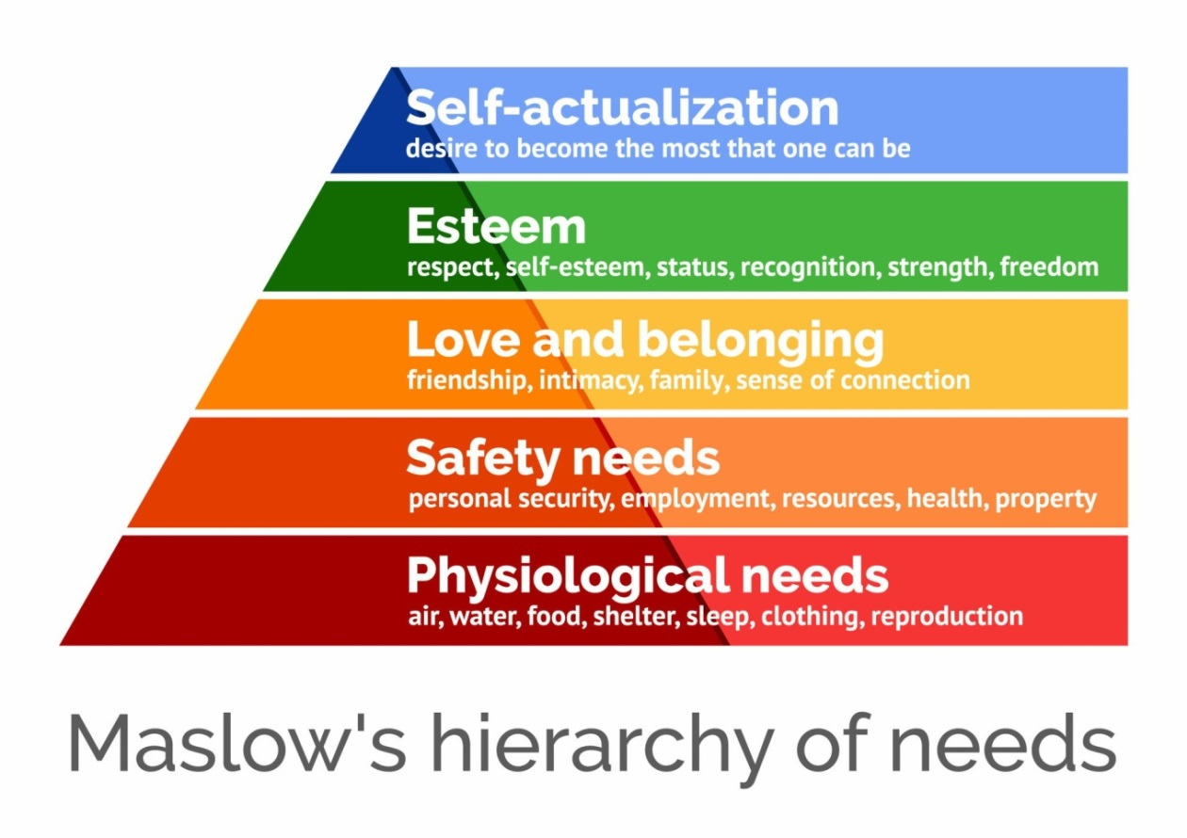
Figure 1: Maslow’s Hierarchy of Needs
Herzberg’s Two Factor of motivation-hygiene theory indicates that job satisfaction and dissatisfaction are not two opposite ends of the same range. (herzberg) However, both concepts are different and not related with each other. Motivating factors such as pay and benefits, recognition and achievement need to be fulfilled by organization in order to satisfy employee with their work. There are many hygiene factors such as working relationships, job security, work environment, company policies and supervision are related with employee job dissatisfaction. It is possible that employees are satisfied with their job or not based on the motivational and hygiene factors because they are considered as independent variables. This theory suggests that when hygiene factors are directly related with employee satisfaction. However, employees are satisfied when these factors are high. Organization's non-monetary benefits and rewards such as flexible work environment, career development opportunities, wellness programs and positive work culture can contribute to overall job satisfaction. The satisfaction of an employee is dependent on the motivator factors. Besides, the satisfaction of an employee is believed to be achieved when motivators are met. Herzberg’s Two Factor of motivation-hygiene theory can describe the complexity of an employee's feelings as they may experience both satisfaction and dissatisfaction simultaneously or neither.
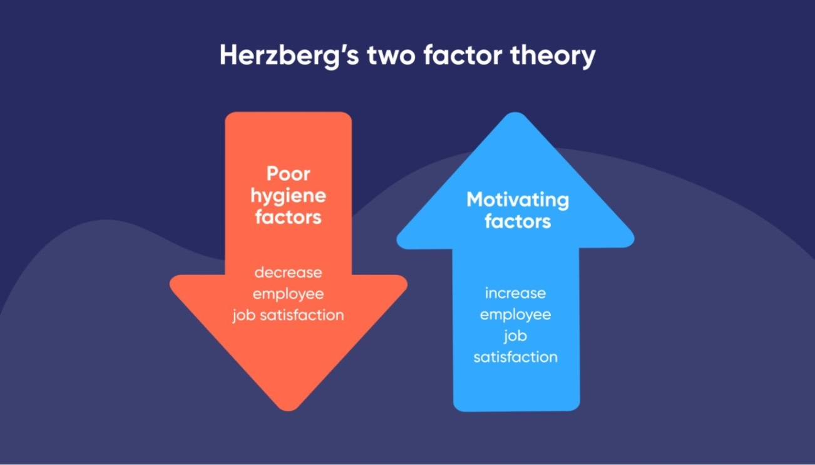
Figure 2: Herzberg’s Two Factor of Motivation-Hygiene theory

2.7 Conceptual Model
Motivation factors
-Salary and bonus
-Work-life balance
-Working environment
-Career development
-Management effectiveness

Organizational Performance
Employee satisfaction

Source: Own Compilation Based on Previous Studies

CHAPTER III

RESEARCH METHODOLOGY

Descriptive analytical research is a research methodology that combines elements of descriptive and analytical approaches to gain insights into a particular phenomenon, behavior, or population. This type of research focuses on providing a detailed description of the characteristics of a subject and analyzing the relationships or patterns within that data. In research, dependent and independent variables are fundamental concepts used to understand relationships between different factors. The independent variable is the factor that researchers manipulate or change to observe its effect on another variable. The dependent variable is the outcome or response that researchers measure to assess the effects of the independent variable. The interconnection of independent and dependent variables is important for hypothesis testing.

3.1 Research Design and Sampling
For a comprehensive understanding of employee satisfaction, mixed-methods research design is often the most effective. It allows for the gathering of both quantitative data (to measure satisfaction levels) and qualitative insights (to understand the reasons behind those levels). Firstly, starting with a quantitative survey to identify trends, gather numerical data on employee satisfaction then followed by qualitative interviews to explore those trends in more depth. Sampling mentions that it is a process of selecting a part of individuals or units within a larger population according to the purpose of regulating research. (sample) The way a sample is selected can significantly influence the validity and generalizability of the study's findings. In this research, convenience sampling method will be used to find the problems in employee satisfaction. Convenience sampling is known as a non-probability sampling technique. (nonpro) This technique is that subjects are selected in regard to their easy availability and accessibility. This method is often used in research when time, budget, or other constraints prevent the use of more rigorous sampling techniques.

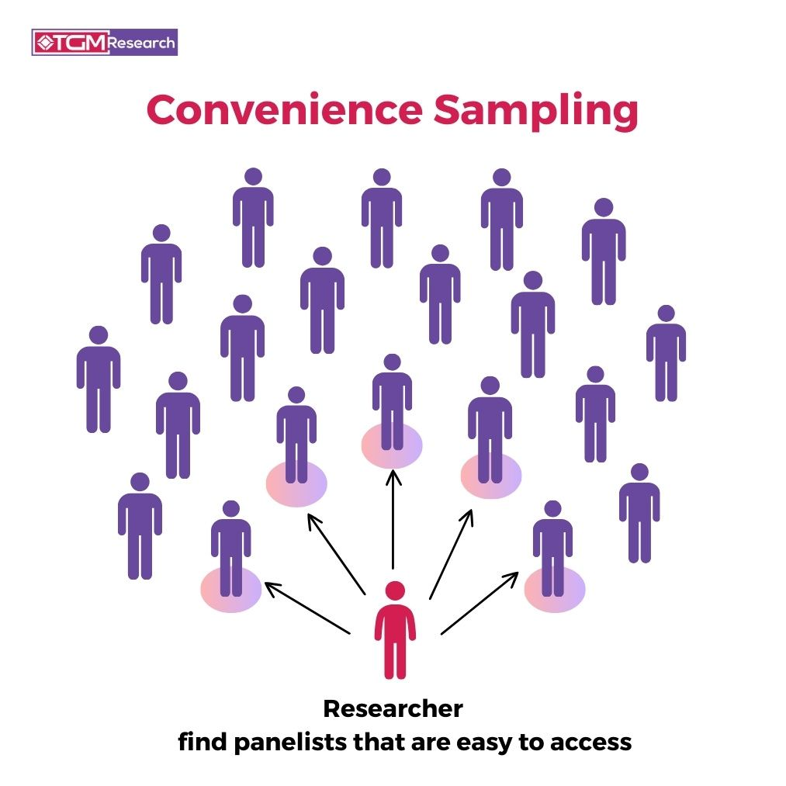
Figure 3: Convenience Sampling

3.2 Data Collection
To comprehensively assess employee satisfaction, a mixed methods approach combining both qualitative and quantitative data collection techniques will be used. This approach ensures a holistic understanding of the factors influencing employee satisfaction. Structured questionnaires will be distributed to all employees to capture a wide range of satisfaction indicators. The survey will identify the satisfaction levels through various dimensions such as salary and bonus, work-life balance, working environment, career development and management effectiveness. In this research, sample of employees from different departments will be asked questionnaire with Likert scales of 1 to 5. Facilitated discussions with small groups of employees will be organized to gather collective feedback on workplace experiences and satisfaction. Focus groups will help to identify common themes and areas for improvement. Direct observation of the workplace environment will be conducted to understand the day-to-day dynamics and interactions among employees. This will provide context to the survey and interview data. Internal documents, including employee feedback forms, performance reviews, and exit interviews will be reviewed to gather additional insights into employee satisfaction levels and trends over time.
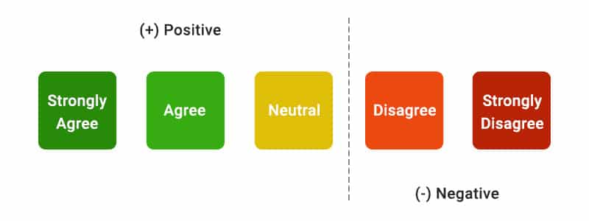
Figure 4: Likert Scales
After collecting data through surveys, descriptive statistics which is to summarize the main features of data. The result for central tendency and dispersion of employee satisfaction scores will get by calculating measures like mean, median, mode, standard deviation and variance. Besides, regression analysis will be applied for predicting employee satisfaction on various factors, for example, compensation, work-life balance. Linear regression helps to understand how independent variables influence employee satisfaction, while multiple regression considers several variables simultaneously.

CHAPTER IV

ANALYSIS AND RESULTS

4.1 Reliability Analysis
In statistics, reliability is the consistency of measurements and assessments. It is a measure to get the same results when repeating a measurement under similar conditions.

Table 4.1 Reliability Analysis of Salary and Bonus
Reliability Statistics
Cronbach's Alpha | Cronbach's Alpha Based on Standardized Items | N of Items
.765 | .783 | 7

 | Mean | Std. Deviation
My company provides appropriate salaries. | 3.39 | .597
My salary is directly impact on my performance. | 3.50 | .676
My salary encourages me to improve the quality of my work. | 3.37 | .745
I am satisfied with the annual increment structure. | 3.29 | .593
My salary keeps up with current cost of living. | 2.90 | .819
The annual bonus will motivate for me. | 3.23 | .904
I am satisfied with my current salary. | 2.99 | .732

In analysis of reliability for salary and bonus, Cronbach's Alpha value is 0.765. It is a measure of internal consistency as well as the comparison of correlation to the variance for individual questions. The higher the alpha value, the more questions are closely related. Cronbach's Alpha values of 0.7 or higher indicate acceptable internal consistency. Cronbach's Alpha based on standardized items is mentioned that Cronbach's Alpha coefficient of internal consistency when all scale items have been standardized. In this case, the value of Cronbach's Alpha based on standardized items is 0.783. Similar to Cronbach's Alpha, Cronbach's Alpha based on standardized items is also acceptable.

4.1.2 Reliability Analysis of Work-life Balance
Cronbach's Alpha value for work-life balance reliability analysis is 0.744. Cronbach's Alpha based on standardized items in this independent variable is 0.739. Both values are higher than 0.7 so these values are acceptable.

4.1.3 Reliability Analysis of Working Environment

Reliability Statistics
Cronbach's Alpha | Cronbach's Alpha Based on Standardized Items | N of Items
.824 | .829 | 7

 | Mean | Std. Deviation
My company provides me the comfortable working environment. (Lighting, Seating, Meeting Room, etc.) | 3.36 | .682
I have good relationship with my colleagues. | 3.99 | .691
Women and men have the same opportunities for career development in my company. | 3.96 | .788
It is easy to get along with my colleagues. | 3.86 | .666
Employees are treated with mutual respects with each other. | 3.70 | .667
All departments have strong collaboration among team members. | 3.49 | .794
Team members share working experiences and support one another. | 3.81 | .572

By the research of reliability analysis, Cronbach's Alpha value for working environment is 0.824. Cronbach's Alpha based on standardized items in this independent variable is 0.829. These values are above 0.7 so they are accurate and appropriate.

4.1.4 Reliability Analysis of Career Development
Reliability Statistics
Cronbach's Alpha | Cronbach's Alpha Based on Standardized Items | N of Items
.891 | .891 | 7

 | Mean | Std. Deviation
I have great opportunities for career development in my company. | 3.39 | .728
I always receive feedback on my performance quarterly. | 3.34 | .700
My organization provides training programs to enhance skills and competencies. | 3.10 | .684
I satisfied with the career improvement from my job. | 3.34 | .700
My company supports career growth as a culture. | 3.27 | .658
I believed that my job satisfaction increased. | 3.33 | .653
I satisfied with job training that my organization provides. | 3.11 | .772

Cronbach's Alpha value for career development in reliability analysis is 0.891. Cronbach's Alpha based on standardized items in this independent variable is 0.891. So, values greater than 0.7 is considered good and acceptable.

4.1.5 Reliability Analysis of Management Effectiveness
 | Mean | Std Deviation
The decisions of management team improve company. | 3.23 | .705
Management team enhances positive working environment. | 3.27 | .658
My supervisor effectively delegates tasks and responsibilities. | 3.49 | .717
Management team encourages teamwork and collaboration. | 3.36 | .566
Management team supports work-life balance. | 2.99 | .577
I satisfied with the handling of conflicts by management. | 3.26 | .502
My supervisor provides effective guidelines to team members. | 3.43 | .791

Alpha value above 0.7 is generally considered acceptable and values above 0.8 are good. Thus, 0.865 is quite strong that means that this value is getting consistent results. Cronbach's Alpha based on standardized items in this independent variable is (.870).

4.1.6 Reliability Analysis of Employee Satisfaction
Reliability Statistics
Cronbach's Alpha | Cronbach's Alpha Based on Standardized Items | N of Items
.815 | .816 | 10

 | Mean | Std. Deviation
I am satisfied with my present job. | 3.49 | .654
My job gives me opportunities to work independently. | 3.53 | .607
I am satisfied with the progress I have made towards my career goals. | 3.60 | .549
I am satisfied with my annual increment salary in my company. | 3.17 | .798
I usually get appreciation from my supervisor due to my performance. | 3.53 | .675
I am proud to tell others that I am one of the members of this company. | 3.44 | .735
I enjoy to work with my colleagues. | 3.90 | .617
I plan to continue my career with this organization for at least two more years. | 3.33 | .880
I am willing to give extra effort to help this organization succeed. | 3.44 | .629
I trust our management team related with salary and bonus. | 3.39 | .572

Cronbach's Alpha value is 0.815 for employee satisfaction by researching with reliability analysis. Cronbach's Alpha based on standardized items in this independent variable is 0.816. So, values greater than 0.7 is considered strong and acceptable.

4.2 Linear Regression Analysis
Model Summary^{b}
Model | R | R Square | Adjusted  R Square | Std. Error of the Estimate | Durbin-Watson
1 | .807ª | .651 | .624 | .341 | 2.094
a. Predictors: (Constant), AVME, AVWB, AVSB, AVWE, AVCD
b. Dependent Variable: AVES
Coefficient of determination also known as R square is 0.651. A larger value of R square indicates more successful regression analysis. R squared should get any values between 0 to 1. R square value of 0.651 means that approximately 65% of the variance in the employee satisfaction which is dependent variable is explained by the five independent variables. This describes a strong relationship between the variables and shows that the analysis provides a good fit to the data.
Adjusted R square value in this research is 0.624. It indicates a reliable measure of goodness of fit for multiple regression. It shows that after adjusting, about 62.4% of the variance is explained by the model.

ANOVAª
Model |  | Sum of Squares | df | Mean Square | F | Sig.
1 | Regression | 13.923 | 5 | 2.785 | 23.928 | .000^{b}
1 | Residual | 7.448 | 64 | .116
1 | Total | 21.371 | 69
a. Dependent Variable: AVES
b. Predictors: (Constant), AVME, AVWB, AVSB, AVWE, AVCD

The F ratio is an important statistical value used to summarize the effect a specific change. Larger F ratio values focus that the effect being studied may have statistical significance and could benefit from additional study. Greater F ratio value indicates that the regression model fits the data. In this research, F value 23.928 indicates a more significant regression model.
The significant value indicates whether the overall regression model is statistically significant. P value of less than 0.05 is usually considered statistically significant. A P value of .000 suggests that the model is highly significant, interpretation the independent variables have a strong relationship with the dependent variable.

Coefficientsª
Model |  | Unstandardized Coefficients |  | Standardized Coefficients | t | Sig. | Collinearity Statistics
 |  | B | Std. Error | Beta | t | Sig. | Tolerance | VIF
1 | (Constant) | -.141 | .387 |  | -.365 | .716
1 | AVSB | .184 | .082 | .180 | 2.251 | .028 | .855 | 1.169
1 | AVWB | .081 | .094 | .077 | .861 | .393 | .684 | 1.463
1 | AVWE | .160 | .083 | .166 | 1.918 | .060 | .725 | 1.379
1 | AVCD | .369 | .097 | .394 | 3.820 | .000 | .512 | 1.951
1 | AVME | .303 | .096 | .280 | 3.161 | .002 | .692 | 1.444
a. Dependent Variable: AVES

Unstandardized Coefficients (B)
Unstandardized coefficients are applied in regression analysis to describe how much dependent variable changes for each unit change in an independent variable. They are also known as raw coefficients.
Standardized Coefficients (Beta)
These coefficients are the same as the unstandardized coefficients and they measure the relationship between variables by comparing how many standard deviations dependent variable changes for each standard deviation change in an independent variable. The values of standard coefficients are adjusted to have mean 0 and standard deviation 1. This allows for comparison of the relative importance of each independent variables in the model.
t-Statistic (t)
The higher the t-value, the greater the confidence we have in the coefficient as a predictor. Low t-values are indications of low reliability of the predictive power of that coefficient. This value tests the null hypothesis that the coefficient is equal to zero (no effect). A larger t-value indicates a more significant p value.
  - AVSB: 2.251 (p = .028)
  - AVWB: .861 (p = .393)
  - AVWE: 1.918 (p = .060)
  - AVCD: 3.820 (p = .000)
  - AVME: 3.161 (p = .002)
Significance (Sig.)
This value indicates whether the predictor is statistically significant. Values less than 0.05 are typically considered significant.

  - AVSB: .028 (Significant)
  - AVWB: .393 (Not Significant)
  - AVWE: .060 (Not Significant, but close)
  - AVCD: .000 (Highly Significant)
  - AVME: .002 (Significant)
In the regression analysis, the significance of the independent variables was assessed to determine their impact on the dependent variable, employee satisfaction (AVES). The independent variable, salary and bonus (AVSB) showed a p-value of .028, indicating that it is statistically significant. Management effectiveness (AVME) also proved to be significant with a p-value of .002. Career development (AVCD) emerged as a highly significant independent variable with a p-value of .000, suggesting a very strong relationship with the dependent variable. On the other hand, work-life balance (AVWB), with a p-value of .393, was not significant, indicating that it does not contribute significantly to the model. Working Environment (AVWE) was close to significance with a p-value of .060 but did not meet the traditional threshold of .05. Overall, AVSB, AVME, and AVCD are key predictors in explaining variations in AVES, while AVWB and AVWE do not significantly contribute to the model.

CHAPTER V

CONCLUSION AND SUGGESTION

5.1 Conclusion
According to the findings of this research, work-life balance and working environment should improve in this company. As described in literature review, company should encourage work-life balance in order to get employee satisfaction. Healthy work-life balance develops to maintaining a harmonious relationship between work and personal life.
Employee satisfaction is an important factor in accomplishing organizational success. This research has inspected various dimensions of employee satisfaction including salary and bonus, work-life balance, working environment, career development and management effectiveness. The outcomes demonstrate a strong correlation between employee satisfaction and overall independent variables. Employee satisfaction research typically investigates the various factors that contribute to an employee's overall happiness and engagement within their workplace. (joy) The research findings generally highlight the importance of comprehensive approach to employee satisfaction. Organizations can perform targeted strategies to increase work experience, to improve retention, productivity and organizational success. According to this research, I would like to prove that job security, work-life balance, recognition, career growth opportunities and supportive management are critical for employee satisfaction. These factors also impact employees' overall well-being and motivation. A positive and inclusive organizational culture encourages employee satisfaction. Companies that emphasize employee well-being likely to have more robust, collaborative and innovative work environments.
Moreover, the analysis has shown that organizations investing in employee satisfaction can engage a positive work culture which can lead to increase productivity and performance in a competitive edge.
In conclusion, enhancing employee satisfaction is not simply a human resources strategy but an essential business necessary. Companies that allow and approach the needs and targets of their employees are greater arranged to achieve long-term growth and sustainability. Future research could further investigate into the developing dynamics of employee satisfaction in the circumstance of remote work and technological advancements.

5.2 Suggestion and Recommendations
Organizations can upgrade poor work-life balance by designating flexible working arrangements such as remote work options, flexible working hours and etc. Encouraging a healthy work culture by enhancing to take breaks and time off is appreciated and can help reduce burnout. Contributing resources like employee wellness programs, mental health support and professional development opportunities can motivate employees' overall well-being. By implementing goals and strategies, organizations can build a supportive and balanced working environment, conducting to happier and more productive employees. To undertake a poor working environment, organizations should begin by investigating and improving the physical working environment to ensure safety and comfort. Open communication is important with an open-door approach by encouraging employees to express their views and ideas. Encouraging and appreciating employees for their productive work can boost morale and motivation. Enhancing work-life balance through flexible working hours and wellness programs supports employees' well-being. Supporting in professional development opportunities like training and coaching helps employees grow and develop in their careers. Strengthening a positive culture of respect, comprehensive and collaboration guarantees all employees feel valued. Good management practices, fair policies and consistent monitoring and adaptation based on employee review can build a supportive and productive working environment which is leading to enhanced employee job satisfaction and organizational success.

REFERENCES
Abdul-Halim, C. A. (2016). The pursuit of HR outsourcing in an emerging economy: The effects of HRM strategy on HR labour costs. Published by John Wiley & Sons, Ltd.
Ahlvika. (2016). Aligning corporate transfer intentions and subsidiary HRM practice implementation in multinational corporations. Elsevier.
Andrea, D., Ellinger,Alexander, E., & Ellinger S. B. K. (2003). Supervisory coaching behavior, employee satisfaction, and warehouse employee performance: A dyadic perspective in the distribution industry. Retrieved from https://doi.org/10.1002/hrdq.1078.
Armsrong, M. (2014). Human resource management. Ashford Colour Press Ltd, UK.
Authority, H. (n.d.). Retrieved from https://www.citizensinformation. ie/en/employment/employment_rights_and_conditions/health_and_safety/health_safety_work.html
Charltons Myanmar (n.d.). Hotels and tourism in Myanmar. Retrieved from https:// www.charltonsmyanmar.com/myanmar-economy/hotels-and-tourism-in-myanmar/
Chi, C. G. (2009). Employee satisfaction, customer satisfaction, and financial performance: An empirical examination. 750 First Street NE, Washington, DC
Cook, J. (n.d.). What is meant by Employee Compensation ? Retrieved from https://study.com/academy/lesson/what-is-employee-compensation-definition-lesson-quiz.html
Decenzo, D. A. (2016). Fundamental of Human Resource Management. USA: John Wiley&Sons, Inc.
Elrehail, H., Harazneh, I., Abuhjeeleh, M., Alzghoul, A., Alnajdawi, S., & Ibrahim, H. M. H. (2020). Employee satisfaction, human resource management practices and competitive advantage: The case of Northern Cyprus. European Journal of Management and Business Economics, 29(2), 125-149.
Hilton (n.d.). Hilton Nay Pyi Taw. Retrieved from https://www.hilton.com/en/hotels /nythzhi-hilton-nay-pyi-taw/
Hilton Worldwide (2014). Hilton worldwide enters Myanmar with first Hilton Hotel in Capital City. Business Wire. Retrieved from https://www.businesswire.com /news/home/20141021005242/en/Hilton-Worldwide-Enters-Myanmar-with-First-Hilton-Hotel-in-Capital-City
HRM Asia (n.d.). Hilton Asia Pacific: Paving the Way. Retrieved from https://hrmasia.com/hilton-asia-pacific-paving-the-way/
Jackson, R. S. (1987). Convergence or Divergence: Human Resource Practices and Policies for Competitive Advantage Worldwide. Management Consulting in Human Resource Management: Central and Eastern European Perspectives in Light of Empirical Experiences.
Jawa, K. (n.d.). The Importance of human resources in today's hotel industry. Retrieved from https://www.linkedin.com/pulse/importance-human-resources-todays-hotel-industry-kshitij-jawa
Lee, H. (2006). The Impact of Organizational Context and Information Technology on Employee Knowledge-Sharing Capabilities. Retrieved from https://onlinelibrary.wiley.com/doi/full/10.1111/j.1540-6210.2006.00595.x
Neckyon, A. (n.d.). Safety tips, Workplace Risk, Safety Culture. Retrieved from https://blog.sliceproducts.com/health-and-safety-of-employees-in-the-workplace
Pavić, I., Alfirević, N., & Mihaliček, A. (2017). The impact of employee satisfaction on customer satisfaction in hotel enterprises. Economic Research-Ekonomska Istraživanja, 30(1), 1287-1301.
Rodriguez, R. S. (2021). Retrieved from https://ifeelonline.com/en/occupational-health/workplace-environment/
Sairafi, M. A. (2008). Retrieved from https://pubmed.ncbi.nlm.nih.gov/19060489/
Sanni, A. S. (2010). Employee Satisfaction and Work Motivation. Academic Publishing GmbH KG .
Schooley, S. (n.d.). What are Employee Compensation Packages? Retrieved from http://www.business.com/articles/types-of-employee-compensation
Soe, J., Oo, Z., & N. Myint, T. (2016). The impact of hotel employee satisfaction on hospitability performance. American Scientific Journal, 2(11). 1-10.
Standard Insights (n.d.). Travel and Tourism in Myanmar. Retrieved from https://standard-insights.com/blog/travel-and-tourism-in-myanmar/
Statista. (n.d.). Hotels in Myanmar – statistics & facts. Retrieved from https://www. statista.com/outlook/mmo/travel-tourism/hotels/myanmar

