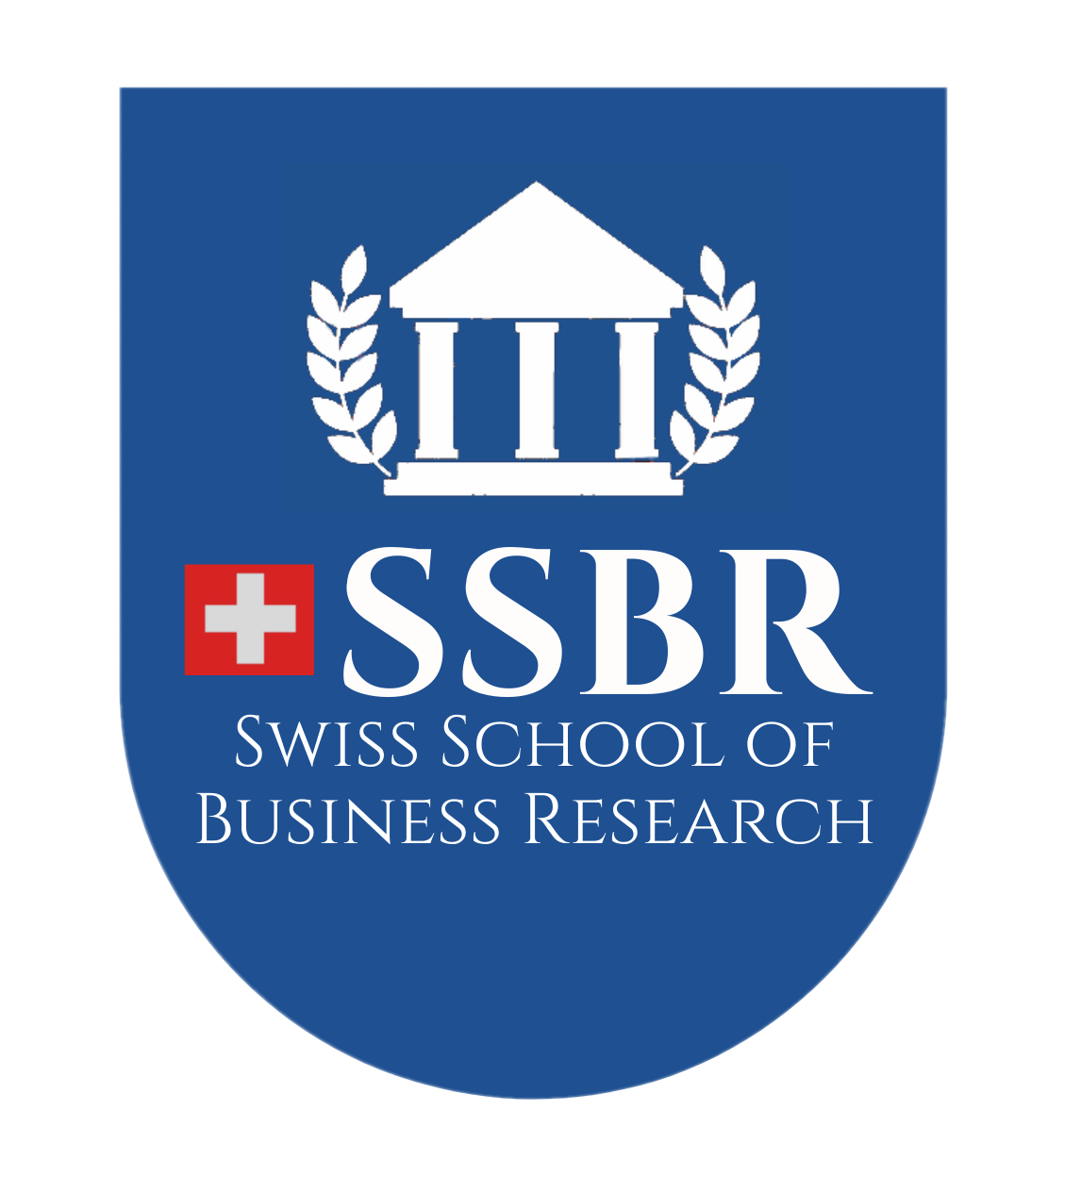
FACTORS AFFECTING EMPLOYEE SATISFACTION IN KAUNG MYAT YAR ORGANIZATION IN MYANMAR

MASTER OF BUSINESS ADMINISTRATION
(MBA)

ZIN MAR MYINT
SSBR/2023/MBA170992

AUGUST 2025
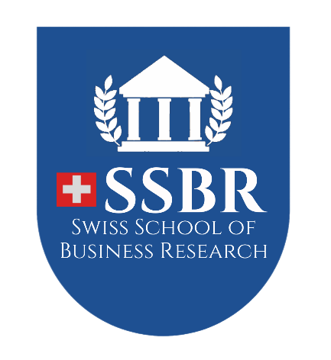

FACTORS AFFECTING EMPLOYEE SATISFACTION IN KAUNG MYAT YAR ORGANIZATION IN MYANMAR

A Thesis Presented
By
ZIN MAR MYINT

Submitted to the Swiss School of Business Research
in partial fulfillment of the requirements for the degree of

MASTER OF BUSINESS ADMINISTRATION
(MBA)

AUGUST, 2025

Copyright by ZIN MAR MYINT, 2025
All Rights Reserved

FACTORS AFFECTING EMPLOYEE SATISFACTION IN KAUNG MYAT YAR ORGANIZATION IN MYANMAR

A Thesis Presented
By
ZIN MAR MYINT

Approved as to style and content by:

Dr. Paing Soe, Chair
President, Centre for Professional Development

Dr. Hla Hla Mon, Supervisor
Professor, Centre for Professional Development

Dr. Stephen Harrison
Dean
Swiss School of Business Research
ACKNOWLEDGEMENTS

Firstly, I would like to present my heartfelt appreciation to Dr. Paing Soe, President of Center for Professional Development and Dr. Stephen Harrison, Dean of Swiss School of Business Research, for their excellence supports, kind understanding and constructive guidance for this thesis.
Next, I am deeply grateful to my supervisor Dr. Hla Hla Mon, Professor of Centre for Professional Development, for her close supervision, expect advice, kind guidance, effective suggestion, and encouragement in supporting to complete this thesis successfully. Without having valuable guidelines, this thesis will not be finished.
I also would like to express my respect and gratefulness to all of our professors, associate professors, lecturers and visiting lecturers who are effort in knowledge sharing of SSBR MBA Programme. In addition, I would like to extend my appreciation to the faculty and all the staffs in Center for Professional Development who have provided me with any administrative support during my academic years.

Finally, I would like to thank specially to the managing director of Kaung Myat

Yar Organization for kindly agreeing to collect the data for this research, and the managers and the staffs of the Kaung Myat Yar Organization for their kind cooperation in providing the data and all the information necessary for this study.

Zin Mar Myint
SSBR/2023/MBA170992

ABSTRACT

The purpose of this study was to investigate the factors affecting the employee job satisfaction at Kaung Myat Yar organization in Myanmar. Employee dissatisfaction can lead to a number of problems for an organization, including toxic work environment, job dissatisfaction of employees and decrease employee performance. This research paper is done based on the responses of 91 employees of Kaung Myat Yar organization in Myanmar by using census sampling method. The finding of the study is that working environment, promotion and leadership style have a positive impact on job satisfaction of employees in Kaung Myat Yar organization in Myanmar. Based on the results, the study recommends that Kaung Myat Yar organization in Myanmar should consider to build the nice working environment, setting clear promotion policies and criteria, and taking good leadership styles to increase job satisfaction of employees.

ABBREVIATIONS

PA Project Assistant
PO Project Officer
CDF Community Development Facilitator

CSO Central of Statistical Organization

HRM Human Resource Management

TABLE OF CONTENTS

ABSTRACT 5
CHAPTER I 11
INTRODUCTION 11
1.1. Background Information of the Study 11
1.2 Background Information of the Study 14
1.3 Problem Statement of the Study 16
1.4 Objectives of the Study 17
1.5 Research Question of the Study 17
1.6 Scope and Limitation of the Study 17
1.7 Relevance of the Study 17
1.8 Organization of the Study 18
CHAPTER II 19
REVIEW OF LITERATURE 19
2.1 Concept of Employee Satisfaction 19
2.2 Factors Affecting Employee Satisfaction 21
2.2.1 Working Environment 21
2.2.2 Career Development 23
2.2.3 Compensation and Benefits 24
2.2.4 Promotion 25
2.2.5 Leadership Style 26
2.3 Previous Studies 28
2.4 Conceptual Framework of the Study 32
CHAPTER III 34
RESEARCH METHODOLOGY 34
3.1 Research Methods 34
3.2 Research Design and Sampling 35
3.3 Data Collection 35
3.4 Population and Sample 35
3.4.1 Reliability Analysis of the Variables 36
3.5 Data Analysis 37
CHAPTER IV 39
ANALYSIS ON FACTORS AFFECTING THE EMPLOYEE SATISFACTION IN KAUNG MYAT YAR ORGANIZATION 39
4.0 Background of Kaung Myat Yar Organization 39
4.1 Profile of Respondents 40
4.1.1 Gender of Respondents 40
4.1.2 Age of Respondents 41
4.1.3 Marital Status of Respondents 42
4.1.4 Education Level of Respondents 42
4.1.5 Working Experience of Respondents 43
4.1.6 Salary Scale of Respondents 44
4.1.7 Current Position of Respondents 45
4.1.8 Department of Respondents 46
4.2 Descriptive Analysis of Dependent and Independent Variables 48
4.2.1 Working Environment 48
4.2.2 Career Development 49
4.3.4 Compensation and Benefits 50
4.3.5 Promotion 51
4.3.6 Leadership Style 52
4.3.7 Employee Satisfaction 53
4.4 Analysis on Factors Affecting Employee Job Satisfaction at Kaung Myat Yar Organization 54
CHAPTER V 57
CONCLUSION 57
5.1 Findings and Discussions 57
5.2 Suggestions and Recommendations 60
5.3 Needs for Further Research 62
5.4. Ethical Issues Relevant to Study 62

REFERENCES
APPENDIX

LIST OF TABLES

Table Description Page

Table (3.1) Reliability Analysis of the Variables 38
Table (4.1) Demographic Data of The Respondents 41
Table (4.2) Age of Respondents 42
Table (4.3) Marital Status of Respondents 43
Table (4.4) Educational Level of Respondents 44
Table (4.5) Working Experience of Respondents 45
Table (4.6) Salary Scale of Respondents 46
Table (4.7) Current Position of Respondents 46
Table (4.8) Department of Respondents 48
Table (4.9) Working Environment 49
Table (4.10) Career Development 50
Table (4.11) Compensation and Benefits 51
Table (4.12) Promotion 52
Table (4.13) Leadership Style 53
Table (4.14) Employee Satisfaction 54
Table (4.15) Factors Affecting Employee Satisfaction 55

LIST OF FIGURES

Figures Description Page

Figure (2.1) Conceptual Framework of Raziq and Maulabakhsh 25
Figure (2.2) Conceptual Framework of Ghi 26
Figure (2.3) Conceptual Framework of Elangovan et al. 26
Figure (2.4) Conceptual Framework of Al-Owaidi et al. 27
Figure (2.5) Conceptual Framework of the Study 28
Figure (4.1) Gender of Respondents 38
Figure (4. 2) Age of Respondents 39
Figure (4.3) Marital Status of Respondents 40
Figure (4. 4) Educational Level of Respondents 44
Figure (4.5) Working Experience of Respondents 42
Figure (4. 6) Salary Scale of Respondents 46
Figure (4.7) Current Position of Respondents 47
Figure (4. 8) Department of Respondents 48

CHAPTER I

INTRODUCTION

In any organization, human resource management is considered to be the most valuable asset. Human capital is one of the most valuable resources of any enterprise, which not only improve outcome but also offers a competitive advantage. It is the sum-total of inherent abilities, acquired knowledge and skills represented by the talents and aptitudes of the employed persons who comprise of executives, supervisors, and the job satisfaction although there are both theoretical and practical differences between the two concepts.

Background Information of the Study
Human, financial, materials and information are the resources of the organizations. The achievement of a business firm extremely depends on various kinds of resources. Among them, human resource is one of the key resources which is wholly related to the organizational effectiveness. The major resource, human which is wholly related to the organizational effectiveness.
A human resource is a person who is compensated for supplying skills or knowledge to help an organization achieve its business goals. Organizations are placing more importance on employee satisfaction and a critical factor for success. A satisfied workforce has greater potential to drive productivity and efficiency while leading to greater employee retention. Improving employee satisfaction means more than just monetary compensation. It requires the improvement of various factors that impact a person’s overall well-being, engagement, and motivation. From work-life balance and career growth opportunities to recognition and a supportive organization culture, organizations need to adopt a holistic approach to fostering an environment where employees feel valued and fulfilled. Organizations can create a workplace where employees thrive, resulting in a happier and more successful organization. Employee satisfaction refers to the degree of contentment that team members experience concerning their roles in the organization.
The benefits of employee satisfaction are far-reaching and lead to a thriving workplace. When the employees of the organization enjoy doing their jobs, they’re more likely to get their work done and stay at the organization often lead to happier customers. Employee satisfaction is the result of overall well-being and workplace engagement. When employees understand how to progress from their current position to more senior roles, they feel a sense of purpose and increased satisfaction.
Employees are the most critical and influential resource for an organization. Employee job satisfaction relates directly to the desirability to stay and their productivity in the organization. There are many factors affecting employee satisfaction. Among them, five factors that will affect job satisfaction of employees are analyzed, that is, work environment, career development, compensation and benefits, promotion and leadership style in this study (Spector, 1997). It has been found that most companies overlook the workplace culture within their firm, which has a negative impact on the productivity of their personnel.
The researcher asserted that a positive working environment includes employee safety, job security, excellent relationships with coworkers, recognition for good performance, desire to perform well, and involvement in business decision-making. Compensation is an extrinsic reward which an employer provides an employee for his or her services. Shaw et al. (1999) had expressed that pay or compensation is an important aspect of doing business because it represents both, one of the largest organizational expenses, and one the most valued employee outcomes. Career development was defined as helping an employee be the best individual they can be in the organization and finding the right place for them, but not just about promotion
(Wang, 2003)
. As per iEduNote, job promotion is a movement to a higher position where responsibility and prestige increase. Most employees want to get improvement and advancement at their jobs. Leadership is another determining factor that shapes staff motivation (Erciyes, 2019). Without understanding the leadership skill, it is hard to motivate the staff and get achievement of the organizations. Creating a healthy working environment for the employee is very important to getting job satisfaction from employees, inducing positive outcomes, and making them happy in their job. Robbins (2001) mentioned that working conditions will influence job satisfaction, as employees are concerned with a comfortable working environment. Leblebici (2012) stated that when employees are satisfied with the workplace quality, their performance will increase.
Employers of most organizations believe that efforts and commitment to organizational goals are prerequisites for employee performance. Employees will be happy with their organization if they are motivated, Employees can get job satisfaction, and the satisfied employees commit to positive behavior to their organization. Employee satisfaction is a comprehensive term that comprises job satisfaction of employees and their satisfaction overall with organizations’ environment, compensation and benefits, carrier development, promotion, and leadership style.
In management, satisfaction is studied in different perspectives such as: customer satisfaction, job satisfaction, employee satisfaction and many more. Employee satisfaction is an indicator of how happy employees are with their job. A person will feel confident and enthused about their work if they adhere to this value of job satisfaction. Factors that ‌affected to employee job satisfaction change over time and cultural aspects.
Measured by how satisfied employees are with their jobs and workplace, employee satisfaction is one of the many factors that can affect the effectiveness of an organization. Successful organizations should have a culture that promotes employee satisfaction.
Each organization is trying to achieve its goals with effective and efficient manner. The problem of the research study is that the human resources are insufficient. All staffs had been given the workloads than the duties. The factors affecting employee satisfaction are working environment, compensation and benefits, and promotion and leadership style of an organization. Satisfaction is one of the competitive advantages which help organization to grow internally and externally. Employees' satisfaction is the individual employee general attitude towards the job.
Satisfaction is the level of fulfillment of one’s needs, wants and desire. Employee satisfaction is a measure of how happy workers are with their jobs and working environment. This study explores how the employees had been given the burdens and the workloads were delayed by the insufficiency of human resources in Kaung Myat Yar organization.
Employees who lack work-life balance often bring stress into the workplace, reducing job satisfaction. Consulting national salary surveys for different positions can help ensure the rates are competitive. If the organization offers below-market rates due to generous benefits, it’s crucial to communicate this clearly to prospective and current employees. When employees understand how to progress from their current position to more senior roles, they feel a sense of purpose and increased satisfaction, career progression keeps them engaged at work. Organizations are actively creating collaborative workplace culture as a way to address employee satisfaction. Fostering teamwork, open communication, and a sense of belonging leads to higher engagement and overall job satisfaction.
To achieve this employee satisfaction, organizations are implementing collaborative tools and platforms that facilitate easy information sharing and employee collaboration. They are also encouraging cross-departmental collaboration, promoting a collective mindset, and breaking down information silos. Furthermore, organizations are creating a foundation of trust so employees feel comfortable sharing ideas, asking questions, and providing feedback.
Human resource management is a strategic approach to effectively managing employees in an organization so that they help their business gain competitive advantages. This is structured and designed to maximize employee performance in meeting the strategic goals of employers (Darvishmotevali & Altinay, 2022). Human resource management is a strategic, integrated and coherent approach to the employment, development and well-being of people working in organization. The overall purpose of human resource management is to ensure that the organization is able to achieve success through people. Human Resource Management aims to improve organizational effectiveness and capability to achieve its goals by making the best use of the resource available to it.
Leadership is a contentious topic in the literature. Leadership is described as a person's ability to lead others. Employees play a key role in ensuring service quality. When employees' expectations and demands are clear, they are more likely to work successfully.

1.2 Background Information of the Study
Employees are the most valuable resources in any organizations. According to Newstrom (2011), employee satisfaction refers to a set of favourable or unfavourable feelings and emotions which employees view with their work. There are many factors that affect employee satisfaction. Among them, the working environment, compensation and benefits, career development, promotion, and leadership style of an organization are used in this study. The working environment refers to day to day efficiency in work and productivity including how the work is being done, where it is being done and when was it done and all the elements associated with it which are required to do that work comes under the work environment (Jena, 2016). A conducive, safe, and positive environment forms the bedrock of job satisfaction. This encompasses not just the physical space but also the cultural and emotional environment of the workplace. In the workplace, compensation is what is earned by employees. It includes salary or wages in addition to commission and any incentives or perks that come with the given employee's position. Compensation is defined as any direct or indirect payments to employees, such as wages, bonuses, stock, and benefits (Gerhart & Milkovich, 1992). Career development was defined as helping an employee be the best individual they can be in the organization and finding the right place for them, but not just about promotion (Wang, 2003).
. Opportunities for career development is one of the significant factors determining employee satisfaction, driving a sense of progress and fulfilment. The opportunity for promotion determines the degree of satisfaction to the employee. According to Sikula (2000), a promotion is a movement within towards an organization of one position of another that involves either an increase or an increase in status. Leadership style can also influence the employees’ job satisfaction. Adebakin and Gbadamosi (1996) defined the leadership as the process of influencing and directing controlling the activities of an organized group in the direction of the achievement of the employee individual and in group.
Employee satisfaction plays an important role in contributing to both positive and negative behaviors at the workplace. It can result in increasing or decreasing productivity, individual’s morale, employee turnover rate, in deviant behavior such as frequent absence from the work place, lack of discipline in performance, high intentions to quit, commitment towards work, feeling boredom and stress. The effectiveness and achievements of an organization highly depends on the job satisfaction of employees and work motivation is one of the most important factors that affect job satisfaction.
In July 2014, Kaung Myat Yar was organized in Pakokku Township. Since its inception period, it has been working on development with 25 members and focused on youth empowerment activities and supported (basic computer training, basic English, developmental trainings), conducting environmental conservation training (tree plantation activities vocational trainings (providing vocational skills to women, livelihood activities for their income generation): for agriculture sector ( providing agricultural technique to farmers and linking to fertilizers suppliers to interest-free loans during the periods): migration issue ( providing migration education and awareness raising for saving loan for local migrants) (Providing follow-up training awareness sharing session to village administrators on the concepts of conducting social accountability and transparency training). The organization intends to promote the human dignity, gender balance and women empowerment. It is registered in December, 2017 in Township Level and October, 2018 in National Level. It began in advance tailoring training, small business management skills training, personal leadership training, sewing basic training, agricultural training, and basic computer training.
This study explores the factors affecting the employee job satisfaction in Kaung Myat Yar organization in Myanmar. Working with effective and efficient manner to achieve the organizational goals is the best atmosphere of the employee.

1.3 Problem Statement of the Study
Kaung Myat Yar organization becomes feeling threat of fierce competition because of getting reduced the opportunities. Every organization or company regularly runs and grows together if the resources, man, money, materials, method, and morale are all complete. When the human resource is less, they cannot go in the field areas, and learn the technical skills. By planning, organizing, leading and controlling on organization’s resources to achieve the organizational goals in an effective and efficient manner, the organization’s image will be good. Employee dissatisfaction can lead to a number of problems for an organization, including toxic work environment, decrease employee performance and increase employee turnover. Moreover, employees in every organization focus their working environment, compensation and benefits, career development, promotion and leadership style.
Similarly, employees in Kaung Myat Yar organization also pay attention to good working environment of Kaung Myat Yar organization. They also focus that compensation provided by organization is fair compensation compare to other organizations. If there is no career development, they will be dissatisfaction. The promotion criteria in any organization must be clear and transparent, and job performance evaluation for promotion must be fair and base on clear performance standard. And finally, leadership style in organization is also important for employees in organization. Therefore, this study explores how the factors affect the employee job satisfaction in Kaung Myat Yar organization in Myanmar.
Employee satisfaction includes the employee's emotions and their feelings. It has a significant impact on their work lives, and as a result, it influences their behavior as employees, including their loyalty, commitment, teamwork, interaction with other employees, attitude, and behavior. Employee satisfaction is a critical component of organizational management. Human resources that are satisfied and efficient are critical for every organization to handle the difficulties of today's ever-changing environment.

Objectives of the Study
The main objective of this study is
- to analyze the factors affecting employee satisfaction in Kaung Myat Yar organization in Myanmar.

1.5 Research Question of the Study
The research question of the study is as follows:
- How do the factors affect employee satisfaction in Kaung Myat Yar organization in Myanmar?

1.6 Scope and Limitation of the Study
This study focuses on employee satisfaction and the affecting factors including work environment, compensation and benefits, career development, promotion and leadership style in Kaung Myat Yar organization. The sample size of this study is all employees in Kaung Myat Yar Organization. The study targets all employees in Kaung Myat Yar Organization. The data are collected all employees who are working in Kaung Myat Yar organization. The present study explores the employee’s satisfaction of Kaung Myat Yar Organization.

1.7 Relevance of the Study
The proposed research study seeks to explore a clear study of employee satisfaction toward five factors which are working environment, carrier development, compensation & benefits, promotion and the leadership style. The results will cover the concern of factors that affect employee satisfaction in Kaung Myat Yar organization. By focusing these factors, the organization can retain effective and efficient employees.
Although there are many factors affecting job satisfaction, job satisfaction is typically related with success of the organization. Ahmad (2018) also mentioned that employee satisfaction is a complicated variable which contains several facets interrelated with employees’ emotion and attitude. Therefore, job satisfaction of employees is exceptionally required for every business firm with success. If business firms could manage in proper way, employees will make useful results like higher effectiveness and better productivity, and lower rate of turnover and absenteeism in individual level as well as organizational level. As per Johnson et al. (2008), job satisfaction has also been correlated with other constructs such as organizational commitment within the last few years. Thus, job satisfaction is directly linked to the expectations of employees and the degree of importance located on various aspects of the job and the workplace (Brown et al., 2019).
Now a days, Human life has become awfully advanced and complicated. In the society of human beings, the satisfaction of each person is gradually higher and higher, and vigorous. So, the satisfaction of employees is actually vital for the organizations. For business firms, it is impossible to have satisfied employees without making them motivated (Sahito et al., 2017).

1.8 Organization of the Study
This thesis consists of five chapters. Chapter-1 introduces factors affecting the employee satisfaction, such as the working environment, career development, compensations and benefits, promotion, and leadership style, specific background of the organization, problem of the statement, the objective of the study, research question and scope and limitation of the study. And then, organization of the study is also described. Chapter-2 is literature review of the study. It consists five factors affected the employee satisfaction, findings from previous studies and conceptual framework of the study. Chapter-3 is methodology that includes research design, questionnaires development, sampling design, data collection methods and additionally ethical consideration. Chapter-4 is analysis of the factors affecting the employee satisfaction in Kaung Myat Yar Organization. Finally, chapter-5 is findings, recommendation and conclusion of the study.

CHAPTER II

REVIEW OF LITERATURE

This chapter includes the concepts of employee satisfaction and factors affecting employee satisfaction. The key concepts for this study are working environment, career development, compensation and benefits, promotion, and leadership style. Additionally, previous studies and conceptual framework of the study are also presented.

2.1 Concept of Employee Satisfaction
Satisfaction is the fulfilment of one’s wishes, expectations, or needs, or the pleasure from the organization or the company. Satisfaction is one of the competitive advantages which help organization to grow internally and externally.
Employee satisfaction is a measure of how happy workers are with their jobs and working environment. Employee satisfaction refers to the degree of contentment that team members experience concerning their roles in the organization. It is worth noting that job satisfaction and workplace satisfaction essentially refer to the same concept. The benefits of employee satisfaction are far-reaching and lead to a thriving workplace. When the employees of the organization enjoy doing their jobs, they’re more likely to get their work done and stay at the organization often lead to happier customers. Employee satisfaction is the result of overall well-being and workplace engagement. When employees understand how to progress from their current position to more senior roles, they feel a sense of purpose and increased satisfaction.
Employee satisfaction plays an important role in contributing to both positive and negative behaviors at the workplace. It can result in increasing or decreasing productivity, individual’s morale, employee turnover rate, in deviant behavior such as frequent absence from the work place, lack of discipline in performance, high intentions to quit, commitment towards work, feeling boredom and stress. The effectiveness and achievements of an organization highly depends on the job satisfaction of employees and work motivation is one of the most important factors that affect job satisfaction.
Employee’s satisfaction is defined as a pleasurable emotional response to work situations as a result of receiving and appreciating what employees get out of their jobs (Latitamishra, 2018). Because it is considered that employees’ productivity is dependent on their level of job satisfaction, it is a critical issue for both human resources management and organizations. Organizations can be more productive if their staff are satisfied. High job satisfaction can lead to organizationally valuable results including lower turnover, increased productivity, and improved efficiency (Kim, 2004). Companies are investing too much time on employee satisfaction programs in order to prevent employee turnover, increase productivity, and contribute to the success of the company.
Individual expectations about work that are aligned with actual results are related to job satisfaction. Job satisfaction is basically an emotional response to a person's perceived fulfillment of needs and what he or she believes the firm has to offer (Zournatzi et al., 2006). The integration of a person's desires and the aspect of a job is considered when measuring job satisfaction. Individual employee satisfaction is influenced by a variety of factors, including monitoring, task nature, and so on.
Employees will feel valued if they receive encouragement from their supervisors. Individuals will be happier in their jobs if they enjoy working with their supervisors or leaders. Employee satisfaction with supervisors was linked to organizational commitment, which can lead to increased productivity, lower turnover, and a greater readiness to help.
Employee satisfaction is influenced by leaders' willingness to assist work-related activities with social, technical, and guidance. Satisfaction with supervision improves employee work satisfaction, and it refers to the level of satisfaction with leaders' treatment, assistance, and direction, as well as the degree to which the overall quality of supervision is deemed satisfactory. Peer contact refers to a healthy formally and informally connected relationship with peers that facilitates staff cooperation.
The characteristics of the work, such as intriguing or dull, complex or ordinary, inventive or degrading, are referred to as the nature of the work (Benrazavi & Silong, 2013). Workplace culture is the most important indicator of employee satisfaction (Ahmed et al., 2010).
Employee’s satisfaction is defined as a pleasurable emotional response to work situations as a result of receiving and appreciating what employees get out of their jobs (Latitamishra, 2018). Because it is considered that an employee's productivity is dependent on his or her level of job satisfaction, it is a critical issue for both human resources management and organizations. Organizations can be more productive if their staff are satisfied. High job satisfaction can lead to organizationally valuable results including lower turnover, increased productivity, and improved efficiency (Kim, 2004). Companies are investing too much time on employee satisfaction programs in order to prevent employee turnover, increase productivity, and contribute to the success of the company.
Individual expectations about work that are aligned with actual results are related to job satisfaction. Job satisfaction is basically an emotional response to a person's perceived fulfillment of needs and what he or she believes the firm has to offer (Zournatzi et al., 2006). The integration of a person's desires and the aspect of a job is considered when measuring job satisfaction. Individual employee satisfaction is influenced by a variety of factors, including monitoring, task nature, and so on.
To prevent job dissatisfaction, employment context factors must exist in the workplace. The term "supervision" describes the degree to which supervision is equal and provides appropriate guidance (Apisit, 2013). Employees will feel valued if they receive encouragement from their supervisors. Individuals will be happier in their jobs if they enjoy working with their supervisors or leaders. Employee satisfaction with supervisors was linked to organizational commitment, which can lead to increased productivity, lower turnover, and a greater readiness to help.

2.2 Factors Affecting Employee Satisfaction
Five factors affecting employee satisfaction in Kaung Myat Yar Organization in Myanmar are working environment, career development, compensation and benefits, promotion and leadership style. There have been a lot of theories, concepts and principles of employee satisfaction and five factors that are affected.

2.2.1 Working Environment
Employees are the most critical and influential resource for a company or an organization. Employee job satisfaction relates directly to the desirability to stay and their productivity in the organization. Creating a healthy working environment for the employee is very important to getting job satisfaction from employees, inducing positive outcomes, and making them happy in their job. Robbins (2001) mentioned that working conditions will influence job satisfaction, as employees are concerned with a comfortable working environment. Leblebici (2012) stated that when employees are satisfied with the workplace quality, their performance will increase.
The work place where employees perform their job and their perception about the job itself is called working condition or working environment. Cohen et al. (1999) classified that ability to utilization, achievement, activity, authority, creativity, independence, responsibility and variety are the main indicators of employees’ working environment. Many previous studies also said that there are various factors that affect the level of employee job satisfaction with their workspaces like ventilation system, temperature of the work place, building style, electricity, traffic and noising sound. According to Ahmad et al. (2012), employee motivation is affected by both personal characteristics as well as workplace environment. They state that organizations must develop an encouraging work environment where employee contribution in problem solving and achieving organizational goals is appreciated to reach higher quality of service and employee productivity (Andy & Zhou, 2017).
The most important features are those that are applicable to working environment and the work nature. According to Zacher et al. (2015), employees are more involved in the workplace by investing in skills that are balanced with compensation. Employee morale can be impacted in both positive and negative ways by the workplace environment. The physical environment as an aspect of the workplace environment has direct impact on the human sense and can slow change interpersonal interactions and thus productivity. So, management must take an active part in defining the physical environment in which the health workers carry out their daily task to make it conductive and productive (MJ et al., 2017).
The characteristics of the work, such as intriguing or dull, complex or ordinary, inventive or degrading, are referred to as the nature of the work (Benrazavi & Silong, 2013). An environment that draws people into an organization, motivates them to stay there, and enables them to perform well can be characterized as an appealing and encouraging workplace. The goal of creating appealing work environments is to provide incentives for joining and staying in an organization (recruitment) (retention). Additionally, supportive work environments offer the conditions necessary for individuals to perform well, utilizing their knowledge, skills, and competences as well as the available resources to produce high-quality work. This is where the office setting and level of care interact.
The two broad elements of work and context make up the working environment. Work encompasses all of the varied aspects of a job, including how it is performed and completed, the tasks involved, training for those jobs, control over activities linked to one's employment, a sense of accomplishment from work, variation in tasks, and the intrinsic worth of a task. The intrinsic component of job happiness has been the subject of numerous study publications. The intrinsic component of job satisfaction and the work environment have a favorable relationship, according to the results. They also discussed the second aspect of job satisfaction known as context, which includes both the social and physical aspects of the workplace (Souza-Poza & May, 2000).
Spector (1997) found that most companies overlook the workplace culture within their firm, which has a negative impact on the productivity of their personnel. The researcher asserted that a positive working environment includes employee safety, job security, excellent relationships with coworkers, recognition for good performance, desire to perform well, and involvement in business decision-making. Once staff members understand that the company values them, they will be highly committed and have a feeling of ownership for their business.

2.2.2 Career Development
The organizations that negotiate careers and have provided suitable career development opportunities will keep the people they need to help them survive. Career can be described as a series of positions occupied by an individual throughout lifespan (Robbins & Coulter, 2002). Career development is the personal improvements made by someone to achieve a career plan. Career development, according to Dessler (2014), is defined as a series of lifelong activities (such as workshops) that contribute to the exploration, formation, success, and fulfillment of one's career.
Career is the constant progress, experience and skill acquisition of a person in a specific work field. Career development was defined as helping an employee be the best individual they can be in the organization and finding the right place for them, but not just about promotion. Opportunities for career development is one of the significant factors determining employee satisfaction, driving a sense of progress and fulfilment. The opportunity for promotion determines the degree of satisfaction to the employee.
Career development is the progression of short-term steps taken to achieve long-term professional goals. It involves the building of role-specific skill sets, and can include taking night classes, networking, seeking out a mentor and taking on new responsibilities in the current job. Effective career development requires a thoughtful approach to decide on a career goal, then map out the experience, competencies and connections. The better the career development of employees, it tends to increase employee satisfaction (Umar, 2015).
Career development is the process of learning and utilizing short-term skills to progress toward long-term professional goals. This process is often lifelong and involves steadily reaching milestones specific to the designated career path. Much of career development calls for reflection and the exploration of purpose in work, and is the foundation for achieving larger career growth.
A career path can be visualized as a ladder, with each rung symbolizing the level of a role on the path. Landing a job is a paramount first step, but odds are they may not want to stay at the entry level forever. Moving up the career ladder and earning promotions is easier said than done, however. It often requires careful planning and taking intentional steps.
Career development is all about gathering what skills and experiences can launch further on the career path, and navigating these processes in increments (or ladder steps) to make career growth manageable. Career development encompasses a number of options, including skill growth, maintaining existing skills, and preparing for the future rather than only getting promoted. Clear career development will also affect employee job satisfaction. According to Shujaat et al. (2013), employee job satisfaction depends on career development opportunities in the organization, by practicing all career development activities to increase employee job satisfaction which ultimately leads to higher work efficiency and productivity.

2.2.3 Compensation and Benefits
Compensation is an extrinsic reward which an employer provides an employee for his or her services. Shaw et al. (1999) had expressed that pay or compensation is an important aspect of doing business because it represents both, one of the largest organizational expenses, and one the most valued employee outcomes. The importance of pay to most employees makes it necessary for companies to analyze the attitudes and behaviors of these employees towards pay, in order to establish the right policies and structures to perform more effectively (Serreqi, 2020). As per Lawler (1981), a fair and equal pay system would encourage job satisfaction, and as per Robbins and Decenzo, (2005), several practical studies have found a strong positive link between employee payment and job performance. The employee is satisfied with the pay and pay is provided according to the working experiences and equal to the work done (Donthu, 2022). There are three modes of methods for showing appreciation on an employee’s effort; salaries size, equity of salary payment and promotion. The better pay, the greater the company value and the better the employee’s commitment and contributions.
Compensation is also considered as monetary and extrinsic reward, which include salary, bonus, and cost of living allowance etc. Therefore, it is really needed that the compensation should be equal to the work of an individual. If the compensation is not equal to the workload, it will cause the dissatisfaction and affect the motivation level of employees. Once the compensation is given in align with the performance, it tends to create better results in terms of employee productivity, motivation and job satisfaction.
In the workplace, compensation is what is earned by employees. It includes salary or wages in addition to commission and any incentives or perks that come with the given employee's position. Compensation defined as any direct or indirect payments to employees, such as wages, bonuses, stock, and benefits (Gerhart & Milkovich, 1992).

2.2.4 Promotion
Different scholars defined the term promotion in different ways. Promoting an employee indicates either a systematic advancement to a higher position of authority or an upward review of their status to a higher professional ladder. As a result, Magdalena (2019) described it as a shift that brings greater authority and responsibility to a higher position in businesses, along with greater responsibilities, status, and pay. This idea is comprehensive since it addresses every facet of career transition. As per iEduNote, job promotion is a movement to a higher position where responsibility and prestige increase. Most employees want to get improvement and advancement at their jobs. It is a job with more prestige and income. There is a huge correlation between promotion opportunities for employees and their satisfaction.
Those things also demonstrated the fundamental relationship between the organization size and employee development and the usage of their capabilities. The success of any organization in the long run depends very much on the satisfaction of its human resources. Promotion is one of the main variables that contribute to satisfaction of employees. As the business of today faces a thread of uncertainty and changes, companies need to have a highly motivated, loyal and satisfied workforce to be successful in the corporate world (Tadesse, 2017). According to a similar viewpoint, Oyadiran (2008) defined promotion as an employee's advancement to a better position, one that is better in terms of increased duties, prestige, status, and skills, as well as a higher rate of pay or salary and other benefits appropriate to the role.
In fact, promotion means the position of an individual become higher. For some people, the key for job satisfaction is promotion as they believe that their standing has improved which gives them authority, power, dignity and satisfaction. Promoting employees to improve their job satisfaction will be difficult without having the right clue as promotions will solve the problem regarding employee satisfaction. In any organization, the promotion criteria must be clear and transparent, and also employee has equal opportunity to get promotion. Job performance evaluation for promotion may be fair and base on clear performance standard. The promotion policy of the organization must meet the expectation of the employees. The promotion must depend on the employee job performance.

2.2.5 Leadership Style
Leadership is described as a person's ability to lead others. Employees play a key role in ensuring service quality. When employees' expectations and demands are clear, they are more likely to work successfully. Despite the fact that leaders are in charge of task and job assignment, different leadership styles handle task assignment differently. Leaders are expected to influence team members in order to assist companies prosper. In an organization, leaders, in particular, have a huge influence on their followers.
Leadership is another determining factor that shapes staff motivation (Erciyes, 2019). Without understanding the leadership skill, it is hard to motivate the staff and get achievement of the organizations. Leadership is an activity of influencing subordinate’s commitment which concerns understanding of their potential in attaining a value-added, shared vision, with passion and integrity. Leadership skill is also significant factor of the achievement or failure of a company as leaders of the organization persuade, guide, monitor, mentor, and stimulate individuals to do the specific tasks and also encourage their juniors for good performance results which leads to the achievement of the specific goals and organizational effectiveness. A leader with good leadership skill can help his/her subordinates to be able to get motivation and performance efficiency.
Egbuta (2019) found that leadership is central determining the tone, culture and performance of the organization and also accounts for achieving organizational objectives since the Human Resources is the most valuable asset of every business organization. According to Zhao et al. (2020), leadership may have an indirect effect on outcomes through HRM practices and leadership and HRM may interact with each other when shaping various outcomes, complementing or substituting each other’s impact. Therefore, leadership is a very important aspect in human resource management and control of employees within the sphere of organization.
In reviewing the leadership literature, this reveals an evolving series of “schools of thought” from “Great Man” and “Trait Theories” to Contemporary Situational Theories”. In early theories tend to emphasize the characteristics and behaviors of successful leaders while the latter one begins to consider the role of followers and contextual nature of leadership. Leadership style is the manner and approach of providing direction, implementing plans and motivating people. Harem (2004) defined leadership styles as the set of acts which the leader shows within the organization due to internal or external pressure and then has the direct impact on organization’s employee behavior positively or negatively. The theories of leadership concerning behavioral approach included varying application of leadership styles which focus in studying what leaders do.
According to Douglas Mc Gregor, Theory X pointed out authoritarian styles of the leaders whereas Theory Y express the leader’s human style. Likert classified leadership styles into four styles: exploitative style, centralized style, utilitarian style, consultative, and co-authoritarian style. The university of Iowa study determined three leadership styles: autocracy style, democracy style and laissez faire style (Najem, 2011). The University of Michigan identified two leadership styles: production concern style and subordinates concern style. Ohio University studies identified two styles of leadership behavior: employee- centered and job- centered. Blake and Mouton identified five leadership styles according to leader's concern for people and concern for production: impoverished management style, authority- compliance style, middle of the road management style, country club management style and team management style.
The contingency approach of Robbins (2009) has pointed to different leadership styles, Fiedler’s contingency theory showed that leadership effectiveness rests on the ability of individual to balance leadership traits with the organizational situation which impact on the appropriate leadership style. These factors consist of leader-member relations, task structure and position power. Leaders may adjust their styles depending on the situation as a result of being autocratic, another democratic and mixture of these styles (Lahloub & Sarayea, 2012). Hersey and Blanchard indicated that there are four leadership style- telling, selling, participating and delegating (Robbins & Coulter, 2009). Bass (1985) identified three leadership styles - laissez faire style, transformational leadership style, and the transactional leadership style. Among the leadership styles, this study focuses on three types of leadership styles; autocratic, democratic and laissez-faire.
The leader must provide clear direction and expectations to the followers for tasks. The good leader inspires the employees to achieve beyond the perceived capabilities. And encourages open communication and feedback. Supervisor actively involves the employees in decision-making processes. Leadership style can also influence the employees’ job satisfaction. Adebakin and Gbadamosi (1996) defined the objective of the leadership is the process of influencing and directing controlling the activities of an organized group in the direction of the achievement of the employee individual and in group.

2.3 Previous Studies
For literal review, preceding researchers are found out. The first previous research is the study on the factors affecting the employee satisfaction in an organization. The factors affecting employee satisfaction and employee retention in the Hotel Industry in Chiangmai, Thailand was studied by Gurung and Layraman (2023). The current research study explored employee satisfaction factors and the relationship between employee satisfaction and employee retention in the hotel industry. The research data for this study was collected from 94 employees from several hotels in Muang Chiangmai, Thailand. In addition, the data was collected through a survey questionnaire personally handed to the sample selected for this research. The study results indicated a positive relationship between employee satisfaction and employee retention. The result also found that work environment and teamwork affect employee satisfaction; however, leadership does not.
Raziq and Maulabakhsh (2015) conducted the research paper of impact of working environment on job satisfaction. The purpose of the study was to analyze the impact of working environment on employee job satisfaction. The study employed a quantitative methodology. Simple random sampling is used for collection of data from 210 employees. The conceptual framework of Raziq and Maulabakhsh (2015) is shown in Figure (2.1).
Figure (2.1) Conceptual Framework of Raziq & Maulabakhsh
Working Environment
- Working hours
- Job Safety & Security
- Relation with Co-workers
- Esteem needs
- Top Management

Job Satisfaction
- Employee loyally
- Sense of ownership
- Level of commitment
- Efficiency & Effectiveness
- Productivity

Source: Raziq & Maulabakhsh (2015)
The results indicated a positive relationship between working environment and employee job satisfaction. The study concluded with some brief prospects that the businesses need to realize the importance of good working environment for maximizing the level of job satisfaction.
Ghi (2019) did the title of factors affecting job satisfaction of bank credit officers in Vung Tau Cit. The objective of the study was to explore the factors affecting job satisfaction of bank credit officers in Vung Tau City. The official sample size of this study is 180. Figure (2.2) shows the conceptual framework of Ghi (2019).

Figure (2.2) Conceptual Framework of Ghi
Job characteristics

Promotion
opportunities

Leadership

Colleagues

Income

Job
Satisfaction

Source: Ghi (2019)
Research findings showed that all factors affected job satisfaction. These factors have positive effect on job satisfaction of bank credit officers.
Elangovan et al. (2023) studied factors influencing job satisfaction among employees in Aspiro Solutions Sdn.Bhd. This study aimed to determine the effects of independent variables on dependent variables by examining the relationships between compensation, work-life balance, performance recognition, career development opportunities, work environment, and job satisfaction of employees at Aspiro Solutions Sdn Bhd. A total of 268 respondents have been analyzed. The conceptual framework of Elangovan et al. (2023) is shown in Figure (2.3).
Figure (2.3) Conceptual Framework of Elangovan et al.
Compensation

Work Balance

Performance
Recognition

Career development
Opportunity

Job characteristics

Work Environment

Source: Elangovan et al. (2023)
This demonstrated how favorable relationships existed between compensation, work-life balance, and the work environment with job satisfaction. Job satisfaction is mainly affected by compensation. The findings also indicated that the most important factor influencing how content employees are with their jobs is work-life balance. The least impact on employees' job satisfaction was had by career development. There is no relationship between employee performance recognition and job satisfaction.
Al-Owaidi et al. (2023) studied the research related to leadership style and its relationship to job satisfaction for employees at the University of Babylon. The goal of this study was to examine the association between leadership styles and job satisfaction from the perspective of a sample of employees (administrative and teachers) with various job titles and scientific titles at the University of Babylon—Iraq and used a questionnaire as a tool for collecting data that adopted a five-point Likert. The sample size was 55 employees. Figure (2.4) shows the conceptual framework of Al-Owaidi et al. (2023).
Figure (2.4) Conceptual Framework of Al-Owaidi et al.
Leadership Style

Democratic Leadership

Autocratic Leadership

Laissez-faire Leadership

Demographic Factors
(Gender, education level, and number of years of experience)

Job
Satisfaction

Source: Al-Owaidi et al. (2023)
The results of the study showed that there was a positive and strong correlation between the style of democratic leadership and job satisfaction and that there was an inverse relationship between the style of autocratic leadership and job satisfaction. The study’s findings also showed that there was no connection between a laissez-faire leadership style and job satisfaction. Accordingly, the study recommended that the style of leadership adopted in the organizations targeted by the study should enhance job satisfaction, loyalty to the organization, and performance in general. The study also suggested expanding the research circle to include a larger number of governmental as well as private universities and adopting other leadership styles as variables for future research. Based on relevant concepts and previous studies, the conceptual framework of this study is developed.

2.4 Conceptual Framework of the Study
Based on the overall review of related previous researchers and theoretical frameworks, the conceptual model is shown in Figure (2.5). The conceptual framework of the study proposed in Figure (2.5) is developed from Raziq and Maulabakhsh (2015), Ghi (2019), Elangovan et al. (2023), and Al-Owaidi et al. (2023). The framework shows affecting factors on employee job satisfaction such as working environment, career development, compensation and benefits, promotion, and leadership style. The relationship between working environment and employee job satisfaction is developed from Figure (2.1). The effect of promotion on employee job satisfaction is developed from Figure (2.2). Two independent variables including compensation and career development are from Figure (2.3). the relationship between leadership styles and employee job satisfaction is developed form Figure (2.4).
Figure (2.5) Conceptual Framework of the Study
Independent Variables
- Working Environment
- Career Development
- Compensation and Benefits
- Promotion
- Leadership style

Dependent Variable
- Employee job satisfaction

Source: Own Compilation (2025)
This framework is applied to design a questionnaire in the methodology part. All the questions are related to factors including working environment, career development, compensation and benefits, promotion, and leadership style. The conceptual framework shows that relationship between independent and dependent variables. Employee satisfaction is dependent variable, while affecting factors including working environment, career development, compensation and benefit, promotion, and leadership style are independent variables.

CHAPTER III

RESEARCH METHODOLOGY

The key research methodologies and methodology used in this study are discussed in this chapter. This chapter also discusses the strategies for conducting primary research. Both primary and secondary data are used in this study. The next part goes over how surveys were conducted to collect the necessary data, as well as how the pilot test was carried out. In this chapter provides the reliability test and analysis of collecting data to ensure that the results are most likely authentic. To analyze the collected data, descriptive statistics and linear regression analysis are applied.

3.1 Research Methods
Research method is the process by which evidence is gathered. Research methods are “practical procedures used to generate and analyze data (Birks & Mills, 2011). This study is designed with the aim to be able to understand, explain, and analyze the correlation between independent variables and the dependent variable.
The methodology that is adopted for the study is such that it facilitates the data accumulation. Observation, surveys, interviews, experiments, and mixed methods are included in the research methods. The information is gathered through survey method. Both quantitative and qualitative methods can be used in basic and practical research. The measurement of quantity or amount is the foundation of quantitative inquiry. In this case, one or more quantities are used to express or characterize a process. Quality-related qualitative phenomena are the focus of qualitative research. It employs logic, is descriptive, non-numerical, and verbal. Its goal is to convey the situation's meaning, emotion, and description.
Mixed research method is used in the study. By integrating quantitative and qualitative research procedures, mixed methods research aims to better understand a study question. Studies employing this research method gather data through the form of questionnaires is called survey method. The survey method has been adopted for collecting the data from employees in Kaung Myat Yar Organization by using 5-point Likert scale questions.

3.2 Research Design and Sampling
The study is undertaken to examine the factors affecting the employee satisfaction in Kaung Myat Yar organization in Myanmar. The researcher uses the primary and secondary data for this study. Primary data is collected from the respondents with questionnaire survey method. Secondary data is obtained from reports and documents from Kaung Myat Yar Organization, text books and relevant research papers.

3.3 Data Collection
Data gathering from Kaung Myat Yar Organization in Myanmar is organized with the management’s approval of the organization. The present study depends on primary data, which is collected through online and questionnaire survey method by using a questionnaire.
A survey method of data collection through questionnaire is used to collect data for this study because Krishnaswami and Ranganatham (2007) recommended that the advantage of this method is that it is less expensive, permits anonymity and may result in more responses that are honest. In addition, Secondary Data of available of internet, thesis, journals and international publications are used on the reviews of the literature.
Data gathering from employees in organization is organized with the management’s approval of the organization. The questionnaire surveys will use to gather the necessary data for this study. The main method of data collection for this research will be questionnaire survey and respondents are asked to rate how much they agree using a 5-point Likert Scale measurement of 1=strongly disagreed, 2=disagreed, 3=neutral, 4=agreed, and 5=strongly agreed.
The data was analyzed using Statistical Packages for the Social Sciences (SPSS) version 23. In linear regression analysis, the entry approach was utilized to identify the connection between the independent factors and the dependent variable.

3.4 Population and Sample
A population is defined as a group of people or elements that share a common personality. Sampling is the statistical process of selecting a sub-section of a population of interest for making the observations or the statistical inferences about that population. For gathering the primary data, the sample size is calculated based on the total population of employees who are working in Kaung Myat Yar Organization in Myanmar. Total population are 91 employees. The study’s sample size was all employees which is 100% of total population. The surveyed questionnaires are used to collect data from respondents by using simple random sampling method. Research papers, reference books, journal articles, and websites are used to gather secondary data.
Data gathering from Kaung Myat Yar Organization in Myanmar is organized with the management’s approval. Both in-depth interviews and questionnaire survey method are used to gather the necessary data for this study. All Employees at Kaung Myat Yar Organization in Myanmar participated in the main method of data collection for this research was questionnaire survey.
The primary data are collected from employees who have been working in Kaung Myat Yar Organization in Myanmar by using structured questionnaire. The questionnaire is designed separately for six different groups of respondents as per their positions: manager and above, coordinator, officer, assistant, CDF, volunteer staff level. The questionnaire forms were designed with 5-point Likert Scales so as to specify the respondents' opinion on the factors.
The primary data were collected from employees who have been working in Kaung Myat Yar Organization in Myanmar by using structured questionnaire. The questionnaire is designed separately for six different groups of respondents as per their positions: Manager and Above, Coordinator, Officer, Assistant, CDF, Volunteer Staff level. The questionnaire forms were designed with 5-point Likert scales so as to specify the respondents' opinion on the factors.

3.4.1 Reliability Analysis of the Variables
Reliability is a measurement of the degree of consistency between several measurements of the variables, which is used to ascertain the respondents' motivation. Internal consistency, which refers to the consistency among the variables in a summated scale, is a typical term for measure dependability. Cronbach's alpha was determined in order to check the internal consistency of the scales or factors obtained for this investigation. Generally speaking, an alpha value close to 1.0 indicates high internal consistency reliability, an alpha value less than 0.6 is considered to be poor, values of 0.7 are considered acceptable and values above 0.8 are deemed to be good.

Table (3.1) Reliability Analysis of the Variables
 | No. of Items | Cronbach’s  Alpha | Interpretation
  Variables
Working Experience | 5 | .702 | Accessible
Career Development | 5 | .900 | Good
Compensation and Benefits | 5 | .907 | Good
Promotion | 5 | .911 | Good
Leadership Style | 5 | .925 | Good
Employee Satisfaction | 5 | .855 | Good
Source: Survey Data (2025)
According to the reliability results of Table (3.1), it can be interpreted that the data is considered as being reliable and valid.
Table (3.1) shows the Cronbach's alpha for each of the following variables: working experience, career development, compensation and benefits, promotion, leadership style, and employee satisfaction. Working experience has a reliability coefficient of 0.702, career development has a reliability coefficient of 0.900, compensation and benefits have a reliability coefficient of 0.907, and leadership style has a reliability coefficient of 0.925. Employee satisfaction is the dependent variable, and its dependability coefficient is 0.855. All of the variables have a satisfactory level of internal consistency because their alpha values are larger than 0.7. All items for each variable support the acceptable level of reliability test, according to the findings of the variables' reliability analysis.

3.5 Data Analysis
Data analysis process is an important part of understanding the data. According to Babbie and Mouton (2017), data analysis is a research method for the objective, systematic, and qualitative explanation of the clear content of a statement. Descriptive statistics include the process of converting the bulk of raw data into tables, charts, frequency distributions and percentages. Data analysis conducted in both descriptive and analytical research method. This study used multiple regression analysis and correlation analysis by using Statistical Package for Social Science (SPSS) software 23 versions was utilized for the multiple regression analysis and correlation analysis that were used in this investigation. Given timely and efficient data administration, a wide range of options for researchers to examine quantitative data, and a better result, this can be achieved.

CHAPTER IV

ANALYSIS ON FACTORS AFFECTING THE EMPLOYEE SATISFACTION IN KAUNG MYAT YAR ORGANIZATION

This chapter expresses the profile of the respondents and motivational factors influencing on employee satisfaction at Kaung Myat Yar Organization in Myanmar. Based on facts and figures of the findings, this chapter exhibits survey results with percentage, frequency and average values.
Data collected from survey respondents via questionnaires will be examined in this chapter to gain insights into the factors affected the employee satisfaction in Kaung Myat Yar Organization in Myanmar. The primary data collected from the target group and analyzed with SPSS software shows their satisfaction and how this relates to the affected factors with the employee satisfaction. For better comprehension and interpretation, the researcher will present the data collected and results to the audience in the form of graphs, charts, and tables. The complete survey data is supplied in the appendix, as the researcher will highlight the important findings in the main body to support the research purpose and objectives and avoid misunderstanding. The data is gathered using the research methodology outlined and provided in the preceding chapter.

4.0 Background of Kaung Myat Yar Organization
Kaung Myat Yar organization has been working on development with 25 members and focused on youth empowerment activities and supported (basic computer training, basic English, developemntal trainings), conducting enviromental conservation training),tree plantation activities Vocational trainings (providing vocational skills to women, livelihood activities for their income generation): for agriculture sector ( providing agricultural technique to farmers and linking to fertilizers suppliers to interest-free loans during the periods): migration issue ( providing migration education and awareness raising for saving loan for local migrants) . The organization intends to promote the human dignity, gender balance and women empowerment. The country is developing peacefully under the leadership of talented and qualified young people. Kaung Myat Yar organization works with government departments, non-governmental organizations, and the private sector/ partners. Kaung Myat Yar Organization has to be able to stand as a publicly recognized organization that provides awareness raising of capacity building for youth and people development and services.

4.1 Profile of Respondents
Profile of the respondents consists of gender, age, marital status, educational levels, working experience, position, department and income level in Kaung Myat Yar Organization. There are 91 employees in Kaung Myat Yar Organization. Of these, all employees were collected by simple random sampling method.

4.1.1 Gender of Respondents
In this study, the gender groups of respondents in Kaung Myat Yar Organization in Myanmar are divided into two groups such as, male and female. The study sought to analyze the gender of the respondents. The findings are presented in Table (4.1) and Figure (4.1) below.

Table (4.1) Demographic Data of The Respondents
Sr. No. | Category |  | Percentage
  Frequency
 | Male | 34 | 37.4
  1.
2. | Female | 57 | 62.6
Total |  | 91 | 100.0
Source: Survey Data (2025)
Figure (4. 1) Gender of Respondents
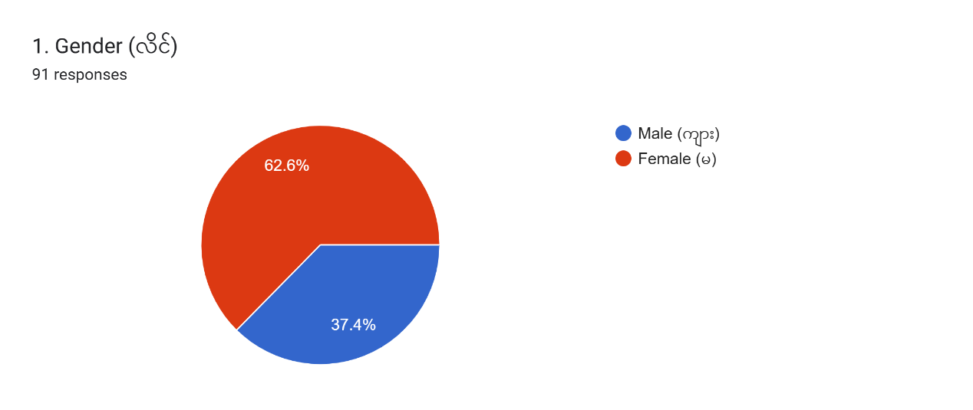
Source: Survey Data (2025)
The result shows that 34 respondents were male and the rest 57 respondents were female. The majority of respondents were females 62.6% and male 37.4%. This means that females were more involved in this study.

4.1.2 Age of Respondents
In this study, the age groups of respondents in Kaung Myat Yar Organization in Myanmar are divided into four groups such as age 18 to 30 years old, 31 to 40 years old, 41 to 50 years old and 50 years old and above. The age of respondents is shown in Table (4.2).

Table (4.2) Age of Respondents
Sr. No. |  | Frequency | Percentage
  Category
1. | 18 to 30 years | 32 | 35.2
2. | 31 to 40 years | 42 | 46.2
3. | 41 to 50 years | 15 | 16.5
4. | 50 years old and above | 2 | 2.2
Total |  | 91 | 100.0
Source: Survey Data (2025)
Figure (4. 2) Age of Respondents
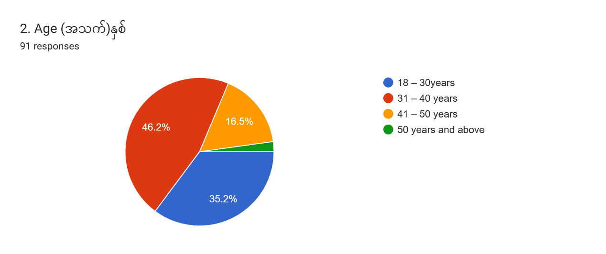
Source: Survey Data (2025)
Employee ages have been divided into four categories: four groups of 18 to 30 years old, one of 31 to 40 years old, one of 41 to 50 years old, and one of 50 years old and above. The findings of the analysis on respondents' ages were provided in Table (4.2) and Figure (4.2), as follows. Table (4.2) and Figure (4.2) show that 32 respondents fell into the "18 to 30 years " age range, another 42 respondents fell into the "31 to 40 years " age range, 15 respondents were in the "41 to 50 years " age range, and 2 respondents fell into the "50 years old and above " age range. The greatest age range, "31 to 40 years," in terms of percentage, is represented by 46.2%. The majority of respondents are workers between the ages of 31 and 40.

4.1.3 Marital Status of Respondents
In Table (4.3) and Figure (4.3), the respondents' marital status is separated into two categories: single and marriage.

Table (4.3) Marital Status of Respondents
Sr. No. |  | Frequency | Percentage
  Category
1 | Single | 59 | 64.8
2 | Marriage | 32 | 35.2
Total |  | 89 | 100.0
Source: Survey Data (2025)
Figure (4.3) Marital Status of Respondents
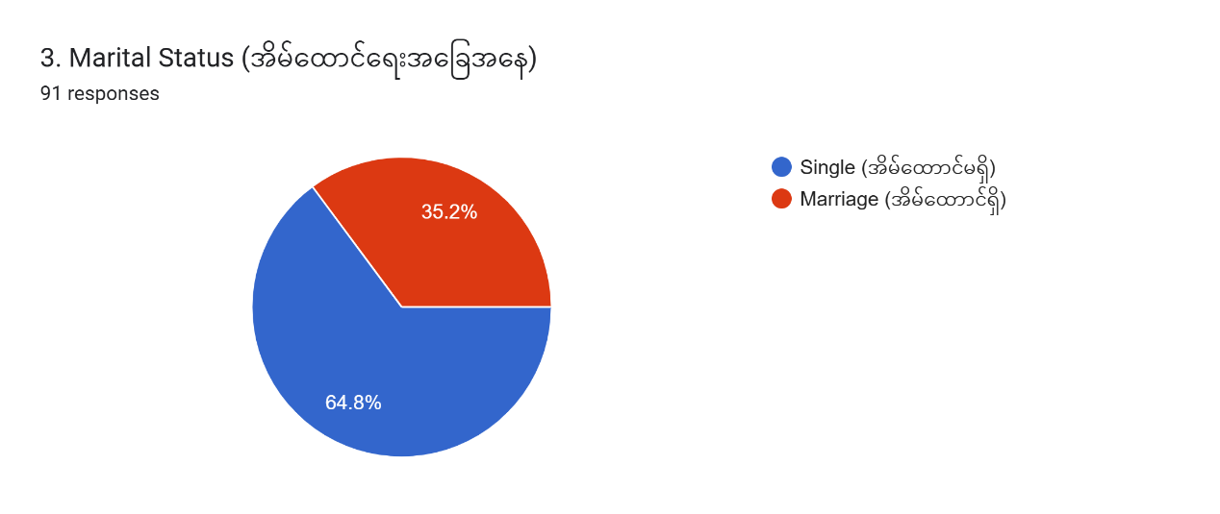
Source: Survey Data (2025)
In terms of marital status, the study showed that the majority of respondents were single and comprised of 64.8% of total respondents, while married respondents were 35.2% as presented in Table (4.3) and Figure (4.3).

4.1.4 Education Level of Respondents
In this study, the education level of respondents is divided into four groups such as graduate, post-graduate, Master and others.

Table (4.4) Education Level of Respondents
Sr. No. | Category | Frequency | Percentage
1. | Graduate | 52 | 57.1
2. | Post-graduate | 3 | 3.3
3. | Master | 5 | 5.5
4. | Other | 31 | 34.1
Total |  | 89 | 100.0
Source: Survey Data (2025)
Figure (4.4) Education Level of Respondents
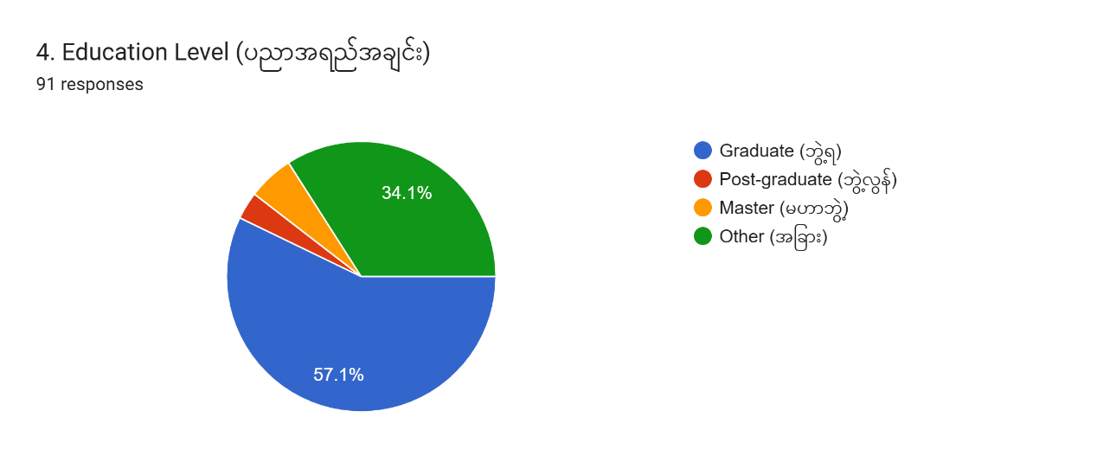
Source: Survey Data (2025)
Depending on their educational backgrounds, respondents are studied. There are four divisions of educational level: graduate, postgraduate, Master and others. The respondents' educational backgrounds are shown in Table (4.4). Graduate respondents make up the majority 52 (57.1%) and most significant category of respondents, followed by other respondents 31 (34.1%), and master of the respondents 5 (5.5%). With 3(3.3%), the group of post-graduate has the lowest percentage.

4.1.5 Working Experience of Respondents
In this study, respondents’ working experience was divided into five groups such as less than 2 years, 2 to 4 years, 5 to 7 years, 7 to 13 years and 13 years and above.

Table (4.5) Working Experience of Respondents
Sr. No. |  | Frequency | Percentage
  Category
1. | Less than 2 years | 24 | 26.4
2. | 2-4 years | 20 | 22.0
3. | 5-7 years | 12 | 13.2
4. | 7 -13 years | 20 | 22.0
5. | 13 years and above | 15 | 16.5
Total |  | 91 | 100.0
Source: Survey Data (2025)
Figure (4.5) Working Experience of Respondents
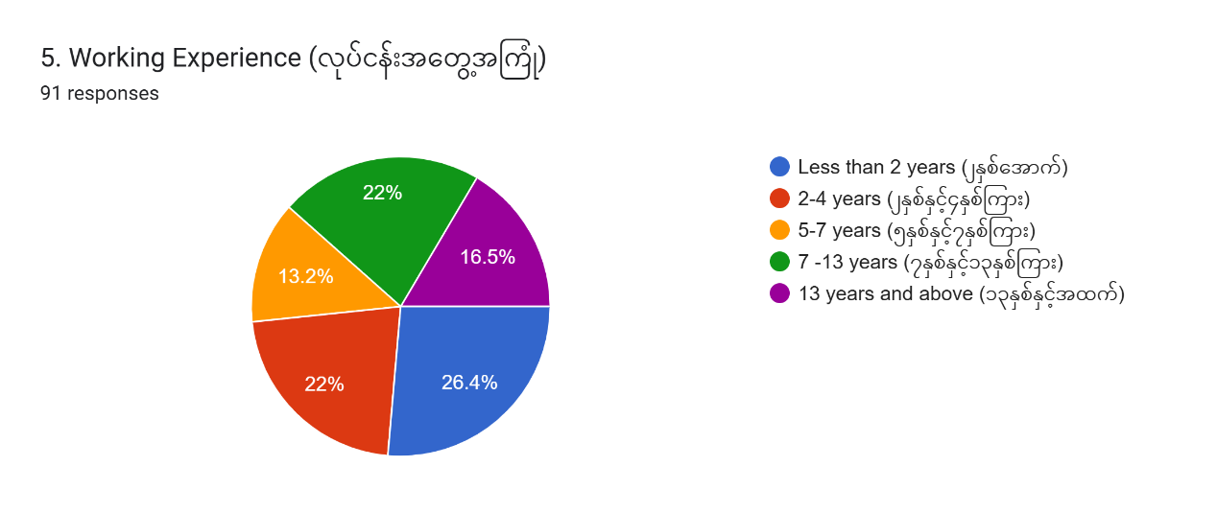
Source: Survey Data (2025)
Out of the total number, the highest number of respondents, which is 24 (26.4%) respondents, had been working in the organization for Less than 2 years. 20 (22%) respondents have been working for 2-4 years and 20 (22%) respondents had served for 7 -13 years. Those who have been working for 13 years and above 15 (16.5%) of the respondents and 12(13.2%) respondents had been working for 5-7 years with Kaung Myat Yar Organization in Myanmar.

4.1.6 Salary Scale of Respondents
In this study, the salary scale of respondents is divided into two distinct groups such as under 500,000 kyats, and 500,000 Kyats and above. The number of the respondents by their monthly incentive is shown in Table (4.6) and illustrated in Figure (4.6).

Table (4.6) Salary Scale of Respondents
Sr. No. | Category | Frequency | Percentage
1. | Under 500,000 Kyats | 28 | 30.8
2. | Over 500,000 kyats and above | 63 | 69.2
Total |  | 91 | 100.0
Source: Survey data (2025)
Figure (4.6) Salary Scale of Respondents
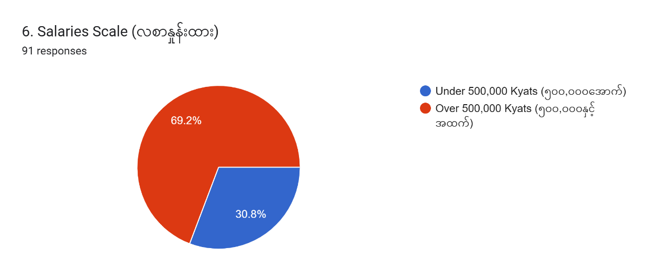
Source: Survey Data (2025)
According to the Table (4.6), the largest percentage, 63 (69.2%), is seen in the group of respondents with an income level over 500,000. The smallest group is the group of respondents with an income level under 500,000 with 28 (30.8%).

4.1.7 Current Position of Respondents
The current position of respondents is categorized into six categories including manager and above, coordinator, officer, assistant, CDF and Volunteer. Table (4.7) shows the current position of respondents by frequency and percentage. Figure (4.7) illustrates the pie chart of the current position of respondents in Kaung Myat Yar Organization in Myanmar.

Table (4.7) Current Position of Respondents
Sr. No. | Category | Frequency | Percentage
1. | Manager and above | 6 | 6.6
2. | Coordinator | 3 | 3.3
3. | Officer | 23 | 25.3
4. | Assistant | 23 | 25.3
5. | CDF | 13 | 14.3
6. | Volunteer | 23 | 25.3
Total |  | 91 | 100.0
Source: Survey Data (2025)

Figure (4.7) Current Position of Respondents
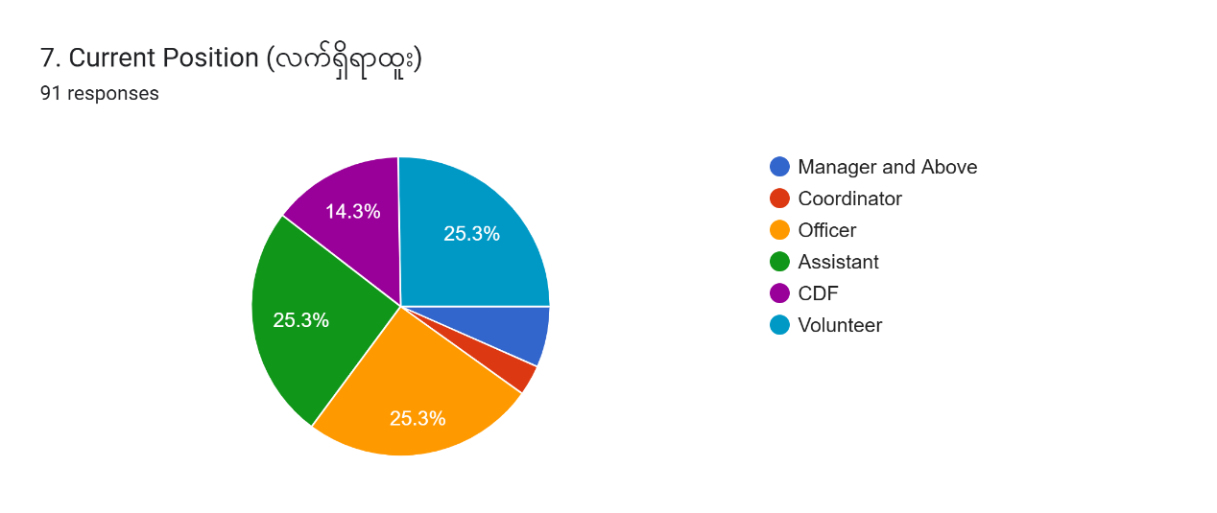
Source: Survey data (2025)
Statistics show that 6(6.6%) of responders are at the manager and above level. In addition, 3(3.3%) of respondents are coordinator level. And, 23(25.3%) of respondents are officer level. And then, 23(25.3%) of the respondents are assistant level. 13 (14.3%) of the respondents are classed into CDF level. And finally, 23 (25.3%) of the respondents are volunteer level.

4.1.8 Department of Respondents
The research also considers the department of respondents, which has been divided into six groups. Operation, Finance Department, HR Department, Admin and Log Department, Meal Department and IT Department are respectively. The operation department run mainly in the field level. And the other departments the supporting department. Table (4.8) and Figure (4.8) show the study's findings for respondents' employment status:

Table (4.8) Department of Respondents
Sr. No. | Category | Frequency | Percentage
1. | Operation | 59 | 64.8
2. | Finance Department | 9 | 9.9
3. | HR Department | 7 | 7.7
4. | Admin & Log Department | 6 | 6.6
5. | Meal Department | 5 | 5.5
6. | IT Department | 5 | 5.5
Total |  | 91 | 100.0
Source: Survey Data (2025)
Statistics show that 54 (64.8%) of responders are at the operation Department. It is the majority in the field level. In addition, 9 (9.9%) of respondents are classed as Finance Department. It supported the operation department. And 7 (7.7%) of respondents are HR Department. It provided the operation and the whole organization. And then, 6 (6.6%) of respondents are Admin and Log Department. 5(5.5%) of the respondents are Meal Department. And finally, 5(5.5%) of respondents are IT Departments.
Figure (4.8) Department of Respondents
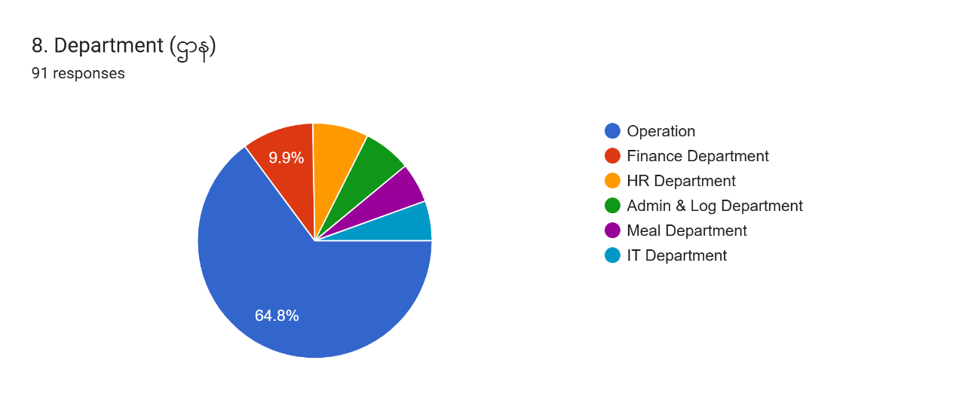
Source: Survey Data (2025)
Table (4.8) indicates that data was gathered from 91 employees. These answers were from the operation department, which had 59 workers (64.8%), the Human Resource department, which had 7 workers (7.7%), and the Finance Department, which had 9 workers (9.9 percent). Additionally, the Admin & Log Department had 6 respondents (6.6 percent), Meal Department had 5 respondents (5.5 percent), and IT service Department had 5 respondents (5.5 percent).

4.2 Descriptive Analysis of Dependent and Independent Variables
The structured questionnaire was used to find out how the respondent felt about their job satisfaction and the affected factors; working environment, career development, compensation and benefits, promotion and leadership style. Calculations were made for the reliability test, factor means, standard deviations, correlations, and regressions.

4.2.1 Working Environment
The respondents’ perception of working experience shows in Table (4.9) including mean value and standard deviation of each statement.

Table (4.9) Working Environment
Sr. No. | Statements | Mean Value | Standard Deviation
1 | Feeling deeply connected to the work | 4.11 | .605
2 | Role aligns with own skills | 4.19 | .595
3 | Working environment motivates to perform the best | 4.16 | .601
4 | Satisfying with the culture in workplace | 4.18 | .589
5 | Being dedicated to diversity and inclusiveness | 4.00 | .660
Overall Mean |  | 4.13
Source: Survey Data (2025)
The analysis of how employee satisfaction of working environment is shown in Table (4.9). According to research, the average employee view of perks is 4.128. It demonstrates that employees are satisfied with the advantages offered by their organization. It can be said that employees have positive feeling about their organization. The maximum mean value is 4.19. The minimum mean value is 4.00. It can be mentioned that the working environment of Kaung Myat Yar Organization is a fine and comfortable environment for the employee. And all staffs in Kaung Myat Yar organization feel closely with the co-workers. In its environment, all staffs in Kaung Myat Yar organization are happy and comfort.

4.2.2 Career Development
The mean values and standard deviations of career development in Table (4.10) is shown in below. Supporting from managers and organizations, professional development opportunities providing by organization, good organization, and providing clear career progression paths are asked.

Table (4.10) Career Development
Sr. No. | Statements | Mean Value | Standard Deviation
1 | Supporting by manager in developing the career skills | 3.84 | .734
2 | Skills and competencies that are provided in Kaung Myat Yar organization | 3.81 | .665
3 | Professional development opportunities that are provided in Kaung Myat Yar organization | 3.89 | .674
4 | A good place to develop career | 3.88 | .612
5 | Providing clear career progression paths within role | 3.81 | .622
Overall Mean |  | 3.85
Source: Survey Data (2025)
As per Table (4.10), it can be seen that the employees of Kaung Myat Yar Organization are strongly interrelated with satisfaction because the value of overall average mean is 3.845 and that value is above 3; the neutral score. “The satisfaction with the work at Kaung Myat Yar Organization” is the greatest mean score,3.89. It expresses that the most employees are satisfied as the organization and the working environments are good for them. The second largest mean value 3.88 is the satisfaction with their supervisors for their fair treatments. Moreover, Kaung Myat Yar employees are satisfied with their colleagues as the organization has the culture where they recognize and value each other’s performance and achievement.
It may also be appeared that employees are satisfied with the remunerations and benefits. And then, employees are satisfied with career development opportunities provided by Kaung Myat Yar organization and also satisfied with recognition from the organization for doing a good job. Employees also perceive that the performance appraisals used by the Kaung Myat Yar organization are fair and clear to them. The lowest mean scores of 3.81 expresses that employees are least satisfied with the bonus scheme provided by Kaung Myat Yar, because they feel that the organization does not give attractive bonuses to the employees.

4.3.4 Compensation and Benefits
Table (4.11) shows the employees’ perception on compensation and benefits including receiving a salary with qualifications, providing medical allowances and travelling allowances, happiness with the salary structure of the organization, fair compensation and benefits, and current compensations and benefits match with expectation.

Table (4.11) Compensation and Benefits
Sr. No. | Statements | Mean Value | Standard Deviation
1 | Receiving a salary that tallies with qualifications | 3.92 | .703
2 | Providing medical allowances and travelling allowances | 3.52 | 1.047
3 | Happiness with the salary structure of the Organization | 3.79 | .738
4 | Compensation and benefits are reviewed and adjusted fairly | 3.69 | .726
5 | Current compensations and benefits match with expectation | 3.72 | .700
Overall Mean |  | 3.73
Source: Survey Data (2025)
The analysis of how employee perceptions of benefits impact employee performance is shown in Table (4.11). According to research, the average employee view of perks is 3.729. It demonstrates that employees are satisfied with the advantages offered by their organization. It can be said that employees have positive feeling about their organization; benefits are provided by the organization. The maximum mean value is 3.92. This study found that the Kaung Myat Yar Organization always bargains on the employee’s career development. The career development plan is clear for the staffs.

4.3.5 Promotion
The mean values and standard deviations of promotion are shown in Table (4.12). Clear and transparent promotion criteria in the organization, fair and base on clear performance standards, having equal opportunity to get promotion, meeting promotion policy of Kaung Myat Yar organization with the expectations of the employees, and depending promotion on job performance are asked to the respondents.

Table (4.12) Promotion
Sr. No. | Statements | Mean Value | Standard Deviation
1 | Clear and transparent promotion criteria in the organization | 3.80 | .718
2 | Fair and base on clear performance standards | 3.84 | .687
3 | Having equal opportunity to get promotion in Kaung Myat Yar Organization | 3.85 | .759
4 | Meeting promotion policy of Kaung Myat Yar organization with the expectations of the employees | 3.88 | .647
5 | Promotion depends on job performance | 3.98 | .607
Overall Mean |  | 3.87
Source: Survey Data (2025)
As having seen in the Table (4.12), regarding promotion, the highest mean value of 3.98 shows that promotion depends on performance of employees, indicating that they know how the organization manages the promotion of employees. Kaung Myat Yar organization informs employees about the methods of promotion, so that employees are motivated to have better performance. The value of second mean, 3.88 indicates that the evaluated promotion methods are comprehensible, and which means that Kaung Myat Yar organization’s performance appraisal system is easy to understand for all employees. The harder they work, the more opportunities for promotion they can get. And being work hard pays off for those who take responsibility for specific jobs and manage problems properly, etc. The promotion policy at Kaung Myat Yar has the lowest mean value, which shows that some policy changes need to be made to meet the expectations of employees. The overall mean value of 3.869 which is more than the natural score of 3 points out that the majority of employees in Kaung Myat Yar organization like promotion scheme.

4.3.6 Leadership Style
The perception of employees on leadership style of supervisors is illustrated in Table (4.13). The statements include providing clear direction and expectations for tasks, inspiring employee to achieve beyond perceived capabilities by supervisor, encouraging open communication and feedback, feeling comfortable sharing my ideas with my supervisor, and involving in decision-making processes.

Table (4.13) Leadership Style
Sr. No. | Statements | Mean Value | Standard Deviation
1 | Providing clear direction and expectations for tasks | 3.92 | .619
2 | Inspiring employee to achieve beyond perceived capabilities by supervisor | 3.93 | .680
3 | Encouraging open communication and feedback | 3.95 | .673
4 | Feeling comfortable sharing the ideas with supervisor | 4.03 | .605
5 | Involving in decision-making processes | 4.00 | .596
Overall Mean |  | 3.97
Source: Survey Data (2025)
As mentioned above in Table (4.13), it is discovered that the employees are satisfied with the manager’s leadership skills because the overall average mean value of 3.97 is higher than the neutral score of 3. The mean value; 4.03 of Kaung Myat Yar organization managers compromises through give-and-take tactics is the highest mean, which means that the majority of staff at Kaung Myat Yar organization are satisfied with a leader’s give and-take tactics. The second-largest mean value of 4.00 express that leaders are always kind and take care of subordinates. Moreover, leaders pay attention to irregularities, mistakes, exceptions, and complaints. Leaders also practice a fair and respectful management style toward subordinates. The lowest mean scores 3.92 means managers do not have the ability to control, give direction and explanation, and make consultations with their subordinates. All the employees of Kaung Myat Yar organization feel flexible for their respective supervisors.

4.3.7 Employee Satisfaction
Five factors affecting the employee satisfaction in Kaung Myat Yar Organization in Myanmar are working environment, career development, compensation and benefits, promotion and leadership style. There have been a lot of theories, concepts and principles of employee satisfaction and five factors that are affected.
The perception on employee satisfaction shows in Table (4.14). The perception on feeling good about working at the Kaung Myat Yar Organization, applying all talents and skills at work, feeling close to the people at work, concerning by superior, and satisfaction with the overall job at this organization are rated by the employees.

Table (4.14) Employee Satisfaction
Sr. No. | Statements | Mean Value | Standard Deviation
1 | Feeling good about working at the Kaung Myat Yar Organization | 4.05 | .736
2 | Applying all talents and skills at work | 4.31 | .627
3 | Feeling close to the people at work | 4.21 | .606
4 | Concerning by superior | 4.04 | .613
5 | Satisfaction with the overall job at this organization | 4.19 | .595
Overall Mean |  | 4.16
Source: Survey Data (2025)
As per Table (4.14), it can be seen that the employees of Kaung Myat Yar organization are strongly interrelated with satisfaction because the value of overall average mean is 4.16 and that value is above 3; the neutral score. “The employee satisfaction at Kaung Myat Yar organization” is the greatest mean score. It expresses that the most employees are satisfied as the organization and the working environments are good for them. The majority mean score is 4.31. The second largest mean value 4.21. Moreover, Kaung Myat Yar organization employees are satisfied with their colleagues as the organization has the culture where they recognize and value each other’s performance and achievement. It may also be appeared that employees are satisfied with the compensation and benefits. And then, employees are satisfied with career development opportunities provided by Kaung Myat Yar organization and also satisfied with recognition from the organization for doing a good job. Employees also perceive that the performance appraisals used by the Kaung Myat Yar organization are fair and clear to them. The lowest mean scores of 4.04 expresses that employees are least satisfied.

4.4 Analysis on Factors Affecting Employee Job Satisfaction at Kaung Myat Yar Organization
This section analyzes the impact of influencing factors on employee satisfaction at Kaung Myat Yar Organization in Myanmar. The regression was used to analyze the influencing factors on employee satisfaction at Kaung Myat Yar Organization. The multiple regression analysis is used to explore which factors have an influence on employee satisfaction. The employee satisfaction is dependent variable, and independent variable is influencing factors (working environment, career development, compensation and benefits, promotion, and leadership style). The result of this model can be seen in Table (4.15).
The association between the affected factors and employee job satisfaction were tested using multiple regression analysis. Table (4.15) displays the outcomes of the multiple regression analysis.

Table (4.15) Factors Affecting Employee Job Satisfaction
Variables | Unstandardized Coefficients |  | Standardized Coefficients | t | Sig.
 | B | Std. Error | Beta | t | Sig.
(Constant) | .425 | .403 |  | 1.053 | .295
Working environment | .340*** | .105 | .270 | 3.227 | .002
Career development | .085 | .117 | .096 | .730 | 468
Compensation and benefits | -135 | .114 | -175 | -1.179 | .242
Promotion | .316** | .121 | .369 | 2.606 | .011
Leadership style | .326*** | .088 | .353 | 3.719 | .000
R | .753
R Square | .566
Adjusted R Square | .541
F Value | 22.208
Durbin-Watson | 1.940
Source; Survey Data (2025)
Note: *** Significant at 1% level, ** Significant at 5% level, * Significant at 10% level
In the Table (4.15), the given model is able to describe some degree of the variation in employee satisfaction of Kaung Myat Yar organization’s employees as the value of R-square is 57%. The adjusted R-square is 54.1. The overall significance of the model, the F-test value, is greatly significant at the level of (0.259). The Standardized Coefficient (Beta) of working environment has a value of (0.270), career development has a value of (.096), compensation and benefits have a value of (-175), promotion has a value of (.369) and the leadership style has a value of (.353), showing that leadership style has the highest contribution to impact the employee satisfaction when employees in that organization are satisfied. The result shows that among the five factors, working environment, leadership styles, and promotion have considerably significant value and are the main determinants of employees’ satisfactions at Kaung Myat Yar organization in Myanmar.
Leadership style has positive and significant effect on employee job satisfaction at 1% significant level. The variables of leadership style have the predictable positive sign and the coefficient value is highly significant at the level of 1%. The positive relationship indicates that the leadership style leads into increasing the employee satisfaction to the organization by Kaung Myat Yar organization employees. Employees in Kaung Myat Yar organization satisfied their leaders because of their clear guide to do their tasks and positive communication between them.
Working environment has positive and significant effect on employee job satisfaction at 1% significant level. Employees feel that their working environment is pleasant and nice. This environment fosters job satisfaction of employees to get high quality results.
Promotion has positive and significant effect on employee job satisfaction at 5% significant level. If employees are happy with the organization, they work harder to make the organization more competitive and to get more the organization achievement. Employee’s job satisfaction and motivation determine the employees’ commitment to an organization. Promotion of employee indicates either a systematic advancement to a higher position of authority or an upward review of their status to a higher professional ladder.
Employee satisfaction is a measure of how happy workers are with their jobs and working environment. Employee satisfaction refers to the degree of contentment that team members experience concerning their roles in the organization. It is worth noting that job satisfaction and workplace satisfaction essentially refer to the same concept. The benefits of employee satisfaction are far-reaching and lead to a thriving workplace. When the employees of the organization enjoy doing their jobs, they’re more likely to get their work done and stay at the organization often lead to happier customers. Employee satisfaction is the result of overall well-being and workplace engagement. When employees understand how to progress from their current position to more senior roles, they feel a sense of purpose and increased satisfaction.
Employees are the most critical and influential resource for a company or an organization. Employee job satisfaction relates directly to the desirability to stay and their productivity in the organization. Creating a healthy working environment for the employee is very important to getting job satisfaction from employees, inducing positive outcomes, and making them happy in their job. Working conditions will influence job satisfaction, as employees are concerned with a comfortable working environment. When employees are satisfied with the workplace quality, their performance will increase.
As per the results of the survey, working environment, compensation and benefits, career development, promotion and manager’s leadership skill could significantly raise the employee satisfaction of Kaung Myat Yar Organization in Myanmar.

CHAPTER V

CONCLUSION

This chapter consists of findings and discussions, suggestions and recommendations derived from the study of this research. This sector also comprises the suggestions on the needs for further research for Kaung Myat Yar Organization in Myanmar.
This study focuses on five corporate-level factors that can have an impact on employee job satisfaction. These factors are analyzed and discussed through a literature review.
Research study is intended to explore a clear study of employee satisfaction toward five factors which are working environment, carrier development, compensation & benefits, promotion and the leadership style. Finding is the results of analysis on employee satisfaction towards five factors. This chapter consists of findings and discussions, implications and recommendations derived from the study of this research. This sector also comprises the suggestions on the needs for further research for Kaung Myat Yar Organization in Myanmar.
Results of data analysis on the affected factors and job satisfaction of Kaung Myar Yar Organization staffs are discussed in this chapter's section on findings.

5.1 Findings and Discussions
Employees in Kaung Myat Yar organization also pay attention to good working environment of Kaung Myat Yar organization. They also focus that compensation provided by organization is fair compensation compare to other organizations. If there is no career development, they will be dissatisfaction. The promotion criteria in any organization must be clear and transparent, and job performance evaluation for promotion must be fair and base on clear performance standard. And finally, leadership style in organization is also important for employees in organization. Therefore, this study explores how the factors affect the employee job satisfaction in Kaung Myat Yar organization in Myanmar.
Human, financial, materials and information are the resources of the organizations. The achievement of a business firm extremely depends on various kinds of resources. Among them, human resource is one of the key resources which is wholly related to the organizational effectiveness. The major resource, human which is wholly related to the organizational effectiveness.
A human resource is a person who is compensated for supplying skills or knowledge to help an organization achieve its business goals. Organizations are placing more importance on employee satisfaction and a critical factor for success. A satisfied workforce has greater potential to drive productivity and efficiency while leading to greater employee retention. Improving employee satisfaction means more than just monetary compensation. It requires the improvement of various factors that impact a person’s overall well-being, engagement, and motivation. From work-life balance and career growth opportunities to recognition and a supportive organization culture, organizations need to adopt a holistic approach to fostering an environment where employees feel valued and fulfilled. Organizations can create a workplace where employees thrive, resulting in a happier and more successful organization. Employee satisfaction refers to the degree of contentment that team members experience concerning their roles in the organization.
Employee satisfaction includes the employee's emotions and their feelings. It has a significant impact on their work lives, and as a result, it influences their behavior as employees, including their loyalty, commitment, teamwork, interaction with other employees, attitude, and behavior. Employee satisfaction is a critical component of organizational management. Human resources that are satisfied and efficient are critical for every organization to handle the difficulties of today's ever-changing environment.
The goal of this study is to learn the factors affecting the employee job satisfaction at Kaung Myat Yar organization in Myanmar. 91 staff members from six departments of the Kaung Myat Yar organization were the subject of this investigation. This study examined on the factors affecting the employee job satisfaction.
This study attempts to determine the factors affecting employee satisfaction on Kaung Myat Yar Organization in Myanmar. An empirical study using a structured questionnaire will be conducted in January, 2025. In this survey, data was collected from all respondents in Kaung Myat Yar Organization in Myanmar. Human resource is one of the most important assets in any organization. If the organization has happy employees, everyone’s satisfaction can be met, and so it can achieve the organization’s goals.
The respondent's profile is represented by seven variables: gender, age, marital status, education level, working experience, Salary Scale, Current Position. According to the survey, most respondents are between the ages of 31 and 40. Regarding the gender of the respondents, it shows that most of the employees are female. The education level of most respondents is graduate. Most of her employees earn over K500,000. The most respondents in Kaung Myat Yar organization are less than 2 years. And the operation staffs are the most.
The respondents' level of agreement with the leadership style of the Kaung Myat Yar organization on the employee's satisfaction is so high significant of 99%. It indicates that the leadership style of the organization is flexible and agreement. The working environment of the organization is file and comfortable of 1%.
The study looks at motivating factors: working environment, career development, compensation and benefits, promotion and leadership style. As a result of compensation and benefits, Kaung Myat Yar organization gives the fair benefits to its employees. The employee also received a compensation and benefits equal to his/her efforts. Kaung Myat Yar organization passes on the same basic salary to another organization. The organization gives the satisfaction of its employees. Therefore, employees are always happy and comfortable at work. For interesting work, the the organization provides employees with necessary equipment such as laptops, tables and other equipment. It supports coffee-maker in the dining-room and every department has air-corn and sufficient work space. The heads of respective department also serve to get good relationship with their followers by using open communication. They give them the training for their career to develop. They need to become professionals in the workplace. On the employee well-being side, the organization strives to improve the relationships between all levels of the organization. The organization attaches great importance to the relationships between its employees. The organization always supports the career development of its employees.
Research findings show that organization need to provide their employees with other motivating factors to improve their satisfaction. Therefore, to improve employee satisfaction, the organization should focus on motivating factors. The survey results show that all employees are performing better at their organization. All employees are ready to perform their respective tasks in the organization, because the organization's affecting factors influence them.
In conclusion, as per research indicates, it is recommended that the organization should keep Kaung Myat Yar organization in their current state within the organization if they want to improve employees’ satisfaction. Thus, the organization can ensure its long-term success by continuously strengthening employee. According to the results of the study, the analysis indicated that affective factors has the greatest impact on job satisfaction.
As a summary, the study finds that working environment, promotion and leadership style are the dominant factors affecting employee satisfaction. Then, employee satisfaction has a positive impact on the employees’ commitment in Kaung Myat Yar organization, suggesting that these factors are superior to those in other organizations. The respondents of the survey are all staffs in Kaung Myat Yar organization. Profile of the respondents consists of gender, age, marital status, educational levels, working experience, position, department and income level in Kaung Myat Yar Organization. There are 91 employees in Kaung Myat Yar Organization. The overall mean of the five factors is studied respectively. The overall mean of employee is significant. And then the overall mean of working environment is high. The overall mean of the leadership style is highly significant. The overall mean of the promotion is good. The overall mean of the career development is over 3. And finally, the overall mean of the compensation is over 3.

5.2 Suggestions and Recommendations
If the human resources are insufficient, other resources; financial, physical and information will be weak. And role and responsibility are not clear. The organization can offer no job security to the employees. This study aims to provide the resources to achieve the organizational goals. By providing the resources, management, team work, strong techniques, the organization will grow with its image.
This paper focuses on five corporate-level that can have an impact on employee job satisfaction. The research study will also clarify the statistical correlation between employee satisfaction and five factors that are affected.
First of all, from the enterprise level, employees' working environment, career development, compensation and benefits, promotion and leadership style have a significant positive impact on employees' job satisfaction. It means that a fine and comfortable working environment, growth and clear career plan, appropriate compensation and benefits and can increase the level of employee satisfaction in any organization. Furthermore, clear and transparent promotion can motivate the employees’ performance. In addition to this, leadership style also affects employee satisfaction. A more accommodating and easy-going leadership style tends to result in more satisfied employees and higher output.
In accordance with the findings, the employees’ satisfaction on the factors are influence. The organization acquires many benefits from the understanding of how it can manage to increase the happiness of employees, which help them to become more effective, and increase employees’ satisfaction to the organization effectiveness. The majority of the staff feel happiness with the influencing factors provided by Kaung Myat organization. But there are some more things that still needed to deploy and develop to make increasing the employees' satisfaction. The level of employee satisfaction in Kaung Myat Yar organization can be increased more by providing more factors of employee satisfaction, such as a positive relationship between annual bonus. Therefore, such kind of factors should be revised more adequately to improve employees' satisfaction at all levels.
At Kaung Myat Yar Organization, motivating factors such as working environment, promotion and leadership style are essential factors to improve employee satisfaction. Employees feel that the working environment is comfort and fine prepared by the organization reflect their efforts and achievements. leadership style is an important factor for Kaung Myat Yar organization to improve employee satisfaction. The promotion style of the organization fair and clear. It is also found that by providing facilities and supporting transportation, employees can work easily and get their work done without delay. This positively affects the tasks of the organization’ employees. By providing incentives from the organization, the motivation of employees increases and their interest in work increases.
In response to the above suggested factors that may affect employee satisfaction, organizations should make changes to improve employee job satisfaction. This is because increased job satisfaction can increase the motivation of employees and their work output, while on the other hand, low satisfaction can even lead to negative phenomena such as quitting the job and absenteeism. In order to increase employee job satisfaction, the organization can first create a clean, comfortable working environment and a clear career development for its employees. Secondly, appropriate employee benefits and compensation are necessary. As an incentive, this will make employees feel that their efforts are equally rewarded and recognized by the organization, thus increasing their satisfaction to their work. As discussed earlier, clear career development, not just job advancement, but also giving employees the right skills of the workplace and choosing the most suitable position for them is an effective way to increase employee job satisfaction.

5.3 Needs for Further Research
In any organization, human resource management is considered to be the most valuable asset. Human capital is one of the most valuable resources of any enterprise, which not only improve outcome but also offers a competitive advantage. It is the sum-total of inherent abilities, acquired knowledge and skills represented by the talents and aptitudes of the employed persons who comprise of executives, supervisors, and the job satisfaction.
This study analyzed all employees at Kaung Myat Yar Organization in Myanmar. This research analyses the impact of motivation on the factors influence the employee satisfaction at Kaung Myat Yat Organization in Myanmar. Due to time constraints, the scope of the study is covered employees of Kaung Myat Yar Organization in Myanmar. For this study, the researcher selected all staffs in Kaung Myat Yar Organization in Myanmar and motivation factors (working environment, career development, compensations & benefits, promotion, and leadership style). Despite its contributions, this study relied on data collected from self-reported interventions and therefore has some limitation that need to be recognized. More research needs to be done with more respondents and more satisfaction factors.
Apart from that, future researcher should use other data collection methods and examine more variables to get a clearer picture of the employee satisfaction on the factors affected.

5.4. Ethical Issues Relevant to Study
Ethical considerations in research are a set of principles that guide the design and practice of research. Scientists and researchers must always follow certain codes of conduct when collecting data from people. In this study, we would like to consider confidentiality and the use of inaccurate data as important factors of ethical considerations for this study without using any kind of leading questions. Moreover, during this study, the researchers do not manipulate data that could affect the reputation of the organization and the reputation of the authors.

REFERENCES

Abdul Raziq , Raheela Maulabakhsh, The Factors Affecting Employee Satisfaction And Employee Retention In The Hotel Industry In Chiangmai, Thailand 2023, Vol. 7, No. 1, 998-1008
Ahmed R. Al-Owaidi, Thabet Ali Saleh, Meriem Benmechirah, Leadership Style and Its Relationship to Job Satisfaction for Employees at the University of Babylon
Burhanudin Burhanudin et al. (2023) ‘The Effect of Job Involvement, Work Environment, and Career Development on Job Satisfaction’, Asian Journal of Management, Entrepreneurship and Social Science, 3(01). doi:10.98765/ajmesc.v3i01.289.
Charter Graphic Press, Gwagwalada, Abuja.
Dessler, Garry. (2017). Human Resource Management, (15th ed.) Pearson
Electronic Journal of Business and Management
Factors Affecting Job Satisfaction of Bank Credit Officers in Vung Tau City
Factors Influencing Job Satisfaction Among Employees in Aspiro Solutions Sdn.Bhd
Gerhart, B., & Milkovich, G. T. (1992). Employee compensation: Research and practice. In M.D. Dunnette & L.M. Hough(Eds.),Handbook of industrial & organizational psychology (2nd ed). Consulting Psychologists Press, Inc.
https://builtin.com/career-development
https://doi.org/10.1051/shsconf/202418101037
https://oshwiki.osha.europa.eu/en/themes/job-satisfaction-theories-and-definitions
https://psmedu365-my.sharepoint.com/:f:/g/personal/ceo_psm_edu_mm/EhPE9-aKfMBPreFRV8EagVcBmPeot0iIpYOoF7bTWdGNhw?e=7cDTSY
https://psmedu365-my.sharepoint.com/:f:/g/personal/ceo_psm_edu_mm/EhIZiUEyMvFBl2Fj253d32oBof7ZQLW6Foq7VjIwZdzIqw?e=rdpog7
https://www.journals.esciencepress.net/index.php/JSAS/article/view/3940
https://www.zendesk.com/blog/employee-satisfaction-guide/
Impact of Working Environment on Job Satisfaction
Impact of Working Environment on Job Satisfaction
International Journal of Innovative Science and Research Technology
Jena, L. K. (2016). Employee Performance at Workplace: Conceptual Model and Empirical Validation. Business Perspectives and Research.
Journal of Positive School Psychology
Lampung Employees. Darmajaya Business Journal, 5(2), 80-89
Madugu, U., & Ogundeji, O. A. (2018). Promotion and job satisfaction: A precursor of high performance in organizations. International Journal of Advanced Academic Research, 4(6), 12-25.
Magdalena, B., & Rulyati, O. (2019). The Influence of Department Promotion on Job
Newstrom, John, W. (2011), Human Behavior at Work, McGraw Hill, thirteenth ed., New York.
Nurki Maya Gurung, Dr. Taein Layraman
Open Journal of Business and Management
Oyadiran, P. A. (2008), Human Resources Management (A Diagnostic Approach).
Procedia Economics and Finance 23 (2015) 717 – 725
Robbins, S. P., & Coulter, M. (2009). Management (10th Edition) Pearson International Edition: Prentice Hall.
Sasmithaa Elangovan, Subaashnii Suppramaniam, Morakinyo Dada
Satisfaction Through Job Performance as an Intervening Variable on TVRI
Shaikh, F. (2022) ‘Relationship Between Employees’ Performance and Workplace Environment’, OPUS: HR Journal, 13(2), pp. 22–36. Available at:https://search-ebscohost-com-s.elink.xjtlu.edu.cn:443/login.aspx?direct=true&db=bsu&AN=162155437&site=eds-live&scope=site (Accessed: 9 July 2023).
Shujaat, Sobia, Saira Sana, dan Dr. Faisal Aftab1 Ishtiaq Ahmed. (2013) .Impact of Career Development on Employee Satisfaction in Private Banking Sector Karachi. Journal of Management and Social Sciences, 9(2), pp. 1-8.
Sikula, A. E. (2000). Personnel administration and human resources management. Toronto: John Wiley & Sons, Inc.
Sjarifudin, D. and Ali, H. (2023) ‘Determination of Job Satisfaction: Analysis of Self-Efficacy, Work Motivation and Work Environment (Garment in Indonesia)’, Dinasti International Journal of Management Science (DIJMS), 4(5), pp. 845–853. doi:10.31933/dijms.v4i4.
Tran Nha Ghi
Umar, Akmal. (2015). The Effect of Motivation and Career Development Against Employees’ Performance and Job Satisfaction of the Governor Office South Sulawesi Province, Indonesia. International Journal of Management Sciences, 5(9), pp.628-638.
Vol.11 No.6, November 2023, 2832-2848
Vol.8 Issue 1, 2023 pp. 40-53
Volume 4, Issue 6, June – 2019, 39-40

APPENDIX
QUESTIONNAIRE

These survey questions are aimed to determine factors affecting employee satisfaction on Organization. Your responses will be kept confidential and will be used to complete for my thesis and for supporting employee career development. This questionnaire is used in order to support only the completion of my thesis. Your response is very important, so please answer all of the questions. We appreciate your contribution and thank you very much in advance.
Part (1): Demographic Characteristics
Please choose the answer that matches your conditions. Answer the following questions by choosing a number where appropriate.
အောက်ပါဖော်ပြထားသောမေးခွန်းများတွင်တစ်ခုချင်းစီအလိုက်မိမိနှင့်ကိုက်ညီမှုအရှိဆုံး သောစကေးကို‌‌ရွေးပေးပါရန်နှင့်ဖော်ပြချက်တစ်ခုအတွက်တစ်ခုသာရွေးပေးပါရန်မေတ္တာရပ်ခံအပ်ပါသည်။
1. Gender (လိင်)
Male (ကျား)
Female (မ)

2. Age (အသက်)နှစ်
18 – 30years
31 – 40 years
41 – 50 years
50 years and above

3. Marital Status (အိမ်ထောင်ရေးအခြေအနေ)
Single (အိမ်ထောင်မရှိ)
Marriage (အိမ်ထောင်ရှိ)

4. Education Level (ပညာအရည်အချင်း)
Graduate (ဘွဲ့ရ)
Post-graduate (ဘွဲ့လွန်)
Master (မဟာဘွဲ့)
Other (အခြား)

5. Working Experience (လုပ်ငန်းအတွေ့အကြုံ)
Less than 2 years (၂နှစ်အောက်)
2-4 years (၂နှစ်နှင့်၄နှစ်ကြား)
5-7 years (၅နှစ်နှင့်၇နှစ်ကြား)
7 -13 years (၇နှစ်နှင့်၁၃နှစ်ကြား)
13 years and above (၁၃နှစ်နှင့်အထက်)

6. Salaries Scale (လစာနှုန်းထား)
Under 500,000 Kyats (၅၀၀,၀၀၀အောက်)
Over 500,000 Kyats (၅၀၀,၀၀၀နှင့် အထက်)

7. Current Position (လက်ရှိရာထူး)
Manager and Above
Coordinator
Officer
Assistant
CDF
Volunteer

8. Department (ဌာန)
Operation
Finance Department
HR Department
Admin & Log Department
Meal Department
IT Department

The following questions are based on the five-point Likert scale from 1 to 5. Please choose on the number that you feel is relevant.
(အောက်ဖော်ပြပါမေးခွန်းများသည် ၁ မှ ၅အထိစကေး၅ရပ်အပေါ်အခြေခံထားသည်။ ကျေးဇူးပြု၍မျှော်လင့်ချက်(Expectation)နှင့်ကိုက်ညီသောသတ်မှတ်ချက်ကို ရွေးပေးပါရန်)

1= Strongly disagree လုံးဝသဘောမတူ, 2= Disagreeသဘောမတူ, 3= Neutral ကြားနေ,
4= Agree သဘောတူ, 5= Strongly Agreeလုံးဝသဘောတူ,
- Working Environment (လုပ်ငန်းပတ်ဝန်းကျင်)
Sr. No | Statements | 1 | 2 | 3 | 4 | 5
1 | I feel deeply connected to the work I do.  (ကျွန်ုပ်၏အလုပ်ခွင်သည် ကျွန်ုပ်လုပ်နေသော အလုပ်နှင့် နက်နက်နဲနဲ ဆက်စပ်နေသည်ဟု ခံစားရသည်။)
2 | My role aligns with my skills.  (ကျွန်ုပ်၏အခန်းကဏ္ဍသည်ကျွန်ုပ်၏ကျွန်းကျင်မှုနှင့်ကိုက်ညီမှုရှိ သည်။)
3 | My working environment motivates me to perform at my best.  (ကျွန်ုပ်၏အလုပ်ခွင်သည် ကျွန်ုပ်ကို အကောင်းဆုံးတာဝန် ထမ်းဆောင်နိုင်ရန်လှုံ့ဆော်ပေးသည်။)
4 | I satisfied with the culture of my workplace.  (ကျွန်ုပ်အလုပ်ခွင်၏မြတ်နိုးတန်ဖိုးထားမှုကိုကျွန်ုပ်စိတ်ကျေနပ်မှု ရှိသည်။)
5 | My organization is dedicated to diversity and inclusiveness.  (ကျွန်ုပ်၏အဖွဲ့အစည်းသည် မတူကွဲပြားမှုနှင့် အားလုံး ပါဝင်နိုင်မှုအတွက် ရည်စူးပါသည်။)

2. Career Development (အသက်မွေးဝမ်းကျောင်းတိုးတက်မှု)
Sr. No | Statements | 1 | 2 | 3 | 4 | 5
1 | I feel adequately supported by my manager in developing my career skills.  (ကျွန်ုပ်၏ အသက်မွေးဝမ်းကြောင်းဆိုင်ရာ ကျွမ်းကျင်မှုများ ဖွံ့ဖြိုးတိုးတက်စေရန်အတွက် ကျွန်ုပ်၏မန်နေဂျာမှ လုံလောက်သော ပံ့ပိုးမှုကို ခံစားရပါသည်။)
2 | I am satisfied the skills and competencies that are provided in Kaung Myat Yar organization.  (အဖွဲ့အစည်းမှ ထောက်ပံ့ပေးသော ကျွမ်းကျင်မှုများကို ကျေ နပ်နစ်သက်မှုရှိသည်။)
3 | I am satisfied the professional development opportunities that are provided in Kaung Myat Yar organization.  (အဖွဲ့အစည်းမှထောက်ပံ့ပေးသောအခွင့်အလန်းများအားလုံးအပေါ် ကျေနပ် နစ်သက်မှုရှိသည်။)
4 | I am satisfied this is a good place to develop my career.  (ကျွန်ုပ်၏အသက်မွေး‌ဝမ်းကြောင်းအတွက်နေရာကောင်းဖြစ်မှုအား ကျေနပ်နစ်သက်မှုရှိသည်။)
5 | My organization provides clear career progression paths within my role.  (ကျွန်ုပ်၏အဖွဲ့အစည်းသည် ကျွန်ုပ်၏အခန်းကဏ္ဍအတွင်း ရှင်းလင်းပြတ်သားသော အသက်မွေးဝမ်းကြောင်းဆိုင်ရာ တိုးတက်မှုလမ်းကြောင်းများကို ပံ့ပိုးပေးပါသည်။)

3. Compensation and Benefits (နစ်နာမှုနှင့် အကျိုးခံစားခွင့်များ)
Sr. No | Statements | 1 | 2 | 3 | 4 | 5
1 | I receive a salary that tallies with my qualifications.  (ကျွန်ုပ်၏ အရည်အချင်းနှင့် ကိုက်ညီသော လစာကို ရရှိသည်။)
2 | The Organization provides medical allowances and travelling allowances.  (အဖွဲ့အစည်းသည် ဆေးဘက်ဆိုင်ရာစရိတ်နှင့် ခရီးစရိတ်များကို ထောက်ပံ့ပေးသည်။)
3 | I am happy with the salary structure of the Organization.  (အဖွဲ့အစည်း၏လစာ ဖွဲ့စည်းပုံနဲ့ ပတ်သက်ပြီး ကျေနပ်ပါသည်။)
4 | I think my compensation and benefits are reviewed and adjusted fairly.  (ကျွန်ုပ်၏ နစ်နာမှုများနှင့် ခံစားခွင့်များကို ပြန်လည်သုံးသပ်ပြီး မျှမျှတတ ချိန်ညှိထားသည်ဟု ကျွန်ုပ်ထင်ပါသည်။)
5 | My current compensations and benefits match what I expect from Kaung Myat Yar organization.  (ကျွန်ုပ်၏နစ်နာမှုများနှင့်ခံစားခွင့်များသည် ကောင်းမြတ်ရာ အဖွဲ့အစည်းမှ မျှော်လင့်ထားသည်နှင့် ကိုက်ညီပါသည်။)

4. Promotion (ရာထူးတိုးမြှင့်ပေးခြင်း)
Sr. No | Statements | 1 | 2 | 3 | 4 | 5
1 | The promotion criteria in our Organization are clear and transparent.  (ကျွန်ုပ်တို့၏ အဖွဲ့အစည်းရှိ ပရိုမိုးရှင်းစံနှုန်းများသည် ရှင်းရှင်းလင်းလင်းနှင့် ပွင့်လင်းမြင်သာမှုရှိသည်။)
2 | I think that job performance evaluation for promotion is fair and base on clear performance standard.  (ရာထူးတိုးခြင်းအတွက် လုပ်ငန်းစွမ်းဆောင်ရည်အကဲဖြတ် ခြင်းသည် မျှတပြီး ရှင်းလင်းသောစွမ်းဆောင်ရည်စံနှုန်း ပေါ်တွင် အခြေခံသည်ဟု ကျွန်ုပ်ထင်ပါသည်။)
3 | I think that employee has equal opportunity to get promotion in Kaung Myat Yar Organization.  (ဝန်ထမ်းကောင်းများရာထူးတိုးရန် တန်းတူအခွင့်အရေး ရှိသည်ဟု ကျွန်ုပ်ထင်ပါသည်။)
4 | I think that promotion policy of Kaung Myat Yar Organization meets the expectations of the employees.  (ကောင်းမြတ်ရာအဖွဲ့အစည်း၏မြှင့်တင်ရေးမူဝါဒသည် ဝန်ထမ်း များ၏ မျှော်မှန်းချက်နဲ့ ကိုက်ညီသည်ဟု ကျွန်ုပ်ထင်ပါသည်။)
5 | I think that promotion depend on my job performance.  (ရာထူးတိုးခြင်းသည်ကျွန်ပ်တို့အလုပ်အတွက် စွမ်းဆောင် ရည် အပေါ် မူတည်သည်ဟုကျွန်ုပ်ထင်ပါသည်။)

5. Leadership Style(ခေါင်းဆောင်မှုပုံစံ)
Sr. No | Statements | 1 | 2 | 3 | 4 | 5
1 | My supervisor provides clear direction and expectations for tasks.  (ကျွန်ုပ်၏ကြီးကြပ်ရေးမှူးသည် အလုပ်များအတွက် ရှင်းလင်းပြတ်သားသော ဦးတည်ချက်များနှင့် မျှော်လင့်ချက်များကို ပေးပါသည်။)
2 | My supervisor inspires me to achieve beyond my perceived capabilities.  (ကျွန်ုပ်၏ ကြီးကြပ်ရေးမှူးသည် ကျွန်ုပ်၏ သိမြင်နိုင်စွမ်းထက် ကျော်လွန်အောင်မြင်ရန် လှုံ့ဆော်ပေးပါသည်။)
3 | My supervisor encourages open communication and feedback.  (ကျွန်ုပ်၏ ကြီးကြပ်ရေးမှူးသည် ပွင့်လင်းသော ဆက်ဆံ မှုနှင့် တုံ့ပြန်ချက်များကို အားပေးပါသည်။)
4 | I feel comfortable sharing my ideas with my supervisor.  (ကျွန်ုပ်၏ အကြံဥာဏ်များကို ကျွန်ုပ်၏ကြီးကြပ်ရေးမှူးနှင့် မျှဝေရန် အဆင်ပြေပါသည်။)
5 | My supervisor actively involves me in decision-making processes.  (ကျွန်ုပ်၏ ကြီးကြပ်ရေးမှူးသည် ကျွန်ုပ်အား ဆုံးဖြတ်ချက်ချသည့် လုပ်ငန်းစဉ်များတွင် တက်ကြွစွာ ပါဝင်ဆောင်ရွက် စေပါသည်။)

Employee Satisfaction (ဝန်ထမ်းများ၏ စိတ်ကျေနပ်မှု)
Sr. No | Statements | 1 | 2 | 3 | 4 | 5
1 | I feel good about working at the Kaung Myat Yar Organization.  (ကောင်းမြတ်ရာအဖွဲ့အစည်းမှာ အလုပ်လုပ်ရသည်ကို စိတ်ချမ်းသာမှုရှိသည်။)
2 | All my talents and skills are used at work.  (ကျွန်ုပ်၏ စွမ်းရည်နှင့် အရည်အချင်းအားလုံးကို လုပ်ငန်းခွင်မှာ အသုံးပြုပါသည်။)
3 | I feel close to the people at work.  (အလုပ်ကလူတွေနှင့် ရင်းနှီးသည်ဟု ခံစားရပါသည်။)
4 | I believe superior is concerned about me.  (အထက်လူကြီးက ကျွန်ုပ်ကို အ‌‌လေးထား သည်ဟု ကျွန်ုပ်ယုံကြည်သည်။)
5 | I am satisfied with my overall job at this Organization.  (ဒီအဖွဲ့အစည်းမှာ ကျွန်ုပ်ရဲ့ အလုပ်အားလုံးအတွက် ကျေနပ်ပါသည်။)

