Swiss Business Research
Department: Business Management
Programme: PhD by Portfolio
Name: John Francisco Murphy
ID: PW7100995
Capstone
The purpose of this document is to examine the history to work opportunities for adults with intellectual disabilities in Ireland, and developing a new Micro Social Enterprise programme as an alternative option to mainstream employment’, to understand the reasoning behind this innovative proposal it is, important to give a brief but important history of employment and work activities of adults with Intellectual Disability.
In Ireland adults with intellectual disability have always struggled to secure parity in the mainstream jobs market in Ireland. Over the year’s research has identified a number of barriers for adults with intellectual disability hoping to enter the competitive labour market.
Work activation and employment opportunities for people with Intellectual Disabilities in Ireland stretches back to the 1930’s, such activities started in the Mental Hospitals as daily occupational routines for residents and included, knitting and crochet, and making small arts and crafts items.
Then with the development of religious services such as the Daughter’s of Charity (1925) and The Brothers of Charity (1938), developing residential institutions, work activities were further added, these included agricultural and horticultural work (normally sited on their own farm lands) and arts and crafts set in larger communal indoor areas. These activities were usually repetitive with very little change or structure and with very little if any, input from the participants involved. REHAB Services was established in 1949 and they set up sheltered1 workshops nationwide.
Irish Wheelchair Association was set up sixty years ago in 1960 when a group of Paralympians took the visionary move to establish an organisation and services that cater for people with physical disabilities.
Further community based sheltered workshops started providing services also in the 1960’s such organisation’s included REHAB Services, (1949) St Michaels House Services (1955) and SOS Kilkenny CLG (1975) in contrast to the Institution run services these community workshops were governed by a board comprising of elected members of the local community.
A ‘social model’ of service delivery was adopted and services were community-based. The central goal was the participation of people with disabilities in their communities and recognition of their rights in society. However, Sheltered-workshops became the focus of exploitation claims after an article published in 2007 in the Irish Times newspaper. The article had established that people with learning disabilities were being as little as €5 a week for full-time work at sheltered workshops and some were being paid nothing at all. Further concerns about the legal implications of such arrangements, where profitable works were being effectively “staffed” by workers on rates far below the minimum wage or participants working for no payment at all.
As a result of this article the HSE and the equality authority carried out separate investigations into the allegations of exploitation in sheltered workshops. At this time more than 4,000 people with intellectual disability were working in sheltered workshops across the country doing such work as; shrink wrapping two for-one offers for supermarkets, putting inserts mail shots or making cardboard boxes.
In what was obviously a knee-jerk reaction after the investigations, all sheltered workshops/community workshops were closed. While it was obvious that adjustments needed to be made to the system, the workshop system had a lot of positives, take one particular workshop in the Kilkenny area of the country who produced such high-quality products, their hand made pottery range was sold in Harrods of London, and their Textile products were sold in Bloomindale’s of New York.
Participants in this work had developed huge skill and techniques levels which were now gone. Probably a better way of dealing with the sheltered workshop difficulty would have been to re-structure them into Social Enterprises adjust pay scales, work times and interduce a formal apprenticeship system of training.
Ironically, the shutting down of the sheltered workshops resulted in those who attended these workshops were now attending day services long-term.
Some of the difficulties facing adults with Intellectual Disability today.
With the vast number of school leavers now attending day services as an obvious next step, the choice element has been reduced for the individual. Unfortunately, the way the day service model works, the only opportunity service providers have to increase their annual budget is if new participants joined the service.
This payment system is on a capitation basis, unfortunately this has led to an almost “Competition” among day service providers for new school leavers. This leaves the individual service user in a very vulnerable predicament, if they wish to move away from the day service, the service then loses their capitation grant which will then leave their budget short, this is a strong argument for service providers to encourage service users to stay in the service if for nothing else only financial reasons. This ultimately leads participants becoming more dependent on day care services rather than more independent members of the community.
While work activation may not be for everyone attending day services which is understandable, but for the cohort of people who wish to move away from day services it is essential they have the opportunity to do so. From an unscientific survey carried out by the Director of Planning and Development BEAM Services CLG in 2022 interviews took place with over 50 service users in multiple services, the findings showed that between 12% to 14% of people attending day services had the potential and the desire to move to a more work orientated environment. In terms of potential numbers, there are 25 service providers in the South East alone providing care and support for some 2,500 people a challenged to move forward with supports.
In the unlikely event that a person with intellectual disability was offered a job, they may not be in a position to take it up, there may be a number of reasons for this; health related issues may restrict the person to working 18 to 20 hours per week. The Endeavour programme has flexibility built into its programme to allow for such circumstances. This will allow the same self-esteem and independent benefits to individuals, and it will not affect their personal benefits such as medical cards. It must be pointed out that the Endeavour Programme is as-well-as and not instead of other services.
Focus study: employment and intellectual Disability age 18 – 30 yrs
Research method for the study
Since empirical research is based on observation and capturing experience, it was important that the steps taken to conduct the experiment and how it was to be analysed. During the research it allowed the opportunity to resolve the problem which occurred during the research.
Step 1
Research Objective
It was important to be clear about what is precisely needed from the study. The problem statement was framed, plan of action, and determined any potential issues with the resources available to the research.
Step 2
Reviewing relevant literature
All relevant Literature was consulted. The researcher was able to identify previous studies that examined the problem and the subject and determined issues encountered.
Step 3
Framing the hypothesis and measurement
Framing the hypothesis and identify the likely outcome, Variables were established along with the context. The margin of error needed to be acknowledged.
Step 4
Defining the research design, methodology and data collection techniques.
Data was gathered in the form of a questionnaire format easi - read, that was distributed to individuals, Focus groups and one to one interview. In this case it was best to use a non-experimental technique.
The data gathered was group of adults with Intellectual disability aged between 18yrs and 30 yrs, This sample was a group who had completed a training programme and were ready to progress in to work.

Step 5
Conducting data analysis and framing the results
Quantitative research method was used together information via questionnaire, interviews, Observational methods, and focus groups. The data gathered used from the study is analysed to address the empirical questions

Step 6
Making conclusions
A report prepared to present the findings of the entire research and how it will be used in this case it will reinforce the lack of employment opportunities for this client group.

Memo

Hi, my name is John Murphy,
I am doing a little bit of research on Employment in services like yours, I would like to have a better understanding if you are interested in having a job, the hours you would like to work. what work might look like for you, have you an interest in micro social enterprise and if so, what you would like to do.
Please find below, questions regarding how work might suit you.
I am very grateful for your assistance in helping me learn this information.
I can be contacted at johnmurphy@inbox.com phone at 0871223453
Many thanks,

John Murphy.

Questionnaire Focus Study
Name: _____________________________
Date: __________________________

1 | Would you like a job? |  | Yes  No
2 | How Many hours would you like to work? | 
3 | What are your perceived difficulties in getting a job. |   This Photo by Unknown Author is licensed under CC BY-NC-ND
4 | What would work look like for you? | €???

5 | What support would you require to do the job? | 
6 | What would your responsibilities be to work? | 
7 | How would having a job change your life? | 
8 | How valuable was your Rehabilitative training (RT) Programme in preparing you for work | 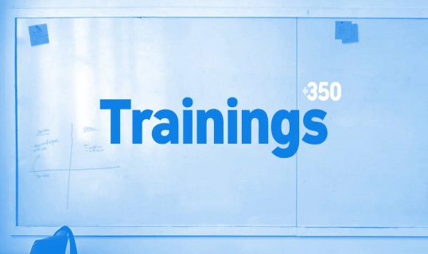
9 | How did you find the transition from school to day services? | 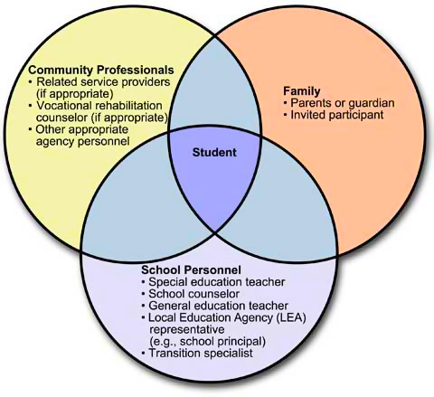  This Photo by Unknown Author is licensed under CC BY-NC-ND
10 | Would you be interested in being part of a Micro -Social Enterprise? | 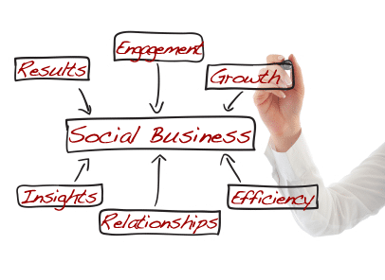
11 | What kind of Enterprise would you like to be part of? | 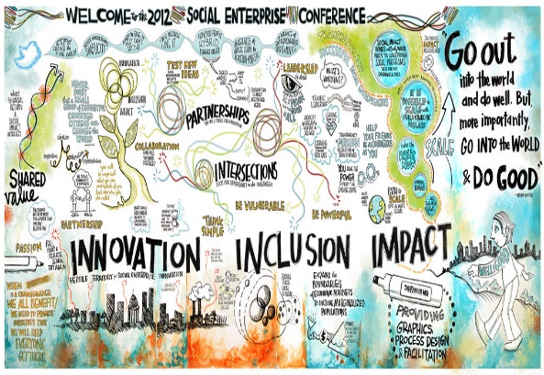

1.Would you like to have a job? | 6. What would you responsibilities in work?
20 - yes | Reply – 12- Show up on time  10 – Be aware of health and safety issues, myself/others  6 – when sick let work know, require a doctor cert  10 – behave appropriately  5 – dress appropriately  3 – responsibility to employer  2 – Advocate for the business  - – fire drills
2.How many hours would you like to work? | 7. How would having a job change your life?
Reply - 1 full time  1- 8 hours per week  4 -10 hours per week  14-19 hours per week | Reply – 16 – Build confidence and self esteem  13– Access to a mentor would help  4– I would have money of my own  8– I will learn valuable experience  3– I could learn to drive  3– it would occupy my mind  2– it would make me happy  7– allow me socialise
3.What are your perceived difficulties to getting a job? | 8.How valuable was your Rehabilitative training (RT) Programme in preparing you for work?
Reply- 5 – learning disability  8– medical issues  8– health and safety  10– competing with others/applicants  8– Hoping the job suits  2– I like to spend time with my friends | Reply- 4 – to repetitive  8-needs more digital technology input  9-to much classroom work  7- more field trips  3-more art and culture  6-to much in house training  4- I enjoyed the RT programme  6- more work experience would prepare us for applying for jobs
4.What would work look like for you? | 9.How did you find your transition from school to day services?
Reply – 6 – equality  5– respect  8– interaction with others  2 – friendly people to talk to  7 – I would like a job description  9 – I would like responsibilities  12 – I would like be in the community like everyone else | Reply – 9-more preparation needed  9 -could spend longer on sampling in day service from school  12 – I was frightened of the move  12 – I didn’t know what to expect  12 – I was stressed getting to know new people
5.What supports would you require to do the job? | 10. would you be interested in being part of a Micro – Social Enterprise
Reply -15 – Help with application and compiling CV  13 – Assistance of a mentor or Job Coach  11 – provide the necessary training/induction  8- help with literacy issues  6 – transport. | Reply 30 yes 5 No  11 What kinds of Enterprises would you like to be part of?  Reply: 25 woodwork projects  10 Craft Development
Focus Study: Employment and intellectual Disability age 18 to 30 yrs
Employment is an important part of community life for all people. For people with intellectual disability (ID), competitive integrated employment offers many important benefits, including opportunities for inclusion as well as enhanced mental health and quality of life. (Dean et al. 2018: Garrels & Sigstad, 2019; Voermans et al. 2020. Recognises the benefits of competitive integrated employment for people with ID.
Many countries have enacted plans to increase employment outcomes (e.g. the United States’ Work-force Innovation and Opportunity Act and Australia’s National Disability Insurance Scheme).While effective systems of support that promote competitive integrated employment are critical for enhancing outcomes, another often overlooked factor may be employer’s attitudes about hiring people with ID (Luecking, 2011).

Ability Focus: (Disability inclusion specialists)
Barriers to employment for people with Disabilities. (April 17th 2020)
There are many barriers faced by people with disabilities when seeking employment. According to the social model of disability, disability is caused by the way society is organised, rather than focusing on someone’s impairments or differences. This model of thinking may be specifically applied to recruitment and employment, as many people feel disabled by the processes of recruitment, job retention and promotion within the Irish work places. While current employment practices enable most, they certainly disable others.
A recent study of the lived experience of over 700 disabled people in the UK conducted by British company “Evenbreak” in November 2019, demonstrated that 82% of job seekers with disabilities believe the main barrier to securing suitable employment is finding employers who are genuinely disabled friendly. Employers were rated poorly by 71% of those surveyed, when it came to their empathy and understanding of disability. The second biggest barrier was the complete lack of confidence in the recruitment process. This included a fear of discrimination, as well as conscious and unconscious bias.
According to a “ComRes” survey of more than 1,600 people in the UK carried out between June and July 2018, 24% of British employers said they would be less likely to hire someone with a disability. 60% of those employers reported concerns that a person with a disability would not be able to do the job advertised. Consistently, negative attitudes and a lack of disability awareness are systematically involved in the creation and sustaining of barriers for people with disabilities.

The United Nations Convention for the Rights of People with Disabilities
We must keep firmly in our minds that Article 27 of the UNCRPD recognises the right of persons with disabilities to work equally with everyone else. This includes the right to make money by working in a job that you choose with a workplace that is inclusive and accessible. The main points of this article means that a person with an intellectual disability:
- You should not be discriminated against during recruitment or at work.
- You should not be forced to work or be treated like a slave.
- You should not work for free unless it’s your free will to volunteer.
- You should have access to training.
- You have the right to work in the community
- You should have access to reasonable accommodations.
- You have the right to have a fair wage and good working conditions.
- You should be involved in the big discussions of your company about working conditions, because your opinion matters.

Attitudes to Employment
People with disabilities would like to take up work but are often afraid because of the loss of benefits such as medical cards or transport supports. According to a report presented by the Disability Federation of Ireland in 2017, there are over a quarter of a million people with disabilities receiving a social welfare illness or disability weekly payment in Ireland. Almost half of these are receiving Disability Allowance. It also stated that 43% of people on Disability Allowance would like to work, given the right supports. Statistics also show that 31% of working people with a disability were at work compared to 71% of those with a disability.
Employment and people with an Intellectual Disability
Adults with Intellectual Disability have always struggled to secureparity in the mainstream jobs market in Ireland. A study carried out by TILDA under the leadership of Professor Mary McCarron of Trinity College Dublin in 2011, found the following:
6.6% of adults with intellectual disabilities were in paid employment.
7.4% of adults with intellectual disabilities were in perceived employment.
12% of adults with intellectual disabilities were in sheltered employment.
73.5% of adults with intellectual disabilities were unemployed.
The research also found that there was a high level of attendance of adults with intellectual disabilities in day services rather than paid employment. People with disability are penalised should they work more than 20 hours per week, all social welfare payments are stopped. This causes stress to the person and their family as it is very difficult to get the payment again once its stopped.
The high percentage of people attending day services is a very worrying trend, attending such services are great for those that need such therapeutic and sensory based activities. But there is a cohort of people attending day services that do not belong there at least on a full time basis. These people have the potential to progress, and become more independent in their lives. For these people long-term attendance in day services only makes them more dependent on that service therefore losing the confidence to move forward. Such people just wrapped up in the “revolving door system” moving from one programme to another usually repeating programmes over and over again. Another alarming aspect of the day services system is that financially it is not in the best interest of service providers to have service users leave, as the loss of revenue affects their annual budgets.
Research & Collaboration
Further research and collaboration with stakeholders made it clear that this lack of employment opportunities was a major gap in disability services generally. During discussions with stakeholders in relation to employment it was identified that money was not the first motivational factor for people, instead it was having a job/work activity and feeling that they were included and contributing in some way to society as their family members were doing.
Unfortunately, the disappointing statists recorded in the TILDA report in 2011, are even worse in 2024, with day services overflowing with people. My own unscientific research suggests that in the south-east region of Ireland there are s
25 services with approx. 2,000 service users attending with on average of 14% of people should not be there, this equates to approximately 280 people in this small region alone.
Direct Barriers to employment opportunities
Many of the reasons put forward as barriers preventing adults with intellectual disabilities entering the jobs market are, lack education, commitment, sustainability, and competition for jobs with college graduates. While some of these may be genuine barriers there are many more. Lets look more closely at the above.
Lack of education
This can definitely be a barrier, poor literacy and numeracy skills is a draw-back, but having graduated from school and still having these issues means that raising the standard sufficiently is going to be a long-term project and the individual is left frustrated and unfortunately still unemployed.
Curriculum vita
Limited access to genuine work experiences opportunities while in the schools programme also means that they have a light and limited CV’s. this system should change to a Recognition of Prior Learning (RPL) Portfolio which is much more expansive, more realistic and presents the person in a different light.
Commitment – sustainably
The commitment of any individual to their work-tlace largely depends on how they perceive their inclusion and input both as an individual and as a team member. But when you don’t have the opportunity to sample such a scenario over a given time it is very difficult to be be accurate on our assessment of the situation.
Other drawbacks – not so well known
Many adults with intellectual disability may also have other issues which also could be considered barriers to employment such as:
- Working with a large group of people.
- Reduced Interpersonal and integration skills’
- Health related issues that may reduce the hours a person can work.
- Stress and confusion, people can react in a negative way to stressful situations, through no fault of their own, these situations such as an over cation to loud noise and running machinery.
Alternatives/Innovation
Taking all of the above into account, coming up with an alternative way of working was going to be a challenge.
The things that had to be eliminated were:
- Reduce the dependency on literacy and numeracy.
- Little or reduced stress in the working environment.
- No expectation to work a full 39 hour week.
Things that had to be included
A flexible working environment to allow for issues that people may have.
- Products
- work that is easily understood and can be worked
- and made by the participants themselves.
Design and innovation
Having satisfied myself that there was no systems out there that could answer these questions, the next step was to design a new system from the standard. When working with the focused groups and asking what areas of crafts did they were interested in over 60% of of both genders said woodwork. As this new system was intended to work as a social enterprise it was developed on a business plan model, the intended products should be of sufficient to be saleable.
An example of this would be making a bird box, service users already make such items in special classes, and while such classes should always continue as it gives participants the opportunity to make their own item to bring home, or sell it at a local market. But there is a huge difference between making one bird box in a classroom, and taking an order for ten boxes, there is no possible way that such an order could be delivered under this system.
It took me two years to come up with the Endeavour Programme, this system consists of a Micro Social Enterprise work-book which covers all aspects of setting up an enterprise in an easy-read format, and it includes a section on Recognition of Prior Learning Portfolio to replace the use of Curriculum Vita currently in use. I also designed a unique series of two steel templates, when these templates are combined in use they can create a total 32 various timber projects, including; clocks, bird houses, butterfly houses and feeders, shelving units, cheese boards, chopping boards, snack pads and jewellery boxes to mention just a few.
The secret and the advantage to this system is that all 32 products are made from two standard size pieces of timber which are pre-cut off site and are stored in stacks ready for use. To make a project the participant selects a project and picks the number of pieces of timber required. Each piece of timber is placed on the right-angle base the master-template is then placed on top, the participant then places the plastic template of the project selected, this covers all other markings on the master template except the ones for the project selected. There holes are then drilled and prepared for assembly. The project is then sandpapered, screwed together, varnished/painted and ready for sale, all without the use of a measuring tape or heavy machinery.
Outcomes and Benefits
The use of the Endeavour Work Buddy allows participants to make a total of 32 various saleable items, without the need to have a high level of literacy or numeracy skills. There are no loud or dangerous machinery noises. Participants can select their own flexibility working hours, and the marketing and sale of the finished products can also take diverse forms. These items can be sold collectively as a team from the workshop at Christmas Fairs etc, or they can be sold individually at local markets. But the biggest outcome from this new process is that adults with intellectual disabilities can have the dignity of going to work the same as everyone else in society, remove the stress from making their products, make an extra income and most of all build their confidence and self-esteem by feeling they belong, are included and are contributing to society. Included in Maslow’s 5 hierarchy of needs are; the need for personal safety, employment, self-esteem, status, recognition and a sense of belonging.
Planning and Funding
I am grateful to the County Carlow Development Partnership who have agreed to fund the development of this programme as part of their SICAP programme on a two year pilot basis. This includes the provision of both a classroom and workshop rent free and all resources required to deliver the programme. This allows the programme to de developed and adjusted and amended as required and to develop the project and on the completed basis, to apply for sustainable funding going forward. In addition, the Irish Government have now changed the funding model to service users to include an option for service users to draw down their own individualised budgets and let them select what areas they wish to attend, in other words if a service user wishes to attend the Endeavour programme for three days per week and a day service for two days per week they are free to do so. This funding for the two year pilot programme will allow for:
- The setting up of a formal structure for the programme.
- Further research and feasibility studies on the programme.
- The development of a detailed and sustainable business.
- The registration of a Social Enterprise
- The application for sustainable fundraising stream
- The development of a marketing plan.
The Endeavour Programme is not designed to be “instead of” what is currently out there but rather to be used “as well as” what s in use and to give greater choice to the individuals.
I have been invited by Dail Eireann’s sub-committee on Disability Matters to give a full information session to them. Additionally, other groups have shown keen interest including, the Irish Travelling community, Irish Courts young offender’s section and special schools.
Potential Financial and Logistical Challenges
While the programme is designed with funding from local partnerships, there is limited discussion of the long-term financial sustainability of the programme, especially beyond the two-year pilot phase. If you have ideas for the medium-term it would be good to include them.
The first step for entrepreneurs is to create a business model. Creating a business model is a very important act of a social entrepreneur, because well-designed business models are crucial factors for the success of the enterprise.
As the programme and its participants are diverse and varied so too will the funding, it is expected that multiple agencies will be involved.
Year 1 & 2
The County Carlow Development Partnership have agreed to fund the setting up of the initial Endeavour Programme for a two-year period. This includes providing rent free classroom and workshop accommodation, including overheads. In addition, they will pay for the printing of both the Training Workbooks and the Tutors Guide.
An important development is to organise a Train-the-Trainer course for tutors to deliver the Endeavour programme, the course material is taken from the already completed Endeavour Tutors Guide, the cost of this course will also be covered in full by the same funding source. When they have completed their Train-the-Trainer course the tutors can register as tutors with the local Kilkenny Carlow Education & Training Board.
Developments in Years 1 & 2
- Form a governance structure
- Draft a sustainable Business Plan
- Register with Enterprise Ireland & the Charities Regulator.
- Printing of Work-books and Tutors Guide.
- Train-the-Trainer course.
- Provide information sessions to Day Services, Schools etc.
- Draft a marketing plan

Year 3 & 4
It is proposed that the Endeavour work-book training course would transfer to the Kilkenny Carlow Education Training Board facility, this will then become a free service to the Endeavour Programme. Including tutors and classroom facilities. As to the timber Enterprise section, it can either stay in the same location depending on how the Enterprise has developed, or be moved to an incubator workshop at the Local Enterprise Office (LEO) which will offer similar funding arrangements. As the Enterprise develops it will require sustainable funding to survive, due to the nature of the participants on the programme, various funding strands will be involved all of who have a particular mandate for involvement these agencies include:
The Health Service Executive (HSE) – personalised budgets.
A personalised budget is an amount of funding that a person with a disability can get from the Irish Government for their supports and services. They can make their own arrangements to meet their support needs, instead of having their needs met directly for them by the state.
POBAL
POBAL works on behalf of the government to support communities toward achieving social inclusion and development. The role of POBAL today is to provide management, funding and support services to 39 programme’s, schemes and services in the areas of social inclusion and inclusive employment.
National Lotto
The Irish National Lotto is the state-licenced lottery of Ireland. Established in 1986 to raise funds for good causes, it began operations on 23rd March 1987.
Enterprise Ireland
Enterprise Ireland is the Irish Governments enterprise development agency; Enterprise Ireland supports the development of Irish-owned companies on their journey to achieving greater scale.
County Carlow Development Partnership
SICAP - Disability Budget
Irish Enterprise Hub
The National Enterprise Hub is a one-stop-shop where you can find and learn about the range of government supports, programmes and grants available to Irish businesses/enterprises. The hub makes it easier than ever to access the resources and guidance you need to succeed.
Occupational skills training
It is hoped to extend the Endeavour Programme to include Special Schools, Day Care Services, Active Retirement etc.
The Endeavour Programme in divided into three separate stages including;
Recognition of Prior Learning (RPL) mentoring and portfolio building
As most young adults with an intellectual have a very limited CV due to various circumstances, this not only reduces their opportunity to compete in the mainstream employment market, but it also affects the self-esteem of the individual. Working towards building a Recognition of Prior Learning (RPL) is a much more expansive and comprehensive way of recording the person’s life experiences and achievements.

Micro Social-Enterprise Work-book and a Micro Enterprise Tutors Guide
This is a carefully designed work-book, which takes into account the potential users fear of text books, the modules have been designed with the input of people with intellectual disability, one such inclusion suggested was the colour of the paper used, there was general agreement that the colours, light blue and light green were preferred colours. There is also a mindfulness section to allow participants to have an “out time” when they feel it is necessary, this inclusion also reduces the stress usually associated with a text book. The Tutors Guide is designed to provide tutors with the essential support techniques and information to guide students through all the modules in the work-book.
Wood-work Social Enterprise development with, Endeavour Work-buddy’s templates.
These templates allow participants to construct 32 separates woodwork items, without the need to be competent in literacy and numeracy. Which will build their self-steem and independence and allows them to set up their own micro social enterprise in a flexible way to suite their lifestyle. Participants individualised budgets can be adjusted to meet this challenge.
Models of Recognition of Prior Learning (RPL) Portfolios
There are two types of portfolios that can be generated.
- Developmental Model / Self oriented portfolio the individual can use it as a means of assessing what has been achieved and set an action plan for further learning / self-development or other activity.
- Credit exchange / outcomes-orientated portfolio allows diagnosis of learning needs measured against specific training levels in industry, or identifying the remaining learning that has to be achieved in order to qualify for an academic credit. (Source: Challis, Maggie (1993) introducing APEL, London, Routledge).

- Developmental Model (self-orientated portfolio)
- Portfolio created as a learning process.
- Structured by a sense of identity and extending through past, present and future.
- The self is explored as a process for its own sake, including areas considered private.
- Emphasis on life experiences, with focus on what has been learned from them without preconceptions about vocational relevance.
- Holistic
- All inclusive, may or may not contain materials that will be useful in applying for jobs or gaining qualification.
- No educational pre-requisites
- Educational guidance elements.
- No pass/fail assessment
- Learner-centered.

- Credit-Exchange portfolio (Outcome-orientated)
- Portfolio as a product
- Structured by existing knowledge of job qualification specification.
- Presents aspects of self at present summed up to fit needs of job or specification.
- Specific to end purpose.
- Editing for a specific purpose
- Academic skills required and college-level learning.
- Particular course pre-selection
- Risk of disappointment
- Institution-centered.

Gathering the Evidence to gain exemption or Credit-Exchange
For each learning outcome stipulated you should identify a piece of evidence to be used to demonstrate the achievement for each specific learning outcome.
The Portfolio/Collection of Evidence should contain the following:
- Personal details and contact information
- Table of contents listing the various sections in the portfolio
- Full details of your work history
- Reference information on award identified for RPL.
- List of learning outcomes/standards
- Reference/index listing evidence-referenced to learning outcomes.
- Copies of correspondence/application form etc.
- Details of meetings with mentor.
Direct Evidence
- Evidence of project or work-based assessment – on the job training for work skills.
- Job specification (s)
- Company Organisation Chart
- Personnel Records of in-house training and development.
- Accounts of personal experiences
- Employment endorsements/testimonials
- Prior qualifications, evidence of certificates/diplomas/degrees of courses attended.
- Staff training records/personal records
- Products of work, samples of documentation/work undertaken, photographs.

Indirect Evidence
- Membership of related organisations and societies.
- General references
- Community Voluntary Work.
- Newspaper Articles about you.
All relevant evidence and documentation related to your prior learning must be identified by you. Some evidence will be readily available. Further research will be required to gather other evidence through contact with present and former employers, personnel departments, trainers, personal contacts as well as other sources. As part of learner support a mentor might assist you to identify the range and types of evidence to be presented.
How much is enough evidence?
There are no hard and fast rules about how much evidence is enough, however as a guide a minimum of two pieces of evidences per learning outcome. If the stated learning outcome you are being assessed against has a number of dimensions, try and provide evidence for each of these. If an assessor feels they would like more evidence to demonstrate a particular skill or facet of knowledge, they are able to ask you for it prior to making their final assessment decision. It is important that evidence generated is accurate, relevant, sufficient, and current.
Advice on compiling your Portfolio
- It is advised that you are methodical with your evidence collection. Use a folder to:
- Use an evidence/Review/Summary sheet as a cover page for your portfolio.
- Store paper-based evidence under unit headings.
- Keep an overall index.
Remember the clearer and well organized your portfolio is, the easier your RPL assessor will find it to work with.
Training Method
Regular discussions and feedback, module lessons, project work, demonstrations, role play, portfolio building, one on one coaching/mentoring, group work. The training approach will be learner centered involving the development of individualized training plans and learners will be encouraged to take responsibility for their training needs and materials.


“Progressing your life through Social Enterprise”
WORKBOOK
Mission Statement
“Our mission is to make entrepreneurial learning accessible to all people who need additional supports, in order to identify and anticipate diverse societal needs, and think entrepreneurially in their pursuit of alternative employment option”.

MODULES

- Induction
- Transitional Challenges
- Community Asset Mapping Exercise
- Introduction to Social Enterprise
- Generating Enterprise Ideas
- Planning your enterprise structure
- Social enterprise and individualised budgets
- Recognition of Prior Learning (RPL).
- Life Skills challenges
- Health & Wellbeing
- Community connections
- Dragons Den – appraisal
- Work Books on – Social Enterprise – Recognition of Prior Learning – Community Connections.

The Endeavour Social Enterprise Programme
Participants on this programme will be introduced to the concept of social enterprise as an alternative pathway to pursue employment options. The course modules are designed as either a collective process or as a single stand-alone module. The content of the modules offered, not only presents the learner with development options from a work perspective, but it also introduces them to their local community. There is no limit to who can participate in this programme.

(1). Recognition of Prior Learning
Recognition of Prior Learning (RPL) may be defined in a number of ways, some more expansive than others. However, all definitions include the key notion that RPL involves the assessment of previously unrecognised skills and knowledge an individual has achieved outside the formal education and training system. RPL assesses this unrecognised learning against the requirements of a qualification or promotion, in respect of both entry requirements and outcomes to be achieved. By removing the need for duplication of learning, RPL encourages you to continue upgrading your skills and knowledge through structure, education and training towards formal qualifications and improved employment outcomes.
“We don’t learn from experience we learn from reflecting on experience”.
John Dewey
Recognition of Prior Learning Portfolio
A personal portfolio can be used for a variety of purposes including:
- Continuous personal/professional development
- Work-life balance.
- Identifying transferable skills
- Identifying Strengths, Challenges, Opportunities and Barriers.
- Preparing for appraisals.
- Preparing for Employment/Promotion.
(2). Transition
This module will address the challenges participants face as they move from their current environment to a more work orientated one. Such moves also coincide with other significant changes taking place in the person’s life. Preparation for transition involves equipping the person with the knowledge to manage this process. This module will focus on the importance of positive decision making.
(3). Health & Wellbeing.
The WHO (World Health Organisation) coined the most well-known modern definition of health. “Health is a condition of complete physical, mental, and social wellbeing, not merely the absence of disease or infirmity.” Wellbeing can be described judging life positively and feeling good, and focusing on positive emotions and moods. Having a strong and well-adapted sense of well-being can help us overcome difficulties and help us achieve our goals in life.
(4). Community Asset Mapping
Community Mapping is all about people identifying the assets of their community, looking at the opportunities and creating a picture of what it is like to live there. The exercise is a valuable and effective method of community exploration and engagement simply because maps are visual and easy to relate to, and using maps and photos, often cut through communication difficulties to reveal feeling and ideas which otherwise might be hard to express.
The basic objectives of community mapping aim’s at collecting data in order to create a map of community assets and resources within a defined area. A community map highlights people, physical structures, organisations, and institutions that can be utilised to create a meaningful community experience for people living within a community.
Community mapping is an approach that helps people to get directly involved in exploring their own community with a view to finding new places to utilise and passing information on to other people. It encourages people to use what they have in their own community before seeking services, goods or assistance elsewhere.
(5). Life Skills.
Learning new skills is an important part of personal development and growth. This is especially relevant when it comes to work related skills. It is essential that we learn life skills related to the workplace such as; communications, time management and problem solving.
But life skills can also give us the opportunity to develop your emotions, your health, personal finances, resilience, responsibility and independent, and building and sustaining relationships.
(6). Introduction to Social Enterprise
A social enterprise or social business is defined as a business with specific social objectives that serve its primary purpose. Social enterprises seek to maximize profits while maximising benefits to society and the environment, and the profits are principally used to fund social programs.
Participants will explore key theories and concepts and examine the role of social enterprise in the community, and will undertake a basic analysis of local community needs. They will also explore how the social enterprise model can a practical and sustainable alternative to mainstream employment.
(7). Planning your Social Enterprise structure. (including “Dragon’s Den” Appraisal).
Participants will actively observe the community around them to identify social, cultural, or environmental challenges and creatively develop ways to address them. They will build their entrepreneurial identity as they engage in solving community-based issues. Participants will also identify their entrepreneurial strengths as well as areas they’d like to improve. Along with working on their business ideas, participants will complete activities, self-reflection, and talk with real entrepreneurs “Dragons Den” about their products, and how to grow their mindsets and skills.
(8). Social Enterprise and Individualised Budgets (Disability Services).
Personalised Budgets can provide individuals with disabilities with more choice and control over the services and supports they get. A personalised budget is an amount of funding that a person with a disability can get from the Government for their supports and services. They can make their own arrangements to meet their support needs, instead of having their needs met directly for them by the state. However, if such options are available to people we must ensure that there are tangible. practicable and outcome focused opportunities available for people to avail of.
(9). Community Connections (Community Achievement Awards)
Community connections is an area for participants to gain insight into how their community really works. It offers an opportunity to link with a wider variety of community groups observe, the work they do and why they do it, and to actively participate in the activities.
(10). Health & Safety at Work
Safety in the workplace can refer to both physical and psychological safety. In both instances, it means having a workplace that's reasonably free from danger to all employees and actively preventing the workplace from becoming unsafe.
How safety is defined affects its application in the workplace and provides an opportunity to influence positive outcomes for all stakeholders. It is essential that participants are made aware of the potential dangers and hazards they may encounter is a working environment.

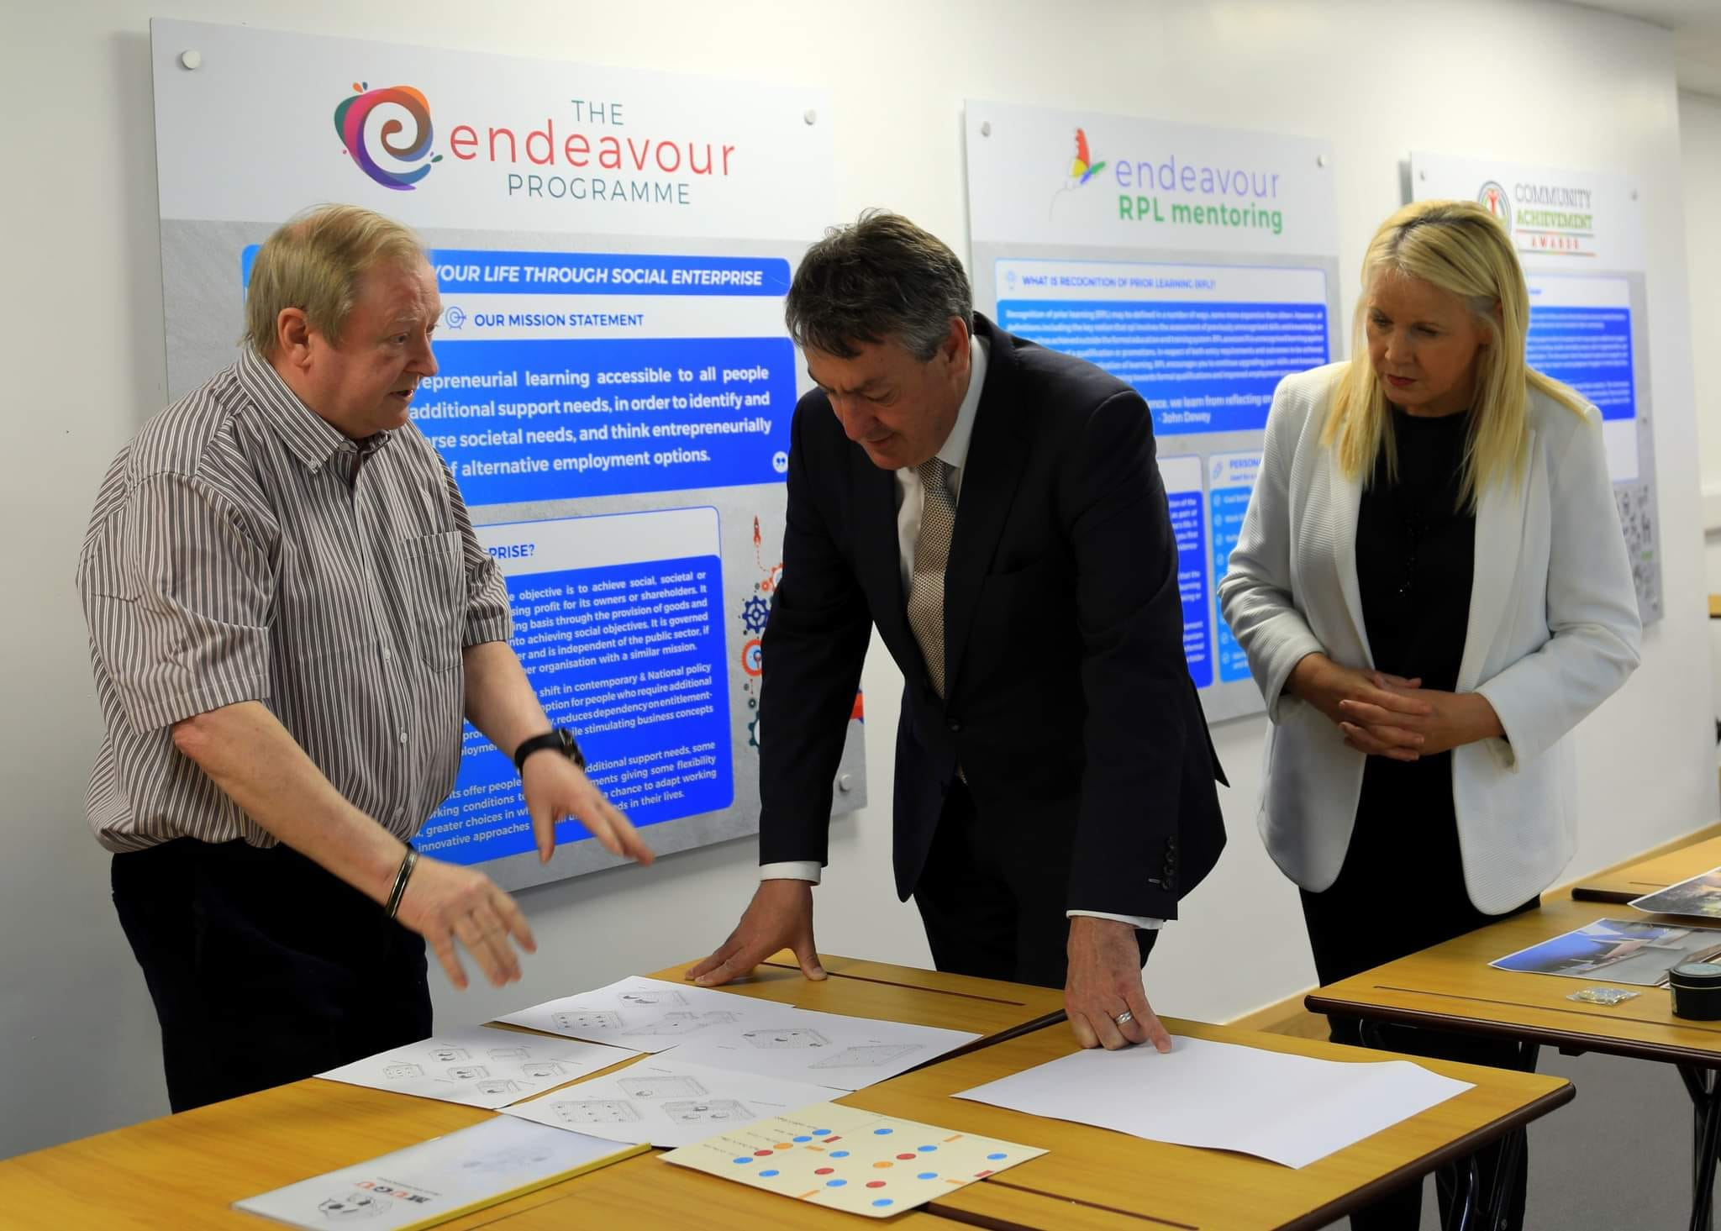
John Murphy explaining his Endeavour Programme to Billy Kelleher MEP and Jennifer Murnane O’Connor TD.
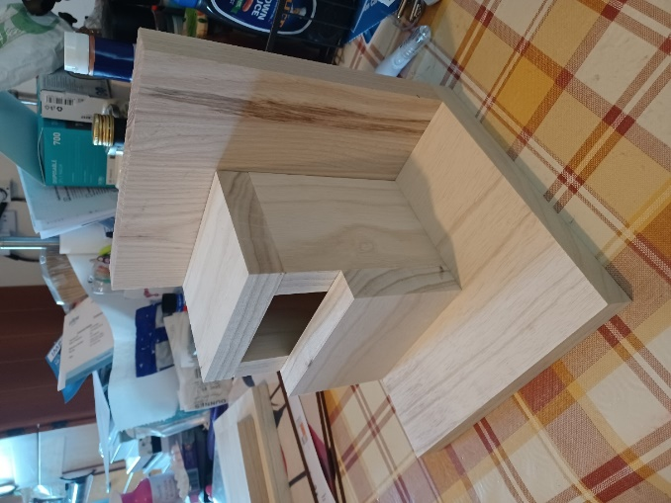
Bird Box

What is the Endeavour Programme?
The Endeavour programme provides opportunities for you to develop entrepreneurial knowledge and skills and how to use them effectively. It offers an opportunity to re-evaluate your working life by exploring your life-long learning through the development of a Recognition of Prior Learning (RPL) portfolio. It also puts forward alternative options to mainstream employment.
The aim of the programme is;
- To develop a range of skills and knowledge through the learning modules provided.
- To identify and recognise the value of the skills and experience you have gained through previous employment, family life, community, voluntary or leisure activities and key experiences and events in your life through the development of a Recognition of Prior Learning (RPL) portfolio.
- To develop a valuable work/life balance approach to daily living.
- To promote active citizenship and community inclusion.
- Develop interpersonal skills and a good understanding of your circle of support.
Endeavour Work Buddy
The one area of interest that came up again and again both genders was woodwork opinions ranged from, loving the texture and smell of the wood, to having great satisfaction making items in classes that they could either bring home or sell at craft days. While there should always be craft classes where participants can make items such as bird boxes etc.; unfortunately, such items are not of sufficient standard or quality to sell in large numbers to the general public, this almost ruled it out as a potential for a successful social enterprise development. Having managed services for over 40 years your author was only too aware of, and frustrated by, the lack of development in this area. Having worked for two years on the Endeavour programme a relevant and worthwhile enterprise workbook was produced, in addition two Endeavour work buddy templates were designed. These templates were designed to eliminate participants need for measuring or reading instructions. Over 32 various timber items can be made by using these templates, but more importantly the items can be repeated again and again and to the same standard for general sales to the public. All items are constructed from a single piece of timber or a combination of the two pieces. These pieces of timber are cut off site in bulk which reduces the risk associated with the use of saws and planers.
Prototypes have been made and presented at information sessions to various funding agencies and to political groups. This has resulted in the Irish Governments committee on Disabilities Matters requesting a further information session in October 2024. The County Carlow Development Partnership CLG have agreed to provide a premises and to fund the project on a two-year pilot scheme. The County Carlow Development CLG is part of the LEADER Initiative (Liaisons Entre Action de I’Economie Rurale) was established by the European Commission 1991. Focusing on the development of sustainable and smart communities, it has been highly successful across the European Union and in all rural - areas of Ireland, including Carlow County.
Its responsibilities and themes, Enterprise and Development and job creation, development of Rural Tourism, development of Rural Towns, social inclusion projects focusing on youth and disadvantaged geographical communities. He Carlow Leader Company is also responsible for the effective development and implementation of a SICAP Programme SICAP (Social Inclusion and Community Activation Programme) provides support to address poverty and social exclusion through local engagement and partnerships between disadvantaged individuals. Community organisations and public sector agencies. The delivery of a high impact SICAP programme is a key priority to social inclusion strategy.
This is a very exciting time for the Endeavour Programme with funding now available to further develop the project, including carrying out larger feasibility studies, business plans and more information sessions. This also eliminates the need for personal funding which was the case up to now. Opportunities for community employment of people with intellectual and developmental disabilities are limited, and have not improved over the past quarter century competitive and supported employment have not improved in 25 years. Endeavour Microenterprise offers an alternative that promises to be satisfying, meaningful, enjoyable, and may cost significantly less to implement than traditional sheltered workshops and adult day activity centres.
The Endeavour Work-book training modules and the Endeavour Work Buddy will inform and support ideas and suggestions from participants to consider setting up a Micro Social Enterprise, this could be the further development of a hobby or interest, and can be delivered from a central base or can be operated from a home base.
Assistive Technology can help people with intellectual disability overcome barriers towards independence and inclusion. Technology can compensate for a person’s functional limitations, people with intellectual disability should be introduced to assistive technology as early as possible. In general, AT devises should be available for use throughout the day and in natural settings, including home, school, services, work environments and recreation, there should be consistency in the kind of assistive technology available, how it is used, and the methods for instructing the user on operating the devises.
Transmitting from one devise to another should be made as smooth as possible by building on, and integrating previously learned skills.
Understanding how important assistive technology is in all our daily lives, I have developed an embryo of a design for a digital App which will help people develop a digital platform for the Endeavour Programme. I have arranged to meet tutors on a Digital Masters Programme at SETU (South East Technological University) to support us to bring it to fruition.
The benefits of such assistive technology to people with intellectual disability are enormous. The proposed completed App would provide:
- A step-by-step assembly imagery process for all the Endeavour Products.
- A simple template on how to cost each product, this template would be self-adjusted as new information is added.
- List and images of all materials used in the enterprise.
- Note taking facility.
- Reference supports
- A suitable digital platform to market the products.
- RPL (Recognition of Prior Learning) archive document to register all works completed, and when.
- The App has a facility to use the cloud for storage.
It is essential that the completed App is safe for people to use and has protection built into the process. Given the vulnerability of the client group it is essential that GDPR is at te centre of any App development. In addition, a survey is currently taking place with prospective participants in relation to their use of digital technology in general, what they use, how they use it and what they would like to have included on the proposed App when its completed.
Projected outcomes
- It will help to broaden participants knowledge and experience in the area of Entrepreneurial learning.
- Participants will gain new confidence and approach to life by the development of their evidenced based RPL Portfolio.
- Participants can, with support develop your idea/project around your current financial entitlements.
- Participants will develop a positive and realistic attitude towards self, work and life.
- Develop a knowledge of community and resources found within the local and wider community.
Social enterprise has the potential to provide training and jobs for the long-term unemployed and people with disabilities, and provides much-needed services in disadvantaged communities. Social enterprises are businesses. Like any other business, they seek to make a profit and succeed commercially. But how they operate, who they employ, how they use their profits and where they work is transforming lives and communities around the world it is particularly popular in, Australia, Canada and the UK.
Indeed, social enterprise now work in every sector of the irish economy, creating and trading consumer products and services, providing local community resources, running creative agencies, arts organisations, recycling projects, cafes and restaurants.
Trading for impact the National Social Enterprise Policy 2024 – 2027, was launched by Minister for Rural and Community Development Heather Humphreys TD on July 24th 2024.
The purpose of the policy is to help cultivate and sustain strong and impactful social enterprises in Ireland to enrich the social, environmental, and economic well-being of people living in our communities. The policy represents a strong commitment by Government to social enterprises and a recognition of their value and potential. The policy outlines five key objectives:
- Building awareness of Social Enterprise
- Growing and Sustaining Social Enterprise
- Supporting the Green Transition
- National and International Engagement
- Impact Measurement
In addition, the National Disability Authority (NDA) of Ireland advised that a concerted effort is required to address the persistent employment gap for persons with disabilities in Ireland. currently the employment rate of persons with disabilities in Ireland is about half of the rate for persons without disabilities – 36.5% vs 72.8% (aged 20 – 64) in 2016. Within the EU, Ireland has one of the largest disability employment gaps. However, among people with a disability who are employed, 14.8% are self-employed.
Unemployment rates the United Kingdom.
This is not only an Irish problem of high unemployment rated among adults with intellectual disabilities. Andrews and Rose (2010) reported that only 11% of adults with intellectual disabilities in the UK engage in employment, and those who are tend to be working part-time. In the US the current rate of integrated paid employment for adults with intellectual disabilities is less than 10% (Wehman et al. 2018).
Morgan and Alexander (2005) states that in their study the employer’s perception on employment of people with intellectual disabilities, they found that some employees said that hiring individuals with intellectual disabilities had distinct advantages. These include their dedication to work, consistent attendance, job coach assistance and reduced turnover within the workplace.
Unemployment rates Ireland.
The report of the Commission on the Status of People with Disabilities (1996) stated that: “The recommendation that persons with disability be granted equal status with all other citizens is a fundamental question of human rights. A society which respects human rights is richer in a way that cannot be measured on any balance sheet. Respect for such rights is a necessary condition for a society to be classified as wealth.
(Watson et al. 2017)

HSE Draft “New Directions” (2012).

The proposed new approach to adult day services charts new territory and has been titled New Directions. It envisages that all the supports available in communities will be mobilised so that people have the widest possible choices and options about how they live their lives and how they spend their time. It places a premium on making sure that being part of one’s local community is a real option. It recognises that people with severe and profound disabilities may need specialised support throughout their lives. The guiding principle for the future is that supports will be tailored to individual need and will be flexible, responsive and person-centred, containing 12 interim draft standards.
Barriers to Employment
Research shows employers attitudes differ when it comes to employing people with intellectual disabilities (Koeman et al. 2017). A lot of employers said that a big barrier for them not employing someone with an intellectual disability was that they didn’t think their literacy skills would be sufficient to do the job.
Another barrier for the employer hiring a person with intellectual disabilities was that the employer was concerned about the ability of the individual with intellectual disabilities to interact appropriately with customers and co-workers (Hernandez et al. 2000).
A barrier that was common throughout this research was that employers thought that if someone had an intellectual disability they presumed that they have a perceived lack of skills (Social, General etc.) (Koeman et al. 2017).
When the HSE initiated its National Review of HSE-funded Adult Services (2007) it was found that more than 4,000 with intellectual disability were in Sheltered Workshops, with some being paid as little as €5. Per week.
Research has identified a number of barriers for persons with developmental disabilities
hoping to enter the competitive labour market. These can be classified into two categories:
personal factors and environmental factors. As stated by Martz et al. (2009), some of the
personal factors that account for low employment rates, poor integration rates, or high job
breakdown are deficient workplace skills, lack of education, and need for assistive technology or
necessary accommodations. Additionally, Martz and colleagues discuss the possibility of
environmental factors, such as physical barriers, found either on the worksite or in the environment.

National Social Enterprise Policy for Ireland 2019 – 2022

Many definitions of social enterprise exist globally and a variety of organisational forms are adopted by social enterprises around the world. The definition also varies depending on geographical region and cultural backgrounds. Up to now there has no single accepted definition of social enterprise in an Irish context and this has created an inherent difficulty in measuring the prevalence and impact of social enterprises. In order to direct appropriate supports to where they are needed, and to develop metrics around the extent and impact of social enterprise, it is important to define what we mean when we refer to social enterprises in an Irish context. The national Social Enterprise policy for Ireland 2019 – 2022 defines social enterprises as follows:
- A Social Enterprise is an enterprise whose objective is to achieve a social, societal or environmental impact, rather than maximising profit for its owners or shareholders.
- It pursues its objectives by trading on an ongoing basis through the provision of goods and/or services, and by reinventing surpluses into achieving social objectives.
- It is governed in a fully accountable and transparent manner and is independent of the public sector. If dissolved, it should transfer its assets to another organisation with a similar mission.

Advantages of Social Enterprise for people with Intellectual Disability
- An increased focus on the vocational aspirations and the potential strengths of people with intellectual disability.
- Economic security, including stability of employment and the payment of a living wage.
- Social cohesion and social inclusion, nurturing and building on connections in and links to the wider community ie; person-to-person relationships, both in the work place, and those developed outside of work.
- Social and cultural empowerment, through policies and practices that intentionally leverage vocational opportunities to enable people to participate in society, have good health, life-long education, and support to exercise choice and self-determination at work and outside of work.
General Barriers to the Employee
- Education – many people with intellectual disability may not have literacy skills. As mentioned above a solution to this would be to support the service user in enhancing their literacy skills.
- Opportunity – employers prefer to employ people with any other disability over people with intellectual disabilities. Inclusive employment being unavailable to people with intellectual disabilities in many regions.
- Transport – staff shortages, accessibility to public transport, especially wheelchair access.
- Accessibility to public buildings. Many buildings are not accessible by wheelchair users or people with poor mobility.
General Barriers to Employer hiring someone with an Intellectual Disabilities.
- Research shows employers attitudes differ when it comes to employing people with intellectual disabilities (Koeman et al. 2017). A lot of employers said that a big barrier for them not employing someone with an intellectual disability was that they didn’t think their literacy skills would be sufficient to do the job.
- Another barrier for the employer hiring a person with intellectual disabilities was that the employer was concerned about the ability of the individual with intellectual disabilities to interact appropriately with customers and co-workers (Hernandez et al. 2000).
- A barrier that was common throughout this research was that employers thought that if someone had an intellectual disability, they presumed that they have a perceived lack of skills (Social, General etc.) (Koeman et al. 2017).
- Straightforward approaches that employers might use to facilitate hiring and retention of workers with intellectual disabilities, such as new public programmes or policy changes that could increase labour force participation amongst adults with intellectual disabilities (Kayes et al. 2011).

Focus Group Findings
In general people interviewed, expressed an interest in acquiring a job, however concerns were expressed as to the difficulties of accessing employment. These concerns ranged from, having a disability, to a feeling of inadequacy compared to other more educated applicants.
Concerns were also put forward about the content and structure of the current Rehabilitative Training (RT) programme. Some people felt it was outdated and too narrow in its focus. It was suggested that more time should be dedicated to doing projects, especially in the community. When it came to wanting a job, all participants said yes, yet only one person wanted a full-time job, the remainder of the group preferring to work 19 hours per week, so as not to lose their allowances (Disability Allowance).
The vast majority of the group expressed dissatisfaction with the transition support the received during their move from school to day services. Asked if they had a hobby or interest that they would like to further develop an active enterprise 65% said they would love to develop something around woodwork.
Advantages of Social Enterprise
An increased focus on the vocational aspirations and the potential (strengths) of people with disability (embedding a person-centred and career goal orientated approach to the provision of employment services).
• Opportunities to explore and move to, and between, higher skilled and better paid work.
• Opportunities to explore vocational options that have a relatively higher social value / status than those commonly inherent in ADEs and other forms of ‘sheltered employment’.
• Economic security, including stability of employment and the payment of a living wage (which can in turn contribute to opportunities for better health promotion, educational opportunities, and social opportunities)
• Social cohesion and social inclusion, nurturing and building on connections in and links to the wider community (i.e., person-to-person relationships, both in the work place, and those developed outside of work as a result of being a ‘worker in the community’) through work activities and the products produced.
• Social and cultural empowerment, through policies and practices that intentionally leverage vocational opportunities to enable people to participate in society, have good health, life-long education, and support to exercise choice and self-determination at work and outside of work.
Micro-Enterprises exist as small businesses, usually run by one or two people. Sometimes, family members help each other with employment opportunities through their micro-enterprise. Micro-enterprises provide people a chance to create their work opportunities for a living. The Endeavour Work-buddy template may also allow people to work from their home environment as independent self-employed individuals with the help of family members.

Micro Social Enterprise Pitch
Introduction

Name:____________________ Company:_____________________

Product Description:______________________________________________

________________________________________________________

________________________________________________________

How the need was identified:________________________________

________________________________________________________

Target Audience:__________________________________________

Benefits of Product / Service:________________________________

________________________________________________________

Cost of Product / Service:___________________________________

Future Projections:_________________________________________

While there is space in the work-book for learners to write notes and answers to the assignments, other means and methods may be used including:
Email, video recordings, Audio recording, USB, other documentation.
The modules in this book can be completed as a group or one by one

References:
- Andrews A. & Rose J. L. (2010) A preliminary investigation of factors affecting employment motivation in people with intellectual disabilities. Journal of Policy and practice in intellectual disabilities 7 (4), 239-244
- Bambra C. (2010). Yesterday once more. Unemployment and health in the 21st century. Journal of Epidemiology and Community Health 64. 213 – 215.
- Carew D. Birkin R. & Booth D. (2010) Employment, Policy and Social Inclusion. The Psychologist 23, 28, 30.
- Chadsey J. & Beyer S. (2001). Social relationships in the workplace. Mental Retardation and Developmental Disabilities 7. 128-133.
- Charity Awareness monitor (2004) The benefits of employing someone with a learning disability in your workplace.
- Dunn E.C. Wewiorski N.J. & Rogers E.S. (2008). The meaning and importance of employment to people in recovery from mental illness.
- Fortune N, Curryer B, , Badland H, Smith- Merry J, Devine A, Stancliffe R, Emerson E, Liewellyn G. Environmental Factors influence Employment for Disabilities (2022 July 26th).
- Government of Ireland (2015). Comprehensive Employment Strategy for People with Disabilities.
- Hemandez B. Keys C. & Balcazar F. (2000) Employment attitudes toward workers with disabilities and their ADA employment rights.
- Jahoda A. Kemp J. Riddell S. & Banks P. (2007)
- Kayes S.H. Jans H.L. & Jones E.C. (2011).
- Kober R. and Eggleton I.R (2005) The effects of different types of employment on quality of life.
- Koeman A. Fischer L. & Werbster G. (2017). The employers perspective on barriers and facilitators to employment of people with intellectual disability.
- Lukas J. Lizasoain L. Galarreta J. & Etxeberria J. (2018). Job satisfaction among disabled people in the sheltered workshop.
- McCarron M. Swinburne J. Burke E. EcGlinchey E. Mulryan N. Andrews V. Foran S. McCallion P. (2011). Growing Older with an Intellectual Disability in Ireland 2011.
- McGlinchey E. McCallion P. Burke E. Carroll R. & McCarron M. Exploring the issue of employment for adults with intellectual disability in Ireland 2013.
- Morgan R. L. & Alexander M. (2005). The employers perception: Employment of individuals with developmental disabilities.
- Nota L. Ginevra M. C. & Carrieri L. (2010). Career interests and self-efficacy beliefs among young adults with an intellectual disability.
- United Nations (2007) United Nations Convention on the Rights of Persons with Disabilities. Article 27, General Assembly.
- Watson D. Lawless M. & Maitre B. (2017). Employment Transitions among People with Disabilities in Ireland.
- Wehman P. Chan F.Ditchman N. & Kang H.J. (2014). Effect of supported employment on vocational rehabilitation outcomes of transition-age youth with intellectual and developmental disabilities.
- Wechman P. Taylor J. Brooke V. Avellone L. Whittenburg H. Ham W. Brooke A. M. & Carr S. (2018). Toward competitive employment for persons with intellectual disabilities and developmental disabilities.
- Abberley P. (1987), The Concept of Oppression and the development of a social theory of disability. Disability, Handicap Soc., 2 (1), pp. 5–19
- Barnes C., Mercer G., Shakespeare T. (1999), Exploring Disability: a Sociological Introduction, Cambridge, Polity Press.
- Carey, P. (1996), ‘Overcoming the barriers—Supporting employment opportunities’, paper presented at a NRB conference, Making the Most of Your Workforce: A Conference on Employment and Disability, Waterford, 31 May 1996.
- Chappell, Anne Louise, Goodley, Dan & Lawthom, Rebecca (2001), “Making Connections: the Relevance of the Social Model of Disability for People with Learning Difficulties,” British Journal of Learning Disabilities, June 2001, Volume 29, Issue 2, pp. 45–50
- Clark and Lillie (2000), “Growing Up With Disabilities: Education Law and the Transition to Adulthood,” Disability Studies Quarterly, Volume 20, No. 4
- Department of Health (1975), The Report of the Working Party of the Minister for Health, Training and Employing the Handicapped [The Robins’ report]
- Department of Social, Community and Family Affairs (2000), White Paper on a Framework for Supporting Voluntary Activity and for Developing the Relationship between the State and the Community and Voluntary sector.
- European Social Fund Programme Evaluation Unit (ESFPEU) (1996), Training for People with Disabilities, Summary Report.
- Smith P. McVilly K. McGillivray J. Chang J. Developing open employment outcomes for people with intellectual disability.

.

