

L04 – Proposal to launch a new machine and business model for Home Haemodialysis Therapy in Singapore
Submitted by: Ng Meng Liang, Karen
Total words: 5833

Acknowledgement
I feel incredibly grateful to my Managing Director, Mr Anbu Srinivasan, for providing valuable insights for this report. His leadership has been Top-notch throughout my career at Fresenius Medical Care, Singapore. I wouldn’t be able to learn and apply this report without sharing and learning from my colleagues: Ruby, Jong-Seop Lee, Stephanie, Monica, Marcus, Leon, Christie, Ming Li, Diana, Kathy, Eliel, Queenie, Ronald, Kok Hoong, Kim Han, Raihan, Rosanne, Willy, Chong Peng, Serina, Joyce Tan, Joyce Wong, Tracy, Charles, Suzie, Winnie, Zheng Hui, Bryan, Cheow Leng, Hock Soon, Shirlee, Jasmine, Dr Nandakumar, Kwun Ting, May Ling, Zheng Hui, Jeff, Shanker, Rashid, Alan, Cheng Siang, Kavin, Paul Kelly, Shirley Ng, Peter Eldridge Mertice, Fatin, Celina, Care Delivery Regional Head Mr Timothy, Raymond and Aaron.
My most profound appreciation to Dr Patrick Loh and Dr Steve Mallon for their guidance. Sincere appreciation to the Swiss School of Business Research Dean, Dr Stephen Harrison, for developing the PhD by Portfolio program. The framework of this program is easy to follow, with insightful latest articles, podcasts, literature to read/listen to and some exciting real-time case studies and sharing. The program is rewarding in my career as it can guide me to craft a well-thought-through strategic plan for my organisation in the next three years.
Lastly, Thanks to my dearest husband, HS Ong and daughter, Jade, for their patience and joy during this challenging period. I will not be able to embark on and enjoy this PhD journey without your support and encouragement.
Due to the confidentiality of the information, the report is purely for academic purposes and is not allowed for publishing or resending to any other parties except the acknowledgement page.

Table of Contents
Topic Page
Executive Summary……………….……………………………….…………….…….. 3
Chapter 1: The Need for Innovation in Dialysis Treatment in Singapore……...6
Chapter 2: Market Dynamics…………………..……………………….……………..9
2.1 PESTLE Analysis…………………………………………………………10
2.2 SWOT Analysis…………………………………………………………...13
Chapter 3: Introduction of NxStage Dialysis Machines; A Technological Marvel……………………………………………………………………………………….14
3.1 Competition………………………………………………………………16
3.2 Marketing Strategies…………………………………………………...21
3.3 Advantages and Benefits of NxStage Dialysis Machines….…….23
3.4 Unique Value Proposition (UVP)…………………………………….25
3.5 Marketing and Communication strategy…………………………….27
Chapter 4: Strategic Decision-making Plan……..…………………………………..28
Chapter 5: Strategic Plan……………………………………………………….……….28
Chapter 6: Potential challenges and reactions……………………………….……….29
Closing…………………….……………………………………………….………………32References…………………………………………………………………………………34Appendix……………………………………………………………………...……………44
- Executive Summary
Fresenius Medical Care (FMC) is a leading dialysis product manufacturer and service provider. The company contributes significantly to the healthcare industry by offering critical products and solutions for treating chronic kidney failure and acute kidney injury. This report proposes a new product and business model to create new growth opportunities for the Care Enablement business in Singapore. There are three businesses in the Care Enablement business unit: In-centre, Home Therapy and Critical Care. For many years, emphasis has been placed on growth in FMC's in-centre and critical care business. There is a need to change the product portfolio and focus on other growth opportunities. The home Therapy business in FMC has been stagnant and less profitable with the current product portfolio. For the past years, the strategic priority for the home therapy business has been to improve profitability as the cost of goods has risen over the years. The current products available are no longer competitive due to rapid technological changes. Home Therapy is dominated by one competitor with nearly 85% of the market share. There is a need for FMC to be the leader in all renal-related businesses and not just in the In-centre business. Therefore, the change proposed in this report will allow FMC to be competitive in the Home Therapy business segment. At the same time, capitalise on the current market situation where the government is exploring alternate home dialysis therapy. There is now an opportunity in the market due to increased interest in home therapy post-COVID from the Ministry of Health. Dialysis patients are immunocompromised, which may affect their health worse during a pandemic outbreak, addressing nursing shortages and high dialysis centres' operational cost challenges.
Home HD is common in countries like Australia, the United States, and Germany (Braden2019). There is an excellent opportunity for FMC SG to be the first mover in home HD therapy using the latest technology, NxStage. Research by McKinsey & Company shows that companies that innovate through the crisis by focusing on new growth outperform competition that is just reactive to the situation (Furstenthal, 2021). Innovation is vital to growth, as highlighted by Cathie Woods (YouTube,2019). Businesses should continuously look for gaps to grow. The strategy of Home Therapy to maintain business and improve margin needs to be reviewed. It is essential to launch Nxstage, which is a product that has a competitive advantage (Porter & Millar, 1985)
This report will highlight the market trend, analysis, marketing mix, and detailed launching plan to examine the potential impact on dialysis patient care in a home environment. PESTLE analysis tools, which are widely used in highly dynamic situations (Gupta,2013), were used to evaluate the business proposal. The renal landscape in Singapore will transform with the introduction of Nxstage dialysis machines, as the HD segment at home has been overlooked.

Chapter 1: The Need for Innovation in Dialysis Treatment in Singapore
Chronic Kidney Disease (CKD) has been progressing fast in Singapore since 2011 (Singapore Registry Data,2021). The leading cause of CKD is diabetes, and Singapore has one of the highest incidence rates of diabetes (Yoon,2022). Every two to three cases of CKD are diabetes-related, as reported by Diabetes Singapore (Refer to Appendix to Figure 1). The increasing ageing population of Singapore, with the proportion of people aged 60 and above, is expected to grow significantly in the next few years, and this will further add burden to the healthcare system. This situation will lead to increased medical expenses and productivity loss (Diabetes SG,2022). There are five stages of CKD, with the most severe CKD5 needing dialysis therapy. Currently, there are a total of 9000 patients on dialysis in Singapore (Singapore Registry Data,2021). Dialysis services can prolong lifespans and improve quality of life, and they are easily accessible in Singapore (One Health,2023). Two types of dialysis modalities are available in Singapore: Hemodialysis (HD) and Peritoneal Dialysis (PD) if transplantation is not the choice.
Hemodialysis (HD) involves removing wastewater products from the patient’s blood through dialysis machines. This procedure is usually performed at a dialysis centre or hospital. The patient has to undergo dialysis three times a week as prescribed by their Nephrologist, depending on their condition.
Peritoneal Dialysis (PD) removes waste products from the body using the peritoneum inside the abdomen as a filter (Healthgrades,2022). PD is performed at home, giving patients more flexibility and autonomy. However, not all patients are suitable for peritoneal dialysis, for example, obese, abdominal scarring and older patients.
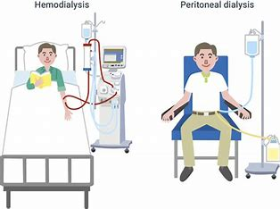
Figure 1. Comparison of HD and PD. Source: Internet
There are no differences in terms of mortality rate between HD and PD modality (Wong,2018). Hemodialysis is mostly done at centres in Voluntary Welfare organisations (62.6%), Private Dialysis Centres (35.3%) and hospitals (2.1%). Very few patients are doing hemodialysis at home due to higher cost, home space and self-cannulation (Chan,2018). Some patients opted for home therapy using PD due to work commitment and flexibility. Dialysis needs long-term treatment and commitment. The patients and caregivers will go through a lot of stress and frustrations over cost, pain, transportation, nursing care, food intake and lifestyle modification. Dialysis patients' concerns are cost, quality of life, and flexibility. Meanwhile, the main concerns of health care professionals (HCPs) are the effectiveness of the treatment, the risk of infection, and the overall quality of life for the patient. It has been proven clinically that frequent Haemodialysis treatment results in better clinical outcomes (Ouwendyk,2023). With home dialysis, patients can do their dialysis more frequently at their convenience (Rayment,2008). Studies have shown that home hemodialysis gives the patient a greater sense of autonomy and satisfaction (Perl, J., 2009). Although peritoneal dialysis is done at home, only 13% of the dialysis population is on PD (The Straits Times,2022). There are various reasons and factors causing the low uptake of home dialysis, such as local resources, higher cost, easy accessibility to dialysis centres in Singapore, fear of self-cannulation, a good transport system in Singapore, etc. Not all CKD patients are suitable for PD. Hence, there is a need to explore Home HD for patients who are not clinically suitable for PD but would like the flexibility and increased frequency.
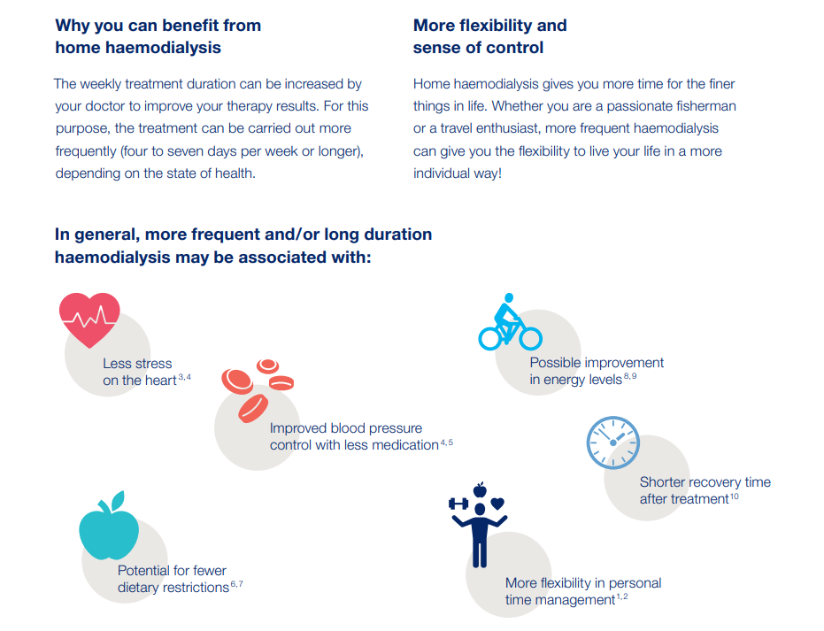 Figure 2. Benefits of home HD. Source: Internal.

Chapter 2: Market Dynamics
The home therapy market has been dominated by Baxter Healthcare, which uses the Home Choice Claria machines for the peritoneal dialysis modality (Baxter website). The total Home Therapy market is about SGD 20M. Home hemodialysis is costlier due to machine costs and involves home renovation for the use of the current HD machine. There is a need for a disruptive innovation for home therapy. Disruptive innovation is when the product offering is not only sophisticated but also accessible to more patients (Twin,2023). NxStage would be a new-market disruptor to both the HD and PD markets by offering a significantly better value/price ratio when compared to Home choice Claria (PD) provided by Baxter Healthcare, Sleep Safe Harmony (PD) provided by FMC and current HD machines. The introduction of NxStage will allow FMC to compete with Baxter, which is currently dominating 85% of the PD market share. NxStage offers a different technology from Home Choice Claria. The launch will increase FMC's market share of home therapy. The strategy is to increase Home dialysis by creating awareness and influencing policy change. Once the Nxstage enters the market and more demand is adopted, a disruption occurs ( Refer to Figure 2). The launch of NxStage will create a new market for Home HD dialysis, where HD is currently only available in hospitals and dialysis centres. Currently, very few rich dialysis patients can afford to do Home HD. According to Professor Clayton, disruptive innovation involves low-end footholds or new market footholds ( Christensen,2015). There are currently only two patients in Singapore who are doing Home HD, which is not significant in the market. The strategy of NxStage is to create new-market footholes to turn dialysis patients to do home dialysis. The plan is to open up the Home HD market instead of competing with Baxter in the PD home therapy market.
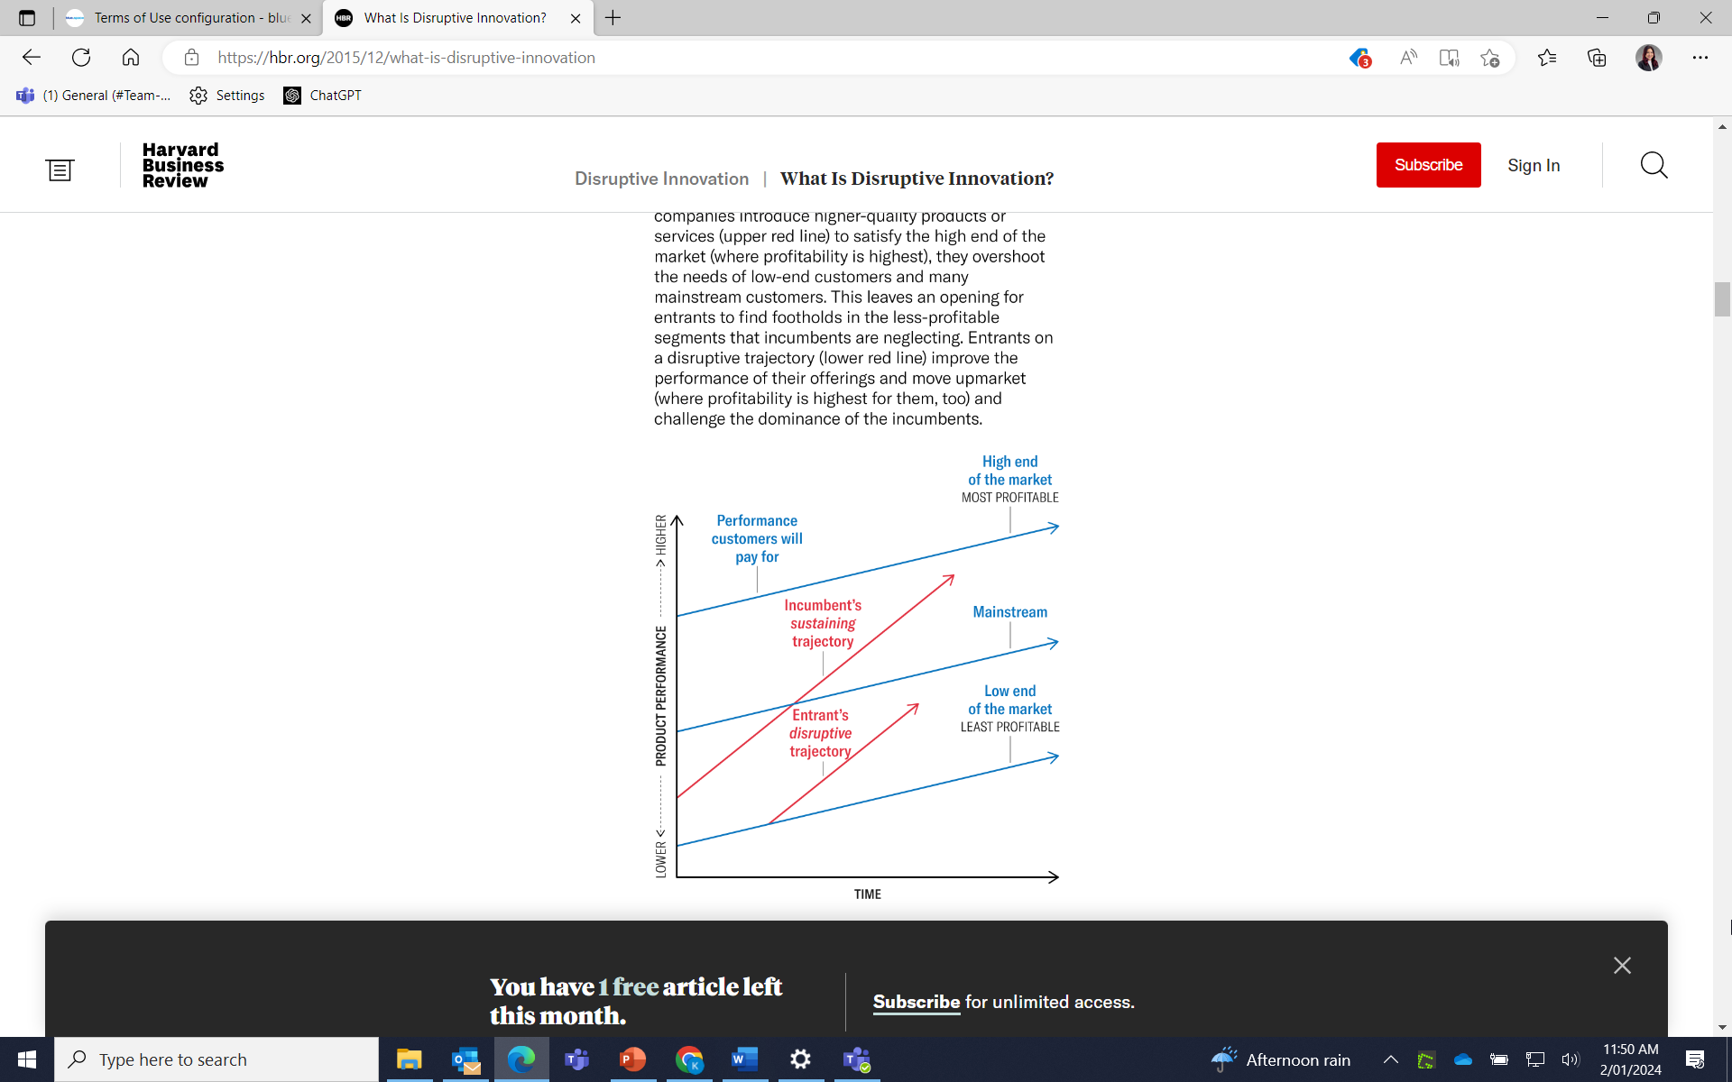
Figure 3. The Disruptive Innovation models. Source: Internet
2.1. PESTLE ANALYSIS
In this report, the PESTLE analysis of political, economic, social, technological, legal, and environmental factors was examined here to give an overview and ensure that the proposed launch plan is well thought through and planned. The PESTLE analysis provides a microeconomic overview and has been proven to be a great source for identifying opportunities and threats for an organisation (Alanzi,2018). In the current VUCA situation, organisations must be quick to recognise potential changes in the market industry in order to react more proactively compared to the competition. Leaders must be aware of the hyper-volatile, uncertain, complicated and ambiguous nature of the 21st century.
In the political factor, we explore the current government policy, analyse the direction of future policy, and identify potential initiatives that the government may initiate. Singapore’s healthcare system is ranked one of the best in the world (Jacobs,2020). Both the Public and Private healthcare providers are regulated by the government. An individual’s health care is funded partially by taxes, individual and employer contributions in the form of insurance and Central Provident Funds. Health care can be funded by Voluntary Welfare Organisations in some instances. It is essential for FMC to stay vigilant on policy changes and trends, i.e., to improve health, early education, concerns about the ageing population, and shortages in nursing manpower to anticipate threats and identify opportunities. We anticipated an interest in Home Dialysis learning from the COVID-19 pandemic. The incidence of respiratory infection and mortality rate is higher among dialysis patients. The same article shows that home dialysis reduces the risk of infections (Rostoker, 2021).
Kidney failure causes an economic burden, with a total spend of $300 million annually in dialysis treatment (NKF’s Key statistic,2022). Singapore’s National Health Expenditure is projected to increase from SGD22 billion in 2018 to SGD 59 billion in 2030 due to the ageing population (MOH,2022). Kidney dialysis is a long-term treatment. The option of organ transplantation is low as the waiting time for deceased donor kidney transplants is around 9.3 years (National Organ Transplant Unit,2021). FMC can use this information to analyse pricing.
Home HD allows more flexibility and frequency, which is more physiological compared to three times dialysis in the dialysis centres. Frequent dialysis is shown to have better clinical outcomes through improvement in the dialysis parameters (Karkar,2015). Despite the benefits of clinical outcomes, home HD uptake remains low due to higher costs, housing constraints, social isolation, self-care confidence level, and family burden (Young,2012). Family plays an important role in the decision to adopt dialysis modalities. In Singapore, most of the population stays in high-rise public housing due to scarcity of land. Home modification will be needed if a conventional HD machine is used. Therefore, there is a need for social disruption to shift behaviour through accepting HD dialysis at home (Furstenthal,2021).
Singapore is considered a high-technology market which values sophisticated machines. Providing innovative product features became a critical decision factor when switching to new products (Msaed et al., 2016; Al-kwifi & McNaughton, 2011; Pae & Hyun, 2006). The NxStage System One is the first and most precise portable haemodialysis machine regulated for home use in the United States (FMC Website). It is designed to be used in small houses and can be easily transported for travel. It is also imperative to invest in AI and technological tools to make quicker and more decisive decisions (Li, TED) (Module 1, assignment 2),
Singapore’s medical device registration is regulated under the Health Products Act (HPA) and Health Products (Medical Devices) Regulations 2010. The process of registration is six to eight months upon submission. The timing of the product launch will need to take into consideration the registration approval timing.
The environment is a key factor in choosing home dialysis. There must be a dedicated place for the machine to be placed, and the place must be kept clean to prevent infection. Based on a study by Singapore General Hospital (SGH), the environment was a key consideration in home dialysis in terms of cleanliness and sufficient space (Ang,2022). The patient also raised concerns about a support system. Literature has shown that consumers are more open to new innovative products during a turbulent market (Fraenkel, Haftor and Pashkevich, 2016).

2.2 SWOT Analysis
SWOT analysis was used to differentiate internal and external factors to identify opportunities and to protect from threats (Edwards, 2014.p167). A SWOT analysis helps identify potential roadblocks and mitigate risk (Morris,2023). FMC is a leading renal provider, and it is recognised as an expert in the field. This further strengthens their position as a trusted provider in the renal field. NxStage has the potential in the Singapore home HD space as it fills the current gap in home dialysis in terms of space constraints, flexibility, and frequent dialysis at the patient’s convenience, and it helps to relieve nursing manpower constraints. The launch of NxStage allows FMC to expand its product portfolio and penetrate the home therapy segment, which is close to 20M.
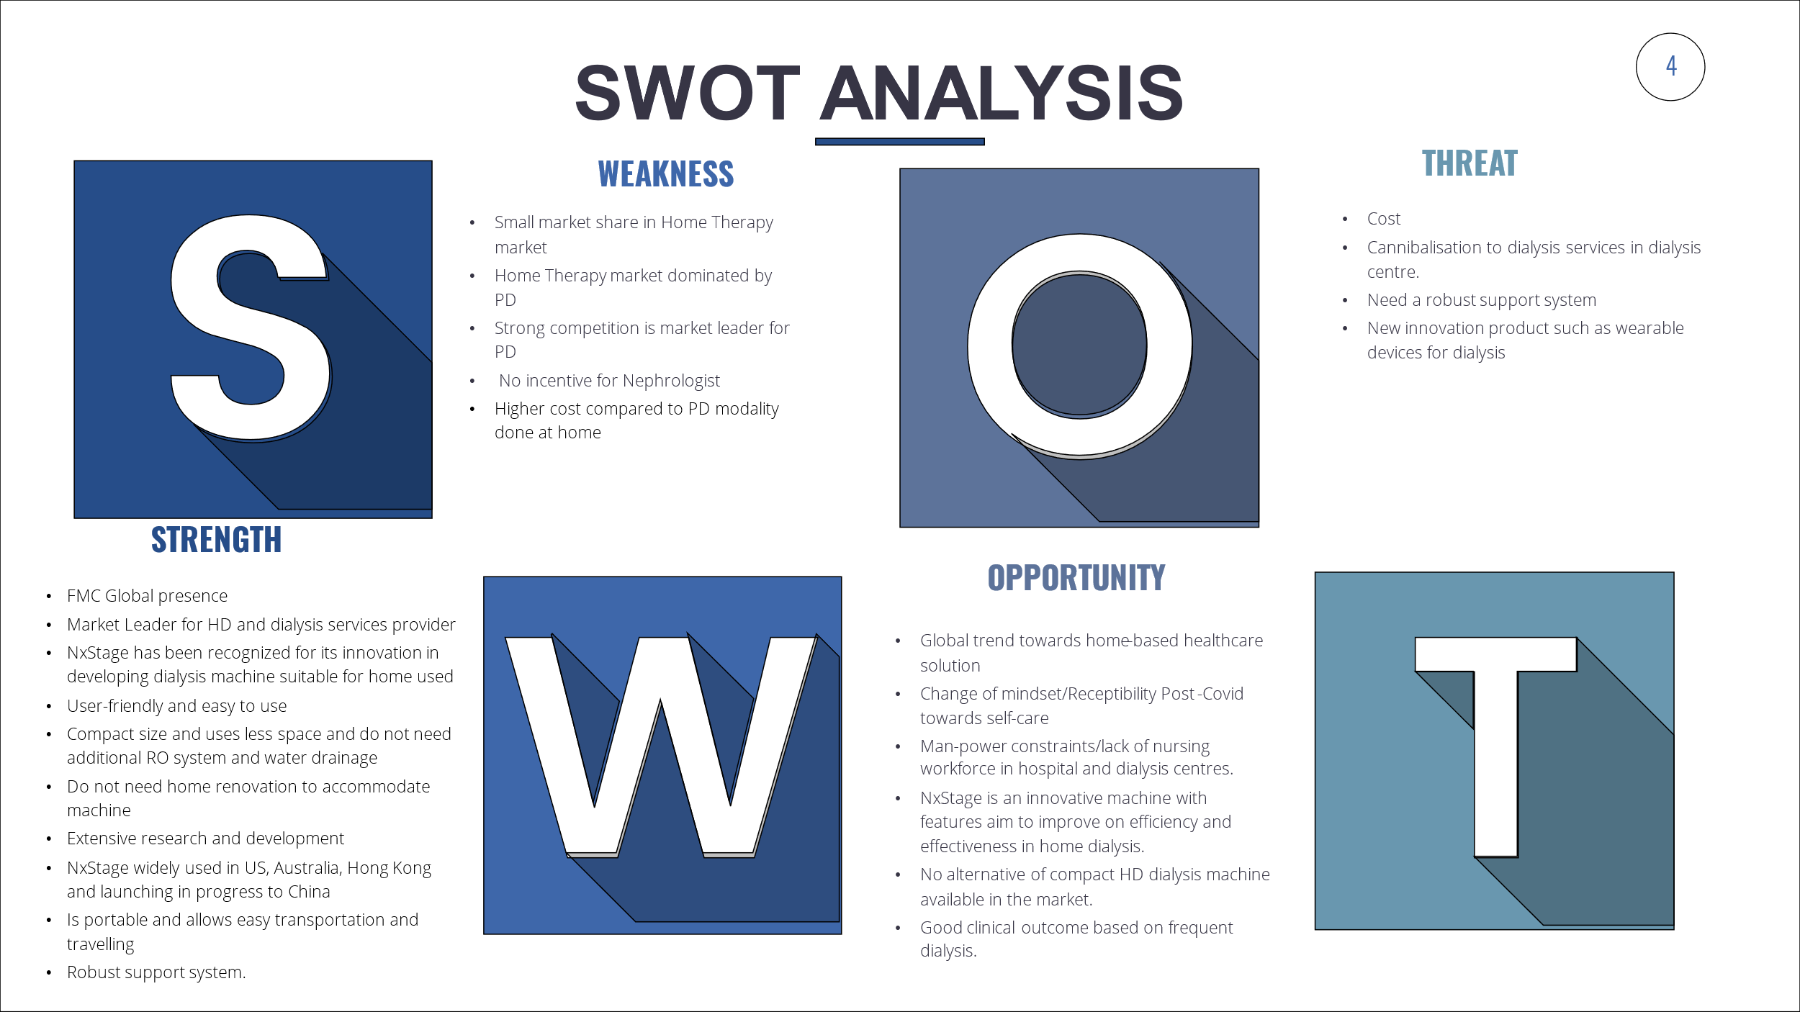
Figure 4. SWOT Analysis. Source: Internal

Based on the SGH survey (Ang,2022), the patients verbalised the importance of support. FMC already has a robust support system in place for their current PD patient. There is dedicated customer service and 24/7 clinical and technical support, which the patient can call if they face any issues/challenges during dialysis. Other support resources available include patient consultation and caregiver training (Refer to Appendix to Figures 2 and 3). As discussed in Module 1, FMC needs diversification to minimise over-dependence on the in-centre business, which may cause FMC to be vulnerable to changes in the market and advancements in alternative kidney therapy (Refer to Appendix to Figure 4).
Chapter 3: Introduction of NxStage Dialysis Machines – A Technological Marvel
FMC has a market share of 15% in the Home Therapy space. Disruptive change is when the market followers become the market leader by transforming the current home business to find new growth areas (Scotts, 2017). Disruptive change is not a terrifying situation and should be looked upon as an opportunity. The Home Therapy have been dominated by PD. Since the majority of the modality is HD, there is an opportunity for growth in Home HD. A survey by McKinsey & Company shows that 90% of the company’s executives believe that post-COVID will change the way businesses are conducted in the next five years and over 70% growth opportunities for the medical industries (Jordan,2020). Nxstage Home HD is designed to provide dialysis patients with simple and practical options to self-dialyse at home. Patients can take control of their dialysis treatment at their convenience, reduce travelling time to dialysis centres, and have a greater sense of achievement. Studies have also shown that frequent dialysis produces better outcomes compared to three times a week in the dialysis centre ((Ouwendyk & Pierratos, 2008; Perl & Chan, 2009; Rayment & Bonner, 2008).
The NxStage system comprises of a portable cycle with simple interface and easy to use cycler. The size of the machine is smaller and less than 80% of the current haemodialysis machine’s size. It can be dialysed anywhere due to its compact size. Unlike the current HD machine, the system can still operate during electricity and water source interruption. The system can use a compact generator and disposable pre-mixed solutions to dialyse.
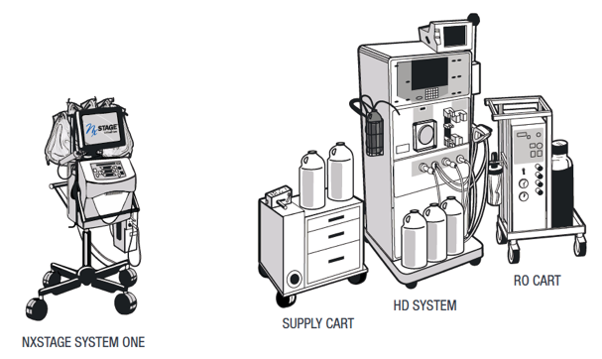
Figure 5. NxStage machine vs HD Machine

3.1 Marketing Strategies
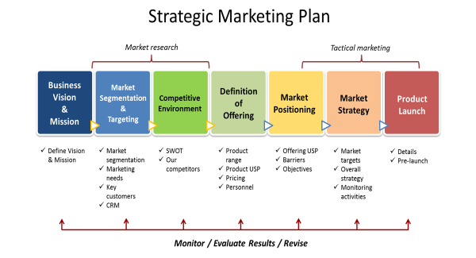
Figure 6. Strategic Marketing Plan. Source: Internal
As a first step for any marketer, a clear understanding of customer needs and market analysis were outlined (Kotler, 2017). Marketing strategy is discussed in this report to ensure that the target market positively influences the product demand in the long term. According to Kotller and Amstrong, a marketing mix is a set of tools that helps organisations accomplish their marketing objectives (7). Marketing Mix comprises marketing tactics/activities that the company does to fulfil the needs of the customers. There are seven elements in a marketing mix to ensure that customer’s needs are met in the short and long term (8).
Product
Peritoneal dialysis are the main modality in the Home Therapy segment. The market is dominated by the competition. In this report, a new product and business model are propose in order to race ahead of the competition. NxStage is a new invention using state of the art technology to provide a more flexible and clinically proven approach to offer home dialysis for patients in the long run.
People
Before the launch, there will be an elaborate discussion with HCP experts and researchers in the home HD fields ( Refer to Appendix to Figure 5&6). Interdisciplinary collaboration was used to instil creativity and solutions. Learning from the human-centred management concept, multi-stakeholder communications, and the interconnection of ethical, social, economic, and institutional factors was applied(Module L01, assignment 2). External experts from the National University of Hospital (NUH), Khoo Teck Phuat Hospital (KTPH), and internal colleagues are involved. NxStage will be launched in phases with the following targeted customers. This will ensure that the launch is a success, as it will require training to ensure the right techniques are applied and the right patients are selected. National University Hosptial and Khoo Teck Phuat Hospital as both Dr S, Dr A and Dr G ( Refer to Appendix to Figure7&8)had experience using NxStage when they both attached to Hammersmith Hospital in the UK and United Christian Hospital in Hong Kong. This report also emphasises the change management method, which looks at an outcome-driven approach where leaders are willing to disrupt the current ways and replace ways that do not work anymore. The Business Plan ( Refer to Appendix to Figure 9 ) was proposed, and Experts were introduced to Key Stakeholders within the FMC Home Therapy leaders to gain receptivity and support for this launch. Surveys were conducted internally on the feasibility test ( Refer to Appendix to Figure 10 ). A project team were set up comprising Sales, Marketing, Technical and Supply Chain team members. Every team member takes ownership and is accountable for their actions in order to succeed in the change. As shared by Li (TED), creating a culture of sharing builds strong networks.
Price
Pricing consideration is one of the important steps in the launch of a new product (Kotler, 2017. p 638). Usually, a price-penetrating strategy is frequently applied to new entrants (Christensen,2015). However, there are several factors to consider when setting the right pricing. Different strategies and approaches are applied to different types of innovation and industries (Christensen,2015). In the Medical industry, low prices may be perceived as lower quality and inferior effectiveness. Generally, dialysis costs are covered by insurance schemes such as MediShield Life, government subsidies, and out-of-pocket payments or funds from charitable organisations. Currently, the costs of PD, Home HD, and In-centre HD are very different. Finding the right cost without cannibalising the in-centre HD business and adding to the financial burden is crucial to this launch. According to (Gijsbrechts, 1993), developing the right pricing strategy is both critical and complicated. Various factors must be considered, such as the environment ((Diamantopoulos, 1991), customers (Tellis,1986) and pricing situation (Noble & Gruca,1999). A detailed plan and discussion were initiated between the finance and sales team to propose the right pricing to the market (Figure 6) and remain profitable for the business (Morris, 1987, p. 79).

Figure 7. Pricing calculation and analysis. $$$ intentionally shaded for this report. Source: Internal.

Promotion & Place
The Chartered Institute of Marketing (2009) defined a place as a location where it is convenient and feasible for customers to buy the products. NxStage is a medical device that can be prescribed by a nephrologist. It will only be distributed and delivered to the patient’s house upon prescription by a nephrologist in the hospital. Promotion of NxStage includes sales promotion of communication, product demonstration, workshops, and training for health care professionals. Promotion is a crucial process where accurate information is provided to the target audience so that they can make decisions (Daniel,2018.
Phase 1 Target: National University Hospital and Khoo Teck Phuat Hospital
Phase 2 Target: Singapore General Hospital
Process
The launch process has been determine as a successful driver within an organisation. Literature has shown link between management moitvation, internal cooperation, market orientation and successful product launch (Kuhn,2007). Therefore it is important to have both the management support and ground support in order to successfully launch NxStage.
In SSBR Module 2, L04, the importance of collaborative problem-solving and decision-making were studied and reported extensively as part of learning. The collaborative problem-solving framework by scholars (Cannon-Bowers et al., 2005) identifies eight core competencies: adaptability, shared understanding of the situation, performance review and sharing, leadership, interpersonal relations, coordination, communication, and decision-making. Another scholar (Cooke et al.,2000) includes the ability to mutually interpret cues, allocate resources and make compatible decisions as essential capabilities. Collaborative problem-solving and decision-making is a dynamic process. The skill of decision-making is vital and indispensable (Mather, 2006). The skill of decision-making plays a pivotal role in daily life, serving as a central aspect essential for adapting to the environment and achieving autonomy. It involves the capacity to select from among two or more options (Morelli, 2022). For the NxStage launch plan, there is an emphasis on collaboration and generating ideas for a successful launch plan among the project team members. Any potential challenges were discussed and outlined in a Problem-solving and decision-making framework. The process involves defining the problem by analysing, developing, and executing the plan with a long-term solution in mind through close monitoring and continuous improvement of the process.
Resources
As a leading provider of renal products in the industry, there is constant pressure to review product pipelines and anticipate any changes by challenging assumptions. Doing a reverse P&L exercise helps to anticipate any hurdle in carrying out the NxStage launch and the necessary revenue needed. This will help in resource-allocation decisions and determine that the launching of NxStage yields higher value and shows potential growth opportunities (Furstenthal,2021).
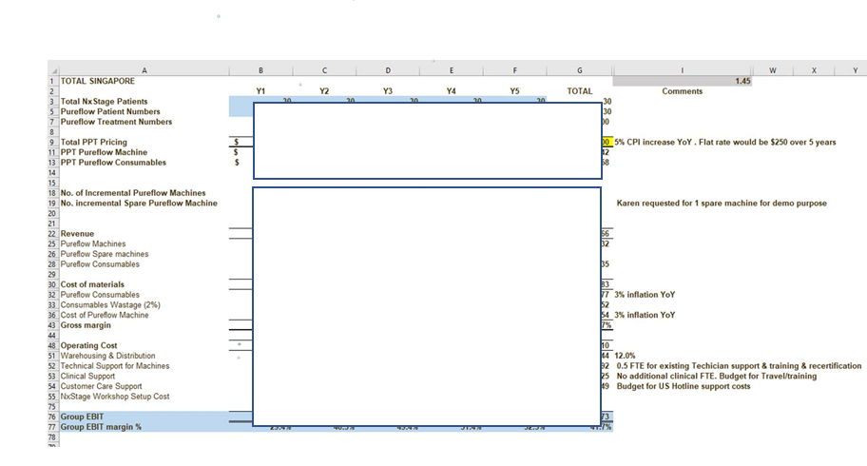
Figure 8. Pricing calculation and analysis. $$$ intentionally covered for this report. Source: Internal.
3.2 Competition
The home therapy market is dominated by Baxter, which offers Home Choice Claria for peritoneal dialysis patients. The total market is about 20M. It is a substantial market for a renal business. Not all patients are suitable for Peritoneal dialysis. NxStage will be targeting patients who are suitable to do hemodialysis in the home setting. There is potential competition for home HD in coming years, for example, NextKidney using sorbent technology ( Nextkidney,2022). NextKidney is currently doing a human trial and expects to launch its product in Europe in 2024. The machine is not FDA approved, and CE marked. FMC must decide to launch Nxstage in Singapore in order to gain the first mover advantage in this business (Lieberman & Montgomery, 1998).
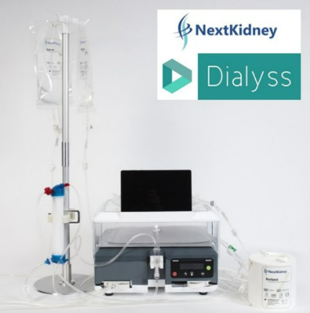
Figure . 9. Competition NextKidney. Source: Internet

3.3 Advantages and Benefits of NxStage Dialysis Machines
The COVID-19 pandemic has taken the world by surprise. Post-Covid challenges due to nursing shortages (Begum,2021), dialysis centres not designed for the pandemic (Khoo,2021), and increased cost of rental in Singapore have increased interest and discussion on Home HD by HCPs and policymakers in the Ministry of Health. The treatment areas in the dialysis centres are small and close to one another due to space constraints. To meet the increased interest and potential demand, dialysis providers must embrace new technologies and capture the growth opportunities. The launch of NxStage will help alleviate healthcare infrastructure challenges. In this chapter, the advantages, risks, and challenges of Home HD are outlined.
Advantages of Nxstage Dialysis Machine
- Enhanced flexibility for patients without following strict schedule in the dialysis centre.
- Improved quality of care
- Relieve the demand for new dialysis centres in a small country like Singapore.
- Reduce nursing workload.
- Literature have shown that frequent HD treatment have better clinical outcome (Ouwendyk & Pierratos, 2008; Perl & Chan, 2009; Rayment & Bonner, 2008)
- Patient can travel and improve family bonding.
Despite the advantages of Home HD, there are risks involved which includes:
- Infection
- Space constraints
- Clinical and Technical support
- Care giver Support
Challenges of Home HD
- Lack of incentives for Nephrologist
- Fear of self-cannulation
- High cost of compact machine and consumables
- Reimbursement framework and funding policy for Home HD is not in placed.
One of the key successes of Home HD is patient motivation (Bieber et al.,2021). Such behaviour can be further reinforced through patient education, appropriate counselling, and support from HCP and Nxstage machine providers. Fresenius can play an active role in training and supporting the patient by providing a 24/7 nurse hotline, technical support, and home visits. Fresenius can modify its business model by offering a mobile home HD service using an Nxstage machine and Nurse. The patient can activate the services through pre-booking as and when they want. This will solve the challenges of fear of self-canulation and occupying space and provide flexibility.
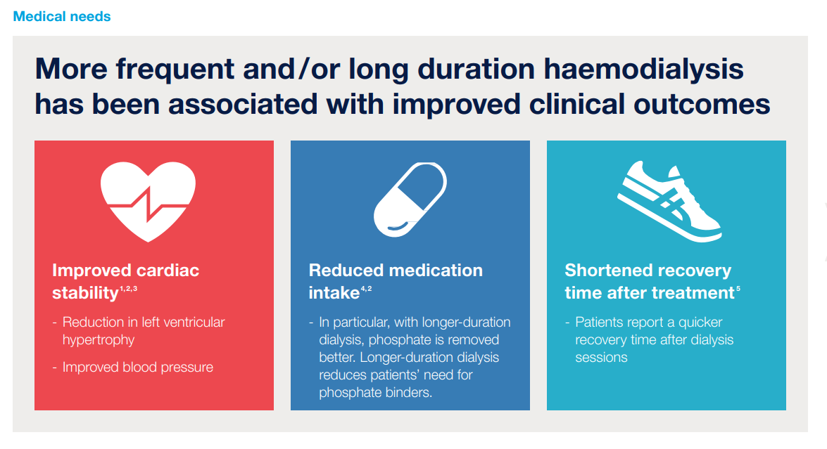
Figure 10. Clinical Outcomes Benefit. Source: Internal
3.4 Unique Value Proposition (UVP)
Based on the extensive understanding of the market and customers, a unique value proposition was developed. Kotler (2018) highlighted the importance of A unique value proposition (UVP), which is a statement that helps to differentiate Nxstage from the competition. It addresses the current pains the customer is experiencing by describing the benefit the patients can expect from Nxstage (Osterwalden et al., 2014). Crafting a compelling UVP further enhances Nxstage's superiority over the competition. NxStage helps improve treatment outcomes and gives patients more freedom to live their lives their way. Normally, haemodialysis patients have a fixed schedule with dialysis centres at the frequency of three times per week, and it might take six to eight hours per patient for a dialysis treatment per day, including travelling and/or waiting time. As a result, this frequency can prevent patients from working properly. With NxStage, patients can dialyse almost anywhere in their homes and at their convenience. This flexibility contributes to minimising the interruption of dialysis treatment in patients' daily lives.
In terms of economic benefits during dialysis treatment, applying NxStage into treatment for HHD patients could lead to significant cost-saving, while the financial burden brings a negative impact on the patient's well-being (Ng et al., 2021). Particularly, Helen and colleagues (2002) showed an annual saving of USD 9,159 for patients using self-care haemodialysis (USD 42,057) compared to patients treated with in-centre haemodialysis therapy (USD 51,252). Thus, using NxStage would be an optimal solution for dialysis patients with financial difficulties and help decrease the negative influence on their physical and mental health.
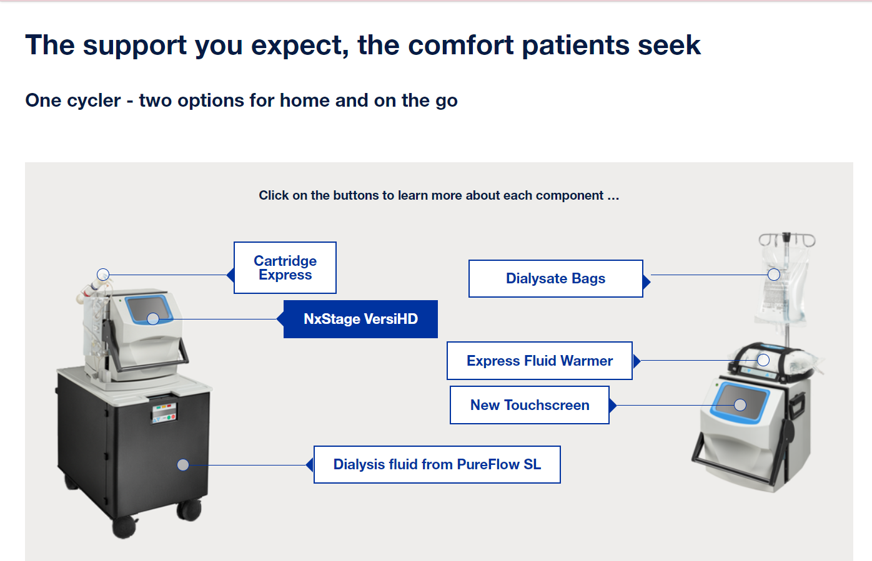
Figure 11. Nxstage offering. Source: Internal

3.5 Marketing and Communication strategy
A robust marketing and communication strategy is developed to create awareness and generate interest around the launch of Nxstage. Various marketing channels were used to reach the target audience. This will ensure long-lasting branding for Nxstage. This report focuses on an omnichannel approach of five marketing channels: social media marketing, events, customer engagement tools, content marketing, sales toolkit and KOL engagement. Because the utilisation of NxStage provides new conceptions of home therapy to HD patients, a broad range of events such as product launches, educational workshops or training sessions are necessary for target groups: nephrologists and HHD patients. Besides, equipping the sales team with essential knowledge and tools by applying the sales toolkit will establish a long-term foundation to promote NxStage to customers, especially nephrologists, to assign NxStage utilisation for patient treatment. Regarding Key Opinion Leader (KOL) engagement, setting up a network of advocates is important in a knowledge-based industry like healthcare. The recommendation from KOLs with an authoritative voice, such as the Head of the Nephrology Department in a national hospital, will help promote NxStage to other nephrologist colleagues in Singapore. With respect to online channels, applying digital marketing, including social media or email marketing in healthcare, would be an effective method to reach a large number of target audiences. According to Pasaribu et al. (2022), digital marketing in the healthcare industry has suffered from exponential growth due to the COVID-19 pandemic. Thus, digital marketing via social media and email/content marketing will help FMC reach out to more customers in the digital age.
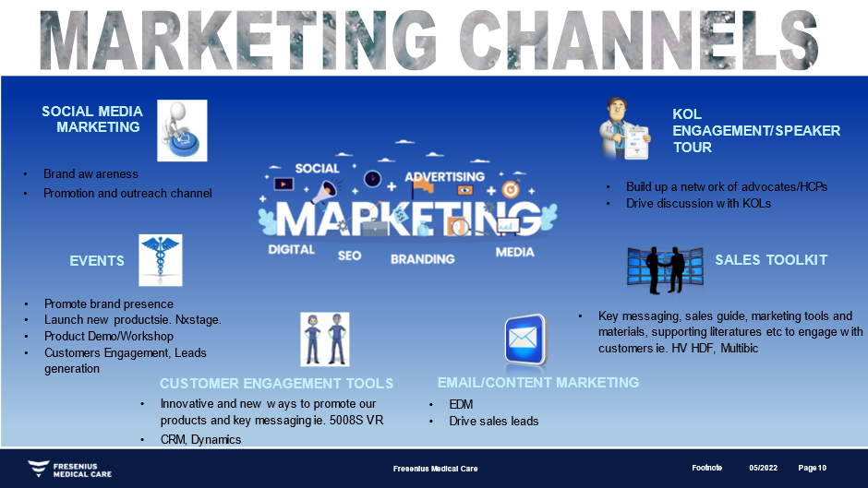
Figure 12. Marketing channels. Source: Internal
Chapter 4: Strategic Decision-making Plan
In strategic decisions, the leader must focus on key factors, which include people, resources, and competition, to meet the business goals (Mintzberg, 1976). These key factors are instrumental to the success of meeting the desired outcome. The decision to launch Nxstage is based on careful analysis of all the collected information. This is aligned with the decision-making process where analysis, evaluation, and best value for the desired goal are involved (Mcshane et al.,2015). The detailed process includes market analysis, capital spending, investment planning, and availability of other options (KuKalls,1991). Once the decision is approved, a strategy plan is outlined.
Chapter 5: Strategic Plan
A strategy plan is a roadmap to reach its goal. SSBR Module 1’s report focuses on the FMC business level strategy and operational strategies in the Singapore market, which is aligned with the corporate strategy goals. The operational strategies are the support level in terms of resources, processes, and people. Both the business strategy and operational strategy must be integrated to form a successful strategy (Johnson & Scholes,2008, p.11). Three key strategic priorities were outlined in the Module 1 report. One of the strategic priorities was to improve the profitability of the home therapy business (Refer to Appendix, Figure 11). The launch of NxStage will align with the key strategic priorities for the Home Therapy business.
Figure 12. Strategic Priorities for Home Therapy. Source: Internal
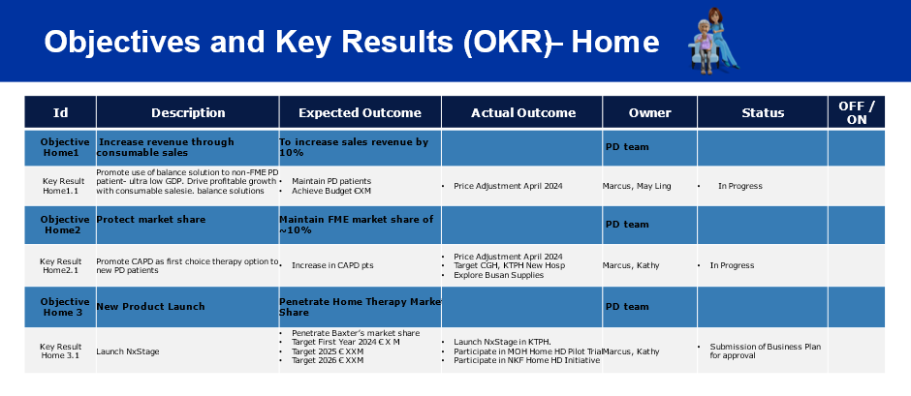
Figure 13. Key Objectives and Tracking Source: Internal
Chapter 6: Potential challenges and reactions
To achieve a competitive advantage, FMC must look to build capabilities within the organisation to ensure that there is consistency in performance. There must be investment in people, processes, and technology (McKinsey survey, 2023 report).
External
Healthcare challenges faced by caregivers are real, as they play an instrumental role in caring for and ensuring the quality of care for patients. A caregiver is responsible for the basic needs of the patient and assisting in the patient’s dialysis at home. Financial burdens, ill-equipped machines, and lack of knowledge are factors that contribute to the stress faced by caregivers (Mara,2023). In Fresenius Medical Care, there are dedicated trained nurses who can provide clinical and training support. This will address the challenges faced by caregivers and patients. Besides, FMC continuously improves and introduces technological innovations to make NxStage more user-friendly to patients. To be specific, in 2023, FMC launched the next generation of NxStage with GuideMe Software in some markets. This new software offers walk-through guidance to make the training experience become more simple for all types of new users, including patients and nurses.
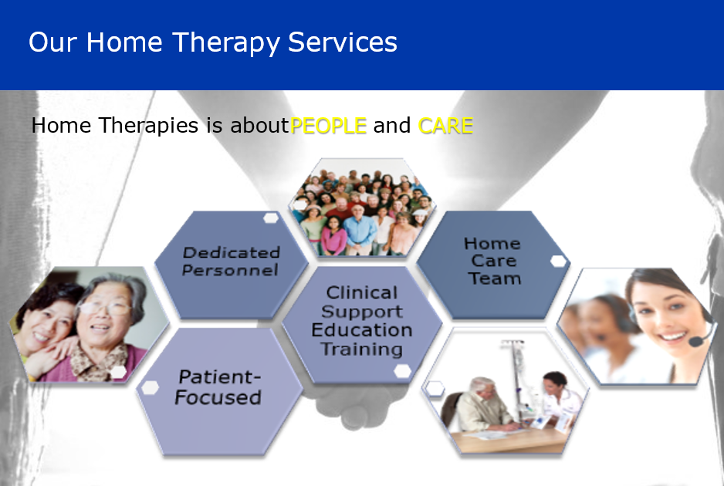
Figure 14. Home Therapy services. Source: Internal
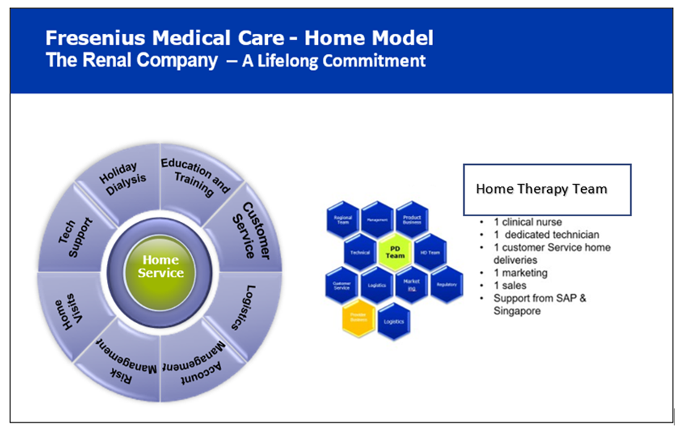
Home Therapy Team
Figure 15. Home Support Model. Source: Internal

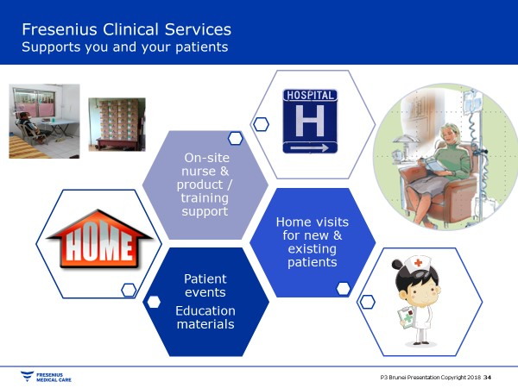
Figure 16. Type of Home Therapy services. Source: Internal
The launch of NxStage will address the challenges faced by the Ministry of Health in terms of Nursing and increase in Chronic Kidney Failure incidence. In the Minister of Health’s opening speech during the Internal Society for Peritoneal Dialysis Congress 2022 opening ceremony, he stresses on the improvement of disease management and explore home therapy as an option (MOH, 2022).
Internal
To launch NxStage in Singapore, a business plan proposal has to be forwarded to the Head of Home Therapy for approval. It is important to have extensive market research on the industry, current and anticipated trend to propose a business plan which is sustainable and profitable for the business. NxStage is considered a strategic launch as it is using technology and innovation to move into new markets in the Home Therapy segment (Erik, 2000).
Closing
As we face economic instability, most organisations, and in this report, FMC, look for new businesses as strategic priorities to accelerate growth. This report focuses on deep analysis and potential pitfalls to make sure the launch plan is successful. NxStage may not be a disruptive innovation in countries like Australia and the United States, as Home HD is common in those countries due to their geographical size. In Singapore, the small size of the country and the accessibility to dialysis centres make Home HD not a popular choice. However, since the pandemic, we have experienced challenges in dialysis centres where the design is not suitable for the pandemic due to the small size of dialysis centres. Singapore is experiencing a shortage supply of nurses and an increased incidence of chronic kidney disease. Based on MOH guidelines for setting up a dialysis centre, it is mandatory for a dialysis centre to fulfil a 1:5 Nurse-to-patient ratio. The launch of NxStage may change the renal landscape of Singapore by creating more awareness and patients opting to do dialysis at home.

References
- Alanzi Salem. Pestle Analysis Introduction. Available at: (PDF) Pestle Analysis Introduction (researchgate.net). Accessed by September 2018.
- Al-kwifi, O.S. and McNaughton, R. (2011), “A model of brand switching by lead users of high- tech capital equipment”, International Journal of Technology Marketing, Vol. 6 No. 3, pp. 194-212. Accessed by 23rd November 2011.
- Ang, Y.T.I., Gan, S.W.S., Liow, C.H. et al. Patients’ perspectives of home and self-assist haemodialysis and factors influencing dialysis choices in Singapore. Ren Replace Ther 8, 42 (2022). https://doi.org/10.1186/s41100-022-00430-7. Accessed by 3rd September 2022.
- Baxter Healthcare website. Available at: https://renalcare.baxter.com/products/homechoice-claria
- Begum Shabana. The Straits Times. Singapore needs more nurses amid Covid-19 pandemic and ageing population. Available at: Singapore needs more nurses amid Covid-19 pandemic and ageing population | The Straits Times. Accessed by 1st August 2021.
- Bieber Scotts D, Bessie A Young, Home Hemodialysis: Core Curriculum 2021. American Journal of Kidney Diseases. Available at: DOI:https://doi.org/10.1053/j.ajkd.2021.01.025. Accessed by 11th September 2021.
- Cathie Woods. Disruptive Innovation: Five big ideas of 2022. Available at: https://www.youtube.com/watch?v=J1YMQGrgiog&list=PL0m0_5gLPdW3dTp5kcAwijPqVp8Go71Gz&index=1. Accessed by August 2019.
- Chan Christopher. Exploring Barriers and Potential Solutions in Home Dialysis: An NKF-KDOQI Conference Outcomes Report. Am.J.Kidney Dis Available at: https://pubmed.ncbi.nlm.nih.gov/30545707/. ( Accessed at: 10th Dec 2018)
- Cannon-Bowers, J. A., Tannenbaum, S.I., Salas, E., & Volpe, C. E. Defining competencies and establishing team training requirements. Team Effectiveness and Decision making in organisations, pp.333, 380. 1995
- Cooke, P., Boekholt, P., & Tödtling, F. (2000). The governance of innovation in Europe: Regional perspectives on global competitiveness. London: Pinter.
- Daniel, C. O. Effect of Marketing Strategies on Organizational Performance.
International Journal of Business Marketing and Management (IJBMM) Volume 3. Issue 9, 1-9. Accessed by 2018.
- Edmondson Amy.C. Jean-François Harvey, Cross-boundary teaming for innovation: Integrating research on teams and knowledge in organizations,Human Resource Management Review,Volume 28, Issue 4,2018,Pages 347-360, ISSN 1053-4822,https://doi.org/10.1016/j.hrmr.2017.03.002.
- Edwards Janice, Mastering Strategic Management- 1st Canadian Edition. Chapter 4. pp.131-132,167
- Erik Jan Hultink, Susan Hart, Henry S.J Robben, Abbie Griffin,Launch decisions and new product success: an empirical comparison of consumer and industrial products, Journal of Product Innovation Management, Volume 17, Issue 1, 2000, Pages 5-23, ISSN 0737-6782, Available at: https://doi.org/10.1016/S0737-6782(99)000272. Accessed by 1st January 2000.
- Fraenkel, Stefan et al. “Salesforce management factors for successful new product launch.” Journal of Business Research 69 (2016): 5053-5058.Accessed by 1st February 2016.
- Furstenthal Laura, Martin Hirt, and Erik Rot.Mckinsey&company. Innovation: Your launchpad out of the COVID-19 crisis. Available at: https://www.mckinsey.com/capabilities/strategy-and-corporate-finance/our-insights/innovation-your-launchpad-out-of-the-covid-19-crisis. Accessed by: 18th March 2021.
- FMC Website. Available at: System One Portable Hemodialysis Machine | NxStage
- Gijsbrechts, E. Prices and pricing research in consumer marketing: Some recent developments. International Journal of Research in Marketing, 10(2), 115–151Diamantopoulos, D. Pricing: Theory and evidence—a literature review. In M. J. Baker (Ed.), Perspectives on Marketing Management (pp. 61–193). Chichester: John Wiley & Son. Accessed by 1993.
- Gupta, A. (2013). Environment & PEST Analysis: An Approach to External Business Environment. International Journal of Modern Social Sciences, 2, 34-43.
- Healthgrades. Peritoneal Dialysis: Preparation, Procedure, and Results. https://cms.prod.content.healthgrades.com/right-care/tests-and-procedures/peritoneal-dialysis. Accessed by 12th July 2022.
- Helen Lee, Braden Manns, Ken Taub, William A. Ghali, Stafford Dean, David Johnson, Cam Donaldson. Cost analysis of ongoing care of patients with end-stage renal disease: The impact of dialysis modality and dialysis access,
American Journal of Kidney Diseases, Volume 40, Issue 3, 2002, Pages 611-622, ISSN 0272-6386. https://doi.org/10.1053/ajkd.2002.34924.
- Home Haemodialysis: Core Curriculum 2021
- Jacobs Jantra, Commentary from Blog. Pacific Prime CXA.How does Singapore’s healthcare system work. Available at: https://www.mckinsey.com/featured-insights/leadership/the-ceo-moment-leadership-for-a-new-era. Accessed by 21st July 2020
- Jordan Bar Am, Mckinsey & Company. Innovation in a crisis: Why it is more critical than ever. Available at: https://www.mckinsey.com/capabilities/strategy-and-corporate-finance/our-insights/innovation-in-a-crisis-why-it-is-more-critical-than-ever. Accessed by 17th July 2020.
- Karkar A, Hegbrant J, Strippoli GFM. Benefits and implementation of home hemodialysis: a narrative review. Saudi J Kidney Dis Transplant. 2015;26(6):1095.
- Key Statistics – The National Kidney Foundation (NKF) Singapore (nkfs.org)
- Khoo, B.Z., See, Y.P., Koh, T.J., & Yeo, S.C. (2020). Coronavirus Disease 2019 (COVID-19) and Dialysis: The Experience in Singapore. Kidney Medicine, 2, 381 - 384.
- Kotler, P.,Armstrong, G.M., (2010). Principles of Marketing. 13 th Global) Edition. Pearson Education, Inc., Boston.
- Kotler, P.,Armstrong, G.M., (2017). Principles of Marketing. 17 th Global) Edition. Pearson Education, Inc., Boston.pp 30.
- Kraus M, Finkelstein FO, Daoui R, et al. Short Daily Hemodialysis (SDHD) improves overall Quality of Life (QOL) and physicial intimacy: interim results from the FREEDOM study. Abstract presented at the American Society of Nephrology Conference, 2011.
- Khan BA, Singh T, Ng ALC, Teo RZC. Health economics of kidney replacement therapy in Singapore: Taking stock and looking ahead. Ann Acad Med Singap. 2022 Apr;51(4):236-240. PMID: 35506407.
- KUHN, Jutta. Launch of new Products. 1st Edition. Available at: https://doi.org/10.1007/978-3-8350-9643. Published 3rd December 2007.
- Li Charlene, TED
- Lieberman, M. B., D. B. Montgomery (1988). First-mover Advantages. Strategic Management Journal, 9(1), 41-58.
- Mara, Teknologi & Buloh, Sungai & Selangor, Malaysia & Omar, Aminda & Mokhtar, Ilham & Ahmad, Mas. (2023). Challenges in Healthcare Management of Individuals with Special Needs in Malaysia: Perceptions of Caregivers. Journal of International Society of Preventive & Community Dentistry. 13. 10.4103/jispcd.JISPCD_234_22.
- Margarita Išoraite "7 P Marketing Mix Literature Review" Published in International Journal of Trend in Scientific Research and Development (ijtsrd), ISSN: 2456- 6470, Volume-5 | Issue-6, October 2021, pp.1586-1591, URL: www.ijtsrd.com/papers/ijtsrd47665.pdf
- Mather, M. (2006). A Review of Decision-Making Processes: Weighing the Risks and Benefits of Aging. In L. L. Carstensen & C. R. Hartel (Eds.), When I'm 64 (pp. 145–173). The National Academies Press.
- Mckinsey & Company. The state of organisations 2023: Ten shifts transforming organisation. Available at: The State of Organizations in 2023 | McKinsey. Accessed by 26th April 2023.
- Ministry of Health (MOH). Projected annual healthcare spending for next decade.Available at: https://www.moh.gov.sg/news-highlights/details/projected-annual-healthcare-spending-for-next-decade/. Accessed by 14th February 2022.
- Mintzberg H. (1979). The Structuring of Organizations: A Synthesis of the Research. Englewood Cliffs, N.J., Prentice-Hall.
- Mcshane and Von-Glinow (2015). Organizational Behavior: Emerging Knowledge and Global Reality (7th Ed). Mcgraw Hill Education: Asia
- Msaed, C., Al-kwifi O.S. and Ahmed, Z.U. (2016), “Building a comprehensive model to investigate factors behind switching intention of high technology products”, Journal of Product investigate factors behind switching intention of high technology products”, Journal of Product and Brand Management, Vol. 26 No. 2, pp. 102-119. Accessed by April 2017.
- MOH. Speech by Mr Ong Ye Kung, Minister For Health, at the 19th International Society For Peritoneal Dialysis Congress 2022 Opening Ceremony. Available at: https://www.moh.gov.sg/news-highlights/details/speech-by-mr-ong-ye-kung-minister-for-health-at-the-19th-international-society-for-peritoneal-dialysis-congress-2022-opening-ceremony. Accessed by 11th August 2022.
- Morelli, M., Casagrande, M. & Forte, G. Decision Making: a Theoretical Review. Integr. psych. behav. 56, 609–629 (2022). https://doi.org/10.1007/s12124-021-09669-x
Morris, M. H. (1987). Separate prices as a marketing tool. Industrial Marketing Management,
16(2), 79–86
- Morris, M. H. Separate prices as a marketing tool. Industrial Marketing Management, 16(2), pp.79–86, Accessed by 1987.
- National Organ Transplant Unit. Live On Resources, 30 June 2021. Available at: https://www.liveon.gov.sg/docs/info_booklets/LiveOn_stats.pdf. Accessed on 13 December 2021
- Nextkidney. Available at: Made In Singapore: Local Science And Tech Companies To Watch - Nextkidney. Accessed by 21th October 2022.
- Ng MSN, Chan DNS, Cheng Q, Miaskowski C, So WKW. Association between Financial Hardship and Symptom Burden in Patients Receiving Maintenance Dialysis: A Systematic Review. Int J Environ Res Public Health. 2021 Sep 10;18(18):9541. doi: 10.3390/ijerph18189541. PMID: 34574463; PMCID: PMC8464840.
- Noble, P. M., & Gruca, T. S. Industrial pricing: Theory and managerial practice. Marketing Science, 18(3), 435–454. Accessed by 1999.
- One Health. Dialysis: A life-saving treatment for kidney disease in Singapore. One Health. Available at: Dialysis in Singapore: Advantages, Costs, and Treatment Options (onehealth.sg). 27th May 2023.
- Ouwendyk, M., & Pierratos, A. (2008). Reflecting on 14 years ofnocturnal hemodialysis in Canada. CANNT Journal, 18(3),55-57.
- Osterwalder, A., Pigneur, Y., Bernarda, G., & Smith, A. (2014). Value Proposition Design: How to Create Products and Services Customers Want. John Wiley & Sons. pp 277.
- Pae, J.H. and Hyun, J.S. (2006), “Technology advancement strategy on patronage decisions: The role of switching costs in high-technology markets”, The International Journal of Management Sciences, Vol. 34 No. 1, pp. 19-27. Accessed by January 2006.
- Perl, J., & Chan, C. T. (2009). Home hemodialysis, daily hemodialysis, and nocturnal hemodialysis: Core curriculum 2009. American Journal ofKidney Diseases, 54, 11711184. doi:10.1053/j.ajkd.2009.06.038
- Rayment, G. A., & Bonner, A. (2008). Daily dialysis: Exploring the impact for patients and nurses. International Journal ofNursing Practice, 14,221-227. doi:l0.llll/j.1440172X.2008.00690.
- Rostoker Guy et al. Why and how should we promote home dialysis for patients with end-stage kidney disease during and after the coronavirus 2019 disease pandemic? A French perspective. J Nephrol. 2021; 34(4): 985–989. doi: 10.1007/s40620-021-01061-7. Accessed by 1st June 2021.
- SB, Novitasari D, Goestjahjanti FS, Hendratono T. The impact and challenges of digital marketing in the health care industry during the digital era and the COVID-19 pandemic. Front Public Health. 2022 Jul 28;10:969523. doi: 10.3389/fpubh.2022.969523. PMID: 35968423; PMCID: PMC9366108.
- Scott Anthony. HBR IdeaCast / Episode 572. To Reinvent Your Firm, Do Two Things at the Same Time. Accessed by Apr 13, 2017
- Singapore Renal Registry Annual Report 2021. Available at: srr-annual-report-2021.pdf (nrdo.gov.sg)
- Singapore Wikipedia. Available at: Singapore - Wikipedia. Updated 2023.
- SONG, L. Z., SONG, M. and DI BENEDETTO, C. A. Resources, supplier investment, product launch advantages, and rst product performance. Journal of Operations Management, 29(1): 86–104. Accessed by 28th February 2012.
- Tellis, G. J. (1986). Beyond the many faces of price: An integration of pricing strategies. Journal of Marketing, 50(4), 146–160. Accessed by 1986.
- The Straits Times. Home dialysis is gentler, more convenient but take-up rate relatively low | C3A. Published on 24th May 2022.
- The Singapore demographics of diabetes. Available at: The Singapore demographics of Diabetes - Diabetes SG. Accessed by 12th January 2022.
- Twins Alexandra. Disruptive Innovation meaning and examples. Investopedia. Available at: Disruptive Innovation: Meaning and Examples (investopedia.com). Accessed by 28th June 2023.
- What is PESTLE Analysis? An Important Business Analysis Tool
- Weinhandl ED, Nieman KM, Gilbertson DT, Collins AJ. Hospitalization in daily home hemodialysis and matched thrice-weekly in-center hemodialysis patients. Am J Kidney Dis. 2015;65(1):98-108.
- Weinhandl ED, Lie J, Gilbertson DT, Arneson TJ, Collins AJ. Survival in daily home hemodialysis and matched thrice-weekly in-center hemodialysis patients. J Am Soc Nephrol. 2012;23(5):895-904.
- Wong B, Ravani P, Oliver MJ, Holroyd-Leduc J, Venturato L, Garg AX, et al. Comparison of patient survival between hemodialysis and peritoneal dialysis among patients eligible for both modalities. Am J Kidney Dis. 2018 Mar;71(3):344–351.
- Wong LY, Liew AST, Weng WT, et al. Projecting the burden of chronic kidney disease in a developed country and its implications on public health. Int J Nephrol 2018;2018:5196285.
- Young BA, Chan C, Blagg C, Lockridge R, Golper T, Finkelstein F, et al. How to overcome barriers and establish a successful home HD program. Clin J Am Soc Nephrol. 2012;7(12):2023–32.
- Yoon, Sungwon, et al. "Personal Goals, Barriers to Self-Management and Desired MHealth Application Features to Improve Self-Care in Multi-Ethnic Asian Patients with Type 2 Diabetes: A Qualitative Study." International Journal of Environmental Research and Public Health, vol. 19, no. 22, 2022, p. 15415.

Appendix
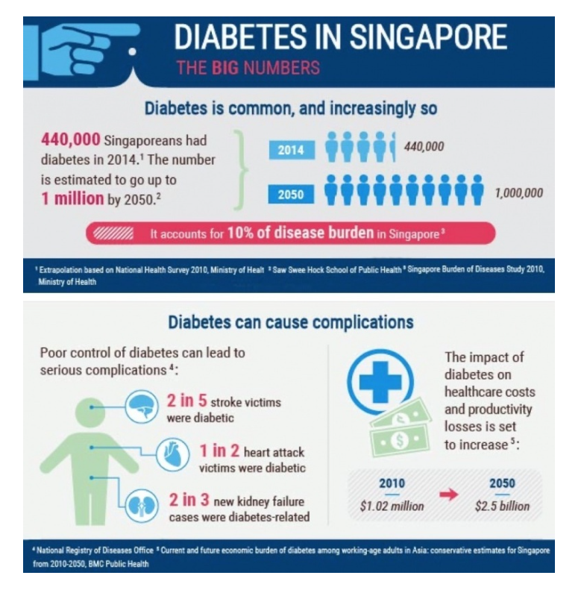
Figure 1. Source: The Singapore demographics of Diabetes - Diabetes SG

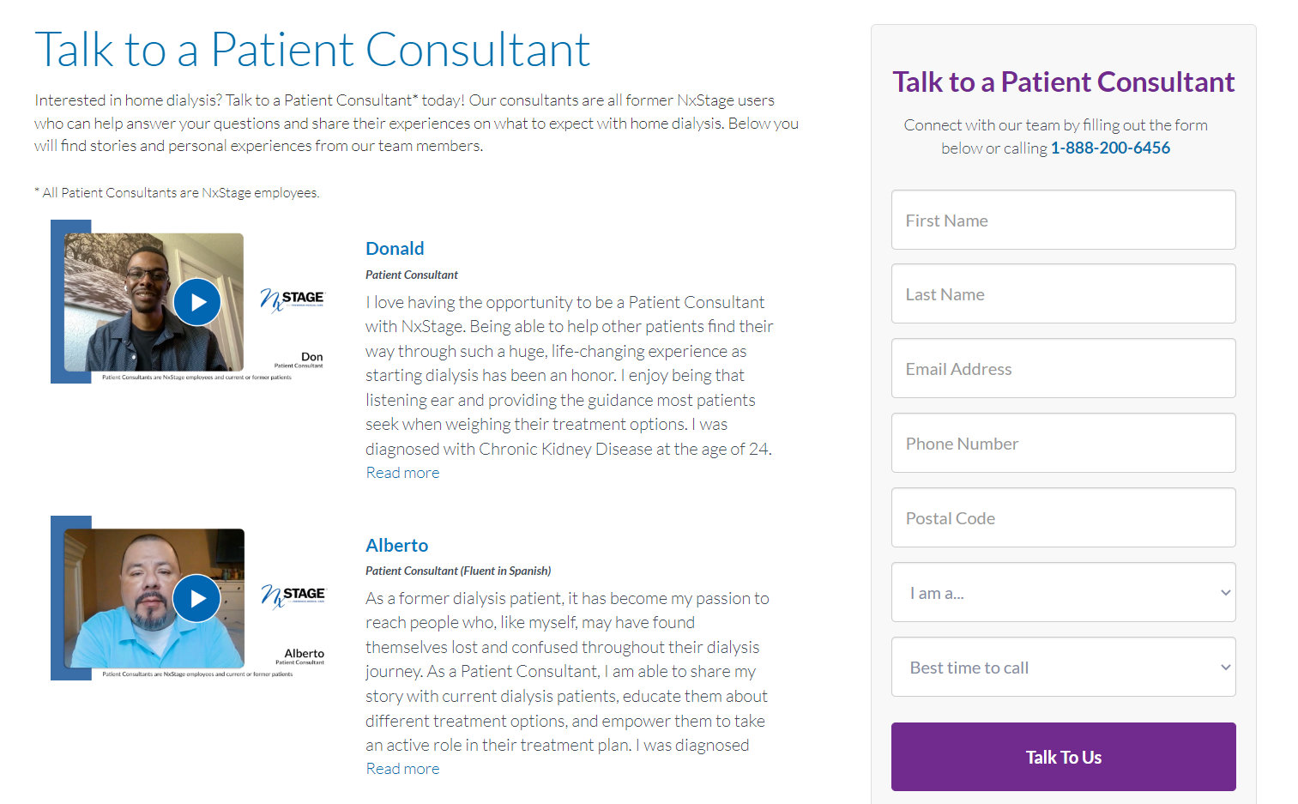
Figure 2. Patient Support. Source: Internal FMC
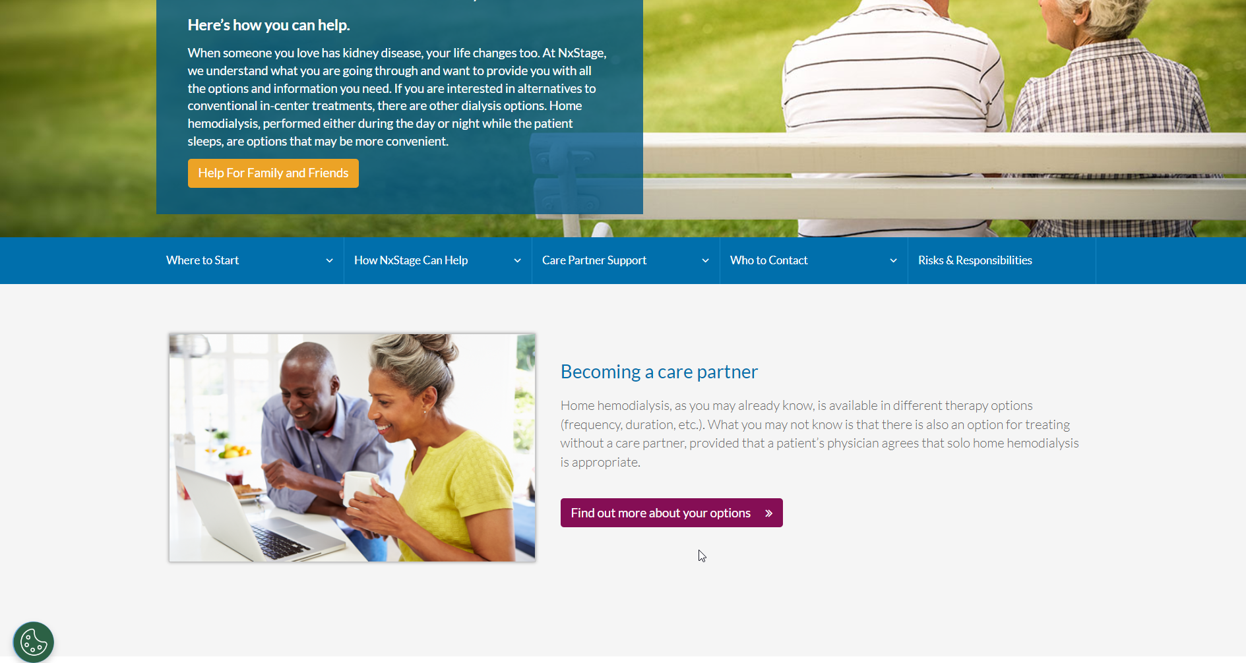
Figure 3. Patient Support program. Source: Internal FMC

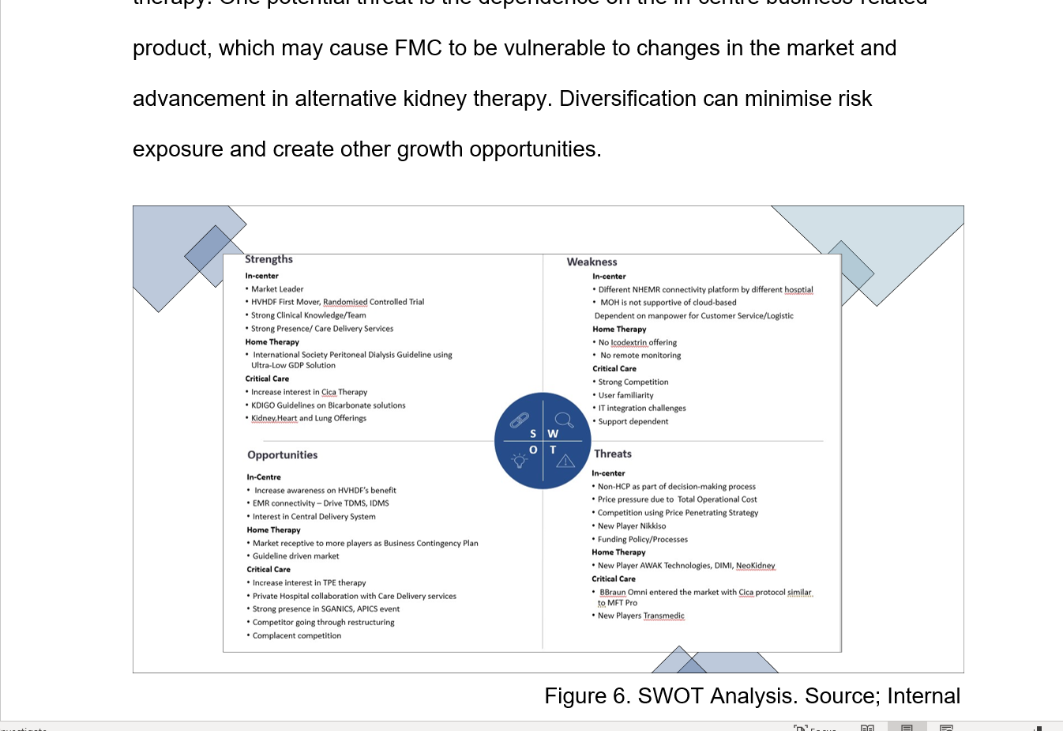
Figure 4. SSBR Module 1 assignment. L04. Page 12. Source: Internal

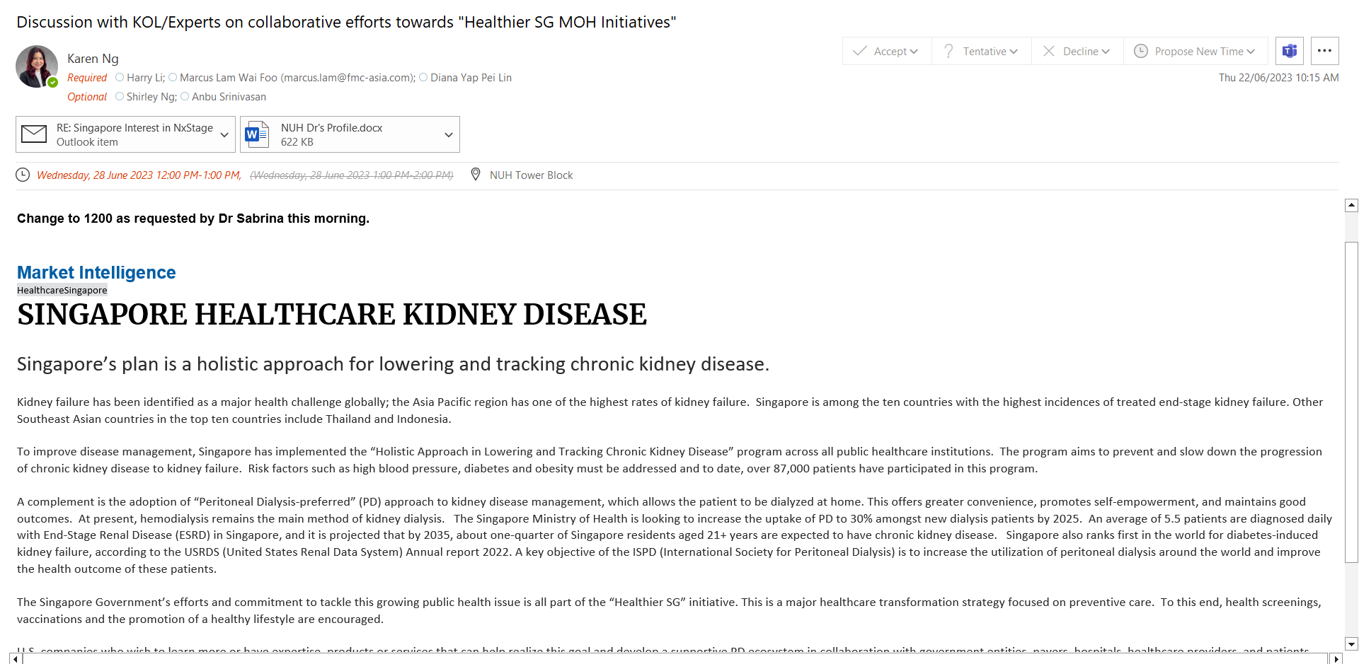
Figure 5. KOL Engagement. Source: Internal.
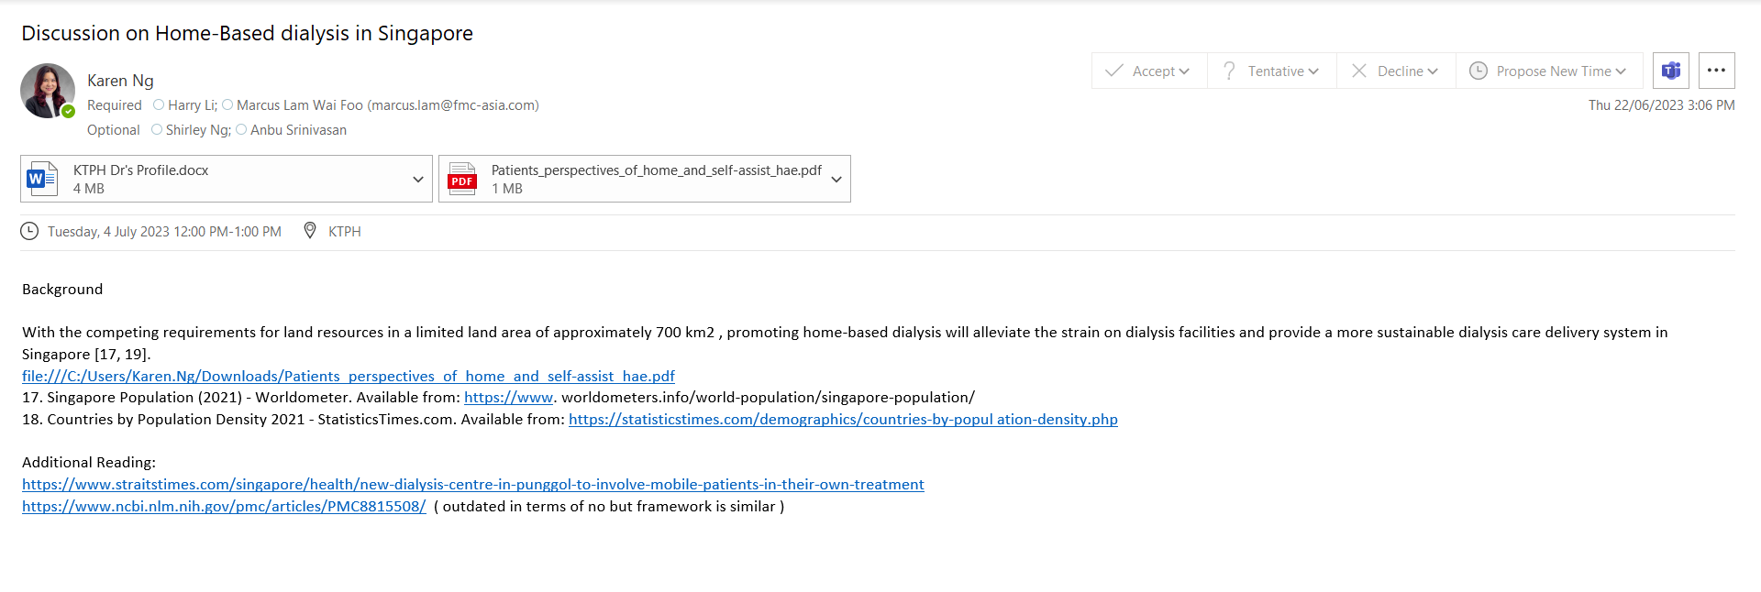
Figure 6. KOL Engagement. Source: Internal.
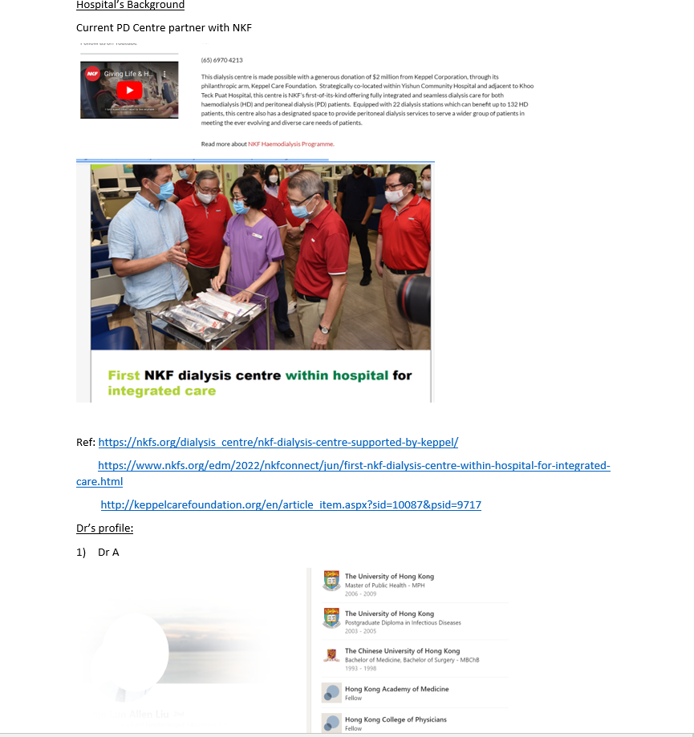
Figure 7. KOL’ s Profile. Source: Internal.

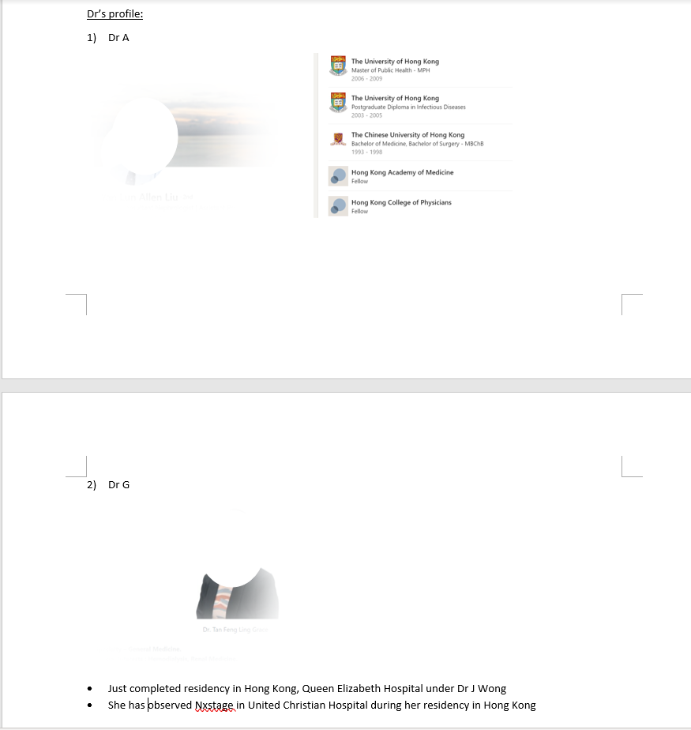
Figure 8. KOL’ s Profile. Source: Internal.
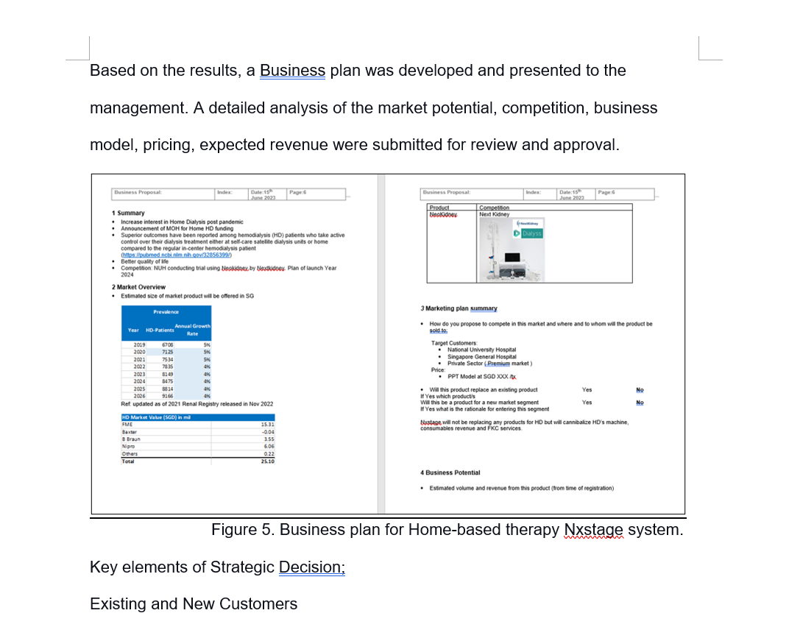
Figure 9. Business Plan. Source: Internal.
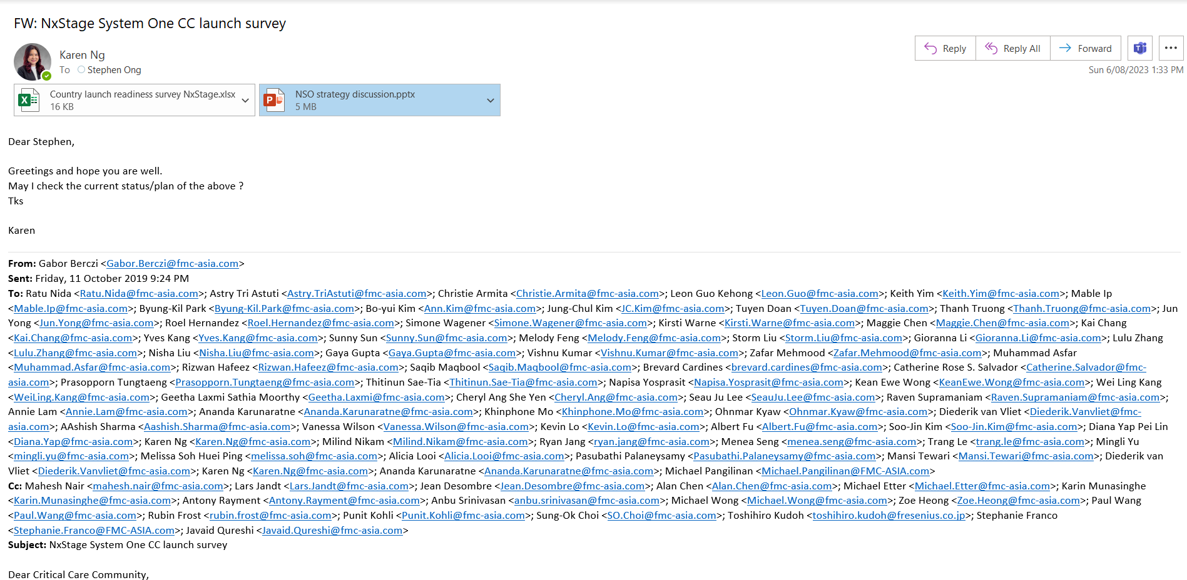
Figure 10. Feasibility Survey. Source: Internal.
Figure 11. Strategic Implementation plan. Source: Module 1. Page 19.

