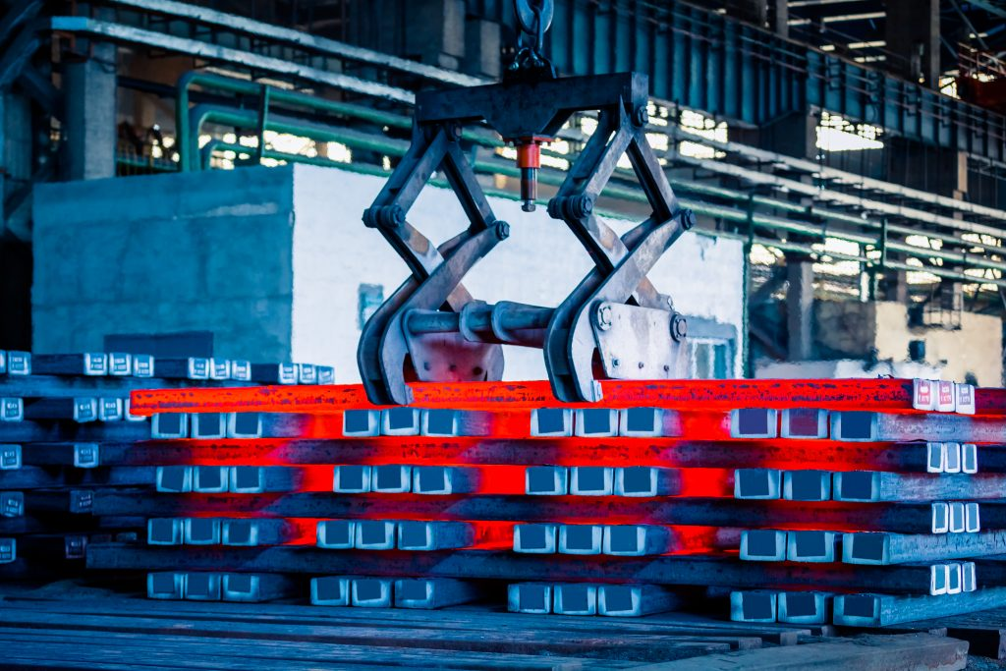
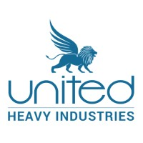
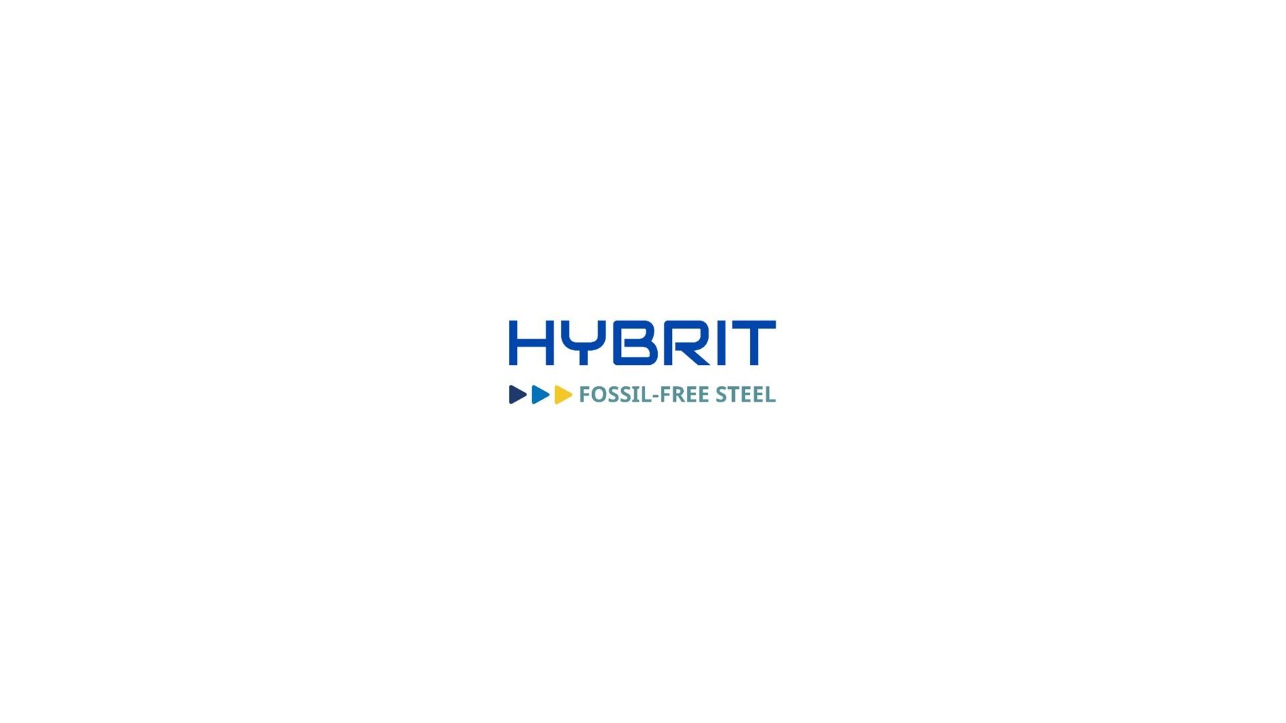
A Plan to Integrate HYBRIT Technology in Steel Manufacturing:
A case for United Heavy Industries

© United Heavy Industries
Executive Summary
This report presented the case of United Heavy Machineries (UHI), a leader in the steel industry in South Africa. It has provided insights into the current steel-making process and its impacts on the environment. Furthermore, it has explicitly delved into the details of the company structure and supply chain along with the issues associated with them. It has proposed a plan for the integration of Hydrogen Breakthrough Ironmaking Technology (HYBRIT) in UHI. HYBRIT uses hydrogen to make sponge iron from iron ores and make steel from them. The whole process uses green energy and does not produce carbon dioxide. Instead, it produces water as a by-product. This report has also presented the stakeholders' communication strategy and the change management strategy that will be implemented within the plan.
Table of Contents
1. Introduction 4
2. Company background 4
2.1. Vision, mission and values 5
2.2. Strategic aims and objectives 6
2.2.1. Strategic aims 6
2.2.2. Strategic objectives 6
2.3. The Strategic Way Forward 6
2.4. Current company structure 7
2.5. Currently used technology 8
2.5.1. Crucible induction furnaces 8
2.5.2. Electric arc furnaces 8
2.5.3. Rolling Mill 9
2.6. Current supply chain 9
2.7. Environmental impacts and sustainability of the current steel-making process 9
2.7.1. Iron ore mining 9
2.7.2. Energy consumption 10
2.7.3. Steel production process 10
2.8. Identified issues 10
2.8.1. Extensive use of fossil fuels 10
2.8.2. Extensive dependence on the upward supply chain 10
2.8.3. High environmental impacts 10
2.8.4. Higher production costs 11
3. Proposed Technological Changes 11
3.1. Hydrogen Breakthrough Ironmaking Technology (HYBRIT) 11
3.2. Feasibility of integrating HYBRIT technology in UHI 12
7.1. Impacts on the environment 13
7.2. Plans to implement the HYBRIT technology in UHI 13
7.2.1. Goal and Objectives 13
7.2.2. Stakeholder analysis 14
7.2.3. Stakeholder communication strategies 14
7.2.4. Proposed Changes in the Supply Chain 15
7.2.5. Changes required in the current company structure 16
7.2.6. Development of Human capital 16
7.3. Potential challenges 16
7.4. Proposed change management plan 17
8. Conclusion 17
References 19
Appendices 22
Current professional context 22
History of UHI 22
Analysis of the macro and micro environmental factors 23
Macro environmental analysis 23
Micro-environmental factors 25

Table of Figures
Figure 1. UHI steel-production facility in South Africa 5
Figure 2. Company structure of UHI 7
Figure 3. Crucible induction furnace (Smalcerz, Węcki and Blacha 2021) 8
Figure 4. Electric arc furnace (Olczykowski 2021) 8
Figure 5. HYBRIT steel-making (HYBRIT 2024B) 12
Figure 6. Stakeholder analysis in stakeholder matrix) 15

Introduction
The global iron and steel market is estimated at US$1.5 billion in 2023. With a projected growth at a CAGR rate of 5.3% between 2024 and 2030, the industry holds immense significance in today’s business world (Grand View Research, 2024). Given the multipurpose property of steel across various industries, it is safe to state that this industry has a bright future. Considering the size of the global industry, it also has immense impacts on the environment including its carbon footprint, impacts on natural resources as well as sustainability. In 2018, the total energy consumption of the iron and steel industry was 33.57 Exajoules. Furthermore, energy cost is a significant source of the manufacturing cost in this industry comprising almost 20% to 40% of the costs. In addition to this, the industry is one of the largest consumers of coal as it uses coking coal for the chemical reactions in reactions to transform iron ore into steel. The blast furnace consumes up to 75% of the energy content in the whole process of steel production. Therefore, it is evident that the industry is responsible for the emissions of greenhouse gases, which are estimated at 2.6 gigatonnes annually (Kim et al. 2022). This is almost 7-9% of global CO2 emissions from man-made activities and 7% of the global emissions from energy use. It is also the highest amount of CO2 emission among heavy industries. Ironically, steel and iron are two of the most crucial ingredients required in renewable energy sources and products that use renewable energy. For instance, wind turbines, a major source of renewable energy, are made out of 71 - 79% steel. Additionally, a major component of electric vehicles is also steel (Kim et al. 2022).
Considering this context, this report proposes a plan to integrate a new technology for steel-making which is known as Hydrogen Breakthrough Ironmaking Technology (HYBRIT). This technology was presented by the Swedish Energy Agency, which replaces coal and coke in steel production with electricity and fossil-free hydrogen. It is expected that this technology will reduce the CO2 emissions by the iron and steel industry by 7-10% (Majumder and Phani 2023). This report has two sections. The first section describes the current situation in the company including the company background, vision, mission and values, the strategic aim and objectives, the strategic goals and objectives, current company structure, the current supply chain, environmental impacts and sustainability issues, the macro and micro-environmental factors and issues identified. The second section discusses the proposed technological changes, the HYBRIT technology and its impacts on the environment. In addition to this, the second part conducts a stakeholder analysis, a communication strategy for stakeholders, and plans to implement the HYBRIT technology in the company. Finally, it discusses the potential challenges and problem-solving and decision-making along with a proposed change management plan.

Company background
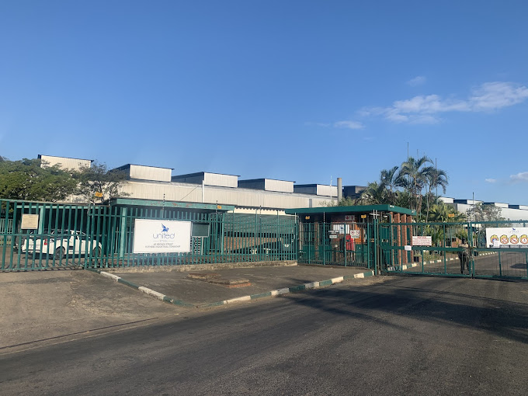
United Heavy Industries (UHI) is one of the most prominent steel-makers in South Africa in terms of its production capacity. It comprises three divisions, which include United Steel, United Energy and United Heavy Engineering. The main pillar of the company is United Steel. This company produces various grades of steel and long steel products. United Energy offers sustainable energy solutions and United Heavy Engineering provides heavy engineering services. UHI currently has operations in four continents which include the US, Europe, Africa and Asia. It has head offices across all these continents. These include offices in New Delhi, London, New York and Durban. UHI has strategically partnered with MECON India and Steel Authority of India Limited (SAIL), two parastatals of the Indian Government (United Heavy Industries 2021).
Figure 1. UHI steel-production facility in South Africa
It is also an ISO9001 and AS9100D certified company which represents its dedication to maintaining its quality and safety. Furthermore, these certifications have allowed UHI to be a supplier to the Aerospace and Defence Industries. Currently, as United Steels is the main division of UHI, this report has specifically focused on United Steels and hence, by UHI, it indicates United Steels. Currently, the company’s steel production capability is 240,000 tonnes at 50% utilisation, which is the fourth highest in South Africa. Presently, UHI aims to completely upgrade all aspects of its operations in the next five years. This involves using state-of-the-art technology to increase its production while significantly reducing its impacts on the environment. Hence, the current motto of UHI is “To embrace green steel production, we strive to create a better, more sustainable environment for future generations”. Furthermore, the company installed a new rolling mill and upgraded the primary melting capacity. Moreover, UHI aimed to increase its steel production capacity to the second highest in South Africa, which is 540,000 tonnes per annum (United Heavy Industries 2021).

Vision, mission and values
- Vision: “World’s most technologically advanced and green heavy industries group”
- Mission: “We at United Heavy Industries have focused our future on the following three key areas that will shape and transform the steel industry in the coming decade: Green steel making, high-performance steel and hybrid additive” (United Heavy Industries 2022).
- Values: The values of UHI include create, sustainability and transformation. These are as follows.
  - Create: UHI intends to create innovative and high-quality products by collaborating with every stakeholder.
  - Sustainability: UHI intends to become highly environmentally responsible through efficient use of resources and engaging with the community.
  - Transforming: UHI is an adaptive organisation that thrives on continuous improvement through empowering its employees (United Heavy Industries 2022).

Strategic aims and objectives
The strategic aims and objectives of UHI have been developed using the macro and micro-environmental factors, available resources and the vision and mission statements of the company. The details of these have been provided in the appendix. The strategic aims and objectives are provided below.

Strategic aims
- “To become the second-largest steel manufacturer in South Africa within the next two years”.
- “To increase the steel production capacity to 540,000 tonnes per annum within the next two years”.

Strategic objectives
- “To install 15-tonne induction furnaces and ladle refining furnaces in order to increase production capacity to 20,500 tonnes per annum”.
- “To commission a rolling mill of 460,000 per annum capacity by the end of 2024”.
- “To reduce the costs associated with steel production and manufacturing processes by 10% within the next six months”.
- “To improve employee engagement, retention, management and overall performance”.

The Strategic Way Forward
- In order to achieve the strategic aims and objectives, UHI plans to implement several steps. These include improvement of steel production capacity, leadership strategy, organisational culture and change management. These are elaborated on below.
- Improvement of steel production capacity: In order to increase the capacity of steel production, UHI intends to install induction furnaces and replace its conventional electric arc furnace. This will lead to increased production, energy efficiency and reduced impact on the environment. Crucible induction furnaces have lower capacities of steel production than electric arc furnaces and therefore, two crucible induction furnaces have to be installed in order to replace the electric arc furnace (Levshin 2019). Simultaneously, by the end of 2024, a new rolling mill with an annual capacity of 460,000 tonnes will be installed to improve its capacity and thereby, the production output. Moreover, UHI aims to produce hybrid additive steel by using wire input-based additive manufacturing. This will enable high-quality and precise casting of metal into any complex shape which has to be developed by a computer. This also minimises waste production as well as surplus materials (Chen et al. 2022).
- Improvement of leadership strategy: Currently, a bureaucratic leadership style is followed in UHI, which can increase productivity and performance. Furthermore, the author also used an affiliative leadership strategy. However, the involvement of employees in the decision-making processes in the current leadership was limited, which often resulted in a lack of connection and engagement of employees, affecting their motivation and belonging to the organisation (Biyana 2021). In order to improve these aspects, a combination of bureaucratic leadership and transformational leadership will be implemented in UHI.
- Improvement of organisational culture: Currently, market culture is followed in UHI to improve financial profit and gain a more competitive edge. In this culture, each employee is provided with distinct responsibilities to reach the larger organisational and financial goals. As employees have limited involvement in the decision-making processes, this culture can also affect their engagement and motivation (AJDAROVSKA and ATTAR 2020). Therefore, the adhocracy culture is planned to be implemented in the company, which can ensure a dynamic and innovative culture in the organisation, leading to higher adaptability and flexibility in the highly competitive industry (Gorzelany et al., 2021).
- Change Management: In order to appropriately implement the aforementioned change, the eight-step change management model will be used. This will allow the company to instil changes in all aspects and activities of the employees.

Current company structure
A divisional organisational structure is followed in UHI. Each division of UHI is directed by the managing directors. They report to the Chief Executive Officer (CEO) of the company. A strict hierarchical organisational structure is followed in each division. The directors of each department are required to report to the managing directors. These departments are finance, production, supply chain, operations, human resources, quality appraisal and checking and safety and environment for steel manufacturing (Figure 3). The managers or heads of each department need to report to the directors of each department. Simultaneously, the in-charges of each shift are needed to report to the heads. Finally, each team reports to the in-charges in the shifts. A top-down approach with a strict chain of command is used in the company. Whereas this ensures smooth and swift operations, it potentially prevents any upward communication from employees.
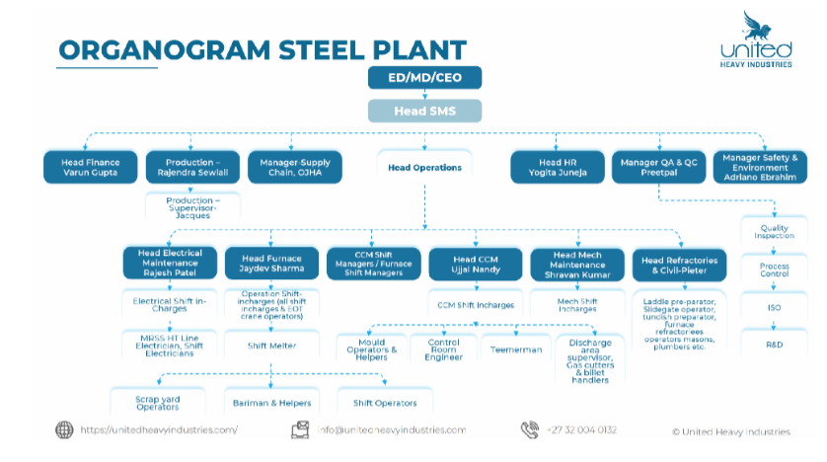
Figure 2. Company structure of UHI

Currently used technology
Currently, UHI uses two crucible induction furnaces, one electric arc furnace and one rolling mill. The details of the technology used in this equipment are provided in the following sections.

Crucible induction furnaces
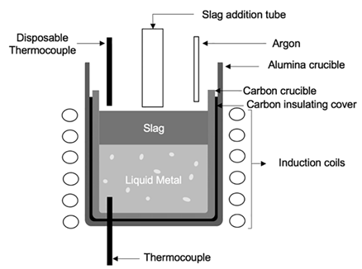
This type of furnace is the current global industry standard. It comprises a crucible made of nonconductive material that holds the charge of metal. This crucible is surrounded by a copper wire coil. The metal to be melted is placed in the crucible. A powerful alternating current is passed through the copper coil, which creates a magnetic field that rapidly reverses due to the alternative current. This magnetic field penetrates the metal through electromagnetic induction and the resultant Eddy currents that flow through the electrical resistance of the metal to be melted, heat the metal by Joule heating. Furthermore, in the case of iron, which is used to manufacture steel, the heating process also involved magnetic hysteresis caused by the reversal of the magnetic dipoles of the atoms. Furthermore, when the metal is melted, the eddy currents ensure good mixing by causing vigorous stirring. The main advantage of this process is that it uses electricity and reduces the need for external heat sources (Smalcerz, Węcki and Blacha 2021).
Figure 3. Crucible induction furnace (Smalcerz, Węcki and Blacha 2021)

Electric arc furnaces
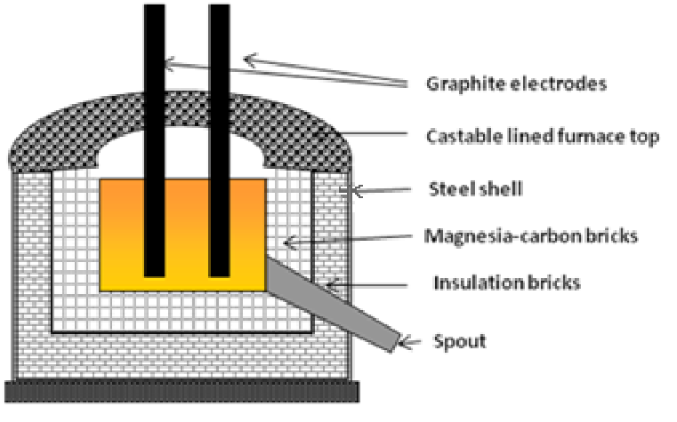
Electric arc furnaces are conventionally used for steelmaking. This furnace comprises a refractory-lined water-cooled vessel covered with a retractable roof. The furnace has three sections, which include the shell, the hearth and the roof. Graphite electrodes are inserted into the furnace through the roof. There are three electrodes. The charged material and the electrodes form the arc. The current passed through the charged material along with the radiant energy from the arc heats the metal. The energy requirement of an electric arc furnace for melting iron and making one ton of steel is 440 kilowatt-hours or 1.6 gigajoules. A 300-tonne and 300-mage-volt ampere electric arc furnace requires 132 megawatt-hours of energy to melt the steel for 35-40 minutes. This requires a significant amount of energy, potentially affecting environmental sustainability (Olczykowski 2021).
Figure 4. Electric arc furnace (Olczykowski 2021)

Rolling Mill
UHI uses a rolling mill that has 460,000 tonnes annual capacity. Rolling mills are used to decrease the thickness of pieces of metals and improve uniformity. As the metal prices are passed through the pairs of rollers, their thickness is reduced leading to products with uniform thickness. UHI has multiple ferrous products including “round steel in rolled or roller peeled design, flat steel rolled, round steel, forged rings, hollow shafts, wire rod, hot rolled coil, cold rolled coil, hot-dip coated coil and others”. All these products have to be uniform in shapes and sizes, which require a rolling mill.

Current supply chain
UHI has two supply chain streams, including the upward stream and the downward stream. Through the upward stream, UHI sources its raw materials for steel production through mining. These include iron ore, coke coals, fuel gases and alloying elements such as manganese and chromium. On the other hand, it requires bauxite ore and copper ore to manufacture its non-ferrous products. These raw materials are sourced from mines through strategic partnerships. Iron ores in UHI are sourced from iron mines in the country. UHI has strategically partnered with African Rainbow Minerals, the owner of the Khumumani Mine, which is the largest iron ore mine in South Africa. Raw materials are also sourced from other countries such as India.

Environmental impacts and sustainability of the current steel-making process
There are multiple aspects of the impacts of steel production on the environment. These include the mining process of iron ore, energy consumption, pollution and emission of greenhouse gases. These are elaborated on below.

Iron ore mining
Iron ore is the main ingredient for steel production. Per year almost 2000 million tonnes of iron ore is mined. The steel industry uses almost 95% of this mined iron ore. The mining process of iron ore requires a high amount of energy and can have significantly negative impacts on the environment. It can cause air pollution by emitting carbon monoxide, carbon dioxide, nitrous oxide and sulphur dioxide. Furthermore, it also causes water pollution by releasing heavy metals and acids from mines to water (Lv, Sun and Su 2019). Acid drainage is a major long-term issue for mining (Langston 2019). It is created by the interaction between sulphur-bearing minerals and heavy metals, oxygen and water. The most common and abundant acid resulting from iron ore mining is sulphuric acid. These resultant acids are released into water sources such as rivers and lakes through rainwater, potentially toxicating the water.
Iron ore mining also affects the air quality during the construction and operation phases. Combustion products including carbon dioxide, fugitive dust, sulphur dioxide, carbon monoxide and nitrous oxide among others are released into the air. These are also the results of diesel generators, on-site road traffic and fuel-oil boilers. In addition to this, fugitive dust is generated during equipment traffic on-site, land clearing and ground excavation among others. The particulate and gas emissions caused by iron ore mining are a major issue associated with environmental impacts and human health (Haque 2022). The acidic conditions caused by sulphuric acid change the pH value of the soil which can harm vegetation and natural flora and fauna. Simultaneously, iron ore mining is also associated with poor water quality. Extracting iron ore can lead to water pollution through leachate and surface runoff. Furthermore, it increases sediment levels in water streams (Aziz et al., 2024).

Energy consumption
As mentioned earlier, steel production is highly energy-intensive. Be it electric arc furnaces or crucible induction furnaces, the average energy required to manufacture steel is around 20 gigajoules, most of which is sourced from burning fossil fuels, negatively impacting the environment. Furthermore, it also has a significant impact on the earth’s sustainability (Na 2022).

Steel production process
Steel production also requires a large amount of coke coal, which can pose extreme threats to the environment. Burning of coke coals can release carbon monoxide, carbon dioxide and toxic gases such as naphthalene into the air. As a result, it exerts immensely negative impacts on the environment by emitting large quantities of greenhouse gases and increasing the overall temperature of the earth. On average the annual CO₂ emissions from steel production is 1.83 tons per ton of steel produced. Therefore, steel production is a major contributor to global warming. Wastewater generated from steel production can contain certain toxic and carcinogenic molecules such as ammonium, ammonia, cyanide and sulphides among others (The World Counts 2024).

Identified issues

Extensive use of fossil fuels
Similar to its competitors, UHI uses coke coal to make steel. Coke coals can be highly expensive and require a mining process that can have impacts on the environment. It destroys natural landscapes and habitats and prevents further vegetation. Furthermore, it can also lead to deforestation and erosion. Coal mining, similar to raw iron mining, contaminates groundwater by releasing previously unearthed minerals into the water bodies. Furthermore, it also causes air and chemical pollution. It releases methane in the atmosphere, which is a greenhouse gas (Jaimes and Maroufi 2020).

Extensive dependence on the upward supply chain
In order to source its raw materials, UHI extensively depends on its supply chain including the mining companies and energy companies. This gives too much power to the hands of the suppliers. Considering the impacts of the COVID-19 pandemic on the global supply chain networks, this extensive dependence can be disruptive to the company and its production capacity. Hence, measurements are required to reduce the dependence on the upward supply chain.

High environmental impacts
The conventional process of steel-making has high impacts on the environment by emitting greenhouse gases in high quantities, heat generation, energy consumption and reduced sustainability. With the increase in demand for steel and steel products, the environmental impacts of the steel production process are expected to rise exponentially. In this context, UHI needs to adopt new technology to enhance this process, optimise energy consumption and reduce environmental impacts (Kaiser et al. 2024).

Higher production costs
Using conventional electric arc furnaces requires a high amount of energy with low production efficiency. Although crucible induction furnaces can produce high-quality steel with less energy, the production quantity is less. Therefore, two crucible induction furnaces had to be installed to replace one electric arc furnace in the company. As a result, the production costs of steel in the conventional steel-making process as followed in UHI are highly cost intensive. Hence, new technology has to be adopted to improve production capacity and reduce production costs and environmental impacts.

Proposed Technological Changes

Hydrogen Breakthrough Ironmaking Technology (HYBRIT)
The HYBRIT technology was a joint venture between Vattenfall, LKAB and SSAB. LKAB is a global supplier of sustainable iron ore and minerals. LKAB intends to reduce its carbon dioxide emission to zero for its own processes by 2045. The HYBRIT technology replaces coking coal and natural gases with fossil-free and sustainable hydrogen. As a result, instead of CO₂, water is produced as a byproduct. The process begins with making iron ore pellets from iron ore concentrate using fossil-free fuel. Sponge iron is produced using fossil-free hydrogen and fossil-free electricity. As a byproduct H₂O is produced. The sponge iron is used along with fossil-free electricity and bio-coal to produce fossil-free crude steel. This process eliminates the production of carbon dioxide throughout steel making (HYBRIT 2024A). The whole process is detailed in the following sections step-by-step.
- Making Iron-ore pellets: In HYBRIT technology, iron ore pellets are produced from iron ore concentrate. In this process, conventional fossil fuels have been replaced by bio-oil. This is 100% renewable. This combined with electric heating and hydrogen combustion produces the first fossil-free iron-ore pellets (HYBRIT 2024B)
- Making sponge iron from iron-ore pellets: In the next step, iron ore pellets are directly reduced to sponge iron in the presence of hydrogen at around 1100⁰C. It is also called Direct Reduced Iron (DRI). The process of converting iron-ore pellets into sponge iron can either be coal-based or hydrogen-based. In the HYBRIT technology, fossil-free hydrogen is used to make sponge iron, thereby, making this process highly energy efficient as well as minimising its environmental impacts. Furthermore, hydrogen-DRI is stronger and easier to transport, store and melt. The low content of iron oxide and carbon increases its mechanical strength and chemical stability. Additionally, as it has a high degree of metallisation of 98-99%, the chances of losses of iron in the process are very low. Therefore, it reduces the chances of loss in the value chain and lowers energy consumption (HYBRIT 2024B).
- Production and storage of fossil-free hydrogen: In HYBRIT technology, hydrogen is produced by using electrolysis to split hydrogen and oxygen from water. In this process, fossil-free electricity is used, making this process fossil-free. The hydrogen can be stored in underground storage facilities near the steel manufacturing facility to reduce transportation costs by up to 40% (HYBRIT 2024B).
- Production of fossil-free crude steel from sponge iron: This is the final process of HYBRIT steelmaking. In this process, the sponge iron is placed in the electric arc furnace, oxygen, biocarbon and slag formers. Fossil-free electricity is used to melt this mixture. Slag formers are used to purify the steel. Additionally, it creates insulation to maximise energy efficiency. Oxygen and biocarbon are added to maximise energy efficiency and minimise electrode consumption (HYBRIT 2024B).
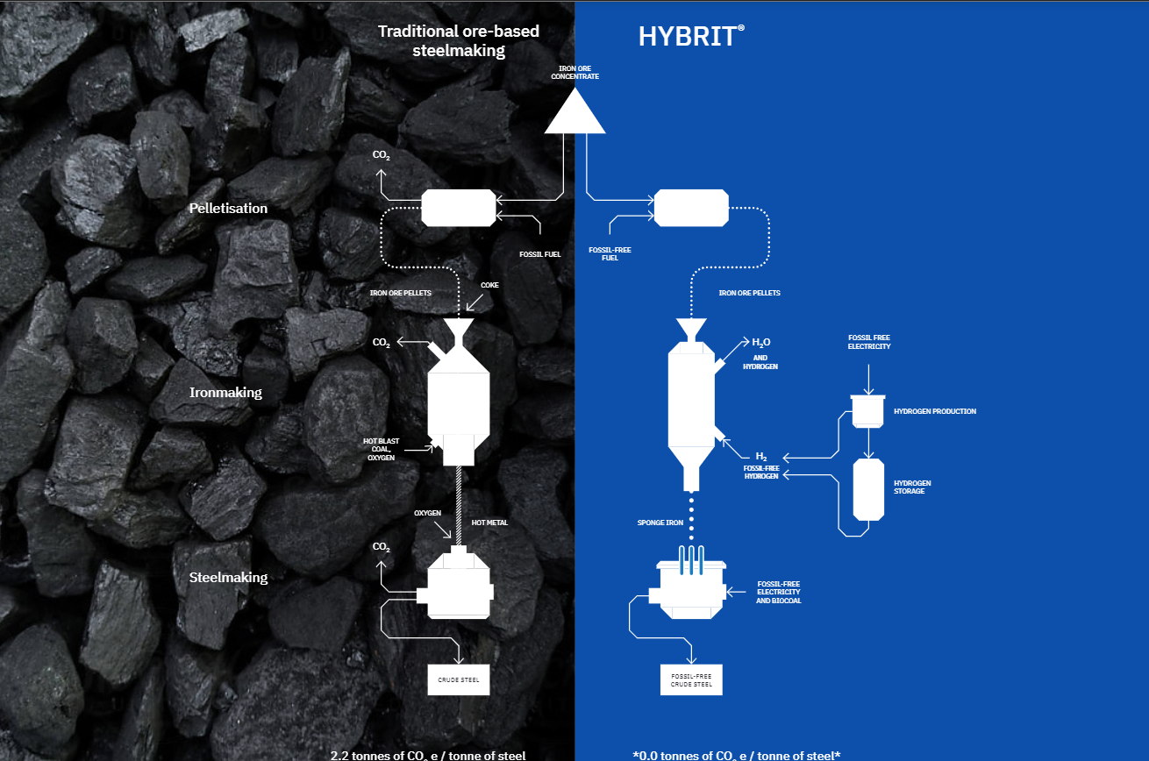
Figure 5. HYBRIT steel-making (HYBRIT 2024B)

Feasibility of integrating HYBRIT technology in UHI
There are certain aspects to be analysed to measure the feasibility of integrating HYBRIT technology in UHI. These are as follows.
- Availability of bio-coal and renewable energy: The availability of bioenergy in South Africa is limited. However, there is a significant opportunity to produce bio-energy from solid biomass from household and industrial waste. Furthermore, the National Policy Framework in South Africa named the Integrated Resource Plan (IRP) 2010-2030 announced the Renewable Energy Independent Power Producers Programme (REIPPP) which plans to produce 6,422 megawatts of electricity (IEA Bioenergy 2021). Therefore, it is evident that South Africa is focusing on developing its capacity to produce electricity from renewable energy, which provides a significant opportunity for UHI to implement HYBRIT technology.
- Availability of hydrogen: In the HYBRIT process, hydrogen is used to produce sponge iron. It is produced using electrolysis from water. Therefore, water availability is a factor in this process. However, in the conventional processes that were used in UHI for steel making, water is also required for cooling the furnace and other purposes. Therefore, water is already available in the UHI steel production plants. Therefore, producing and storing hydrogen should not be an issue in UHI.
- Availability of iron ore: Currently, steel in UHI is produced using both iron ore and scrap iron. Steel from iron ore is produced in the electric arc furnaces and scrap iron in the crucible induction furnaces. Furthermore, UHI has a strategic partnership with African Rainbow Minerals, which ensures the seamless supply of iron ore for steel production. Therefore, there is no issue in sourcing iron ore for UHI.
- Availability of equipment: In the HYBRIT steelmaking process, the equipment required includes electric arc furnaces, electrolysers and combustion chambers. UHI already has an electric arc furnace, which will be used to make steel from sponge iron. However, it will need to acquire a chamber to convert iron ore pellets to sponge iron. Simultaneously, it will also need to source electrolysers to produce hydrogen. This may feel resource-intensive, however, most of these are one-time investments and considering the cost and energy efficiency, the cost of these investments will be recovered within a short period of time.
- Budgetary requirements: Implementing this strategy will require significant capital investment for the new machinery and technology. Furthermore, obtaining permission from HYBRIT to use this patented technology will require further capital investment. This proposal will also require UHI to train its employees in using the new technology efficiently. The proposed estimated budget for this plan is presented below.
Actions for the next 8 months | Budget (US$)
HYBRIT Technology | 50,000,000
Iron ore | 17,280,000
Fossil-free hydrogen production | 10,000
Fossil-free electricity | 15,000
Bio-coal | 10,000
Training of the employees | 10,000
Total | 67,325,000

Impacts on the environment
The HYBRIT technology was funded by the innovation fund from the European Union for its environmental sustainability. The technology is owned by energy company Vattenfall, steel company SSAB and mining company LKAB. By completely replacing natural gas and coal in the steel-making and hydrogen production process with hydrogen, bio-coal and renewable energy courses, HYBRIT completely eliminates the production of carbon dioxide, which will help UHI to drastically reduce its carbon footprints as well as improve its cost and energy efficiency (European Union 2023). Some of the major ways the steel-making process makes huge impacts on the environment include its resource-intensive and energy-intensive nature along with the emission of greenhouse gases. HYBRIT not only improves resource and energy efficiency, but it also produces water as a byproduct, potentially replacing the water used only in the hydrogen production process. Therefore, it is evident that using hydrogen DRI and replacing conventional energy sources with renewable energy and bio-fuel, HYBRIT drastically improves the environmental impacts of steel production as well as sustainability in the process by reducing its reliance on natural resources and reserves.

Plans to implement the HYBRIT technology in UHI

Goal and Objectives
Goal: The goal of this plan is to completely integrate HYBRIT technology in the steel-making process in UHI within the next eight months.
Objectives
The following objectives have been developed to achieve the goal.
- To successfully acquire the permission to implement HYBRIT technology from Vattenfall, SSAB and LKAB within the next month.
- To successfully obtain the required capital from investors and banks within the next month.
- To successfully acquire a combustion chamber for the production of sponge iron from iron ore pellets within the next four months.
- To install and begin production of hydrogen for steel-making within the facility within the next two months.
- To educate and train the employees regarding the HYBRIT steel-making process within the next six months.
- To begin pilot testing of the new HYBRIT steel-making in the UHI steel production facility within the next seven months.

Stakeholder analysis
There are three levels of stakeholders that will be associated with the process of implementing HYBRIT technology in UHI. These include the macro, meso and micro levels of stakeholders. These are provided below.
- Macro stakeholders: The macro stakeholders have the highest levels of influence and power in the plan; however, they also have the lowest levels of interest. These include the providers of HYBRIT technology including steel company SSAB, energy company Vattenfall and mining company LKAB. Furthermore, the South African Government will also be a macro stakeholder as it determines the laws and environmental regulations, which must be maintained throughout this process. The other macro stakeholders will be banks and investors who will be contacted for the capital investment that is required to integrate HYBRIT technology. Finally, the board of directors and shareholders will be the other macro stakeholders.
- Meso stakeholders: The meso-level stakeholders are the people who carry on and implement the decisions and actions determined by the macro stakeholders although they have a limited level of influence in the process. In this plan, the meso level of stakeholders will include the directors of different departments including finance, production, supply chain, operations, human resources, quality appraisal and checking and safety and environment. Furthermore, the meso stakeholders will also include the employees of Vattenfall, SSAB and LKAB who will be charged with the responsibilities of integrating the HYBRIT technology as well as educating the existing employees of UHI.
- Micro stakeholders: The micro level of stakeholders have the lowest level of influence in the whole process although they bear the impacts of the decisions taken by the macro stakeholders. These include the employees of UHI who are directly associated with production, operations, procurement, distribution and human resource activities.

Stakeholder communication strategies
Different communication strategies will be used to maintain communication with the different levels of stakeholders associated with this plan. These are as follows.
- Macro stakeholders with the highest influence: These include Vattenfall, SSAB and LKAB. Firstly, UHI needs to contact these companies to gain access to HYBRIT technology and permission to use this technology to improve environmental sustainability as well as other aspects of steel production. Therefore, throughout the process, UHI needs to keep these stakeholders highly satisfied by constantly communicating with them and providing them with feedback and necessary information. Furthermore, the investors and banks that will provide the necessary capital for the implementation of this plan will also have to be kept satisfied.
- Macro stakeholders with the highest influence and highest interest: These will include the CEO and the board of directors of the company as they have the highest influence as well as interest in the progress of UHI and its overall condition. These stakeholders will have to be managed closely by collecting their inputs and making sure to achieve the goals timely. Furthermore, all the macro stakeholders will be included in the decision-making process to keep them satisfied.
- Meso stakeholders: The meso stakeholders have low interest as well as low influence and hence, have to be monitored throughout the process to ensure that the decisions and actions determined by the macro stakeholders are addressed in proper ways and timely.
- Micro stakeholders: The micro stakeholders will be kept informed throughout the process. Furthermore, feedback will be collected from them to inform the decision-making.
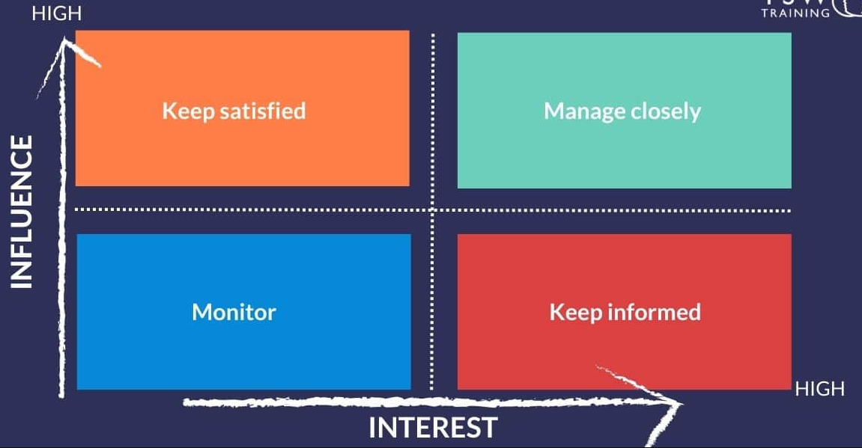
- Vattenfall, SSAB and LKAB.
- Investors and banks
- South African Government
- Supervisors and in-charges
- Employees
- Board of directors
Figure 6. Stakeholder analysis in stakeholder matrix)

Proposed Changes in the Supply Chain
Currently, UHI sources its iron ore from African Rainbow Minerals, which will be continued in the new HYBRIT process of steelmaking. However, this process will drastically reduce the use of scrap iron and hence, UHI will need to make necessary changes in its supply chain to reduce and eventually stop acquiring scrap iron from its suppliers. Furthermore, initially, UHI can directly source hydrogen DRI from India as it is one of the world’s largest manufacturers of sponge iron. However, as the HYBRIT technology will be implemented in the company, it should be able to manufacture its own sponge iron from iron ore sourced from the existing supply chain. This will significantly reduce its reliance on the supply chain.

Changes required in the current company structure
Currently, the company follows a strict hierarchical structure that does not allow two-way communication. However, it is extremely important to include the micro-stakeholders in the decision-making processes by collecting their feedback and inputs and conveying them to the highest levels of decision-making and stakeholders. Therefore, in order to accommodate the inputs and communication from the lowest levels of the stakeholders, the company needs to adopt a transformational leadership style as well as a supervised team-based organisational culture (appendix). This culture will allow a more agile approach to problem-solving as well as interpersonal communication between different levels of employees.

Development of Human capital
Human capital refers to the collective skills and knowledge of the human resources within an organisation (Goldin 2024). The current employees at UHI are experts in all aspects of the traditional steel-making process followed by the company. However, it can be assumed that most of them have little knowledge about the HYBRIT steel-making process. Therefore, they have to be educated and trained to use the new technology. This can be conducted by contacting the inventors of this technology, which include Vattenfall, SSAB and LKAB and requesting them to train and educate the existing human resources of UHI to ensure the proper implementation of the plan and integration of HYBRIT technology in UHI.

Potential challenges
There can be certain challenges in integrating the HYBRIT technology in UHI. These are as follows.
- Lack of availability of renewable energy: HYBRIT technology requires renewable energy and biologically sourced coals as energy sources. South Africa is still in the process of adopting renewable energy and making it available for industrial use. However, as the government has announced its 2030 plan to increase the production of bio-renewable energy and provided financial support and funding for this cause, it is expected that renewable energy will be more available in the country.
- Collecting the necessary capital: Although UHI can implement this plan using the existing facility and equipment, still certain machinery and equipment will be required, which will need capital investment. Therefore, UHI needs to convince its investors and banks to acquire the necessary capital to implement this plan to integrate HYBRIT technology.
- Collection of raw materials: It is evident that UHI will be able to source its primary raw material, which is iron ore from the existing suppliers. However, initially, it will have to source sponge iron from other suppliers which can increase capital expenditure for a short period of time.
- Convincing the existing customers: Finally, UHI will need to sell its steel manufactured using the HYBRIT process to make a profit and run its operations. It is assumed that a certain percentage of the existing customers will have doubts regarding the quality of the steel as the cost of steelmaking will reduce in HYBRIT, which can certainly reflect on the price of steel. Therefore, a major challenge for UHI will be to convince its customers about the higher quality of the steel produced in this process.

Proposed change management plan
Implementing this plan will need certain disruptive changes in the current organisation of UHI. In order to ensure that the current employees and the stakeholders of the organisation successfully and effectively adapt to these changes, the eight-step change management model by John Kotter will be used (Graves et al. 2023). The steps that will be applied in this plan are provided in the following section.
- Step 1: Creating a sense of urgency: In this step, the employees will be motivated to make the required changes by educating them about the negative impacts of traditional steel-making processes on the environment. Furthermore, they will be inspired to make the required changes by informing them about their roles in the change management process. This intrinsic motivation will ensure that the change will be sustained for the long term (Liu, Hau and Zheng 2019).
- Step 2: Building a guiding coalition: A guiding coalition with the employees will be formed by educating, guiding and collaborating with them throughout the decision-making processes.
- Step 3: Forming a strategic vision: Each team leader will be given the responsibility of developing a strategic vision for that particular team collaboratively.
- Step 4: Enlisting an army of volunteers: Employees will be motivated by both intrinsic and extrinsic motivation to volunteer for the change case.
- Step 5: Enabling actions by removing barriers: Employees will be encouraged to innovate and be creative in implementing the required actions for the change. Furthermore, any communication barriers and challenges regarding the availability of resources will be removed to support their actions.
- Step 6: Generating short-term wins: Short-term goals for each team will be developed and when the employees or members of that particular team achieve the short-term goal, they will be recognised to motivate them to perform better as well as to track progress.
- Step 7: Sustaining change: In order to sustain the change, the employees will be encouraged to make the necessary changes as well and feedback will be collected from them. Monitoring systems will also be implemented to ensure this aspect.
- Step 8: Instituting the change in the Organisation’s DNA: In this final step, the change is maintained by creating behavioural changes among the employees by continuously upgrading their knowledge and skills and supporting them with required knowledge and capital resources.

Conclusion
The current report presented an elaborate and detailed plan to integrate HYBRIT technology into the current organisational structure of UHI. Currently, UHI follows the traditional process of steelmaking using fossil fuels and energy. This process is highly cost and energy-intensive. Furthermore, this process has significant impacts on the environment and sustainability due to excessive energy consumption, high carbon emission, air pollution and water pollution. Furthermore, this cost-intensive process also increases the manufacturing cost. In this scenario, the HYBRIT technology for steelmaking provides an effective solution to address all these problems. HYBRIT uses hydrogen to convert iron ores to sponge iron and make steel using renewable energy. The whole process does not emit any carbon dioxide or other greenhouse gases. Instead, it produces water as a byproduct. Given the current scenario in South Africa, it might be a short-term issue for UHI to source renewable energy, however, it will be solved as the government has announced plans to increase the production of renewable energy, Furthermore, the existing equipment, machinery and resources will be adequate in implementing this technology.

References
AJDAROVSKA, Z. and ATTAR, M., 2020. Analysing the relationship between organisational culture and organisational ambidexterity. Business & Management Studies: An International Journal, 8(3), pp.3550-3581.
Aziz, H.A., Ariffin, K.S., Wang, M.H.S. and Wang, L.K., 2024. Dredging and Mining Operations, Management, and Environmental Impacts. In Industrial Waste Engineering (pp. 333-396). Cham: Springer International Publishing.
Biyana, M., 2021. An evaluation of bureaucratic leadership as a panacea for effective performance among subordinates (Doctoral dissertation, Cape Peninsula University of Technology).
Chen, W., Xu, L., Zhao, L., Han, Y., Wang, X., Hu, C. and Jing, H., 2022. Application of hybrid additive manufacturing technology for performance improvement of martensitic stainless steel. Additive Manufacturing, 51, p.102648.
European Union, 2023. The HYBRIT story: unlocking the secret of green steel production [Online]. European Union. Available at: <https://climate.ec.europa.eu/news-your-voice/news/hybrit-story-unlocking-secret-green-steel-production-2023-06-20_en> [Accessed 18 October 2024].
Goldin, C., 2024. Human capital. In Handbook of cliometrics (pp. 353-383). Cham: Springer International Publishing.
Gorzelany, J., Gorzelany–Dziadkowiec, M., Luty, L., Firlej, K., Gaisch, M., Dudziak, O. and Scott, C., 2021. Finding links between organisation’s culture and innovation. The impact of organisational culture on university innovativeness. Plos one, 16(10), p.e0257962.
Grand View Research, 2024. Steel Market Size, Share & Trends Analysis Report, Grand View Research (online). Available at: < https://www.grandviewresearch.com/industry-analysis/steel-market> [Accessed 18 October 2024].
Graves, L., Dalgarno, N., Van Hoorn, R., Hastings-Truelove, A., Mulder, J., Kolomitro, K., Kirby, F. and van Wylick, R., 2023. Creating change: Kotter’s change management model in action. Canadian Medical Education Journal, 14(3), p.136.
Haque, N., 2022. Life cycle assessment of iron ore mining and processing. In Iron Ore (pp. 691-710). Woodhead Publishing.
HYBRIT, 2024A. Fossil–free steel – a joint opportunity [online]. HYBRIT. Available at: < https://www.hybritdevelopment.se/en/> [Accessed 18 October 2024].
HYBRIT, 2024B. Fossil-free steel production ready for industrialization [Online]. HYBRIT. Available at: < https://www.hybritdevelopment.se/wp-content/uploads/2024/08/hybrit-broschure-fossil-free-steel-production-ready-for-industrialisation.pdf#page=2.04> [Accessed 18 October 2024].
IEA Bioenergy, 2021. Implementation of bioenergy in South Africa – 2021 Update [Online]. IEA Bioenergy. Available at: <https://www.ieabioenergy.com/wp-content/uploads/2021/11/CountryReport2021_SouthAfrica_final.pdf> [Accessed 18 October 2024].
Jaimes, W. and Maroufi, S., 2020. Sustainability in steelmaking. Current opinion in green and sustainable chemistry, 24, pp.42-47.
Kaiser, F., Reichel, T., Echterhof, T., Mier, D., Unamuno, I. and Pfeifer, H., 2024, May. Decreasing the environmental impact of the electric steel-making process through implementation of furnace retrofitting solutions. In IOP Conference Series: Materials Science and Engineering (Vol. 1309, No. 1, p. 012009). IOP Publishing.
Kim, J., Sovacool, B.K., Bazilian, M., Griffiths, S., Lee, J., Yang, M. and Lee, J., 2022. Decarbonizing the iron and steel industry: A systematic review of sociotechnical systems, technological innovations, and policy options. Energy Research & Social Science, 89, p.102565.
Langston, N. (2019). Sustainable Mining and the North. In Environment and Sustainability in a Globalizing World (pp. 162-181). Routledge.
Levshin, G.E., 2019. Improving Induction Crucible Furnaces. Steel in Translation, 49, pp.82-86.
Liu, Y., Hau, K.T. and Zheng, X., 2019. Do both intrinsic and identified motivations have long-term effects?. The Journal of Psychology, 153(3), pp.288-306.
Lv, W., Sun, Z. and Su, Z., 2019. Life cycle energy consumption and greenhouse gas emissions of iron pelletizing process in China, a case study. Journal of Cleaner Production, 233, pp.1314-1321.
Majumder, A. and Phani, M.K., 2023, October. Green Steel Technology: A Viable Approach for Sustainable World. In The International Conference on Metallurgical Engineering and Centenary Celebration (pp. 366-374). Singapore: Springer Nature Singapore.
Na, H., Sun, J., Qiu, Z., Yuan, Y. and Du, T., 2022. Optimization of energy efficiency, energy consumption and CO2 emission in typical iron and steel manufacturing process. Energy, 257, p.124822.
Olczykowski, Z., 2021. Electric arc furnaces as a cause of current and voltage asymmetry. Energies, 14(16), p.5058.
Smalcerz, A., Węcki, B. and Blacha, L., 2021. Influence of the power of various types of induction furnaces on the shape of the metal bath surface. Advances in Science and Technology. Research Journal, 15(3).
The World Counts, 2024. 240 kilos of steel for every single person in the world – every year [online]. Available at: <https://www.theworldcounts.com/challenges/planet-earth/mining/environmental-impact-of-steel-production> [Accessed 18 October 2024].
United Heavy Industries, 2020. Re-engineering the future [Online]. Available at: <https://www.youtube.com/watch?v=SRbRA3HeCpM>[Accessed 18 October 2024].
United Heavy Industries, 2021. Welcome to United Heavy Industries. Available at: <https://unitedheavyindustries.com/> [Accessed 18 October 2024].
United Heavy Industries, 2022. 5 Years Goal and Strategy. Durban; United Heavy Industries.

Appendices

Current professional context
The writer of this report, Mr. Kanishka Dhar is the Chief Executive of Operations and Finance of United Heavy Industries (UHI) (pty) Ltd. He is a third-generation steel maker. An accomplished, innovative and versatile executive, Mr Dhar has an immensely successful track record in managing UHI and its organisational resources while meeting the goals and delivering sustainable financial results. The author’s relentless efforts have resulted in maintaining strategic alliances with industry leaders leading to effectively supporting key business initiatives. With a strong base of business knowledge and unique competencies regarding finance and accounting, Mr Dhar has been successfully developing and managing high-fidelity cross-functional teams that serve the organisation and its strategic objectives. Mr Dhar has a unique affiliative leadership style that effectively maintains harmony and teamwork. Mr Dhar also motivates his teams by appreciating their efforts and providing extrinsic motivation in order to improve their engagement and performance. He has exceptional experience and expertise in designing metrics and key ratios to measure historical performances to drive informed decision-making processes.
Currently, UHI is going through processes for massive expansion including the upgradation of machinery and manufacturing facilities as well as increasing the number of production units. Mr Dhar is explicitly involved in multiple areas. These are as follows.
- Leading Original Equipment Manufacturers (OEMs), consulting firms, civil construction companies, Engineering firms and Steel fabrication companies in order to conceptualise, design and implement various upgrades at United Steels (US).
- Spearheading corporate finance teams in order to effectively meet the organisational requirements including financial institutions, external legal counsel and other stakeholders. He is also behind the accumulation of US$ 12 million as the total capital in 2020. By the end of 2023, the targeted capital raise for the organisation was US$ 32 million.

History of UHI
UHI was built by Mr Bhalchandra Purshottam in Mumbai in 1972. The first name of the company was “Supreme Foundry”. Supreme Foundry expanded its operations to Special steels by commissioning new blast furnaces by 1985. Furthermore, the company diversified its operations by importing and distributing steel products in India. By 1995, the operations of Supreme Foundry expanded to South Africa and Mozambique to export steels produced in India and Middle Eastern countries. In 2003, Supreme Foundry partnered with Travcare, Consilium Technologies and Dhar Steel and formed the Dhar Group of Companies (DGC). In 2015, DGC diversified its operations by forming Dhar Defense Systems and Yellow Brick Road Production. IN 2017, Kaushik Enterprises and Dhar Steel merged to form the United Heavy Industries (UHI), which is continuing its operations in the four continents.

Analysis of the macro and micro environmental factors

Macro environmental analysis
PESTLE analysis
Political | Economic | Social | Technological | Legal | Environmental
South Africa has a fairly stable political system. However, there are certain issues such as corruption that can cause political instability. | South African Rand is not performing well against the US dollar. Therefore, it can be a negative factor for UHI, especially in sourcing raw materials from other countries. | People in South Africa are highly encouraged regarding entrepreneurial activities. Generally, South Africa has a favourable social environment. | South Africa generally has a positive technological environment for business activities. | UHI operates in four continents and therefore, it needs to abide by the applicable laws in each one of the four continents, which can be highly complex. | As mentioned earlier, steelmaking has significant environmental impacts and therefore, UHI needs to abide by all the national and international standards to minimise its impacts on the environment.

Porter’s Five Forces analysis
Competitive Rivalry | Potential for new entrants | Power of suppliers | Power of consumers | Threat of substitution
High | Low | High | High | Low
Competitor analysis
Aspects | UHI | ArcelorMittal South Africa | Cape Gate | Scaw Metals
Production Capacity | 240,000 tonnes (50% utilisation) | 5.5 million tonnes (12% utilisation) | 500,000 tonnes (905 utilisation) | 400,000 tonnes (50% utilisation)
Target market | Manufacturers of steel products, heavy engineering, construction, automotive and transportation industry, aviation and defence industries. | Manufacturers of steel products, heavy engineering, construction, automotive and transportation industry, aviation and defence industries, mining companies, government for infrastructure and agricultural products | Manufacturers of steel products, agricultural companies and wire product manufacturers. | Heavy industries, infrastructure and railway, oil, agriculture, gas and power generation companies.
Competitive strategy | - Differentiation + cost leadership.  - Differentiation-focus | Differentiation + cost-leadership | Differentiation + cost-leadership | Differentiation + cost-leadership
Products | Raw materials, semi-finished ferrous products, long and flat ferrous products, abrasives, minerals and non-ferrous products. | Flat, long and tubular steel products | Hot rolled round bars in could and length and light steel products | Steel billets, strand, wire and scraper rope.

Micro-environmental factors
SWOT analysis

Strengths | Weaknesses
- Long history and expertise.  - High production capacity  - Technological availability  - Available raw materials  - Human resources  - Research and development  - Adaptability and flexibility | - Niche-market  - Market-based organisational culture  - Low employee involvement  - High environmental impact  - High production cost  - Misaligned supply chain
Opportunities | Threats
- Using new technologies to reduce environmental impacts.  - Improving steel production capacity while reducing manufacturing costs.  - Reorienting the supply chain to adapt to the new technological changes. | - Changes in environmental laws.  - Increased customs duty for raw materials.  - Sudden changes in the economic environment

  - Strategic aims
- To become the second-largest steel manufacturer in South Africa within the next two years.
- To increase the steel production capacity to 540,000 tonnes per annum within the next two years.
  - Strategic objectives
The following strategic objectives have been developed to achieve the aforementioned aims.
- To install 15-tonne induction furnaces and ladle refining furnaces in order to increase production capacity to 20,500 tonnes per annum.
- To commission a rolling mill of 460,000 per annum capacity by the end of 2024.
- To reduce the costs associated with steel production and manufacturing processes by 10% within the next six months.
- To improve employee engagement, retention, management and overall performance.

