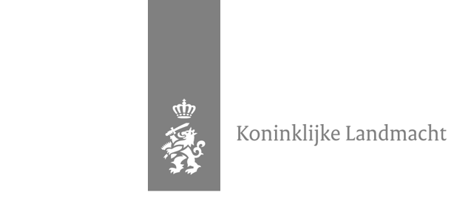

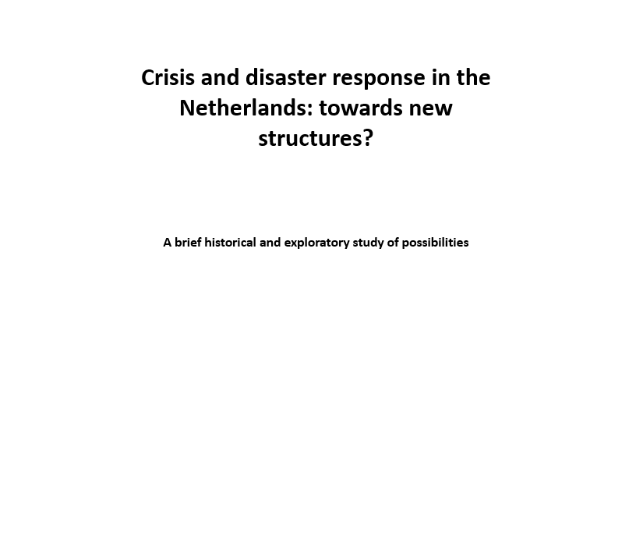
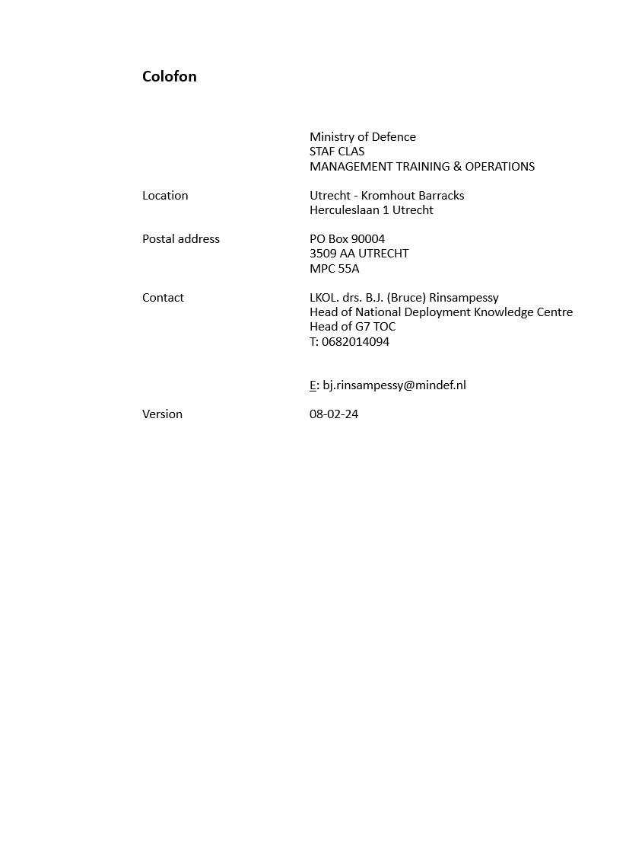
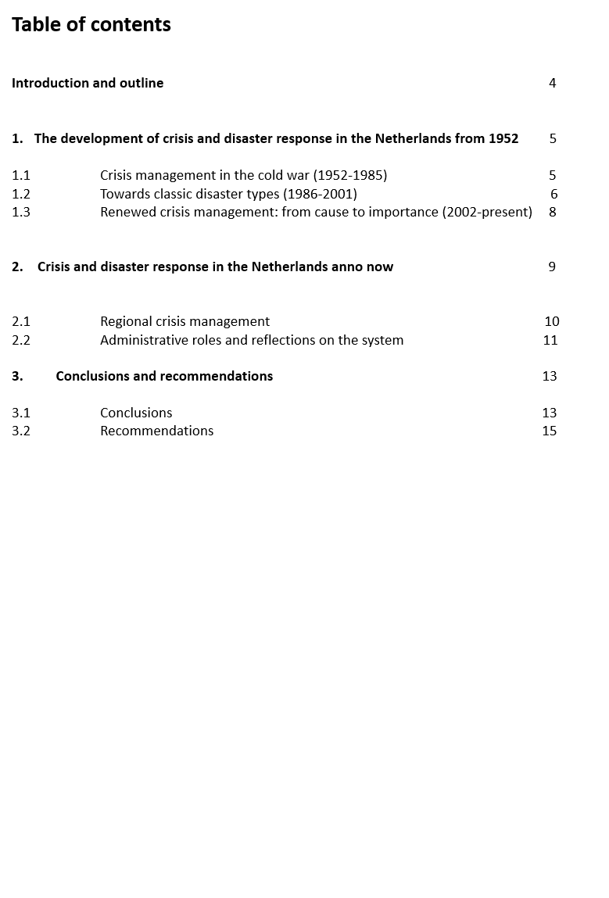

Introduction and outline
The Netherlands can be called vulnerable due to its geographical location, population density, technology, industry, open (digital) structures and economic interconnectedness. The impact when disruptions occur for the Netherlands are significant. It is not only major disasters and crises that are disruptive to Dutch society. Incidents such as major accidents, settlements in the criminal circuit, increasing polarization, climate activism or threats to government personnel can also be disruptive, hindering the normal performance of government tasks and potentially disrupting the functioning of Dutch society. For this reason, governments have mapped and elaborated the risks as much as possible in, for example, crisis plans, contingency plans and incident response plans. Incidentally, this trend is not limited to the Netherlands. Developments around the world are causing countries to prepare for times of need in the background. And that is no unnecessary luxury in the current era. Berndtssen (2023) argues that government organizations worldwide are increasingly trying to promote cooperation with other public and private parties to be better prepared for the undesirable. But, what plans has the Netherlands already made to be better prepared and equipped in times of emergency or war? And, what is necessary to make existing structures work better in the Netherlands? The aim of this report is therefore to provide insight into how the Netherlands has developed and is currently functioning in the area of crisis and disaster relief, in order to recognise and explore from there where opportunities for improvement for the government can be seen. Also, the sources, conclusions and recommendations used in this report can serve operational and educational purposes, as well as serve as input for discussions and debates. The central question in this report is as follows:

- What is needed to make the existing crisis and disaster structures in the Netherlands work better?

In addition to using data from previously conducted research on this topic, this report will refer to academic work, including (among others) Cohen (2019), Spithoven et al (2022), Boin, et al (2019) and Van der Boom (2000). In addition to these sources, other relevant (internet) sources and practical experiences gained by the author over the years will be used to answer the central question. In order to answer the central question, it is also important to set out the historical and contemporary perspective on crisis and disaster structures. Therefore, the first research question addresses the historical perspective and the second research question describes the present. Then, from these perspectives, the literature, research already completed and policy documents are jumped to conclusions and recommendations for discussion. The research questions are as follows and are answered respectively in sections 1-3:

- How has crisis and disaster response in the Netherlands developed since 1952?
- What does the current system of crisis and disaster response in the Netherlands look like?
- What conclusions and recommendations can be formulated?
1 The development of crisis and disaster relief in the Netherlands from 1952 onwards
In order to be able to make valid recommendations to improve the current system in the Netherlands, it is important to explain how crisis and disaster relief has developed: ''study the past to understand the future''. Three distinctive periods can be identified from the year 1952 onwards. The paragraphs below outline these distinctive periods (Rinsampessy, 2022).

1.1 Crisis management in the cold war (1952-1985)
On 10 July 1952, the Protection of Population Act came into force. This made the ‘’Bescherming Bevolking’’ (hereinafter BB) as an organization a reality. The BB was established to protect the Dutch population against enemy air attacks. The organization of the BB was assigned the important task of ensuring that, in wartime, social life behind the military front could continue as normally as possible by, for example, providing assistance to the population. This mainly achieved that the resilience of the population, despite all the possible horrors that wars could bring, would remain unbroken. In addition to the aforementioned wartime tasks, tasks were later assigned at the time of peacetime disasters (Ministry of the Interior, 1952). However, the BB was primarily responsible for putting out fires, rescuing people in distress and supporting the population at the time of threats of war or the consequences of acts of war (Ministry of the Interior, 1952).

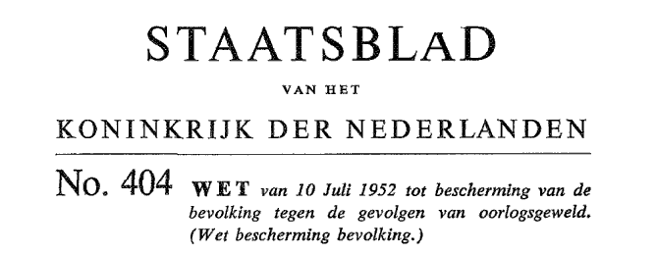

Figure 1:The official publication of the central government in 1952.

The BB was not a military organization, but an organization of voluntary civilians to provide assistance to fellow citizens during times of war disasters. The Ministry of the Interior wrote the following about the BB in its 1952 policy plan:

''However powerful the military air defenses may be, it is certain that enemy air formations will often succeed in breaking through the air defenses, albeit only partially. We must take into account that an unexpected new war will again be "total". The adversary will also seek his objectives behind the front line and therefore will not spare the hinterland and the population. The aim now of the BB organization is to minimize the effect of any enemy air attacks on the "home front" (Ministry of the Interior, 1952).''

Just before the creation of the BB in, the Dutch government had the so-called ''air protection service'' (LBD), which aimed to protect civilians from air attacks (Van der Boom, 2000). However, this organization proved to function inadequately. The LBD was therefore disbanded shortly after World War II. Given the increasing threat of the Cold War, the urgency grew to create an organization to protect Dutch civilians: the BB. The BB was thus to protect civilians from air attacks and was also called ''civil defense'' (Hooiveld, 2008). Civil defense comprised the set of non-military measures aimed at the continuation and maintenance of society in case of war or its consequences (Minister van Volksgezondheid, Welzijn en Sport, 2008). The BB can be seen as part of the broader principle that comprised ''civil defense''. Examples of projects that fell within civil defense were: creating port facilities, procuring equipment for surgical teams, building shelters and procuring materials to extinguish fires and rescue people during emergencies (Ministry of the Interior, 1979). The BB was thus part of civil defense and was particularly repressive in nature. Guidelines were also issued to protect buildings from air raids. Thus, deployment during wartime conditions was mainly taken into account. Deployment in peacetime, for instance during a major fire, hardly played a role in the early days of the BB (Hooiveld, 2008).
The organization of the BB was clearly related to the fact that the Netherlands is a decentralized unitary state. The Netherlands has the national, provincial and local (or municipal) levels. The interior minister directed a national commander, who in turn directed the provincial commanders. At the municipal level, so-called ''block squads'' existed that, for example after an air raid, had to rescue, evacuate and care for civilians (Hooiveld, 2008). A so-called block consisted of a number of streets where together about 1,000 people lived. Each block had a block team consisting of about 20 people. A block team consisted of a block chief and his deputy, 4 first-aiders, 6 fire guards, 6 rescuers and 2 reporters (Van der Boom, 2000). The reporters supported the block chief in exploring the ''block'' (Hooiveld, 2008). It thus consisted of a rescue service, a fire service and a first-aid service. At the local level, the block and district squads were managed by an appointed Head of Population Protection (HBB). The HBB was appointed by the mayor/mayors within a particular disaster area. This person was assisted by commanders from the various services namely, the fire chief, the commander of the Clearance and Rescue Service, the Police Commissioner, the head of the Medical Service and the head of the Social Care Service (Leverink, 2010). At the BB's peak, some 165,000 people were involved in its activities. Although the BB had proved its usefulness during the 1953 flood disaster, a decline in its popularity followed in the following years. There were increasing doubts about the effectiveness of the BB and sources implicitly suggest that the BB may have been created as a symbolic government policy and deterrence strategy (Van Run, 2000). The number of volunteers declined over the years and (perhaps with it) so did political support. After all, around 1980, the threat of war to the Netherlands decreased significantly due to decreasing (political) tensions between east and west. The effect was that less money was set aside for the BB. Incidentally, this also played out in the 1960s. At that time, for instance, there was already a lack of materials, which obviously influenced the decrease in volunteers (Van Run, 2000). In 1980, Home Affairs Minister Hans Wiegel sorted out that the BB would eventually cease to exist. In the process, the BB's tasks would be transferred to the regional fire brigade, the medical services, the red cross and the mobile corps. However, the formal dissolution of the BB lasted until the year 1986. In that year, the BB ceased to exist (Van Run, 2000).
In summary, the following characteristics for the period ''Cold War crisis management 1952-1985'' can be described:

- Fear of war and natural disasters;
- Distinction in peace and war situations;
- Fixation on a foreseeable crisis;
- The role of the fire brigade is defined by law;
- Responsibility lies with the central government.

1.2 Towards classic disaster types (1986-2001)
The year 1985 actually marks the starting point of a new period in crisis and disaster response in the Netherlands. Indeed, in that year, the Disaster Response Act (WRZO) and the Fire Services Act formally came into force (Hooiveld, 2008). The main principles of both laws are as follows: disaster relief is a municipal responsibility and the day-to-day emergency services (police, ambulances and fire brigade) form the basis for disaster relief. Here, the fire brigade is the spider in the web for disaster relief in the preventive and repressive sense and thus forms the operational core (Lower House of the States General, 2007). Coordination and operational leadership had to be ensured within this organizational structure. This was to be shaped by the fire brigade. It was eventually determined that the operational leader would not be in direct charge of other services (Groot and Helsloot, 2018). Therefore, truly central operational leadership was not yet in place. In 1982, the National Firefighting Academy determined that the "supreme command is minus the how and with what". This put the operational leader in charge of the fire brigade at the time of crises and disasters, but did not rule over the other partners. By the Public Health Service (GGD), for example, the operations leader was not always recognised it appears (Groot and Helsloot, 2018). This may have been partly because other emergency services prioritized independence and wanted limited guidance from the fire brigade. The new and unfamiliar organizational structure was not (yet) loved.
Two years before the Disaster Act and Fire Services Act became effective, the project reorganization of disaster relief started in 1983 (Groot and Helsloot, 2018). The aim of this project was to effectively (re)design and set up the new disaster response organization based on the new legislation. Within this, the principle of ''unité de doctrine'' was applied. Indeed, underlying this is a question, namely: how can all organizations form one organization at a time (the so-called hour U)? The answer to this question was found by looking at the organization and performance of the Dutch armed forces. By clarifying the supreme command (which is strategic in nature), the operational, tactical and technical levels, so-called ''unité de doctrine'' was pursued (Groot and Helsloot, 2018). This produced the organizational structure below (see Figure 2) that can be seen as the ''red-painting of military blueprints'' (Scholtens, 2007). In this, the operations leader was given a different role. For instance, the operations leader had to start translating policy decisions into operational orders. Here, the municipal fire brigade commander retained supreme command unless otherwise determined by the mayor. In this, the first split between the municipality as an entity and the formation of a safety region can be observed. This was reflected in 1990 in the decision that made the regional fire brigade responsible for disaster preparedness. However, the operations leader was provided by the municipal fire brigade (Groot and Helsloot, 2018).

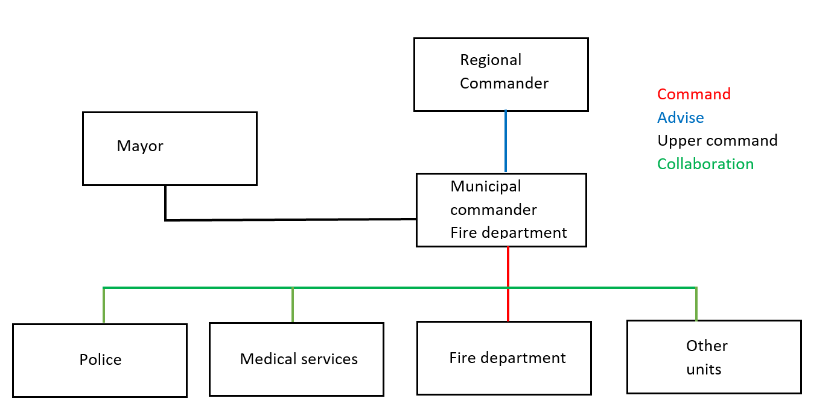

Figure 2: Unité de doctrine.

In summary, the following characteristics can be described for the period 'towards classical disaster response for 18 disaster types 1986-2001':

- 1986 dissolution of the ‘’Bescherming Bevolking’’ (BB);
- Preparing for 18 classic disaster types;
- Performing from 'small to big';
- Responsibility lies with the municipality;
- Complex operational and managerial management;
- Multidisciplinary cooperation is gaining ground.

1.3 Renewed crisis management: from cause to importance (2002-present)
Despite efforts to aptly shape the disaster organization, several critical evaluation reports on incidents that took place during this period are brought out in the period from 2000 to 2004. Take, for example, the report by the General Audit Office in 2001, which found that cooperation was difficult to achieve and that a systematic risk policy was lacking (Ministry of the Interior, 2003). This picture was also confirmed after the Enschede firework disaster (2000) and the Volendam café fire (2001). Here, it was indicated that administrative and operational cooperation was partly lacking and that too few exercises were carried out (Lower House, 2001). This led to the need to further professionalize the existing disaster response. Earlier, this was also cited in the Disaster Response Policy Paper. To achieve further professionalization, the Disaster Response Quality Promotion Act (WKR) came into force in 2004. The WKR led to amendments to the 1985 Fire Services Act, the Disasters and Serious Accidents Act, the Ambulance Transport Act and the Medical Assistance Act. It thus promoted the quality of disaster response through a planned approach and the tightening of provincial supervision. The Act also aimed to increase risk awareness among all parties involved, more multidisciplinary cooperation, better supervision, integrated planning by the regional board of the fire brigade and better quality assurance (Groot and Helsloot, 2018). This with the aim of avoiding complex legislation and, as stated earlier, promoting multidisciplinary cooperation (Ministry of the Interior, 2009). In 2004, the minister of interior also used the authority obtained from the Fire Services Act (1985) to define the territorial division of the fire brigade and GGD/GHOR regions (Van Veldhuisen et al., 2013). This dovetailed with the 25 realized police regions. In addition to the Disaster Response Quality Promotion Act, the Cabinet position on Safety Regions appears in response to the Enschede and Volendam disasters. Within this position, it is once again emphasized that the current disaster response system is not functioning sufficiently. The ultimate goal of this position is to achieve a more collaborative approach. By this is meant: locally where democracy demands it and it is effective, regionally where effectiveness and efficiency demands it and it is democratically justified. It is important to mention that this position does not yet address the later Safety Regions Act. This position mainly focused on adapting existing laws and regulations (Van Veldhuisen, 2013).
In 2004, the Crisis Management Policy Plan became effective to ensure that, despite many innovations and efforts, disaster management is better organized. The aim of the policy plan was to be better prepared for future crises. Evaluations of, for example, the attack on the WTC towers in New York, The War with Iraq, Avian Influenza and the threat of the SARS epidemic, showed that the existing disaster response system was inadequately tailored and prepared for contemporary threats that were more complex and large-scale than ever before (Van Veldhuisen, 2013). It also appeared that disaster response was still too much oriented towards classic disasters (see section 1.2) and that steering was too unclear and non-committal (Ministry of the Interior, 2004). The policy plan also addressed vital interests that ideally needed to be protected. Protecting Dutch vital interests through crises and disaster relief, already written about in 1997, was explicitly mentioned in this policy plan. In it, the Safety Regions were to be at the heart of the crisis management organization. A clear link was made in the Crisis Management Policy Plan between the vital interests (referring to the national security policy) of the Netherlands and the crisis and disaster response system. After the government had given its thinking on the organization of crisis and disaster response, a third report was prepared by the Inspectorate for Public Order and Safety (IOOV), which contributed to the formation of the Safety Regions (Van Veldhuisen, 2013). Within this report, it looked at the municipal management of the fire service and also at the entire administrative system of the fire service. It turned out that the fire service and its organization within municipalities was not high on the agenda. However, it would not be long before this tilted (Van Veldhuisen, 2013).
In summary, the following characteristics can be described for the period 'renewed crisis management: from cause to importance 2002-present':

- From cause to importance;
- Disaster response organization to 'small to big' organization;
- Responsibility disaster response from national government, to municipality, to Safety region (Wvr);
- Multidisciplinary (and supra-regional) cooperation was further professionalized.

2 Crisis and disaster response in the Netherlands
In 2003, the civil-military cooperation agreement was signed at the national level in the Netherlands by the government (parliamentarymonitor.nl, 2023). The year 2003 can therefore be considered the formal start of the further development of, among other things, civil-military cooperation in the Netherlands. Around the same year, the first contours of so-called security regions also became visible, in which the armed forces took on a structural supporting role over the years. The Safety Regions Act (Wvr) in 2010 formalized this structure and to this day forms the basis for the disaster response and crisis management system and thus the way regional crisis management is organized (Wetten.overheid.nl, 2023). The operation of the law ensures efficient and decisive emergency assistance (VNG, 2023). The Wvr aims to provide a legal basis for disaster response and crisis management in the Netherlands. It was abundantly clear that the pre-2010 disaster and crisis organization of governments did not provide sufficient solutions for more complex and far-reaching incidents such as the aforementioned fireworks disaster in Enschede in 2000 (Enschede.nl, 2023). The aim of the Wvr is to achieve an efficient and high-quality organization (Overheid.nl, 2020). Figure 3 shows the geographical division of the 25 safety regions.

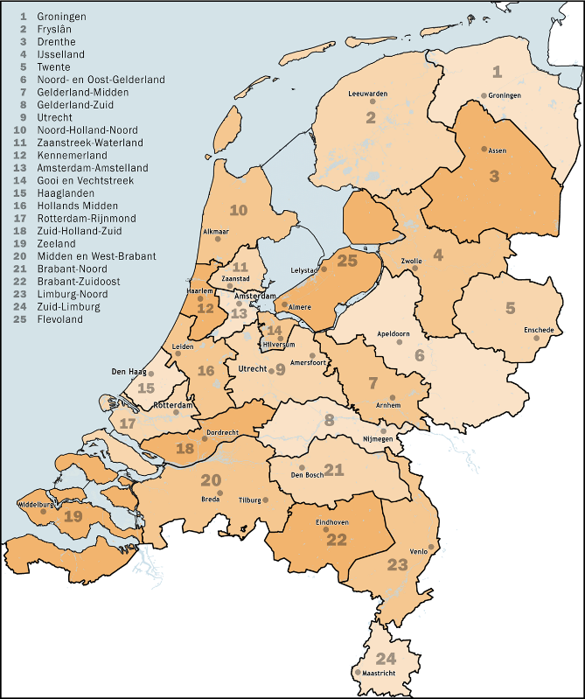
Figure 3: The 25 safety regions in the Netherlands. See also:
https://www.veiligheidsregioflevoland.nl/organisatie/

2.1 Regional crisis management
The safety region is a public body for safety care, based on joint arrangements (VNG, 2023). Safety regions enable multidisciplinary cooperation between crisis partners and ensure that assistance is provided where and when it is needed (VNG, 2023). In addition, the safety region has a directing function in the field of (physical) safety, has the necessary expertise and is a place where networks come together (Spithoven, et al, 2022). The safety region consists of a board, the Fire Service and the Medical Aid for Accidents and Disasters (GGD/GHOR). The board is formed by mayors of the participating municipalities and is responsible for establishing and maintaining the fire service, the GGD/GHOR, preparing for crises and disasters and organizing disaster response and crisis management. It is also charged with other tasks mentioned in section 10 Wvr (Spithoven, et al, 2022). The fire brigade mainly carries out fire fighting and emergency assistance. In addition, the fire brigade performs other tasks within the framework of disaster relief and crisis management as laid down in section 25 Wvr, with the fire brigade increasingly focusing in recent years on (fire) prevention and proactively, so that fires and calamities do not occur. The GGD/GHOR is legally charged with coordinating and directing medical assistance and advising other authorities and organizations. Unlike the fire brigade, the GGD/GHOR is not a large stand-alone organization, but more of a (private) network structure that directs other medical assistance organizations in case of scaled-up care (Spithoven, et al, 2022). The police are responsible for maintaining public order and security based on the Dutch Police Act. The police have ten regional units and their own structure to act quickly and adequately in large-scale order and security situations (Spithoven, et al, 2022).
Incidentally, these regional police units are not congruent with the 25 safety regions in the Netherlands. It is worth pondering whether this should be the case in the future. Finally, it is important
to note that safety regions work closely with security partners such as: the armed forces, water boards, power companies and telecom providers. Which parties are cooperated with during a disaster or crisis obviously depends on the nature and scope of the incident. Figure 4 shows which safety region cooperates with units of the Netherlands armed forces. The three operational brigades in the Netherlands are linked to safety regions through (at least) 25 liaison officers. In this way, the armed forces actively participates in the planning of safety regions and there is the possibility of requesting military assistance or support via the liaison officers if this is deemed necessary.

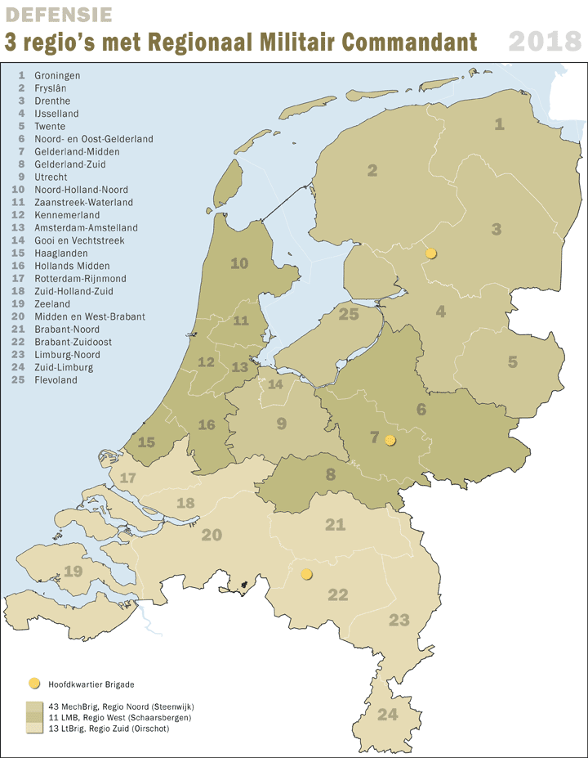

Figure 4: The relationship between military brigades and the 25 safety regions in
the Netherlands. North and part of central Netherlands fall under the 43e brigade, parts of west and east Netherlands fall under the 11e brigade and south Netherlands fall under the 13e brigade. A battalion of the National Reserve is integrated into each brigade. See also: https://www.defensie.nl/onderwerpen/taken-in- netherlands/collaboration-for-security and https://www.defensie.nl/organisatie/landmacht/eenheden/natres

2.2 Administrative roles and reflections on the system
Local, regional and national administrators play an important role in disaster response and crisis management in the Netherlands. Table 1 provides a brief overview of the formal responsibilities, tasks and powers of various actors in crisis management and disaster response at the three aforementioned levels (Spithoven et al, 2022).

Level | Director | Responsibilities, powers and duties
Local | Mayor and aldermen (B&W) | - The mayor may issue any orders or rules he deems necessary in the event of a disaster or major accident (Articles 175 and 176 of the Municipalities Act).  - The mayor has supreme command in the municipality (Article 5 Wvr).  - There is coordination on enforcement in the local triangle between mayor, prosecutor and police, among others.
Regional | Chairman of the safety region (VZ VR) | - If, in the opinion of the chairman of the safety region, a disaster crosses municipal borders, he or she will convene the Regional Policy Team and be given the authority to act on behalf of the municipalities for  the whole area to take decisions (Article 39 Wvr).
Regional | The board of the safety region (safety administration) | - Is in charge of preparing to combat disasters and crisis situations (article 17 Wvr).  - Establishes a crisis plan for the entire area of the region: an organizational overview that regulates responsibilities, powers and tasks at the time of disaster and crisis management.  - Establishes a region-wide policy plan based on an inventory of risks (risk profile).  - Prepares an emergency response plan for any disaster whose location, nature and consequences are foreseeable.
National | The commissioner of the king (cvdK) | - Can issue policy instructions to mayors on behalf of the minister (section 42 Wvr).  - Does not have an operational organization or team and has no line of command with the operations leader (OL).
National | Minister of Justice and Security (J&V) | - Can issue policy instructions to the chairman of the safety region via the CdK (article 42 Wvr).  - Sets policy in consultation with relevant counterparts; in this case, coordination is done from J&V's National Crisis Centre (NCC).

Table 1: The formal responsibilities, powers and duties in crisis management and disaster response (Spithoven et al. 2022).

The Netherlands has a national crisis structure in addition to local and regional ones. This structure can be activated in situations of urgency, where national security or safety is at stake or where there is a major impact on society (such as the Corona pandemic). These are mostly situations where Dutch established security interests are at stake (Hasselman, 2023). Dutch security interests are as follows: a] territorial security, b] physical security, c] economic security, d] ecological security, e] social and political stability and f] international rule of law (NCTV, 2022). In such situations, regular (regional) structures and procedures are no longer adequate (NCTV, 2022). When this occurs, it may be desirable for the central government at a high official and political-administrative level to ensure coordination and decision-making for an intended coherent approach. The Minister of Justice and Security (J&V) is coordinating minister for crisis management. The minister bears responsibility for the organization, functioning, coherence and integrated approach of crisis management policy and the associated system. With coordination and decision-making at a high official level (Directorate-General level), response activities are carried out and coordinated by and from the Departmental Crisis Coordination Centre (DCC). Each ministry in the Netherlands has a so-called DCC so that striking measures can be taken from its own policy area. J&V has the National Crisis Centre (NCC) attached to the National Coordinator for Counterterrorism & Security (NCTV). The NCC supports the national crisis structure and involves parties with information management, knowledge and facilities (NCTV, 2022). Moreover, the NCC acts as the central point of contact within the central government for all public and private partners. An important spider in the web, in other words. If a more integrated approach is deemed necessary, an Interdepartmental Crisis Management Committee (ICCb) can be convened under the chairmanship of the NCTV. The ICCb can make its own decisions if necessary (NCTV, 2022). For coordination and decision-making at the political-administrative level, the Ministerial Committee on Crisis Management (MCCb) is convened in the Netherlands. If necessary, the MCCb, chaired by the Minister of J&V or the prime minister, decides (by a majority vote) on the set of measures and provisions (NCTV, 2022). These decisions form the framework for implementation by public and private partners. If necessary, the MCCb can deviate from the provisions in the NCTV's National Handbook. Both ICCb and MCCb can invite experts to participate in meetings so that they can provide advice to the committees. This could include representatives of the armed forces, epidemiologists, police professionals, intelligence and security services, but also private partners with some form of expertise (NCTV, 2022). It thus involves an interplay of public and private parties. Figure 5 provides an overview of the system at the national level.

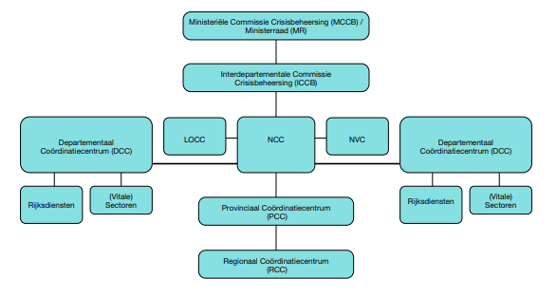

Figure 5. The national crisis system in outline. See also https://www.vrhm.nl/regionaleplannen/crisisplan/3.5.html

The above describes the crisis and disaster response system in the Netherlands. Both at local, regional and national levels, there has been considerable investment in its development over the past 20 years. But, to what extent has this system, which cannot only be considered complex by outsiders, proven effective? Isn't the whole structure organized too complexly? And, how do professionals reflect on the system in the Netherlands? Table 2 summarizes the reflections of (71) crisis professionals working in the system (Hasselman, 2023). It is worth noting that the level of cooperation throughout the entire system is perceived as positive. With regard to organizational structure, it appears that up to and including the regional level, predominantly positive reflections are given and that improvement in supra-regional structures deserves attention. It is interesting to mention that decision-making from supra-regional level is considered moderate and that leadership at the strategic level in particular deserves attention. With regard to the aspects of continuity and development, it is notable that the system is considered sufficiently flexible and prepared, but that there are concerns about the level of functioning when it comes to so-called ''creeping crisis'': crises that develop stealthily and tend to be protracted (Boin, 2019).

Variables | Reflection
Collaboration | The level of cooperation is considered positive.
Organizational structure | The regional level is perceived as positive. Above the regional and national levels requires attention: too complex, politically charged and not organized clearly enough.
Decision-making | Decision-making is organized too hierarchically. As a result, there is insufficient room for initiative at other levels. The higher up in the structure of the system, the more fragmented decision-making becomes. Decision-making at supra-regional and national level scores poorly as a result of political pressure, multiple decision-makers and lack of information.
Leadership | Sometimes decisions are not taken for fear of (political) consequences. Leaders need more direction. Leadership at the strategic level in particular is of insufficient quality. See Annexes 1 and 2 for guidance.
Continuity & development | One area of concern is the flexibility of the system, but respondents said the system provides sufficient action perspective for foreseeable and predictable crises and disasters. Being prepared for the so-called ''creeping crisis'' remains a concern too. Positive developments are: intensifying cooperation is recognised, an eye for (hybrid) threats and cyber exists, the climate and social unrest is receiving attention.

Table 2: Summary of variables studied and respondents' reflections (Hasselman, 2023).

3. Conclusions and recommendations
The central question in this report was: what is needed to make the existing crisis and disaster structures in the Netherlands work better? The sections below present the answer, conclusions and recommendations.

3.1. Conclusions
From the above, it can be concluded that the crisis and disaster response system has developed significantly over a period of 70 years partly as a result of far-reaching events in the past. For example, the BB came into existence in 1952 as a result of threats posed by the Cold War from 1945 onwards, and the crisis and disaster response organization was mainly focused on acting in war situations. However, the need grew in the late 1950s to organize a crisis and disaster response organization in peacetime. Partly prompted by meso-factors such as global industrialisation, the cold war, increasing population growth and intensification of road and air traffic. The cold war, the 1953 flood disaster and the explosions that took place at, for example, Shell Pernis in 1968 reflected this. To cope with these developments, the WRZO Act and the Fire Services Act, among others, came into force in 1985. However, these laws proved to be insufficient and various projects were subsequently launched and ideas were posited for improvement. The Enschede Firework Disaster and the Volendam Café Fire led to even more critical views on the hitherto established crisis and disaster response organization. Thereby, the attacks on the WTC towers and the impending SARS epidemic contributed to pre-existing doubts as to whether the system that existed in the Netherlands was sufficiently capable of being effective. This eventually led to a system with a supra-municipal character. This disaster and crisis organization is now regulated in the 2010 Safety Regions Act. However, what is necessary to make existing crisis and disaster structures in the Netherlands work even better?
First, what has proven necessary in the light of the central question is a historical picture regarding how crisis and disaster structures have developed in the Netherlands. Experience shows that when it comes to past (civilian and military) structures and working methods, knowledge quickly sinks in. It is therefore necessary to look back more often to find solutions for challenges in the present. Explapolation from there can take place. However, it is important to consider the historical context in the current context. Looking at the BB that existed until 1986, for example, it can be argued that given the current context and international threats, such a structure should return. Within the Association of Netherlands Municipalities (VNG), this possibility is currently being explored, rightly so (VNG, 2023). Ideally, a variant of the BB should be organized and embedded at the safety regional or local level. History shows that the nationally organized BB system did not function adequately, resulting in its dissolution. Moreover, if hitching a ride on the safety regional or local structure, volunteers can be recruited locally who, subsequently, can also provide local support in areas familiar to them. To explore this further, Berndtsson's study ‘’Total Defence Forces’’ (2023) offers many starting points.
Secondly, in principle, this report does not explicitly advocate completely new national structures in the field of crisis and disaster management. The existing structures function more than adequately, especially at the regional level (Hasselman, 2023). What does remain a point of attention is the further development of structures above the regional level. Research by Hasselman (2023) shows that it is precisely at that level improvement appears necessary on the variables of cooperation, organizational structure, decision-making, leadership and continuity & development. Looking at how, for example, Portugal organized the vaccination programme during the corona pandemic, it is striking to note that single-headed (military) leadership proved to be a major success factor. The concept of rapidly adaptive organizations also offers solace and deserves exploration (Kalkman, 2023). Top military officer and Admiral Henrique Gouveia e Melo was put in charge of the vaccination programme by the Portuguese government. This proved very successful and shows that military input during a crisis pays off and deserves more attention and further development in the Netherlands too (see also Kalkman, 2023).
Thirdly, based on the above, a somewhat more implicit conclusion can be drawn, namely: the further development of the Dutch armed forces in the system. Currently, the Dutch national government is working hard to create so-called National Crisis Plans (LCPs), which aim to better prepare the Netherlands for disruption and war. LCPs are being written on topics such as extreme violence, cyber and oil (NCTV, 2023). An LCP is also being written when it comes to military threats; the so-called LCP-MD. In principle, these are very positive developments. However, when considering how the Dutch army is currently organized, it can be argued that unbundling the three existing National Reserve battalions from the three existing brigades is a necessity and should be fast-tracked (see also Figure 4). After all, given the current strategy, the three brigades (11, 13 and 43) are meant to operate in unison with German combat units in the east. The three existing National Reserve battalions (10, 20 and 30) are destined to take care of securing vital objects within the country's borders, among other things. And that involves a constitutional duty. The fact that these National Reserve battalions are currently integrated into the three brigades may be considered undesirable. Bringing the three National Reserve battalions together in, for example, a National Command offers room for specific further development, a clear command structure and readiness for deployment within the Netherlands. A National Command is therefore highly recommended (point paper, 2022). Also, it should be noted that the army is currently preparing to operate mainly in the east. As a result, so-called ''east-west'' thinking is emphasized too much and seems to enjoy disproportionate attention. After all, to ultimately be able to operate in the east, it is crucial to first create good (logistical and medical) preconditions in the west. More attention to ''west-east'' thinking within the army (and armed forces) is required and, in the light of the central question, does call for new structures.

3.2 Recommendations
Following the above, the recommendations below can be formulated.

- Realize a national 'Grand Strategy'.
The Netherlands does not have a National Grand Strategy (NGS) that looks up to 60 years ahead and from which coherent sub-strategies are derived (see also Demir, 2018). The highest document in the hierarchy is National Security Strategy (2019), which should be a sub-strategy of the NGS. An NGS could stipulate that 4% of Dutch GNP should be spent on the armed forces in order to realize strategic goals in the NGS. This would allow, for instance, the armed forces to continue developing in a structural and stable way, becoming stronger and more independent of political winds.

- Replace existing supra-regional structures.
Revise the structure at supra-regional level along the lines of existing structures at regional level. Or, replace the structure at the supra-regional level and realize at that level an adaptive (military) structure appropriate to the threat, crisis or disaster. Thus, concretise the concept of rapidly adaptive organizations at the supra-regional level (see Kalkman, 2023).

- Create a BB 2.0.
Intensifying cooperation between government and industry is also highly recommended in this light (see also Berndtsson, 2023). A BB 2.0 also contributes to increasing the social resilience of the Netherlands.

- Unbundle the National Reserve in favor of a National Command.
Although the armed forces are focused on cooperation with Germany, it is important to organize the defense of the Netherlands under a single command. Currently, the National Reserve is organized in a fragmented way. Besides expanding the number of National Reserve units, a National Command is highly recommended (point paper, 2022).

- More joint training, education and practice.
Although predominantly positive, the fact that more joint education, training and exercises are being conducted remains an area of concern. Achieving even more synergy in this area will improve the quality of decision-making and problem-solving capabilities, and organizational units will become more attuned to each other. Small training sessions rather than large exercises are recommended in this regard (Boin, 2019).

- Link the concept of Mission Command (MC) to leadership development.
Although Boin (2019) argues that centralized authority is overrated, applying the concept of Mission Command (MC) is highly recommended during crisis and war situations. MC should receive (even) more attention in the armed forces' educational programmes at the Netherlands Defence Academy and with government partners.

- Invest more in training on leadership and integrity.
Evaluations show that there is no unity of opinion and implementation within crisis and disaster response on the concept of supreme command. Here too, learning from the armed forces proves to be of added value. In this light, it is also important to invest in the concept of integrity. Systematic and daily assurance of integrity in relation to leadership requires not only good expertise and support, but also explicit attention and commitment in the line. Precisely because leadership on integrity does not come naturally, it is important that leaders at all levels continue to develop skills such as moral judgment, moral deliberation, organizing and dealing with contradiction and inclusion and affirming norms. Integrating integrity into human resources policies can achieve this.

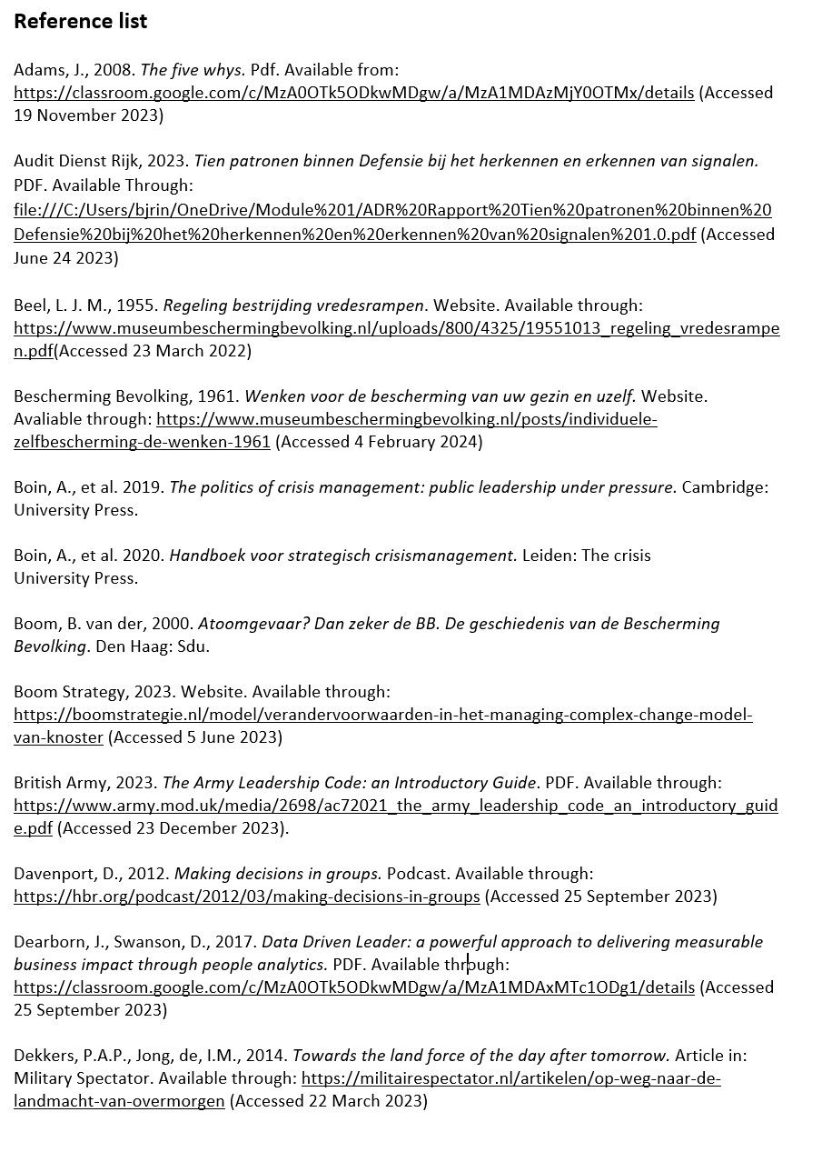
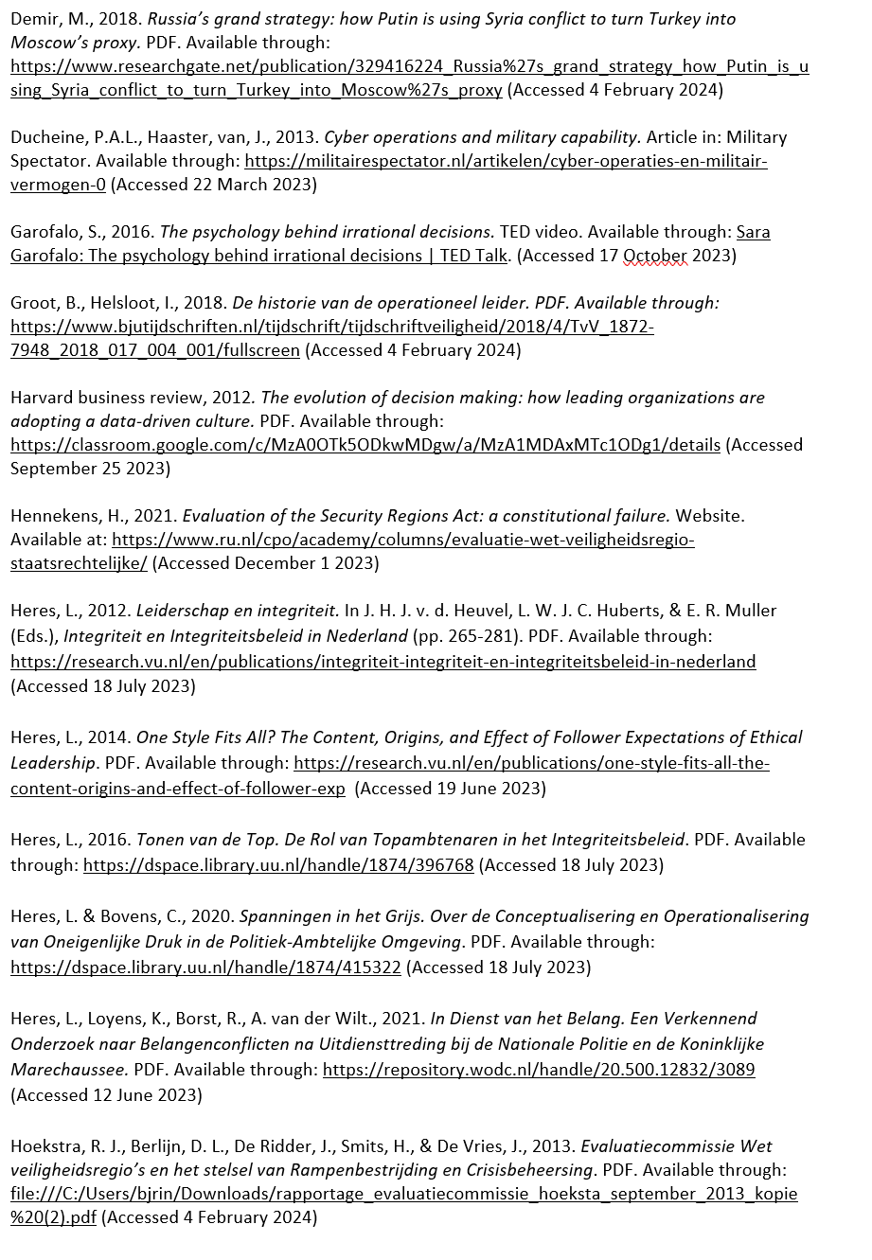
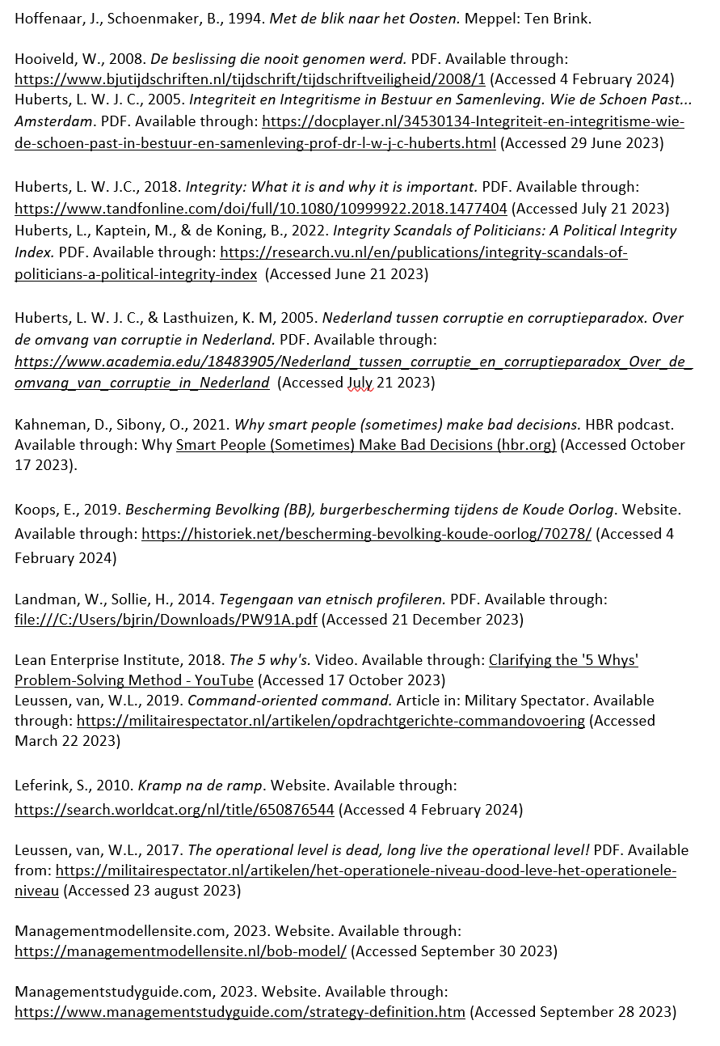
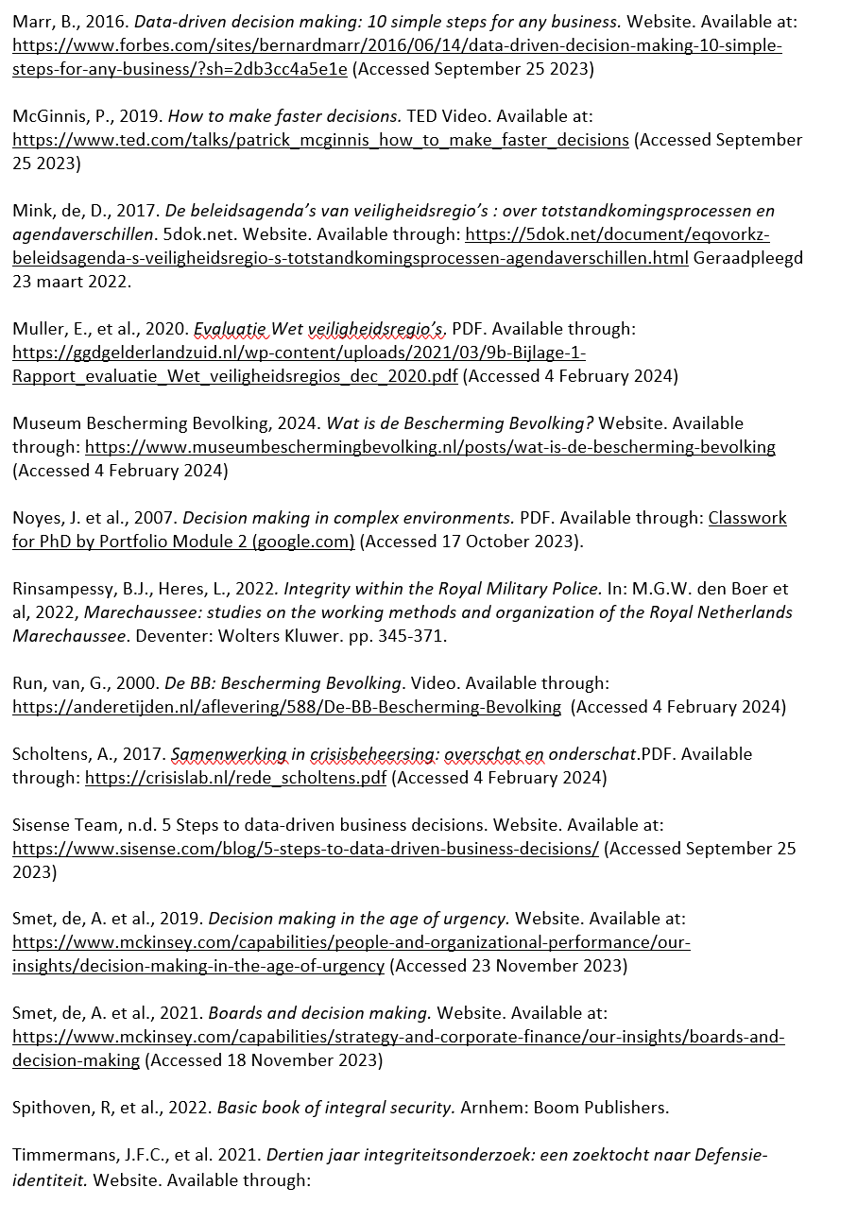
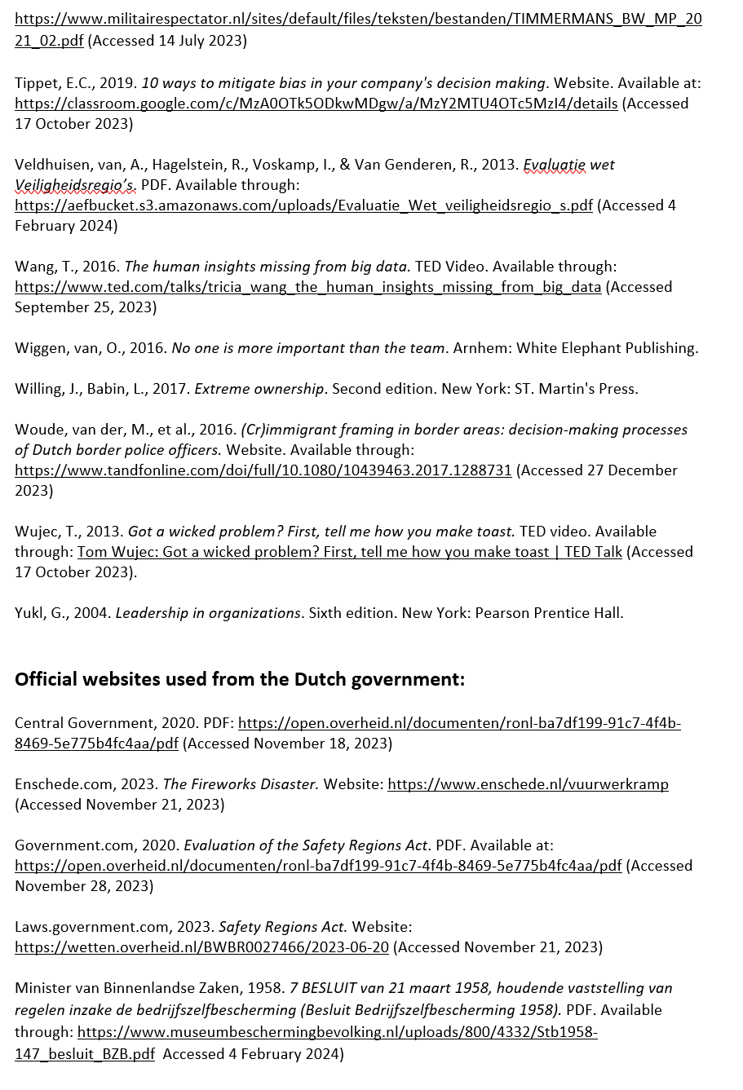
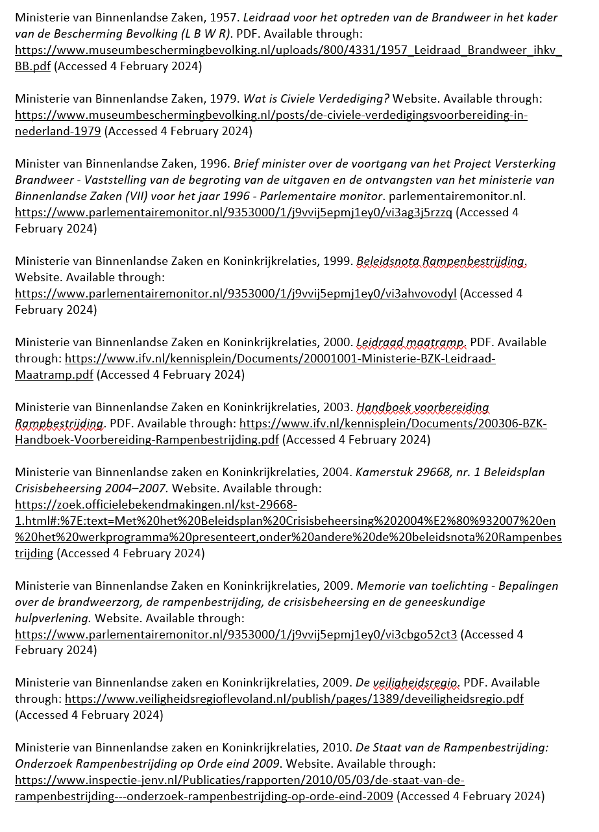

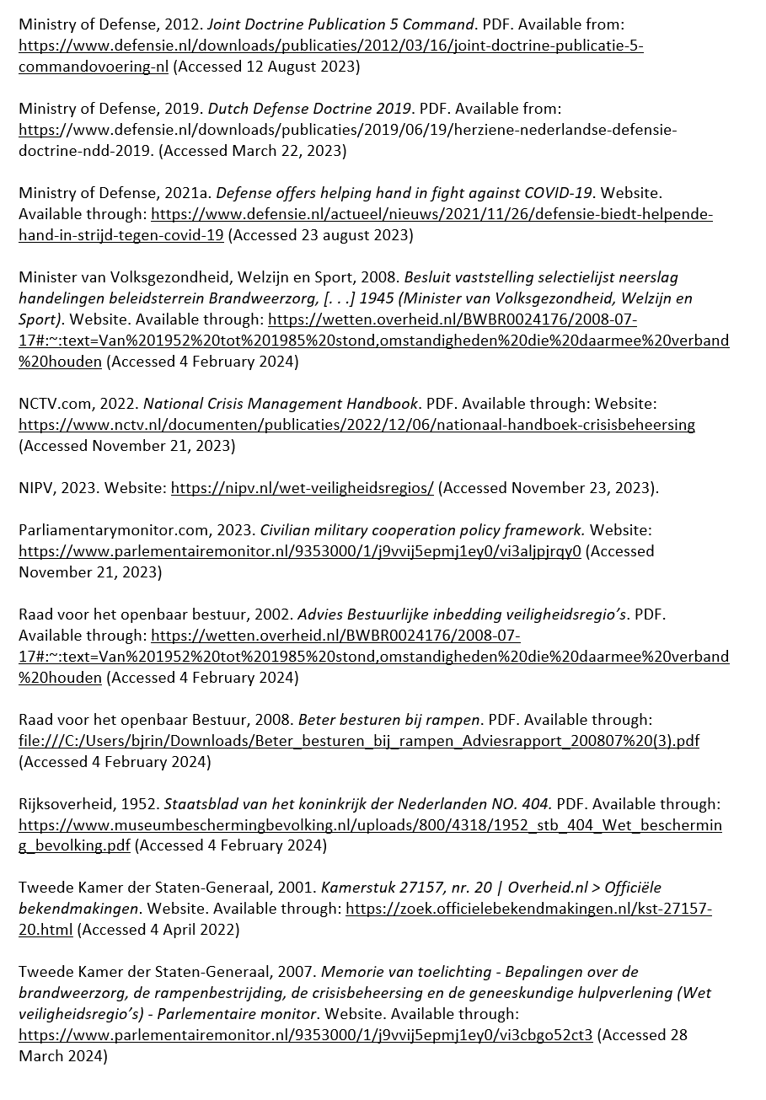

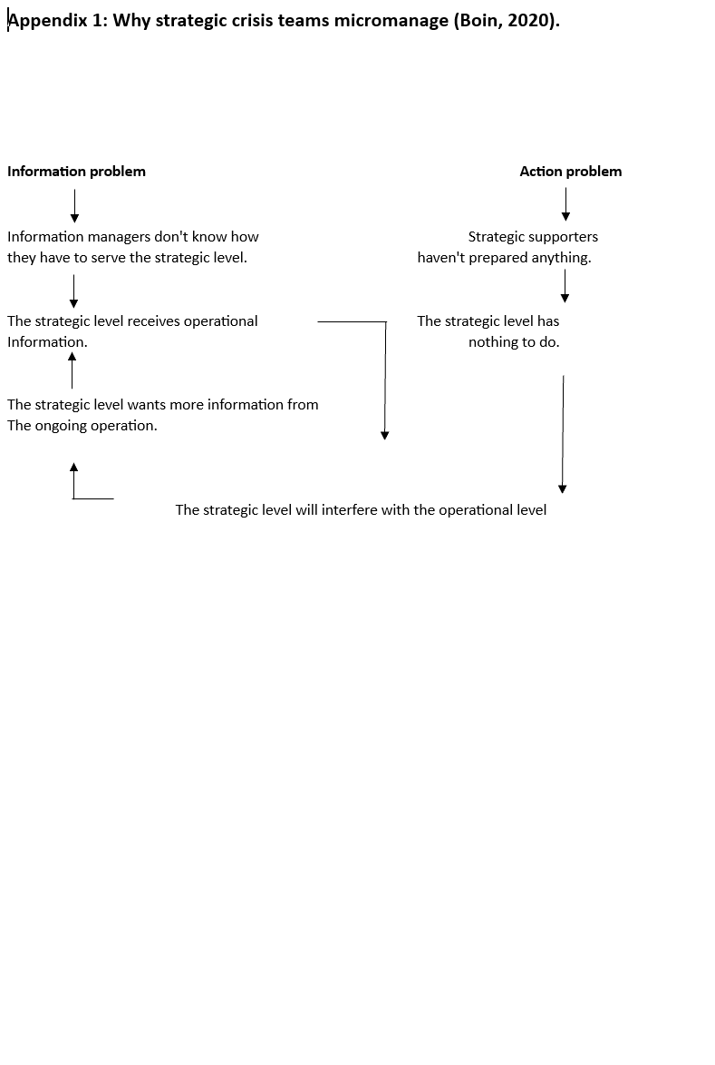
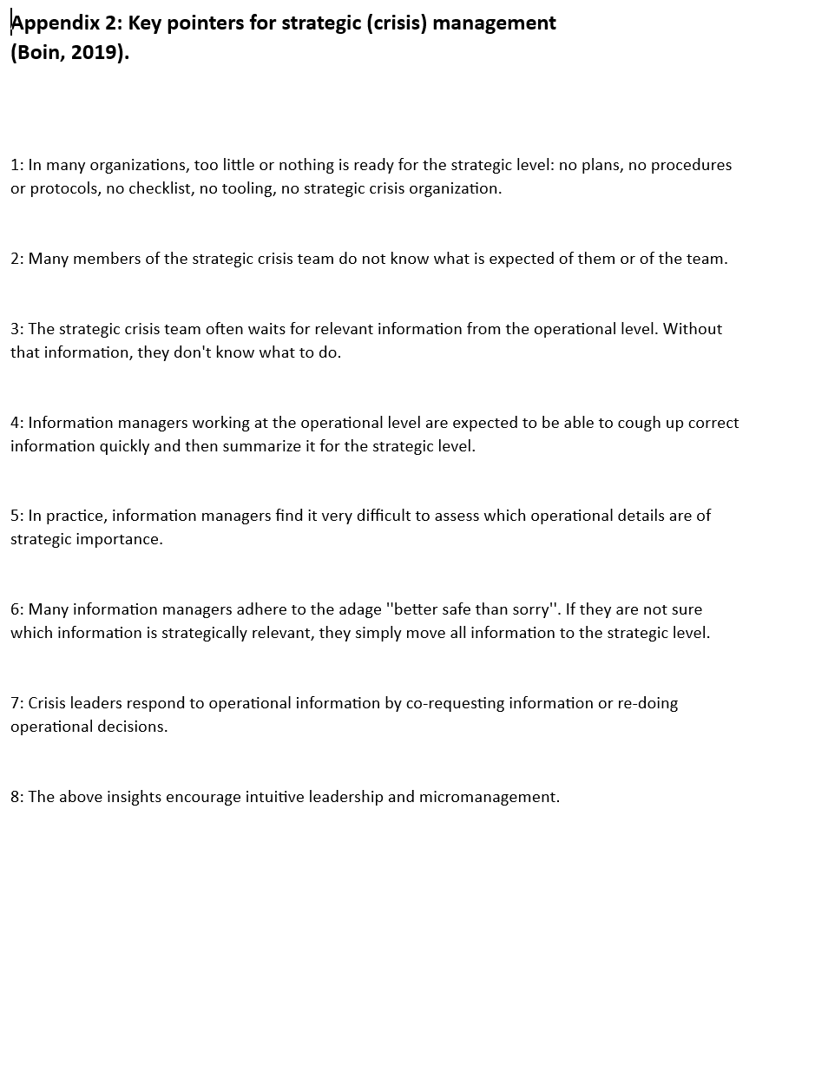

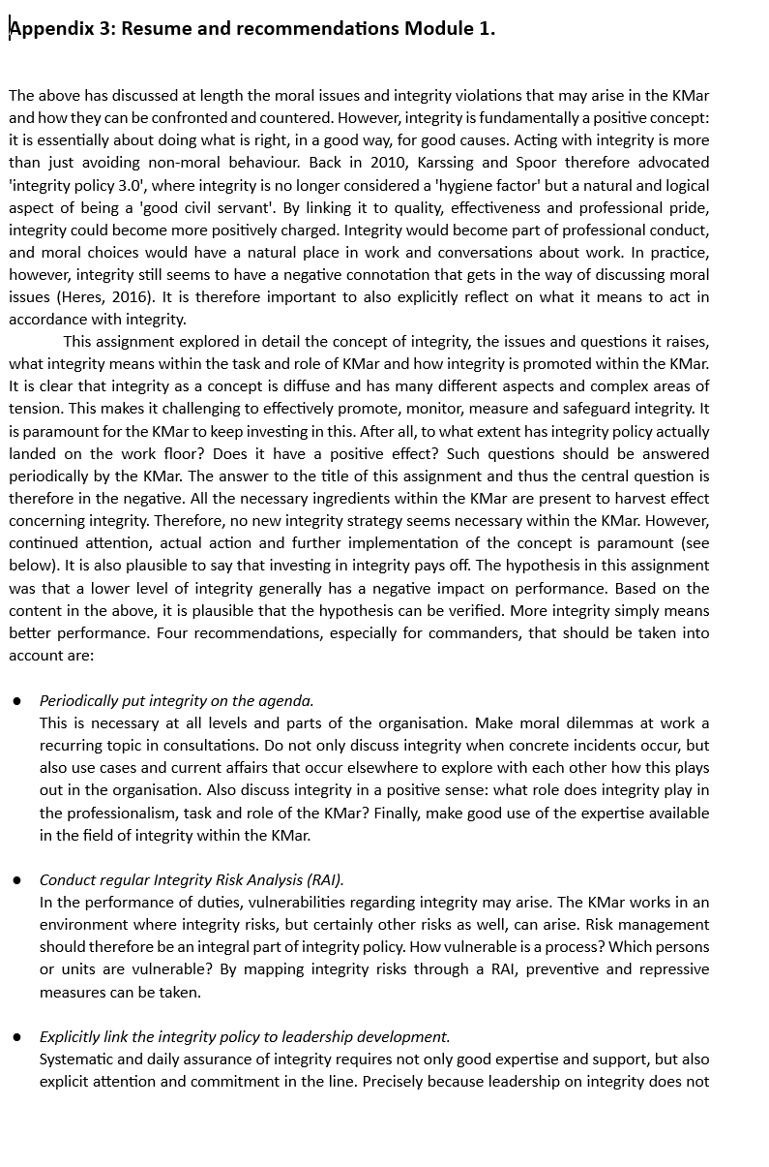
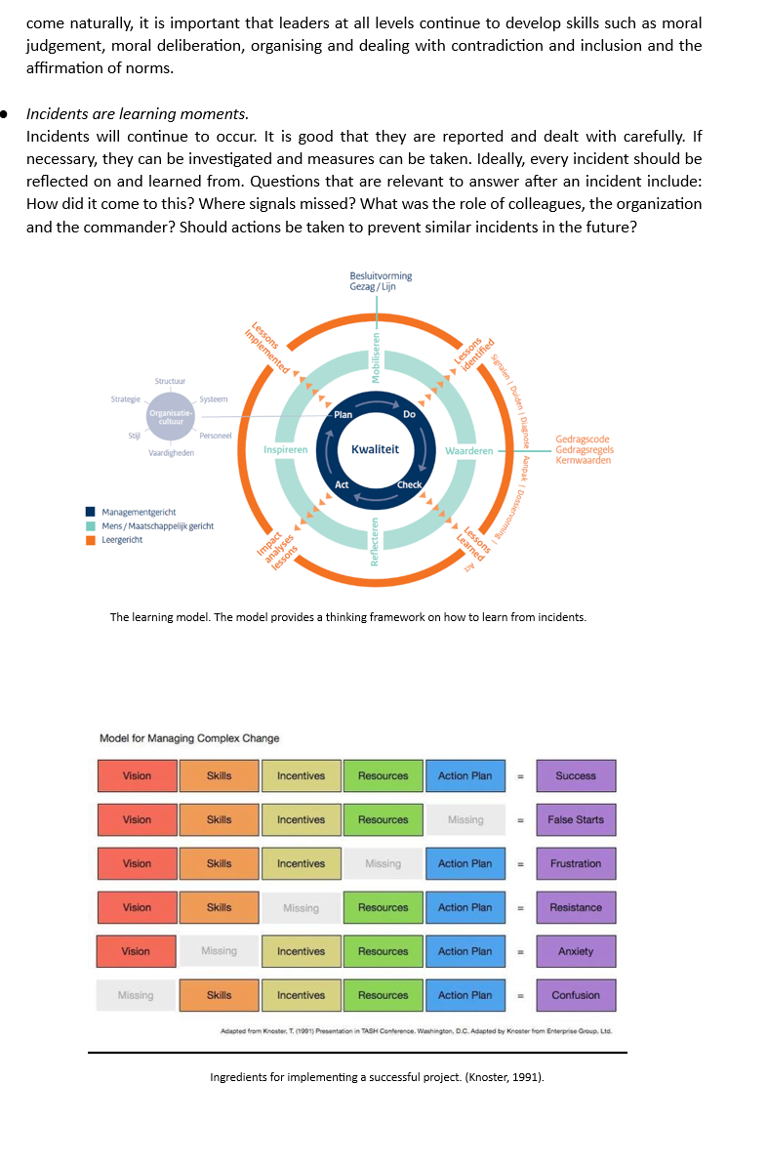
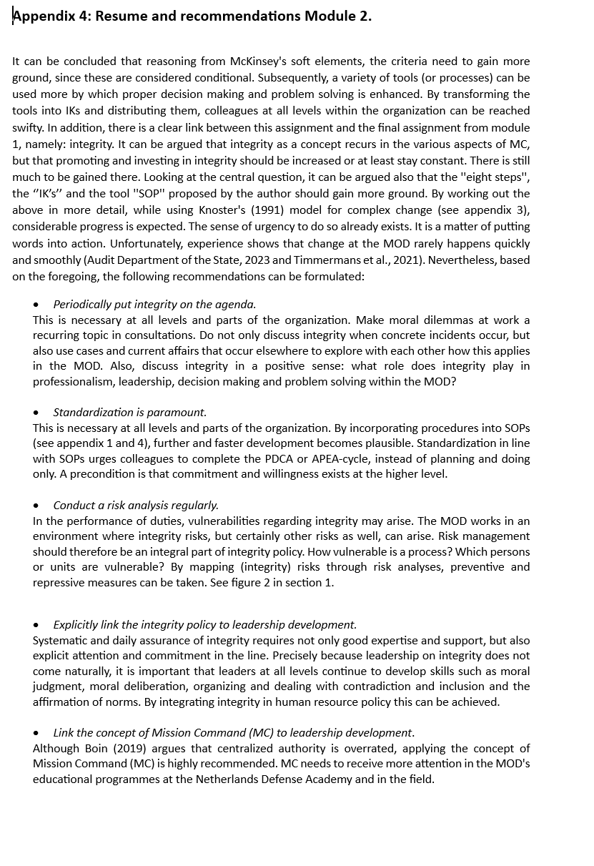
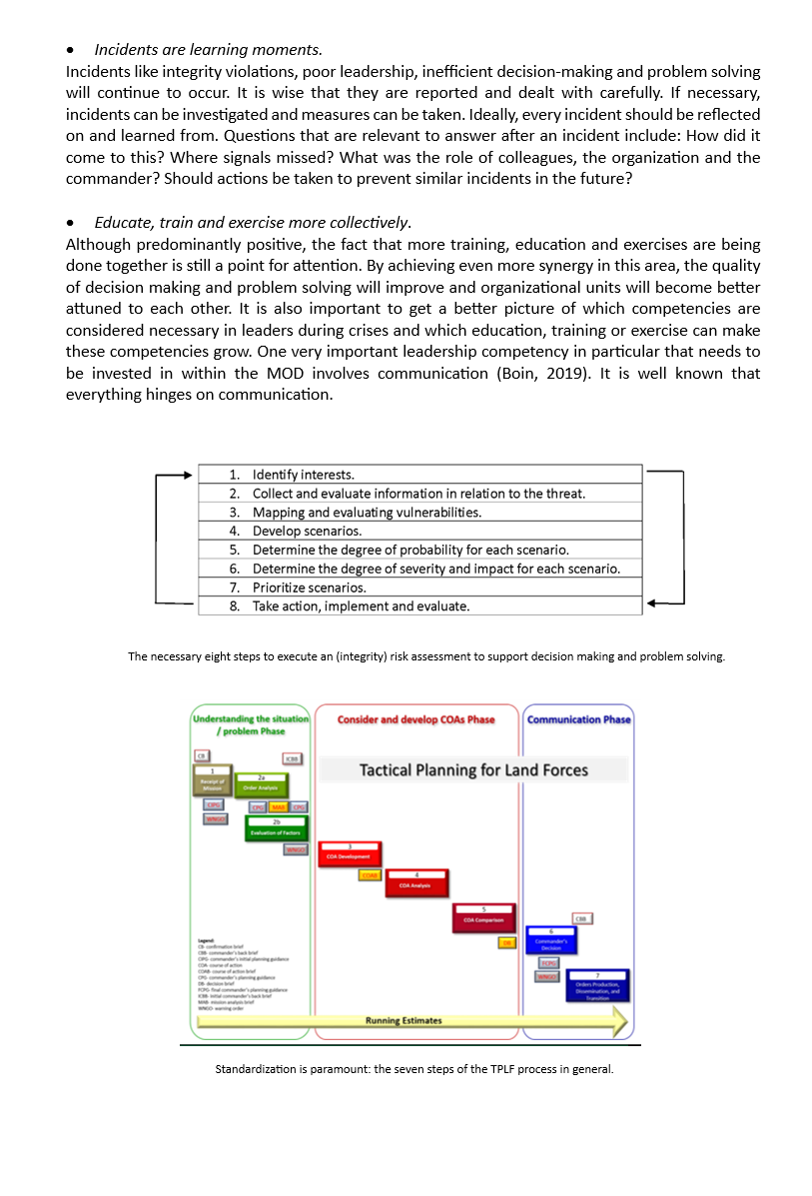

The Protection of Population Act is still in force. Source: wetten.nl - Regeling - Population Protection Act - BWBR0002096 (overheid.nl) (Accessed 24-01-24)
For details, see What is Population Protection? (museumbeschermingbevolking.nl) (Accessed 24-01-24)
See also: 1952_goal_and_design_BB.pdf (museumprotection.co.uk) (Accessed 24-01-24)
See: Information on Staatsblad 1952, 404 | Overheid.nl > Officiële bekendmakingen (officielebekendmakingen.nl) and Staatsblad van het Koningrijk der Nederlanden (officielebekendmakingen.nl) (Accessed 24-01-2024)
See: https://www.museumbeschermingbevolking.nl/ for more information. (Accessed 6-01-2024)
See also : The Cold War - Summary and Timeline | History. The year 1991 marks the end of the Cold War. (Accessed 18-01-2024)
See: https://www.museumbeschermingbevolking.nl/ for more information. (Accessed 20-01-2024)
See also: wetten.nl - Regeling - Wet rampen en zware ongevallen - BWBR0003765 (overheid.nl) and wetten.nl - Regeling - Brandweerwet 1985 - BWBR0003764 (overheid.nl) (Accessed 24-01-2024).
For more background, see 20151002+01+75+years+supervision+of+the+firefighters.p (Accessed 24-01-2024).
See also: TvV_1872-7948_2018_017_004_001.pdf (boomcriminology.co.uk) (Accessed 24-01-2024).
For details, see 18 disaster types: https://archief.nipv.nl/wp-content/uploads/sites/2/2022/03/201012-VROM-BZK-Tab00-Leidraad-Risico-Inventarisatie-deel-Overige-Ramptypen.pdf (Accessed 24-01-2024)
For details, see WKR - Disaster Response Quality Promotion Act :: Mijnwetten.nl (Accessed 24-01-2024).
See also: Minister's letter on implementation Cabinet position on Safety Regions - Safety Regions - Parliamentary Monitor (Accessed 24-01-2024).
For details on the security strategy, see https://www.rijksoverheid.nl/documenten/publicaties/2023/04/03/veiligheidsstrategie-in-vogelvlucht (Accessed 24-01-2024).
See https://nipv.nl/bestuurlijke-netwerkkaarten-en-bevoegdhedenschemas/ for details on administrative network cards. Unfortunately, this site has not been translated into English.
For details, see: https://www.rijkswaterstaat.nl/water/waterbeheer/bescherming-tegen-het-water/watersnoodramp-1953. From the armed forces, 15,500 soldiers were deployed (Hoffenaar, 1994).
For more details, see: https://vng.nl/artikelen/bescherming-bevolking-pleidooi-voor-een-bb-nieuwe-stijl
This is also known as the principle of ''couleur locale'' in crisis and disaster response.
See video on Radical and Swift Adaptive Organising in Response to Unexpected Events by Kalkman (2023): https://www.youtube.com/watch?v=7ZtmZZCExCQ&t=10s
For more details, see: https://www.rtlnieuws.nl/nieuws/buitenland/artikel/5260929/vaccinatie-portugal-militair-corona-sluipschutter. See also https://novalaw.unl.pt/en/admiral-gouveia-e-melo/.
See https://www.denederlandsegrondwet.nl/id/vkjaj9cxqpwx/artikel_97_krijgsmacht. For the purpose of defense and protecting the interests of the Kingdom, as well as for the purpose of maintaining and promoting the international legal order, there is an armed force. The government has supreme authority over the armed forces.
See: https://www.researchgate.net/publication/329416224_Russia%27s_grand_strategy_how_Putin_is_using_Syria_conflict_to_turn_Turkey_into_Moscow%27s_proxy (Accessed 4 February 2024)
See: https://www.linkedin.com/posts/roman-sheremeta-14972a50_brilliant-speech-by-latvias-foreign-minister-ugcPost-7155606944139923457-iLEh?utm_source=share&utm_medium=member_ios (Accessed 4 February 2024)
See crisis management progress NCTV at: https://www.rijksoverheid.nl/documenten/kamerstukken/2023/12/14/tk-voortgang-crisisbeheersing.
See: https://militairespectator.nl/artikelen/civil-defence-sweden-building-resilience-involving-society-whole (Accessed 4 February 2024)
See also: https://www.rijksoverheid.nl/documenten/rapporten/2020/12/04/tk-bijlage-evaluatie-wet-veiligheidsregio-s (Accessed 4 February 2024).
Unfortunately, the national Dutch security interests are not derived from a national grand strategy.

