Building a Distributed Mental Wellbeing Capability Ecosystem:
A Platform Based Business Model Innovation for Mental Health First Aid USA

By Nicole Cadovius, MBA, MSM, FAAIDD

PhD by Portfolio Module 3
Professor Steve Mallon
Swiss School of Business Research
Zurich, Switzerland
February 14, 2026

Introduction: From Training Scale to System Capability
Mental wellbeing has become a structural leadership and organizational challenge in the late 2020s. Anxiety, depression, substance use, and burnout remain elevated following COVID 19, while workforce shortages and access disparities continue to strain clinical systems (World Health Organization, 2022; National Council for Mental Wellbeing, 2023). Demand has not returned to pre pandemic levels; it has stabilized at a higher baseline.
Clinical systems alone cannot absorb this burden. Prevention, early identification, and non-clinical capability must complement treatment infrastructure. Mental Health First Aid USA (MHFA USA) has addressed this gap by training more than 4.5 million individuals nationwide to recognize and respond to signs of mental health and substance use challenges.
The evidence based, internationally licensed curriculum has expanded to over 50 countries, reaching more than 8 million First Aiders globally. Within the United States, MHFA USA is a leader in the mental health sector, offering scalable in person, virtual, and hybrid training options, as well as fourteen evidence based curricula, as seen in Figure 1 (National Council for Mental Wellbeing, 2026).
Figure 1: Mental Health First Aid Course Types and Community Effects
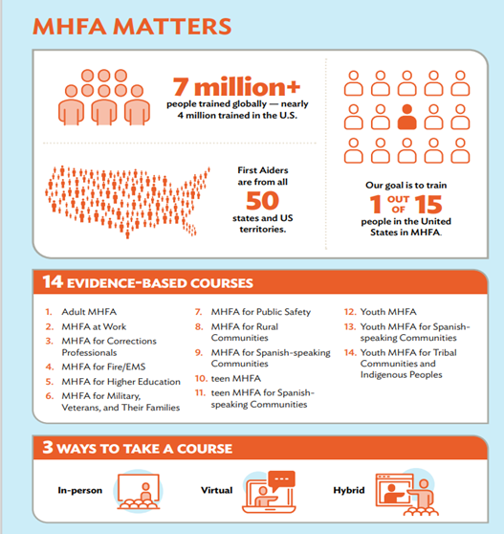
However, simply increasing the scale of training is no longer sufficient in the US. The rise of brief wellbeing workshops, digital awareness modules, and various “wellness” offerings reflects a market preference for speed and convenience, yet many lack strong evidence or ongoing support. Often, organizations implement one off program that demonstrate intent but fail to foster lasting capabilities (Croft et al., 2024; Jones et al., 2019). As a result, MHFA USA now faces an operating model challenge rather than a curriculum challenge.
The central issue is not whether MHFA works, but whether its business model can sustain impact amid ongoing structural pressures.
This paper proposes a structural shift: MHFA USA should transition from a transactional training provider to a distributed capability orchestrator, functioning within a platform led by the National Council for Mental Wellbeing (The National Council), a model Cadovius calls the Distributed Mental Wellbeing Capability Ecosystem. This approach doesn't alter the curriculum, expand practice scope, or involve clinical delivery; instead, it rethinks how value is created, coordinated, and sustained across sectors.
MHFA operates within the National Council, which unites policy expertise, clinical leadership, technical support, infrastructure, and an extensive network of member organizations. These combined assets support a new operational model that emphasizes coordinated support rather than isolated programs. To address increased competition and the demand for ongoing, adaptable learning, MHFA USA can transition from a transactional training provider to a national facilitator of distributed mental wellbeing capabilities, with the National Council serving as a platform.
Instead of centralizing or replacing current systems, the National Council streamlines policy alignment, implementation assistance, and access to educational resources, fostering large-scale collaboration. By leveraging its core strengths, the National Council moves from managing separate programs to cultivating an ecosystem that addresses mental health and substance use needs along the continuum from prevention to treatment.
This Distributed Mental Wellbeing Capability Ecosystem clarifies roles: MHFA’s non-clinical capacity is embedded early in workplaces, schools, and community settings, frequently in partnership with workforce development and peer support initiatives by National Council member organizations. MHFA First Aiders serve on the front lines, offering resources and, when appropriate, connecting individuals with mental health or substance use needs to Federally Qualified Health Centers for integrated care or to Certified Community Behavioral Health Clinics for specialized or crisis services.
This structure ensures ethical boundaries between non-clinical capacity building and clinical care, while improving continuity and fairness of access.
MHFA First Aiders and Instructors are trained to locate local resources, but the National Council’s platform broadens access to a vetted network of service providers and technology partners. While it does not guarantee treatment, the platform increases options and streamlines delivery. It also enables National Council members to adopt advanced technologies that extend the workforce and improve workflows and business processes.
This proposal has been informed by Cadovius’ role as Lead Advisor for MHFA USA within the National Council for Mental Wellbeing, as well as prior executive leadership in large scale system redesign, statewide strategic planning, and technical assistance initiatives. Across multiple roles include directing statewide transformation projects, administering federally and state funded technical assistance centers, and leading cross sector strategic initiatives.

Figure 2 illustrates the Distributed Mental Wellbeing Capability Ecosystem Cadovius's (2026) which underpins the paper’s business model innovation. The model shows MHFA USA as a national orchestrator on a National Council platform, linking community settings with integrated primary care and behavioral health partners. It outlines the pathway from early recognition to clinical care, distinguishes between non-clinical skills development and clinical treatment, and illustrates scalable coordination, governance, and learning. The platform enhances member value, operational efficiency, workforce expansion, and technology and AI integration through its services and partnerships.
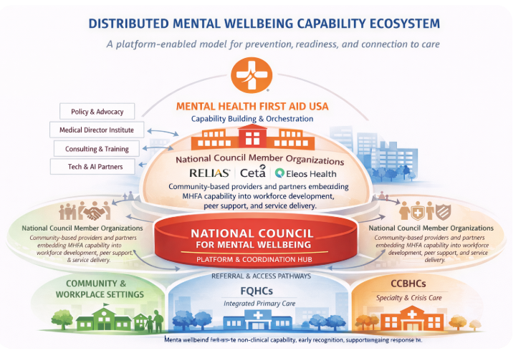
Figure 2: Distributed Mental Wellbeing Capability Ecosystem
Source: Cadovius (2026), generated using ChatGPT (OpenAI)
Cadovius’ conceptual model draws from disruptive innovation theory, ecosystem and platform strategies, collaborative governance, and capabilities perspectives. The model demonstrates how MHFA USA and the National Council can increase their impact and scale influence without assuming direct responsibility for care delivery.
Grounded in practical realities, including funding constraints, licensing requirements, political sensitivity, and the need for clear clinical roles, the proposed ecosystem works within these boundaries to align with current policy priorities and leverage established infrastructure. This pragmatic approach enables sustainable growth, expands the scope of services, and provides resources for innovative initiatives with member organizations.
Ultimately, the model calls for a structural shift rather than incremental change, aiming to strengthen preparedness, resilience, system coherence, ethics, integrity, and public trust in mental wellbeing support.
Methodological Approach and Rationale
The conceptual model is grounded not only in disruptive innovation theory but also in programmatic strategy shaped by Cadovius’ leadership in multi-state and national technical assistance initiatives. This experience includes directing the Geriatric Technical Assistance Center for the New York State Office of Mental Health and coaching over 125 organizations through SAMHSA’s Bringing Recovery Supports to Scale initiative. These efforts inform the proposal’s practical perspective, which addresses persistent structural challenges such as siloed program implementation, workforce pressures, fragmented referral coordination, and performance metrics that focus on activity rather than lasting capability.
By integrating widely recognized perspectives, this analysis provides actionable insights relevant to MHFA USA’s current landscape. It supports informed organizational decision making. The proposed Distributed Mental Wellbeing Capability Ecosystem is not intended as a universal solution or a call for sweeping governance changes. Instead, it offers a pragmatic approach to leveraging existing strengths and relationships. Its goal is to help MHFA USA transition from transactional training to an enablement focused model that better addresses the evolving demands of mental wellbeing in the United States.
This proposal sets itself apart by applying proven concepts tailored to MHFA USA’s unique context. The result is a practical set of recommendations designed to help senior leaders make effective decisions and move from abstract theory to actionable guidance.
Industry and System Context: Mental Wellbeing in the Late 2020s
Mental wellbeing challenges arise across social, economic, and institutional systems. Responsibility for addressing them is fragmented among healthcare, education, employment, and community organizations. This fragmentation leads to inefficiencies, inequities, and gaps in support (Patel et al., 2018). issues highlighted in the aftermath of the Covid-19 pandemic
The pandemic caused significant increase in anxiety, depression, substance use, and burnout (Holmes et al., 2020). These concerns have persisted and are now more closely tied to economic insecurity, workforce disruption, and social isolation. Such pressures are structural rather than temporary.
The United States faces a persistent shortage of mental health professionals, especially in rural and underserved communities (National Council for Mental Wellbeing, 2023). Long wait times, high out of pocket costs, and uneven insurance coverage limit access. As a result, individuals are often pushed toward emergency care. Clinical systems are overstretched and not equipped to meet population-level needs.
Relying on interventions only after individuals reach crisis is both costly and ethically questionable. There is a growing movement to prioritize prevention, education, and early support for mental wellbeing (Barry et al., 2019). However, current clinical models are not designed to deliver these at scale. This gap presents a key opportunity for MHFA USA. Rather than competing with traditional services, MHFA USA can help build mental health capacity in everyday environments where it is currently lacking.
Strategic Foundations and Key Tensions

A PESTLE analysis (CIPD, 2023) was conducted to assess the political, economic, social, technological, legal, and environmental forces shaping the operating environment of the National Council and MHFA USA. Collectively, these factors reveal structural pressures that challenge key assumptions underlying the current model. The environment now requires coordination, adaptability, and sustained system readiness rather than reliance on episodic training delivery.
While the existing MHFA USA model continues to deliver value, several tensions are evident. Impact is primarily measured through participation and certification rates rather than long term systemic outcomes. Financial sustainability remains closely tied to training volume. The integration of MHFA capabilities within organizations varies widely and often depends on individual champions rather than deliberate institutional design. Together, these dynamics indicate a growing misalignment between MHFA USA’s mission and its prevailing operating logic.
This paper proposes repositioning MHFA USA from a program centric training provider to a national enablement and orchestration entity, while maintaining strict adherence to Mental Health First Aid International curriculum standards. The proposed shift emphasizes long term system coherence and capability embedding over short term transactional efficiency. It aligns with the National Council’s broader objective of strengthening mental wellbeing systems and ensuring equitable access to quality care.

External Drivers
Political and policy fragmentation across federal and state levels create variability in funding, regulation, and prevention priorities, requiring governance structures that balance national consistency with local flexibility. Rising awareness of mental health challenges has increased demand for accessible preventative support, yet constrained funding environments encourage cost efficient solutions that may undermine sustainability. Technological advancements, including digital platforms and AI, expand scalability but introduce new responsibilities related to privacy, equity, and data governance. Legal and regulatory complexities necessitate strict boundary management to preserve curriculum integrity and public trust. At the same time, recurring community crises underscore the need for infrastructure capable of timely, coordinated response.

Internal Drivers
Internally, reliance on participation metrics limits visibility into long term system impact. Revenue concentration around training volume exposes financial vulnerability in a competitive marketplace. Decision making processes designed for broad stakeholder engagement can diffuse authority and slow execution.
Workforce shortages further highlight the need for capability integration beyond single event training. Collectively, these factors reinforce the need for an operating model that better aligns structure with mission and strengthens MHFA USA’s role in advancing durable mental wellbeing systems.
Figure 3, External and Internal Drivers Informing the MHFA USA Platform Based Model (Cadovius, 2026), contrasts the current training centered approach with a platform based ecosystem model. It highlights external forces—such as policy fragmentation, socioeconomic shifts, and technological change—intersect with internal operational and financial constraints. The platform model responds by strengthening coordination, clarifying governance, and diversifying value creation to sustain impact amid evolving demands.

Figure 3: External and Internal Drivers Informing the MHFA USA Platform Based Model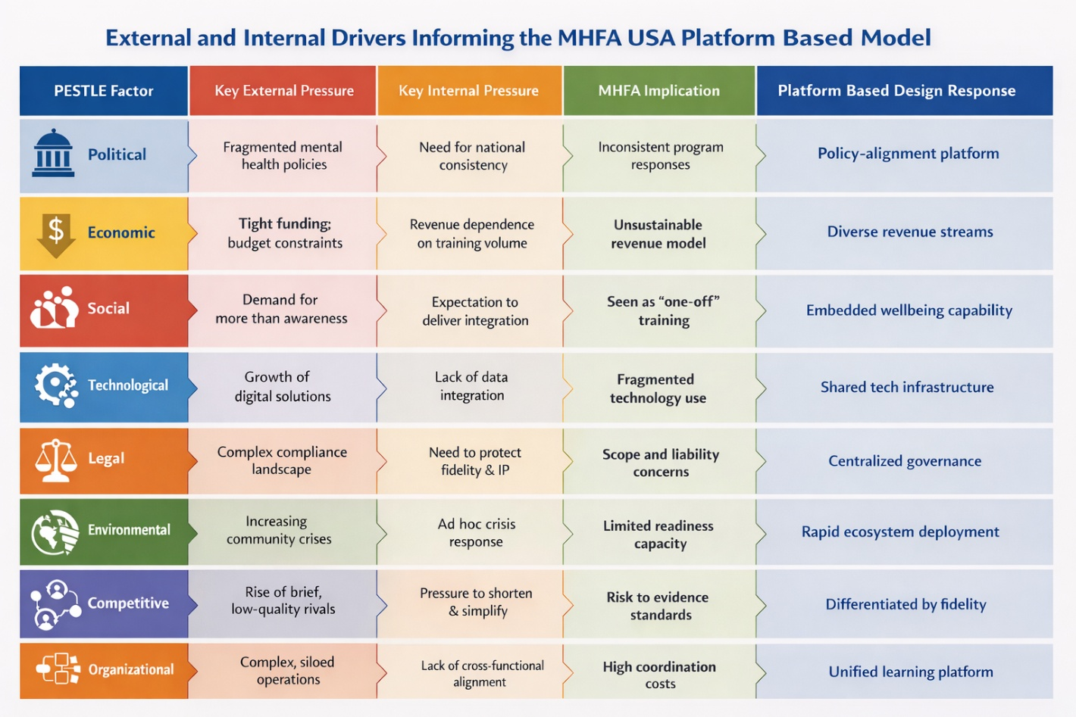
Source: Cadovius (2026), generated using ChatGPT (OpenAI)
Disruptive Innovation and Mental Wellbeing
Christensen’s disruptive innovation theory separates sustaining innovations, which enhance existing services, from disruptive ones that reach people who previously had no access by offering simpler, more accessible solutions (Christensen, 1997; Christensen et al., 2015). According to the World Health Organization, one in eight people live with a mental disorder, yet a considerable proportion lack support due to stigma, access to care, support costs, limited awareness, or inadequate services (World Health Organization, 2022).
Traditional mental health systems diagnose and treat illness after it is recognized, but they are less effective at building general coping skills across the population before crises occur. Mental Health First Aid (MHFA) fills this gap by training people without clinical backgrounds to notice signs of distress, respond appropriately, and connect others to care. Because MHFA is offered in community settings and is affordable, it adds to clinical services rather than compete with them (Kitchener and Jorm, 2002). Recreating this approach within clinical systems would need major changes in workforce roles, training, and delivery structures, highlighting MHFA’s unique and lasting contribution to mental wellbeing.
MHFA USA’s ability to disrupt remains a central strength. Yet, maintaining this advantage as the field grows and changes demands a business model that continues to build capacity beyond simply providing training. The platform based ecosystem proposed here aims to achieve exactly that.
Stakeholder Roles and Decision Making in the Platform Based Ecosystem
Transitioning to a Distributed Mental Wellbeing Capability Ecosystem requires new approaches to decision making and stakeholder engagement. MHFA USA’s earlier stakeholder strategy laid groundwork, but its collaborative processes caused delays and unclear decision ownership as the organization grew (Cadovius, 2025). Dispersed authority now creates bottlenecks and stifles innovation and partnerships.
Drawing on Cadovius’s extensive experience at the intersection of policy, practice, and operations, this intervention is informed by both theory and practical challenges faced in real world scenarios. The ecosystem model prioritizes targeted involvement based on decision type—clarifying who informs, decides, and implements. Stakeholders include platform stewards, capability orchestrators, delivery partners, and community stakeholders, each with defined roles in value creation and decision influence. Figure 4 demonstrates the expansive stakeholder network that can be activated in the ecosystem (Cadovius, 2026)
Figure 4: MHFA USA and The National Council Stakeholder Network
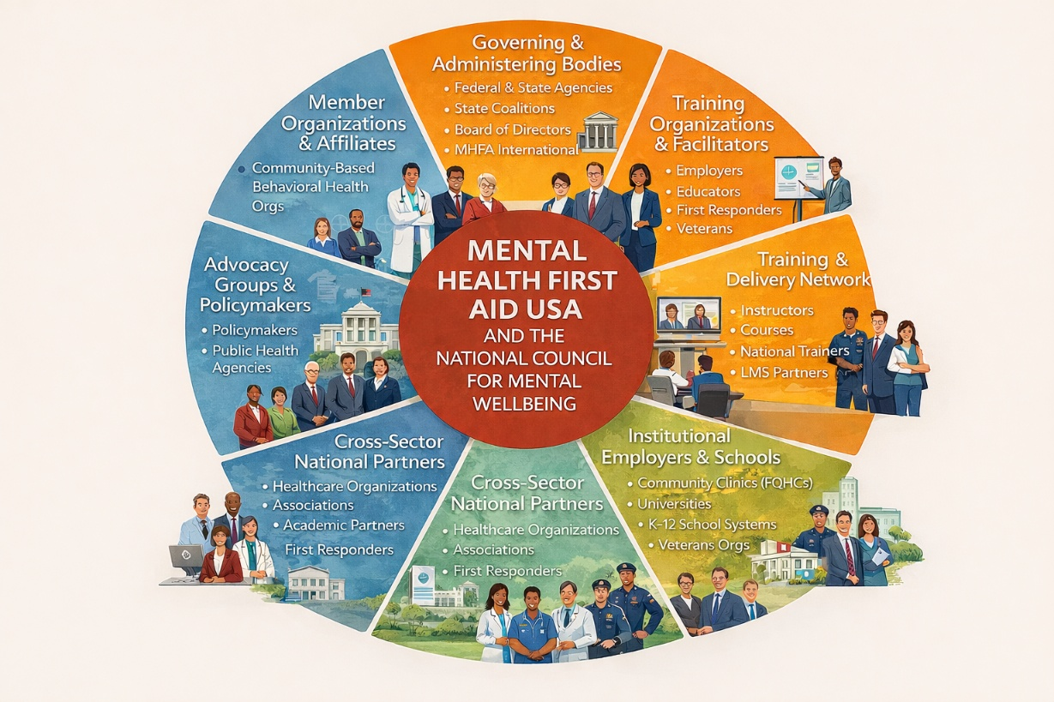
Source: Cadovius (2026), generated using ChatGPT (OpenAI)

The National Council, acting as platform steward, manages strategic decisions with structured input and executive responsibility (McKinsey & Company, 2024). MHFA USA serves as capability orchestrator, coordinating curriculum and standards with partner input, avoiding over collaboration. Delivery partners drive implementation and innovation, focusing on execution rather than national standards (Hollnagel, 2017). Community stakeholders provide advisory input through feedback and pilot evaluations, ensuring innovation without decision paralysis.
This architecture promotes effective collaboration and accountability, addressing risks of excessive collaboration (Harvard Business Review, 2018). Sequenced participation and clear escalation pathways ensure decision ownership. Adopting this model enables MHFA USA to balance inclusion with efficient, transparent decision making, supporting sustained innovation and growth in mental wellbeing.
Business Model Innovation for MHFA USA
MHFA USA has reached national scale with an evidence based training model that teaches practical skills for addressing mental health challenges. While this foundation remains solid, changes in the environment have revealed limitations of a model focused on one off training sessions. Increased demand, workforce shortages, and greater expectations on non-clinical systems require a shift in approach (National Council for Mental Wellbeing, 2023; World Health Organization, 2022). The new business model leaves MHFA content and licensing intact but redefines how value is delivered, moving from training centric events to a platform approach that enables broader mental wellbeing support across sectors.
Constraints of the Current Model
Training delivery is the main value driver in the current model, with revenue coming from participant fees, instructor training, recertification, grants, and contracts. Impact is measured by activities like training numbers and courses delivered, but this approach ties growth to volume and limits lasting change. Training often stands alone, so MHFA USA's influence on reinforcing skills or integrating them into organizations is restricted. Sustained capability relies on local champions rather than robust infrastructure. These issues result from the operating model’s design—not the MHFA program—since models focused on scale tend to miss deeper system change unless their value creation logic shifts (Christensen, Raynor and McDonald, 2015).
Rationale for Business Model Evolution
Business model evolution is driven by shifting demand, sustainability challenges, and the need to align with MHFA USA’s mission. Organizations now want more than initial training; they seek lasting support for mental wellbeing integrated into leadership and operations. Short term revenues are less dependable amid rising expectations and limited funding. Maintaining mission impact also requires strong ethics and compliance with licensing rules.
Evaluating innovative approaches using outdated metrics can hinder alignment and innovation. Instead, MHFA USA should pilot strategies that build long term capability and uphold evidence based standards.
Figure 5 illustrates the Transformation in Value Flow highlighting the Distributed Mental Wellbeing Capability Ecosystem (Cadovius, 2026) The current model generates episodic value at the point of training. The proposed model creates circulating value across customers, behavioral health providers, health systems, and policy infrastructure, supported by governance and learning mechanisms. This shift from linear transaction to ecosystem circulation represents the core business model innovation of the proposal
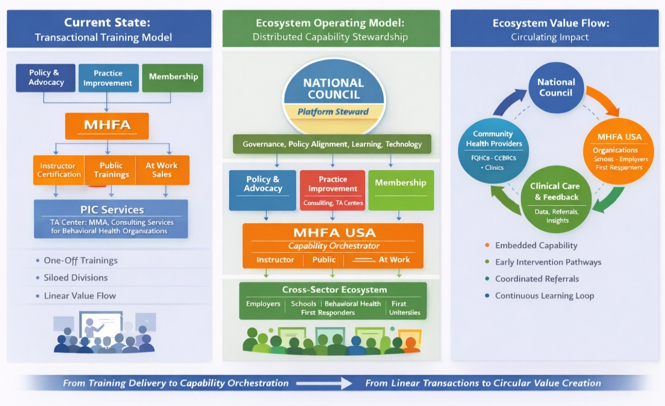
Figure 5: Transformation Value Flow; from training to distributed mental wellbeing capability ecosystem
Source: Cadovius (2026), generated using ChatGPT (OpenAI)

The Proposed Model: Ecosystem Enablement Within Clear Boundaries
The proposed model shifts MHFA USA’s focus from just delivering training to helping organizations embed MHFA into their ongoing systems, supporting adoption and integration without altering curriculum or intellectual property. Value comes through long term partnerships, sector specific strategies, and clear development pathways that go beyond initial training to include reinforcement, leadership involvement, and quality assurance. This approach helps diversify resources by forming partnerships, securing grants, and offering subscription services, all aimed at supporting and empowering users rather than altering MHFA's intellectual property. Expanding products and sales internationally should be seen as a way to grow and strengthen the wider ecosystem.
Operating Model Shift: From Provider to Orchestrator
As its business model changes, MHFA USA transitions from direct provider to national orchestrator. It maintains standards, creates sector specific enablement structures, brings together partners, and supports system wide learning. Instead of centralizing, MHFA USA coordinates stakeholders around common goals.
Research highlights that orchestration, shared standards, and enablement are crucial for scaling impact in decentralized settings (Adner, 2017), where influence relies on design, stewardship, and coordination rather than control.
Implementation Approach and Risk Management
Implementation will proceed in distinct phases. The initial phase prioritizes comprehensive design and internal alignment, including the clear delineation between licensed content and business model innovation, development of sector specific enablement frameworks, and transparent communication with MHFAI. The second phase is dedicated to targeted pilot partnerships chosen for their potential to generate insights, rather than for scale. During this stage, metrics focus on integration quality, partner satisfaction, and early signals of sustained capability.
The final phase encompasses scaling and institutionalization. Successful practices are formalized through standardized partnership structures, robust governance mechanisms, and comprehensive enablement resources. At this point, conventional performance and financial measures may be reintroduced without impeding innovation (Harvard Business Review, 2021).
Key risks include role ambiguity, quality dilution, and strain on internal capacity. These challenges are mitigated through precise scope definition, stringent quality assurance, phased expansion, and ongoing support for instructors and partners. Collectively, these safeguards reinforce MHFA USA’s credibility and mission, ensuring that business model innovation contributes positively rather than detracts from organizational integrity.

Distributed Ecosystem Implementation, Collaboration, and Governance

Leading Through Interdependence
Cadovius’s leadership in transitioning 67 Florida school districts and over 1,900 Youth Mental Health First Aid instructors to a new learning management and governance model demonstrated the feasibility of structured operating model changes at scale. This initiative shifted accountability from individual instructors to district leads, established regular communication, and instituted ongoing feedback with executive leadership. The key takeaway is that lasting impact arises from architectural alignment rather than simply expanding training, informing the phased transition strategy described in this proposal.
The proposed platform model redefines MHFA USA’s operational approach, emphasizing effective coordination across a distributed partner network. Each partner is responsible for integrating mental wellbeing practices within their own systems, shifting the focus from simple delivery to sustained, collaborative integration and transitioning the organization from transactional partnerships to ongoing, interdependent relationships.
Organizations now seek MHFA USA’s support not only for training but also for embedding MHFA competencies into leadership, policy, and daily operations. MHFA USA’s role is to enable these outcomes through robust design, quality assurance, and coordination, prioritizing empowerment over direct oversight. Research on ecosystem strategy underscores that clear role definition and accountability increase collective impact (Adner, 2017).
Implementation challenges require adaptive, not just technical, solutions. Navigating cultural alignment, fidelity versus flexibility, and responsibility distribution cannot be resolved by standardization alone. Sustainable progress is achieved through structured dialogue, collaborative sense making, and iterative learning (Heifetz, Grashow, and Linsky, 2009). MHFA USA’s leadership must facilitate these conversations, clarify tradeoffs, and offer guidance for managing complexity while upholding standards.

Stakeholders, Trust, and Decision Clarity
The ecosystem is comprised of stakeholders with varied incentives, constraints, and areas of influence. MHFA USA teams manage national strategy and quality; instructors bring local expertise and credibility; sector partners embed MHFA within their missions; and Mental Health First Aid International maintain curriculum and intellectual property authority. Funders and policymakers affect legitimacy and expectations, resulting in a context driven distribution of authority rather than a rigid hierarchy.
Resistance is expected during operational shifts, with concerns about roles, workload, income, and accountability naturally arising. Addressing these issues requires transparency, clear responsibility definition, and structured engagement, not simply persuasion (Ansell and Gash, 2008).
Clarity in decision making is essential. MHFAI retains control over curriculum and intellectual property; MHFA USA manages partnership frameworks, enablement models, quality oversight, and U.S. developed intellectual property. Partners determine how to operationalize MHFA within their settings, and instructors apply professional judgment while adhering to fidelity requirements. This clarity reduces friction, builds trust, and supports effective collaboration.
Trust is fundamental for ecosystem coordination. Without it, transaction costs rise and momentum stalls. MHFA USA fosters trust through consistent standards, transparent communication, and feedback culture focused on continuous improvement. Research highlights autonomy, shared purpose, and demonstrated competence as essential for engagement in complex collaborations (Harvard Business Review, 2018).

Governance, Learning, and System Stewardship
Effective governance in a distributed ecosystem centers on fostering alignment and accountability rather than issuing top down directives. For MHFA USA, this means upholding nonnegotiable standard curriculum integrity, ethical compliance, and scope of practice—while allowing adaptive implementation. Collaborative governance research points to the need for transparent rules and processes, especially with shared authority (Ansell and Gash, 2008).
Cadovius’s experience with international exchanges in Norway, Japan, South Korea, and Australia highlights the value of structured interdependence in complex service environments. Systems that sustained innovation over time clearly defined roles, established formal collaboration mechanisms, and aligned funding incentives across prevention and treatment domains. The proposed governance model draws on these principles, emphasizing coordinated stewardship with distinct responsibilities.
Learning drives both continuous improvement and oversight. Initiatives such as partner learning forums, instructor communities of practice, and periodic system reviews enable MHFA USA to proactively identify risks, share effective practices, and adapt support strategies without centralizing program delivery. Organizations investing intentionally in learning are better positioned to innovate and thrive in complex environments (McKinsey & Company, 2021).
It is essential to distinguish between core elements requiring strict consistency and those amenable to adaptation. This enables the ecosystem to evolve while preserving evidence based integrity and stakeholder trust. Poor boundary management risks fragmentation, inconsistent participant experiences, and loss of credibility with MHFAI and stakeholders.

The Role of the National Council for Mental Wellbeing as Platform Steward
Within the envisioned ecosystem, the National Council for Mental Wellbeing assumes an enabling function, providing foundational infrastructure, legitimacy, and strategic coordination, distinct from direct program delivery or daily orchestration.
This stewardship leverages the Council’s strengths in policy leadership, practice advancement, convening, and national advocacy. As platform steward, the Council aligns ecosystem activities with policy objectives, translates system insights into actionable member guidance, and grounds innovation in evidence, equity, and ethical considerations. Positioning MHFA USA within this broader platform enables cross sector coordination among prevention, early recognition, and clinical services while preserving functional differentiation.
The Council’s policy division monitors regulatory trends, identifies funding opportunities, and aligns system activities with state and national priorities. Its practice improvement and technical assistance connect non-clinical capacity building with clinical system preparedness, assisting organizations in integrating MHFA skills within operations, leadership, and care pathways.
As platform steward, the National Council drives responsible innovation by aggregating demand, forming partnerships, and providing shared infrastructure for piloting innovation, ensuring that the platform is aligned with and advances the National Council’s strategic goals. The National Council does not duplicate MHFA USA or partner roles; instead, it maintains a strategic outlook, oversees standards and goals, and ensures alignment with the public mission as the ecosystem evolves. Figure 6 shows The National Council’s Strategic Goals (The National Council Strategic Planning Committee, 2024).

Figure 6: National Council for Mental Wellbeing Strategic Goals

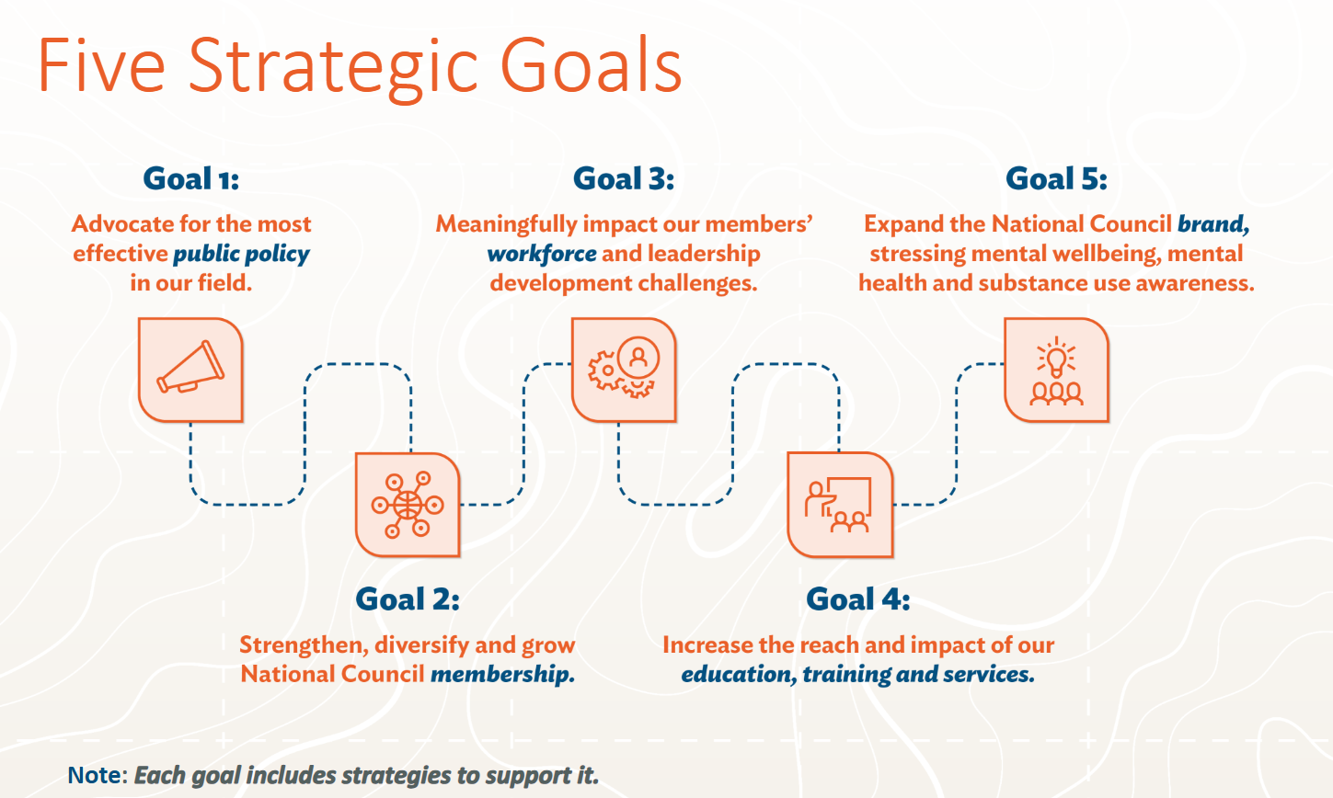

The proposed ecosystem model for MHFA USA clarifies ethical boundaries by emphasizing its role in building capabilities, rather than taking on clinical responsibilities. With ongoing workforce shortages, it is especially important to distinguish between non-clinical support and formal clinical care. The model promotes clear referral processes, organizational accountability, and strong leadership, helping to prevent the informal transfer of clinical duties to non-clinical staff (Patel et al., 2018).
Sustaining the system is both a financial and moral issue. Models based solely on short term, transactional cycles can make services unstable and hinder lasting impact. In contrast, forming long term partnerships and approaches focused on empowerment helps organizations develop stronger capabilities over time. Aligning operations with long term outcomes supports evidence that real, lasting change happens when organizations focus on sustained results instead of quick wins (McKinsey & Company, 2021).
As MHFA USA’s impact grows, its responsibility as a leader also increases. Maintaining trust in such a critical area calls for both ambition and restraint. Values like transparency, consistency, and seeing partners as collaborators, not just implementers, grow in importance as the organization expands. Here, responsible innovation means advancing thoughtfully, balancing progress with sound judgment and honesty (Heifetz, Grashow and Linsky, 2009).

Execution Roadmap: Translating Architecture into Action
The transition from a transactional training model to a Distributed Mental Wellbeing Capability Ecosystem requires disciplined execution. This shift affects governance, performance measurement, revenue logic, stakeholder coordination, and organizational identity. As such, it must be sequenced carefully to preserve operational continuity while building new structural capacity.
Figure 7 illustrates a practical 24 month roadmap (Cadovius, 2026). It has three clear phases: stabilize and design (first 6 months), structured piloting and beginning to build things in (months 6–18), and finally, scaling up and full integration (months 18–24). The approach establishes a strong foundation for change focused on governance in place before growing. Establishing an environment where products, services, and innovations can be piloted prior to their formal implementation, ensuring that organizational learning takes place before standardizing new operational methods.

Figure 7: Implementation Roadmap
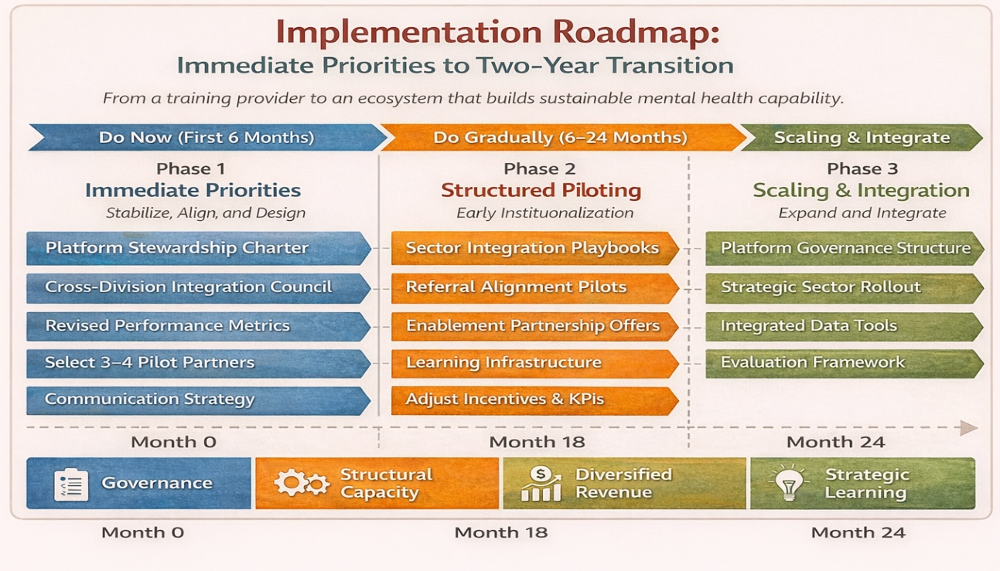
Source: Cadovius (2026), generated using ChatGPT (OpenAI)
Phase 1 (0–6 Months): Stabilize, Align, and Design
During this initial phase, the focus is on clarifying structure and encouraging internal alignment. Important steps include formalizing platform stewardship, fostering cross division coordination, broadening performance indicators, and selecting pilot partners who are prepared and open to learning. Progress is reflected in the adoption of governance tools, the onboarding of pilot partners, the development of sector playbooks, and the introduction of new performance metrics—all while maintaining current revenue levels.

Phase 2 (6–18 Months): Structured Piloting and Early Institutionalization
In this stage, integration playbooks are applied within pilot organizations, referral alignment is initiated with behavioral health providers, and partnership models begin to diversify revenue streams. Milestones include the use of playbooks, reinforcement of practices in pilot organizations, launching referral pilots, introducing a new revenue offering, and tracking progress through dashboards.

Phase 3 (18–24 Months): Scaling and Integration
Validated practices are gradually institutionalized, with permanent governance established, targeted expansion pursued, and standardized evaluation implemented. Outcomes may include formal leadership oversight, expansion into new sectors or states, improved referral coordination, decreased reliance on per seat revenue, and adoption of ecosystem evaluation.
By the end of the twenty four month period, MHFA USA and the National Council aim to demonstrate enhanced structural capacity, focusing on sustainable growth and organizational development rather than simply increasing activity. Figure 8 illustrates key performance indicators over the 24 month implementation plan (Cadovius, 2026)

Figure 8: Key Performance Indicators for 24 Month Implementation Plan

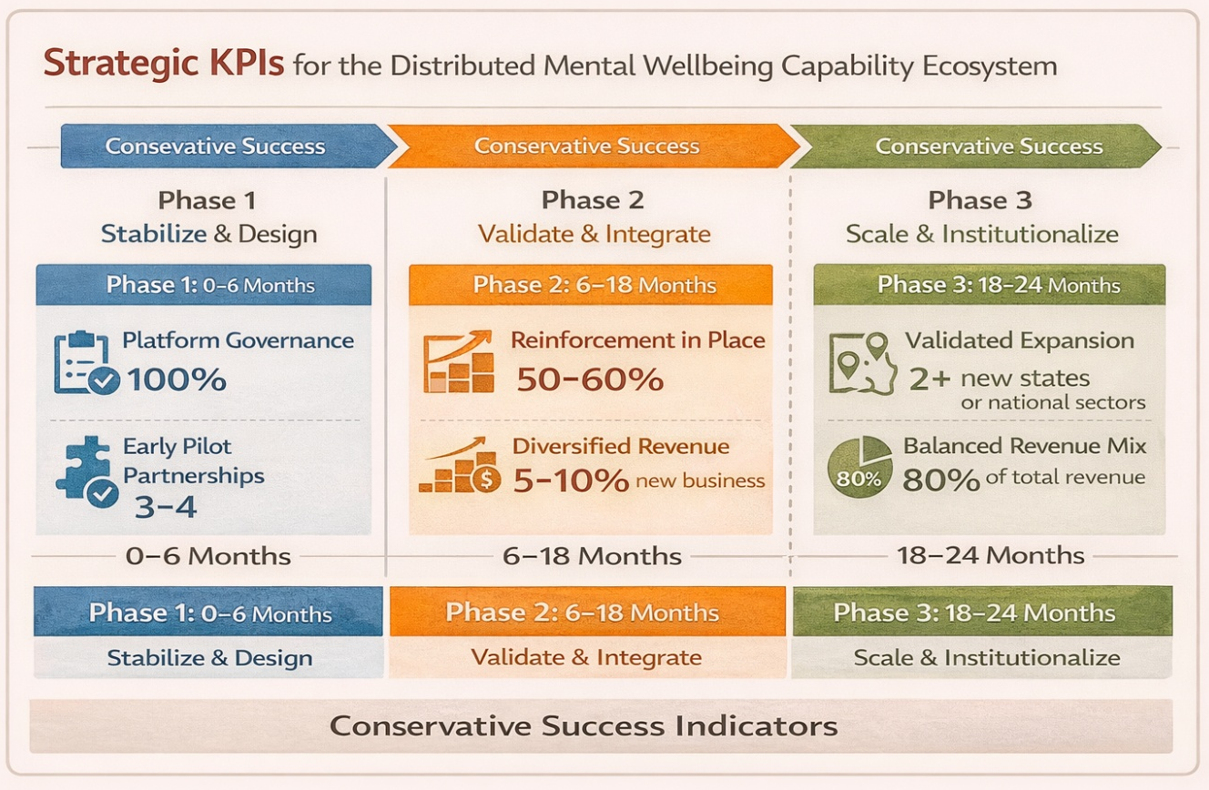
Source: Cadovius (2026), generated using ChatGPT (OpenAI)

Risk Mitigation
Several risks must be proactively managed throughout this transition. These include role ambiguity across divisions, temporary revenue instability, resistance from instructors or members, premature expansion before organizational readiness, and potential dilution of curriculum integrity. To address these challenges, it is essential to implement comprehensive governance documentation, introduce a phased rollout plan, maintain open and transparent communication channels, and set conservative, realistic scaling targets. Preserving the boundaries of the curriculum and refraining from premature clinical integration are critical safeguards required to maintain program fidelity.
Overlooking the integration of technology and artificial intelligence (AI) in the implementation plan would represent a significant risk, as these tools are increasingly essential for driving operational efficiency, scalability, and data driven decision making. To address this, it is vital to proactively incorporate a logic model that leverages digital solutions to map out partnership and client journeys throughout the ecosystem. This approach enables the design of clear pathways for engagement and support, ensuring that product and service offerings are strategically aligned with client needs.
By intentionally embedding technology enabled processes, the organization can facilitate seamless collaboration between partners, expand the reach of mental wellbeing resources, and provide clients with tailored experiences that support their progress. Developing such a logic model also creates opportunities to propose and pilot innovative products and service supports, fostering partnerships that empower clients to embed sustainable solutions within their organizations and communities. This, in turn, strengthens the network of support available and enhances each client’s path to improved mental wellbeing.
Integrating these elements into the broader platform strategy aligns with the phased, disciplined transformation approach outlined in the implementation plan. It helps ensure that new digital capabilities are introduced in a way that preserves program integrity, complements existing governance structures, and supports the long term resilience and adaptability of the MHFA USA model.
Financial risks are mitigated by adopting a strategy of gradual revenue diversification, which avoids abrupt changes to the business model and supports long term stability. To overcome cultural resistance, the organization will leverage early pilot success stories and clearly communicate which core aspects of MHFA’s evidence based training will remain unchanged. Intentional change management strategies will be deployed to guide stakeholders through the ecosystem’s evolution and foster buying in at every level.
Operational risk is further reduced by sequencing the redesign of governance and measurement frameworks ahead of any large scale external expansion. This disciplined, step by step approach ensures that foundational structures are in place before scaling, supporting both organizational resilience and the integrity of the MHFA model.

The Disruptive Influence and Impact of MHFA USA's and The National Council’s Transformation

The business model transformation signals a genuinely disruptive advance in the mental health landscape, an innovation not rooted in expanded clinical duties, but in a new orchestration of national capabilities within a stewarded platform. This approach, shaped by Cadovius’s diverse experience in regulatory recovery, statewide strategic planning, technical assistance and practice improvement initiatives, draws on lessons from the field and the rigor of organizational research. Cadovius’s expertise has been instrumental in designing a system where clearly defined authority, disciplined execution, and transparent communication are central, complementing research findings that emphasize the importance of robust structures and management practices for enduring change (Adner, 2017; Christensen, Raynor, and McDonald, 2015).
By safeguarding MHFA’s core mission and drawing distinct boundaries between capability building and clinical care, the new model empowers organizations to create evidence-based mental wellbeing strategies. It responds to gaps that traditional episodic training models have struggled to bridge, ensuring that performance measurement evolves beyond mere participation to integrated organizational capability.
Cadovius’s practical insights enhance the phased, disciplined platform, supporting measured growth, targeted partnerships, and intentional stakeholder engagement qualities echoed in the literature on sustainable innovation and adaptive leadership (McKinsey & Company, 2021; Heifetz, Grashow, and Linsky, 2009).
This disruption is profound, as it shifts the paradigm from centralized, rapid expansion to a coordinated, distributed ecosystem, enabling innovation across sectors. Through robust governance and scalable processes, MHFA USA is uniquely positioned to catalyze a nationwide infrastructure for mental wellbeing, ready to meet future challenges with resilience and clarity. Cadovius’s experience in aligning executive leadership and stewarding collaborative frameworks is visible in the implementation of the Distributed Mental Wellbeing Capability Ecosystem, a practical blend of aspiration and operational viability.
Post implementation, the impact will be substantial. MHFA USA will not only reinforce its own mission, but also advance a new standard for coordinated action, stakeholder trust, and sustainable innovation. Cadovius’s practical leadership, combined with research insights, offers a model for significant and sustained change in complex, evolving systems.

References
Adner, R. (2017).
Ecosystem as structure: An actionable construct for strategy.
Journal of Management, 43(1), pp. 39–58.
Ansell, C., and Gash, A. (2008).
Collaborative governance in theory and practice.
Journal of Public Administration Research and Theory, 18(4), pp. 543–571.
Cadovius, N. (2025).
Transforming decision making: Stakeholder driven strategy and innovation at MHFA USA.
Unpublished doctoral portfolio paper, Swiss School of Business Research.
Christensen, C.M., Raynor, M. and McDonald, R. (2015).
What is disruptive innovation? Harvard Business Review. Available at: https://hbr.org/2015/12/what is disruptive innovation
(Accessed: 4 February 2026).
CIPD. (2023). PESTLE analysis. London: Chartered Institute of Personnel and Development.
Available at: https://www.cipd.org/uk/knowledge/factsheets/pestle analysis factsheet/
(Accessed: 5 February 2026).
Harvard Business Review. (2018). Why people lose motivation—and what managers can do to help. Harvard Business Review. Available at: https://hbr.org/2018/03/why people lose motivation and what managers can do to help (Accessed: 25 January 2026).
Harvard Business Review. (2021). Do not let financial metrics prematurely stifle innovation.
Harvard Business Review. Available at: https://hbr.org/2021/03/dont let financial metrics prematurely stifle innovation
(Accessed: 7 February 2026).
Harvard Business Review Podcast. (2017). To reinvent your firm, do two things at the same time. Harvard Business Review Podcast. Available at: https://hbr.org/podcast/2017/04/to reinvent your firm do two things at the same time
(Accessed: 1 January 2026).
Heifetz, R., Grashow, A. and Linsky, M. (2009). The practice of adaptive leadership.
Boston, MA: Harvard Business Press.
Holmes, E.A. et al. (2020). Multidisciplinary research priorities for the COVID 19 pandemic.
The Lancet Psychiatry, 7(6), pp. 547–560.
Kitchener, B.A. and Jorm, A.F. (2002). Mental Health First Aid training for the public: Evaluation of effects on knowledge, attitudes and helping behavior.
BMC Psychiatry, 2(1). Available at: https://bmcpsychiatry.biomedcentral.com/articles/10.1186/1471 244X 2 10
(Accessed: 5 February 2026).
McKinsey & Company. (2021). The innovation commitment. Available at: https://www.mckinsey.com/business functions/strategy and corporate finance/our insights/the innovation commitment (Accessed: 29 December 2025).
Mental Health First Aid USA. (2025). About Mental Health First Aid. Available at: https://mentalhealthfirstaid.org/about/ (Accessed: 17 January 2026).
National Council for Mental Wellbeing. (2020). Advancing integrated care: A new model for behavioral health. Washington, DC: National Council for Mental Wellbeing. Available at: https://www.thenationalcouncil.org (Accessed: 31 January 2026).
National Council for Mental Wellbeing. (2021). About the National Council for Mental Wellbeing. Washington, DC: National Council for Mental Wellbeing. Available at: https://www.thenationalcouncil.org/about (Accessed: 28 January 2026).
National Council for Mental Wellbeing. (2021). COVID 19 and the behavioral health workforce: Challenges and opportunities. Washington, DC: National Council for Mental Wellbeing.
Available at: https://www.thenationalcouncil.org (Accessed: 28 January 2026).
National Council for Mental Wellbeing. (2021). Prevention and early intervention in behavioral health. Washington, DC: National Council for Mental Wellbeing. Available at: https://www.thenationalcouncil.org (Accessed: 5 January 2026).
National Council for Mental Wellbeing. (2022). The psychiatric shortage: Causes and solutions.
Washington, DC: National Council for Mental Wellbeing. Available at: https://www.thenationalcouncil.org (Accessed: 6 January 2026).
National Council for Mental Wellbeing. (2022). Equity in mental health care: Challenges and opportunities. Washington, DC: National Council for Mental Wellbeing. Available at: https://www.thenationalcouncil.org (Accessed; 10 January 2026).
National Council for Mental Wellbeing. (2022). Mental health and substances use care in the post pandemic era. Washington, DC: National Council for Mental Wellbeing.
Available at: https://www.thenationalcouncil.org (Accessed: 10 February 2026).
National Council for Mental Wellbeing. (2023). Addressing the mental health workforce shortage. Washington, DC: National Council for Mental Wellbeing.
Available at: https://www.thenationalcouncil.org (Accessed: 21 January 2026).
National Council for Mental Wellbeing. (2026). 2026 MHFA Summit Sponsorship Prospectus.
Washington, DC: National Council for Mental Wellbeing.
Available at: https://www.thenationalcouncil.org/wp content/uploads/2026/01/2026 MHFA Summit Sponsorship Prospectus v3 1 1.pdf (Accessed: 7 February 2026).
Nussbaum, M.C. (2011). Creating capabilities: The human development approach.
Cambridge, MA: Harvard University Press.
Patel, V. et al. (2018). The Lancet Commission on global mental health and sustainable development. The Lancet, 392(10157), pp. 1553–1598.
Slade, M., Leamy, M., Bacon, F., Janosik, M., Le Boutillier, C., Williams, J., and Bird, V. (2012).
International differences in understanding recovery: A systematic review.
British Journal of Psychiatry, 201(6), pp. 445–452.
Van Alstyne, M.W., Parker, G.G. and Choudary, S.P. (2016). Pipelines, platforms, and the new rules of strategy. Harvard Business Review. Available at: https://hbr.org/2016/04/pipelines platforms and the new rules of strategy
(Accessed: 7 February 2026).
Ware, N.C., Hopper, K., Tugenberg, T., Dickey, B., and Fisher, D. (2007). A theoretical model of empowerment in psychiatric rehabilitation. Psychiatric Services, 58(4), pp. 469–475.
World Health Organization. (2022). World mental health report: Transforming mental health for all. Geneva: World Health Organization. Available at: https://www.who.int/publications/i/item/9789240049338 (Accessed: 7 February 2026).

