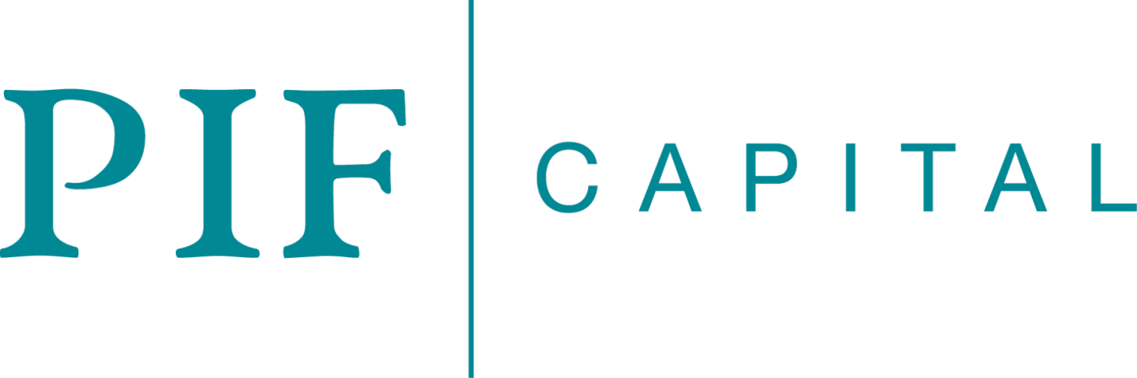

Portfolio Module 3 Assignment
Grace Lim

Table of Contents
 |  |  | Page
- Executive Summary |  |  | 3
- Problem Statement |  |  | 4
- Proposed Solution
 | - The 148 System |  | 4
 | - ConsultTech |  | 6
 | - EduTech |  | 7
 | - InvestTech |  | 7
 | - BizDevTech |  | 8
- Qualification
 | - Industry Overview |  | 9
 | - Micro and Macro Level Analysis |  | 11
 | - Key Core Advantage of the 148 System |  | 13
- Implementation |  |  | 13
- Timeline |  |  | 14
- Investment and ROI |  |  | 14
- Conclusion |  |  | 17
- References |  |  | 18
- Appendices |  |  | 20

- Executive Summary
This proposal is directed to PIF Capital, presenting an innovative platform ecosystem for its considerations. The proposal commences by introducing the company and providing a brief background of the SME financing industry and emphasizing its fragmentated nature. Subsequently, unveiling the 148 System, a comprehensive platform ecosystem designed to revolutionise the SME financing industry, and offers a detailed breakdown of the individual technology platforms, elucidating their functionalities, features, and value propositions to the key stakeholders. Following that, the paper then provides an extensive industry to qualify the proposed solutions, highlighting the pain points of the professionals, entrepreneurs, business alliances and investors within financial industry. Additionally, we conduct an analysis of potential challenges on both micro and macro level and describe the mitigation efforts undertaken by PIF Capital thus far. The paper then discusses the key core advantage of building a platform ecosystem providing a detailed implementation process with a timeline in the form of a Gantt chart, allowing for visual representation of estimated time taken to build the platforms. A budget model is provided to estimate the total cost involved based on the proposed implementation and other considerations involved. The paper then provides an analysis on the return-on-investment that illustrates the financial returns over a forecast period of five years for an informed decision-making process. The paper the provides a recommendation for PIF Capital to adopt a disruptive mindset and adopt the implementation of an ecosystem in the capital markets industry.

- Problem Statement
PIF Capital (PIF), Singapore, is a leading Small, Medium Enterprise (SME) capital consultancy firm and has a growing presence in the Southeast Asian region among the SMEs within the capital markets. To ensure sustained growth and maintain our competitive advantages in the dynamic business landscape, PIF has embraced a business strategy centered oninnovation and excellence, with a key focus on building a robust capital ecosystem. SMEs represent about 90% of business worldwide, play a pivotal role in driving economic activity. However, a significant number of SMEs face unmet financing needs, particularly in the East Asia and Pacific regions, accounting for 46% of the total finance gap (World Bank, n.d.). One of the primary challenges impeding SME growth is the prevailing fragmentation within the industry. This fragmentation leads to limited access to equity financing and a lack of seamless connections between crucial stakeholders, including, inter alia, professionals, entrepreneurs, business alliances and investors. Consequently, inefficiencies plague the capital markets, business ecosystems and the economy.
While PIF has been offering structured learning environment with offline education courses on capital wisdom since its inception, several challenges persist within the traditional education paradigm. These challenges hinder the overall effectiveness of our programs and limit educational opportunities for the wider entrepreneur population. The current offline nature of PIF’s education business segment makes it challenging to increase the frequency of these events, primarily I am the only speaker for these events, and the passive nature of the lessons can potentially limit the effectiveness of our content delivery. Given that PIF is the only provider of capital wisdom education content in the market outside China, clients from various regions make special arrangements to travel to Singapore to attend our lessons. Unfortunately, once they return home, they are unable to access the content, which further restricts the value of our services to them. While PIF offers online live broadcasting through Zoom, clients are unable to access the content at their own convenience, hindering the overall accessibility and flexibility of our educational offerings. To address these challenges and enhance the value of our services, it is imperative for PIF to merge the offline business with an online platform..
In recent years, PIF has strategically diversified its operations, extending its business portfolio to encompass consultancy services in conjunction with its existing education business segment. However, this facet of the business is subject to human errors, such as, communication and documentation errors, as well as inconsistency in research and report quality. Due to the personal nature of consultancy, there is bound to be differences in communication methods with clients and stakeholders, resulting in occasional inconsistences in deliverables. PIF’s core advantage is our high penetration in the SME market, which allows us to curate a database of private SME data that is usually difficult to access. However, our current processes are not leveraging on the potential of big data, and hence there is a need for PIF to incorporate new systems and technologies to maximize the value obtained from the business. On a similar note, roadshows currently hosted by PIF are resource intensive with little result creation, as significant time and effort invested into coordinating different stakeholders and organising the event may not necessarily yield desired results. This highlights the urgent need to incorporate systems and technologies into the current business offerings by PIF and make the process more structured, allowing for expansion efforts in the near future.
Thus, this paper serves as a proposal for the implementation of cutting-edge technologies across various markets, enabling stakeholders to establish a dynamic ecosystem to leverage on connectivity and automation to improve comprehensiveness and efficiency that current solutions by PIF fail to provide.
- Proposed Solution
  - The 148 System
Our revolutionary 148 System forms a dynamic ecosystem that seamlessly connects the fragmented entrepreneurs, investors, professionals, and business alliances, fostering active participation on the platform and elevating efficiency and effectiveness in the capital markets.
With 1 ecosystem, we offer 4 resource platforms catering for entrepreneurs, investors, professionals, and business alliances for the players as mentioned above and 8 capital events that are categorised into (i) Know-How, (ii) Execution, (iii) Growth and (iv) Support (Figure 1). These platforms were developed as part of our new business transformation with the PEBI® System (Figure 2). To ensure a comprehensive solution for all players, we have designed the platforms to serve it such that entrepreneurs are served with EduTech, investors are served with InvestTech, professionals are served with ConsultTech and lastly, business alliances are served with BizDevTech. The 8 capital market events are local onsite eventsaims to equip the participants with valuable knowledge, which they can then implement and develop through strategies and events. One of our prominent knowledge-based events is the weekly Initial Public Offering Square (IPO²) held every Tuesday. During this event Small, Medium Enterprises (SMEs) owners are introduced to essential concepts such as business valuations, price-to-earnings ratios, and growth strategies related to IPOs. Additionally, we organise international and private roadshows, enabling SMEs to apply the knowledge gained from the events to real-world strategies. Overall, our ecosystem ensures a comprehensive and tailored approach to support entrepreneurs, investors, professionals, and business alliances in their respective endeavors.
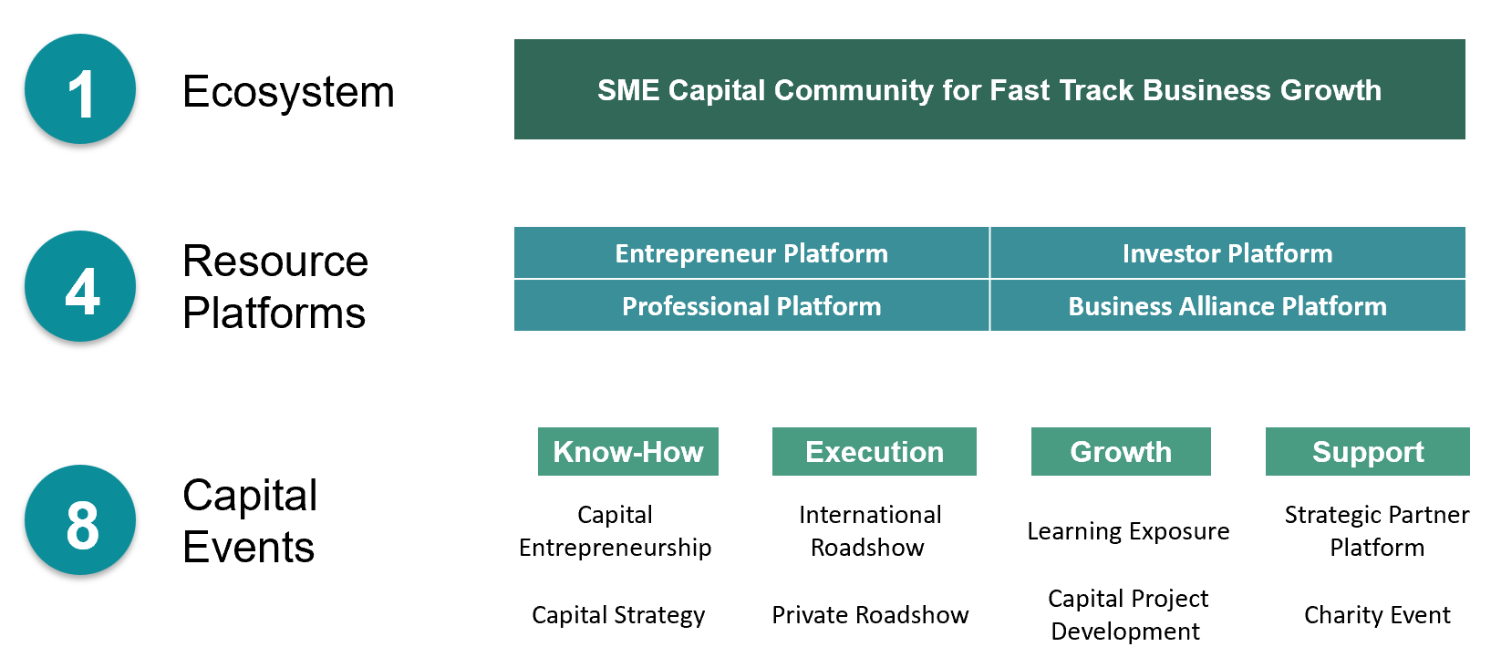
Figure 1: Overview of the 148 System

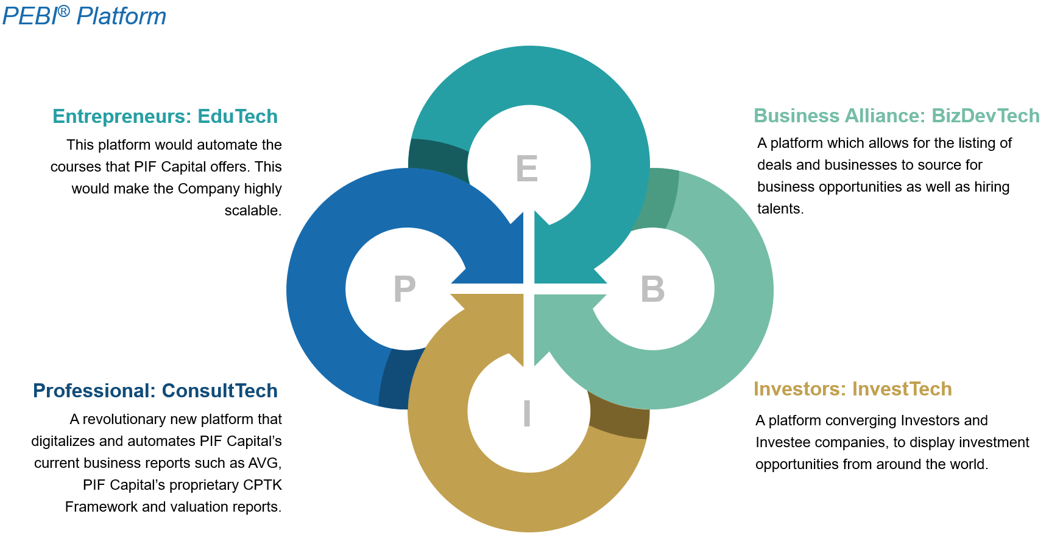
Figure 2: Overview of the PEBI® System
The flow of different clients through our ecosystem allows for the creation of a value web, where various players can learn, develop trust in the business’ networks and capabilities. This, in turn, enables us to establish a sustainable client acquisition funnel and development of further downstream businesses such as Antz Capital and BeUnicorn. Currently, the 148 System is primarily conducted offline with the 8 capital events being held as weekly engagements sessions. Meanwhile, we are actively developing the 4 online resource platforms. These platforms are supported by digital technology infrastructures, that help to make resources and participants more accessible to each other on an as-needed basis and are powerful catalysts that facilitates connectivity,coordination, and collaboration of ecosystems (Hagel, 2015). I will then be discussing the workings and benefits for entrepreneurs, investors, professionals and alliances.
- ConsultTech
ConsultTech disrupts the business valuation market by digitizing and automating the oncetime-consuming and research-intensive process. Powered by advanced artificial intelligence, ConsultTech seamlessly transforms PIF’s business reports including, valuation reports, AVG, and PIF’s proprietary CPTK framework, into easily accessible and shareable digital formats across organisation teams. The incorporation of automated processes expedites report generation by automatically compiling market and industry data while performing basic financial modelling, such as discounted cash flow and comparable analysis to generate comprehensive reports.
This game-changing automation significantly streamlines the efforts of team of analysts and client facing executives, previously burdenedwith multiple interviews and extensive industry research to collect information. Through its advanced analytics capabilities, ConsultTech employs data visualization techniques, predictive modelling, and scenario analysis to valuable insights, trends, and potential risks in entrepreneurs and their businesses. This empowers decision-makers with data-driven strategies, optimization of portfolio performance, and identification of lucrative growth opportunities and value creation possibilities. The transformative nature of this technology alters established mindsets of entrepreneurs, shifting their focus from solely revenue and profits to valuation. Furthermore, ConsultTech’s digital solution leads to substantial cost-savings that can be passed onto clients; particularly entrepreneurs, effectively lowering the entry barrier for them to access professional business valuation. Business valuations become an integral part of business operations, and innovative technologies reshape various industrial norms, prompting entrepreneurs to embrace valuations as a way to recognise their worth and growth potential. The evolving landscape now recognises business valuations as an essential tool for optimizing performance, fostering growth, and maintaining a competitive edge in the modern business environment.
- EduTech
EduTech is an innovative online learning platform that fosters global connections between industry experts and entrepreneurs. Instructors have the autonomy to develop and publish courses on a wide range of subjects related to the capital markets and equity financing. These comprehensive courses encompasses video on-demand content, live-streaming sessions and post-course quizzes. As a remarkable feature, users enjoy lifetime access to course materials, affording them the liberty to learn at their own pace and revisit content as needed, promoting an enriched and personalised learning experience. Aligning with PIF’s overarching vision of fostering a vibrant capital community, EduTech facilitates user engagement through discussion boards, Q&A sections, and messaging features. Industry players who join EduTech retain the liberty to set the pricing for their courses, with the platform receiving a proportionate share of the revenue generated. Notably, distinguished courses offered by PIF on EduTech include IPO², SME Capital Entrepreneurship (SCE), Applied Capital Strategy (ACS) are thoughtfully modularized to cater to the convenience of entrepreneurs, liberating them to access the platform at their own convenience to learn anytime and anywhere, eliminating geographical limitations and constraints. Such a business model allows instructors to monetize their expertise and incentivizes them to create high-quality content, while ensuring sustainability of the platform.
Embracing the revolutionary ““Competition to Collaboration” (C2C) ethos, EduTech fosters a culture of shared expertise, transcending traditional competitive paradigms. Unlocking the full value that entrepreneurs can bring to the SME equity financing market, it is pivotal that entrepreneurs first develop the foundational knowledge that is demanded in capital markets and at this point, it is imprudent to adopt a competitive stance against our competitors, as such stance would only serve to curtail the total addressable market of entrepreneurs further down the chain. Instead, mbracing collaboration over competition becomes imperative to broaden the scope of opportunities available to entrepreneurs throughout the value chain. By prioritizing the development of knowledge and fostering a cooperative ecosystem, we can empower entrepreneurs to thrive and drive transformative growth in the SME equity financing landscape. The disruptive C2C model for EduTech instigates a paradigm shift in knowledge dissemination within the equity financing landscape, propelling EduTech to curate a diverse repertoire of courses from accomplished industry players.. The platform’s competitive edge surpasses that of traditional educational platforms and content creation firms on financial knowledge. It extends beyond mere expertise and knowledge, encompassing the crucial aspect of communication – how conveniently and comprehensively the knowledge is made available to entrepreneurs in a coherent manner. Leveraging cutting-edge technology, EduTech’s unapparelled advantage lies in offering entrepreneurs a wider variety of courses and teaching styles, thus enhancing the efficiency of their education. There is thus an increase the efficiency of educating these entrepreneurs due to the leverage on technology that enables the offerings of EduTech to be made more accessible and affordable to a broader range of entrepreneurs, and also allows for rapid scaling of EduTech into the market outside China so that more entrepreneurs can benefit from elevated financial knowledge about the capital markets.
- InvestTech
InvestTech emerges as a comprehensive online platform, seamlessly connecting investors and investees to streamline the investment process. Acting as a centralized hub, it facilitates deal sourcing, administrative support, and communication among stakeholders. Investees are entrepreneurs that have flowed down from EduTech after they have gained knowledge about the capital markets, have implemented strategies to transform their business and are now ready for their fund-raising processes. EduTech plays a crucial role in the ecosystem as education through the platform would allow PIF or the finance industry to establish credibility and rapport with the entrepreneurs, thus building trust between entrepreneurs and PIF (Dimmick, 2023). Having both InvestTech and EduTech as platforms reinforces the convenience and comprehensiveness of the services provided and overall, this is also a disruptive model of client acquisition relative to traditional networking and referrals.
InvestTech operates on a subscription-based model, for both investees and investors and being as-a-service, both players have the flexibility to customise the platform features to their needs. The platform is structured around a 3S model: services, support and survey (feedback). Investees would be able to upload their pitch materials such as pitch decks, corporate decks, elevator pitches in a form of a short video onto the platform for viewing by investors. The projects uploaded onto InvestTech are categorized into 20 industries to ensure consistency and scalability, subsequently, once investors have identified an investment project that they are interested in, they would be able to connect and communicate directly on the platform. Incorporation of artificial intelligence and machine learning would enhance the service aspect of InvestTech as the platform is able to recommend investees and projects based on an investors’ historical click-data, viewings and transactions, thus increasing the efficiency and effectiveness of deal sourcing as it has become more targeted and purposeful. Mandatory grading and review of an investee’s project as part of the survey model would aid other investors in their analysis of any particular project. The creation of a space for constructive criticism and suggestions by experienced investors can not only help the investees to improve on their project but can potentially also help less seasoned investors to sharpen their analysis. In the event that an investor has identified an investee and is interested to advance on the deal, InvestTech also provides support in the form of provision of customisable letter of intents, term sheets, non-disclosure agreements and more. The platform reinvents the process of an investment, from a process that was complex and opaque to those outside of the industry, to one that is convenient and accessible for SMEs and entrepreneurs. The centralised deal flow onto a platform increases efficiency and effectiveness for an investor as the downtime before generating a quality investment deal would decrease and for an investee, funding for projects would be more accessible, allowing projects to move faster than before. As a whole, the industry could potentially become more fluid, and ease of every transaction will increase as more on-board onto InvestTech and enter the 148 System.
- BizDevTech
The primary focus of the 148 System is entrepreneurs, with other players like investors, professionals and business alliances serving as complementary entities to meet the needs of entrepreneurs. For instance, entrepreneurs seeking investments, would require the support of investors for fund raising, and they would then require the advice and services of professionals. Additionally, entrepreneurs would also need business alliances to connect them with relevant business opportunities as they might not have the expertise and market understanding. As such, BizDevTech (BDTech) is developed with entrepreneurs in mind and is designed to connect both entrepreneurs and business alliances. It is a platform that facilitates the listing of deals and businesses, enabling users to discover potential business opportunities and recruit talented individuals.
BDTech operates as an online marketplace for merger and acquisitions (M&A) activity, and it provides services that encompass the entire deal process, from deal sourcing, pipeline management, due diligence management and post M&A management. Listing companies can create detailed profiles to enable ease of review by other users, allowing them to gain insights into the company which can aid in evaluating the suitability of the business opportunity. Similar to InvestTech, the platform utilizes artificial intelligence and machine learning to recommend users with more relevant opportunities, streamlining the M&A process by removing irrelevant targets. Companies looking to sell or acquire can list on BDTech and these listings provide detailed information about the company and this comprehensive information enables users to assess the potential value and compatibility of a target business. Furthermore, the platform would also allow for entrepreneurs and business alliances to input their historical transaction data which could also help the platform push out more personalised choices and this also facilitates both players to access each other’s credentials before deciding if they want to work together. Investors from InvestTech may also on-board BDTech if they are interested in M&A and other potential business expansion opportunities that are available for an acquisition or merger. BDTech may also offer market insights and industry trends related to M&A activities to help investors and companies stay informed about the market landscape, emerging opportunities, and potential risks. The platform can also provide financial reporting and operational management for tasks, target assignment for portfolio companies and sales tracking and forecasts, helping users to digitalise their post M&A integration process.
The integration of the 4 resource platforms is the core advantage of the 148 System. Having these two platforms as digital solutions reduces the need for players to engage middlemen and as more participate in these platforms, the industry would become less fragmented. Interested parties can directly engage the listing company through the platform. and they may also move over to ConsultTech to engage with professionals who are able to provide advisory services or connect these players with third-party advisors to assist in structuring the M&A transactions, valuation, and negotiation process. Once both parties agree on the terms and conditions, both ConsultTech and BDTech can support the execution of the transaction such as legal documentation, transfer of assets, financial transactions, and other necessary steps to complete the M&A deal. The platform encourages greater transparency in transactions and allows entrepreneurs to enter the deals market and facilitate further business synergy which can potentially have a collective impact on a country’s economy in the long run.
- Qualification
  - Industry Overview
Entrepreneurs and SMEs have traditionally turned towards bank financing for external sources of credit, however, the Global Financial Crisis (GFC) that started in 2007 has prompted more to explore the potentially pivotal role that capital markets can play in SME financing (Carvajal, n.d.). According to a webinar by the European Capital Markets Institute (Alloti, Bianchi & Thomadakis, 2020), notable circumstances that have contributed to the lack of access to equity financing by SMEs are information asymmetry; high listing, maintenance and administrative costs; lack of equity culture in certain countries and inadequate management practices. The type of information on equity financing and capital markets available for free access on the Internet are often too technical in nature and even if it is accessible to entrepreneurs, there is a lack of a safe learning environment for them to clarify their doubts. As discussed in Section 2., PIF is currently the sole provider of such content and with expansion into the online market outside China, rapid dissemination of capital wisdom to the large number of entrepreneurs would require for more industry players to be onboarded onto such a platform for greater efficiency and effectiveness. Furthermore, the lack of proper documentation and record keeping of business activities makes it more challenging for SMEs to obtain bank loans as they represent a riskier investment than larger companies and this is amplified post-GFC with greater regulatory scrutiny and rise in risk aversion (Vollmer, 2015).
Investors, as key stakeholders in the capital markets, face even greater challenges in today’s market conditions such as the shortage of quality investments that may result in inefficiency in the capital markets. The definition of quality investments may differ for different types of investors and the competition for such deals is intense and identifying undervalued or promising companies that align with one’s investment criteria requires significant efforts and resources. Furthermore, attracting and acquiring investees would start with prospecting, which most often involves referrals and networking. As digital marketing strategies gain popularity in recent years, stricter laws and regulations have also been put in place to safeguard clients from misinformation. The Monetary Authority of Singapore will soon require financial institutions (FIs) to implement additional controls when engaging in prospecting and marketing through physical and digital means (Aw, 2023). It is becoming more difficult for FIs to source for targets as substantial amounts of networking has to be done within the industry before obtaining network- or referral-based projects.
Additionally, the effects of the challenging macroeconomic environment and rapidly changing consumer needs imply that entrepreneurs have to angle their approach towards growth to one that is flexible and adaptable. While new businesses built through internal innovation and organic growth can be effective, it is often insufficient and too slow for companies who are meeting ambitious growth targets and performance indexes (León, Jenkins, Königsfeld & Salomon, 2022). M&A is often handled as an external part of the growth strategy and this siloed approach is a result of a lack of knowledge and consequently a lack of access to the deals market, resulting in significant revenue and innovation potential to remain untapped. Furthermore, entrepreneurs that are aware of inorganic growth, are often not confident in their playbooks with disorganised M&A strategies, consequently, resulting in missteps in the acquisition processes, wasting significant efforts and resources. According to Christensen, Alton, Rising and Waldeck (2011), the M&A failure rate is between 70% to 90% and that executives can increase the success rate of such deals if they understand their target selection criteria, decide on a structure for purchase considerations and how to integrate operations subsequently. Target selection criteria begins with determining the purpose of the acquisition activity, which then requires insight into market data and performance, making the process very complex for entrepreneurs or businesses that have not conducted any M&A activity before. Moreover, market data screening and collection is a laborious task that is time-consuming and repetitive, and analysis of the data collected may not yield the results wanted even if significant effort was invested.
Platforms for M&A deal brokering have a nascent presence in the market and current software is able to combine all the features and functionality necessary, making the process for efficient and transparent for both parties. These platforms struggle with the on-boarding process and sustainability of platform relevance to previous users, resulting in their lack of ability to scale up and penetrate the M&A market. To get investees on-board of such platforms requires less convincing as compared to getting investors on-board and this can result in an issue where there are disproportionately larger number of investees than investors on the platform. Consequently, the platform becomes unsustainable as minimal projects would have been completed and the relevancy of digitalizing M&A with such platforms would come under scrutiny. Additionally, industry networking is a continuous process that involves relationship building, nurturing connections and establishing trust overtime and this is an aspect that bankers or consultants cannot skip. However, the effectiveness of networking efforts varies across different people, and it is a long-term strategy. The high barriers to acquiring investors and investees has resulted in inefficiency in the markets due to the substantial time and efforts that are involved and given that digital prospecting is set to be more stringently monitored, there are greater challenges facing the industry that cannot be managed without innovation. Investors, business alliances, professionals and investees, particularly that of SMEs, are unable to gain access to each other due to the fragmented nature of the market and hence, the purpose of InvestTech and BDTech is to centralize the investing process to allow for convenience and scalability of the solution to regional markets that can eventually elevate the industry on a macro level.
Being overly focused on operations and sales while not understanding the business and where it is positioned in the market is the mistake every entrepreneur makes. An IBISWorld Report published in 2014 revealed that 98 per cent of business owners do not know the value of their business and majority attribute the statistics due to the lack of finances and resources available for them to find out. Valuation is the new language of business today and while valuation is a complex process involving detailed analysis of the industry, geography and macroeconomic conditions, entrepreneurs should not shy away from this. Challenges in the macroenvironment demand entrepreneurs to shift their focus onto value creation in their businesses. Investors need to understand the value and potential return on their investment and a well-supported valuation provides credibility and transparency, increasing the likelihood of attracting potential investors. Many entrepreneurs are afraid to explore exit opportunities such as Initial Public Offerings, acquisitions, or secondary market transactions due to the assumed complexities and lack of confidence of obtaining a business valuation. While middle and large corporations have access to the financials and resources to obtain periodic business valuations and strategy reviews, the market overlooks the SMEs and their potential (Figure 3).
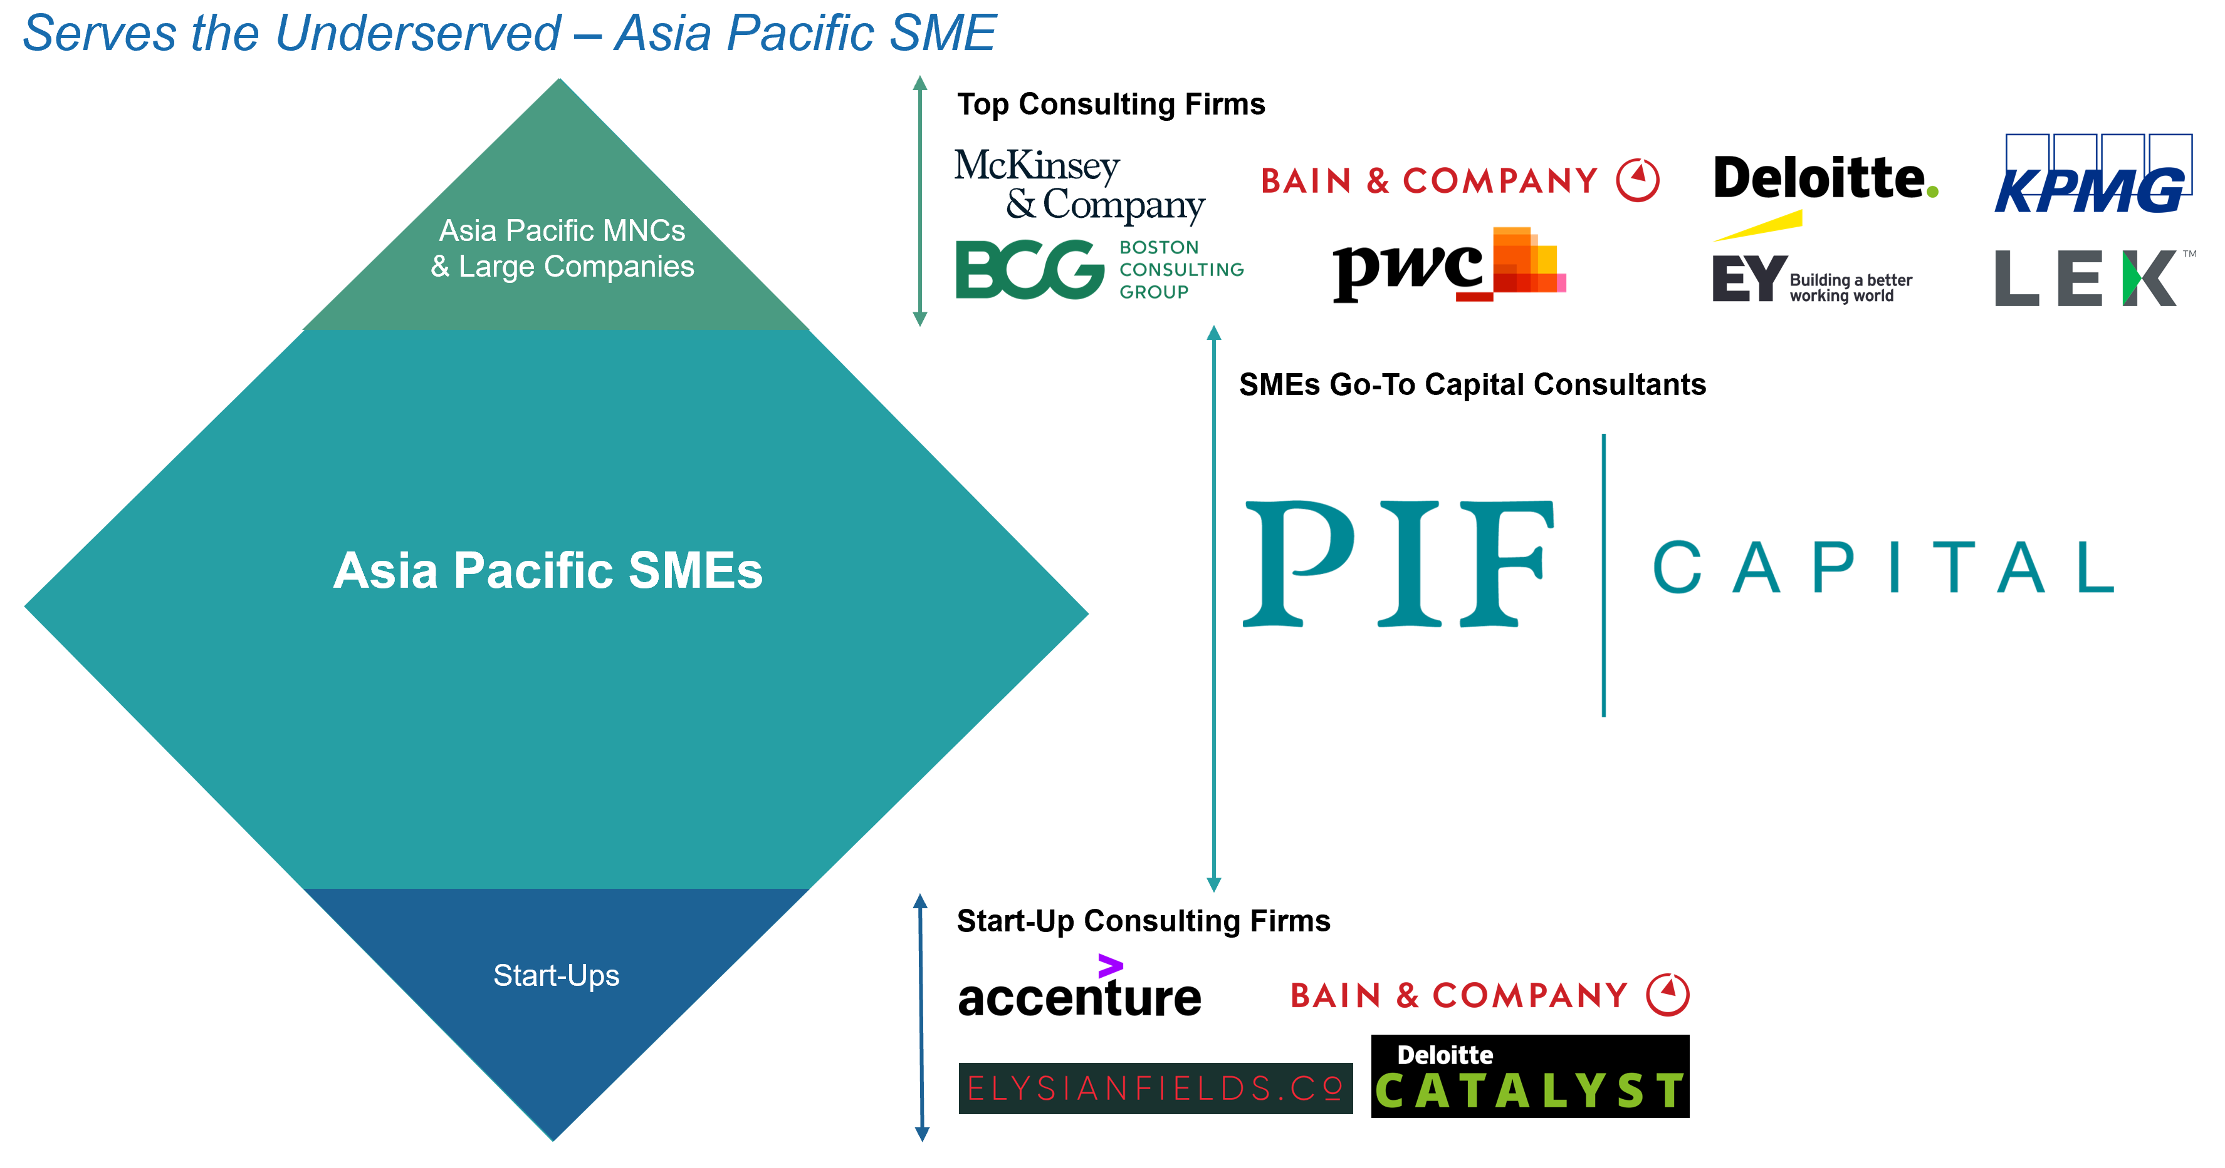
Figure 3: Market Segment of PIF
  - Micro and Macro Level Analysis
Strategic business alignment (SBA) is the degree to which employees understand, support and apply the company’s strategic initiatives and having such an alignment is of increasing importance because employees are more likely to make decisions that are consistent with the company’s objectives (Gagnon & Michael, 2003, p.25). On a micro level, a potential reaction might be the misalignment of employees’ understanding of organisational goals and business strategies with what the management has envisioned, and this can result in detriments to organisational health and effectiveness. Effective communication through our weekly meetings and training sessions would help me to mitigate this potential issue by developing personal motivations to create better employee alignment.
Another possible challenge to anticipate would be the onboarding of users onto the PEBI® platform and how to drive traffic after the onboarding process. Platforms usually struggle with onboarding of users with companies investing large costs into client acquisition and platform traffic as their platforms usually do not allow for flexibility across a single type of user. In order to mitigate issue, PIF would have to build the platform based on an ecosystem and this is exactly what the 148 System and the PEBI® platform is about. PIF currently has about 20 to 30 thousand offline clients, which can immediately be onboarded the online EduTech platform. As such, a single user can be onboarded once, and they are able to move across platforms as different types of stakeholders (Figure 2) and the flexibility offered with an ecosystem would ensure sustainability of traffic across the various platforms.
On a macro level, given that the concept of capital markets is currently very foreign to majority of the SMEs in Singapore, especially the ASEAN market, there is a certain degree of rejection and resistance of our products by the markets that our business is facing at this point in time. There is a low degree of understanding, support and execution of these initiatives provided to SMEs and this is an issue that we predicted when we first started out our efforts and have since started to mitigate this issue by first raising awareness through a top-down approach. To illustrate, recently, PIF and Antz Capital, alongside a regional partner: Growth Partners Asia, hosted a press conference in Phnom Penh, Cambodia with the guest of honour, His Excellency Preap Kol – Minister Attached to Prime Minister Royal Government of Cambodia Responsible on Foreign Investment, International Relations, Good Governance Reform. The press conference was about “SME Capital Entrepreneurship (SCE) Business Matching Summit Cambodia 2023” which would help to connect SMEs, entrepreneurs, investors and businesses from the region. Obtaining support and endorsement by the governments around the region is one of the fastest ways for us to convey the importance of our business strategies and underlying purposes and this is one of our core advantages relative to other businesses in the same industry.
Development of the 148 System enables mobility within the company; with our offline-to-online model, and from outside in, allowing for the company to seize the upside of disruption (Schreiber, Forer & De Yonge, 2017). Mobility of our system from the outside in is targeted to the liberalisation of the China capital markets as it is essential for there to be platforms and business models to be ready now to welcome the Chinese into the international market upon the liberalisation in the next 10 to 20 years. Disruptors should look at existing technologies and products in a different way because an innovation does not equate to a disruption (Plummer, 2022) and with the PEBI® platform, we are able to solve the issue pertaining to the current offline offerings and simultaneously create solutions for other related markets. The 4 resource platforms may not be a novel concept as discussed, but the value of the system is in it being the solution to connect the regional markets to the changing mindsets of the Chinese entrepreneurs and the greater Chinese capital markets. Expanding to areas outside China are now the focus of Chinese entrepreneurs as they have realised that replicating their success factors in their business model, which they have tried-and-tested all these years, is the key for them to rapidly scale up overseas. PIF has started establishing partnerships with Chinese educators for them to onboard EduTech with their content and connections. Hence, the current context presents an opportunity for PIF start building the systems and capabilities such that it can immediately welcome the influx of investments from China once liberalisation occurs. Adopting the same ambition of Chinese entrepreneurs, building these platforms and ecosystem now would give us the runway to do trial-and-error, identify our success factors and when the time comes, the solution can be implemented to connect the Chinese market to the rest of the economy.
  - Key Core Advantage of the 148 System
This is captured by the term coined by PIF: 资码开盟 (zī mǎ kāi méng), ZMKM. Turning businesses from offline to online are deliberate strategies for entrepreneurs to use digital solutions to handle the China market. The key core advantage of the 148 System is its three mutually reinforcing flywheels: data flywheel, growth flywheel and cost flywheel (Pidun, Reeves and Zoletnik, 2023). The data flywheel is based on the learning effects of our EduTech which would help to create a value proposition for the 148 System as it is not just a learning hub, but it is a hub that can directly connect you to a network of key stakeholders. The growth flywheel is based on the direct and indirect network effects of the ecosystem and as discussed above, the stakeholders of the respective platforms would be able to have access to each other directly or indirectly through a trickledown effect and tapping on user growth in terms of more entrepreneurs on-boarding the platform would bolster the value of the ecosystem and in turn, attract more users. Lastly, with the establishment of the data and growth flywheel within the 148 System, we would be able to achieve the cost flywheel; based on achieving cost savings with economies of scale as a larger user base would lower the average cost per user to build up the ecosystem and respective platforms. Relative to other similar platforms or ecosystems that may arise in the future, this solution is still able to remain its position as an industry disruptor as the cost flywheel would have been activated and refine our strategies throughout the time that was spent doing trial-and-error to minimize and ultimately avoid loss-making strategies. Being able to leverage on the first-mover advantage would benefit in the future when the China economy opens up as PIF would then be well-positioned to capture the full value the Chinese entrepreneurs can offer.
- Implementation
Implementation of technology into the PEBI® System is to consolidate data from multiple platforms into a centralised database and achieve data integration across the different stakeholders. As shown in Figure 4, the backend customer relationship management (CRM) module and integrated resource management solution provided by Odoo is able to store and manage data from the 4 resource platforms. I proposed to use Odoo as it is an open-source enterprise resource planning software suite that can provide a range of integrated business applications and the software ecosystem solution provided by Odoo is well-aligned with our needs. With our dynamic platform, backend technical framework has to be robust and Odoo is able to automatically apply usability improvements to all of their integrated apps and evolve faster than other solutions (Odoo, n.d.). The PEBI® platforms would be connected to each other as it is centralised onto a core hub, which is the mobile application. The features and functions of the PEBI® platforms as described in the earlier paragraphs are implemented through a mobile app, eliminating the need for multiple standalone applications. There is a reduction in the fragmentation of industry players as discussed in Industry Overview and users are then able to access a range of functionalities and services across PEBI® platforms within a single app. Each platform is assigned to a team member, and they would be responsible for building the platform brief according to internal discussions and external research, allowing for the comprehensiveness of the platform. I recommend for PIF to start building EduTech first in order to establish a client database and as discussed in 4b., PIF already has a ready database of offline clients that can immediately be onboarded the online platform.
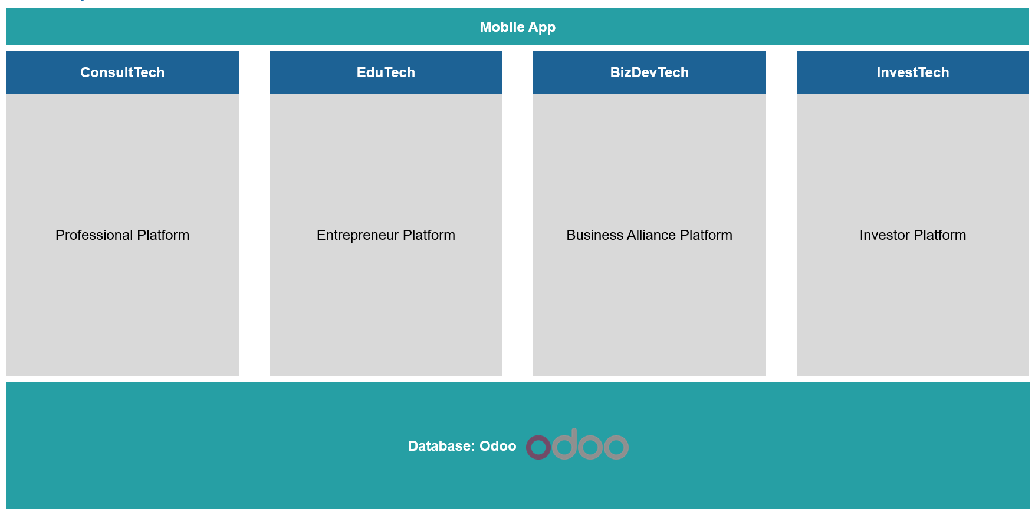
Figure 4: Backend Integration of the PEBI® System
- Timeline
This project is estimated to take about 15 months to develop and deploy the mobile application (Figure 5). PIF has engaged a Chinese software development company for this project, and we are currently in the development and programming phase. In order to alleviate the costs involved in building this mobile application and PEBI® platforms, PIF has applied and successfully been awarded the Enterprise Development Grant (EDG) from Enterprise Singapore, worth SGD 293,000. The EDG supports projects that help businesses upgrade, innovate, grow and transform the business in the Singapore business landscape.
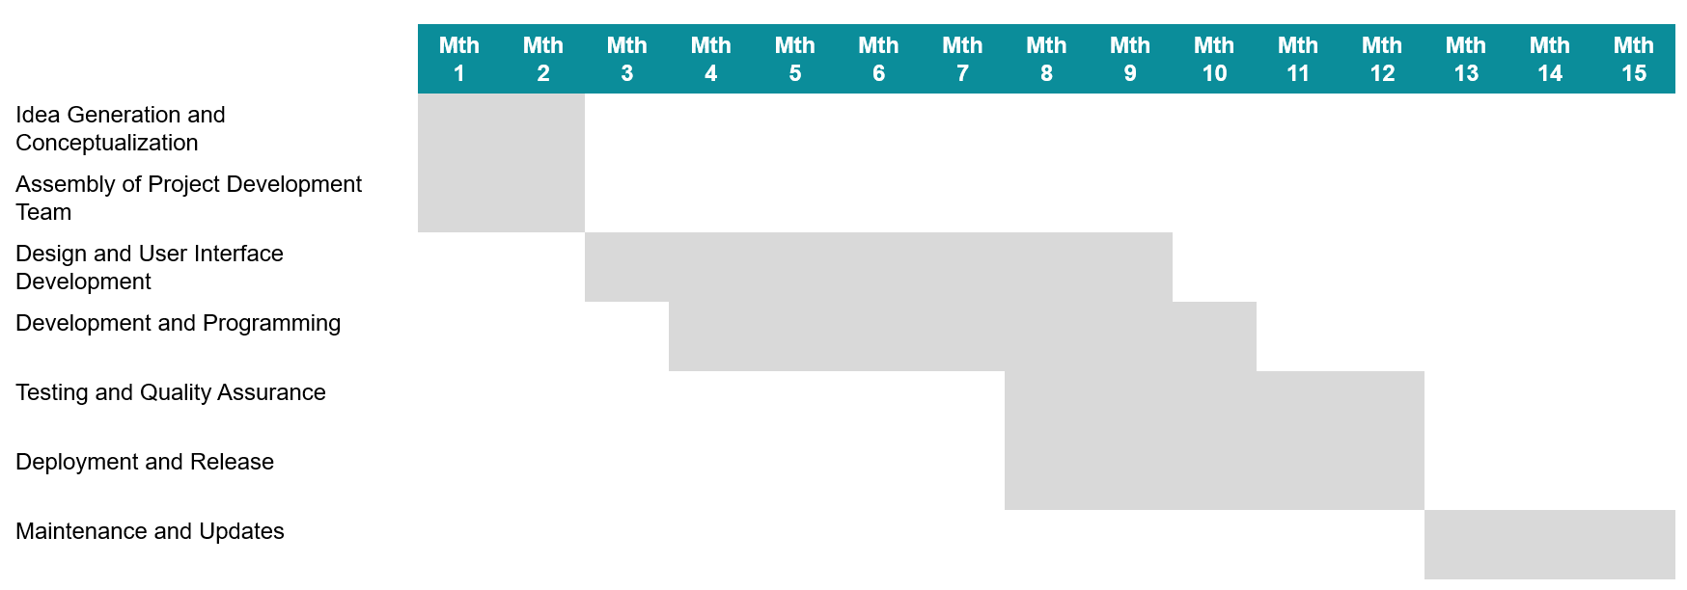
Figure 5: Project Timeline
- Investment and ROI
The estimated cost of developing the platform as provided by the Chinese developer is SGD 250.000. To provide a realistic estimation of the platform development, we have forecasted the costing structure as such: initial development cost of SGD 250.000 in Financial Year (FY) 2024 Forecasted (F), an additional SGD 10,000 in FY2025F for further enhancements and SGD 20,000 annually for additional features. The cost of establishing a technical support team and general and administrative costs such as marketing expenses have also been included in the estimations.
A revenue model of the PEBI® platform would illustrate the financial implications and returns from this project. The different revenue streams of the respective PEBI® platforms are described in Figure 6 and these revenue streams can be further refined post-deployment of the project. Due to the cost savings that we will achieve with the digitalisation of our services and development of a capital ecosystem, PIF is able to pass it on to clients through a gradual decrease in pricing, allowing for development of a competitive edge in terms of reasonable pricing for quality and comprehensive products and service offerings, coupled with high turn-around time due to the digitalisation of our processes.
Figure 6: PEBI® Platform Revenue Streams
Given the availability of a robust platform with features that are similar to what InvestTech is planning to develop, it is more economical for PIF to look into an acquisition of a similar platform and engage a software development team to upgrade any features that InvestTech needs. One such platform that I previously engaged with back in 2021 is Wholesale Investor (Figure 7); they are a leading provider of capital raising and venture investment solutions through their proprietary platform, CRIISP™. Wholesale Investor utilizes artificial intelligence and machine learning to matchmake and provide both investees and investors with access to each other. From previous discussions in 2021, Wholesale Investor has valued themselves at AUD 5 million and a rough estimation of their valuation in FY2024F would be SGD 7 million with the inclusion of performance-linked pay outs to incentivise the platform owner to continue to network and get investors onboard.


Figure 7: Wholesale Investor
To better estimate the value of the PEBI® platform, sum-of-the-parts method (Appendices A – B). The costing model is forecasted over a period of five years from FY2024F to FY2028F. In order to account for the fact that shares in PIF are not expected to become liquid assets for some time, a discount for lack of marketability (DLOM) is required and a discount of 30.0% is used. An equal weightage of 25.0% is given to each of the four platforms and when using the sum-of-the-parts valuation method, return on investment is 13,291% (Figure 8), which demonstrates this project would yield economic benefits and hence, it makes financial sense for PIF to embark on this project to develop and incorporate an ecosystem for the four stakeholders as discussed as the financial returns are far higher than the costs.
Figure 8: Estimated ROI for the project
- Conclusion
In conclusion, this paper has discussed the unmet financing needs of SMEs in the region and the effects of a fragmented capital market industry on these SMEs and the overall industry effectiveness. The paper then advocates for the use of a new system in the form of a technological ecosystem that connects professionals, entrepreneurs, business alliances and investors. The need for such a one-stop platform solution is increasingly prevalent due to the changing business landscape that will soon digitalise the capital markets industry, presenting the need for PIF to be able to adapt, innovate and value-add to current digital solutions. There is a need for SME entrepreneurs to be equipped with such relevant knowledge and having a C2C model for such education platforms is the key for rapid adoption of new mindsets pertaining to equity financing. Furthermore, traditional methods of prospecting and networking often vary in effectiveness, causing the industry to be ineffective and inefficient. The lack of connectivity to the SME market further exacerbates the issue as many stakeholders tend to overlook their growth potential and inability to access private data implies white spaces in the market for SME deal activities.
Having a mobile application to integrate the four platforms: ConsultTech, EduTech, BDTech and InvestTech provides value to the users as it is able to connect the previously fragmented stakeholders without excessive and siloed tools. In order to validate the proposal to build a platform ecosystem, a financial model was created, with input assumptions according to guidance from PIF management. From that, it can be concluded that the financial returns are far higher than the costs, thus making it rational for PIF to embark on this journey.
Word count: 6,514

References
Allotti, V., Bianchi, M., & Thomadakis, A. (2020, July 9). How (more) equity financing for SMEs can become reality - ECMI. https://www.ecmi.eu/sites/default/files/how_more_equity_financing_for_smes_can_become_reality.pdf
Aw, C. (2023, April 25). Singapore financial institutions to meet stricter data protection and consumer safeguards. The National Law Review. https://www.natlawreview.com/article/singapore-financial-institutions-to-meet-stricter-data-protection-and-consumer
Carvajal, A. F. (n.d.). Capital Markets and smes in emerging markets and developing economies : Can they go the distance?. World Bank. https://documents.worldbank.org/en/publication/documents-reports/documentdetail/270221582271669731/capital-markets-and-smes-in-emerging-markets-and-developing-economies-can-they-go-the-distance
Dimmick, M. (2023, March 24). The Art of Consulting: Building Trust, managing expectations, and delivering results. LinkedIn. https://www.linkedin.com/pulse/art-consulting-building-trust-managing-expectations-marc/
Hagel, J. (2015). The power of platforms - deloitte us. https://www2.deloitte.com/content/dam/Deloitte/za/Documents/strategy/za_The_power_of_platforms.pdf
León, M. B., Jenkins, P., Konigsfeld, J., & Salomon, L. (2022, December 21). Buy and scale: How incumbents can use M&A to grow new businesses. McKinsey & Company. https://www.mckinsey.com/capabilities/mckinsey-digital/our-insights/buy-and-scale-how-incumbents-can-use-m-and-a-to-grow-new-businesses
Odoo. (n.d.). Open source ERP and CRM: Odoo. Odoo S.A. https://www.odoo.com/
Pidun, U., Reeves, M., & Zoletnik, B. (2023, January 24). What is your business ecosystem strategy?. BCG Global. https://www.bcg.com/publications/2022/what-is-your-business-ecosystem-strategy
Plummer, M. (2022, December 28). Council post: The importance of becoming a disruptor in 2023. Forbes. https://www.forbes.com/sites/forbestechcouncil/2022/12/27/the-importance-of-becoming-a-disruptor-in-2023/?sh=2e45489450d5
US, D. (n.d.). Business Ecosystems Come Of Age. https://www2.deloitte.com/content/dam/insights/us/articles/platform-strategy-new-level-business-trends/DUP_1048-Business-ecosystems-come-of-age_MASTER_FINAL.pdf
Vollmer, S. (2015, July 24). 7 ways to ease smes’ access to Capital Markets. FM Magazine. https://www.fm-magazine.com/news/2015/jul/access-to-capital-markets-201512692.html
Waldeck, A., Rising, C., Alton, R., & Christensen, C. M. (n.d.). The new M&A Playbook. The New M&A Playbook - Article - Faculty & Research - Harvard Business School. https://www.hbs.edu/faculty/Pages/item.aspx?num=39920
World Bank. (n.d.). Improving SMEs’ access to finance and finding innovative solutions to unlock sources of capital. World Bank. https://www.worldbank.org/en/topic/smefinance

Appendices
Appendix A: Costing Model

Appendix B: Sum-of-the-Parts Valuation

