Isaac Ayodele
Swiss School of Business & Research (SSBR) – APRIL 2024
Swiss School of Business & Research (SSBR) - PhD By Portfolio in FinancE

FINAL Dissertation

candidate: Isaac Ayodele

Table of Contents
Section A: Research Proposal 3
1. Introduction 3
2. Findings and Analysis 5
Section B: Exploring Retail Investor Needs 7
3. Introduction 7
4. What Retail Investors Are Looking For 8
5. Conclusion 16
Section C: Benefits and Risks of Crowdfunding in Retail Portfolios 17
6. Introduction 17
7. What Are the Benefits of Crowdfunding for Retail Investors? 17
8. What Are the Risks of Crowdfunding for Retail Investors? 19
9. Crowdfunding Risk Mitigation Strategies 20
10. Conclusion 21
Section D: Retail Portfolio Construction and Optimisation 22
11. Introduction 22
12. Portfolio Construction 23
13. Portfolio Optimisation 24
References 27

RESEARCH TOPIC:
DisruptiVE TREND in Retail Portfolio Construction And Optimisation

Sub-Topic:
the Impact of Private Market Investing (Crowdfunding) on Retail Investor Returns

Section A: Research Proposal

Introduction
Problem Statement
On the totem pole of traditional investment beneficiaries, mainly cash-based assets (e.g. money market funds), listed equities, bonds and even liquid alternatives, retail investors tend to be left holding the worst end of the stick when things go wrong, and are not always highly rewarded when times are good. This claim would seem anecdotal until we assess the fact that multiple factors lead to the differences in results that institutional and retail investors observe in their respective portfolios.
These differences range from available deployable capital to how much influence they can individually wield in the capital markets. They also include depth of investing experience and the number of regulatory restrictions that each of these investor types have to deal with (Kilroy, 2022).
The possibility of high returns in a world of continuously emerging unicorns, as well as ultra-successful entrepreneurs and wealth managers, has continued to attract retail investors to the capital markets. However, individuals do not have the same types of direct access, sophisticated infrastructure, or indeed pockets that are deep enough, to meaningfully benefit from investing at the right time in order to harvest very large returns over time. For example, they do not have, and probably cannot afford, to regularly pay for access to all required data or first-hand company research etc. to select the best stocks that would maximise their returns. Quite logically, a few hundreds or thousands of pounds, dollars or euros would barely move the needle in a world of deca or centi-millions, and sometimes billions, which large corporations can deploy in the public capital markets, or indeed, in large private market deals.
The recessionary winds and blowouts from the great financial crisis (GFC) and COVID-19 have shown very clearly that when times are good and market participants are bullish, retail investors appear to get the crumbs of the ‘return pie’, but when times turn sour, they are likely to feel the biggest financial pain.

Research Objective
The appetite of retail investors for better returns, as well as transparency and access, has led to the kind of creative thinking that birthed a somewhat nascent, but appealing product in the alternative investments space – Crowdfunding. Its core appeal seems to be its applicability to different sectors, such that deals can be structured around different asset classes (e.g. property) without compromising the ability of retail investors to participate in picking deals that match their investment objectives and style, whether that is momentum investing, e.g. early stage investing, IPO funding or private lending, specifically venture debt. It also allows them to take a front-row seat in deciding which of these companies no longer fit their portfolios, so that these deals can be removed from their portfolios at the earliest possible time, e.g. via a discounted sale in the secondary market if this is available. Today, we seem to have a more democratised financial world where retail investors directly engage company C-suite executives without the formality of an Annual General Meeting (AGM) or class action, as is applicable in the public or listed securities market.
This dissertation aims to do the following. First, it would explore whether the ability and empowerment that crowdfunding provides to retail investors is a permanent game changer on the investment landscape. Anecdotally, it is interesting that today, a pool of retail investors can invest under somewhat similar terms as institutional investors into deals that previously would have been the exclusive preserve of large financial organisations such as banks, or their ultra-wealthy clientele, or even Sovereign Wealth Funds. That paradigm seems to be increasingly evolving towards a more level playing field for large and small market participants.
Secondly, this research intends to assess whether crowdfunding is indeed the best long-term solution for retail investors, rather than the traditional long-only funds that were curated and managed on a discretionary basis, which also gave institutional fund managers incredible amounts of influence, including the ability to set and collect all kinds of recurring fees regardless of fund performance.
Finally, this dissertation will explore how retail investors can utilise crowdfunding to achieve their return objectives, both capital appreciation and income generation. This can be as a satellite product to a core traditional asset portfolio, or as a core portfolio in itself.
It should be noted that Reward or Charity-based crowdfunding will be completely excluded from this research. The focus is strictly on investment crowdfunding.

Literature Review
In relation to data gathering and analysis, the plan during this research is to focus on eliciting and using:
- Secondary Data: This will be based on projects done by professionals, academics and independent institutes or journals that have analysed the sector and publicly published their work. Their findings will be synthesised and juxtaposed with the direct observations from the primary research to see where the preponderance of evidence lies. The goal is to carry out an objective assessment of the topic. So, educated opinions will not be taken as fact or truth, especially where no empirical evidence supports them. However, they will be acknowledged for completeness only where relevant.
- Quantitative and Qualitative Data: Calculations and numerical data will be reused and their sources would be cited. Also, they would be predominantly secondary information. This is because of the time and resource constraints of having to singularly find, capture, clean and accurately analyse enough quantitative data. For qualitative datasets, questionnaires may be shared with appropriate organisations as part of the primary research.
The following academic literature will be instrumental in completing the research. A lot more sources will be used, but the following show a range of targeted references that would be read and cited:
- Investment and Pensions Complaints Statistics (2020) – UK Financial Ombudsman Service
- Equity crowdfunding: a systematic review of the literature (2020) - Kazem Mochkabadi and Christine K. Volkmann
- Crowdfunding: Fundamental Cases, Facts, and Insights (2019) – Professor Douglas Cumming, Schulich School of Business, York University
- Crowdfunding as a Financing Resource for Small (2017) – Melissa Cohen, Walden University
- U.S. Crowdfunding Market Size Estimate (2013) – Fung Institute’s Program for Innovation in Entrepreneurial and Social Finance, UC Berkeley
- $43+ Billion Global Crowdfunding Market is Expected to Grow at a CAGR of over 16.50% During 2022-2028 (2022) – Vantage Market Research, USA

Findings and Analysis
Current Gaps of Traditional Investing versus Crowdfunding
Before exploring crowdfunding, which is predominantly a digital concept, it is worth assessing the current investment landscape within which retail investors operate, but also the limitations of the conventional options that arguably make crowdfunding a credible and very compelling alternative to traditional assets.
There is an incredible amount of literature on the challenges of traditional investments. The most obvious observations are:
- Knowledge asymmetry of traditional assets between investment firms and retail clients.
- Erratic and unpredictable returns of traditional assets (equities, bonds and some commodities, including their exchange-traded/listed or Over-the-Counter/OTC derivatives). These would be compared to the more predictable returns of crowdfunding where, for example, interest rates on debt are specified upfront or target multiples of return are outlined for equity crowdfunding deals in the relevant investment memoranda.
- The ‘oil tanker effect’ of large institutional investors and their aversion to change, until they have no choice. Firms using Crowdfunding as a means of raising capital seem to have leaner organisational structures and the nimbleness to quickly make decisions and adapt their products to market changes.
- Traditional investment firms can be quite bureaucratic, and institutional fund managers cannot be directly contacted, nor can the decision makers of the companies they invest in be easily or directly reached. However, Crowdfunding allows retail investors to more easily engage with key decision-makers in potential investee companies via investment portals. These can be either prospective or existing retail investors.
- Larger firms have legacy and clunky systems, as well as outdated technology in many cases. On the other hand, Crowdfunding firms have more efficient platforms that seem to deliver better client experiences, including a more personalised service such as an Account or Relationship Manager.
Overlap with Modules 1 and 2:
Legal and General Investment Management (LGIM) is a traditional asset manager that recently started to build its Real Assets and Alternatives business.
The company is still an institutional player and the problems solved and decisions made within the organisation are aimed at benefitting its institutional investors. Although retail clients can invest in some of the company’s funds, they grapple with the same gaps that have already been outlined above.
Research Questions:
The core bases for the research are the following key and related questions:
- What precipitated the birth of Crowdfunding, or what gaps are traditional investment firms unable to fill for retail clients? Although we have already alluded to the challenges above, research findings will be explored as to why providing Crowdfunding as an alternative to retail investors is necessary in a world where individual circumstances are bespoke, and as such the construction of their portfolios need to be the same.
- Why has Crowdfunding grown so quickly since its launch? The research will assess the breadth and depth of the retail clients’ displeasure with traditional assets and the appeal of Crowdfunding as a viable option.
- Is Crowdfunding a sustainable product in retail clients’ portfolios? This will assess whether this new asset is a passing fad or something that is here to stay.
- Do Crowdfunding product providers pose a threat to established traditional investment providers? This will explore how much competition Crowdfunding can provide to its much larger and more established counterparts in the investment products space.
Current Risks and Disclaimer
This research does not intend to present Crowdfunding as a panacea for all investment issues that retail investors face. As a result, it will reveal the limitations and risks of the product, which paradoxically can be the advantages of traditional asset investing. The key areas of focus will be as follows:
- Immaturity of the asset class: Crowdfunding firms are at the nascent stage of their evolution. They are not yet developed enough to remove concerns that some of their offerings to clients are experimental in terms of:
  - Operational processes
  - Available data, e.g. limited or no performance history
  - Fragmented value chain requiring external dependencies and higher running costs
  - Fees: Hybrid of Hedge Fund and Private Equity / Venture Capital structures, e.g. 2 and 20 or IRR of X%
- Idiosyncratic risk of the asset:
  - Debt
    - Counterparty Default Risk (Property and Small and Medium-sized Enterprises/SMEs)
    - Techniques and tools for hedging are not as easy to determine and apply
  - Equity
    - Pricing Risk
    - Techniques and tools for hedging are not as easy to determine and apply
- Esoteric and non-fungible nature of the asset class: As Crowdfunding is fairly new and so does not have similar trading volume and market depth as traditional assets, it rarely ever provides a big enough secondary market, if at all. This often means that the retail investor is “stuck with” the deals throughout the product’s lifecycle regardless of its performance or non-performance. How this risk can be managed will be further explored.
- Reaction to Black Swan events: Given the fact that Crowdfunding is still relatively at its infancy, there haven’t been many economic shocks to allow the market as a whole to observe its reaction in stressed conditions. The only macroeconomic shock has been COVID-19, and a lot of the financial fallout from the pandemic was absorbed by generous governmental intervention through quantitative easing and support for all businesses, especially SMEs, who are the primary users of capital raised through Crowdfunding.
So, while the COVID-19 pandemic may have been its first major economic shock, it could be considered a poor proxy for what would happen if a scenario such as the 2008 GFC were to occur again. Would the businesses being crowdfunded survive, or would they fold in an adverse economic climate? The scale of the impact and the adaptation capability of crowdfunded business has not really been truly tested yet.
This dissertation is intended to expatiate on these risks and analyse the impact of both sector-specific and bigger macroeconomic events on Crowdfunding.
Offerings of Crowdfunding Firms
The products and value provided by these firms are as follows:
- Debt and Loan Agreements mainly to fund:
  - Property acquisition, construction and development
  - SME funding
- Equity
  - Property acquisition, construction and development
  - SME funding
- Ancillary Value Propositions:
  - Enhanced value through technology
  - Transparency
  - Speed
  - Ease and convenience
  - Security
The goal of this research is to provide an objective and neutral opinion based on industry findings, not just in terms of historical events or the current state of this burgeoning asset class, but also what the future trajectory looks like in terms of its continuous adoption among retail investors.
Areas requiring further research will also be outlined to allow any related topic that is referenced to be explored in the future.

Section B: Exploring Retail Investor Needs

Introduction
We begin with an exploration of the appeal and suitability of Crowdfunding as a fairly new investment option for retail investors, considering the key factors that matter to them when investing. Said differently, to understand why retail investors could and should consider Crowdfunding in their portfolios, we must go back to basics and assess the reasons that compel them to decide to invest in the financial markets in the first place, irrespective of the asset class. By doing so, we will be able to see the needs that are unmet by the current market offerings and why Crowdfunding specifically could meet those needs out of the plethora of options that are available in the marketplace.
The underpinning assumption is that retail investors are generally driven by several common factors. In this instance, we will take the commonality of reasons as the norm, not the exception or outliers. Also, we will assume that the available assets are accessible to most retail investors.
Another underpinning assumption here is that the factors apply across most markets, especially developed economies where although it is still relatively new, Crowdfunding is no longer a burgeoning asset class or investment vehicle. In essence, we will explore the dissertation topic through the lens of developed markets such as the United Kingdom, Western European countries, the United States and Canada, including economies in the Asia-Pacific region, namely Hong Kong, Singapore and Australia. As such, examples will be drawn using data from these regions. The objective is to reach conclusions that are as generally accurate and congruent as possible, regardless of geography or region.
It was estimated that as of 2022, the Crowdfunding market was worth over US$19 billion (Vantage, 2022). This is expected to grow at a compounded annual growth rate of 16.50% per year until 2030, at which point it is expected to reach US$66.72 billion (Vantage, 2022). Such a level of linear market expansion suggests that an increasing number of retail investors will find Crowdfunding appealing and relevant to what their investment needs and objectives.

What Retail Investors Are Looking For
Who Are Retail Investors?
This is a fundamental question, as we need to establish exactly what is meant by retail investors. According to the UK Financial Conduct Authority (FCA), there are three types of investment clients. These are outlined in detail in the regulator’s Conduct of Business Sourcebook Client Categorization rules (FCA, 2024). The descriptions below are not exhaustive, but some key points to note are the following:
- Eligible Counterparties: Similar to professional clients, there are two categories of these clients:
  - Per-se Eligible Counterparties: They include EEA and non-EEA entities such as investment firms, central banks and supranational organizations.
  - Elective Eligible Counterparties: These include counterparties or equivalent undertakings that are not from an EEA State but who satisfy the regulatory conditions and requirements for being treated as an eligible counterparty.
- Professional Clients: There are two types in this category:
  - Per-se Professional Clients: An entity that is authorized by the FCA or a regulator, or which according to MIFID rules has a balance sheet of over €20m, a net turnover of €40m, or has its own funds at or over €2m. This sub-category extends to national or regional governments, including their agencies.
  - Elective Professional Clients: These are clients that have been qualified or passed a quantitative test in order to elect to be treated as professional clients. The test includes confirmation that the client has carried out transactions, in significant size, on an appropriate trading venue at an average frequency of 10 trades or deals per quarter over the previous four quarters.
- Retail Clients: These are potential or existing clients who do not fit into the description of professional clients and eligible counterparties provided above. They are everyday individuals who have ambitions to invest their disposable income in the markets to achieve decent returns. These can be further subcategories into 2 types:
  - Certified high net worth investors
  - Certified sophisticated investors
  - Other retail investors
The first two types of retail investors are required to self-certify to the investment companies that they are engaging with that they meet a number of preconditions set out by the FCA, which have been summarised below:
“It is possible to ‘self-certify’ yourself as a HNWI or a sophisticated investor. To self-certify as a HNWI you have to earn at least £100,000 per year or have net assets (excluding your property, pension rights and so on) of at least £250,000.
To self-certify as a sophisticated investor you must:
- have been a member of a business angels network for at least six months; or
- have made at least one investment in an unlisted security in the previous two years; or
- have worked in a professional capacity in the provision of finance to small- or medium-sized businesses in the last two years or in the provision of private equity; or
- be or have been within the last two years a director of a company with a turnover of at least £1m.”
Source: SWLaw (2022)
This research will focus on all three types of retail investors and explore how crowdfunding could generally help them achieve their financial goals regardless of their financial means.
What (Retail) Investors Want
The concept of what a long term investor, rather than a short term speculator, is looking for is underpinned by a number of factors. The most evident ones have been outlined below by the large US financial media company, Forbes:
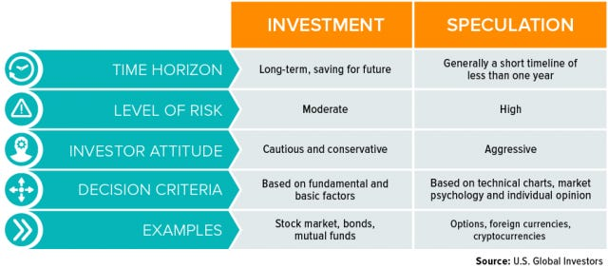
In essence, a retail investor in our context is someone who is looking to get a steady, and ideally a higher than average, or even average return on their investment over the long term and at a moderate level of risk.
The key points here are return and risk, which tie in with the principles proposed by Harry Markowitz in his article about Portfolio Selection in 1952. The crux of what Markowitz was proposing was that investors wanted returns, but have to assume a level of risk in order to realise these. As such, this becomes the risk-return trade off, where investors are generally willing to take on more risk if they can see a commensurate or potentially higher level of return. So, risk and return necessarily move in tandem.
Markowitz later proposed the Modern Portfolio Theory which at its core suggested that investors would need to evaluate different combinations of securities, i.e. diversify their investments across different stock issuer names, in order to optimise their return for the level of risk that they are comfortable assuming. So, the other important point to consider is optimisation, rather than maximisation, as the optimal level of return is not always the same as the maximum level of return for an investors. Once the highest possible return has been calibrated in line with the investor’s risk appetite, then that may be the optimal return for that investor.
Another point which Markowitz made was that by combining securities into a diversified portfolio, the overall risk will be less than the risk inherent in holding any one individual stock and so reduce the combined variability of their future returns. The risks associated with holdings stocks are:
- Systematic – This risk applies to the entire stock market
- Unsystematic – This is also referred to as idiosyncratic risk, as it is specific to the stock held by an investor over and above the systematic risk. This risk is also considered diversifiable, i.e. it can be reduced by buying other stocks that are uncorrelated.
So based on the above, we can only describe what investors are looking for as an optimal level of return at a level of risk that fits their appetite on a steady basis, for a long period of time.
Beyond returns, retail investors also want the following: strong market performance, fee compression, tech-enabled transparency, greater access to markets, and new personalized products. More recently, they want opportunities or deals that have Environmental, Social and Governance investing strategies (CFA Institute, 2024).
Options Available to Retail Investors
Beyond cash savings, if we were to assess the investment landscape in 2024, we could still create two types of traditional offerings from investment providers to retail investors namely, equity and equity-like products, as well as fixed income or income-generating products. Both product types are available in the public and private markets.
In the context of the topic being explored, crowdfunding fits within the private markets and can be either equity or income-based. From a scope perspective, other types of crowdfunding, e.g. for rewards, are not considered relevant to the topic, and so will not be discussed.
Building on Markowitz’s argument for diversification in order to build an optimal portfolio, this ground breaking research at the time it was published influenced equity portfolio construction and contributed in no small way to the creation of diversified investment vehicles, namely funds.
The characteristics of these two types of investment offerings, equity and fixed income, can be mapped to the vehicles available to investors today:
Characteristic | Description | Examples | Common  Investment Vehicles | Risk Level | Minimum Investment Ticket Size
High Volume – High Value | These are high quality stocks with steady or strong performance, which are available in the public markets. | Listed Blue Chip Stocks and Listed Funds | Direct investing,  Mutual Fund, Pension Fund or Hedge Fund | Low – Medium | High
High Volume – Low Value | These are low quality stocks with erratic/unsteady performance, which are available in the public markets. | Most Listed Single Stocks and Listed Funds | Direct investing, Pension Fund,  Mutual Fund | High | Low
Low Volume – High Value | These are high quality stocks with limited amounts available, often in private markets. | Growth Equity, Private Equity, Private Debt | Private Fund, Crowdfunding (single deals) | Medium –  High | High
Low Volume – Low Value | These are low quality stocks with limited amounts available, often in private markets, e.g. private equity | Angel Investing, Venture Capital | Direct investing, Private Fund,  Crowdfunding (single deals) | High | Low – Medium

Although they are diversified, it should be noted that from a return perspective, whether a retail investor choses a Mutual or Pension Fund, these have not performed outstandingly well in recent years, especially actively managed funds for which fees are quite exorbitant in many cases. So today, diversification is not enough to meet the optimal return objective of the retail investor.
When the Organisation for Economic Co-operation and Development (OECD) published its retrospective one year review of the performance of pension funds in 2021, covering the period 2019 – 2020, it was discovered that only one country had a performance of above 10% return on investment, and that was Hong Kong, China. Pension Funds in most countries had modest returns of between 4.1% – 9.3%.
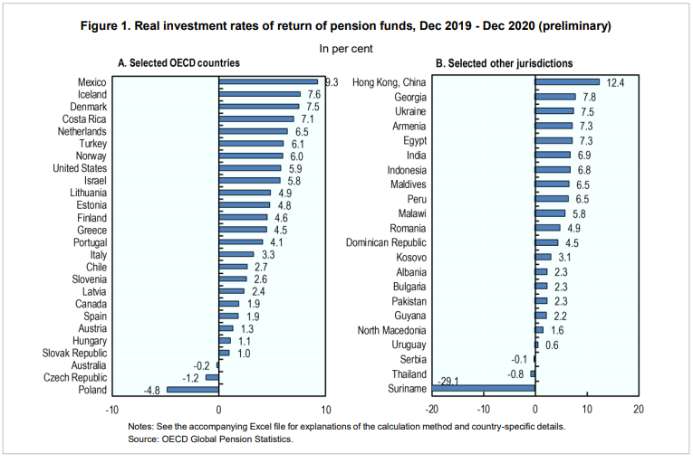
Also, for High Net Worth retail investors, the returns of Hedge Funds have been quite subdued compared to market indices (Preqin, 2021). Returns here are being described as the month-to-month change in NAV after fees have been deducted to reflect the perspective of the investor.
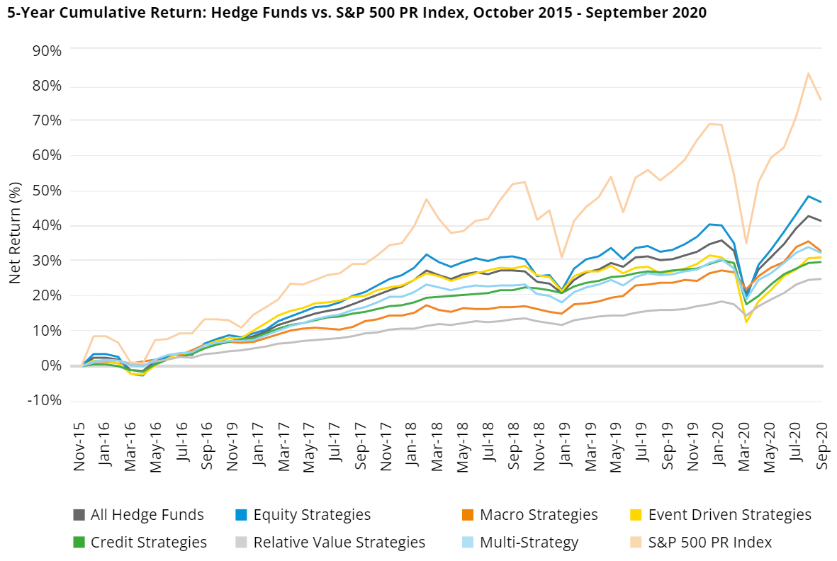
Source: Preqin (2021)
This explains the disillusionment with actively managed funds, including Mutual Funds with absolute return or other hedge fund-like strategies, and the rise in redemptions, including a mass exodus towards passive funds since 2018 which now dominate the equity markets (Bloomberg Intelligence, 2021).
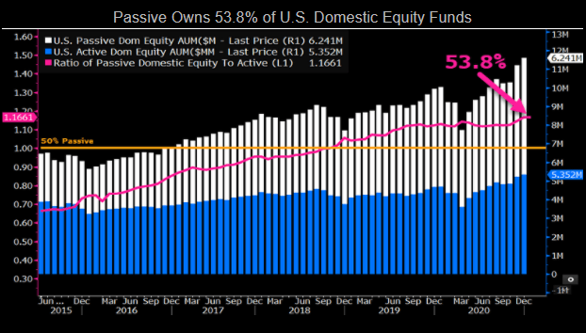
Source: Bloomberg Intelligence, 2021

Current Gaps of Traditional Investing versus Crowdfunding
Given the explanation of the limited returns of listed stocks and vehicles such as funds, there are other challenges with these traditional investments. These are explained further below:
- Knowledge asymmetry of traditional assets between investment firms and retail clients: Many retail investors do not have the option of knowing enough about the stocks that are picked by fund managers. Even in directly selected company stocks, investors rarely have the volume of data, level of sophisticated knowledge and depth of infrastructure to thoroughly understand how all the companies that they are selecting work. This would often include the risk factors that could upend the expected earning or performance of those companies, and subsequently, the investor’s portfolio.
In Finance theory, the reality of many investors experience would suggest that the market is inefficient as the best form of information available to investors is weak-form based on the Efficient Market Hypothesis (Fama, 1970).
- Erratic and unpredictable returns of traditional assets (equities, bonds and some commodities, including their listed or OTC derivatives): The underlying premise for investing in listed stocks or bonds, whether directly or indirectly through funds, is that the price of the asset will move all the time based on demand and supply. Also, those who buy these assets do not always have a long-term view, so speculators such as large trading outfits (investment banks that speculate) or hedge funds that binge on shorting stocks can adversely influence or skew stock prices. This often leads to an increase in price volatility and the erratic behaviour of buying and selling on whim, depending on the changing sentiments of participants about factors such as the economy, geo-political events etc. Since these factors are beyond anyone’s control, so retail investors tend to end up dealing with the consequences of continuous market movements, whether positive or not. Comparatively, in private markets, such as crowdfunding, what is on offer are more predictable returns, for instance, an expected interest rate on debt deals, or target multiples of return on equity deals.
- The ‘oil tanker effect’ of large institutional investors and their aversion to change, until they have no choice: While many investment companies, including funds, claim to care about investors, as we will see in the next chapter during our analysis of the traditional markets versus private markets, especially crowdfunding, most large investment firms have acted contrary to their fiduciary duties again and again. The most obvious and punitive behaviour is misalignment of interest with the investors when it comes to fees. Investment companies collect their fees regardless of performance. Also, poor-performing funds can be explained away to investment committees for years without considering that the return objectives of clients have not been met. The alternative is the plethora of crowdfunding firms with leaner organisational structures and the nimbleness to make decisions and adapt their products to market changes quickly to investor demands.
- Traditional investment firms can be quite bureaucratic, and fund managers can’t be directly contacted, nor can the decision makers of the companies that they invest in be easily or directly reached. If correspondence is at all possible, it tends to be minimal and slow. Crowdfunding allows retail investors to more easily engage with key decision makers in potential investee companies that they are still considering or those that they have already invested in.
- Larger firms have legacy and clunky systems, as well as outdated technology in many cases. Where large transformational initiatives are launched, change projects can take years to implement. So from an investor experience perspective, positive change can be slow when investing in traditional assets through investment firms. On the other hand, crowdfunding firms have more efficient platforms that seem to deliver better client experience, including a more personalised service such as an Account or Relationship Manager.

Why Private Markets, and specifically, Crowdfunding?
We will first begin with the recent reports that private markets have been outperforming the public investment markets for a considerable period of time now. When we consider private equity, there has been a meaningful level of growth in fund raise and return (McKinsey, 2022).
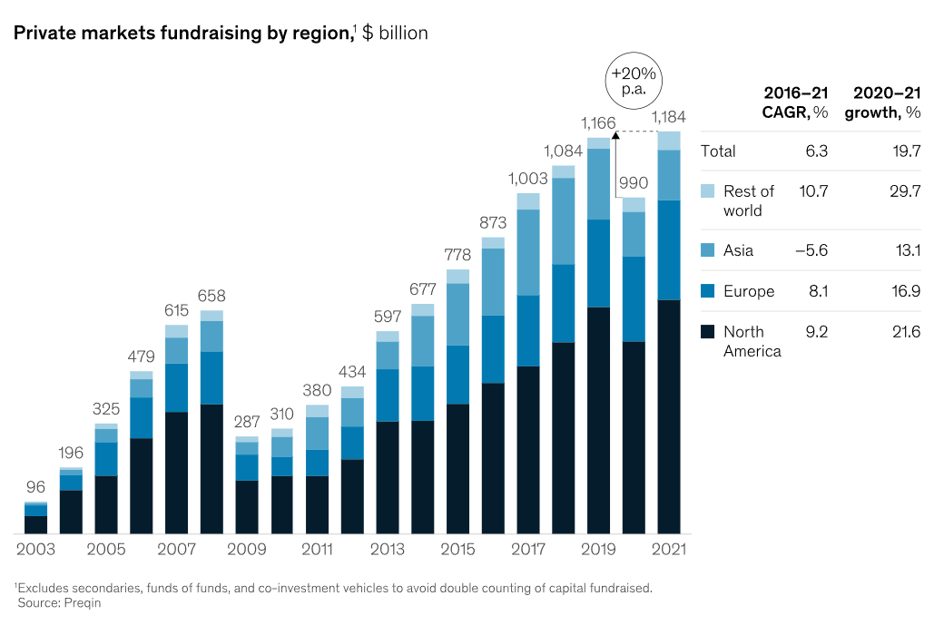
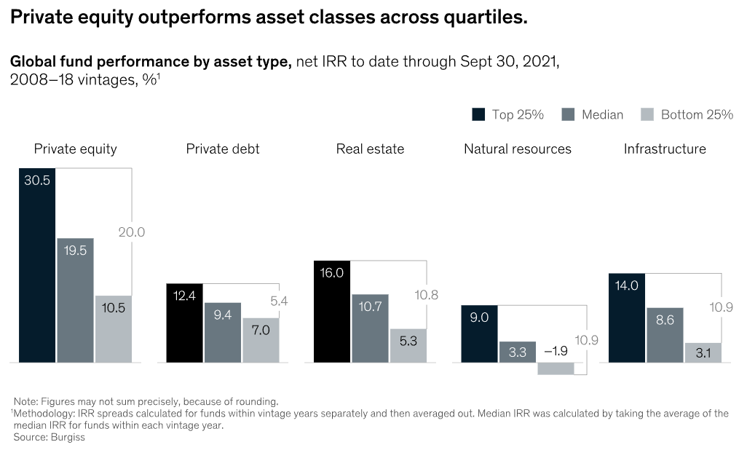
The same types of observations have been made in the private debt market.
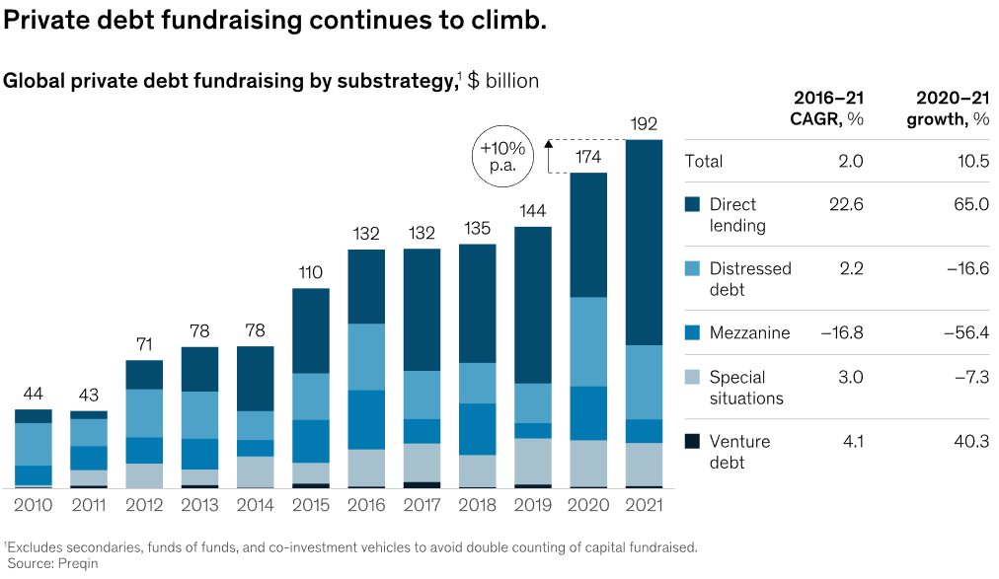
Specifically, property or real estate deals tend to have grown quite significantly, with investors being bullish about the likelihood that returns, mainly in terms of intrinsic value, will rise over a period of time. The housing shortages in many developed markets continue to keep prices high, and so deals in private markets especially in relation to property are continuing to be made on a large scale.
It is difficult to envisage a repeat of the 2008 sub-prime mortgage debt crisis, as credit risk has significantly improved from regulatory as well as internal business management standpoints. As such, while it is highly likely that defaults will continue to occur, their volume, scale and severity can be better curtailed with strong risk management controls in place at a company and at a systemic level.
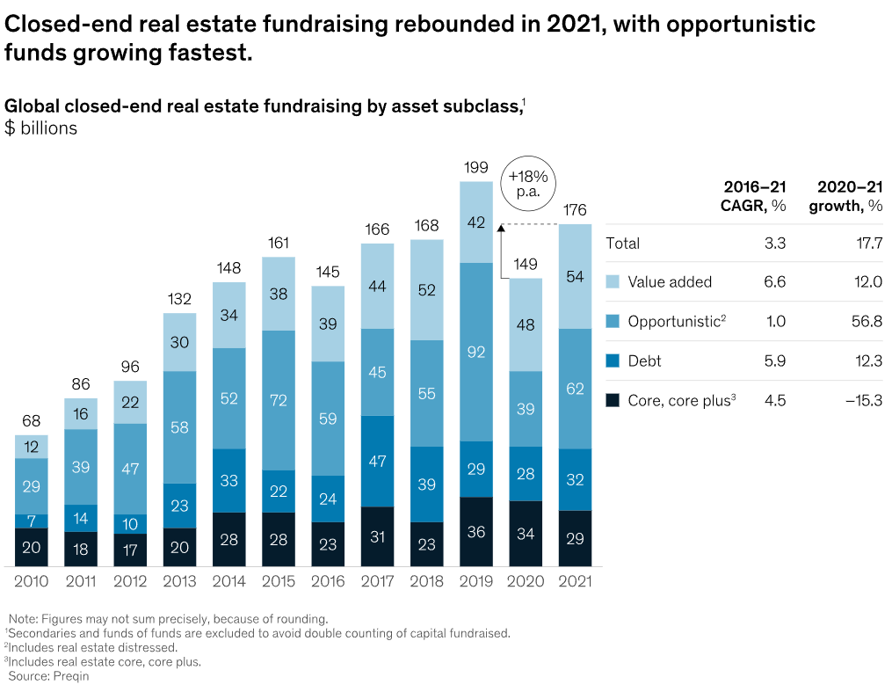
Secondly, crowdfunding products come in different forms as outlined below. More importantly, these variations provide opportunities to retail investors to participate more actively and directly in the private markets. As we have established, the empirical evidence of better performance in private deals is increasingly becoming incontrovertible. The forms of crowdfunding are:
- Debt and Loan Agreements: These are often done in the form of creating a special purpose vehicle (SPV) and tranches of investments are sold to investors once the objectives of the fund raises have been clearly outlined in investment memoranda. Oftentimes, funds are raised for:
  - Property acquisition, construction and development. Examples of these companies are Planet Home Investment AG in Germany.
  - Small and Medium-sized Enterprise loan funding. Examples of these companies are Triple Point Income Service in the UK.
- Equity: These companies raise funds
  - Property: It is possible for investors to own a piece of the upside in the value appreciation of a property or a series of properties. This does not mean that they would be entitled to a fixed return, but rather a prorated part of the difference between the purchase and sale price of specific properties. Examples of companies that attempt to do these are FundRise in the United States of America.
  - SME funding: This is arguably the most popular form of crowdfunding. Platforms such as Seedrs in the United Kingdom or OurCrowd in Israel regularly raise funds for companies that are up and coming. The pitches tend to be akin to those provided to angel investors or venture capitalists, so investors can directly ask company management teams questions relating to different parts of the businesses being funded.
Crowdfunding also provides additional value propositions to retail investors, which they cannot easily get from public investment companies that offer traditional assets:
  - Enhanced value through technology and transparency: Many deals are accessible online and via platform applications, so investors can see upcoming, live and closed deals. They can also access the relationship management or client support teams on the Crowdfunding platforms to get technical support or more detailed information, oftentimes, once an investor has signed a Non-Disclosure Agreement (NDA).
  - Speed, ease and convenience: The time between when companies or projects that require funding initiate a request via the platform, including thorough due diligence, and when they are available to investors are much shorter than the process and hurdles for getting into or raising funds from the public markets.
  - Security: The illiquidity of private deals provides a degree of protection to investors, as their holdings cannot be quickly converted to cash. More pertinently, the technology used by many crowdfunding platforms have improved embedded security settings to minimise cybersecurity risks such as hacking.

Conclusion
Unfortunately, traditional assets have not met these needs in a compelling way over a long period of time. So as the ground begins to shift beneath traditional asset managers and investment companies, it is important to call out the commensurate shift in the power structure, where investors are voting with their feet by redeeming more of their units from mutual, pension and hedge funds, then redirecting their cash to private markets where the needs that we have already mentioned can be better met.

Section C: Benefits and Risks of Crowdfunding in Retail Portfolios

Introduction
The research has focused on the core advantages of crowdfunding as well as the downsides that an investor needs to be aware of. It is essential to assess crowdfunding as an investment vehicle that can be used to contain different kinds of asset classes at reasonably affordable entry points, also referred to as ticket prices or minimum investment amounts.
Overall, although publicly traded assets offer the advantage of liquidity, this can sometimes turn out to be a double-edged sword for investors. That is because an imbalance in trading (buying and selling) these assets can be overly influenced by the predominant market sentiments, which are very prone to one of two extremities; market excitement or market hysteria. The issue with swings in market sentiment is not necessarily bad. However, the protraction of the swings can have negative impacts on the portfolios of all, but pertinently, retail investors.
So, the evolution towards lower volatility in market prices and longer valuation periods, e.g. quarterly, semi-annually or yearly have been pulling investors into the private markets. The price of this steadiness is illiquidity. When the market was much smaller and only available to institutional investors as well as high net-worth individuals, the typical length of being tied into deals was much longer, with exits in private equity deals for instance, not being expected until after 10 years and distributions of capital and return probably a little sooner, from about year 6 or 7 onwards. Private property deals were also much more long-term with limited options to exit at a significantly higher price point. This meant that although investors enjoyed recurring rental income, they were tied into these deals for fairly long periods of time.
Crowdfunding has measurably changed and continues to change the terrain in important ways. For example, it is a flexible package for any private asset class that investors might be interested in, while also allowing secondary markets to be available to exit deals, no different from Private Equity (PE) secondaries. The core difference is that while in PE deals, the investor is tied into the funds for a long time, unless they have invested in a secondaries investment deal, assessing crowdfunding platforms such as Seedrs and Crowdcube suggests that more and more deals are making it to the secondary market where they can be sold on.
With much lower entry points, lower volatility in price, higher likelihood of return (and losses) as well as periodic exit opportunities for investors, crowdfunding is proving to be quite appealing and potentially advantageous for retail investors on a net and long term basis.

What Are the Benefits of Crowdfunding for Retail Investors?
As previously mentioned, there are several types of crowdfunding, and our focus is solely those done for investment purposes. They offer potentially earnings in terms of return on investment, for instance via equity growth in share value or earned interest for Peer-To-Peer lending. A towering example of the huge returns that retail investors could benefit from is Revolut, which was launched in July 2015 by ex-finance professionals. The company’s goal was to reduce the difficulties and punitive fees of transacting and managing accounts held in foreign currencies for retail clients. In essence, they intended to democratise foreign exchange. Their B shares were promoted on Crowdcube and supported by 433 investors. Interestingly, the company only raised 97% of its target of GB£1,030,000 by the end of its multi-week campaign. The highest investment in the funding round was GB£5,000.
According to AltFi, the alternative finance association in the UK, within a couple of years of fundraising, Revolut’s business had grown from a valuation of GB£42 million to over GB£1.2 billion. This meant that for every GB£1 that was invested, there had been 19 times the original amount. As of July 2022, Revolut was said to be on its way towards an IPO, and it was valued at US$33 billion, an equivalent of GB£28 billion.
While this sort of return can be rare, the key point remains unchanged that retail investors can come into funding rounds of viable businesses and potential unicorns very early and at affordable amounts. While return on investment is not always guaranteed, the upside of success stories such as Revolut can significantly offset any losses incurred in other deals that led to a loss of capital.
The second benefit of crowdfunding is tax benefits, especially in the UK market where certain equity crowdfunding opportunities can be eligible for tax efficient Enterprise Investment Schemes (EIS). The size of a business is not the determinant of eligibility. However, once the following conditions have been met, these businesses can be eligible:
- Qualifying trades: Most trades will qualify, including any research and development. However, some trades will not qualify if more than 20% of their activities include coal or steel production, farming or market gardening, leasing, legal or financial services.
- Limits on the money raised: The kind of schemes that would allow either dividends to be paid tax-free or investment return realised without capital gains tax in the UK differ and can be categorised by the maximum amount a given company can raise in its lifetime:
  - Small Enterprise Investment Scheme investments – A lifetime limit of GB£150,000 is allowed.
  - Social Investment Tax Relief investments – The maximum that can be raised is £1.5 million.
  - Enterprise Investment Scheme and Venture Capital Trust investments is £12 million
Higher amounts can be raised for companies that conduct research, development or innovation and meet certain/additional conditions.
For investors, it is important to note that companies that are meet the eligibility criteria for Enterprise Investment Schemes and the Seed Enterprise Investment Schemes, can provide tax certificates to help them claim a given percentage of tax relief on their investments, thus reducing their tax bills. Strict criteria must be met, such as keeping the investment for a set period of time.
The United States also has a scheme for Qualified Small Business Stock (QSBS) which offers tax benefits qualified investors. The Bank of New York Mellon’s wealth division indicated to US investors that an important point to note in terms of qualifying for the scheme is when they acquired the small business’s stock. This drives the eligibility amount in the United States:
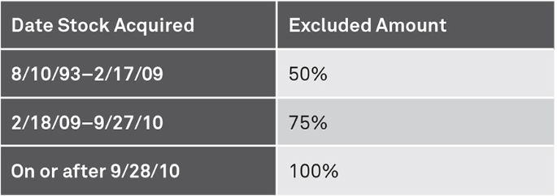
Source: Bank of New York Mellon Wealth
As reflected in the table, up to 100% of an investment can be eligible for tax relief, for example, if it results in a loss.
To benefit from tax relief whether in the US or the UK, there are a few checks that should be carried out:
- Prior to investing, investors should ask the issuing company to certify in written form that their firm would meet the criteria of a qualified small business or small-and-medium-sized enterprise.
- The investor needs to ensure that the amount being raised will not exceed any pre-set criteria, such as the lifetime limits.
- An accurate record of eligible investments, such as the date of purchase and the purchase price, should be duly logged and maintained.
- The minimum holding period of five years should be met. In most cases, if the stock sale is initiated before the five-year period is up, then the investor may not receive any tax relief, and if it has already been given, then it may be clawed back.
- The option to use losses to defer tax commitments also provides a significant advantage to investors and should be explored.
So, beyond the flexibility and opportunity that a retail investor has to invest in private stocks at an affordable rate, there are also the advantages of reduced volatility, a high upside return and most helpfully for retail investors, the chance of enjoying tax-free returns in some cases, and at a minimum tax relief to offset any high tax paid on personal income or returns from other investments. However, it is incumbent on retail investors to ensure that the companies that they are investing in during a crowdfunding campaign are eligible or qualify for tax relief schemes.
Another significant advantage is the opportunity that investors have to curate their own portfolios. A final point is crowd wisdom. Oftentimes, as was the case with Revolut among others, the growth in demand from investors can be an indication that there is something unique about the company being crowdfunded. Although, the crowd can also get it wrong, they generally can be proven right in the long run, once the business begins to gain significant commercial traction.

What Are the Risks of Crowdfunding for Retail Investors?
With crowdfunding, making or generating higher returns is not always guaranteed, and in the case of small and medium-sized businesses, investors run the risk of never seeing any of their money again. This means that there is a risk of total economic write-off of investments.
Although this statement is also true for other more established investment vehicles such as picking single stocks or investing in corporate bonds, the recourse for getting back a part of the invested amount does not always exist. This means that for assets invested in listed companies or mutual funds for example, it can be possible to have recourse to the Financial Services Compensation Scheme (FSCS) in the UK which protects up to GB£85,000 per investor per firm. A similar type of protection exists in the US where up to US$500,000 is protected by the Securities Investor Protection Corporation (SIPC). This is a protection against any loss of cash and securities (stocks and bonds) that is held by an investor at a distressed or non-performing SIPC-member brokerage firm.
Unfortunately, no such protection exists for crowdfunding investors. This is why in the United States, investors need to be accredited, which means they must meet minimum standards, and in the UK a similar set of pre-qualification of the investors apply. For example, according to the financial regulator, the investor needs to be certified sophisticated at the very least, which means that they self-certify that one of the following applies to them:
- They are a member of a network or syndicate of business angels and have been so for at least the last six months before the date below;
- They have made more than one investment in an unlisted company in the two years before the date below;
- They are working, or have worked in the two years prior to the date below, in a professional capacity in the private equity sector, or in the provision of finance for small and medium enterprises;
- They are currently, or have been in the two years prior to the date below, a director of a company with an annual turnover of at least GB£1 million.
They also have to sign up to the following statement:
“I accept that the investments to which the promotions will relate may expose me to a significant risk of losing all of the money or other property invested.” (UK Financial Conduct Authority, 2022)
By appending a signature to the statement above and proving eligibility to the company that is fund raising, or more probably the investment platform introducing the deal, this implies a forfeiture of any recourse to the government’s compensation scheme if the investment were to fall below performance expectations or fail outright.
The second primary disadvantage is illiquidity, which can be a challenge for investors for whom the speed of asset conversion to cash is essential. Even if the crowdfunding platform had a secondary market, there is always price risk that the small market, which is also not big or deep enough, would offer a lower-than-expected price for the stocks. If the price is not agreeable, it is likely that the asset would remain on the secondary market for a long time.
A final point to note is that fees are often charged at much higher rates on private platforms for crowdfunding than on traditional investment platforms. For example, Crowdcube charges investors that use its platform a fee of 1.65% (which was increased from 1.5% as of 1 February 2022) of the amount invested.
Seedrs charges a lower amount at 1%, which is comparatively modest. However, this would be less appealing if this were assessed against platform charges from organisations such as Hargreaves Lansdown or AJ Bell that facilitate the buying and selling of stocks, they tend to be a flat capped amount, and fees tend of around 0.45% per annum for assets held. With the brokerage space being open to new entrants, companies like Freetrade offer opportunities to invest for no platform fee or charges.
A final disadvantage is that given the size of the organisations or deals that are crowdfunded, asymmetric information will always exist. This means that the investor will only ever know as much as the companies disclose to the crowdfunding platform. The advantages of independent auditors and an opportunity to source an organisation’s previously published financial statements from credible sources can be limited or even not applicable in the case of crowdfunded organisations. As such, investors would need to make a decision to invest or not invest based on available information only.

Crowdfunding Risk Mitigation Strategies
The risk of outright loss can be mitigated in two ways. Firstly, the investor can diversify across different investment companies and across different sectors. This would help reduce the risk of correlation within their portfolio and is no different from the diversification concept proposed by Harry Markowitz.
The second mitigation is ensuring that no investment is made in an organisation that has limited information available is a small part of the investor’s portfolio if it has to be made at all. This goes with the principle of only investing what can be afforded to be lost.
According to the FSCS, there is the possibility of a crowdfunding platform failing, which could make it very difficult to for investors to access their money. So, where a crowdfunding investment is non-performing, whether it be equity or loan, as long as there is a secondary market where the investment can be sold, the opportunity should be taken in order to ensure that overall portfolio losses are minimised.
An investor needs to ensure that while the crowdfunding platform that they will be using may be subject to a minimum of £0.50/€0.50, it also needs to be capped at a reasonable level, for example a maximum of £250/€250. In some cases, a fixed investment amount is charged relative to the amount being invested, but this can also be capped as is the case with Seedrs.
By ensuring that the upper limit of charges is known, an investor can make an informed choice about the most appropriate investment crowdfunding platform to use that would not impact their rate of return because of uncapped fees. It should be noted that this principle also applies to traditional publicly listed assets.

Conclusion
As we have seen, no investment is full proof, and certainly not alternatives, including those funded via crowdfunding. It is therefore essential for retail investors to keep the merits and dangers of this investment vehicle in mind, so that they can use it in a way that optimises their returns but does not expose them to significant risks of total loss.
All in all, as the asset class matures, many of the disadvantages and risks will be reduced and this will only increase the appeal of crowdfunding in the near future. How this continues to complement or even replace traditional assets in retail investor’s portfolios remains to be seen.

Section D: Retail Portfolio Construction and Optimisation

Introduction
It has been established that most investors tend to have a couple of challenges, primarily in relation to their level of knowledge and understanding of the markets relative to their investment objectives, as well as their level patience especially when they choose to be hands-on with their investments.
The fundamental and generally accepted principle of selecting the ‘right’ assets, investing at the ‘right’ time and for the ‘right’ duration of time sounds simple on the surface but is quite challenging to do for most investors, whether experienced and sophisticated or not.
Getting the mix of ‘rightness’ aligned across all three requirements for successful investing (assets, time and duration) has eluded a lot of market participants, which is why several institutional and retail investors lose a lot of money in the markets.
The significance of getting the correct mix was emphasised by the market regulator in the United States which stated the following in its publication intended to educate retail investors:
“While money doesn’t grow on trees, it can grow when you save and invest wisely”. (Securities and Exchange Commission, 2022)
And at the same time, the regulator proceeded to caution those looking to benefit from returns in the market by stating that:
“When you “invest,” you have a greater chance of losing your money than when you “save.”” (Securities and Exchange Commission, 2022)
Numerous investors have experienced this first hand, either directly or indirectly. The direct losses that have been suffered have been through picking single listed stocks that were either the fad or most popular names at the time of investing. We have indicated that the focus of this dissertation is investments for the medium to long term as opposed to short term trading. To that end, the focus here is on retail investors who prefer to hold on to securities for a number of years in the hopes of realising both or either one of recurring returns, whether that is dividends on equity or interest on debt instruments, or intrinsic capital appreciation in what they have invested in. A net positive total return is what investors look for, whether institutional or retail.
It was reported by the Data Science team at Capital.com, an online brokerage firm, that about 70% of Do-It-Yourself (DIY) investors lose money. These are retail investors who pick listed stocks. The metrics observed by the broker indicated that majority of investors lose money. This of course means that the returns that they are trying to achieve remain elusive for the most part.
A workaround or alternative would be for retail investors to delegate the responsibility to professional investors for a fee. For example, they may choose to invest in listed stocks indirectly through a mutual fund. However, it does turn out that majority of mutual funds also lose money.
The reality of this risk is confirmed by the US SEC who advised that:
“All funds carry some level of risk. With mutual funds, you may lose some or all of the money you invest because the securities held by a fund can go down in value.” (Securities and Exchange Commission, 2022).
Since neither self-selecting nor delegating the picking of stocks to professionals significantly minimises the risk of loss, then it makes sense to explore why that is the case and more pertinently, what can be done to mitigate or if possible, eliminate the risk.
As we have established in Chapters 1 and 2, asymmetric information tends to contribute to the risks borne by retail investors. This risk often materialises in the poor quality of due diligence that they do when selecting companies or a suitable fund manager to take care of their financial/investment affairs.
The question that we set out to answer in this research was whether considering alternative investments and specifically using crowdfunding as a vehicle was a viable option for investors looking to minimise volatility risk in their equity holdings for example, or get inflation-beating returns on their debt securities. We wanted to establish whether exploring options beyond traditional investing would get them closer to achieving their investment goals.

Portfolio Construction
Given the fact that there is no simple way of completely eliminating all forms of investment risk in totality, we have seen that alternatives could help address some of the concerns that all investors have to deal with when putting their money into traditional assets.
According to FINRA (the Financial Industry Regulatory Authority), which is a US government-authorised organisation that oversees U.S. broker-dealers, risk cannot be eliminated. However, investors can apply two simple investment strategies to manage both systemic risk which affects the entire market or economy, and idiosyncratic or non-systemic risk which affects a sector or more specifically, a single company. The steps are:
- Asset Allocation: Making sure that different asset classes are in the retail investor’s portfolio. These can vary by asset class, for example, shares, bonds, property, commodities (e.g. precious metals) and even cash. This would increase the probability that some of the investments will yield satisfactory returns overall, which means that some might succeed in providing expected or better-than-expected returns, while others might be flat or lose money, including the capital invested. By avoiding concentration risk in one asset class, retail investors can make their portfolios more resilient to investment risk. This is essentially the principle of diversification.
- Hedging: This refers to buying securities that offset the potential loss on another investment. That is a way to reduce and manage investment risk. This would mean that retail investors must build the knowledge required to understand not just the characteristics of the assets that they are investing in but also the risks that they are most sensitive to, and finally how those areas of sensitivity can be reduced, or in some cases eliminated by creating the right mix of asset classes and asset risk profiles.

It should be noted that the neutralisation effect of hedging limits the overall portfolio return, but that need not be a concern for retail investors who should instead think of hedging in terms of risk management and reduction or if at all possible, risk elimination. The price to pay for that would be the sacrifice of some returns or upside. How much exactly is a matter of investor objectives/appetite.
Retail investors also need to note that both asset allocation and hedging must be done within the context of their financial goals, but also practical considerations, such as how much they have available to invest, how long they intend to leave it invested for, the kinds of periodic (monthly, quarterly or annual) returns that will make their goals achievable and any adjustments to be made for costs associated with investing, such as fees and taxes on capital gains, dividends or received interests. What this means then is that retail investors should think in terms of net returns (after all deductions), not gross.
The other point that we mentioned in this research was that the poor performance of traditional assets did not mean that the investment principles that seemed to have somewhat failed for most retail investors, whether or not they are DIY or indirect market participants, weren’t wrong or selectively applicable to the listed or public markets. We established that the principles would apply to private markets as well, and probably more markedly in the performance of alternative asset portfolios.
This meant then that retail investors would need to educate themselves in three areas of investment performance as outlined by the UK’s Chartered Institute for Securities and Investments (CISI) who indicated that similar to listed stocks, investment performance can be attributed to:
- Asset allocation
- Sector Choice
- Security Selection
By gaining a good understanding of what should comprise their portfolios and constantly assessing the performance of their investments based on the attribution measures above, the risk of information asymmetry can be reduced, and by creating a multi-asset portfolio, asset-specific risks can be reduced. Again, it is worth emphasising that these principles do not just apply to listed or publicly traded securities, but those accessible in the alternatives space too.

Portfolio Optimisation
As we have seen, Crowdfunding is simply a mechanism for participating on deals that would have been difficult for retail investors to put money into some years ago. Having observed a growth in the effort to democratise investment opportunities in general because of the diversification and upside advantages it provides to investors, crowdfunding can be seen as a useful vehicle that retail investors can and should use to explore some of the best deals in the alternative investments space.
The most developed economies have retail investors has the biggest holders of public equities. Certainly in the United States, households own more equities, either directly or indirectly via funds than any other group of market participants. The diagram below shows the enormity of the retail investment contribution to asset holdings in 2020.
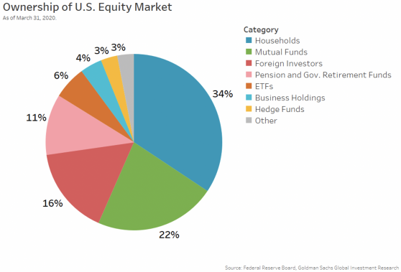
According to NASDAQ, many retail investors tend to hold equities, both listed and private, particularly the more affluent they are.
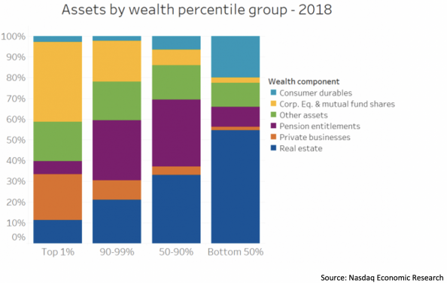
This graph depicts the appetite that retail investors have in not just preserving household wealth but in growing it. To that end, it would be a colossal market failure if the available assets didn’t serve them, and if the retail investors in turn didn’t take steps to reallocate their capital to asset classes and vehicles that can help them preserve and grow the value of their investments.
Although it is not advisable for investors to redeploy the bulk of their capital into Crowdfunding campaigns or deals, specifically equity or debt, such as loan notes, they need to understand the inherent risks and work on reducing these where possible, and sometimes this means walking away from opportunities that lack the required rigour of depth, market credibility and reliability of projected returns. These limitations can be for any number of reasons, e.g. the concept is unproven, the market is shallow and unlikely to adopt the investee company’s products, the management is inexperienced or they have board members with questionable pasts, and where available, the financial statements are suspicious or have inexplicable or illogical assumptions. While this is not an exhaustive list of red flags for an investor in Crowdfunding deals, any of them would constitute sufficient to refrain from investing.
The British Business Bank, a UK government-owned development bank, cited a recent paper by Wilson and Testoni which suggested that equity Crowdfunding may be significantly riskier than business angel or venture capital finance, due to a “lack of adequate pre-investment screening and due diligence, weaker investment contracts and poorer post-investment support and monitoring”, arising from relatively inexperienced investors lacking the required investment know-how.
However, the bank stated that “The scale of these potential risks will become better known over time as we observe the performance of a range of crowdfunded investments.” (British Business Bank, 2014).

While this assessment is fair, a good amount of time has elapsed since the research was conducted and the Crowdfunding space has evolved. There are now more cases of successful exits according to Crunchbase which provides key data to enterprises, investors and the public about businesses worldwide and the transactions that they do. Crunchbase provided an indication that equity crowdfunding organisations with over US$1million in revenue as of 2024 were around 1,183. Their portfolio companies saw exits mainly by strategic acquisitions by larger, more established publicly listed organisations. The investments were mostly from Private Equity, Venture Capital, Micro Venture Capital firms and Angel Investor Groups. Individuals could also participate through platforms such as Seedrs and Crowdcube. In total US$1.2B has so far been invested as of the first quarter of 2024.
Not every deal would work and not every deal would be safe, but while the market matures, it is helpful both to the economy and retail investors themselves that crowdfunding now exists and it represents an increasingly credible alternative investment vehicle for diversifying away from volatile, and most times, poor performing publicly listed investment opportunities, to allow them invest in deals that were not previously accessible. Other than liquidity risk, the other types of investment risks are not totally dissimilar from those from listed markets. By applying the same disciplines and basic principles, those risks can be mitigated.
Whether or not crowdfunding deals provide solid returns or higher rates of interest in a consistent manner is to some extent a product of trial and error, but largely thorough due diligence and caution whenever a retail investor has even the tiniest inkling of doubt about a crowdfunding opportunity.
The upsides are significant, and the downsides are 100% loss of capital. But in markets like the UK where there are options to offset the losses against individual tax liabilities for EIS-eligible and Small EIS (SEIS) eligible schemes, and as a result recoup parts of their losses, retail investors have every incentive to give crowdfunding a more thorough look as a viable investment vehicle to achieve the portfolio objectives.
Finally, to optimise a portfolio, the retail investor would need to assess the implication of reallocating their investment to Crowdfunding deals, which on average can provide better returns than traditional assets. In the table below, a traditional 60/40 asset split between stock and bonds has been adjusted to reflect returns based on the introduction of a debt Crowdfunding deal into the portfolio. Other than the investment amount, the returns are actual historical data.
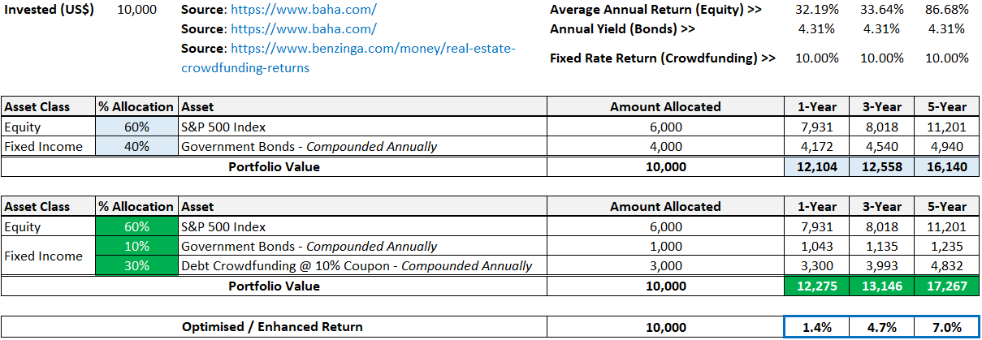
As shown above, the retail investor’s return is enhanced by adding a private market Crowdfunding deal to turbo-charge the returns of a similar asset class, the public market government bond. If the listed bond were to be replaced entirely with the private market deal, then the result would be even better, producing 12331, 13342 and 17643 for the 1-year, 3-year and 5-year periods respectively. This would mean a 1.9%, 6.2% and 9.3% increase in returns respectively over the specified investment horizons.
Workings are embedded below:

References

- Adams, J. How FinTechs are responding to their falling valuations (2022). Link: https://www.americanbanker.com/payments/list/how-fintechs-are-responding-to-their-falling-valuations#:~:text=Revolut,an%20investment%20round%20in%202021 [Accessed Mar 2024]
- Bloomberg Intelligence (2021). Passive likely overtakes active by 2026, earlier if bear market. Link: https://www.bloomberg.com/professional/blog/passive-likely-overtakes-active-by-2026-earlier-if-bear-market/ [Accessed Mar 2024]
- British Business Bank. Research Report – Equity Crowdfunding in the UK: Evidence from the Equity Tracker (2014). Link: https://www.british-business-bank.co.uk/wp-content/uploads/2015/03/230315-Equity-crowdfunding-report-final.pdf [Accessed Mar 2024]
- Capital.com. New Research - Success is limited until DIY investors break bad habits (2022). Link: https://www.ft.com/partnercontent/capital-com/new-research-success-is-limited-until-diy-investors-break-bad-habits.html [Accessed Mar 2024]
- CFA Institute (2022). Levels of Trust in Financial Services Reaches All-Time High. Link: https://www.cfainstitute.org/en/about/press-releases/2022/levels-of-trust-in-financial-services-reaches-all-time-high [Accessed Mar 2024]
- Chartered Institute for Securities & Investment (2020). International Certificate in Advanced Wealth Management Workbook. Pages 303 – 304.
- Chartered Institute for Securities and Investment. International Certificate in Advanced Wealth Management: Applied Financial Advice and Management (2016). Page 356.
- Companisto (2022). About Us. Link: https://www.companisto.com/en/about [Accessed Mar 2024]
- Crowdcube. Revolut (2016). Link: https://www.crowdcube.com/investment/revolut-21142 [Accessed Mar 2024]
- Crowdcube. What are the fees for investing on Crowdcube? (2022). Link: https://help.crowdcube.com/hc/en-us/articles/360001527460-What-are-the-fees-for-investing-on-Crowdcube- [Accessed Mar 2024]
- Crunchbase. Crowdfunding Companies that Exited (2022). Link: https://www.crunchbase.com/hub/crowdfunding-companies-that-exited [Accessed Mar 2024]
- Fama, E.F (1970). Efficient Capital Markets: A Review of Theory and Empirical Work. Link: https://www.jstor.org/stable/2325486 [Accessed Mar 2024]
- Financial Conduct Authority (2022). Conduct of Business Sourcebook, Chapter 3 – Client Categorisation. Link: https://www.handbook.fca.org.uk/handbook/COBS/3.pdf [Accessed Mar 2024]
- Financial Conduct Authority. COBS 4.12 Restrictions on the promotion of non-mainstream pooled investments (2022). Link: https://www.handbook.fca.org.uk/handbook/COBS/4/12.html#DES583 [Accessed Mar 2024]
- Financial Services Compensation Scheme. FSCS announces higher protection limits of £85,000 for some products and services (2022). Link: https://www.fscs.org.uk/media/press/2019/apr/higher-protection-limits/#:~:text=FSCS%20protects%20deposits%2C%20investment%20business,to%20pay%20claims%20against%20it [Accessed Mar 2024]
- FINRA. The Reality of Investment Risk (2022). Link: https://www.finra.org/investors/learn-to-invest/key-investing-concepts/reality-investment-risk [Accessed Mar 2024]
- FundRise (2022). About Us. Link: https://fundrise.com/ [Accessed Mar 2024]
- H. Markowitz (1952). Portfolio Selection. Wiley Online Library. Link: https://onlinelibrary.wiley.com/doi/epdf/10.1111/j.1540-6261.1952.tb01525 [Accessed Mar 2024]
- HM Revenue and Customs. Use a venture capital scheme to raise money for your company (2018). Link: https://www.gov.uk/guidance/venture-capital-schemes-raise-money-by-offering-tax-reliefs-to-investors#trades [Accessed Mar 2024]
- Holmes, F (2018). Forbes Inc. Investing vs. Speculating: Why Knowing the Difference Is Key. Link: https://www.forbes.com/sites/greatspeculations/2018/10/31/investing-vs-speculating-why-knowing-the-difference-is-key/ [Accessed Mar 2024]
- Kilroy, A. Institutional Investors vs. Retail Investors (2022). Link: https://smartasset.com/investing/institutional-investor-vs-retail-investor [Accessed Mar 2024]
- Lanyon, D. Revolut crowdfunding investors toast 1,900% return (2018). Link: https://www.altfi.com/article/4633_revolut-crowdfunding-investors-toast-1900-return [Accessed Mar 2024]
- McKinsey (2022). McKinsey’s Private Markets Annual Review. Link: https://www.mckinsey.com/industries/private-equity-and-principal-investors/our-insights/mckinseys-private-markets-annual-review [Accessed Mar 2024]
- Miller, J. BNY Mellon Wealth Management. The Tax Benefits of Investing in Small Businesses (2022). Link: https://www.bnymellonwealth.com/articles/strategy/the-tax-benefits-of-investing-in-small-businesses.jsp [Accessed Mar 2024]
- NASDAQ. Who Counts as a Retail Investor? (2020). Link: https://www.nasdaq.com/articles/who-counts-as-a-retail-investor-2020-12-17 [Accessed Mar 2024]
- OECD (2021). Pension Funds in Figures. Link: https://www.oecd.org/finance/private-pensions/Pension-Funds-in-Figures-2021.pdf [Accessed Mar 2024]
- Office of Investor Education and Advocacy, Securities and Exchange Commission (SEC). Saving and Investing (2022). Link: https://www.sec.gov/investor/pubs/sec-guide-to-savings-and-investing.pdf [Accessed Mar 2024]
- OurCrowd (2022). How to Invest. Link: https://www.ourcrowd.com/how-to-invest [Accessed Mar 2024]
- Planet Home Investment (2022). Crowd Investments. Link: https://planethome-invest.com/en/crowdinvesting/# [Accessed Mar 2024]
- Preqin (2022). Measuring Hedge Fund Returns. Link: https://www.preqin.com/academy/lesson-3-hedge-funds/measuring-hedge-fund-returns [Accessed Mar 2024]
- Securities Investor Protection Corporation. What SIPC Protects (2022). Link: https://www.sipc.org/for-investors/what-sipc-protects#:~:text=SIPC%20protects%20against%20the%20loss,a%20%24250%2C000%20limit%20for%20cash [Accessed Mar 2024]
- Seedrs (2022). Invest. Link: https://www.seedrs.com/invest/raising-now?sort=trending_desc&sort_collection=campaigns [Accessed Mar 2024]
- Seedrs. Fees (2022). Link: https://www.seedrs.com/how-to-invest-in-startups [Accessed Mar 2024]
- SWLaw (2022). Are You a Sophisticated Investor? Link: https://www.swlaw.co.uk/site/library/privateclient/finplan/areyou_a_sophisticated_investor.html [Accessed Mar 2024]
- Triple Point Income Service (2022). How it Works. Link: https://www.incomeservice.co.uk/how-it-works [Accessed Mar 2024]
- US Securities and Exchange Commission. Mutual Funds (2022). Link: https://www.investor.gov/introduction-investing/investing-basics/investment-products/mutual-funds-and-exchange-traded-1 [Accessed Mar 2024]
- Vantage Market Research (2022). $43+ Billion Global Crowdfunding Market is Expected to Grow at a CAGR of over 16.50% During 2022-2028. Link: https://www.globenewswire.com/en/news-release/2022/04/20/2425273/0/en/43-Billion-Global-Crowdfunding-Market-is-Expected-to-Grow-at-a-CAGR-of-over-16-50-During-2022-2028-Vantage-Market-Research.html [Accessed Mar 2024]

