Module 3
Capstone Project

Humanitarian Ethical Decision-Making (HEDM) Framework: Fostering Sustainable Impact and Social Responsibility

Requirement of

John MACATO

submitted at the PhD by Portfolio Programme
of the Swiss School of Business Research (SSBR)

Mentor: Steve MALLON

Date of Submission: 30.05.2024

Table of Contents

Figures 3
Abbreviations 4
Question 5
Abstract 6
Introduction 7
The Gap in Ethical Decision-Making in the Humanitarian Sector 8
The Humanitarian Ethical Decision-Making (HEDM) Framework 10
Ethical Leadership and Values Alignment 10
Stakeholder Engagement and Empowerment 11
Sustainability Integration and Impact Assessment 12
Risk Management and Ethical Decision Support 12
Continuous Learning and Improvement 13
Implementation of the HEDM Framework and EthicEase 14
Key Features of EthicEase 15
Incorporating Artificial Intelligence in EthicEase 16
EthicEase Product Proposal 17
Conclusion 20
Bibliography 21
Annexe 1: Summary of ICRC Strategy 2019-2024 27
Annexe 2: Strategic Objectives and Proposed Commitments 28
Annexe 3: The Ten-Step Method of Decision-Making 31

Figures

Figure 1: Humanitarian Ethical Decision-Making (HEDM) Framework 10

Abbreviations

AI Artificial Intelligence
ECOSEC Economic Security
HCD Healthcare in Detention
HEDM Humanitarian Ethical Decision-Making
ICRC International Committee of the Red Cross
IHL International Humanitarian Law
MHPSS Mental Health and Psychosocial Support
NLP Natural Language Processing
NSAG Non-State Armed Groups
OSV Other Situations of Violence
PHC Primary Healthcare
PHEC Pre-hospital Emergency Care
PROT Protection
PRP Physical Rehabilitation Program
SAG State Armed Groups
SCM Supply Chain Management
SDG Sustainable Development Goals
WATHAB Water and Habitat

Question

In this module students will scaffold the work they have done in Modules 1 and 2 to create something entirely new for their organisations. The idea here is to be creative or innovative and to find ways to reinvent part of or the entirety of the organisation. The idea needs to be genuinely disruptive so that it would create a dynamic of real change in the organisation. Students need to consider their proposals on a micro and macro level, taking into consideration potential reactions from all points of the business as well as effective ways to manage those reactions. Students should focus on and demonstrate knowledge of what is happening in their industries, current and anticipated trends etc. Attention should be paid to significant themes like sustainability and the environment, global political situation, technological disruption and business in the post-Covid 19 era.
This proposal could cover:
A new product
A new way of working or a new process to make work more efficient
A new organisational structure
A way of using new systems or new technology
A plan to expand into new markets
A plan to create an entirely new business in a new market
A way to build resilience into the business to be ready for future crises.
Students will clearly reference the work on strategy from Module 1 and the work on collaborative problem solving and decision making from Module 2 in their work for this module. Summaries of these two documents should be included as appendices.
The work should be influenced by the student’s own professional background - eg Finance, Marketing, Training, HR etc, and MUST reflect current advanced and cutting edge thinking in that context. The focus is on what’s next and current and anticipated trends.
The work should clearly recognise key issues of sustainability, good practice and make sense in a post-Covid19 context.
The work should cover all 4 learning outcomes:
1. Demonstrate knowledge of the most advanced frontiers of a field of work.
2. Demonstrate the most advanced and specialised skills and techniques, including synthesis and evaluation, required to solve critical business problems and to extend or redefine professional practice.
3. Demonstrate substantial authority, innovation, autonomy and professional integrity.
4. Develop new ideas or processes at the forefront of work.
The work will be presented as follows:
A 6000-word report with all information required to convince senior management of the efficacy of the proposal presented by the student. (70% of the grade).
A recorded poster presentation giving a brief summary of the main points of the proposals and the justifications for it. (20% of the grade). The poster presentation should last for a minimum of 5 minutes and a maximum of 10 minutes. You can see an example of what is required here: https://guides.library.ucla.edu/posters.
Participation in a live Q&A with the student’s mentor, a member of the wider SSBR academic team and a member of the senior team of the student’s organisation. Where the student is self-employed or the owner of the business in question, someone from a similar professional context will be found to participate in the live Q&A (10% of the grade).
Students will clearly demonstrate how they have satisfied the LOs for this module by completing the Student Task Completion Checklist (below) to show how their work fulfils each of the learning outcomes.

As with Modules 1 and 2 a collection of resources has been attached for you to review before you start your work. Every step of your proposal needs to make a connection with current or past thinking about the ideas you are focusing on, and you need always to correctly cite and reference these connections, in the body of your work (citations) and in the bibliography at the end of the report.

Abstract

In our increasingly interconnected world, humanitarian organisations grapple with the imperative to prioritise social responsibility and sustainability. This paper delves into the Humanitarian Ethical Decision-Making (HEDM) framework, offering a comprehensive guide for navigating intricate ethical dilemmas while maximising positive societal and environmental impact, particularly in humanitarian endeavours. Drawing upon advanced ethics, collaboration, and strategic foresight, HEDM empowers humanitarian organisations to uphold humanitarian values and principles, engage stakeholders, and drive substantive change. This paper illuminates the profound significance and implications of ethical decision-making in the humanitarian sector. Based on the HEDM framework, the EthicEase mobile application emerges as a ground-breaking tool, providing a user-friendly platform to enhance ethical literacy and responsible action. Leveraging HEDM principles, EthicEase enables individuals and organizations to confront ethical challenges with confidence and integrity, fostering a future of ethical leadership and positive societal transformation.

Introduction

In the realm of humanitarian ethics, Module 1 provided a panoramic view of the strategic underpinnings guiding organizational decision-making, notably spotlighting the International Committee of the Red Cross (ICRC) and its visionary plans spanning 2019-2024. Through a meticulous analysis, the ICRC's commitment to upholding the International Humanitarian Law (IHL) and delivering essential healthcare services in conflict zones emerged as a testament to its unwavering dedication (ICRC, 2023a) in upholding humanitarian ethics. The proposed Health Strategic Plan for 2024-2027 further underscored this commitment, outlining strategic objectives aimed at fostering sustainable health outcomes, influencing policy, and embracing data-driven decision-making while prioritising staff well-being (ICRC, 2023c).

Module 2 built upon this foundation, elucidating the critical role of collaboration and effective decision-making processes in navigating the intricate landscape of humanitarian endeavours. While the ICRC Strategic Plan laid a solid groundwork, there remained opportunities for refinement, particularly in deepening the focus on beneficiary perspectives to enhance accountability. Integrating structured methodologies like Design Thinking and establishing clear escalation mechanisms for decision-making could further expedite conflict resolution and foster inclusivity. Module 2 highlighted that addressing ethical dilemmas requires a multifaceted approach, encompassing diverse perspectives, cultural sensitivity, and transparent communication to ensure alignment with organizational values and humanitarian principles. The Ten-Step decision-making method by Pekel and Walace (2006) was introduced as a guiding tool for ethical decision-making.

However, in terms of decision-making, gaps were identified in consideration of sustainability integration, ethical decision-making support, and continuous learning and improvement in humanitarian ethics. These gaps highlight the need for a more comprehensive approach to decision-making processes within humanitarian organisations (Gond et al., 2012). In an attempt to address these gaps, the Humanitarian Ethical Decision-Making (HEDM) framework was established, providing essential ethical guidance amidst rising social responsibility and sustainability demands. The HEDM framework empowers organizations to navigate ethical complexities with confidence and integrity by fostering ethical leadership, collaborative problem-solving, and a culture of inclusion, diversity and sustainability integration. Through collective intelligence and unwavering commitment, it aims to drive meaningful change and advance the humanitarian mission, upholding principles of integrity, compassion, and solidarity.

Based on the HEDM framework, the creation of EthicEase, a mobile application emerges as a ground-breaking tool, providing a user-friendly platform to enhance ethical literacy and responsible action. Leveraging the HEDM principles, EthicEase enables individuals and organizations to confront ethical challenges with confidence and integrity, fostering a future of ethical leadership and positive societal transformation.

The Gap in Ethical Decision-Making in the Humanitarian Sector

In the humanitarian sector, gaps have been identified in terms of integrating sustainability, ethical decision-making support, continuous learning and improvement, and stakeholder management and empowerment in humanitarian ethics. These gaps highlight the need for a more comprehensive approach to decision-making processes within humanitarian organisations (Gond et al., 2012).

Studies suggest that organisations can mobilise a configuration approach to integrate sustainability within organisational strategy through the roles and uses of management control systems (MCS) and sustainability control systems (SCS) (Gond et al., 2012). This approach aligns sustainability goals with strategic objectives and enhances decision-making processes in humanitarian operations. Ethical decision-making is crucial in organisations, and an issue-contingent model can guide individuals in making ethical choices within organisational contexts (Jones, 1991). By adopting such models, humanitarian organisations can provide structured frameworks for ethical decision-making, ensuring that ethical considerations are integrated into operational practices. Incorporating sustainability into organisational renewal processes can lead to strategic sustainability integration, supporting ethical decision-making and business model decisions (Halldorsson et al., 2018). By merging management tools and sustainability principles, organisations can develop practical approaches to guide the strategic integration of sustainability, fostering continuous learning and improvement in humanitarian ethics.

Furthermore, the integration of sustainability on different management levels, including operational, strategic, and normative levels, requires top management support and an open organisational culture regarding sustainable development (Kiesnere & Baumgartner, 2019). By fostering a culture that values sustainability and continuous improvement, organisations can enhance their ethical decision-making processes and promote sustainable practices in humanitarian operations. Continuous improvement in sustainability integration can be achieved through the development of process-oriented performance indicators and sustainability assessment frameworks (Medne & Lapiņa, 2019; Sangwan et al., 2019). These tools enable organisations to monitor their sustainability performance, identify areas for improvement, and drive organisational learning and development in humanitarian ethics.

Stakeholder management and empowerment also play a crucial role in addressing the gaps in ethical decision-making in the humanitarian sector. Involving stakeholders in decision-making processes and empowering them to make choices and decisions can enhance the ethical considerations and sustainability practices within organisations (Kalu & Rugami, 2021). By incorporating stakeholder perspectives and engaging them in decision-making processes, organisations can ensure that ethical values and sustainability goals are aligned with the needs and expectations of all stakeholders.

By leveraging management control systems, ethical decision-making models, sustainability integration strategies, and performance indicators, and managing and empowering stakeholders, humanitarian organisations can bridge the identified gaps in sustainability integration, ethical decision-making support, and continuous learning and improvement in humanitarian ethics. The development of the HEDM framework is a crucial step towards achieving this comprehensive approach.

The Humanitarian Ethical Decision-Making (HEDM) Framework

The Humanitarian Ethical Decision-Making (HEDM) framework provides a structured approach to ethical decision-making by integrating advanced principles of ethics, collaboration, and strategic foresight. This section delves into each component of the HEDM framework, examining its implications for organizational practice and societal impact.

The diagram below illustrates the key components of the HEDM framework, emphasizing its structured approach to ethical decision-making in the humanitarian sector. Each component underscores the importance of ethics, collaboration, and strategic foresight in addressing critical challenges and maximizing positive impact on society and the environment.

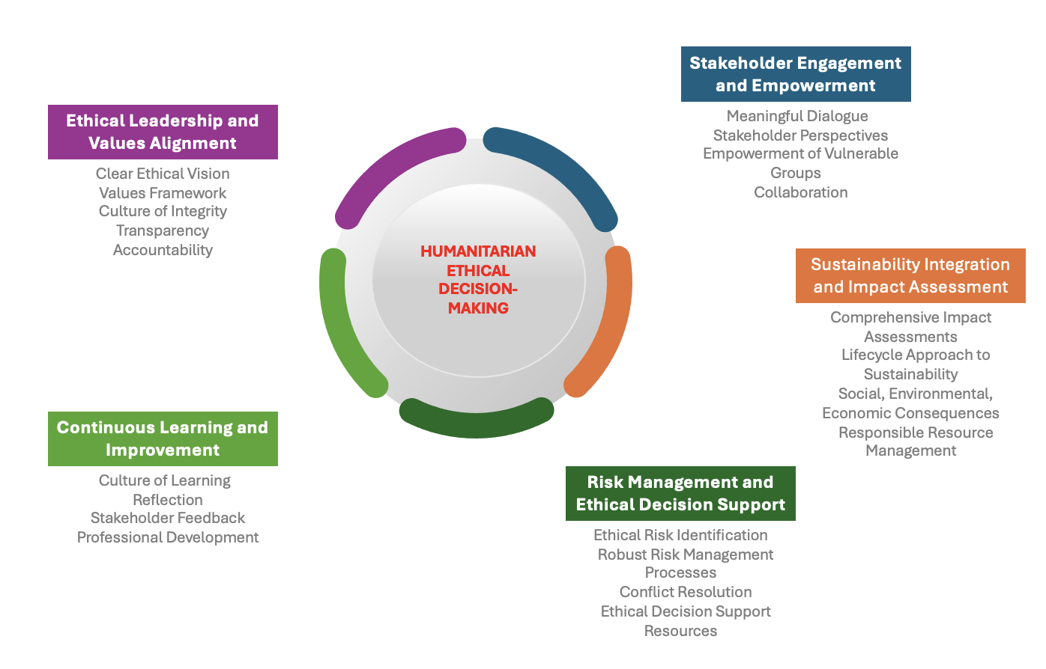
Figure 1: Humanitarian Ethical Decision-Making (HEDM) Framework

Ethical Leadership and Values Alignment

Ethical leadership is crucial in the Humanitarian Ethical Decision-Making (HEDM) framework within the humanitarian sector, emphasising the establishment of a clear ethical vision and values framework to guide organizational behaviour and decision-making processes. Leaders in humanitarian settings play a pivotal role in cultivating a culture of integrity, transparency, and accountability, aligning operational objectives with humanitarian principles to ensure coherence between values and actions. By exemplifying ethical standards, leaders inspire trust and confidence among employees, stakeholders, and the broader community. Authentic leadership, closely intertwined with ethical leadership, focuses on positive psychological capacities and ethical conduct to enhance self-awareness, moral perspective, and relational transparency among leaders and followers.

Studies have shown a correlation between authentic leadership and positive organizational outcomes and employee behaviours (Walumbwa et al., 2007; Avolio & Gardner, 2005). Furthermore, research underscores the importance of elements such as employee trust, transparent communication, and employee engagement in fostering an environment conducive to ethical leadership (Eagly et al., 2003). Servant leadership has been identified as a predictor of inclusive organizations, underscoring the significance of leadership styles in shaping organizational culture (Salem et al., 2022). Moreover, leadership's role in promoting learning organizations and encouraging employee voice behaviour has been explored, highlighting the impact of ethical climate, organizational culture, and psychological processes on employee outcomes (Avolio et al., 2004; Sheather et al., 2022). In healthcare settings, authentic leadership has been associated with mitigating burnout among healthcare providers, emphasizing leadership's critical role in addressing organizational challenges and supporting staff well-being (Salem et al., 2019).

These references underscore the pivotal role of ethical and authentic leadership in steering organisational behaviour, fostering positive work environments, and driving sustainable outcomes within the humanitarian sector.

Stakeholder Engagement and Empowerment

Stakeholder engagement is a crucial element of ethical decision-making in humanitarian action, necessitating organizations to consider the diverse needs and viewpoints of different stakeholders. The HEDM framework promotes meaningful dialogue and decision-making processes that respect stakeholder perspectives and empower marginalized or vulnerable groups to contribute to shaping outcomes. Actively engaging stakeholders in decision-making processes helps organizations establish trust, encourage collaboration, and enhance the legitimacy of their actions.

Slack et al. (2018), Lemke & Harris-Wai (2015), and Osobajo et al. (2021) offer valuable insights into stakeholder engagement and ethical decision-making in various contexts. For instance, Slack et al. (2018) discuss enhancing stakeholder engagement through ethics review in biomedical HIV prevention trials, emphasizing the significance of broad engagement practices. Lemke & Harris-Wai (2015) explore stakeholder engagement in policy development for human genomics, outlining challenges and opportunities in this domain. Additionally, Osobajo et al. (2021) present a conceptual framework for stakeholder engagement to promote sustainable development in a maritime cluster, highlighting the value creation that arises from dialogue and motivation among involved parties.

These studies collectively emphasize the importance of stakeholder engagement in ethical decision-making processes within humanitarian action, stressing the necessity of inclusive dialogue, collaboration, and empowerment of stakeholders to ensure the efficacy and legitimacy of organizational actions.

Sustainability Integration and Impact Assessment

Integrating sustainability considerations into all aspects of decision-making is imperative for organizations committed to ethical practices. The HEDM framework emphasizes the need for comprehensive impact assessments to evaluate the social, environmental, and economic consequences of proposed actions. Studies suggest that organisations can mitigate potential harms by adopting a lifecycle approach to sustainability and ensure decisions align with long-term societal and environmental well-being (Chen, 2020; Kunz & Gold, 2015). Through sustainable practices and responsible resource management, organizations can minimize their ecological footprint and contribute to the broader goals of environmental conservation and climate action.

The paper by Chen (2020) contributes significantly to the integration of sustainability in the humanitarian sector by proposing a strategic framework for sustainable humanitarian supply chains. This framework contextualises sustainability within humanitarian operations, emphasising the concept of net sustainability value as a key metric. By focusing on a single bottom-line approach and promoting interdisciplinary sustainability studies, this research enhances the operationality of Sustainable Development Goals (SDGs) in humanitarian settings.

Additionally, the study by Kunz & Gold (2015) complements this by conceptualizing a framework for sustainable humanitarian Supply Chain Management (SCM). By explicitly holding humanitarian supply chain operations accountable for their social, environmental, and economic impacts, this framework aligns with the imperative of integrating sustainability considerations into decision-making processes within the humanitarian sector.

These references collectively underscore the importance of sustainable practices and responsible resource management in minimising ecological footprints and contributing to broader environmental conservation and climate action goals within humanitarian operations.

Risk Management and Ethical Decision Support

Identifying and managing ethical risks associated with humanitarian activities is essential for maintaining integrity and compliance with ethical standards. The HEDM framework advocates for robust risk management processes and controls to mitigate conflicts of interest, human rights violations, and environmental harm. Studies suggest that providing employees with access to ethical decision support resources, such as training programs and guidelines, and mobile applications further strengthens organisational capacity to navigate complex ethical dilemmas. By equipping employees with the knowledge and tools to identify and address ethical risks, organizations can uphold ethical standards and mitigate potential negative impacts on stakeholders and the environment.

The paper by Charles et al. (2016) provides insights into designing an efficient humanitarian supply network, emphasizing the unique constraints and context of humanitarian operations. This research highlights the importance of considering uncertainties, limited budgets, and cost-efficiency pressures in humanitarian logistics. Moreover, the study by Besiou et al. (2011) delves into system dynamics for humanitarian operations, offering an example of applying system dynamics methodology to analyse a subsystem within the humanitarian sector. This research contributes to enhancing the overall effectiveness of humanitarian relief operations through a systemic approach.

These references collectively underscore the significance of ethical risk management and sustainable decision-making processes within the humanitarian sector, emphasizing the need for tailored approaches that consider the specific challenges and requirements of humanitarian operations.

Continuous Learning and Improvement

Ethical decision-making is an ongoing process that requires a commitment to learning and reflection. The HEDM framework promotes a culture of continuous improvement, where employees are encouraged to critically examine their decisions and behaviours. Studies suggest that organisations can enhance ethical literacy and decision-making skills across the organisation by collecting feedback from stakeholders and incorporating lessons learned into future decision-making processes (Besiou et al., 2011; Sheather et al., 2022). Through ongoing training and professional development initiatives, organizations can empower employees to navigate ethical challenges with confidence and integrity.

The study by Besiou et al. (2011) demonstrates the applicability of system dynamics methodology as a valuable tool for humanitarian decision-makers to understand the consequences of their actions on humanitarian operations. This research significantly contributes to improving decision-making processes within the humanitarian sector by advocating for a systemic approach. Additionally, the research conducted by Sheather et al. (2022) explores the efficacy and relevance of ethical guidance for humanitarian workers and organisations. Through a comprehensive literature review and empirical data collection via focus group discussions with frontline workers, this study provides insights into the practical implications of ethical guidance in humanitarian contexts.

These studies collectively underscore the critical role of ethical decision-making and continual enhancement within the humanitarian sector. They emphasise the significance of employing systematic methodologies and ethical frameworks to advance organisational practices and decision-making processes.

Implementation of the HEDM Framework and EthicEase

Implementing the Humanitarian Ethical Decision-Making (HEDM) framework in the International Committee of the Red Cross (ICRC) involves the development of a mobile app, EthicEase, tailored for humanitarian practitioners operating in armed conflicts. This app is designed to assist users in navigating complex ethical challenges by providing step-by-step guidance, real-time support, ethical scenarios, community engagement, and personalised learning pathways (Grote & Berens, 2019). By incorporating the HEDM framework, EthicEase aims to enhance the organisation's capacity to address ethical dilemmas effectively, such as ensuring the safety of aid workers and maintaining neutrality (Grote & Berens, 2019).

To further enhance the functionality of EthicEase, Artificial Intelligence (AI) features are integrated into the app, including AI-powered decision support, Natural Language Processing (NLP), Predictive Analytics, Continuous Learning, and Personalized Ethical Training (Grote & Berens, 2019). These AI features enable the app to analyse ethical dilemmas, provide tailored recommendations, understand user queries, predict potential issues, learn from interactions, and customize training modules based on user profiles (Grote & Berens, 2019). By leveraging AI, EthicEase becomes a comprehensive tool for ethical decision-making in the humanitarian sector, promoting ethical literacy and critical thinking among users (Grote & Berens, 2019).

The development of EthicEase aligns with the growing importance of ethical decision-making in various domains, including healthcare, disaster relief operations, and humanitarian aid (Davies et al., 2021; Cuthbertson, 2023; Simm, 2020). The app's user-centric design ensures that ethical decision-making is accessible to individuals with diverse backgrounds and expertise levels (Grote & Berens, 2019). By fostering a culture of ethical awareness and responsibility, EthicEase contributes to maximizing the positive impact of humanitarian organizations on the communities they serve (Grote & Berens, 2019).

The integration of the HEDM framework and AI features in EthicEase represents a significant advancement in supporting ethical decision-making in the complex humanitarian sector. By providing practical guidance, real-time support, and personalized learning pathways, EthicEase empowers users to navigate ethical dilemmas with confidence and integrity, ultimately contributing to the promotion of ethical literacy and critical thinking in society.

Key Features of EthicEase

Guided Decision-Making: EthicEase provides users with step-by-step guidance through the ethical decision-making process. From identifying key stakeholders to evaluating potential consequences, EthicEase helps users navigate complex ethical dilemmas with clarity and confidence. By breaking down the decision-making process into manageable steps, EthicEase empowers users to make informed and ethical decisions in any situation.

Real-Time Support: EthicEase offers real-time support and assistance whenever users encounter ethical challenges. Whether you need quick advice or in-depth analysis, EthicEase provides access to ethical resources, case studies, and expert opinions to help you make informed decisions on the go. This real-time support ensures that users have the information and guidance they need to address ethical dilemmas effectively, enhancing their confidence and competence in ethical decision-making.

Ethical Scenarios: EthicEase features a diverse library of real-life ethical scenarios across various contexts, including the workplace, and community engagements. These scenarios serve as valuable learning tools, allowing users to explore different ethical dilemmas and consider potential courses of action. By engaging with these scenarios, users can develop their ethical reasoning skills and gain insights into best practices for ethical decision-making in different situations.

Community Engagement: EthicEase fosters a sense of community among users through its built-in community forum. Here, users can share their experiences, seek advice from peers, and learn from each other's perspectives. This collaborative environment encourages open dialogue and knowledge-sharing, enriching users' understanding of ethical issues and decision-making approaches. By connecting with like-minded individuals, users can expand their ethical horizons and contribute to a culture of ethical awareness and responsibility.

Personalized Learning: EthicEase offers personalized learning pathways and training modules to help users enhance their ethical literacy and decision-making skills over time. By tracking progress, setting goals, and receiving feedback, users can continuously improve their ethical decision-making abilities. Whether you're a novice or an experienced practitioner, EthicEase provides tailored resources and support to meet your unique learning needs, ensuring that you can navigate ethical dilemmas with confidence and competence.

EthicEase is more than just a mobile application—it can be a trusted companion for ethical decision-making in today's complex humanitarian sector. With its user-friendly interface, comprehensive features, and commitment to promoting ethical literacy and critical thinking, EthicEase empowers users to navigate ethical dilemmas with confidence and integrity. By leveraging the principles of the HEDM framework, EthicEase ensures that ethical decision-making is accessible to everyone, regardless of their background or expertise in the field.

Incorporating Artificial Intelligence in EthicEase

Incorporating Artificial Intelligence (AI) in EthicEase enhances its functionality and effectiveness (Wahl et al., 2018). AI features such as AI-Powered Decision Support enable the analysis of complex ethical dilemmas and provide tailored recommendations based on past cases and ethical principles (Wahl et al., 2018).

AI Features in EthicEase:

- AI-Powered Decision Support: AI algorithms can analyse complex ethical dilemmas and provide tailored recommendations based on a vast database of past cases and ethical principles. This ensures users receive informed and context-specific guidance.
- Natural Language Processing (NLP): NLP in EthicEase allows the app to understand user queries in natural language, making interactions intuitive and user-friendly (Wahl et al., 2018). This feature also enables the app to analyse discussions in the community forum and highlight key insights.
- Predictive Analytics: Predictive Analytics in EthicEase helps in identifying and addressing potential ethical issues by analysing trends and patterns in user data (Wahl et al., 2018). This proactive approach helps organisations identify and address ethical concerns before they escalate.
- Continuous Learning and Improvement: Continuous Learning and Improvement facilitated by AI in EthicEase allows the app to refine its guidance and resources based on user interactions and feedback (Wahl et al., 2018). This allows the app to refine its guidance and resources, ensuring they remain relevant and effective over time.
- Personalised Ethical Training: Personalized Ethical Training in EthicEase is achieved through AI customisation of training modules based on the user's role, experience, and previous interactions with the app (Wahl et al., 2018). This ensures that each user receives a personalised learning experience tailored to their specific needs and ethical challenges.

The integration of AI in EthicEase aligns with the principles of ethical governance for AI systems, ensuring trust and effectiveness (Winfield & Jirotka, 2018). The use of AI in healthcare, as seen in the study by Guan (2019), promises advancements but also raises ethical challenges that require governance for responsible deployment. The application of AI in knowledge creation processes, as explored by (Neștian et al., 2020), demonstrates the potential for enhancing organisational learning and decision-making. Furthermore, the incorporation of AI in system dynamics models, as discussed by Gadewadikar (2023), presents opportunities for improved decision-making and system analysis.

EthicEase Product Proposal

Product | EthicEase
Description | EthicEase is a revolutionary mobile application designed to empower individuals and organizations to navigate ethical dilemmas confidently and responsibly. In today's complex and interconnected world, ethical decision-making is paramount in the humanitarian sector.  EthicEase aims to provide users with a user-friendly platform that integrates the HEDM framework and real-world case studies to support informed and principled choices.
Problem Statement | Ethical decision-making is often challenging due to the complexity of ethical dilemmas, varying perspectives, and the lack of accessible resources. Humanitarian organisations and individuals frequently encounter situations where they must weigh competing interests, consider long-term consequences, sustainability integration, stakeholder engagement, risk management and upholding ethical standards. Without adequate guidance and support, navigating these dilemmas can lead to ethical lapses, reputational damage, and negative societal impact.
Solution Overview | EthicEase offers a comprehensive solution to address these challenges by providing users with:  Decision-Making Frameworks: Access to a diverse range of ethical decision-making frameworks, including utilitarianism, deontology, virtue ethics, and humanitarian principles, among others. Each framework is explained in detail, along with practical examples and scenarios for application.  Case Studies: Real-world case studies from various sectors, allowing users to explore ethical dilemmas and analyse different approaches to resolution. These case studies are updated regularly to reflect current events and emerging ethical issues.  Expert Insights: Contributions from ethics experts, thought leaders, and practitioners, offering valuable perspectives, insights, and best practices on ethical decision-making in different contexts.  Interactive Tools: Interactive tools and simulations to engage users in ethical reasoning exercises, role-playing scenarios, and decision-making simulations. These tools are designed to enhance ethical literacy, critical thinking skills, and moral reasoning.  Community Forums: A community forum where users can connect with peers, seek advice, share experiences, and engage in discussions on ethical topics of interest. The forum provides a supportive environment for learning, collaboration, and peer support.  Artificial Intelligence (AI) incorporation: Enhances its functionality and effectiveness. AI features such as AI-Powered Decision Support enable the analysis of complex ethical dilemmas and provide tailored recommendations based on past cases and ethical principles.
Target Audience | EthicEase is designed for a diverse range of users, including:  Organizations: humanitarian organizations seeking to embed ethical principles into their operations, policies, and decision-making processes. Non-profit organizations, government agencies can benefit from it if contextualised according to their needs  Professionals: Healthcare professionals, lawyers, educators, managers, and other professionals who regularly encounter ethical dilemmas in their work and seek guidance on navigating them effectively.  Students: Undergraduate and graduate students studying humanitarian action, ethics, philosophy, law, business, healthcare, and related fields who want to deepen their understanding of ethical concepts and apply them in practice.
Features | User-Friendly Interface: Intuitive and user-friendly interface, making it easy for users to navigate and access resources on ethical decision-making.  Personalized Recommendations: Customized recommendations and resources based on users' interests, preferences, and previous interactions with the app.  Offline Access: Option to download resources for offline access, ensuring accessibility even in low-connectivity environments.  Secure and Confidential: Built-in security features to protect users' privacy and confidentiality, particularly important when discussing sensitive ethical issues.  Regular Updates: Regular updates with new case studies, expert insights, and interactive tools to keep content fresh, relevant, and engaging.
Implementation Plan | Development Phase: Collaborate with ethics experts, developers, and designers to build the EthicEase mobile application, ensuring it meets the highest standards of usability, accessibility, and security.  Testing and Feedback: Conduct extensive testing and gather feedback from beta users to identify any bugs, usability issues, or areas for improvement.  Launch and Promotion: Launch EthicEase on major app stores (e.g., Apple App Store, Google Play Store) and promote it through targeted marketing campaigns, social media channels, and partnerships with relevant organizations and institutions.  User Training and Support: Provide comprehensive user training materials, tutorials, and customer support to help users get the most out of the app and address any questions or concerns they may have.
Evaluation Impact | User Feedback: Solicit feedback from users through surveys, reviews, and user engagement metrics to assess satisfaction levels, identify areas for improvement, and prioritize future updates and enhancements.  Impact Assessment: Evaluate the impact of EthicEase on users' ethical decision-making skills, knowledge, and confidence through pre- and post-implementation assessments, case studies, and qualitative interviews.  Long-Term Monitoring: Continuously monitor app usage, engagement metrics, and user satisfaction over time to track long-term trends and ensure ongoing relevance and effectiveness.

EthicEase represents a significant step forward in promoting significant steps in sectors and industries. By providing users with accessible resources, practical tools, and a supportive community, EthicEase empowers individuals and organisations to make informed, moral choices that contribute to positive societal impact and sustainable outcomes.

This product proposal outlines the key features, target audience, implementation plan, and evaluation strategies for the EthicEase mobile application, aiming to address the pressing need for ethical decision-making support in today's complex world.

Conclusion

The exploration of the ICRC’s strategic foresight and collaborative decision-making in Modules 1 and 2 led to the development of the Humanitarian Ethical Decision-Making (HEDM) framework and the EthicEase mobile application, signifying a transformative approach to addressing ethical challenges in the humanitarian sector. Module 1 provided a foundational understanding of strategic decision-making within humanitarian organisations like the ICRC, highlighting their steadfast commitment to International Humanitarian Law (IHL) and essential healthcare services. The introduction of the ICRC's Health Strategic Plan for 2024-2027 emphasized the importance of sustainable health outcomes, policy influence, data-driven decision-making, and staff well-being.

Building on this, Module 2 illuminated the significance of collaboration and effective decision-making processes, underscoring the need to integrate beneficiary perspectives and structured methodologies like Design Thinking to enhance accountability and inclusivity. The identification of gaps in sustainability integration, ethical decision-making support, and continuous learning led to the establishment of the HEDM framework. This framework provides comprehensive ethical guidance, fostering ethical leadership, collaborative problem-solving, and a culture of inclusion and diversity.

The creation of EthicEase, a mobile application leveraging the HEDM framework, emerges as a groundbreaking tool to enhance ethical literacy and responsible action. By incorporating AI-powered decision support, real-time guidance, ethical scenarios, community engagement, and personalized learning pathways, EthicEase empowers individuals and organizations to navigate ethical dilemmas with confidence and integrity.

The integration of AI in EthicEase further enhances its functionality, providing tailored recommendations, understanding user queries through Natural Language Processing (NLP), predicting potential ethical issues, and facilitating continuous learning and improvement. This comprehensive approach aligns with the principles of ethical governance for AI systems, ensuring trust and effectiveness.

EthicEase's user-friendly interface, interactive tools, and secure environment make ethical decision-making accessible to a diverse audience, including humanitarian organisations, professionals, and students. The application not only supports immediate ethical decision-making needs but also fosters a culture of ethical awareness and responsibility, contributing to positive societal impact and sustainable outcomes.

The HEDM framework and EthicEase represent significant advancements in the humanitarian sector, promoting ethical leadership, stakeholder engagement, sustainability integration, risk management, and continuous learning. These initiatives underscore the importance of ethical decision-making in complex humanitarian contexts, ultimately aiming to drive meaningful change and uphold principles of integrity, compassion, and solidarity.

Bibliography

Anderson, E., Solomon, S., Heitman, E., DuBois, J., Fisher, C., Kost, R., & Ross, L. (2012). Research ethics education for community-engaged research: a review and research agenda. Journal of Empirical Research on Human Research Ethics, 7(2), pp. 3-19. https://doi.org/10.1525/jer.2012.7.2.3

Ansell, C. and Gash, A. (2007). Collaborative governance in theory and practice. Journal of Public Administration Research and Theory, 18(4), pp. 543-571. https://doi.org/10.1093/jopart/mum032

Avolio, B. and Gardner, W. (2005). Authentic leadership development: getting to the root of positive forms of leadership. The Leadership Quarterly, 16(3), pp. 315-338. https://doi.org/10.1016/j.leaqua.2005.03.001

Bai, Y., Lin, L., & Liu, J. (2017). Leveraging the employee voice: a multi-level social learning perspective of ethical leadership. The International Journal of Human Resource Management, 30(12), pp. 1869-1901. https://doi.org/10.1080/09585192.2017.1308414

Clarke, P. and Campbell, L. (2020). Decision-making at the sharp end: a survey of literature related to decision-making in humanitarian contexts. Journal of International Humanitarian Action, 5(1). https://doi.org/10.1186/s41018-020-00068-2

Coppi, G., Jimenez, R., & Kyriazi, S. (2021). Explicability of humanitarian AI: a matter of principles. Journal of International Humanitarian Action, 6(1). https://doi.org/10.1186/s41018-021-00096-6

Cuthbertson, J. (2023). Ethical decision making in disaster and emergency management: a systematic review of the literature. Prehospital and Disaster Medicine, 38(5), pp. 622-627. https://doi.org/10.1017/s1049023x23006325

Davies, J., Brockie, A., & Breeze, J. (2021). Bioethics in humanitarian disaster relief operations: a military perspective. BMJ Military Health, 168(6), pp. 449-452. https://doi.org/10.1136/bmjmilitary-2021-001927

Delić, M., Slåtten, T., Milić, B., Marjanovic, U., & Vulanović, S. (2017). Fostering learning organisation in transitional economy – the role of authentic leadership and employee affective commitment. International Journal of Quality and Service Sciences, 9(3/4), pp. 441-455. https://doi.org/10.1108/ijqss-02-2017-0012

Droffelaar, B. and Jacobs, M. (2018). Nature‐based training program fosters authentic leadership. Journal of Leadership Studies, 12(3), pp. 7-18. https://doi.org/10.1002/jls.21569

Eckenwiler, L., Hunt, M., Crismo, J., Conde, E., Hyppolite, S., Luneta, M., & Schwartz, L. (2023). Viewing humanitarian project closure through the lens of an ethics of the temporary. Disaster Prevention and Management an International Journal, 32(2), pp. 311-322. https://doi.org/10.1108/dpm-11-2022-0226

Erkutlu, H. and Chafra, J. (2013). Effects of trust and psychological contract violation on authentic leadership and organizational deviance. Management Research Review, 36(9), pp. 828-848. https://doi.org/10.1108/mrr-06-2012-0136

Gadewadikar, J. (2023). A methodology for parameter estimation in system dynamics models using artificial intelligence. Systems Engineering, 27(2), pp. 253-266. doi: https://doi.org/10.1002/sys.21718

Geale, S. (2012). The ethics of disaster management. Disaster Prevention and Management: An International Journal, 21(4), pp. 445-462. doi: https://doi.org/10.1108/09653561211256152

Gond, J., Grubnic, S., Herzig, C. & Moon, J. (2012) 'Configuring management control systems: theorizing the integration of strategy and sustainability', Management Accounting Research, 23(3), pp. 205-223. https://doi.org/10.1016/j.mar.2012.06.003

Gotsis, G. and Grimani, A. (2016). The role of servant leadership in fostering inclusive organizations. The Journal of Management Development, 35(8), pp. 985-1010. https://doi.org/10.1108/jmd-07-2015-0095

Greenough, P., Bateman, L., Sorensen, B., & Foran, M. (2011). Innovations in humanitarian technologies working group–report of the proceedings, humanitarian action summit 2011. Prehospital and Disaster Medicine, 26(6), pp. 482-486. https://doi.org/10.1017/s1049023x12000131

Grote, T. and Berens, P. (2019). On the ethics of algorithmic decision-making in healthcare. Journal of Medical Ethics, 46(3), pp. 205-211. https://doi.org/10.1136/medethics-2019-105586

Guan, J. (2019). Artificial intelligence in healthcare and medicine: promises, ethical challenges, and governance. Chinese Medical Sciences Journal, 0(0), p. 99. doi: https://doi.org/10.24920/003611

Guan, H., Liye, D. & Zhao, A. (2022) 'Ethical risk factors and mechanisms in artificial intelligence decision making', Behavioral Sciences, 12(9), p. 343. https://doi.org/10.3390/bs12090343

Halldorsson, A., Gremyr, I., Winter, A. & Taghahvi, N. (2018) 'Lean energy: turning sustainable development into organizational renewal', Sustainability, 10(12), p. 4464. https://doi.org/10.3390/su10124464

Hannah, S., Avolio, B., & Walumbwa, F. (2011). Relationships between authentic leadership, moral courage, and ethical and pro-social behaviours. Business Ethics Quarterly, 21(4), pp. 555-578. https://doi.org/10.5840/beq201121436

Hendricks, S. (2021). Rethinking innovation and the role of stakeholder engagement in sport and exercise medicine. BMJ Open Sport & Exercise Medicine, 7(2), e001009. https://doi.org/10.1136/bmjsem-2020-001009

Hoover, S., Tiwari, S., Kim, J., Green, M., Richmond, A., Wynn, M., & Corbie-Smith, G. (2019). Convergence despite divergence: views of academic and community stakeholders about the ethics of community-engaged research. Ethnicity & Disease, 29(2), pp. 309-316. https://doi.org/10.18865/ed.29.2.309

Hunt, M., Eckenwiler, L., Hyppolite, S., Pringle, J., Pal, N., & Chung, R. (2020). Closing well: national and international humanitarian workers’ perspectives on the ethics of closing humanitarian health projects. Journal of International Humanitarian Action, 5(1). https://doi.org/10.1186/s41018-020-00082-4

ICRC. (2023a). ICRC Strategy 2019-2022. International Committee of the Red Cross. [Online] Available at: <https://www.icrc.org/en/publication/4354-icrc-strategy-2019-2022> [Accessed 22 May 2024].

ICRC. (2023b). ICRC Organizational Chart. International Committee of the Red Cross. [Online] Available at: <https://www.icrc.org/en/document/icrc-organizational-chart> [Accessed 22 May 2024].

ICRC. (2023c). Health Strategy 2020-2023: Effectively Addressing Health Needs of People Affected by Armed Conflict. International Committee of the Red Cross. [Online] Available at: <https://www.icrc.org/en/publication/4454-health-strategy-2020-2023-effectively-addressing-health-needs-people-affected-armed> [Accessed 22 May 2024].

Jiang, H. and Luo, Y. (2018). Crafting employee trust: from authenticity, transparency to engagement. Journal of Communication Management, 22(2), pp. 138-160. https://doi.org/10.1108/jcom-07-2016-0055

Jiang, H. and Shen, H. (2020). Toward a relational theory of employee engagement: understanding authenticity, transparency, and employee behaviours. International Journal of Business Communication, 60(3), pp. 948-975. https://doi.org/10.1177/2329488420954236

Jones, T. (1991) 'Ethical decision making by individuals in organizations: an issue-contingent model', Academy of Management Review, 16(2), p. 366. https://doi.org/10.2307/258867

Kalu, C. and Rugami, J. (2021). Stakeholder involvement and infrastructure projects implementation at kenya ports authority. International Journal of Business Management Entrepreneurship and Innovation, 3(1), 78-90. https://doi.org/10.35942/jbmed.v3i1.166

Kiesnere, A. & Baumgartner, R. (2019) 'Sustainability management emergence and integration on different management levels in smaller large‐sized companies in Austria', Corporate Social Responsibility and Environmental Management, 26(6), pp. 1607-1626. https://doi.org/10.1002/csr.1854

Kovács, G. & Spens, K. (2009) 'Identifying challenges in humanitarian logistics', International Journal of Physical Distribution & Logistics Management, 39(6), pp. 506-528. https://doi.org/10.1108/09600030910985848

Langsdale, S. and Cardwell, H. (2022). Stakeholder engagement for sustainable water supply management: what does the future hold? Journal of Water Supply Research and Technology—aqua, 71(10), pp. 1095-1104. https://doi.org/10.2166/aqua.2022.041

Lemke, A. and Harris-Wai, J. (2015). Stakeholder engagement in policy development: challenges and opportunities for human genomics. Genetics in Medicine, 17(12), pp. 949-957. https://doi.org/10.1038/gim.2015.8

McPherson, K., Barnard, J., Tenney, M., Holliman, B., Morrison, K., Kneeland, P., & Moss, M. (2022). Burnout and the role of authentic leadership in academic medicine. BMC Health Services Research, 22(1). https://doi.org/10.1186/s12913-022-08034-x

Medne, A. & Lapiņa, I. (2019) 'Sustainability and continuous improvement of organization: review of process-oriented performance indicators', Journal of Open Innovation Technology Market and Complexity, 5(3), p. 49. https://doi.org/10.3390/joitmc5030049

Meskens, G. (2020). Ethical considerations on stakeholder engagement in radiological risk governance. Radioprotection, 55, pp. S259-S262. https://doi.org/10.1051/radiopro/2020043

Nair, B., Prasad, T., & Nair, S. (2021). Self‐awareness trigger leading to authentic leadership: conceptualization and development of reliable and valid self‐awareness trigger scale. Dynamic Relationships Management Journal, 10(1). https://doi.org/10.17708/drmj.2021.v10n01a02

Neștian, A., Tiţă, S. & Guță, A. (2020). Incorporating artificial intelligence in knowledge creation processes in organizations. Proceedings of the International Conference on Business Excellence, 14(1), pp. 597-606. doi: https://doi.org/10.2478/picbe-2020-0056

Nurmala, N., Leeuw, S. & Dullaert, W. (2017) 'Humanitarian–business partnerships in managing humanitarian logistics', Supply Chain Management an International Journal, 22(1), pp. 82-94. https://doi.org/10.1108/scm-07-2016-0262

Nurmala, N., Vries, J. & Leeuw, S. (2018) 'Cross-sector humanitarian–business partnerships in managing humanitarian logistics: an empirical verification', International Journal of Production Research, 56(21), pp. 6842-6858. https://doi.org/10.1080/00207543.2018.1449977

Osobajo, O., Koliousis, I., & McLaughlin, H. (2021). Stakeholder engagement: a conceptual framework and initial validation to foster sustainability development in a maritime cluster. European Journal of Sustainable Development Research, 5(1), em0149. https://doi.org/10.21601/ejosdr/9664

Park, E. (2011) 'An integrated ethical decision-making model for nurses', Nursing Ethics, 19(1), pp. 139-159. https://doi.org/10.1177/0969733011413491

Pekel, J. and Wallace, D. (2006). 10-Step Method for Ethical Decision-Making (Short Version). [pdf] Available at: <https://management.org/businessethics/10-Step-Method-Short-Version.pdf> [Accessed 22 May 2024].

Salem, H., Nafad, R. & Taha, S. (2022). Legal response of physicians towards workplace violence during COVID-19 pandemic in Egypt: a cross-sectional study. Zagazig Journal of Forensic Medicine, 0(0), pp. 0-0. doi: https://doi.org/10.21608/zjfm.2022.128014.1110

Sangwan, K., Bhakar, V. & Digalwar, A. (2019) 'A sustainability assessment framework for cement industry – a case study', Benchmarking an International Journal, 26(2), pp. 470-497. https://doi.org/10.1108/bij-01-2018-0021

Schick‐Makaroff, K., Storch, J., Pauly, B. & Newton, L. (2014) 'Searching for ethical leadership in nursing', Nursing Ethics, 21(6), pp. 642-658. https://doi.org/10.1177/0969733013513213

Shrestha, A., Tamrakar, D., Shrestha, B., Shrestha, A., Pyakurel, P., & Spiegelman, D. (2022). Stakeholder engagement in a hypertension and diabetes prevention research program: description and lessons learned. Plos One, 17(10), e0276478. https://doi.org/10.1371/journal.pone.0276478

Simm, K. (2020). Ethical decision-making in humanitarian medicine: how best to prepare?. Disaster Medicine and Public Health Preparedness, 15(4), pp. 499-503. https://doi.org/10.1017/dmp.2020.85

Slack, C., Wilkinson, A., Salzwedel, J., & Ndebele, P. (2018). Strengthening stakeholder engagement through ethics review in biomedical HIV prevention trials: opportunities and complexities. Journal of the International Aids Society, 21(S7). https://doi.org/10.1002/jia2.25172

Wahl, B., Cossy-Gantner, A., Germann, S. & Schwalbe, N. (2018). Artificial intelligence (AI) and global health: how can AI contribute to health in resource-poor settings?. BMJ Global Health, 3(4), e000798. doi: https://doi.org/10.1136/bmjgh-2018-000798

Walumbwa, F., Avolio, B., Gardner, W., Wernsing, T., & Peterson, S. (2007). Authentic leadership: development and validation of a theory-based measure. Journal of Management, 34(1), pp. 89-126. https://doi.org/10.1177/0149206307308913

Wang, H. and Yen, Y. (2021). How the organizational ethical climate accounts for employee voice behavior: a multilevel analysis. Asia Pacific Journal of Human Resources, 61(1), pp. 124-145. https://doi.org/10.1111/1744-7941.12315

Winfield, A. & Jirotka, M. (2018). Ethical governance is essential to building trust in robotics and artificial intelligence systems. Philosophical Transactions of the Royal Society A: Mathematical, Physical and Engineering Sciences, 376(2133), 20180085. doi: https://doi.org/10.1098/rsta.2018.0085

Annexe 1: Summary of ICRC Strategy 2019-2024

The International Committee of the Red Cross (ICRC) Strategy for 2019-2024 outlines the organization's overarching goals and priorities during that period. Here is a summary of the ICRC Strategy for 2019-2024 (ICRC, 2023a):

1. Humanitarian Action: The ICRC aims to provide assistance and protection to people affected by armed conflicts and other situations of violence. It focuses on addressing the immediate needs of affected individuals, including healthcare, water, sanitation, and other essential services including access to health. The strategy emphasizes the importance of ensuring the dignity and safety of those affected.

2. Promoting Compliance with International Humanitarian Law (IHL): The ICRC places a strong emphasis on promoting and reinforcing respect for International Humanitarian Law. It engages in dialogue and cooperation with parties to the conflict, states, and other stakeholders to strengthen compliance with IHL and reduce the humanitarian impact of armed conflicts.

3. Addressing the Humanitarian Consequences of Weapon Contamination: The ICRC recognizes the devastating impact of explosive weapons and other hazardous devices on civilians. It seeks to prevent harm from weapon contamination, assist victims, and advocate for stronger norms and practices related to the use of weapons in populated areas.

4. Enhancing Protection and Respect for Individuals: The strategy underscores the ICRC's commitment to protecting and promoting the rights and dignity of individuals affected by armed conflict and other situations of violence. It focuses on addressing specific protection concerns, including violence against healthcare, detention-related issues, missing persons, and sexual violence.

5. Strengthening Humanitarian Diplomacy: The ICRC aims to enhance its humanitarian diplomacy efforts to influence and engage with states, armed groups, and other actors to improve the protection and assistance provided to affected populations. It seeks to promote an understanding of humanitarian needs, principles, and solutions.

6. Partnerships and Coordination: The ICRC recognizes the importance of partnerships and coordination to maximize its impact and effectiveness. It collaborates with other humanitarian organizations, National Red Cross and Red Crescent Societies, states, and other stakeholders to strengthen humanitarian responses and ensure a coordinated approach.

7. Organizational Adaptation: The strategy acknowledges the need for the ICRC to continually adapt to the evolving humanitarian landscape. It emphasizes investing in staff, technology, and innovation to enhance operational capabilities, improve efficiency, and respond effectively to emerging challenges.

Overall, the ICRC Strategy for 2019-2024 outlines the organization's commitment to providing assistance, protection, and promoting respect for international humanitarian law in armed conflicts and other situations of violence. It focuses on addressing immediate needs, advocating for stronger compliance with humanitarian norms, and ensuring the dignity and safety of affected individuals.

Annexe 2: Strategic Objectives and Proposed Commitments

STRATEGIC OBJECTIVE 1 | Strengthen the ICRC’s capacity to deliver quality essential health services and address lifesaving needs in a timely and effective manner across all health programmes in sup- port of the ICRC’s overall emergency response.
Commitments:
  - The ICRC aims to enhance its ability to provide high-quality prehospital and hospital care, including surgical interventions, to individuals injured in conflict and those requiring life-saving surgical treatment. This will be achieved by actively collaborating with partners within the Movement, academic institutions, and other humanitarian organizations to build and strengthen its expertise in hospitals and surgical services.
  - To improve the efficiency of emergency responses across all health programs, the ICRC will ensure that its staff receive adequate training and onboarding. Additionally, the organization will have access to reliable health data management tools and logistical support to enable timely and effective emergency interventions.
  - The ICRC will establish clear decision-making processes regarding proposed health-care activities that deviate from established standards or traditional ICRC practices. The objective is to foster internal accountability at both technical and managerial levels for institutional decision-making.
  - The ICRC will prioritize the care of vulnerable groups by either delivering services directly or forming sustainable partnerships with National Societies to ensure their well-being and access to healthcare.
  - The ICRC remains committed to integrating practical measures within all health programs to reduce attacks on healthcare workers, facilities, and ambulance services. Moreover, the organization will work to minimize the consequences of such attacks on individuals affected by armed conflict and other forms of violence.
STRATEGIC OBJECTIVE 2 | Contribute to sustainable health outcomes by actively bolstering the resilience of both health systems and communities amidst crises.
Commitments
  - The ICRC will respond to emergency health needs while proactively initiating discussions with local and national health authorities and development stakeholders at an early stage to ensure sustainable outcomes, foster collaboration, and enhance local capabilities.
  - By default, the ICRC's health-care initiatives will support and reinforce existing health systems and facilities. However, the organization acknowledges that specific contexts or circumstances may require standalone emergency responses.
  - The ICRC will continue to cultivate and expand its partnerships and networks of expertise, collaborating with humanitarian and academic organizations, to empower and strengthen local health-care capacities.
  - The ICRC will enhance its own capacity and expertise in supporting health-care systems by promoting knowledge and skill development across relevant units and departments. Moreover, the organization will forge stronger collaborations with relevant development actors to bolster its effectiveness in this endeavour.
STRATEGIC OBJECTIVE 3 | Influence practice and policy in key areas of health expertise, particularly the clinical management of people wounded by weapons, the provision of health care to people deprived of their liberty, the rehabilitation of persons with physical disabilities, and the provision of mental health and psychosocial support services to people affected by armed conflict and other violence.
Commitments:
  - The ICRC will persist in advocating for the adoption of ethical approaches and proven methodologies in critical areas such as caring for weapon-wounded individuals, providing health care in detention facilities, facilitating physical rehabilitation, and offering mental health and psychosocial support. These efforts will extend to local, national, regional, and global levels, actively contributing to the development or revision of relevant technical guidelines and protocols.
  - The ICRC will intensify its endeavours to persuade and collaborate with authorities and relevant stakeholders, ensuring that populations affected by armed conflict and violence have unhindered access to essential health-care services. The organization will actively support the formulation of policies aimed at safeguarding health-care workers, facilities, and ambulance services.
  - The ICRC will systematically document its health-care initiatives and foster knowledge-sharing and collaboration with diverse entities, including components of the Movement, local partners, health-care workers, and humanitarian organizations. Through these efforts, the ICRC seeks to exert a positive influence on health-care practices within the humanitarian sphere.
STRATEGIC OBJECTIVE 4 | Enhance Data-Driven Decision-Making and Learning to improve and strengthen the process of making informed and evidence-based decisions by utilizing relevant and reliable data and emphasizes the importance of using data as a valuable resource to drive efficiency, transparency, and effectiveness in decision-making processes.
Commitments:
  - The ICRC will establish a comprehensive data collection and management system that ensures the gathering of relevant and reliable data from various sources, encompassing health programs in conflict zones.
  - The ICRC will invest in training and capacity-building initiatives for its staff to enhance their proficiency in data analysis and utilization, enabling evidence-based decision-making in all aspects of health interventions.
  - The ICRC will promote a culture of learning and knowledge-sharing within the organization, encouraging regular evaluations and assessments of health programs based on data insights to identify areas for improvement and innovation.
  - The ICRC will collaborate with academic institutions, research organizations, and technology partners to leverage advanced data analytics and visualization tools, empowering data-driven decision-making processes that enhance efficiency, transparency, and effectiveness in humanitarian operations.
Source: ICRC, 2023c

This strategy strongly commits to integrating actions within ICRC health programming to prevent and decrease attacks on healthcare workers, infrastructure, and ambulance services. It also highlights the importance of taking a multidisciplinary approach to address various factors affecting health outcomes, such as water and sanitation, economic security, and protection. Additionally, the strategy recognizes the interconnectedness of health operations with effective people management, the establishment and continuation of meaningful and enduring partnerships, and the secure utilization of health data and digital technologies (ICRC, 2023c).

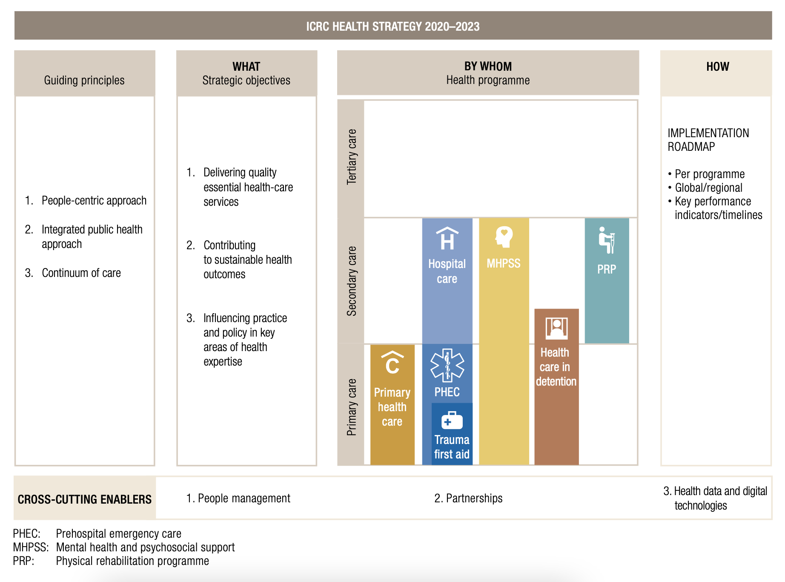
ICRC Health Strategy 2024-2027

Annexe 3: The Ten-Step Method of Decision-Making

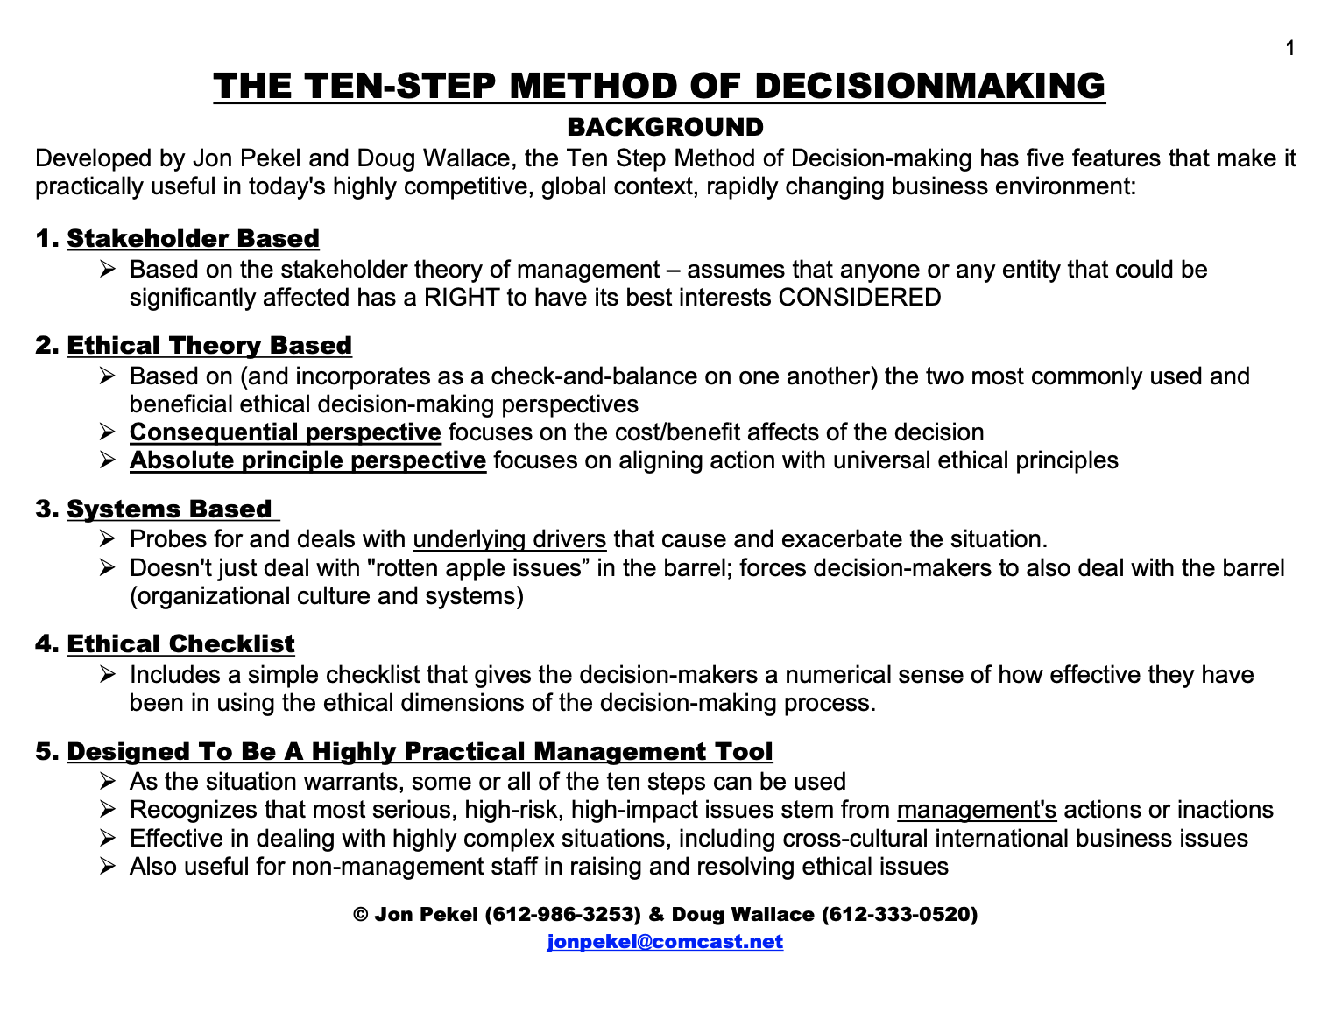
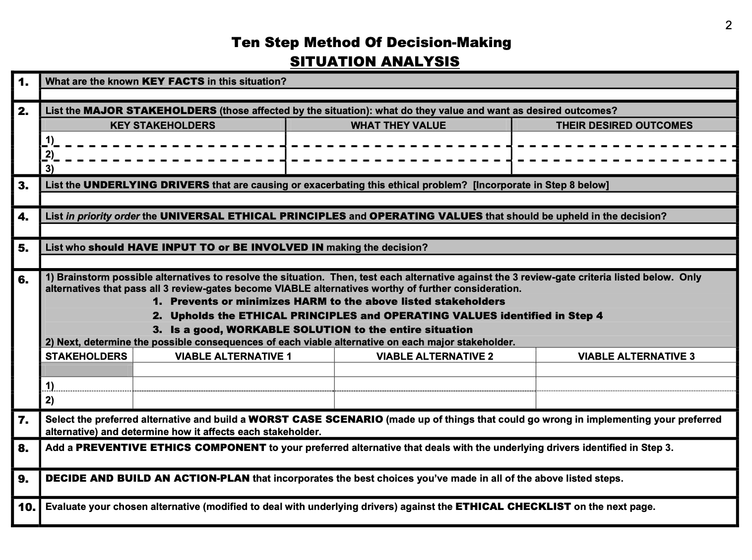
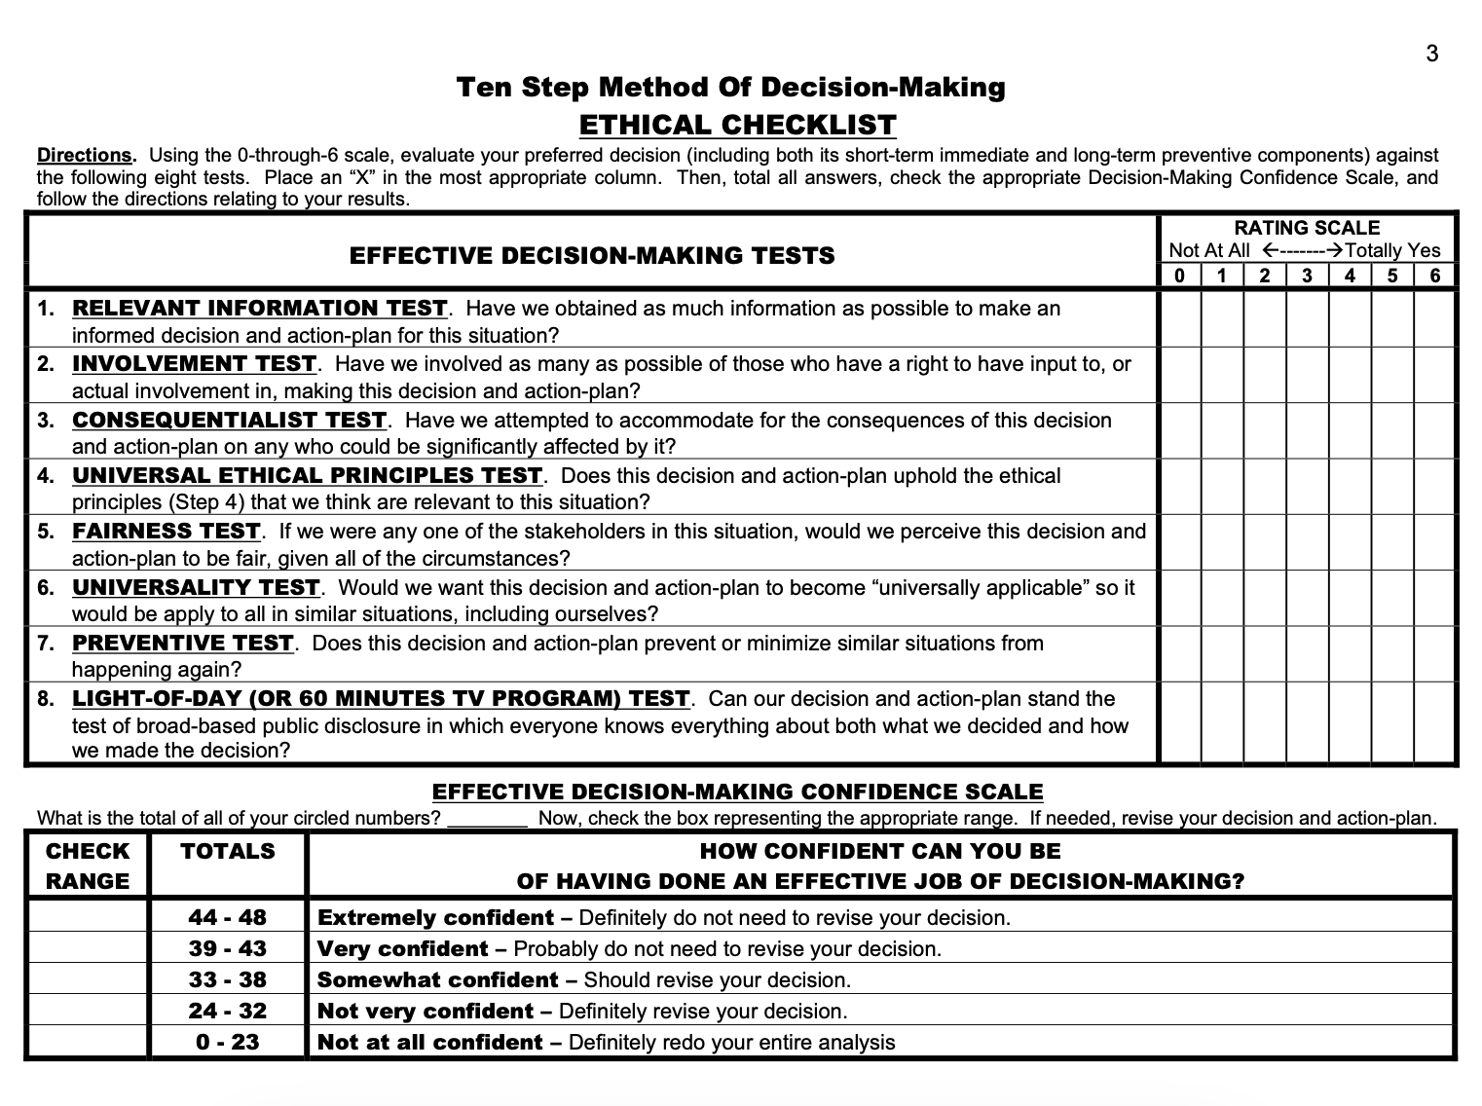

See Annex 1 for the Summary of ICRC Strategic Plan 2019-2024
See Annex 2 for the Summary of proposed ICRC Health Strategic Plan 2024-2027
See Annex 2 for Pekel and Walace the Ten-Step Method of Decision Making

