

Analysis of the Swiss Watch Market: Trends, Challenges, and Future Outlook

Master's work carried out with a view to obtaining the MBA Master’s degree

By:
Claudio Casella

Master work advisor:
Cillian Harte

Grenchen, 16/06/2024
Swiss School of Business Research (SSBR)
Master of Business Administration

Table of Contents
Abstract 3
Acknowledgements 4
Introduction 5
Background of the Study 5
Context of the Swiss Watch Market 5
Problem Statement 6
Objectives of the Study 6
Research Questions 7
Significance of the Study 7
Scope and Limitations 8
Structure of the Thesis 8
Overview of Chapters 8
Literature Review 9
Key Characteristics of Market Segments 9
Overview of the Swiss Watch Industry 10
Historical Development of Swiss Watches 11
Key Players in the Market 12
Market Segmentation 14
Key Characteristics of Each Segment 15
Consumer Behavior and Preferences 16
Trends in the Global Watch Market 17
The Impact of Technology on Swiss Watches 18
Challenges Facing the Swiss Watch Industry 19
Theoretical Framework 20
Data Analysis Methods 21
Research Design 21
Data Collection Methods 22
Primary Data 22
Sampling Techniques 24
Data Analysis Methods 25
Ethical Considerations 26
Limitations of the Research 28
Analysis and Findings 29
Consumer Preferences and Trends 31
Impact of Digitalization 35
SWOT Analysis of the Swiss Watch Industry 36
Case Studies 39
Discussion 41
Interpretation of Findings 41
Implications for the Swiss Watch Industry 43
Policy and Strategic Recommendations 45
Conclusion and Recommendations 50
Summary of Key Findings 50
Suggestions for Future Research 52
References 53

Abstract
The Swiss watch industry, renowned for its unparalleled craftsmanship and luxurious appeal, has held a prestigious position in the global market for centuries. This thesis aims to provide an in-depth analysis of the current trends, challenges, and outlook of the Swiss watch market. The primary objectives of the study are to understand the dynamics of the market, evaluate shifting consumer preferences, and assess the impact of technological advancements on traditional Swiss watchmakers
The methodology employed in this research includes a mixed-method approach, combining quantitative data from industry reports and market analyses with qualitative insights obtained through interviews with key industry stakeholders, including executives from major Swiss watch brands, industry analysts, and retailers. Primary data was collected through surveys distributed to a diverse group of consumers across different demographic segments, capturing a wide range of opinions and preferences. Secondary data was meticulously sourced from reputable industry publications, company annual reports, and academic journals to provide a comprehensive background and context for the study.
Key findings of the research reveal that while the Swiss watch market continues to dominate the luxury segment, it faces significant challenges from the rapid rise of smartwatches and evolving consumer behaviors. The analysis indicates a notable shift in consumer preferences towards digital and multifunctional timepieces, which poses a threat to traditional mechanical watches. Despite these challenges, the Swiss watch industry remains resilient, buoyed by its strong brand heritage, innovative designs, and the superior quality of its products. Additionally, there is an increasing trend of personalization and customization in luxury watches, catering to the unique tastes of high-end consumers.
Swiss watchmakers need to adopt a dual strategy to thrive in the evolving market landscape. This involves preserving the traditional appeal and exceptional craftsmanship of mechanical watches while simultaneously embracing technological advancements. Recommendations for industry stakeholders include investing in cutting-edge
digital marketing strategies, exploring strategic collaborations with technology companies to integrate smart features into traditional designs, and targeting younger demographics through innovative and affordable product offerings. Future research should focus on long-term consumer trends and the potential for integrating advanced technologies, such as blockchain for authenticity verification and augmented reality for virtual try-ons, into traditional watchmaking practices.

Acknowledgements
I would like to express my deepest gratitude to my thesis advisor Cillian Harte for his unwavering support, invaluable guidance, and insightful feedback throughout this research. His expertise and encouragement have been instrumental in shaping this thesis.
I also extend my sincere thanks to all the participants who took the time to complete the surveys and participate in interviews. Your contributions were crucial to the success of this study, providing essential insights and perspectives.
Special thanks to the industry experts and executives who generously shared their knowledge and experiences, enriching the quality of this research.
I am profoundly grateful to my family and friends for their continuous encouragement and understanding during this challenging journey. Your support has been my driving force.

Introduction

Background of the Study

Context of the Swiss Watch Market
The Swiss watch market represents the pinnacle of horological excellence, renowned for its meticulous craftsmanship, innovative technology, and aesthetic appeal. Swiss watches, synonymous with luxury and precision, have established a reputation that transcends geographical boundaries. This industry comprises a diverse range of products, from high-end luxury watches to more accessible, yet still premium, timepieces. Swiss watchmakers are celebrated for their ability to combine traditional techniques with cutting-edge technology, creating watches that are both functional and works of art. The Swiss watch industry plays a crucial role in the country's economy, contributing significantly to exports and providing employment to thousands.
- Importance in the Global Market
Swiss watches command a substantial share of the global luxury watch market. Despite facing competition from other watchmaking countries like Japan and Germany, Swiss brands maintain a dominant position due to their exceptional quality and heritage. The global demand for Swiss watches is driven by their status symbol, quality assurance, and the prestige associated with owning a Swiss-made timepiece. The industry is not only vital for its direct economic impact but also for its influence on related sectors such as tourism and luxury retail. The Swiss watch industry's export value, particularly to markets in Asia, Europe, and North America, underscores its global significance.
- Historical Significance
The historical roots of Swiss watchmaking date back to the 16th century when Huguenot refugees brought their watchmaking skills to Geneva. Over the centuries, Swiss watchmakers have been at the forefront of technological and design innovations. Notable milestones include the development of the first automatic wristwatch, the introduction of the tourbillon, and advancements in chronograph and perpetual calendar mechanisms. The industry's resilience is epitomized by its recovery from the Quartz Crisis of the 1970s, a period when the advent of affordable quartz watches from Japan threatened the traditional mechanical watch market. Swiss watchmakers responded by emphasizing the luxury and craftsmanship of mechanical watches, thereby reasserting their market dominance.

Problem Statement
- Current Challenges in the Swiss Watch Market
The Swiss watch industry faces several contemporary challenges that threaten its traditional market dominance. One of the most significant challenges is the competition from smartwatches, which offer features such as connectivity, fitness tracking, and customization, appealing to a younger, tech-savvy demographic. The industry also grapples with changing consumer preferences, where there is a growing demand for multifunctional and digital timepieces over traditional mechanical watches. Additionally, economic fluctuations and geopolitical uncertainties can impact consumer spending on luxury goods, further complicating the market landscape for Swiss watches.
- Gap in the Existing Literature
Despite the rich history and substantial body of research on Swiss watches, there is a noticeable gap in contemporary studies that focus on the current market dynamics, particularly the impact of digitalization and changing consumer preferences. Most existing literature centres around the historical and cultural aspects of Swiss watchmaking, with limited exploration of modern market challenges and strategic responses by Swiss watchmakers. This thesis aims to bridge this gap by providing an up-to-date analysis of these factors, offering valuable insights for industry stakeholders and contributing to academic knowledge.

Objectives of the Study
- Main Goals of the Research
The primary objective of this study is to conduct a comprehensive analysis of the Swiss watch market, focusing on the current trends, challenges, and future outlook. The study aims to provide a detailed understanding of the market dynamics and offer strategic recommendations for industry stakeholders.
- Specific Objectives
To assess the impact of technological advancements on the Swiss watch market: This involves examining how smartwatches and other digital technologies are affecting the demand for traditional Swiss watches.
To understand consumer preferences and behaviors related to Swiss watches: This includes analyzing demographic and psychographic factors that influence purchasing decisions.
To identify strategic responses by Swiss watchmakers to market changes: This entails exploring how major Swiss brands are adapting to challenges such as competition from smartwatches and shifting consumer preferences.
To provide recommendations for industry stakeholders to navigate the evolving market landscape: This includes suggesting strategies for maintaining competitiveness and leveraging opportunities presented by technological advancements.

Research Questions
Key Questions Guiding the Research
- How have technological advancements, particularly smartwatches, impacted the Swiss watch market? This question explores the extent to which smartwatches have influenced consumer preferences and market dynamics.
- What are the current consumer preferences and behaviors towards Swiss watches? This question aims to identify the key factors driving consumer decisions and how these preferences are evolving.
- What strategies are Swiss watchmakers adopting to remain competitive in the global market? This question examines the approaches taken by Swiss brands to address market challenges and capitalize on new opportunities.
- What are the potential future trends in the Swiss watch industry? This question seeks to forecast the long-term trends that could shape the industry, including technological innovations and changes in consumer behavior.

Significance of the Study

- Relevance to Industry Stakeholders
This study provides valuable insights for various industry stakeholders, including watchmakers, marketers, retailers, and investors. For watchmakers, understanding the impact of technological advancements and consumer preferences is crucial for product development and strategic planning. Marketers can benefit from insights into consumer behavior to tailor their marketing strategies effectively. Retailers will gain a better understanding of market trends, helping them optimize their inventory and sales strategies. Investors can use the findings to make informed decisions regarding investments in the Swiss watch industry.
- Contribution to Academic Knowledge
From an academic perspective, this research contributes to the body of knowledge on luxury marketing, consumer behavior, and innovation management. By addressing the contemporary challenges and opportunities in the Swiss watch market, this thesis fills a gap in existing literature and provides a foundation for future research. It offers a comprehensive analysis that combines historical context with current market dynamics, serving as a reference for scholars and researchers interested in the luxury goods sector and the impact of technological advancements on traditional industries.

Scope and Limitations

- Boundaries of the Research
This study focuses on the Swiss watch market, with particular emphasis on the luxury and high-end segments. It covers market trends, consumer behavior, and the impact of technological advancements on traditional Swiss watchmaking. The geographic scope includes key global markets where Swiss watches have significant penetration, such as Europe, North America, and Asia.
- Potential Constraints
The research may face several constraints, including limited access to proprietary industry data and potential biases in survey responses. Additionally, the rapidly changing technological landscape may affect the timeliness of the findings. The study will primarily rely on secondary data from industry reports, company publications, and academic journals, complemented by primary data collected through surveys and interviews. While every effort will be made to ensure the accuracy and reliability of the data, these limitations will be acknowledged and addressed in the analysis.

Structure of the Thesis

Overview of Chapters
Chapter 1: Introduction - This chapter provides the background, problem statement, objectives, research questions, significance, scope, and structure of the thesis. It sets the stage for the detailed analysis and discussions in the subsequent chapters.
Chapter 2: Literature Review - This chapter reviews existing literature on the Swiss watch industry, covering historical development, market dynamics, consumer behavior, and the impact of technology. It identifies gaps in the literature and establishes the theoretical framework for the study.
Chapter 3: Research Methodology - This chapter describes the research design, data collection methods, sampling techniques, data analysis methods, ethical considerations, and limitations of the research. It outlines the methodological approach used to achieve the study's objectives.
Chapter 4: Analysis and Findings - This chapter presents the results of the market analysis, including market size, growth, and segmentation. It explores consumer preferences, the impact of digitalization, and provides a SWOT analysis of the Swiss watch industry. Case studies of key players are also included.
Chapter 5: Discussion - This chapter interprets the findings, comparing them with existing literature and discussing their implications for the Swiss watch industry. It provides policy and strategic recommendations for industry stakeholders based on the analysis.
Chapter 6: Conclusion and Recommendations - This chapter summarizes the key findings, answers the research questions, and provides practical recommendations for industry stakeholders. It also suggests areas for future research to further explore the evolving Swiss watch market.
Chapter 7: References - This chapter lists all sources cited in the thesis, following proper academic formatting guidelines.

Chapter 8: Appendices - This chapter includes supplementary materials such as survey questionnaires, interview transcripts, detailed data tables, and other relevant documents.

Literature Review

Key Characteristics of Market Segments

- Luxury Watches: Craftsmanship, Prestige, and Heritage
Luxury watches epitomize horological excellence, known for their superior craftsmanship, meticulous attention to detail, and rich heritage. These timepieces, often made from precious metals like gold and platinum, feature intricate complications and exquisite designs, showcasing the expertise and artistry of master watchmakers.
Brands such as Rolex, Patek Philippe, and Breitling, with their centuries-old legacies, embody exclusivity and prestige. Owning a luxury watch is not just a purchase but an investment in quality and a statement of taste. These watches often become heirlooms, valued by collectors and connoisseurs for their timeless elegance and lasting value.
- Mid-range Watches: Value, Quality, and Accessibility
Mid-range watches blend Swiss quality, functional design, and affordability, appealing to young professionals, watch enthusiasts, and everyday wearers. Brands like Omega, TAG Heuer, and Tissot are known for their robust mechanical movements, durable construction, and versatile designs.
While lacking the exotic materials and intricate complications of luxury watches, mid-range watches deliver exceptional value for money. They serve as gateway timepieces for aspiring collectors, offering an affordable entry into Swiss watchmaking without compromising on quality and style.
- Low-end Watches: Style, Trends, and Affordability
Low-end watches cater to the mass market, focusing on style, trends, and affordability. Brands like Swatch, Timex, and Casio offer colourful, trendy designs that appeal to fashion-conscious consumers and everyday wearers.
These watches often use quartz movements for precise timekeeping and durable materials like plastic or stainless steel. Popular among those who see watches as fashion accessories, low-end watches provide an affordable way to update personal style with seasonal designs reflecting current trends.

Overview of the Swiss Watch Industry
- Historical Evolution
The Swiss watch industry began in the 16th century when Huguenot craftsmen, fleeing religious persecution in France, settled in Geneva. These artisans brought expertise in jewellery and metalwork, forming the first watchmaking guild in 1601, which set high standards for quality.
Swiss watchmaking flourished in the Jura region, particularly in towns like La Chaux-de-Fonds and Le Locle, where isolation and skilled artisans provided an ideal environment. The 18th and 19th centuries saw significant growth and innovation, with Daniel Jean Richard introducing interchangeable parts, leading to mass production. Iconic firms like Vacheron Constantin (1755) and Audemars Piguet (1875) were also founded during this period.
- Current Status
Today, the Swiss watch industry is a global symbol of luxury, craftsmanship, and precision. Despite challenges from digital disruption and evolving consumer preferences, Swiss watches remain highly respected and admired. The industry includes both historic maisons and contemporary independents.
Leading brands like Rolex, Patek Philippe, and Audemars Piguet are renowned for their commitment to quality and innovation. Rolex, known for models like the Submariner and Daytona, epitomizes precision and adventure. Patek Philippe, established in 1839, is synonymous with haute horlogerie, while Audemars Piguet pushes design boundaries with creations like the Royal Oak.
The industry also features a range of brands catering to diverse tastes, from avant-garde independents like MB&F and Richard Mille to heritage maisons like Jaeger-LeCoultre and Blancpain.
Facing the rise of smartwatches and wearable technology, Swiss brands are adapting and innovating to stay relevant. Despite these challenges, the Swiss watch industry thrives through its blend of heritage, innovation, and unmatched craftsmanship.
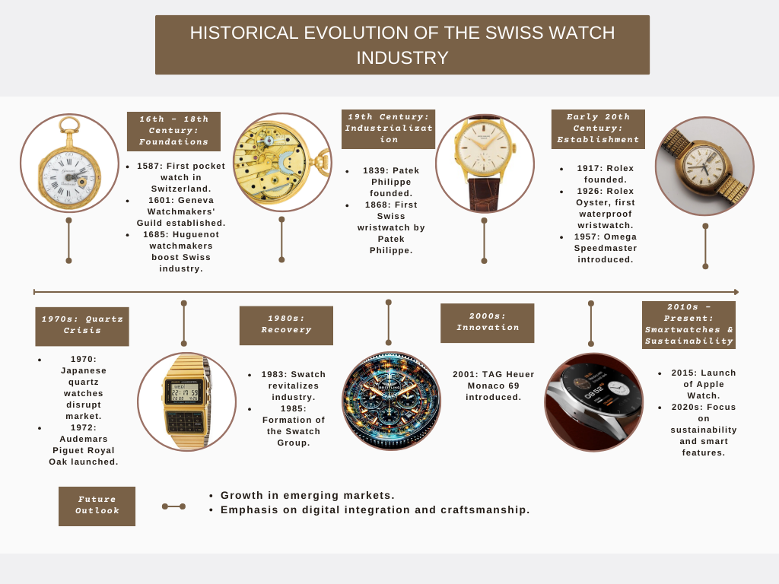

Historical Development of Swiss Watches
- Key Milestones
The history of Swiss watches is marked by significant milestones. In 1780, Abraham-Louis Breguet invented the tourbillon, enhancing timekeeping accuracy by countering gravity's effects. This invention set new standards in horology.
The 19th century brought industrialization, with Daniel Jeanrichard introducing mass production techniques like the division of labour and interchangeable parts. These innovations allowed Swiss watchmakers to meet growing global demand, establishing Switzerland's dominance in the watch market.
World War I highlighted the practicality of wristwatches over pocket watches, leading to a surge in their popularity among soldiers and a permanent shift in consumer preferences.
The 20th century saw further innovations. The development of automatic movements, such as Rolex's Oyster Perpetual in 1931, eliminated the need for manual winding. Swiss watchmakers also introduced iconic models like Patek Philippe's Calatrava and Audemars Piguet's Royal Oak, solidifying Switzerland's reputation for excellence in craftsmanship and design.
- Evolution of Technology and Design
Technological advancements have significantly shaped the Swiss watch industry. The mid-20th century saw the advent of electronic movements and quartz technology, offering unmatched accuracy and affordability. However, the 1970s Quartz Crisis, driven by Japanese brands like Seiko, threatened the traditional mechanical watch market.
In response, Swiss watchmakers emphasized the craftsmanship, heritage, and luxury of mechanical watches, sparking a renaissance. This resurgence highlights a renewed consumer appreciation for the artistry and exclusivity of mechanical timepieces, which are now valued as expressions of personal style and identity rather than mere timekeeping devices.

Key Players in the Market

- Major Companies
The Swiss watch market boasts a rich array of brands, each contributing to its esteemed heritage and global renown.
- Rolex: Founded in 1905 by Hans Wilsdorf and Alfred Davis, Rolex epitomizes timeless luxury and precision engineering. Its iconic models like the Submariner and Daytona are revered worldwide, symbolizing style, achievement, and adventure.
- Patek Philippe: Established in 1839, Patek Philippe is synonymous with haute horlogerie and artisanal craftsmanship. Its intricate complications, from perpetual calendars to grand complications, showcase the brand's dedication to excellence.
- Breitling: Since 1884, Breitling has been the choice of aviation professionals, renowned for its accuracy and durability. Models like the Navitimer and Chronomat embody the spirit of adventure and exploration.
- The Swatch Group: Formed in 1983, the Swatch Group is a powerhouse in the watch industry, boasting brands like Omega, Longines, and Tissot. Each brand offers a distinct identity, from Omega's pioneering spirit to Longines' timeless elegance.
- Richemont: Established in 1988, Richemont owns prestigious maisons like Cartier, Jaeger-LeCoultre, and IWC Schaffhausen. These brands epitomize luxury and innovation, from Cartier's iconic collections to Jaeger-LeCoultre's technical sophistication.

- Market Share Analysis
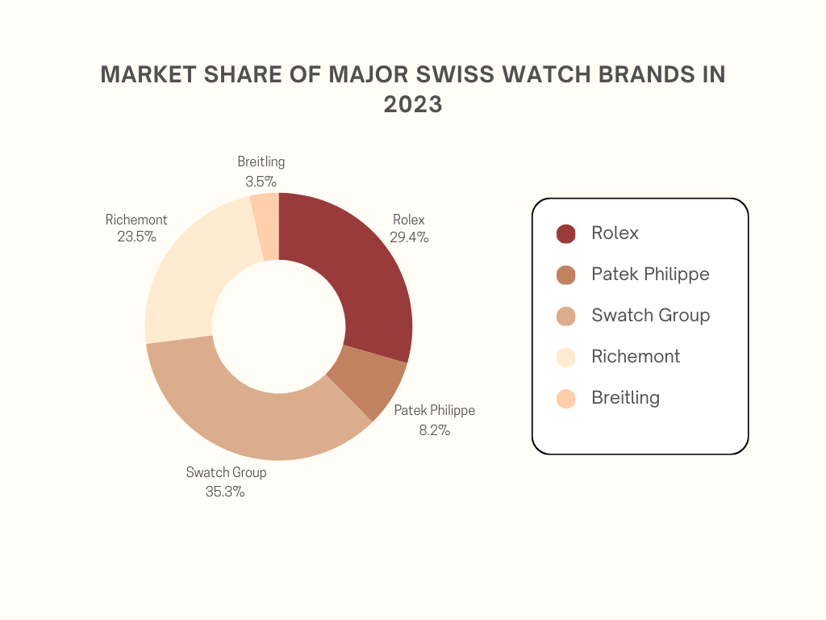

Despite the diversity of brands in the Swiss watch market, a few key players command significant market share, reflecting their dominance and influence in the industry.
Rolex, with its unrivaled brand equity and iconic status, holds a substantial share of the market, valued at approximately 25% of the industry's total value. The enduring appeal of Rolex timepieces, coupled with the brand's relentless pursuit of excellence, ensures its continued success and relevance in the ever-evolving luxury watch market.
The Swatch Group follows closely behind, contributing around 30% of industry sales through its extensive portfolio of brands catering to diverse consumer preferences. From entry-level fashion watches to high-end mechanical timepieces, the Swatch Group's brands appeal to a broad spectrum of customers worldwide, driving its market share and profitability.
Richemont and LVMH, though fewer in number, command significant market share through their prestigious maisons and luxury offerings. With brands like Cartier, Piaget, and TAG Heuer, Richemont and LVMH cater to discerning clientele seeking exceptional craftsmanship, design, and heritage.
While independent brands and artisanal watchmakers may have a smaller overall market share, they play a vital role in driving innovation, creativity, and diversity within the Swiss watch industry. Their dedication to craft and willingness to push boundaries contribute to the industry's vibrancy and resilience, ensuring its continued relevance in the global marketplace.

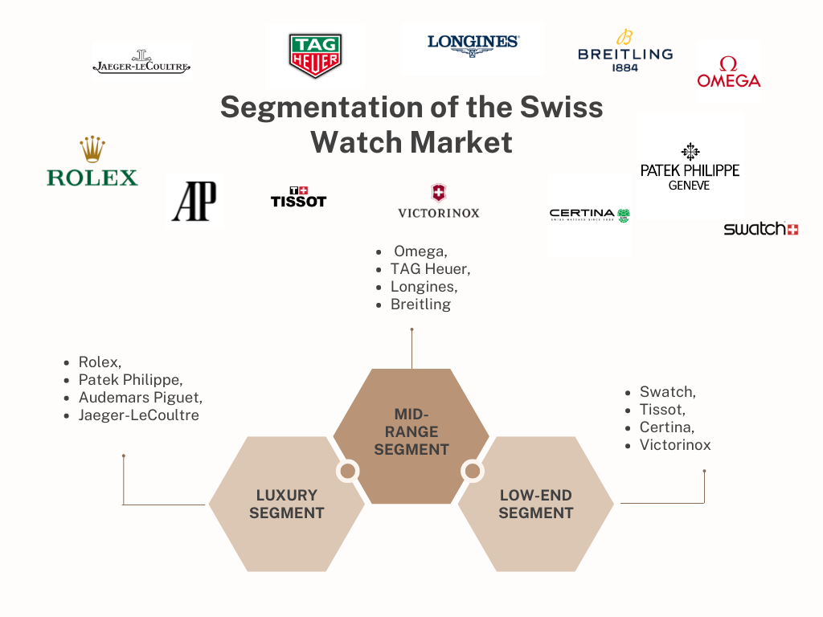
Market Segmentation

- Luxury, Mid-range, and Low-end Segments
- Luxury Segment: At the zenith of the Swiss watch market lies the luxury segment, renowned for its emphasis on exclusivity, craftsmanship, and heritage. Brands like Rolex, Patek Philippe, Audemars Piguet, and Jaeger-LeCoultre command premium prices, offering timepieces that blend tradition with innovation. Limited production runs and bespoke customization options further enhance the allure of luxury Swiss watches.
- Mid-range Segment: The mid-range segment caters to consumers seeking Swiss-made timepieces with a balance of quality, reliability, and affordability. Brands like Omega, TAG Heuer, Longines, and Breitling offer diverse collections with robust mechanical movements and durable materials at a more accessible price point than luxury brands. These watches appeal to discerning consumers appreciative of Swiss craftsmanship but more budget-conscious than luxury buyers.
- Low-end Segment: The low-end segment targets budget-conscious consumers and fashion-oriented buyers, offering Swiss-made watches at affordable price points. Brands like Swatch, Tissot, Certina, and Victorinox provide colourful and versatile timepieces with quartz movements and playful designs that reflect current fashion trends. While not as technically sophisticated as luxury or mid-range watches, low-end Swiss watches offer accessibility and style without compromising quality.

Key Characteristics of Each Segment

- Luxury Segment
- Exclusivity: Limited production runs, bespoke customization, and high price points.
- Craftsmanship: Emphasis on hand-made components, intricate complications, and precious materials like gold and platinum.
- Heritage: Strong brand histories, often spanning centuries, with a focus on traditional watchmaking techniques.
- Iconic Designs: Examples include Rolex Submariner and Patek Philippe Grand Complications, known for their timeless elegance and investment value.
- Mid-range Segment
- Quality and Affordability: Swiss-made with robust mechanical movements, usually stainless steel and sapphire crystal, offering a balance between quality and cost.
- Diverse Collections: Brands like Omega and TAG Heuer offer multiple models catering to various lifestyles, such as the sporty TAG Heuer Carrera and the elegant Omega Seamaster.
- Technical Innovation: Incorporation of modern technologies and design innovations while maintaining affordability.
- Broader Demographic Appeal: Targeted towards professionals and enthusiasts valuing Swiss craftsmanship but seeking more accessible price points.
- Low-end Segment
- Accessibility: Affordable price points making Swiss watches available to a wider audience.
- Trendy Designs: Focus on current fashion trends with vibrant and playful designs, such as Swatch's colourful and versatile watches.
- Functional Movements: Predominantly quartz movements for precise timekeeping and lower maintenance.
- Youthful Appeal: Attracts younger, fashion-conscious consumers with a blend of style and practicality, seen in brands like Tissot and Certina.

Consumer Behavior and Preferences

- Buying Patterns
- Luxury Watch Buyers: Luxury watch buyers seek prestige, craftsmanship, and heritage, favouring brands like Rolex, Patek Philippe, and Audemars Piguet. They prioritize brand heritage, craftsmanship, and exclusivity, valuing complications that showcase technical prowess and innovation.
- Mid-range Consumers: Mid-range consumers balance quality and affordability, preferring brands like Omega, TAG Heuer, and Longines. They conduct thorough research, considering movement type, material quality, and design aesthetics when making purchasing decisions.
- Low-end Buyers: Low-end consumers prioritize style and price, opting for brands like Swatch, Tissot, and Fossil. They prioritize affordability and fashionable designs, influenced by social media trends and personal taste.
- Brand Reputation: Brand reputation, particularly among luxury watch buyers, guides choices. Trusted maisons like Rolex and Patek Philippe command loyalty, reflecting prestige and heritage.
- Product Features: Features like movement complexity and design heavily influence preferences. Enthusiasts favor intricate complications and high-quality materials, showcasing technical expertise and design.
- Pricing: Pricing is critical across segments. Luxury buyers invest in craftsmanship and exclusivity, while mid-range and low-end consumers seek value for money.
- Social Influences: Peer recommendations, celebrity endorsements, and cultural trends shape perceptions. Consumers may be influenced by social circles, celebrity endorsements, and fashionable trends.

Trends in the Global Watch Market
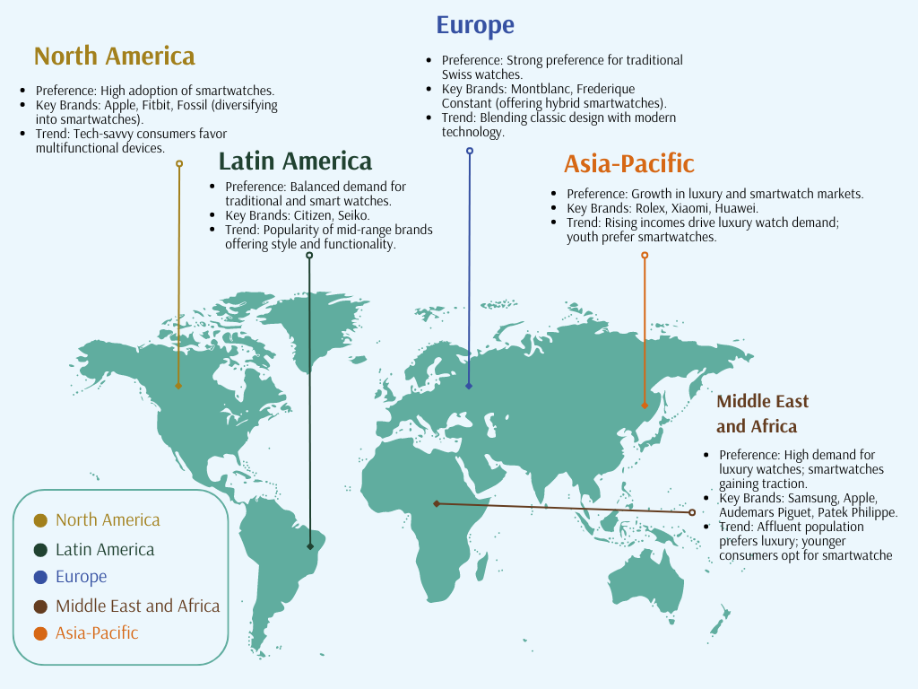

- Emerging Trends
- Rise of Smartwatches: Smartwatches from tech giants like Apple and Samsung are reshaping the market, offering multifunctional features beyond timekeeping. Traditional watchmakers like TAG Heuer and Breitling are also entering this space with hybrid models, blending Swiss craftsmanship with smart technology.
- Sustainability and Ethical Sourcing: Consumer demand for sustainability and ethical practices is driving brands to adopt eco-friendly measures in their supply chains. Practices include responsible material sourcing, reduced energy consumption in manufacturing, and eco-friendly packaging. Brands like Breitling are striving for carbon neutrality, while ensuring ethical sourcing of materials.
- Customization and Personalization: Consumers seek unique products that reflect their individuality, leading to a rise in customization and personalization services. Luxury brands like Rolex and Patek Philippe offer bespoke options, allowing customers to tailor every aspect of their timepieces. Mainstream brands like Swatch and Timex also offer customizable options through online configurators, enhancing brand engagement and loyalty.
- Future Outlook: As the market evolves, embracing trends like smartwatches, sustainability, and customization will be crucial for brands to remain competitive and relevant. By adapting to changing consumer preferences and technological advancements, watch manufacturers can position themselves for success in a dynamic market landscape.

- Comparison with Other Regions
- North America: The United States leads in the adoption of smartwatches and wearable tech, with brands like Apple and Fitbit dominating the market. Traditional watchmakers, like Fossil, are diversifying into smartwatches to cater to tech-savvy consumers.
- Europe: Europe maintains a strong preference for traditional Swiss watches but is also embracing smartwatches. Brands like Montblanc and Frederique Constant offer smartwatches that blend classic design with modern technology.
- Asia-Pacific: China and India are driving growth in both luxury and smartwatch markets. Rising incomes fuel demand for luxury brands like Rolex, while tech-savvy youth drive sales of smartwatches from Xiaomi and Huawei.
- Latin America: Latin America shows a balanced demand for traditional and smart watches. Mid-range brands like Citizen and Seiko are popular, offering style and functionality at accessible prices.
- Middle East and Africa: Luxury watches are in high demand among the affluent population, while smartwatches gain traction among younger consumers. Brands like Samsung and Apple are prominent, alongside luxury brands like Audemars Piguet and Patek Philippe catering to local tastes.

The Impact of Technology on Swiss Watches

- Digital and Smart Watches
Digital and smartwatches have transformed the watch market, offering features beyond timekeeping like fitness tracking, heart rate monitoring, and smartphone connectivity. Leading brands such as Apple, Samsung, and Garmin provide a range of functionalities catering to tech-savvy consumers. Traditional Swiss watchmakers like TAG Heuer and Breitling have adapted by introducing hybrid models like the Connected series and Exospace B55, blending Swiss craftsmanship with modern smart features. These watches appeal to those seeking both luxury and practicality.
- Technological Innovations
In addition to smartwatches, traditional Swiss watches are undergoing technological advancements that enhance performance and longevity. Silicon components, pioneered by brands like Ulysse Nardin and Omega, reduce friction and improve accuracy, requiring less maintenance. Omega's Co-Axial escapement is a prime example of how technology enhances precision in mechanical movements.
Furthermore, Swiss watchmakers are integrating Computer-Aided Design (CAD) and Computer-Aided Manufacturing (CAM) into their processes for greater precision and efficiency. This ensures that watches maintain high standards of quality while meeting modern demands for innovation.
- Future Outlook
The integration of technology in Swiss watches will likely continue, driven by consumer demand for both craftsmanship and functionality. Brands embracing these advancements while preserving heritage are poised to stay competitive in the market.

Challenges Facing the Swiss Watch Industry

- Competition from Other Countries
Swiss watchmakers face increasing competition from countries like Japan and Germany, renowned for their high-quality timepieces at competitive prices. Japanese brands like Seiko and Citizen offer innovation and affordability, with Seiko's Grand Seiko line directly challenging Swiss luxury brands.
Germany's A. Lange & Söhne and NOMOS Glashütte are known for precision engineering and distinctive designs, rivaling Swiss counterparts in quality and prestige.
Chinese manufacturers like Seagull and Fiyta are also emerging as contenders, improving in quality and expanding their global market presence with more affordable options.
- Economic and Regulatory Issues
Economic fluctuations, like the 2008 financial crisis and the COVID-19 pandemic, affect luxury spending, impacting Swiss watch sales. Currency fluctuations, especially the Swiss franc's strength, can make watches more expensive internationally, reducing competitiveness.
Regulatory hurdles, such as stringent environmental rules and trade regulations, add complexity. For example, the "Swiss Made" ordinance tightened criteria for labelling watches, potentially increasing production costs.
Trade policies like tariffs from events like the US-China trade war and Brexit introduce uncertainties.
Addressing Challenges:
- Emphasize innovation in technology and design to stand out.
- Expand into emerging markets like China and India.
- Adapt marketing strategies to local preferences to capture demand.

Theoretical Framework
- Relevant theories and models
- Porter’s Five Forces Model: Porter’s Five Forces Model is a valuable tool for understanding the competitive forces within the Swiss watch industry. The five forces include:
- Threat of New Entrants: The barriers to entry in the Swiss watch market are high due to the significant investment required in technology, craftsmanship, and brand building. However, emerging brands and technological advancements, particularly in smartwatches, pose a potential threat.
- Bargaining Power of Suppliers: Swiss watchmakers rely on high-quality materials and skilled labour, which can give suppliers considerable bargaining power. However, established relationships and vertical integration help mitigate this power.
- Bargaining Power of Buyers: Consumers of luxury watches have high bargaining power due to the availability of numerous high-end brands and the importance of brand prestige and quality in purchasing decisions.
- Threat of Substitutes: The threat of substitutes is significant with the rise of smartwatches and other wearable technology that offer multifunctional capabilities beyond traditional timekeeping.
- Industry Rivalry: The rivalry among existing competitors is intense, with brands continually innovating and differentiating their offerings to maintain market share.
- Brand Equity Theory: which focuses on the value derived from consumer perceptions of a brand, is particularly relevant to the Swiss watch industry. Brands like Rolex, Patek Philippe, and Omega have built strong brand equity through consistent quality, heritage, and effective marketing. This strong brand equity translates into customer loyalty, premium pricing, and a significant competitive advantage.

- Consumer Behavior Models: Consumer behavior models, such as the Theory of Planned Behavior (TPB) and Maslow's Hierarchy of Needs, provide insights into why consumers choose Swiss watches. TPB explains that consumer intentions to purchase are influenced by attitudes, subjective norms, and perceived behavioural control. For luxury watches, factors like social status, personal gratification, and perceived value play crucial roles. Maslow's Hierarchy of Needs suggests that once basic needs are met, consumers seek self-actualization and esteem needs, which can be fulfilled by owning luxury items like Swiss watches.
- Application to the Study
These theories and models are applied in the study to analyse market dynamics and consumer preferences in the Swiss watch industry. Porter’s Five Forces Model helps identify the competitive pressures and strategic positioning of Swiss watch brands. Brand Equity Theory provides a framework to assess how established brands maintain their market dominance through strong brand identities. Consumer behavior models elucidate the motivations behind purchasing decisions, offering insights into marketing strategies that can enhance consumer engagement and loyalty.

Data Analysis Methods

Research Design
Our research adopts a mixed methods approach, strategically blending both qualitative and quantitative methodologies to comprehensively explore the multifaceted .

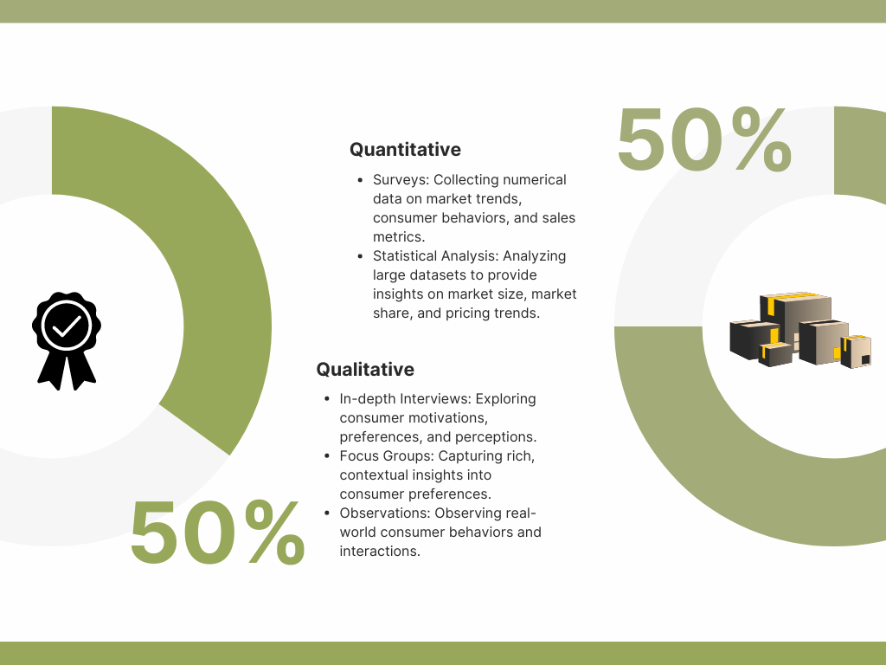

- Type of Research: Mixed Methods Approach
landscape of the Swiss watch market. This integrated approach ensures a holistic understanding by harnessing the strengths of both quantitative and qualitative data.
Quantitative methods entail the systematic collection and analysis of numerical data to quantify market trends, consumer behaviors, and sales metrics within the Swiss watch industry. Surveys, statistical analysis, and data mining techniques are employed to gather and analyse large datasets, providing insights into market size, market share, pricing trends, and other quantifiable aspects of the market.
Qualitative methods, on the other hand, delve into the subjective experiences, perceptions, and motivations of consumers, industry professionals, and other stakeholders within the Swiss watch ecosystem. Techniques such as in-depth interviews, focus groups, and observational studies are utilized to capture rich, contextual insights into consumer preferences, brand perceptions, and industry dynamics.
- Justification
The adoption of a mixed methods approach is strategically justified by the intricate nature of the Swiss watch market, which comprises diverse consumer segments, intricate industry dynamics, and multifaceted market forces. This approach allows us to harness the complementary strengths of quantitative and qualitative methods to address the complexities inherent in studying this market.
Quantitative methods provide valuable statistical rigor and enable us to quantify market trends and consumer behaviors at scale. For instance, surveys can be distributed to a large sample of consumers to gather data on purchasing patterns, brand preferences, and demographic trends. Statistical analysis techniques allow us to identify correlations, patterns, and trends within the data, providing quantitative insights into market dynamics.
Qualitative methods, on the other hand, offer depth and richness of understanding by exploring the underlying motivations, perceptions, and attitudes of consumers and industry stakeholders. Through in-depth interviews and focus groups, we can uncover nuanced insights into consumer decision-making processes, brand loyalty, and the emotional connections consumers have with Swiss watches. Additionally, observational studies allow us to observe consumer behaviors in real-world settings, providing valuable context and understanding.

Data Collection Methods

Primary Data
For primary data collection, our research employs a comprehensive approach encompassing surveys, interviews, and observations to gather both quantitative and qualitative insights into the Swiss watch market
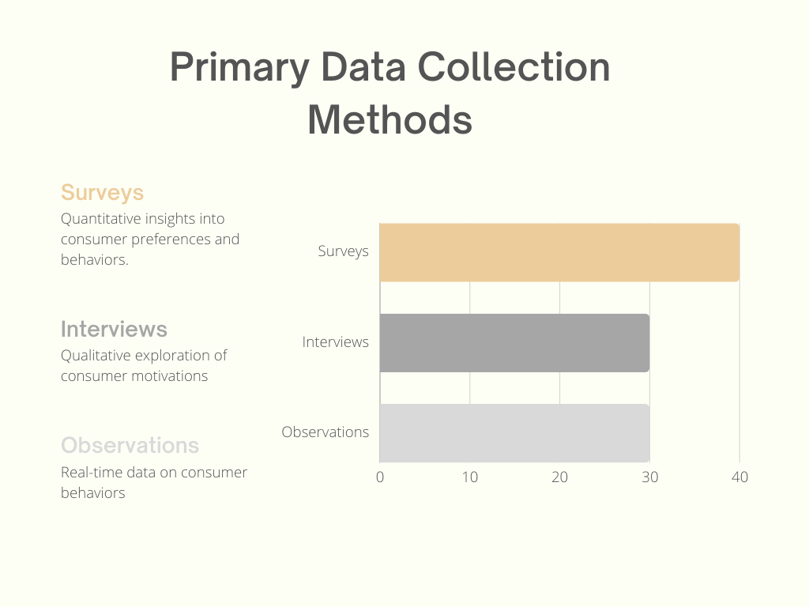

- Surveys: Surveys serve as a pivotal tool for gathering quantitative data on consumer preferences, purchasing behaviors, and brand perceptions at scale. We design structured questionnaires tailored to capture a wide range of information relevant to the Swiss watch market. These surveys are distributed through various channels, including online platforms, social media, and email lists, to reach a diverse sample of respondent’s representative of the target market. Sample survey questions may include:

- "Which factors influenced your decision to purchase a Swiss watch?"
- "On a scale of 1 to 10, how satisfied are you with your current Swiss watch brand?"
- "How frequently do you purchase Swiss watches?"
- "What features do you prioritize when selecting a Swiss watch? (e.g., brand reputation, design, price)"

- Interviews: In-depth interviews offer a qualitative exploration of consumer motivations, preferences, and perceptions, providing a deeper understanding of the underlying attitudes and behaviors driving purchasing decisions within the Swiss watch market. We conduct semi-structured interviews with a select group of participants chosen to represent diverse demographics, lifestyles, and purchasing behaviors. These interviews allow for open-ended discussions that uncover rich insights not captured by quantitative surveys alone. Sample interview topics may include:

- "Can you describe your emotional connection to your favourite
- Swiss watch brand?"
- "What factors do you consider when deciding to purchase a Swiss watch?"
- "How important is brand prestige and heritage in your decision-making process?"
- "Can you recall a memorable experience or interaction with a Swiss watch brand?"
- Observations: Observational studies complement survey and interview data by capturing real-time interactions and behaviors within the retail environment. We conduct field observations at Swiss watch boutiques, department stores, and online retail platforms to observe consumer behavior, brand interactions, and product preferences firsthand. Through direct observation of consumers browsing, trying on, and purchasing Swiss watches, we gain valuable contextual data on factors influencing purchasing decisions. Sample observational notes may include:

- "Many customers spent considerable time examining watches displayed in the window before entering the store."
- "Several customers were observed comparing prices and features of different Swiss watch models using their smartphones."
- "Sales associates engaged in personalized interactions with customers, providing detailed information about watch features and customization options."
- "A group of friends were overheard discussing the latest Swiss watch models and sharing recommendations based on their personal experiences."

- Secondary Data
Secondary data sources play a crucial role in providing context, historical data, and industry insights that complement our primary data collection efforts.
- Industry Reports: Industry reports from market research firms, trade associations, and financial analysts offer valuable insights into market trends, competitive dynamics, and key performance indicators within the Swiss watch industry. These reports provide quantitative data on market size, growth projections, and segment analysis, as well as qualitative analysis of industry trends, consumer preferences, and competitive strategies.
- Academic Papers: Academic research papers contribute theoretical frameworks, empirical findings, and industry analyses that enrich our understanding of the Swiss watch market. These papers may explore topics such as consumer behavior, brand management, innovation, and globalization within the luxury goods industry, providing theoretical insights and practical implications for our research.
- Market Research Publications: Market research publications, including industry journals, trade magazines, and online publications, offer timely updates on market developments, product launches, and consumer trends within the Swiss watch industry. These publications provide real-time insights into industry news, emerging trends, and competitive strategies, helping to inform our research and contextualize our findings within the broader industry landscape.

Sampling Techniques
- Sample Size and Selection Criteria
The determination of sample size and selection criteria is crucial for ensuring the validity and reliability of our research findings. It is guided by the research objectives, population characteristics, and the desired level of statistical precision.
For quantitative surveys aimed at capturing broad market trends and consumer preferences, we aim to achieve a representative sample size that provides sufficient statistical power to generalize findings to the broader population of interest. Sample size calculations may be based on considerations such as the desired margin of error, confidence level, and anticipated effect size. Additionally, sampling criteria are established to ensure diversity and representativeness within the sample. These criteria may include demographic factors such as age, gender, income level, education level, and geographic location. For example, if our research aims to understand consumer preferences for Swiss watches across different age groups and income levels, we will ensure that our sample includes participants from various demographic categories to reflect the diversity of the target market.
- Sampling Methods
Several sampling methods may be employed, depending on the research design, objectives, and population characteristics:
- Random Sampling: In random sampling, every member of the population has an equal chance of being selected for inclusion in the sample. This method ensures that the sample is representative of the population and minimizes bias. Random sampling may be conducted using techniques such as simple random sampling, where participants are selected randomly from the population without any specific criteria.
- Stratified Sampling: Stratified sampling involves dividing the population into homogeneous subgroups or strata based on certain characteristics (e.g., age, income, geographic location) and then randomly selecting participants from each stratum in proportion to its size in the population. This method ensures that each subgroup is adequately represented in the sample, allowing for more precise estimation of population parameters.
- Purposive Sampling: Purposive sampling, also known as judgmental or selective sampling, involves selecting participants based on specific criteria relevant to the research objectives. This method is often used in qualitative research, such as interviews or focus groups, where participants are chosen for their unique perspectives, experiences, or expertise. For example, if our research aims to explore the experiences of luxury watch collectors, we may purposively select participants who have a demonstrated interest in luxury watches and extensive experience in collecting.

Data Analysis Methods
- Analytical Tools and Software
Data analysis in our research involves the utilization of various analytical tools and software to examine both quantitative and qualitative data. These tools enable us to systematically analyse and interpret the data, facilitating the extraction of meaningful insights and conclusions.
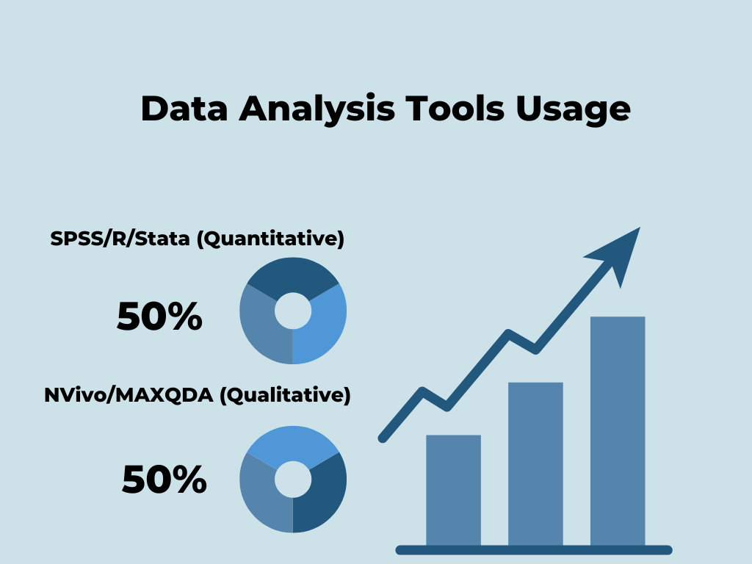

- Quantitative Analysis Tools: For the analysis of quantitative data, we utilize statistical software packages such as SPSS (Statistical Package for the Social Sciences), R, or Stata. These software packages offer a wide range of statistical techniques, including descriptive statistics, inferential analysis, regression modelling, and hypothesis testing. Through these tools, we can examine relationships between variables, test hypotheses, and uncover patterns within the data. For example, we may use regression analysis to identify factors influencing consumer preferences for Swiss watches or conduct cluster analysis to segment consumers based on their purchasing behavior.
- Qualitative Analysis Software: Qualitative data analysis is facilitated by specialized software such as NVivo or MAXQDA. These software platforms provide tools for data organization, coding, and thematic analysis. Qualitative data analysis involves systematically coding textual data, identifying themes and patterns, and interpreting the underlying meanings. Through these software tools, we can manage large volumes of qualitative data efficiently and conduct rigorous analysis to uncover insights. For example, we may use thematic analysis to identify recurring themes in interview transcripts related to consumer perceptions of Swiss watch brands or conduct content analysis to explore the portrayal of luxury watches in online reviews and social media discussions.

- Data Processing Steps
Data processing encompasses several steps to transform raw data into meaningful insights:


  - Data Cleaning: Data cleaning involves identifying and correcting errors, inconsistencies, and missing values in the dataset. This ensures the accuracy and reliability of the data before analysis. For example, we may clean survey data by removing incomplete responses or outliers that could skew the results.

  - Coding: In qualitative data analysis, coding involves systematically categorizing and labeling segments of textual data based on their content or meaning. This process allows us to organize the data and identify recurring themes or patterns. For example, we may code interview transcripts to categorize responses into themes such as brand loyalty, product quality, and pricing considerations.
  - Analysis: Once the data is cleaned and coded, we proceed with the analysis using appropriate techniques. For quantitative data, this may involve calculating descriptive statistics, conducting inferential analysis, or performing regression modelling. For qualitative data, analysis may entail thematic analysis, content analysis, or narrative analysis to uncover insights and interpretations.

Ethical Considerations
- Confidentiality and Consent
Ethical considerations are paramount in our research to ensure the protection of participants' rights, privacy, and confidentiality throughout the data collection and analysis process. Several key aspects of ethical considerations include:
- Informed Consent: Prior to participating in the research, all participants are provided with clear and comprehensive information about the purpose of the study, the nature of their involvement, and any potential risks or benefits associated with participation. They are also informed about their rights as participants, including the voluntary nature of their participation, the option to withdraw from the study at any time without penalty, and the confidentiality measures in place to protect their identity and privacy.
- Confidentiality Measures: Strict confidentiality measures are implemented to safeguard participant data and ensure anonymity where necessary. This includes the use of unique participant identifiers instead of personal identifiers in research documents and data files, storing participant information securely in password-protected databases or encrypted storage systems, and limiting access to confidential data only to authorized research personnel.
- Protection of Privacy Rights: Participants' privacy rights are respected throughout the research process, and efforts are made to minimize any potential intrusion into their personal lives. For example, sensitive or identifying information collected during interviews or surveys is kept confidential and used only for research purposes. Additionally, participants are assured that their responses will be aggregated and anonymized in any reporting or dissemination of research findings to protect their privacy.

- Ethical Approval
To ensure that our research adheres to ethical guidelines and principles, ethical approval may be sought from institutional review boards (IRBs) or ethics committees. This approval process involves a thorough review of the research protocol, including the study design, data collection procedures, informed consent process, and measures for protecting participant confidentiality and privacy. Examples of ethical considerations addressed during the review process include:
Assessing the potential risks and benefits of the research to participants and ensuring that any potential harm is minimized.
Ensuring that participants provide voluntary informed consent without coercion or undue influence.
Protecting the rights and welfare of vulnerable populations, such as minors, elderly individuals, or individuals with diminished capacity to consent.
Addressing any conflicts of interest or biases that may influence the conduct or outcomes of the research.

Limitations of the Research
- Potential Biases
Several potential biases may impact the validity and reliability of our research findings:
- Sampling Bias: Despite efforts to achieve a representative sample, sampling bias may occur if certain groups within the target population are overrepresented or underrepresented in the sample. For example, if our survey primarily attracts respondents from a specific demographic or geographic region, the findings may not accurately reflect the diversity of the overall population of Swiss watch consumers.
- Response Bias: Response bias may arise if participants provide socially desirable responses or if there are errors in data collection or measurement. For instance, participants may be inclined to provide favourable opinions about Swiss watches due to their perceived prestige, leading to inflated ratings or biased responses. Additionally, errors in survey design or administration could introduce inaccuracies into the data.
- Researcher Bias: Researcher bias occurs when the personal beliefs, preferences, or expectations of the researchers influence the interpretation or analysis of the data. For example, if researchers have a vested interest in promoting a particular brand of Swiss watches, they may inadvertently interpret the findings in a way that aligns with their biases. To mitigate researcher bias, multiple researchers may independently analyse the data and compare their interpretations to ensure objectivity and reliability.

- Limitations in Methodology
Several limitations in the research methodology may affect the scope and reliability of our findings:
- Constraints in Data Collection Methods: The choice of data collection methods, such as surveys, interviews, or observations, may impose limitations on the depth and breadth of data gathered. For example, while surveys allow for efficient data collection from a large sample size, they may lack the nuanced insights obtained through in-depth interviews or observational studies.
- Sample Size Limitations: The sample size of our study may be limited by practical constraints, such as time, budget, or access to participants. A smaller sample size may reduce the statistical power of our analysis and limit the generalizability of findings to the broader population. It is important to acknowledge the limitations of sample size and interpret the findings accordingly.
- Challenges in Data Analysis: Analyzing complex data sets may present challenges, such as missing data, outliers, or non-normal distributions. Additionally, the choice of analytical techniques and software tools may influence the interpretation of results. By transparently documenting the data analysis process and discussing any limitations or assumptions, we can enhance the credibility and reliability of our findings.

Analysis and Findings
Market Analysis
- Market Size and Growth
- Enduring Growth Factors: The Swiss watch market's resilience and growth stem from its heritage, precision engineering, and timeless appeal. Despite challenges like the Quartz Crisis, the industry pivoted towards craftsmanship and luxury, reinforcing its prestige.
- Historical Resilience: Periods of significant growth, notably post-World War II, saw the introduction of iconic models like the Rolex Submariner and Omega Speedmaster. During the Quartz Crisis, Swiss watchmakers emphasized mechanical craftsmanship, catering to enthusiasts valuing tradition and quality.
- Current Landscape: In 2022, the Swiss watch industry's export value reached CHF 23.7 billion, with consistent annual growth rates of 3-5%. Brands like Rolex and Patek Philippe continue to thrive, driven by demand in Asia and the United States.
- Future Outlook: Opportunities lie in emerging markets like Asia, sustainability initiatives, technological innovation, and experiential marketing. Swiss brands are expanding in Asia, embracing sustainability, blending tradition with technology, and enhancing consumer experiences to drive future growth.

- Case Studies and Examples
- Rolex: Rolex's ability to maintain high demand and scarcity for its products, such as the Daytona and Submariner models, highlights effective brand management and marketing strategies. Despite high production volumes, the brand's meticulous quality control and selective distribution maintain an aura of exclusivity.
- Patek Philippe: Known for its complicated timepieces, Patek Philippe exemplifies the fusion of heritage and innovation. The Grandmaster Chime, with 20 complications, showcases the brand's technical mastery and appeals to collectors seeking unique and intricate watches.
- Breitling: Breitling has successfully repositioned itself by focusing on its aviation heritage and modernizing its product line. The Navitimer collection remains a favourite among aviation enthusiasts, while the Superocean series appeals to divers and adventure seekers.
Market Share of Key Players
- Luxury Segment:
- Rolex: Commands roughly 25% of the market, celebrated for its quality, scarcity, and iconic models like the Submariner.
- Patek Philippe: Holds a significant share in the high-end segment with complex movements and limited production, epitomizing legacy and heritage.

- Omega: Known for innovation and notable partnerships, capturing market share with models like the Speed master and Seamaster.
- Emerging and Mid-Range Brands:
- Breitling: Appeals to aviation enthusiasts and younger demographics with precision and sporty designs, rejuvenating its image with strategic partnerships.
- TAG Heuer: Targets a younger audience, blending tradition with modern technology, and leveraging associations with motorsports and celebrities.
- Mid-Range and Fashion Brands:
- Tissot: Offers Swiss quality at accessible prices, known for reliability, versatility, and involvement in sports sponsorships.
- Swatch: Pioneered fashionable and affordable plastic watches, maintaining relevance through creativity, innovation, and collaborations.
- Impact of Digital Platforms:
- The Swiss watch market faces disruption from DTC brands like Daniel Wellington and MVMT, leveraging social media and e-commerce to reach younger, style-conscious consumers. Established luxury brands adapt by enhancing online presence, offering virtual experiences and e-commerce options to remain competitive and accessible.

Consumer Preferences and Trends
- Luxury Watches:
- Characteristics: Exemplary craftsmanship, intricate complications, and timeless designs define luxury watches. Brands like Patek Philippe and Audemars Piguet are renowned for their attention to detail and use of precious materials.
- Consumer Demographics: Primarily affluent individuals and collectors who value status symbols and see watches as investment pieces.
- Mid-Range Watches:
- Characteristics: Offering Swiss quality at accessible prices, mid-range watches like those from Longines and Oris strike a balance between luxury and affordability with diverse designs.
- Consumer Demographics: Attractive to young professionals seeking quality and achievement symbols, as well as watch enthusiasts interested in fine watchmaking.
- Fashion and Lifestyle Watches:
- Characteristics: Trend-driven designs, innovative materials, and affordability characterize fashion and lifestyle watches, exemplified by brands like Swatch and Daniel Wellington.
- Consumer Demographics: Popular among younger, fashion-conscious individuals who view watches as style statements and value aesthetics over mechanical intricacies.
- Market Dynamics:
- Emerging Markets: Growing disposable incomes in markets like China and India drive demand for luxury and mid-range watches, prompting tailored marketing strategies.
- Sustainability and Innovation: Rising trends in sustainability lead brands to adopt eco-friendly practices, as seen in watches like Breitling's Superocean Héritage II Chronograph 44 Outerknown.
- Digital Disruption: While luxury brands maintain focus on heritage, they integrate smart technology to attract tech-savvy consumers, exemplified by TAG Heuer's Connected Modular series.

Demographic Analysis
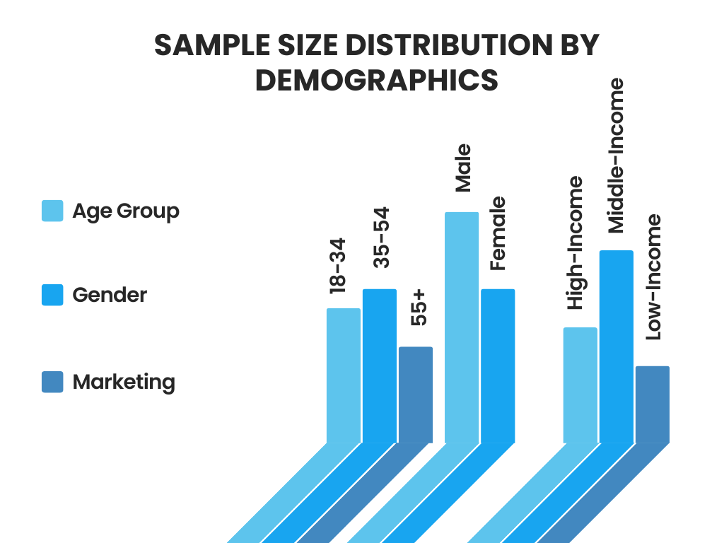

- Age, Gender, and Income Distribution: The Swiss watch market attracts a diverse range of consumers, segmented by age, gender, and income, each with distinct preferences and purchasing behaviors. Understanding these demographic factors is crucial for brands to tailor their offerings and marketing strategies effectively.
- Age: Swiss watch consumers span various age groups, from young professionals to older, affluent individuals.
- Young Adults (18-34): This segment is increasingly attracted to fashion and lifestyle brands such as Swatch and Tissot, which offer trendy designs at more affordable prices. They are also the primary consumers of smartwatches, valuing technological integration and multifunctional capabilities. For instance, TAG Heuer's Connected series appeals to this demographic by blending traditional Swiss craftsmanship with modern smart features
- Middle-aged Adults (35-54): These consumers often seek mid-range to high-end watches that balance quality and affordability. Brands like Omega, Longines, and TAG Heuer are popular in this segment, offering sophisticated designs and reliable performance. The Omega Seamaster and Longines Master Collection are examples of models that cater to this demographic, combining elegance with technical precision.
- Older Adults (55+): This group tends to favour luxury brands that signify status and heritage. Rolex, Patek Philippe, and Audemars Piguet are highly sought after for their timeless appeal and investment value. Watches like the Rolex Datejust and Patek Philippe Calatrava are favoured for their classic designs and high craftsmanship.
- Gender: While traditionally male-dominated, the Swiss watch market has seen a growing interest among female consumers, leading to more gender-inclusive designs and marketing.
- Men: Historically, men have been the primary consumers of Swiss watches, especially in the luxury segment. Brands like Rolex and Omega offer robust, masculine designs with technical complications that appeal to male buyers. The Rolex Submariner and Omega Speedmaster are iconic models that exemplify this trend.
- Women: Female consumers are increasingly important to the market, driving demand for elegant, smaller-sized watches. Brands are responding with collections specifically designed for women, such as the Patek Philippe Twenty-4 and the Rolex Lady-Datejust. Additionally, brands like Chopard and Cartier offer jewellery watches that blend horology with high fashion, appealing to women who appreciate both aesthetics and craftsmanship.
- Income Distribution: Income levels significantly influence purchasing decisions in the Swiss watch market, dictating the range of brands and models consumers can afford.
- High-Income: High-income consumers are the primary market for luxury watches, willing to invest substantial amounts in brands like Rolex, Patek Philippe, and Audemars Piguet. These consumers value exclusivity, quality, and the prestige associated with luxury timepieces.
- Middle-Income: Middle-income consumers typically opt for mid-range brands that offer a balance of quality and affordability. Brands like Tissot, Longines, and TAG Heuer cater to this segment with watches priced between $500 and $5,000, offering a taste of Swiss craftsmanship without the luxury price tag.
- Low-Income: Lower-income consumers generally prefer entry-level Swiss watches or fashion brands like Swatch. These watches provide Swiss quality at accessible prices, often below $500, and appeal to younger, fashion-conscious buyers.
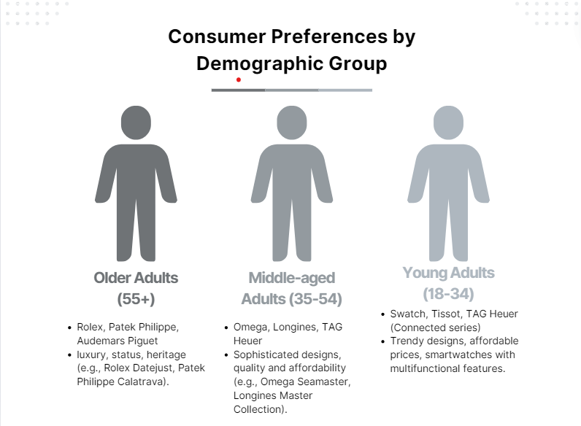

Psychographic Analysis
- Lifestyle, Interests, and Attitudes: Psychographic analysis delves into the lifestyles, interests, and attitudes of consumers, offering deeper insights into their purchasing motivations and brand affinities.
- Lifestyle: Professional and Business-Oriented: Professionals and business executives often seek watches that complement their corporate attire and signify success. They prefer brands like Rolex, Omega, and TAG Heuer for their sophisticated and elegant designs. For instance, the Rolex Datejust and Omega De Ville are popular choices for their understated elegance and professional appeal.
- Active and Sports Enthusiasts: Active individuals and sports enthusiasts gravitate towards watches that offer durability, functionality, and sporty aesthetics. Brands like Breitling, TAG Heuer, and Omega cater to this lifestyle with models like the Breitling Superocean, TAG Heuer Aquaracer, and Omega Seamaster, which offer water resistance, chronograph functions, and robust designs.
- Fashion-Conscious: Fashion-forward consumers look for watches that make a statement and align with the latest trends. Brands like Swatch, Michael Kors, and Gucci target this segment with vibrant, trendy designs. The Swatch Big Bold collection, for example, appeals to young, style-conscious buyers with its bold colours and contemporary aesthetics.
- Interests: Horology Enthusiasts: Enthusiasts and collectors have a deep appreciation for the art of watchmaking, often seeking out timepieces with historical significance, technical complexity, and limited editions. Brands like Patek Philippe, Audemars Piguet, and Jaeger-LeCoultre are revered in this community for their high horological standards. The Patek Philippe Grand Complications and Audemars Piguet Royal Oak Offshore are prized for their intricate complications and craftsmanship.
- Technology Aficionados: Tech-savvy consumers are drawn to smartwatches and hybrid models that offer connectivity and advanced features. The Apple Watch leads this segment with its extensive functionality, while traditional brands like TAG Heuer have also entered this space with models like the TAG Heuer Connected, blending smart technology with traditional watchmaking.
- Attitudes: Prestige and Status-Oriented: Consumers who view watches as status symbols prioritize brands that convey wealth and success. Luxury brands like Rolex, Patek Philippe, and Audemars Piguet fulfil this desire with their high price points, exclusivity, and association with high social status. Owning a Rolex Submariner or a Patek Philippe Nautilus is often seen as a testament to one's success and discerning taste.
- Value-Conscious: Value-conscious consumers seek the best possible quality and features within their budget. They often compare different brands and models to find the most cost-effective options. Brands like Tissot and Seiko appeal to these consumers by offering high-quality, Swiss-made watches at more accessible prices. The Tissot Le Locle and Seiko Presage are examples of models that offer excellent value for their craftsmanship and reliability.
- Eco-Conscious: An emerging segment of consumers is increasingly concerned with sustainability and ethical practices. These buyers prefer brands that demonstrate a commitment to environmental responsibility and ethical sourcing. Breitling's Superocean Héritage II Chronograph with its recycled ocean plastic strap and brands like Panerai, which emphasizes eco-friendly practices, cater to this growing demographic.

Impact of Digitalization

Adoption of Digital and Smart Watches
The digital revolution has reshaped the watch industry, with smartwatches gaining traction due to their multifunctionality and integration with digital lifestyles.
- Apple Watch:
- Features: Apple Watch leads the smartwatch segment with features like fitness tracking, heart rate monitoring, GPS, and mobile payments, appealing to tech-savvy consumers.
- Integration: Seamless integration with the Apple ecosystem enhances its popularity among users.
- Samsung and Garmin:
- Offerings: Samsung's Galaxy Watch series and Garmin's smartwatches offer advanced features tailored to different consumer needs, from health monitoring to outdoor activities.
- Appeal: Stylish aesthetics and robust functionalities attract a diverse range of users, including athletes and outdoor enthusiasts.
- Traditional Watch Manufacturers:
- Adaptation: Brands like TAG Heuer and Breitling have introduced hybrid smartwatches, blending traditional craftsmanship with modern features.
- Examples: TAG Heuer Connected series offers customizable digital dials and fitness tracking, while Breitling's Exospace B55 integrates smartphone connectivity and traditional chronograph functions

Effects on Traditional Watch Sales
The surge in digital and smartwatches has notably impacted traditional watch sales, particularly in the lower and mid-range segments.
- Entry-Level Segment:
- Impact: Brands like Casio and Timex, known for their affordable quartz watches, face heightened competition from multifunctional smartwatches.
- Consumer Shift: Younger demographics are increasingly drawn to smartwatches due to their additional features and convenience.
- Mid-Range Segment:
- Nuanced Impact: While some traditional brands experience sales declines, others, like Omega and Longines, maintain market presence through craftsmanship and heritage.
- Appeal Factors: Watches like the Omega Seamaster and Longines Master Collection retain popularity due to timeless designs and mechanical intricacy.
- Luxury Segment:
- Resilience: Luxury watch sales remain robust as high-end consumers prioritize craftsmanship, exclusivity, and status symbolism over smartwatch features.
- Demand: Brands like Rolex, Patek Philippe, and Audemars Piguet continue to thrive, with models such as the Rolex Daytona and Patek Philippe Nautilus maintaining high demand.
- Value Proposition: Luxury watches emphasize artistry, tradition, and long-term value, offering a distinct proposition from smartwatches.

SWOT Analysis of the Swiss Watch Industry
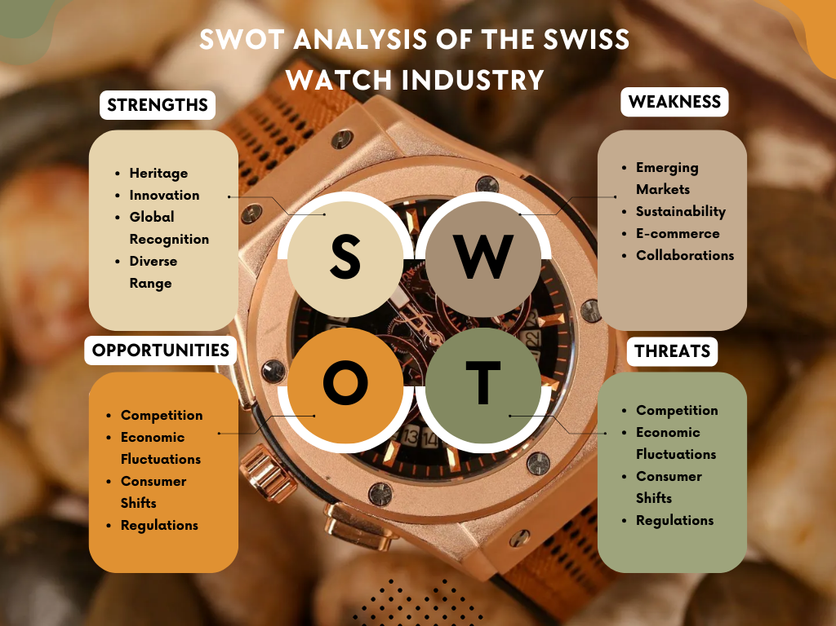

- Strengths:
- Heritage and Craftsmanship: The Swiss watch industry boasts a rich heritage and reputation for unparalleled craftsmanship, which have been meticulously built over centuries. Brands like Rolex, Patek Philippe, and Audemars Piguet symbolize luxury, precision, and quality. Their meticulous attention to detail and the use of high-quality materials distinguishes Swiss watches from their global competitors.
- Innovation: Despite their traditional roots, Swiss watchmakers have consistently pushed the boundaries of horological innovation. For instance, TAG Heuer's development of high-precision chronographs and Patek Philippe's intricate complications showcase the industry's commitment to technological advancement.
- Global Brand Recognition: Swiss watches are globally recognized and coveted. This strong brand recognition translates into a competitive edge, allowing Swiss watchmakers to command premium prices and maintain loyal customer bases. The prestige associated with owning a Swiss watch is a significant driving factor for consumers.
- Diverse Product Range: The industry offers a broad spectrum of products, from high-end luxury timepieces to more affordable, high-quality watches. Brands like Omega and Longines cater to the mid-range market, while Swatch appeals to budget-conscious consumers, ensuring that the Swiss watch industry can attract a wide array of customers.
- Weaknesses:
- High Production Costs: The meticulous craftsmanship and premium materials that define Swiss watches result in high production costs. This can make it difficult to compete on price with mass-produced watches from other countries, particularly in the entry-level and mid-range segments
- Dependence on Traditional Markets: The industry has historically relied heavily on established markets in Europe and North America. This dependence can be risky, especially during economic downturns in these regions. Diversifying into emerging markets is crucial but presents its own set of challenges.
- Slow Adaptation to Digital Trends: Although some Swiss brands have embraced smartwatches and digital technologies, the industry has been slower to adapt compared to tech giants like Apple and Samsung. This hesitation has allowed competitors to capture significant market share in the rapidly growing smartwatch segment.
- Counterfeiting Issues: The high value and prestige associated with Swiss watches make them prime targets for counterfeiters. The prevalence of fake Swiss watches can erode brand trust and lead to significant revenue losses.

- Opportunities:
- Emerging Markets: Rapid economic growth and rising disposable incomes in countries like China and India present substantial opportunities for Swiss watchmakers. Tailoring marketing strategies and product offerings to suit the tastes and preferences of consumers in these markets can drive significant growth.
- Sustainability Initiatives: There is a growing consumer demand for environmentally responsible and ethically sourced products. Brands that adopt sustainable practices and transparently communicate these efforts can enhance their appeal to environmentally conscious consumers. For example, Breitling's use of recycled materials and commitment to carbon neutrality are steps in this direction.
- Expansion of E-commerce: The increasing reliance on digital platforms for shopping offers a lucrative opportunity for Swiss watch brands to expand their reach. Developing robust e-commerce strategies and leveraging digital marketing can attract a younger, tech-savvy audience.
- Collaboration and Limited Editions: Collaborations with designers, artists, and other luxury brands can create buzz and drive sales. Limited edition watches, such as those resulting from partnerships between Hublot and contemporary artists, often become highly sought-after collectibles.
- Threats
- Intense Competition: The Swiss watch industry faces fierce competition from both traditional and non-traditional players. Japanese brands like Seiko and Citizen offer high-quality watches at more affordable prices, while tech companies dominate the smartwatch market.
- Economic Uncertainty: Economic downturns and fluctuations in currency exchange rates can significantly impact the luxury watch market. The high cost of Swiss watches makes them particularly sensitive to changes in consumer spending power.
- Changing Consumer Preferences: Younger consumers may prioritize functionality and connectivity over traditional craftsmanship, posing a threat to the market for mechanical watches. The growing preference for smartwatches and wearables reflects this shift.
- Regulatory Changes: Stricter regulations related to trade, tariffs, and environmental standards can affect production and distribution costs. Navigating these regulatory challenges while maintaining profitability is a critical concern for the industry.

Case Studies
Detailed examination of specific companies or events.
Examining specific companies or events within the Swiss watch industry provides valuable insights into strategic approaches, challenges faced, and lessons learned. This section will delve into the cases of Rolex and TAG Heuer, two prominent Swiss watchmakers that have successfully navigated the evolving market landscape.
- Rolex Mastery of Brand Prestige and Innovation
- Company Overview: Rolex is synonymous with luxury and precision, boasting an unparalleled reputation built over more than a century. Its strategic focus on innovation, exclusivity, and timeless design has cemented its position as a leader in the luxury watch segment.
- Strategic Approach: Rolex’s commitment to innovation is exemplified by its development of the Oyster case in 1926, the world's first waterproof watch case. This innovation, coupled with the creation of the Perpetual rotor in 1931 (a self-winding mechanism), underscored Rolex’s technical prowess and set new standards in the industry.
- Market Positioning: Rolex has adeptly maintained its brand prestige through limited production runs and meticulous quality control. The brand’s iconic models, such as the Submariner and the Daytona, have become symbols of status and wealth. Rolex’s sponsorship of high-profile events, such as Wimbledon and the Oscars, further reinforces its association with excellence and luxury.
- Lessons Learned:
- Consistent Innovation: Continuous investment in research and development is crucial for maintaining a competitive edge.
- Brand Management: Carefully managing brand image through strategic marketing and limited production can sustain long-term brand prestige.
- Quality Assurance: Rigorous quality control ensures product reliability, fostering customer loyalty and trust.

- TAG Heuer Balancing Tradition and Modernity
- Company Overview: TAG Heuer, a renowned Swiss watch brand, has successfully blended its rich heritage with contemporary innovation. Known for its precision timekeeping and sporty designs, TAG Heuer appeals to a broad demographic, including younger consumers.
- Strategic Approach: TAG Heuer’s entry into the smartwatch market with the TAG Heuer Connected series highlights its ability to adapt to technological trends. By integrating smart functionalities while maintaining the aesthetic appeal of traditional Swiss watches, TAG Heuer has positioned itself at the intersection of heritage and modernity.
- Market Positioning: TAG Heuer targets both the luxury and mid-range segments, offering a variety of models that cater to different lifestyles and preferences. Collaborations with celebrities and partnerships with major sports events, such as Formula 1, have bolstered its brand visibility and appeal.

- Lessons Learned:
- Adaptability: Embracing technological advancements can attract a new segment of consumers without alienating traditional buyers.
- Market Diversification: Offering a range of products across different price points helps capture a wider audience and mitigate market risks.
- Strategic Partnerships: Collaborations and sponsorships can enhance brand recognition and align the brand with desirable attributes such as performance and prestige.

- Case Study the Quartz Crisis:
- Event Overview: The Quartz Crisis of the 1970s and 1980s posed a significant threat to the Swiss watch industry. The advent of quartz technology, pioneered by Japanese companies like Seiko, introduced affordable and highly accurate quartz watches, disrupting the dominance of mechanical watches.
- Industry Response: Swiss watchmakers had to innovate rapidly to survive. The Swatch Group, founded in response to the crisis, introduced the Swatch watch in 1983. Swatch watches combined quartz technology with colourful, fashionable designs and affordable prices, revitalizing the Swiss watch industry.
- Lessons Learned:
- Innovation in Adversity: Crisis can be a catalyst for innovation. The Swatch Group’s response demonstrated the importance of agility and creativity in overcoming industry challenges.
- Market Segmentation: Diversifying product offerings to include lower-priced, fashionable options can attract a broader customer base and drive market recovery.
- Brand Reinvention: Reinventing the brand and adapting to changing market conditions can rejuvenate an industry and restore competitiveness.

Discussion

Interpretation of Findings
- Analysis of Key Results
The Swiss watch market’s growth, despite historical challenges like the Quartz Crisis, highlights the industry’s resilience. Brands like Rolex and Patek Philippe strategically
emphasized luxury and heritage to maintain their appeal, solidifying their positions as symbols of prestige.
Market dominance remains with established luxury brands like Rolex, Patek Philippe, and Omega, known for their enduring quality and iconic designs. However, emerging players like Breitling and TAG Heuer are gaining ground, targeting younger demographics with innovative designs and marketing campaigns focused on heritage and sports. These efforts showcase the industry’s adaptability and commitment to staying relevant amid evolving consumer preferences.
- Insights Derived from the Data
The segmentation analysis provides a nuanced understanding of consumer preferences across different market segments:
- Luxury Watches: Luxury watches remain the primary drivers of market growth, attracting affluent consumers who value exclusivity and investment potential. The high demand for models like the Rolex Submariner and Patek Philippe Nautilus illustrates this segment’s appeal. These timepieces are not just functional but are also viewed as status symbols and valuable investments. Limited edition releases and high complications, such as tourbillons and perpetual calendars, add to their allure and exclusivity.
- Mid-Range Brands: Mid-range brands such as Tissot and Longines play a pivotal role in democratizing Swiss watchmaking, offering high-quality timepieces at more accessible price points. The Tissot PRX series, for instance, combines retro design with modern features, appealing to young professionals and enthusiasts who seek quality without the high price tag associated with luxury brands. Longines, with collections like the Longines Master Collection and the HydroConquest, offers sophisticated designs and reliable performance, making it a popular choice among mid-range buyers.
- Fashion and Lifestyle Brands: Fashion and lifestyle brands like Swatch and Daniel Wellington cater to younger, fashion-conscious consumers. These brands prioritize trendy designs, affordability, and vibrant marketing strategies to attract a broader audience. Swatch’s Big Bold Jelly collection, with its playful and colourful designs, exemplifies this segment's appeal. These watches serve as fashion accessories and often feature limited edition collaborations with artists and designers, generating excitement and appeal among young consumers.
- Direct-to-Consumer Innovations: The direct-to-consumer model also allows brands to gather valuable consumer data and feedback, enabling them to tailor their products and marketing strategies more effectively. Brands like MVMT and Vincero have successfully utilized social media and influencer marketing to build their brands and reach a global audience. This model not only reduces costs but also enhances the brand’s ability to engage directly with its customer base, fostering loyalty and community.

- Comparison with Literature
How findings align or contrast with existing studies
- Alignment with Existing Studies: This research aligns with existing literature on luxury goods, particularly Swiss watches. Studies like Kapferer and Bastien (2012) highlight the importance of brand heritage, craftsmanship, and exclusivity in attracting consumers seeking status and uniqueness. The enduring success of brands like Rolex and Patek Philippe, with their iconic models, exemplifies this. Additionally, research like the Bain & Company Luxury Study (2020) underscores the growing importance of emerging markets, particularly Asia, for luxury goods. This study's findings corroborate this trend, showing increased demand for both luxury and mid-range Swiss watches in these regions, especially during cultural events like Chinese New Year and Diwali.
- Contrasts with Existing Studies: This research, while aligning with the literature's focus on luxury, also highlights the significant role of mid-range and fashion segments. Brands like Tissot and Swatch, with their accessible price points and trend-driven designs, attract younger consumers and those seeking value. Mid-range brands like Longines and Oris cater to a broader demographic with heritage and affordability. Additionally, the rise of direct-to-consumer channels, exemplified by online brands like MVMT and Vincero, presents a disruptive trend that is transforming the market. This model enhances customer access and fosters innovation, while leveraging social media for brand building and engagement.

Implications for the Swiss Watch Industry
- Strategic Implications
The research findings reveal several strategic imperatives for the Swiss watch industry to sustain and enhance its market position.
- Luxury Brands: Luxury watch brands like Rolex, Patek Philippe, and Omega must strike a balance between preserving their rich heritage and embracing modern innovations. The incorporation of smart functionalities, such as connectivity features and health monitoring, can attract tech-savvy consumers while retaining the essence of traditional craftsmanship. For example, TAG Heuer’s Connected Modular series seamlessly blends the luxury aesthetics of Swiss watches with the advanced features of a smartwatch, catering to a younger demographic without alienating traditional customers. Furthermore, continuing to produce limited editions and bespoke pieces can enhance the allure of exclusivity, which is a key driver for luxury watch purchases.
- Mid-Range Brands: Mid-range brands such as Tissot and Longines should focus on offering exceptional value through superior quality, innovative design, and functional versatility. By highlighting their Swiss-made heritage and expanding their product lines to include both classic and contemporary designs, these brands can appeal to a diverse consumer base. For instance, Tissot's introduction of the T-Touch Connect Solar integrates solar-powered smart technology with traditional watchmaking, providing an eco-friendly and innovative option that resonates with modern consumers. Ensuring robust customer engagement through personalized services and loyalty programs can also foster brand loyalty and repeat purchases.
- Fashion and Lifestyle Brands: Fashion and lifestyle brands like Swatch should continue to leverage emerging trends and cultural influences to stay relevant and appealing to younger, fashion-conscious consumers. These brands can benefit from limited edition releases, collaborations with popular artists or influencers, and vibrant marketing campaigns. Swatch’s collaboration with artists such as Keith Haring and the release of the Big Bold Jelly collection, which features playful and colourful designs, exemplify successful strategies that capture consumer interest and drive sales. Additionally, embracing sustainable practices and materials can align with the growing consumer preference for eco-friendly products.
- Digital and Direct-to-Consumer Channels: The rise of digital and direct-to-consumer (DTC) channels presents a significant opportunity for all segments of the Swiss watch industry. Embracing e-commerce platforms and enhancing online presence can provide brands with broader market reach and greater control over brand narrative. Brands like MVMT and Daniel Wellington have successfully utilized social media marketing and influencer partnerships to build strong brand identities and engage directly with consumers. Established Swiss brands can adopt similar strategies to tap into new market segments and strengthen their digital footprint.

- Policy Recommendations
- Support for Innovation: Policymakers should foster an environment conducive to innovation within the Swiss watch industry. This can be achieved through grants, subsidies, and tax incentives for research and development initiatives aimed at integrating advanced technologies while preserving traditional craftsmanship. Collaborative efforts between industry and academic institutions can further spur innovation and ensure the continuous development of cutting-edge products.
- Intellectual Property Protection: Protecting intellectual property (IP) is crucial for maintaining the competitive edge of Swiss watch brands. Enhanced IP laws and enforcement mechanisms can safeguard designs, technologies, and trademarks from counterfeit and infringement, thereby preserving brand integrity and consumer trust. International cooperation on IP protection can also mitigate the risks associated with global trade.
- Trade Policies and Market Access: Facilitating market access to emerging economies through favourable trade policies can drive significant growth for the Swiss watch industry. Negotiating trade agreements that reduce tariffs and non-tariff barriers can make Swiss watches more competitively priced in markets like China and India. Additionally, participating in international trade fairs and establishing local partnerships can help Swiss brands penetrate these high-growth markets more effectively.
- Sustainability Initiatives: Policymakers can support the industry’s shift towards sustainability by implementing regulations that encourage the use of eco-friendly materials and processes. Providing incentives for sustainable practices, such as the use of recycled metals and renewable energy in manufacturing, can help brands meet the growing consumer demand for environmentally responsible products. Furthermore, transparency in supply chains can be promoted through certification programs and industry standards.

Policy and Strategic Recommendations
Suggestions for Industry Stakeholders

- Innovation and Technology Integration:
- Investment in Smart Functionalities: To remain competitive, Swiss watch brands should invest in integrating smart technologies like health monitoring, GPS, and smartphone connectivity into their timepieces. This caters to a growing tech-savvy demographic that values both tradition and functionality. Successful examples include TAG Heuer’s Connected Modular series, offering customizable watches with modern features, and Montblanc’s Summit 2, combining Swiss elegance with the latest wearable technology.
- Use of Sustainable Materials: Integrating sustainable materials and practices is crucial in today's environmentally conscious market. Brands can gain a competitive edge by demonstrating their commitment to sustainability. Panerai’s Eco Titanium, a recycled titanium alloy, and Breitling’s Superocean Héritage II Chronograph, featuring straps made from recycled ocean plastic, exemplify this trend. By embracing sustainability, Swiss watchmakers can appeal to a growing segment of eco-conscious consumers.

- Market Diversification:
- Expansion into Emerging Markets: Swiss watch brands should focus on expanding their presence in emerging markets, particularly in Asia, where rising disposable incomes and a growing middle class present significant opportunities. Omega’s success in these markets, driven by tailored marketing strategies and exclusive product offerings, highlights the potential of such regions. For instance, Omega’s Speedmaster “Apollo 11” 50th Anniversary Limited Edition resonated well with consumers in China, combining the allure of space exploration with the prestige of Swiss watchmaking.
- Brands should also consider collaborations with local influencers and cultural icons to enhance brand resonance and authenticity. For example, Longines’ partnership with Chinese actress Zhao Liying has significantly boosted its visibility and appeal in the Chinese market.

- Localized Marketing Campaigns:
- Developing marketing campaigns that are culturally relevant and resonate with local consumers is essential for success in diverse markets. This can include releasing limited edition watches that celebrate local festivals or cultural symbols. For instance, Audemars Piguet’s limited edition watches inspired by Chinese mythology have found great success in the Chinese market.

- Sustainability Initiatives:
- Commitment to Eco-Friendly Practices: Embracing eco-friendly practices is essential for enhancing brand image and attracting environmentally conscious consumers. Initiatives like Breitling’s use of recycled ocean plastic for watch straps highlight the brand’s commitment to sustainability. Brands can also explore the use of renewable energy sources in their manufacturing processes and implement recycling programs for old watches.
Implementing closed-loop production processes, where materials from old or unsold watches are recycled and reused, can significantly reduce environmental impact. For example, IWC Schaffhausen has made strides in sustainable manufacturing by focusing on energy efficiency and waste reduction in its production processes.
- Transparency in Supply Chains: Transparency in sourcing and supply chains can build trust and loyalty among consumers. Brands should provide detailed information about the origins of their materials and the ethical practices involved in their sourcing. For example, Chopard’s commitment to using 100% ethical gold in its products demonstrates a high level of transparency and ethical responsibility.

- Enhancing Online Presence:
- Investment in E-Commerce Platforms: The increasing importance of digital channels necessitates a robust online presence. Brands should invest in comprehensive e-commerce platforms that offer a seamless shopping experience. The Swatch Group’s initiative to enhance its online sales platforms has significantly improved accessibility and consumer engagement. A well-designed e-commerce site should feature high-quality images, detailed product descriptions, and customer reviews to aid in the decision-making process.
Additionally, offering virtual consultations and customer service via online chat can enhance the online shopping experience. For instance, high-end brands like Vacheron Constantin provide virtual appointments where customers can interact with brand experts in real-time, creating a personalized shopping experience.

- Digital Marketing Strategies: Effective digital marketing strategies are essential for reaching a global audience and engaging with consumers. Brands should leverage social media, influencer partnerships, and targeted online advertisements to build brand awareness and drive sales. Daniel Wellington’s successful use of social media influencers to create buzz around its products serves as a model for other brands. By partnering with influencers who resonate with their target audience, brands can effectively reach and engage potential customers.
Additionally, creating engaging content, such as behind-the-scenes videos, virtual tours of manufacturing facilities, and stories about the brand’s heritage and craftsmanship, can captivate and educate consumers.

- Virtual Try-On Experiences: Incorporating virtual try-on technologies on e-commerce platforms can enhance the shopping experience by allowing consumers to visualize how watches will look on their wrist. This reduces the hesitation associated with online purchases and can increase conversion rates. Brands like Tissot have implemented augmented reality (AR) tools that enable customers to try on watches virtually using their smartphones.
Future Strategies
- Collaborations and Limited Editions:
- Creating Unique and Exclusive Models: Collaborations with renowned fashion designers, artists, and other brands can lead to the creation of unique, limited-edition models that generate significant consumer excitement and exclusivity. This strategy not only attracts attention but also positions the collaborating brands as innovative and trendsetting.

For instance, Hublot’s collaboration with renowned artist Takashi Murakami resulted in the creation of a series of colorful, limited-edition watches that blended art and horology, appealing to both watch enthusiasts and art collectors. Another example is TAG Heuer’s partnership with Porsche, resulting in limited-edition models that celebrate the shared heritage and performance-driven ethos of both brands.

These collaborations create buzz and anticipation, often leading to waiting lists and heightened demand. They also allow brands to tap into new customer bases by combining different fan communities, thus expanding their reach and influence.

- Consumer Engagement:
- Personalized Experiences and Services: Building strong relationships with consumers through personalized experiences and services is essential for fostering loyalty and enhancing brand value. Brands should focus on creating immersive experiences that engage consumers both online and offline.

For example, personalized concierge services that offer bespoke watch customization and maintenance can significantly enhance the customer experience. Brands like Vacheron Constantin offer tailored services where clients can design their watches, selecting specific materials, movements, and engravings, resulting in unique, personalized timepieces.

Online, brands can use data analytics to personalize marketing efforts and recommendations, creating a more tailored shopping experience. Virtual try-on features and interactive digital content can engage consumers, allowing them to explore and experience the brand in an immersive way. For instance, Omega’s virtual showroom enables customers to explore its collections interactively, providing a rich and engaging online experience.

- Training and Development:
- Investing in Artisans and Technicians: Investing in training programs for artisans and technicians is crucial for preserving the high standards of Swiss watchmaking. By ensuring that the industry continues to produce exceptional timepieces, brands can meet and exceed consumer expectations.

Brands like Patek Philippe and Audemars Piguet have established extensive training programs and in-house academies to cultivate the next generation of watchmakers. These programs focus on both traditional watchmaking techniques and modern innovations, ensuring a blend of heritage and contemporary skills.

Additionally, collaborations with technical schools and institutions can provide formal education and certification programs, further enhancing the skill set of the industry’s workforce. This continuous investment in human capital ensures that the legacy of Swiss watchmaking is preserved and advanced.

- Protecting Intellectual Property:
- Strengthening Laws and Regulations: Protecting designs and innovations is essential for safeguarding the industry’s heritage and preventing counterfeiting. Strengthening intellectual property laws and regulations can help maintain the exclusivity and authenticity that Swiss watches are known for.

The Swiss watch industry has long been targeted by counterfeiters, which undermines brand value and consumer trust. Brands like Rolex have taken significant steps to protect their designs through robust legal measures and anti-counterfeiting technologies, such as micro-engraving and blockchain verification.

Industry-wide initiatives, supported by government regulations, can further enhance these efforts. For instance, the Federation of the Swiss Watch Industry (FH) works actively to combat counterfeiting through legal actions and international cooperation. Brands can also employ advanced technologies, such as unique serial number tracking and RFID tags, to verify authenticity and protect their intellectual property.

- Balancing Tradition with Innovation: Swiss watchmakers must continue to innovate while respecting their rich heritage. This involves integrating modern technologies into traditional designs and using sustainable practices to appeal to contemporary consumers.

Omega’s integration of the Co-Axial escapement, a modern horological innovation, into its traditionally crafted watches is a prime example of balancing innovation with tradition.

- Expanding into New Markets: Identifying and entering new markets, particularly in emerging economies, can drive growth. Tailored marketing strategies that resonate with local cultures and preferences will be key to success.

The success of brands like Longines in the Asian market, where they have tailored their collections and marketing efforts to local tastes and preferences, highlights the potential of this strategy.

- Adapting to Evolving Consumer Preferences: Understanding and adapting to the changing preferences of consumers, particularly younger generations, will be critical. This includes offering products that align with trends such as sustainability, digital connectivity, and personalized experiences.

Brands like Swatch have successfully adapted by offering trendy, affordable watches that appeal to younger, fashion-conscious consumers, demonstrating the importance of staying attuned to market trends.

Conclusion and Recommendations

Summary of Key Findings
- Recap of Main Results: The Swiss watch market has shown notable resilience and growth, largely driven by a strategic blend of tradition and innovation. Despite significant challenges like the Quartz Crisis, the industry pivoted successfully, emphasizing luxury, craftsmanship, and heritage to maintain its market position. Brands such as Rolex, Patek Philippe, and Omega dominate the market, leveraging their rich histories, commitment to quality, and continuous innovation to attract a loyal customer base.
- Luxury Segment: The luxury segment remains the market's primary growth driver. High-end timepieces, known for their impeccable craftsmanship, intricate complications, and timeless designs, are particularly appealing to affluent consumers who view them as status symbols and investment pieces. Iconic models like the Rolex Submariner and Patek Philippe Nautilus continue to see strong demand.
- Mid-Range Segment: Mid-range brands such as Tissot and Longines have democratized Swiss watchmaking by offering high-quality timepieces at more accessible price points. These brands appeal to young professionals and enthusiasts who seek the prestige of Swiss-made watches without the high price tag of luxury brands. The Longines Master Collection, for instance, is popular among mid-range buyers for its sophisticated design and reliable performance.
- Fashion and Lifestyle Segment: Fashion and lifestyle brands, including Swatch and Daniel Wellington, target younger, fashion-conscious consumers. These brands prioritize trendy designs, vibrant aesthetics, and affordability. The success of Swatch’s Big Bold Jelly collection, known for its playful and colourful designs, highlights the appeal of this segment.
- Digital and Direct-to-Consumer Channels: The rise of digital and direct-to-consumer channels is transforming traditional distribution models. Online platforms enhance consumer access to a wide range of brands and models, fostering competition and innovation within the market. Brands must adapt to these changes to stay competitive in an increasingly digital world.
- Emerging Markets: Emerging markets, particularly in Asia, offer significant growth opportunities for the Swiss watch industry. Rising disposable incomes and a growing middle class in countries like China and India are driving demand for both luxury and mid-range watches. Brands like Omega have effectively penetrated these markets with tailored campaigns and exclusive product offerings.
Answer to Research Questions
- Direct Responses to the Research Questions Posed:
- How has the Swiss watch market evolved over the years?
- The market has evolved by emphasizing luxury, craftsmanship, and heritage, successfully navigating challenges such as the Quartz Crisis and adapting to technological advancements and changing consumer preferences.
- What are the current market dynamics and key players?
- The market is dominated by established luxury brands like Rolex, Patek Philippe, and Omega, with emerging players such as Breitling and TAG Heuer gaining traction. Mid-range and fashion brands also play significant roles, catering to diverse consumer segments.
- What are the major consumer trends and preferences?
- Consumers continue to value luxury and heritage in high-end segments, while mid-range brands appeal to those seeking quality at accessible prices. Fashion brands attract younger consumers with trendy designs and innovative marketing.
- How is digitalization impacting the Swiss watch market?
- Digitalization is enhancing market accessibility through online sales platforms and direct-to-consumer models, driving competition and innovation while challenging traditional distribution channels.

- Practical Advice Based on Findings:
- Innovation and Technology Integration: Brands should invest in integrating modern technologies, such as smart functionalities and sustainable materials, without compromising on traditional craftsmanship. For example, TAG Heuer’s Connected Modular series effectively blends traditional watchmaking with smart technology, appealing to tech-savvy consumers.
- Market Diversification: Expanding into emerging markets with tailored marketing strategies and localized product offerings can capture the growing demand in regions like Asia. Omega’s targeted campaigns and exclusive models in these markets serve as effective examples.
- Sustainability Initiatives: Embracing sustainable practices enhances brand image and appeals to environmentally conscious consumers. Breitling’s Superocean Héritage II Chronograph, with its recycled ocean plastic strap, is an exemplary step in this direction.
- Enhancing Online Presence: Investing in e-commerce platforms and digital marketing is essential to reach a global audience. Swatch Group’s investment in its online sales platforms has improved accessibility and consumer engagement, setting a benchmark for others to follow.
- Collaborations and Limited Editions: Collaborations with fashion designers, artists, or other brands can create unique, limited-edition models that generate excitement and exclusivity. This strategy has been effectively employed by brands like Hublot and TAG Heuer, driving consumer interest and brand differentiation.
- Consumer Engagement: Building strong relationships with consumers through personalized experiences and services can foster loyalty. Brands should focus on creating immersive brand experiences, both online and offline, to enhance consumer engagement. For example, exclusive events, virtual try-ons, and bespoke services can significantly boost consumer loyalty.
- Training and Development: Investing in training programs for artisans and technicians can preserve the high standards of Swiss watchmaking. This ensures that the industry continues to produce exceptional timepieces that meet consumer expectations, maintaining the brand’s reputation for quality.
- Protecting Intellectual Property: Strengthening laws and regulations to protect designs and innovations can safeguard the industry's heritage and prevent counterfeiting. This can include stricter enforcement of intellectual property rights and international cooperation to combat counterfeits.

Suggestions for Future Research
- Potential Areas for Further Study:
- Impact of Smartwatch Integration: Further research could explore the long-term effects of integrating smartwatch technology into traditional Swiss watch brands. Understanding consumer perceptions and the balance between digital functionality and traditional craftsmanship can provide deeper insights into this trend.
- Consumer Behavior in Emerging Markets: Detailed studies on consumer behavior in emerging markets, particularly in Asia and Africa, can help brands tailor their strategies more effectively. Analyzing preferences, purchasing power, and cultural influences in these regions can offer valuable guidance for market entry and expansion.
- Sustainability in Watchmaking: Investigating the impact of sustainability initiatives on brand perception and consumer loyalty can provide actionable insights. Research could focus on the effectiveness of different sustainable practices and their influence on purchasing decisions.
- Digital Transformation and E-Commerce: Examining the role of digital transformation and e-commerce in reshaping the Swiss watch market can offer strategic insights. Understanding how digital channels influence consumer behavior, brand loyalty, and market dynamics can help brands optimize their online strategies.

References
- Bain & Company. (2021). Luxury goods worldwide market study. Retrieved from https://www.bain.com/global-assets/documents/2021/
- Euromonitor International. (2020). Global watches report. Retrieved from https://www.euromonitor.com/global-watches-report-2020
- McKinsey & Company. (2019). The luxury goods market: A global overview. Retrieved from https://www.mckinsey.com/industries/retail/our-insights/the-luxury-goods-market-a-global-overview
- Statista. (2021). Swiss watch industry - Statistics & facts. Retrieved from https://www.statista.com/topics/1679/swiss-watch-industry/
- Key Players and Market Share
- Breitling. (2021). Superocean Héritage II Chronograph. Retrieved from https://www.breitling.com/us-en/superocean-heritage-ii/
- Hublot. (2021). Hublot Big Bang collaboration. Retrieved from https://www.hublot.com/en-us/big-bang
- Patek Philippe. (2021). Nautilus collection. Retrieved from https://www.patek.com/en/collection/nautilus
- Rolex. (2021). Submariner. Retrieved from https://www.rolex.com/watches/submariner.html
- TAG Heuer. (2021). Connected Modular series. Retrieved from https://www.tagheuer.com/en-us/watches/tag-heuer-connected
- Consumer Preferences and Trends
- Deloitte. (2020). Global Powers of Luxury Goods. Retrieved from https://www2.deloitte.com/global/en/pages/consumer-business/articles/gx-cb-global-powers-of-luxury-goods.html
- KPMG. (2021). Luxury goods: A global view. Retrieved from https://home.kpmg/xx/en/home/insights/2021/06/luxury-goods.html
- Digitalization and Market Dynamics
- Accenture. (2020). The future of retail: How digitalization is transforming the industry. Retrieved from https://www.accenture.com/us-en/insights/retail/future-retail-digitalization
- BCG. (2019). How digital is reshaping the luxury watch industry. Retrieved from https://www.bcg.com/publications/2019/digital-reshaping-luxury-watch-industry
- Swatch Group. (2021). Online sales platform. Retrieved from https://www.swatchgroup.com/en/services/online-sales-platform
- Sustainability and Innovation
- Breitling. (2021). Sustainability initiatives. Retrieved from https://www.breitling.com/us-en/sustainability/
- Frost & Sullivan. (2020). Sustainability in the luxury goods sector. Retrieved from https://www.frost.com/news/press-releases/sustainability-luxury-goods-sector/
- Research Methodology
- Creswell, J. W., & Creswell, J. D. (2018). Research design: Qualitative, quantitative, and mixed methods approaches (5th ed.). Thousand Oaks, CA: SAGE Publications.
- Saunders, M., Lewis, P., & Thornhill, A. (2019). Research methods for business students (8th ed.). Harlow, England: Pearson Education.
- Ethical Considerations
- Israel, M., & Hay, I. (2006). Research ethics for social scientists: Between ethical conduct and regulatory compliance. London: SAGE Publications.
- Smith, E. R. (2020). Ethical issues in conducting research. In B. B. Roberts & E. R. Smith (Eds.), Research ethics and integrity (pp. 45-67). New York, NY: Springer.
- Market Projections and Economic Analysis
- OECD. (2020). Economic outlook for Southeast Asia, China, and India 2020: Rethinking education for the digital era. Paris: OECD Publishing. Retrieved from https://www.oecd.org/education/economic-outlook-southeast-asia-china-india-2020.htm
- World Bank. (2021). Global economic prospects. Washington, DC: World Bank. Retrieved from https://www.worldbank.org/en/publication/global-economic-prospects
- Industry Reports and Case Studies
- Deloitte. (2021). Global luxury goods market report. Retrieved from https://www2.deloitte.com/global/en/pages/consumer-business/articles/global-luxury-goods-market.html
- Frost & Sullivan. (2021). Global watch industry insights. Retrieved from lhttps://www.frost.com/news/press-releases/global-watch-industry-insights/

