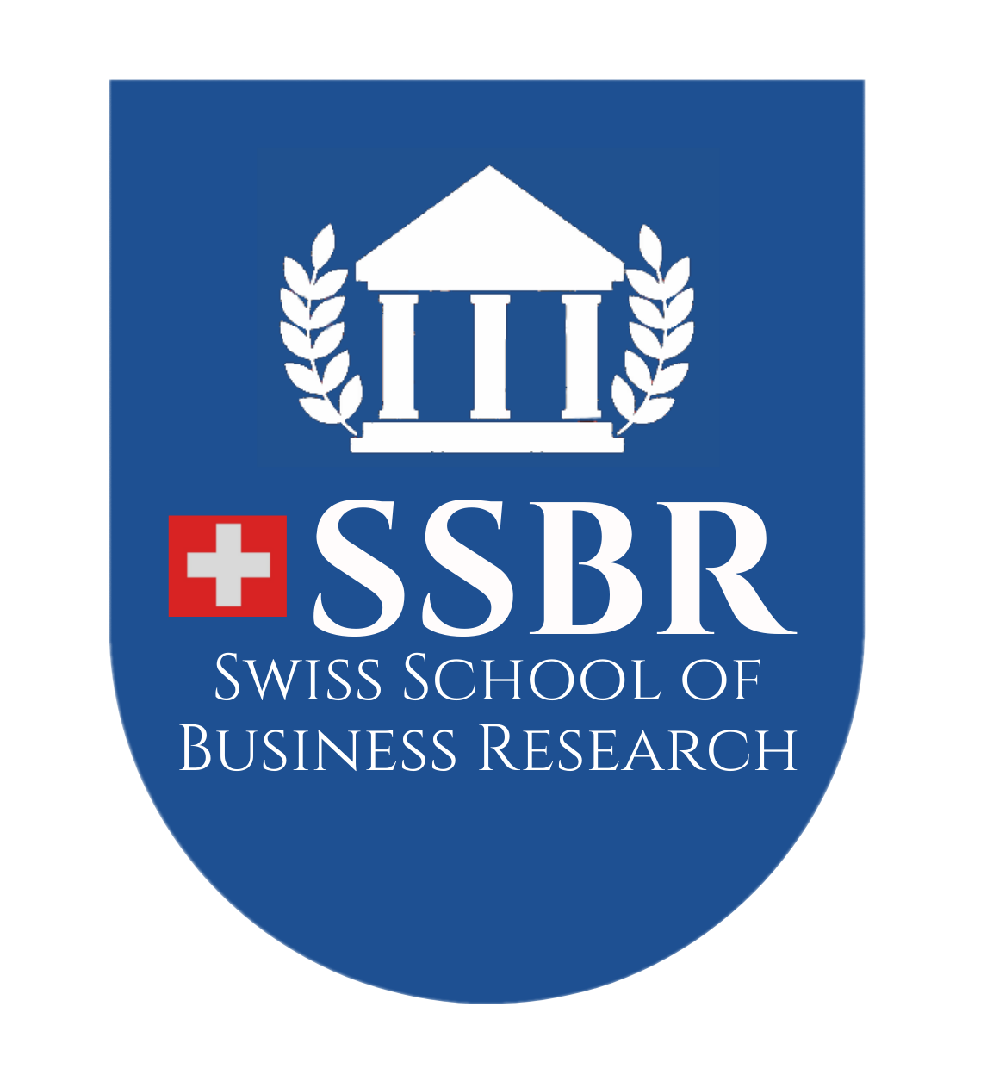
The Effectiveness of Corporate Social Responsibility (CSR) in Building Brand Reputation:
A Case Study of Mount Zion Company Limited, Myanmar

MASTER OF BUSINESS ADMINISTRATION
(MBA)

YAMIN PA PA TUN
(SSBR/2025/MBA23081980)

JUNE, 2026
The Effectiveness of Corporate Social Responsibility (CSR) in Building Brand Reputation:
A Case Study of Mount Zion Company Limited, Myanmar

A Thesis Presented
by
YAMIN PA PA TUN

Submitted to the Swiss School of Business Research
in partial fulfillment of the requirements for the degree of

MASTER OF BUSINESS ADMINISTRATION
(MBA)

JUNE, 2026

Copyright by YAMIN PA PA TUN, 2026

All Rights Reserved

The Effectiveness of Corporate Social Responsibility (CSR) in Building Brand Reputation:
A Case Study of Mount Zion Company Limited, Myanmar

A Thesis Presented
by
YAMIN PA PA TUN

Approved as to style and content by:

Dr. Paing Soe, Chair
President, PSM International College

Dr. Su Hlaing Oo, Supervisor
Professor, PSM International College

Dr. Stephen Harrison
Dean
Swiss School of Business Research

ACKNOWLEDGEMENTS
First and foremost, I give glory and thanks to my Lord and Savior, Jesus Christ, for His grace, strength, and provision throughout my academic journey. This achievement would not have been possible without His mercy and guidance.
I also would like to sincerely thank Dr. Paing Soe, President of PSM International College and Dr. Stephen Harrison, Dean of the Swiss School of Business Research (SSBR), for the opportunity to pursue this MBA programme and for their support and encouragement throughout my studies.
My deepest gratitude is extended to my supervisor, Dr. Su Hlaing Oo, for her valuable guidance, constructive feedback, and continuous support, which greatly contributed to the completion of this thesis. I also appreciate all professors, associate professors, visiting lecturers, tutors, and staff of PSM for their academic and administrative support during my studies.
I would also like to express my sincere gratitude to the Chief Executive Officer, Board of Directors, and employees of Mount Zion Company Limited for granting permission to conduct this study and for their valuable participation, cooperation, and support during the data collection process. Their contributions provided the essential information required for the successful completion of this research.
Finally, I express my heartfelt gratitude to my beloved husband for his unwavering support and encouragement, and to my precious daughter, Rachel, whose love and inspiration have been my greatest motivation throughout this journey.
To all who have supported me directly or indirectly, I remain sincerely grateful.

Yamin Pa Pa Tun
(SSBR/2025/MBA23081980)

ABSTRACT

This study examines the impact of Corporate Social Responsibility (CSR) on brand reputation at Mount Zion Company Limited, using Carroll's (1991) CSR Pyramid Model as the theoretical framework. The model consists of four dimensions of CSR: economic, legal, ethical, and philanthropic responsibilities. The study addresses the limited empirical evidence on how CSR practices influence brand reputation in emerging economies such as Myanmar. Quantitative research design was employed, and primary data was collected through structured questionnaires from 376 respondents at Mount Zion Company Limited. The data were analyzed using the Statistical Package for the Social Sciences (SPSS), applying descriptive statistics, correlation analysis, and multiple regression analysis to examine the relationships between CSR dimensions and brand reputation. The study is limited to Mount Zion Company Limited and focuses on the four dimensions of CSR as the independent variables and brand reputation as the dependent variable. The findings are based on respondents' perceptions collected through a cross-sectional survey and may therefore have limited generalizability beyond the organization. The results indicate that Corporate Social Responsibility has a positive and statistically significant impact on brand reputation. Among the four CSR dimensions, ethical responsibility and philanthropic responsibility have the strongest influence, followed by economic and legal responsibilities. The findings suggest that organizations can strengthen their brand reputation by integrating CSR into their business strategies and maintaining responsible relationships with stakeholders. The study recommends that Mount Zion Company Limited continue enhancing its CSR initiatives, particularly by promoting ethical business practices and expanding community development programs. These efforts are expected to strengthen stakeholder trust, improve corporate reputation, and support long-term organizational sustainability.
Keywords: Corporate Social Responsibility, Brand Reputation, Carroll's CSR Pyramid, Myanmar, Stakeholders

TABLE OF CONTENTS
ACKNOWLEDGEMENTS i
ABSTRACT ii
TABLE OF CONTENTS iii
LIST OF TABLES v
LIST OF FIGURES v
ABBREVIATION vi
CHAPTER I 1
INTRODUCTION 1
1.1Background information of the Study 1
1.2 Problem statement of the study 3
1.3 Objective of the Study 5
1.4 Research questions of the Study 5
1.5 Scope and limitation of the study 6
1.6 Organization of the Study 7
CHAPTER II 9
LITERATURE REVIEW 9
2.1 Introduction and Importance of the Subject Area 9
2.2 Theoretical Concepts of Corporate Social Responsibility and Principles 10
2.2.1 Evolution of Corporate Social Responsibility 10
2.2.2 Importance of CSR in Developing Countries 11
2.2.3 CSR in Emerging Economies 11
2.2.4 Dimensions of CSR (Carroll’s model) 12
2.3 Brand Reputation 15
2.4 Variables of the Study 16
2.5.Review of Empirical Studies 18
2.5.1 The Empirical studies in Myanmar 18
2.5.2 Corporate Social Responsibility and Brand reputation 19
2.5.3 The Economic Dimension of CRS and Brand Reputation 20
2.5.4 Legal Dimension of CRS and Brand Reputation 22
2.5.5 Ethical Dimension of CSR and Brand Reputation 22
2.5.6 Philanthropic Dimension of CRS and Brand Reputation 23
2.6 Conceptual Framework of the Study 24
2.7 Research Hypotheses 25
CHAPTER III 26
RESEARCH METHODOLOGY 26
3.1 Research Methods 26
3.2 RESEARCH DESIGN AND SAMPLING 26
3.3 Data Sources and Methods of Data Collection 27
3.3.1 Data collection instrument 27
3.3.2 Population and Sample Size 28
3.3.3 Sample Size Determination 28
3.4 Ethical Consideration 29
CHAPTER IV 30
ANALYSIS AND RESULTS 30
4.1. Demographic background 30
4.2. Descriptive Statistics 33
4.2.1. Economic Responsibilities 33
4.2.2. Legal Responsibilities 34
4.2.3. Ethical Responsibilities 35
4.2.4. Philanthropic Responsibilities 36
4.2.5. Brand Reputation 37
4.3.Reliability Analysis 38
4.4.Normality……………………………………………………………………...38
4.5 Inferential statistics 40
4.5.1. Correlation Analysis 40
4.5.2. Regression Analysis 41
4.6 Summary of Chapter 41
CHAPTER V 43
CONCLUSION 43
5.1 Findings and discussions 43
5.2 Contributions of the Study 49
5.2.1 Theoretical Contribution 49
5.2.3 Policy contribution 50
5.3 Suggestions and Recommendations 51
5.4 Suggestions for Further Research 52
REFERENCES 53
APPENDIX 57

LIST OF TABLES

Table (4.1) Demographic background 32
Table (4.2.1.) Economic Responsibilities 34
Table (4.2.2.) Legal Responsibilities 35
Table (4.2.3.) Ethical Responsibilities 35
Table (4.2.4.) Philanthropic Responsibilities 36
Table (4.2.5.) Brand Reputation 37
Table (4.3.) Reliability Analysis 38
Table (4.4.) Normality 39
Table (4.5.1.) Correlation Analysis 40
Table (4.5.2.) Regression Analysis 41

LIST OF FIGURES

Figure 2.1 Carroll's CSR Pyramid Model 14

Figure 2.2 Conceptual framework of the study from the pyramid of CSR Carroll (1991) 25

ABBREVIATION

CSR : Corporate Social Responsibility
BR : Brand Reputation
CR : Corporate Reputation
BOD : Board of Directors
SPSS : Statistical Package for the Social Sciences
N : Number of Respondents / Sample Size
ER : Economic Responsibility
LR : Legal Responsibility
EtR : Ethic Responsibility
PHR : Philanthropic Responsibility

CHAPTER I

INTRODUCTION

Background information of the Study

Corporate Social Responsibility (CSR) refers to the ethical obligation of businesses to contribute to sustainable economic development while improving the quality of life of employees, communities, and society as a whole. According to (Carroll A. B., The pyramid of corporate social responsibility: Toward the moral management of organizational stakeholders, 1991), CSR includes economic, legal, ethical, and philanthropic responsibilities that organizations must fulfill. Similarly, the (Commission, 2011) defines CSR as the responsibility of enterprises for their impact on society, encouraging companies to integrate social and environmental concerns into their operations and stakeholder interactions. (Philip Kotler, Nancy Lee, 2011) Further emphasize CSR as a commitment to enhance community well-being through responsible business practices and the allocation of corporate resources.
CSR is a critical strategy for organizations to enhance their reputation, cultivate consumer trust, and cultivate enduring loyalty. CSR is a corporation's dedication to the effective management of its social, environmental, and economic ramifications in order to benefit society in addition to its financial performance (Archie B. Carroll and Kareem M. Shabana, 2010).
It is the idea that businesses should operate according to principles and policies that make a positive impact on society and the environment. Companies make decisions through corporate social responsibility (CSR) based on financial gain and profitability, as well as the influence of their actions on the communities in which they operate and the world at large. CSR extends beyond the legal duties that businesses are required to fulfill; by voluntarily adopting business practices that are ethical, sustainable, and responsible, businesses strive to give advantages to their customers, shareholders, employees, and society as a whole. Most of the time, the business model and procedures of a corporation are constructed around the organization's financial goals. When it comes to making decisions, however, corporate social responsibility (CSR) programs encourage business leaders to take into account corporate citizenship or the greater impact that the company has on society. Corporate social responsibility is a tool that assists businesses in ensuring that their activities are conducted in an ethical manner, are safe, and have a beneficial influence whenever it is possible to do so. Through corporate social responsibility (CSR) efforts, businesses strive to reduce their negative influence on the environment, make a contribution to the resolution of societal issues, and guarantee that their brand identity accurately reflects their core beliefs.
When effectively implemented, sustainable CSR demonstrably enhances brand reputation, fosters deeper customer loyalty, drives significant customer acquisition. Furthermore, it serves as a powerful tool for attracting and retaining top talent and proactively mitigating business risks (Muhanga, 2025). In recent years, Corporate Social Responsibility (CSR) has developed as an essential strategic strategy for businesses that want to strengthen their brand reputation and improve their competitive advantage. This is because CSR is referred to as "corporate social responsibility." There are many different metrics that are being used to evaluate modern enterprises. These criteria include their financial performance as well as their influence on the growth of their communities and society. Education, healthcare, nutrition, and the elimination of poverty are typically the focal points of corporate social responsibility (CSR) projects in developing nations like Myanmar. These initiatives are undertaken with the goal of resolving social difficulties.
Education is a fundamental human right. It empowers individuals, strengthens communities and fosters inclusive societies (Pinna, 2026). Education is a highly effective tool for social and economic growth. In Myanmar, access to quality education enables young people to obtain knowledge, develop skills, and boost their future employment prospects. Education encourages critical thinking, social awareness, and civic responsibility. However, many low-income students struggle to continue their education due to financial constraints, a lack of school resources, and limited educational assistance. Scholarships, school supplies, and learning programs can all contribute to lowering school dropout rates and providing disadvantaged youngsters with equitable chances. By investing in education, communities may create a better competent workforce that contributes to national development and poverty reduction.
Hunger and malnutrition the most devastating problems facing the majority of the world’s poor. Despite in general improvement in food availability, health and social services, hunger and malnutrition exists in some form in almost every country (WHO, 1992). Proper nutrition is critical for the physical and cognitive development of children and adolescents. Many families in Myanmar experience economic constraints that make it difficult for them to offer balanced and nutritious meals. Poor nutrition can cause stunting, impaired immunity, and lower academic performance in children. Nutritional assistance programs, such as school feeding efforts and community nutrition support, can help ensure that children obtain the nutrients they require for healthy growth. Improved nutrition not only improves children's health, but it also helps them concentrate, learn effectively, and engage actively in school.
Healthcare is a critical pillar of society that ensures a healthier, more equitable, and prosperous future for all (AIU, 2024). Access to healthcare services is another essential factor in Myanmar's well-being improvement. Many communities, especially rural and low-income metropolitan regions, have limited access to inexpensive healthcare facilities and medical services. Healthcare assistance initiatives, such as free medical examinations, health education, immunization campaigns, and financial help for medical treatment, have the potential to greatly enhance community health outcomes. Early healthcare intervention helps to avoid diseases, lowers medical costs for families, and ensures that people may live productive lives.
In the neighborhood of Yangon, Mount Zion Company Limited is actively involved in the implementation of corporate social responsibility (CSR) programs. These initiatives prioritize providing educational support, assistance with sustenance, and medical aid to rural populations. These programs are being undertaken with the intention of improving the standard of living in communities that are economically disadvantaged. Despite the fact that these corporate social responsibility (CSR) activities make a contribution to social welfare, it is essential to determine whether or not they effectively improve the brand image of the firm, the trust of stakeholders, and the general reputation of the brand among consumers.

1.2 Problem statement of the study

Mount Zion Company Limited is committed to supporting rural communities in Myanmar through the implementation of Corporate Social Responsibility (CSR) initiatives in the areas of education, nutrition, and medical aid. These initiatives reflect the company's commitment to contributing to social welfare while fulfilling its broader responsibilities beyond economic performance. Through its CSR activities, the company seeks to create positive social impacts, improve the well-being of local communities, and strengthen relationships with its stakeholders. Although considerable resources have been invested in these programs, there is insufficient empirical evidence to determine whether these CSR initiatives effectively influence stakeholder perceptions and enhance the company's brand reputation.
Many organizations assume that engaging in CSR activities naturally leads to improved corporate image, increased customer trust, and stronger brand reputation. However, previous studies have suggested that the effectiveness of CSR depends not only on the implementation of socially responsible activities but also on how these initiatives are perceived by stakeholders. If CSR programs are not aligned with stakeholder expectations or are not effectively communicated, their potential benefits may not be fully realized. Consequently, organizations cannot rely solely on the existence of CSR initiatives but must also evaluate their effectiveness in achieving both social and organizational objectives.
Furthermore, in emerging economies such as Myanmar, empirical research examining the relationship between CSR and brand reputation remains relatively limited. While CSR has become an increasingly important strategic practice among businesses, there is still a lack of organization-specific evidence regarding which dimensions of CSR contribute most significantly to building a positive brand reputation. This research gap makes it difficult for organizations to allocate resources effectively and develop CSR strategies that create sustainable value for both society and business.
Monitoring and evaluating CSR initiatives are therefore essential to ensuring that these programs achieve their intended outcomes. Effective monitoring and evaluation enable organizations to assess the social impact of their CSR activities, promote accountability and transparency, identify strengths and weaknesses, and support evidence-based decision-making. Through continuous assessment, companies can improve the design and implementation of CSR programs while strengthening stakeholder confidence and organizational credibility. As noted by Naik (2024), despite the challenges associated with monitoring and evaluation, its benefits significantly outweigh the costs by enhancing the long-term effectiveness, sustainability, and overall impact of CSR initiatives.
Against this background, there is a need to examine whether the CSR initiatives undertaken by Mount Zion Company Limited have successfully contributed to enhancing its brand reputation. Specifically, this study investigates the influence of the four dimensions of Carroll's (1991) CSR Pyramid—economic, legal, ethical, and philanthropic responsibilities—on the company's brand reputation. By identifying the relative contribution of each CSR dimension, the study seeks to provide empirical evidence that can support more effective CSR planning and implementation.
The primary objective of this study is to evaluate the effectiveness of Corporate Social Responsibility practices in enhancing the brand reputation of Mount Zion Company Limited and to provide practical recommendations for improvement. The findings are expected to help the company identify existing gaps in its CSR strategies, strengthen stakeholder relationships, improve corporate image, and develop more sustainable CSR initiatives that create long-term value for both the organization and the communities it serves.

Objective of the Study

The primary objective of this study is to evaluate the effectiveness of Corporate Social Responsibility (CSR) initiatives in contributing to the development and enhancement of Mount Zion Company Limited’s brand reputation. In today’s competitive business environment, CSR has become an essential strategic tool that not only supports community development but also strengthens corporate identity, public trust, and long-term sustainability. Therefore, this study aims to explore how CSR practices implemented by Mount Zion Company Limited influence stakeholders’ perceptions and the overall image of the organization. Specifically, the objectives are as follows:
- To identify the corporate social responsibility initiatives that Mount Zion Company Limited has implemented in the areas of education, nutrition, and medical assistance.
- To examine the effect of corporate social responsibility practices on brand reputation at Mount Zion Company Limited.

1.4 Research questions of the Study
In order to achieve the objectives of this study, a set of structured research questions has been developed to guide the investigation. These questions are designed to ensure a systematic examination of Corporate Social Responsibility (CSR) practices and their influence on corporate brand reputation. Research questions are essential in academic studies as they help to clearly define the focus of the study, guide data collection, and ensure that the research remains aligned with its objectives.
Accordingly, this study seeks to address the following key research questions:
- What CSR activities are implemented by Mount Zion Company Limited in the areas of education, nutrition, and medical assistance?
- How do CSR activities influence the brand reputation of Mount Zion Company Limited?

1.5 Scope and limitation of the study
The purpose of this study is to assess the effectiveness of Corporate Social Responsibility (CSR) activities implemented by Mount Zion Company Limited in Myanmar and to determine the extent to which these initiatives contribute to the enhancement of corporate brand reputation. The study focuses specifically on CSR programs conducted in selected rural communities located near Yangon, with particular emphasis on three key areas: education support, nutritional assistance, and medical aid services. These areas have been selected because they represent the core CSR initiatives of the company and are considered essential in addressing basic community development needs. The study primarily gathers data from three key stakeholder groups, namely employees of Mount Zion Company Limited, customers, and beneficiaries of CSR programs within the targeted rural communities. These groups are selected because they are directly or indirectly affected by the company’s CSR initiatives and are therefore able to provide relevant insights regarding the perceived effectiveness and impact of such programs on corporate reputation and community well-being.
However, this study is subject to certain limitations. Firstly, the geographical scope is limited to selected rural areas near Yangon and may not fully represent CSR activities or perceptions in other regions of Myanmar where the company may also operate. Secondly, the study focuses only on three CSR dimensions—education, nutrition, and medical assistance—and does not cover other possible CSR areas such as environmental sustainability or economic empowerment initiatives. Thirdly, the findings of the study are based on the perceptions of selected respondents, which may introduce a degree of subjectivity and may not fully capture the views of all stakeholders associated with the company.
Despite these limitations, the study is expected to provide meaningful insights into how CSR activities influence stakeholder perceptions and contribute to the development of corporate brand reputation. The findings may also serve as a useful reference for improving the effectiveness of CSR strategies within Mount Zion Company Limited and similar organizations operating in comparable contexts.

1.6 Organization of the Study
In order to give a methodical and thorough analysis of the efficacy of Corporate Social Responsibility (CSR) in enhancing brand reputation at Mount Zion Company Limited, Myanmar, this study is divided into five chapters. Each chapter is intended to cover particular facets of the research and work together to accomplish the study's goals.
The study's introduction is given in Chapter One. The study's backdrop is given in this chapter, which also highlights the growing significance of corporate social responsibility (CSR) in contemporary company operations and its contribution to improving brand reputation. The problem statement, which highlights the research gap and the necessity of assessing the success of Mount Zion Company Limited's CSR initiatives, is also covered. The chapter also describes the study's scope and constraints, research questions, objectives, and general structure. This chapter establishes the background, goal, and direction of the research, which forms the basis of the study.
The pertinent literature on corporate social responsibility and brand reputation is reviewed in Chapter 2. The chapter opens with an overview of the topic and discusses the significance of CSR in modern corporate settings. The theoretical underpinnings of corporate social responsibility (CSR) are then covered, including key theories and frameworks that clarify the connection between socially conscious business practices and an organization's reputation. The chapter also looks at the study's main variables, which are brand reputation and CSR initiatives, and investigates how they relate to one another using previously published scholarly research. To find research gaps and support the current study, prior empirical investigations carried out by researchers in various nations and sectors are also examined. Lastly, the study's conceptual framework is created to show how the independent and dependent variables relate to one another.
The research approach used for the study is the main topic of Chapter 3. The research strategy and methodologies used to examine the efficacy of CSR efforts at Mount Zion Company Limited are described in this chapter. It also explains the data gathering techniques used, such as the data sources, sample techniques, and research tools used to obtain information from respondents. The chapter also covers the ethical issues that were noted during the research process, such as informed consent, voluntary involvement, confidentiality, and data handling. The methodology chapter guarantees that the study is carried out methodically and that the results are accurate and legitimate. The study's analysis and findings are presented in Chapter 4. The population and sample chosen for the study are described at the start of the chapter. After that, it offers a thorough statistical analysis of the information gathered from respondents. The replies are analyzed using a variety of statistical methods to look at the connection between brand reputation and CSR initiatives. To aid in comprehension, the results are displayed using tables, charts, and detailed explanations. The results are also interpreted in this chapter, along with their implications for the goals of the study and the body of current literature.
The study's main conclusions and debates are presented in Chapter Five. Conclusions about the success of CSR activities in enhancing Mount Zion Company Limited's brand reputation are made in light of the findings. Additionally, the chapter offers ideas and recommendations that could help the business enhance the execution and results of its CSR initiatives. Lastly, suggestions for more research are made in order to promote future investigations into CSR and brand reputation in Myanmar and other comparable settings. This chapter summarizes the main findings and provides both academic and practical contributions, acting as the study's conclusion.

CHAPTER II

LITERATURE REVIEW

2.1 Introduction and Importance of the Subject Area
Corporate Social Responsibility (CSR) has become an increasingly important strategic approach for organizations seeking to enhance their sustainability, competitiveness, and public image. Beyond its philanthropic role, CSR is widely recognized as a business strategy that strengthens stakeholder relationships, builds trust, and contributes to long-term brand reputation. When effectively implemented, CSR initiatives create shared value for both society and organizations, particularly in developing countries where social and community needs remain significant.
The importance of CSR has increased as businesses are expected to contribute not only to economic growth but also to social welfare and community development. In recent years, many organizations have implemented CSR activities such as educational support programs, healthcare services, nutritional assistance, environmental conservation projects, and community development initiatives. These efforts help organizations respond to societal expectations while fostering positive relationships with customers, employees, communities, and other stakeholders.
Existing literature suggests that the effectiveness of CSR depends largely on how initiatives are designed, communicated, and aligned with stakeholder expectations (Freeman, 1984). Organizations that successfully integrate CSR into their business strategies are more likely to strengthen stakeholder trust, enhance their corporate image, and improve their overall reputation. As a result, examining CSR practices within a real organizational setting can provide valuable insights into how socially responsible activities contribute to corporate success.
This study is particularly relevant because it evaluates the CSR initiatives implemented by Mount Zion Company Limited, focusing on educational support, nutrition assistance, and medical aid programs provided to rural communities near Yangon. These initiatives reflect the company's commitment to community development and social responsibility. By assessing stakeholder perceptions of these CSR activities, the study seeks to determine how CSR influences trust, brand image, and overall brand reputation.
Furthermore, this study contributes to the existing body of knowledge by providing empirical evidence on the relationship between CSR and brand reputation within the Myanmar context, where limited academic research has been conducted on this subject. The findings may serve as a useful reference for business practitioners, policymakers, and future researchers who are interested in understanding the strategic value of CSR and its impact on stakeholder relationships and organizational reputation. The study also highlights the role of CSR in supporting rural communities through healthcare, nutrition, and education programs, demonstrating how socially responsible business practices can contribute to both community well-being and long-term organizational performance.

2.2 Theoretical Concepts of Corporate Social Responsibility and Principles

2.2.1 Evolution of Corporate Social Responsibility
Corporate Social Responsibility (CSR) has evolved significantly over the past several decades. The concept emerged from the growing recognition that businesses have responsibilities beyond generating profits and maximizing shareholder wealth. One of the earliest scholars to discuss CSR was (Bowen, 1953), who argued that business leaders have an obligation to pursue policies and make decisions that align with the values and expectations of society. Bowen's work is widely regarded as the foundation of modern CSR theory.
During the 1960s and 1970s, CSR gained increasing attention as societies became more concerned about environmental protection, consumer rights, labor welfare, and ethical business conduct. Researchers began to emphasize that organizations should consider the social consequences of their decisions and contribute positively to society. (Davis, 1960) suggested that social responsibility extends beyond economic and legal obligations, while (McGuire, 1963) emphasized that businesses have responsibilities to society that go beyond profit generation.
The development of stakeholder theory by (Freeman, 1984) further expanded the concept of CSR by highlighting the importance of addressing the interests of various stakeholder groups, including customers, employees, suppliers, investors, governments, and local communities. According to this perspective, long-term organizational success depends on maintaining positive relationships with all stakeholders rather than focusing solely on shareholders.
A major milestone in CSR development was (Carroll A. B., A three-dimensional conceptual model of corporate performance, 1979) framework, which identified four dimensions of CSR: economic, legal, ethical, and philanthropic responsibilities. Carroll later refined this framework into the CSR Pyramid Model (1991), which remains one of the most widely accepted approaches for understanding and evaluating CSR practices. Today, CSR is recognized as a strategic management tool that contributes to sustainable development, stakeholder trust, organizational legitimacy, and long-term business success.

2.2.2 Importance of CSR in Developing Countries
The importance of CSR is particularly evident in developing countries, where governments often face challenges in providing adequate social services and infrastructure. In such environments, businesses can play an important role in supporting community development and improving social welfare. CSR initiatives frequently focus on education, healthcare, poverty reduction, environmental conservation, and community empowerment programs that address pressing social needs.
CSR contributes to sustainable development by encouraging organizations to balance economic objectives with social and environmental responsibilities. Through responsible business practices, companies can help improve living standards, create employment opportunities, support local communities, and promote social inclusion. These contributions are especially valuable in developing countries where limited public resources may constrain development efforts.
Furthermore, CSR helps organizations build trust and legitimacy among stakeholders. Consumers, employees, and communities increasingly expect businesses to demonstrate social responsibility and ethical behavior. Organizations that actively engage in CSR activities are often perceived more positively by stakeholders, leading to stronger relationships, improved reputation, and enhanced competitive advantage. Consequently, CSR has become an important strategy for organizations seeking to achieve both business success and positive social impact.

2.2.3 CSR in Emerging Economies
In recent years, CSR has become increasingly important in emerging economies as globalization, technological advancement, and stakeholder awareness continue to reshape business environments. Emerging economies often experience rapid economic growth, urbanization, and industrial expansion, creating both opportunities and challenges for businesses. As a result, organizations are expected to contribute not only to economic development but also to social and environmental sustainability.
Unlike organizations in developed countries, companies operating in emerging economies often face unique challenges such as weak regulatory systems, limited institutional support, income inequality, environmental degradation, and social development gaps. Consequently, CSR initiatives in emerging economies frequently focus on addressing community needs and promoting inclusive development. Many organizations invest in educational programs, healthcare services, environmental protection projects, and poverty alleviation initiatives as part of their CSR strategies.
Research suggests that CSR practices in emerging economies contribute significantly to stakeholder trust, corporate reputation, customer loyalty, and organizational performance. Businesses that demonstrate commitment to social responsibility are more likely to gain public support and maintain positive relationships with stakeholders. Moreover, CSR enables organizations to differentiate themselves from competitors while strengthening their long-term sustainability.
In the context of Myanmar, CSR has become increasingly relevant as businesses are expected to support national development and community welfare. Many organizations have implemented initiatives related to education, healthcare, nutrition assistance, and community development. These activities not only contribute to social progress but also enhance organizational reputation and stakeholder confidence. Therefore, understanding CSR practices within the context of Myanmar provides valuable insights into the role of responsible business behavior in promoting both community development and organizational success.

2.2.4 Dimensions of CSR (Carroll’s model)

Economic Responsibility: The Foundation of CSR
Economic responsibility forms the foundation of Carroll's CSR Pyramid Model. Businesses are primarily established as economic entities responsible for producing goods and services that meet customer needs while generating profits for owners and shareholders. According to (Carroll A. B., 1991), profitability is essential because it enables organizations to survive, grow, and fulfill their other social responsibilities.
This dimension includes maintaining financial sustainability, generating adequate returns on investment, improving operational efficiency, creating employment opportunities, and contributing to economic development. Organizations that successfully fulfill their economic responsibilities establish the necessary resources and stability to address legal, ethical, and philanthropic obligations. Therefore, economic responsibility serves as the basis upon which all other dimensions of CSR are built.
Legal Responsibility: Obeying the Law
The second level of Carroll's CSR Pyramid is legal responsibility. While businesses are expected to pursue profitability, they must do so within the framework of laws and regulations established by society. Legal responsibilities reflect society's expectation that organizations will conduct their operations in a lawful and responsible manner.
According to (Carroll A. B., 1991), organizations are required to comply with local, national, and international laws, honor contractual obligations, engage in fair business practices, and adhere to industry standards and regulations. Compliance with legal requirements demonstrates that a company operates as a responsible corporate citizen. By fulfilling both economic and legal responsibilities, organizations create a solid foundation for achieving higher levels of social responsibility.
Ethical Responsibility: Acting Beyond Legal Requirements
Ethical responsibility represents the third level of the CSR Pyramid and extends beyond mere compliance with laws and regulations. Ethical responsibilities encompass behaviors, practices, and standards that society expects from organizations even when they are not formally codified into law.
This dimension includes fairness, honesty, integrity, transparency, and respect for stakeholder interests. (Carroll A. B., 1991) emphasized that businesses should recognize and embrace evolving moral standards and avoid compromising ethical principles in pursuit of economic objectives. Ethical organizations treat employees, customers, suppliers, and communities fairly while taking decisions that reflect societal values and expectations. Consequently, ethical responsibility strengthens stakeholder trust and contributes positively to corporate reputation.
Philanthropic Responsibility: Contributing to Society
At the top of Carroll's CSR Pyramid is philanthropic responsibility, which refers to voluntary activities undertaken by organizations to improve the quality of life within communities and society as a whole. Unlike economic, legal, and ethical responsibilities, philanthropic activities are not required by law but are encouraged by society.
Philanthropic responsibility includes charitable donations, educational support, healthcare assistance, community development projects, employee volunteer programs, and other initiatives that contribute to social welfare. (Carroll A. B., 1991) noted that society expects businesses to actively support community well-being and contribute resources to worthwhile causes. Although philanthropic activities may not generate immediate financial returns, they often create long-term benefits such as enhanced corporate reputation, stronger stakeholder relationships, and increased employee commitment.
In summary, Carroll's CSR Pyramid Model suggests that socially responsible organizations should strive to fulfill all four dimensions of responsibility simultaneously. Economic responsibility provides the foundation for organizational survival, legal responsibility ensures compliance with societal rules, ethical responsibility promotes morally appropriate behavior, and philanthropic responsibility reflects a commitment to community welfare. Together, these dimensions provide a comprehensive framework for understanding how CSR contributes to organizational success and sustainable stakeholder relationships.
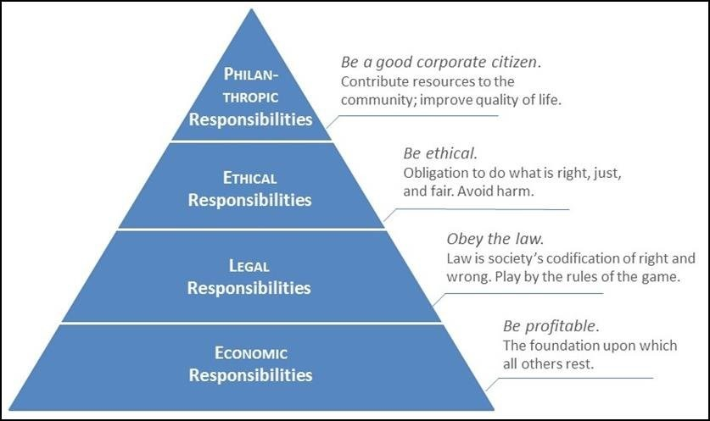
Figure 2.1 Carroll's CSR Pyramid Model
Source: Adapted from Carroll (1991).

Carroll's CSR Pyramid Model illustrates that corporate social responsibility consists of four interrelated dimensions: economic, legal, ethical, and philanthropic responsibilities. Economic responsibility forms the foundation of the pyramid because businesses must remain profitable to survive. Legal responsibility requires organizations to comply with laws and regulations. Ethical responsibility reflects societal expectations beyond legal requirements, while philanthropic responsibility represents voluntary contributions to community welfare. Together, these dimensions provide a comprehensive framework for evaluating corporate social responsibility practices.

2.3 Brand Reputation
Brand reputation refers to the overall perception and evaluation of an organization held by its stakeholders, including customers, employees, investors, suppliers, and the wider community. It is developed over time through stakeholders' experiences, observations, and interactions with the organization. A positive brand reputation reflects the extent to which stakeholders perceive an organization as trustworthy, reliable, responsible, and capable of delivering value. As an intangible asset, brand reputation is considered one of the most valuable resources of an organization because it can influence customer loyalty, stakeholder trust, employee commitment, and long-term business success.
According to (Fombrun, 1996) corporate reputation represents the collective assessment of a company's ability to meet the expectations of its stakeholders. Similarly, reputation is often viewed as a reflection of an organization's past actions and future prospects, which influence how stakeholders perceive the organization's overall quality and credibility. A strong reputation enables organizations to differentiate themselves from competitors and maintain a sustainable competitive advantage in increasingly competitive business environments.
Brand reputation plays an important role in influencing stakeholder behavior. Customers are more likely to purchase products and services from organizations with a positive reputation, while investors tend to have greater confidence in companies that are perceived as trustworthy and responsible. Furthermore, organizations with strong reputations are often able to attract and retain talented employees, establish stronger relationships with business partners, and gain greater public support during periods of uncertainty or crisis.
Several factors contribute to the development of brand reputation. These include product and service quality, financial performance, customer satisfaction, ethical business conduct, corporate governance, stakeholder relationships, and corporate social responsibility initiatives. Among these factors, CSR has gained increasing attention as an important contributor to reputation building. Modern stakeholders expect organizations not only to achieve economic success but also to demonstrate responsibility toward society, the environment, and the communities in which they operate.
Previous studies have consistently found a positive relationship between CSR and brand reputation. Organizations that actively engage in socially responsible activities are generally viewed more favorably by stakeholders because such activities demonstrate commitment to ethical behavior, transparency, accountability, and community development. CSR initiatives can enhance stakeholder trust, improve corporate image, and strengthen the overall reputation of an organization. As a result, many organizations increasingly integrate CSR into their business strategies as a means of building and maintaining a strong reputation.
In the context of Mount Zion Company Limited, brand reputation reflects stakeholders' perceptions of the company's commitment to both business excellence and social responsibility. Through initiatives such as educational support, nutrition assistance, and healthcare programs for rural communities, the company seeks to create positive social impact while strengthening stakeholder trust and goodwill. Therefore, examining the relationship between CSR practices and brand reputation is important for understanding how socially responsible activities contribute to the long-term success and sustainability of the organization.
Overall, brand reputation represents a valuable intangible asset that influences stakeholder perceptions, organizational performance, and competitive advantage. Given the growing importance of CSR in modern business practices, understanding the impact of CSR on brand reputation remains an important area of academic and practical interest. This study therefore investigates how the economic, legal, ethical, and philanthropic dimensions of CSR influence the brand reputation of Mount Zion Company Limited.

2.4 Variables of the Study
This study examines the relationship between Corporate Social Responsibility (CSR) practices and brand reputation at Mount Zion Company Limited. The variables selected for this study are based on (Carroll A. B., 1991) CSR Pyramid Model, which identifies four dimensions of corporate social responsibility: economic responsibility, legal responsibility, ethical responsibility, and philanthropic responsibility. These four dimensions serve as the independent variables, while brand reputation serves as the dependent variable.
Independent variables are factors that are expected to influence or affect another variable, whereas the dependent variable is the outcome that may change as a result of the independent variables. In this study, the four dimensions of CSR represent the independent variables because they reflect the company's commitment to responsible business practices. Brand reputation is considered the dependent variable because it represents stakeholders' overall perceptions and evaluations of the company, which may be influenced by the organization's CSR initiatives.
Brand reputation is the dependent variable in this study. It refers to the overall perception, image, and level of trust that stakeholders hold regarding an organization. A strong brand reputation is developed over time through consistent business performance, ethical conduct, quality products and services, and meaningful engagement with stakeholders. Reputation is considered a valuable intangible asset because it influences customer loyalty, stakeholder trust, employee commitment, and long-term organizational success.
In the context of this study, brand reputation reflects how customers, employees, community members, and other stakeholders perceive Mount Zion Company Limited. Positive perceptions of the company's CSR activities may strengthen its reputation by demonstrating responsibility, accountability, and commitment to societal well-being. Therefore, the study seeks to examine the extent to which the four dimensions of CSR contribute to the development and enhancement of the company's brand reputation.
Overall, this study aims to investigate the relationship between the independent variables—economic responsibility, legal responsibility, ethical responsibility, and philanthropic responsibility—and the dependent variable, brand reputation. By examining these relationships, the study seeks to provide insights into how CSR initiatives influence stakeholder perceptions and contribute to the long-term reputation and success of Mount Zion Company Limited.

Review of Empirical Studies
2.5.1 The Empirical studies in Myanmar

Corporate Social Responsibility (CSR) has received increasing attention in Myanmar as businesses recognize the importance of contributing to social, environmental, and economic development while maintaining positive relationships with stakeholders. Several empirical studies have examined CSR practices in Myanmar and their implications for organizational performance, stakeholder trust, and corporate reputation.
(Ralf Barkemeyer; Jason Miklian, 2019) polled a lot of Myanmar-based and foreign-based businesses to find out how they felt about responsible business practices and CSR adoption. From the study, it was clear that Myanmar companies knew a lot about CSR and sustainable development projects. The researchers did notice, though, that local businesses often made community service, charity work, and social contributions their main CSR practices. The results show that corporate social responsibility (CSR) projects have a big impact on how people see businesses and how well they work with their local communities.
In the same way, (Junsun Bae; Peter Lund-Thomsen; Adam Lindgreen, 2021) looked into how clothing makers in Myanmar do CSR. Researchers talked to people and looked at case studies of clothing factories and found that more and more companies were using CSR practices to meet the needs of stakeholders and keep good relationships with local communities and foreign buyers. The study found that ethical business practices increased the credibility of an organization and raised the trust of stakeholders, which led to a better public perception of the company.
(Tang-Lee, 2016) examined CSR and public engagement practices at the Letpadaung Copper Mine in Myanmar and found that CSR initiatives can improve community perceptions and corporate image when they are supported by meaningful stakeholder engagement. The study emphasized that CSR programs are most effective when they address the genuine needs of local communities and encourage inclusive participation in decision-making processes. The findings further highlighted the importance of aligning CSR activities with stakeholder expectations to enhance organizational legitimacy and public acceptance.
Recently, (Rekha Rao-Nicholson; Htwe Htwe Thein; Yifan Zhong , 2024) looked at the CSR actions that multinational companies in Myanmar were doing. Their research showed that as part of their CSR plans, many companies focused on programs for health care, education, community development, and social welfare. The researchers came to the conclusion that CSR projects showed a commitment to social development and healthy business practices, which made organizations more trustworthy and improved relationships with stakeholders.
These studies consistently show that CSR practices have a positive effect on how stakeholders see a company, how trustworthy it is, and how well-known it is in Myanmar. When businesses take care of their economic, legal, moral, and charitable duties, they are more likely to build trust and a good image in their communities. Still, most of the studies that have been done so far have been on multinational companies, manufacturing industries, and big development projects. Not much study has been done on how Carroll's four dimensions of CSR relate to brand reputation in Myanmar companies that work in a wide range of industries.
This study looks at how economic responsibility, legal responsibility, ethical responsibility, and philanthropic responsibility affect the Mount Zion Company Limited brand image in order to fill in that research gap. Researchers hope that these results will add to what is known about CSR and help companies that want to improve their image by doing business in a socially responsible way.

2.5.2 Corporate Social Responsibility and Brand reputation

Corporate social responsibility (CSR) has become an increasingly important strategic concern for organizations worldwide. Many companies engage in CSR activities not only to fulfill their social and ethical obligations but also to enhance their corporate image, strengthen their reputation, and improve relationships with stakeholders (Fomburn, 1996) (Michael E. Porter; Mark R. Kramer, 2006). As stakeholders have become more aware of social and environmental issues, organizations are under growing pressure to demonstrate responsible business practices and contribute positively to society.
Scholars have argued that CSR is often driven by strategic considerations rather than purely altruistic motives. Organizations frequently adopt CSR initiatives to gain competitive advantages, strengthen stakeholder trust, improve legitimacy, and enhance long-term business performance (Michael E. Porter; Mark R. Kramer, 2006); (Moon, 2007). From this perspective, CSR can be viewed as a strategic investment that generates both social benefits and organizational value.
Effective CSR initiatives can provide several advantages to organizations. By demonstrating commitment to ethical conduct, community development, and environmental responsibility, companies can improve their public image, build stronger relationships with stakeholders, and enhance their reputation among customers, employees, investors, and regulators (Fombrun, 1996) (Freeman, 1984). A positive corporate reputation can contribute to increased customer loyalty, improved employee attraction and retention, greater investor confidence, and enhanced organizational performance.
Furthermore, many researchers suggest that CSR serves as an important communication tool through which organizations demonstrate their values and commitment to responsible business practices. When CSR activities are aligned with stakeholder expectations and effectively communicated, they can strengthen organizational legitimacy and reinforce a favorable corporate image (Freeman, 1984) (Michael E. Porter; Mark R. Kramer, 2006). However, organizations with strong reputations often face higher stakeholder expectations and greater public scrutiny, requiring them to maintain consistent and credible CSR practices in order to preserve stakeholder trust and legitimacy (Fombrun, 1996); (Freeman, 1984).
Overall, the existing literature indicates that CSR contributes positively to corporate image and reputation when it is implemented strategically, aligned with stakeholder expectations, and supported by genuine organizational commitment. Consequently, CSR has become an important component of reputation management and sustainable business strategy in contemporary organizations (Carroll A. B., 1991); (Fombrun, 1996).

2.5.3 The Economic Dimension of CRS and Brand Reputation

The economic dimension represents the foundation of Carroll's CSR framework and emphasizes the responsibility of businesses to be profitable, efficient, and sustainable while creating value for stakeholders (Carroll A. B., 1991). Economic responsibility requires organizations to generate profits, provide employment opportunities, deliver quality products and services, and ensure long-term business viability. As businesses fulfill these responsibilities, they contribute to economic development while maintaining the confidence of customers, investors, employees, and other stakeholders.
Previous studies have suggested that the economic dimension of CSR plays an important role in shaping corporate reputation. Organizations that demonstrate strong economic performance, operational efficiency, and the ability to create value for stakeholders are more likely to gain stakeholder trust and develop a favorable public image. Stakeholders often perceive economically responsible organizations as reliable and capable of generating sustainable value, which contributes positively to their overall reputation (Fomburn, 1996). Furthermore, organizations that effectively balance profitability with stakeholder expectations are more likely to achieve long-term success and maintain positive relationships with customers, employees, investors, and the wider community (Michael E. Porter; Mark R. Kramer, 2006).
Furthermore, CSR initiatives can generate strategic benefits that contribute to long-term organizational success. (Michael E. Porter; Mark R. Kramer, 2006) argued that strategically implemented CSR activities can create competitive advantages by strengthening stakeholder relationships, enhancing organizational legitimacy, and improving corporate reputation. Similarly, (Fomburn, 1996) emphasized that a strong reputation can provide organizations with valuable intangible assets, including customer loyalty, investor confidence, and improved access to resources.
Conversely, organizations that fail to meet stakeholder expectations regarding economic performance and social responsibility may experience reputational damage and reduced stakeholder support. Poor corporate conduct, declining product quality, or failure to create value for stakeholders can negatively affect public perceptions and organizational performance. Therefore, the economic dimension of CSR is closely associated with corporate reputation, as stakeholders often evaluate an organization's credibility and trustworthiness based on its ability to balance profitability with broader social responsibilities.
Overall, the literature suggests that economically responsible business practices contribute positively to corporate reputation by enhancing stakeholder confidence, strengthening competitive advantage, and supporting long-term organizational sustainability.

2.5.4 Legal Dimension of CRS and Brand Reputation

The legal dimension of corporate social responsibility (CSR) and its impact on corporate image has been examined by several scholars. (Elisabet Garriga; Domènec Melé , 2004) Argue that companies have a legal obligation to comply with laws and regulations, and that this legal compliance can contribute to a positive corporate image. Specifically, they suggest that firms that adhere to legal requirements and avoid illegal activities are more likely to be perceived as ethical and socially responsible by the public.
Similarly, (Dirk Matten;Jeremy Moon, 2008) emphasize the importance of the legal framework in shaping CSR practices. They contend that in some countries, CSR is primarily driven by legal requirements, and companies that go beyond these legal mandates are more likely to be viewed as socially responsible. This indicates that the legal dimension of CSR can have a significant influence on a company's public perception and image.
(Stefano Pivato;Nicola Misani;Antonio Tencati, 2008) Expand on this idea, noting that a company's compliance with labor laws, environmental regulations, and other legal standards can serve as a signal of its commitment to social responsibility. They suggest that this legal compliance can lead to improved stakeholder trust and a more favorable corporate image. (Zadek, 2004) Has observed that companies that proactively engage in legal compliance and self-regulation are often perceived as more transparent and trustworthy, which can enhance their corporate image and reputation. This suggests that the legal dimension of CSR is a critical factor in shaping a company's public perception and overall image.

2.5.5 Ethical Dimension of CSR and Brand Reputation

The ethical dimension of corporate social responsibility (CSR) has been described as the voluntary activities of firms that go beyond their legal responsibilities to promote and pursue social goals (Archie B. Carroll and Kareem M. Shabana, 2010). These ethical responsibilities cover strategies for environmental sustainability, civil rights, and adhering to moral norms and values recognized in society (Archie B. Carroll and Kareem M. Shabana, 2010).
(Digital, 2024) Reported the Link between Business Ethics and CSR as Complementary Values: Ethics and CSR are interrelated, with ethical behavior forming the foundation of CSR. A company committed to ethical practices is more likely to engage in meaningful CSR initiatives. Long-Term Value Creation: By adhering to ethical standards and promoting CSR, companies build trust with stakeholders, enhancing their brand value and ensuring long-term profitability. Addressing Stakeholder Expectations: Both ethics and CSR help companies meet the expectations of customers, investors, and employees who increasingly prioritize social and environmental responsibility.

2.5.6 Philanthropic Dimension of CRS and Brand Reputation

The philanthropic dimension of corporate social responsibility (CSR) encapsulates the voluntary actions and programs undertaken by businesses in response to societal demands to be a good corporate citizen (Archie B. Carroll and Kareem M. Shabana, 2010). These philanthropic activities involve the firm's engagement in programs that contribute to human welfare and community development (Archie B. Carroll and Kareem M. Shabana, 2010). Research has shown that such philanthropic CSR activities can have a positive impact on customer demands, resulting in greater customer satisfaction (Hassan, 2013). Firms that engage in voluntary, philanthropic initiatives are often perceived as socially responsible by the community and are more likely to be preferred by the public (Wood, 2010)
The findings of these studies consistently indicate that CSR practices positively influence stakeholder perceptions, organizational credibility, corporate image, and reputation. Organizations that effectively fulfill their economic, legal, ethical, and philanthropic responsibilities are more likely to gain stakeholder trust and maintain a favorable public image. Furthermore, CSR initiatives have been found to contribute to customer satisfaction, employee commitment, and long-term organizational performance.
Despite the growing body of literature on CSR, most existing studies have focused on multinational corporations, manufacturing industries, extractive sectors, and large-scale development projects. Limited empirical research has examined the relationship between Carroll's four dimensions of CSR and brand reputation within the context of Myanmar-based organizations operating across diverse sectors. In particular, there is a lack of research investigating how stakeholders perceive CSR initiatives implemented by local organizations that actively engage in community development activities.
Therefore, this study seeks to address this research gap by examining the impact of economic responsibility, legal responsibility, ethical responsibility, and philanthropic responsibility on the brand reputation of Mount Zion Company Limited. By focusing on stakeholders' perceptions of the company's CSR initiatives in education, healthcare, and nutrition support programs, this study aims to contribute to the existing literature on CSR and provide practical insights for organizations seeking to strengthen their reputation through socially responsible business practices.

2.6 Conceptual Framework of the Study
The conceptual framework of this study is primarily based on (Carroll A. B., 1991) Corporate Social Responsibility (CSR) Pyramid Model. According to Carroll, CSR consists of four interrelated dimensions: economic responsibility, legal responsibility, ethical responsibility, and philanthropic responsibility. These dimensions represent the independent variables of the study and are used to evaluate stakeholders' perceptions of the CSR practices implemented by Mount Zion Company Limited.
The dependent variable of the study is brand reputation, which refers to stakeholders' overall perceptions and evaluations of the organization's trustworthiness, credibility, and commitment to social responsibility. Previous literature suggests that organizations that effectively fulfill their economic, legal, ethical, and philanthropic responsibilities are more likely to develop a positive reputation among stakeholders.
This study therefore proposes that the four dimensions of CSR influence the brand reputation of Mount Zion Company Limited. The conceptual framework illustrates the relationship between the independent variables (economic responsibility, legal responsibility, ethical responsibility, and philanthropic responsibility) and the dependent variable (brand reputation). The framework serves as a guide for examining how stakeholders' perceptions of CSR activities contribute to the development of the company's reputation. By analyzing these relationships, the study aims to provide empirical evidence regarding the role of CSR in enhancing brand reputation and strengthening stakeholder trust in Mount Zion Company Limited.
The conceptual framework of the study is presented in Figure 2.2.
Conceptual Framework Diagram
The diagram below represents the conceptual framework of the study, illustrating the relationship between CSR (independent variables) and brand reputation (the dependent variable).
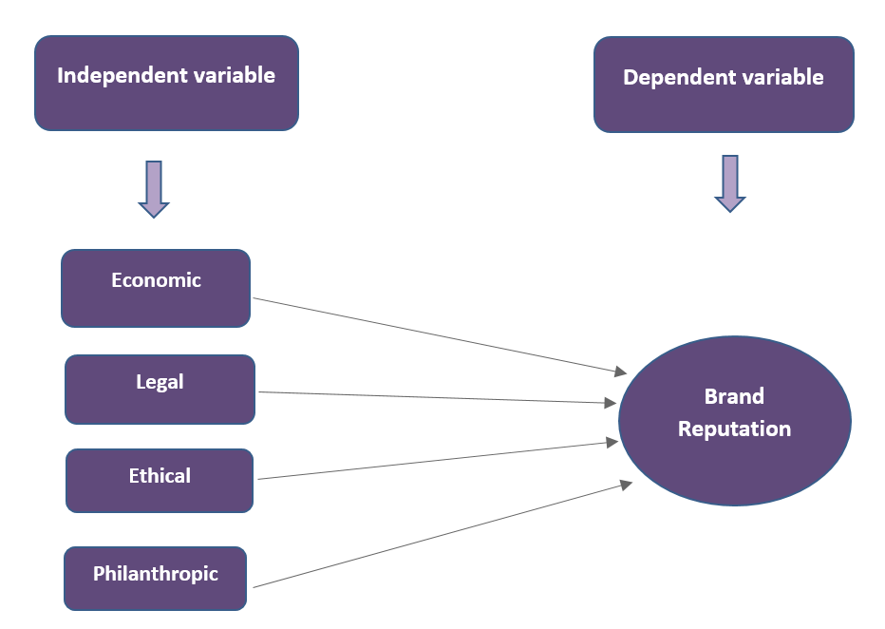

Figure 2.2 Conceptual framework of the study from the pyramid of CSR Carroll (1991)

2.7 Research Hypotheses
H1: There is a significant relationship between the economic dimension of CSR and brand reputation.
H2: There is a significant relationship between the legal dimension of CSR and brand reputation.
H3: There is a significant relationship between the ethical dimension of CSR and brand reputation.
H4: There is a significant relationship between the philanthropic dimension of CSR and brand reputation.

CHAPTER III

RESEARCH METHODOLOGY

3.1 Research Methods

Research methodology is an essential component of the research process. It provides a structured approach to conducting research, ensures the reliability and validity of research findings, facilitates communication and collaboration, and helps to advance knowledge in a particular field. As such, it is important for researchers to carefully consider the research methodology and select the most appropriate method to ensure that the study yields meaningful and accurate results (Bahishti, 2022).
This investigation underscore the significance of Corporate Social Responsibility (CSR) and its influence on the brand reputation of Mount Zion Company Limited. The objective of the investigation is to quantify stakeholder perceptions and examine the correlations between corporate social responsibility (CSR) initiatives, trust, brand image, community perception, and brand reputation through the application of statistical methodologies.
The research approach used for the study covers in the following chapters. It will describe the population and sample, data gathering techniques, tools, quality controls, and data processing strategy. The objective is to present a systematic process that was followed to achieve the research objectives and test the hypotheses.

3.2 RESEARCH DESIGN AND SAMPLING

This study adopts a quantitative research approach to examine the relationship between Corporate Social Responsibility (CSR) and brand reputation of Mount Zion Company Limited. The quantitative approach is appropriate because it allows numerical measurement of variables and statistical testing of relationships between CSR dimensions and brand reputation.
The research design is both descriptive and explanatory. The descriptive component explains the CSR activities and brand reputation perceptions, while the explanatory component investigates the cause-and-effect relationships between CSR dimensions (economic, legal, ethical, and philanthropic responsibilities) and brand reputation.
A case study approach is also applied, focusing specifically on Mount Zion Company Limited. This enables an in-depth analysis of CSR practices within a real organizational context. The study uses a deductive approach, where hypotheses derived from CSR theory are tested using empirical data.
Data were collected from employees, customers, and members of the local community using structured questionnaires. The quantitative data were then analyzed to determine the strength and direction of relationships between CSR dimensions and brand reputation.

3.3 Data Sources and Methods of Data Collection

Both primary and secondary data sources were used in this study. Primary data were collected through structured questionnaires distributed to employees, customers, and local community members. The questionnaires were designed to gather information on CSR awareness, perceptions of CSR activities, and perceived impact on brand reputation. Secondary data were obtained from journals, books, company reports, websites, and other relevant publications to support the theoretical foundation of the study.

3.3.1 Data collection instrument

The structured questionnaire was administered electronically using Google Forms, which allowed respondents to complete the survey conveniently through online access. The use of this platform also enabled automatic data recording, minimized manual entry errors, and facilitated efficient data export for statistical analysis.
This structured questionnaire was created in accordance with the particular goals and characteristics of the study served as the primary data gathering tool. In order to gauge respondents' degree of agreement or disagreement regarding the impact of CSR on organizational image, the questionnaire was created using a 5-point Likert scale. There were three parts to it. Respondents' background information will be the emphasis of section one, awareness and perception of CSR efforts will be the subject of section two, and organizational image will be the subject of section three.

3.3.2 Population and Sample Size

The target population for this study will include all employees of Mount Zion Company, customers and community members (villagers) who benefit from CSR programs. The total number of employees in the company is 265. Out of these, 79 employees are directly participating in CSR activities of the organization, while 186 employees are indirectly participating. In addition, there are more than 1000 regular customers who are above 18 years. For this study and due to resource constraints, only 180 customers will be selected through random sampling techniques. Furthermore, there are about 200 members of the local community around the CSR program area. Out of this, a sample of 50 members was selected randomly for the study.

3.3.3 Sample Size Determination

To select the sample employees, Yamane's formula for sample size determination will be used. The formula is:
n = N / (1 + Ne^2)
Where:
n is the sample size
N is the population size
e is the level of precision (set at 0.05)
Using this formula for the employee population (N) of 265:
n = 265 / (1 + 265(0.05) ^2)
= 159
This sample size of 159 was then proportionately allocated to the two employee strata as:
Directly involved employees (79): 79/265*159 =47
Indirectly involved employees (186): 186/265*159= 112
For customers (more than 1000) and local community (200), simple random sampling technique was used to select samples of 180 customers and 50 local community members respectively.
The total planned sample size of the study was 389 respondents. However, after data collection and screening for completeness and validity, a total of 376 valid responses were obtained and used for final analysis. The response rate was considered satisfactory for statistical analysis.

3.4 Ethical Consideration

In order to guarantee that the research is conducted in a responsible and acceptable manner, ethical considerations are a critical component of this investigation. This investigation into the brand reputation and Corporate Social Responsibility (CSR) of Mount Zion Company Limited adhered to a number of ethical standards to safeguard the privacy and rights of all participants.
Firstly, informed consent was obtained from the Chief Executive Officer (CEO) and the Board of Directors (BOD) of Mount Zion Company Limited, as well as from all participants, prior to their participation in the study. The purpose of the research, the voluntary nature of participation, and the right of respondents to withdraw from the study at any time without any consequences were clearly explained to all participants.
Secondly, anonymity and confidentiality were rigorously upheld. The questionnaire did not gather the identities of respondents, and all responses were solely utilized for academic purposes. In order to prevent the identification of individual participants, the data were reported in aggregated form.
Thirdly, the investigation guaranteed the security and preservation of data. The researcher had sole access to the data that was collected through Google Forms, which was stored securely. Unauthorized parties were not granted access to the data.
Furthermore, the investigation refrained from causing any distress or injury to the participants.
Lastly, the study upheld academic integrity by ensuring that all sources of literature were properly cited and that plagiarism was avoided throughout the research process.
In general, these ethical standards guaranteed that the investigation was conducted in a responsible, respectful, and transparent manner.

CHAPTER IV

ANALYSIS AND RESULTS

4.1. Demographic background

This section presents the descriptive analysis of the demographic background of the respondents who participated in this study ($N=376$). The profile includes key variables such as gender, marital status, age, educational attainment, and relationship with Mount Zion Company Ltd., duration of engagement, awareness, and participation in the company’s Corporate Social Responsibility (CSR) initiatives.
Gender Distribution In terms of gender, the sample comprises a predominantly male population. Out of the 376 total respondents, 259 are male, accounting for 68.9% of the sample. Conversely, female respondents represent 31.1% with a frequency of 117. This indicates that the survey captured perspectives from both genders, though male participants form the vast majority of the research sample.
Regarding the marital status of the participants, more than half of the sample are married. Specifically, 205 individuals are married, representing 54.5% of the total. Single respondents constitute the second largest group with 99 participants (26.3%), while the remaining 72 respondents fall under other marital categories, making up 19.1% of the sample.
The age distribution of the respondents spans across various cohorts, with the largest representation found in the middle-aged bracket. Participants aged 31–40 years form the largest segment, comprising 125 individuals (33.2%). This is followed by the 26–30 years cohort with 84 respondents (22.3%), and the 41–50 years cohort with 68 respondents (18.1%). The youngest group (18–25 years) consists of 48 individuals (12.8%), while the mature group aged 51 and above accounts for 51 individuals (13.6%). This distribution suggests that the study captured an experienced and mature workforce or respondent pool.
The academic background of the respondents indicates a highly educated sample. Over half of the participants hold a Graduate degree (n=201, 53.5%). Those with Post Graduate qualifications represent 23.7% (n=89), while Undergraduate degree holders account for 19.4% (n=73). A minor segment of the sample consists of Doctorate holders, accounting for 13 individuals or 3.5%. Overall, 80.7% of the respondents possess at least a graduate-level degree or higher, ensuring high reliability in understanding the questionnaire context.
The data reveals that the respondents maintain diverse relationships with Mount Zion Company Ltd. The largest group of stakeholders consists of Consumers, totaling 153 individuals (40.7%). Internal stakeholders, specifically Employees, constitute 36.2% of the sample with a frequency of 136. Additionally, Community Members represent 23.1% (n=87) of the survey participants. This diverse stakeholder inclusion provides balanced insights from internal, market, and social perspectives.
Regarding the duration of knowing or working with Mount Zion Company Ltd., a significant majority have an established long-term connection with the firm. The largest proportion has been associated with the company for 1–5 years, representing 167 respondents (44.4%). Respondents with less than 1 year of association make up 26.6% (n=100), followed by those with 5–10 years of engagement at 21.5% (n=81). A small but notable segment of 28 individuals (7.4%) has been connected with the company for over 10 years.
The survey results reveal an exceptionally high level of stakeholder awareness regarding the firm's corporate social activities. An overwhelming 96.0% of the respondents (n=361) stated that they are fully aware of Mount Zion Company’s CSR initiatives. In contrast, only a minimal fraction of 15 respondents (4.0%) reported being unaware of these projects. This highlights the high visibility and effective communication of the firm's social contributions.
When asked to identify the specific CSR activities that Mount Zion Company has been contributing to the community, a vast majority of the participants recognized the multi-dimensional nature of the company’s efforts. Specifically, 319 respondents (84.8%) selected "All of the above," acknowledging that the firm simultaneously supports education, nutrition, and medical programs. For individual sectors, 38 respondents (10.1%) highlighted education support, 10 respondents (2.7%) noted medical assistance, and 9 respondents (2.4%) pointed out nutrition support.
Finally, the active involvement of the respondents in the company's social activities was examined. More than half of the sample has actively participated in these initiatives, with 216 individuals (57.4%) answering "YES". Meanwhile, 160 respondents (42.6%) stated they have "NO" previous participation in these CSR projects. This indicates that while awareness is nearly universal, actual grassroots participation remains an area with potential for further engagement.
Table (4.1) Demographic background
Category | Level | Frequency | Percentage
Gender | Male | 259 | 68.9
Gender | Female | 117 | 31.1
Gender | Total | 376 | 100%
Marital status | Single | 99 | 26.3
Marital status | Married | 205 | 54.5
Marital status | Other | 72 | 19.1
Marital status | Total | 376 | 100.0
Age | 18-25 years | 48 | 12.8
Age | 26-30 years | 84 | 22.3
Age | 31-40 years | 125 | 33.2
Age | 41-50 years | 68 | 18.1
Age | 51 and above | 51 | 13.6
Age | Total | 376 | 100.0
Education | Undergraduate | 73 | 19.4
Education | Graduate | 201 | 53.5
Education | Post Graduate | 89 | 23.7
Education | Doctorate | 13 | 3.5
Education | Total | 376 | 100.0
Relationship with  Mount Zion Company Ltd. | Employee | 136 | 36.2
Relationship with  Mount Zion Company Ltd. | Consumer | 153 | 40.7
Relationship with  Mount Zion Company Ltd. | Community Member | 87 | 23.1
Relationship with  Mount Zion Company Ltd. | Total | 376 | 100.0
Know or work with  Mount Zion Company Ltd. | Less than 1 year | 100 | 26.6
Know or work with  Mount Zion Company Ltd. | 1-5 years | 167 | 44.4
Know or work with  Mount Zion Company Ltd. | 5-10 years | 81 | 21.5
Know or work with  Mount Zion Company Ltd. | Over 10 years | 28 | 7.4
Know or work with  Mount Zion Company Ltd. | Total | 376 | 100.0
Awareness of the company’s CSR initiatives | NO | 15 | 4.0
Awareness of the company’s CSR initiatives | Yes | 361 | 96.0
Awareness of the company’s CSR initiatives | Total | 376 | 100.0
Choice of the CSR activities that Mount Zion Company has been contributing to the community | Education support | 38 | 10.1
 | Nutrition support | 9 | 2.4
 | Medical assistance | 10 | 2.7
 | All of the above | 319 | 84.8
 | Total | 376 | 100.0
Participation in any of the company’s CSR initiatives | NO | 160 | 42.6
Participation in any of the company’s CSR initiatives | YES | 216 | 57.4
Participation in any of the company’s CSR initiatives | Total | 376 | 100.0
Source: Survey Data (2026)
Figure 1: Demographic background

4.2. Descriptive Statistics

To interpret the level of agreement from the 5-point Likert scale, the mean score intervals were classified based on (Best, 1977) criteria: 1.00–1.80 (very low), 1.81–2.60 (low), 2.61–3.40 (moderate/average), 3.41–4.20 (high), and 4.21–5.00 (very high). The mean and standard deviation (SD) values for each item, as well as the total composite mean and SD for each construct based on the 2026 survey data (N=376), are analyzed and interpreted as follows:

4.2.1. Economic Responsibilities

Economic Responsibilities Regarding the construct of Economic Responsibilities, the statistical findings demonstrate a very high overall level of agreement among the respondents, with a composite mean score of $4.555$and a standard deviation of .$419$. When examining individual items, ER 1 achieved the highest individual mean score of $4.60$($SD=.585$), followed closely by ER 4 ($M=4.56,SD=.562$) and ER 5 ($M=4.55,SD=.573$). Item ER 2 recorded the lowest mean within this dimension at $4.52$($SD=.624$). According to (Best, 1977) scale criteria, every single item within this factor comfortably falls into the "very high" agreement range (4.21–5.00), suggesting that respondents strongly perceive the economic obligations of the organization as well-fulfilled.

Table (4.2.1.) Economic Responsibilities

Economic responsibilities | Sample size | Mean | SD
- The company is committed to being as profitable as possible. | 376 | 4.60 | .585
- The company contributes to local development by creating job opportunities in the community. | 376 | 4.52 | .624
- The company ensures transparency in its financial dealings and reporting. | 376 | 4.54 | .614
- The company manages its financial resources responsibility to ensure long-term sustainability. | 376 | 4.56 | .562
- The company maintains financial stability and avoids high-risk behavior. | 376 | 4.55 | .573
Total | 376 | 4.555 | .419
Survey (2026) Source: Survey Data (2026)

4.2.2. Legal Responsibilities

Legal Responsibilities for the Legal Responsibilities dimension, the overall descriptive statistics indicate a very high level of consensus, yielding a cumulative mean of $4.546$and a standard deviation of $.421$. Among the five measured items, LR 5 attained the highest mean score of $4.57$($SD=.566$), followed by both LR 2 and LR 3, which shared identical mean scores of $4.55$. On the other hand, items LR 1 and LR 4 reflected the lowest agreement level in this cluster with a mean of $4.53$. Reflecting (Best, 1977) interpretation framework, all legal responsibility statements are classified within the "very high" bracket, which implies a strong organizational adherence to legal frameworks and regulatory compliances as perceived by the sample.

Table (4.2.2.) Legal Responsibilities
Legal Responsibilities | Sample size | Mean | SD
- The company strives to comply with various regional laws and regulations. | 376 | 4.53 | .574
- The company always acts in a manner consistent with the  Expectations of the government. | 376 | 4.55 | .622
- The company makes every effort to fulfil their legal obligations | 376 | 4.55 | .573
- The company provides goods/services that meet legal requirements. | 376 | 4.53 | .614
- The company always tried to be a law-abiding corporate citizen. | 376 | 4.57 | .566
Total | 376 | 4.546 | .421
Source: Survey Data (2026)

4.2.3. Ethical Responsibilities

The analysis of Ethical Responsibilities reveals a remarkably strong endorsement from the participants, resulting in an overall mean score of $4.588$($SD=.386$), representing a very high level of agreement. Within this factor, item ETR 5 marked the peak mean score at $4.63$($SD=.565$), closely supported by ETR 3 with a mean of $4.61$($SD=.556$). Conversely, items ETR 1, ETR 2, and ETR 4 demonstrated identical mean ratings of $4.57$. Applying the interpretative parameters established by (Best, 1977), the entire spectrum of ethical items functions within the "very high" threshold, underscoring that the ethical practices and standards of the firm are highly recognized and accepted by the respondents.

Table (4.2.3.) Ethical Responsibilities
Ethical Responsibilities | Sample size | Mean | SD
- The company always acts in a manner consistent with societal Ethical norms. | 376 | 4.57 | .590
- The company treats all customers equally regardless of their background or status. | 376 | 4.57 | .561
- The company respects customer privacy and protects personnel data. | 376 | 4.61 | .556
- The company is honest and transparent in its communication with customers. | 376 | 4.57 | .571
- The company has zero tolerance for corruption and bribery. | 376 | 4.63 | .565
Total | 376 | 4.588 | .386
Source: Survey Data (2026)

4.2.4. Philanthropic Responsibilities

Philanthropic Responsibilities With respect to Philanthropic Responsibilities, the descriptive data shows an overall mean of $4.587$paired with a standard deviation of $.403$, indicating a very high overall response rate. A closer inspection of individual statements shows that items PHR 3 and PHR 4 scored the highest, each securing a mean of $4.61$. These are followed by PHR 1 ($M=4.59,SD=.549$) and PHR 2 ($M=4.57,SD=.590$), while item PHR 5 presented the lowest average score within the construct at $4.56$($SD=.608$). Based on (Best, 1977) scale limits, all philanthropic elements fall squarely into the "very high" level of consensus, proving that corporate citizenship and charitable involvements are heavily emphasized and appreciated.

Table (4.2.4.) Philanthropic Responsibilities
Philanthropic Responsibilities | Sample size | Mean | SD
- The company always acts in a manner consistent with philanthropic and charitable expectations of society. | 376 | 4.59 | .549
- The company supports education through funding scholarship programs. | 376 | 4.57 | .590
- The company supports nutrition through funding food programs. | 376 | 4.61 | .554
- The company supports medical assistance within local community, especially to the senior citizens. | 376 | 4.61 | .574
- The company supports and encourages its customers and employees to participate in charities and community programs. | 376 | 4.56 | .608
Total | 376 | 4.587 | .403
Source: Survey Data (2026)

4.2.5. Brand Reputation

Brand Reputation Finally, the Brand Reputation construct displayed the highest overall composite mean among all variables under study, attaining a value of $4.631$with a standard deviation of $.409$, denoting a very high standing. Among the individual components evaluated, item B 4 emerged with the highest single mean score of $4.67$($SD=.529$), followed by item B 3 at $4.62$($SD=.563$). Item B 5 exhibited the lowest mean value within this specific set at $4.61$($SD=.541$). Evaluated against Best’s (1977) criteria, every item in this category firmly aligns with the "very high" tier, signifying that the organization maintains a stellar and highly favorable corporate reputation in the view of the target population.

Table (4.2.5.) Brand Reputation
Brand Reputation | Sample size | Mean | SD
- The CSR initiatives of Mount Zion company have influenced my  - perception of the company in a positive way. | 376 | 4.62 | .563
- I am happy to recommend Mount Zion Company due to its strong reputation and positive image. | 376 | 4.67 | .529
- I will choose Mount Zion company because the company participates in charity and community support. | 376 | 4.61 | .541
Total | 376 | 4.631 | .409
Source: Survey Data (2026)

Reliability Analysis

According to (Nunnally, 1978) and (Sekaran, 2003), reliability refers to the consistency and stability of a research instrument, ensuring that the questionnaire measures the intended concepts accurately over time without bias. To evaluate the internal consistency of the measurement scales used in this study, Cronbach’s alpha coefficients were calculated based on the survey data collected in 2026. Universally, a Cronbach’s alpha value of .70 or higher indicates an acceptable and reliable scale, whereas values above .60 are deemed satisfactory for exploratory research or constructs with fewer items (Hair et al., 2010). As stated in Table (4.3), the reliability test results demonstrate that the variables possess sufficient internal consistency. The dimensions of Corporate Social Responsibility (CSR)—namely Economic Responsibilities (5 items, α=.752), Legal Responsibilities (5 items, α=.758), Ethical Responsibilities (5 items, α=.717), and Philanthropic Responsibilities (5 items, α=.741)—all exceeded the recommended threshold of .70, proving to be highly reliable and acceptable. Although the "Brand Reputation" construct consists of 3 items and yielded a slightly lower alpha value of .615, it still falls within the acceptable and permissible range for statistical analysis in social science research. Consequently, all factors in this instrument are confirmed to be reliable and valid for further empirical assessment.

Table (4.3.) Reliability Analysis
Category | Cronbach’s alpha | Total items
Economic responsibilities | .752 | 5
Legal Responsibilities | .758 | 5
Ethical Responsibilities | .717 | 5
Philanthropic Responsibilities | .741 | 5
Brand reputation | .615 | 3
Source: Survey Data (2026)

Normality

In quantitative data analysis, assessing the normality of data distribution is a fundamental prerequisite before conducting parametric statistical tests. In this study, univariate normality was evaluated using skewness and kurtosis measures for each construct based on the survey data with sample = 376. According to Kline (2011), data can be considered to follow a normal distribution if the absolute value of skewness is less than 3.0 and the absolute value of kurtosis does not exceed 10.0. Alternatively, (Hair et al., 2010) and (Byrne, 2010) suggest that a kurtosis value greater than 7.0 indicates a significant departure from normality, implying that values falling substantially below this benchmark confirm structural normality. As stated in Table (4.4), the skewness values for all constructs, Economic Responsibilities (−1.469), Legal Responsibilities (−1.418), Ethical Responsibilities (−1.572), Philanthropic Responsibilities (−1.469), and Brand Reputation (−1.654)—fall well within the acceptable range of ±2.0 to ±3.0, reflecting mild negative skewness but remaining statistically acceptable. Regarding kurtosis, the values range from 2.388 to 4.944. Although these values are higher than some conservative baselines (such as 0.7), they remain safely below the liberal threshold of 10.0 suggested by (Kline, 2011) and the 7.0 threshold established by (Byrne, 2010) to diagnose severe non-normality. Specifically, the kurtosis for Economic Responsibilities (2.726), Legal Responsibilities (2.388), Ethical Responsibilities (3.323), Philanthropic Responsibilities (2.460), and Brand Reputation (4.944) indicates that the distributions are moderately peaked (leptokurtic) but do not violate the critical assumptions required for further multivariate analysis. Therefore, the data distribution is deemed acceptable for parametric operations.

Table (4.4.) Normality
Category | Sample size | Skewness | Kurtosis
Economic responsibilities | 376 | -1.469 | 2.726
Legal Responsibilities | 376 | -1.418 | 2.388
Ethical Responsibilities | 376 | -1.572 | 3.323
Philanthropic Responsibilities | 376 | -1.469 | 2.460
Brand reputation | 376 | -1.654 | 4.944
Source: Survey Data (2026)

4.5 Inferential statistics

4.5.1. Correlation Analysis

The Pearson correlation analysis was conducted to examine the relationships between the dimensions of Corporate Social Responsibility (CSR) such as Economic, Legal, Ethical, and Philanthropic responsibilities and Brand Reputation. It reveals that all four dimensions of Corporate Social Responsibility (CSR) are statistically significant and positively correlated with Brand Reputation at the p<.01 level. Among four independent variables, Philanthropic Responsibilities exhibit the strongest positive correlation (r=.512), followed by Ethical Responsibilities which show a moderate positive correlation (r=.462). Similarly, Legal Responsibilities (r=.421) and Economic Responsibilities (r=.401) both demonstrate moderate positive correlations with Brand Reputation. Furthermore, the data indicates strong positive relationships between the CSR dimensions themselves, most notably a very strong positive correlation between Legal and Economic Responsibilities (r=.745) and a strong positive correlation between Ethical and Legal Responsibilities (r=.675). Overall, the results suggest that as an organization increases its commitment to these CSR dimensions, there is a corresponding and significant improvement in its Brand Reputation.

Table (4.5.1.) Correlation Analysis
Category | Economic responsibilities | Legal Responsibilities | Ethical Responsibilities | Philanthropic Responsibilities | Brand reputation
Economic responsibilities | 1.00
Legal Responsibilities | .745** | 1.00
Ethical Responsibilities | .593** | .675** | 1.00
Philanthropic Responsibilities | .559** | .595** | .650** | 1.00
Brand reputation | .401** | .421** | .462** | .512** | 1.00
Note: N = 376, p < .01 (2-tailed).
Source: Survey Data (2026)

4.5.2. Regression Analysis

The multiple regression analysis demonstrates that the overall model for the four CSR dimensions is statistically significant, F=39.543,p<.001, with an R2 of .299 and an Adjusted R2 of .291, indicating that these factors collectively explain 29.1% of the variance in Brand Reputation. Individually, Economic Responsibilities is not found to significantly influence Brand Reputation (β=.077,t=1.142,p=.254, 95% CI [-.054, .204]) , So H1: Economic Responsibilities has a significant influence on Brand Reputation and Legal Responsibilities (β=.058,t=.794,p=.428, 95% CI [-.083, .196]) were not supported, as their p-values exceeded the .05 significance threshold and their confidence intervals included zero and therefore, H2: Legal responsibilities influence on brand reputation is not supported either. However, Philanthropic Responsibilities is found to positively influence on brand reputation (β=.328,t=5.433,p<.001, 95% CI [.212, .453]), and therefore H3: Philanthropic Responsibilities influence on brand reputation is supported. Finally, Ethical Responsibilities is also found to positively influence on Brand reputation (β=.164,t=2.520,p=.012, 95% CI [.038, .308]), therefore H4: Ethical Responsibilities influence on Brand reputation is supported.

Table (4.5.2.) Regression Analysis
Factors | $$β$$ | t | Sig. | Upper interval | Lower interval
Economic responsibilities (X1) | .077 | 1.142 | .254 | -.054 | .204
Legal Responsibilities (X2) | .058 | .794 | .428 | -.083 | .196
Ethical Responsibilities(X3) | .164 | 2.520 | .012 | .038 | .308
Philanthropic Responsibilities(X4) | .328 | 5.433 | <.001*** | .212 | .453
F |  | 39.543 | < .001***
R² | .299
Adjusted R² | .291
Notes: p < .05, **p < .01, ***p < .001
Source: Survey Data (2026)

Summary of Chapter
This chapter presented the analysis and findings of the study based on data collected from 376 respondents. Descriptive statistics were used to examine the demographic characteristics of the respondents and their perceptions of Corporate Social Responsibility (CSR) dimensions and Brand Reputation. The results indicated that Economic, Legal, Ethical, and Philanthropic Responsibilities, as well as Brand Reputation, were all perceived at a very high level.
The reliability analysis confirmed that all measurement scales were sufficiently reliable, while the normality test showed that the data met the assumptions required for parametric analysis. Pearson correlation analysis revealed that all CSR dimensions were positively and significantly related to Brand Reputation.
The multiple regression analysis further showed that the overall model was statistically significant. Among the four CSR dimensions, Ethical Responsibilities and Philanthropic Responsibilities were found to have significant positive effects on Brand Reputation, whereas Economic Responsibilities and Legal Responsibilities did not have a significant influence. These findings suggest that ethical conduct and philanthropic activities play a more important role in enhancing the Brand Reputation of Mount Zion Company Limited. The discussion and implications of these findings are presented in the next chapter.

CHAPTER V

CONCLUSION

5.1 Findings and discussions
Ethical Responsibilities and Brand Reputation
The findings of this study revealed that Ethical Responsibilities have a significant positive influence on Brand Reputation (β = .164, p = .012). This result suggests that stakeholders place substantial importance on ethical conduct when evaluating an organization's reputation. In today's business environment, stakeholders are increasingly concerned not only with what organizations achieve but also with how they achieve their objectives. Ethical behavior demonstrates that an organization respects stakeholder interests, operates fairly, maintains transparency, and adheres to moral principles beyond mere legal compliance. When stakeholders perceive an organization as ethical, they are more likely to trust the organization, support its activities, and develop positive perceptions of its brand.
The significance of Ethical Responsibilities in this study supports (Carroll A. B., 1991) CSR Pyramid Model, which identifies ethical responsibilities as a critical component of corporate social responsibility. According to Carroll, organizations are expected to conduct their business in a manner that is fair, just, and consistent with societal expectations, even when such practices are not mandated by law. Ethical responsibilities bridge the gap between legal obligations and societal expectations, reflecting the moral standards that stakeholders expect organizations to uphold. The findings of this study suggest that stakeholders associated with Mount Zion Company Limited value ethical behavior as an important determinant of organizational reputation, thereby providing empirical support for Carroll's theoretical framework.
The results are also consistent with numerous previous studies examining the relationship between CSR and corporate reputation. Many researchers have found that ethical conduct contributes positively to stakeholder trust, customer loyalty, and organizational credibility. Ethical practices such as transparency, honesty, fair treatment of customers, protection of personal information, and anti-corruption measures strengthen stakeholder confidence and reduce reputational risks. The findings therefore reinforce the argument that ethical behavior is not merely a moral obligation but also a strategic asset that contributes to long-term organizational success.
The importance of ethical conduct is particularly relevant within Myanmar's business environment. As Myanmar continues its economic development and integration into regional and international markets, stakeholders are becoming increasingly aware of issues relating to business ethics, transparency, accountability, and good governance. Public trust has become a valuable organizational asset, especially in sectors that directly interact with communities and consumers. Organizations that demonstrate integrity, fairness, and transparency are more likely to gain stakeholder confidence and establish a sustainable competitive advantage. In the context of Mount Zion Company Limited, which operates across multiple sectors including healthcare, education, charitable services, and construction, maintaining strong ethical standards is particularly important because these sectors involve significant stakeholder interaction and social responsibility. Therefore, ethical conduct serves not only as a moral obligation but also as a crucial driver of Brand Reputation and long-term stakeholder trust.
Philanthropic Responsibilities and Brand Reputation
The findings further revealed that Philanthropic Responsibilities were the strongest predictor of Brand Reputation among all CSR dimensions examined in this study (β = .328, p < .001). This result indicates that stakeholders place considerable value on organizations that actively contribute to community welfare and social development. Philanthropic activities are highly visible to the public and often create direct benefits for communities. As a result, stakeholders tend to associate such activities with compassion, social commitment, and corporate citizenship, leading to more favorable perceptions of organizational reputation.
One possible explanation for the strong influence of Philanthropic Responsibilities is that stakeholders often perceive charitable activities as voluntary actions that extend beyond the organization's economic and legal obligations. Unlike profitability and legal compliance, which are generally viewed as expected business practices, philanthropic initiatives demonstrate a genuine commitment to improving societal well-being. Consequently, stakeholders may regard organizations that invest in community development as more trustworthy, caring, and socially responsible.
The findings are particularly relevant to Mount Zion Company Limited because community development forms a central component of the company's mission and CSR strategy. Since its establishment in 2015, the company has actively supported rural communities near Yangon through various initiatives in education, nutrition, and medical assistance. Through its associated entities, including Divine's Grace Clinic, The Mission Music Academy, Gorgeous Smile Dental Clinic, Mount Zion Dental Trading, One 2 One Charitable Trust, and its construction division, the company has contributed to improving the quality of life of local communities. These initiatives have likely enhanced stakeholder awareness of the company's social contributions and strengthened positive perceptions of its reputation.
Furthermore, stakeholder expectations toward community development have increased significantly in recent years. Modern stakeholders increasingly expect organizations to contribute positively to society rather than focusing solely on profit generation. Communities, consumers, employees, and other stakeholders often evaluate organizations based on their social impact and commitment to addressing societal challenges. In developing countries such as Myanmar, where access to quality education, healthcare, and social services may remain limited in certain areas, corporate contributions to community development can create substantial social value. Consequently, organizations that actively support education, healthcare, nutrition, and charitable causes are more likely to gain public recognition and stakeholder goodwill. The strong influence of Philanthropic Responsibilities found in this study therefore reflects the growing expectation that businesses should play an active role in supporting social development and improving community well-being.
Economic and Legal Responsibilities and Brand Reputation
Although Economic Responsibilities and Legal Responsibilities were perceived at very high levels by respondents, the regression analysis revealed that neither dimension significantly influenced Brand Reputation. Economic Responsibilities recorded a positive but insignificant relationship with Brand Reputation (β = .077, p = .254), while Legal Responsibilities also demonstrated a positive but insignificant relationship (β = .058, p = .428). These findings suggest that although stakeholders acknowledge the company's strong economic performance and legal compliance, these factors do not substantially differentiate the organization when forming judgments about its reputation.
One possible explanation is that stakeholders view economic performance and legal compliance as fundamental expectations of any responsible business organization. Profitability, financial stability, job creation, and compliance with laws are considered essential requirements for organizational survival rather than exceptional achievements that enhance reputation. Therefore, stakeholders may take these responsibilities for granted and place greater emphasis on CSR activities that exceed basic business obligations.
This interpretation is consistent with Carroll's CSR Pyramid Model, which positions economic and legal responsibilities as foundational responsibilities that organizations are expected to fulfill before addressing higher-level ethical and philanthropic responsibilities. Once stakeholders are satisfied that an organization is financially stable and legally compliant, these dimensions may no longer serve as major determinants of reputation. Instead, stakeholders begin evaluating organizations based on how they contribute to society and uphold ethical values.
Another possible explanation relates to the characteristics of the respondents. The majority of respondents were already highly aware of Mount Zion Company Limited's CSR activities, with 96 percent indicating awareness of the company's social initiatives. Therefore, when assessing Brand Reputation, respondents may have focused more heavily on the company's visible social contributions and ethical conduct rather than on its financial performance and legal compliance. This may explain why Ethical Responsibilities and Philanthropic Responsibilities emerged as significant predictors while Economic and Legal Responsibilities did not.
Overall, the findings indicate that Ethical Responsibilities and Philanthropic Responsibilities are the most important CSR dimensions influencing Brand Reputation at Mount Zion Company Limited. While Economic and Legal Responsibilities remain essential foundations for sustainable business operations, stakeholders place greater value on ethical conduct and meaningful contributions to society when evaluating the company’s reputation.
Additional Discussion of Overall Findings
The findings of this study provide important insights into how different dimensions of Corporate Social Responsibility contribute to the Brand Reputation of Mount Zion Company Limited. While all CSR dimensions were perceived positively by stakeholders and demonstrated significant positive correlations with Brand Reputation, the regression analysis revealed that not all dimensions contribute equally to stakeholders' evaluations of the company. This finding highlights the complexity of stakeholder perceptions and demonstrates that different CSR activities may generate varying levels of influence on organizational reputation.
One notable finding of this study is that all CSR dimensions received very high mean scores from respondents. This indicates that stakeholders generally perceive Mount Zion Company Limited as a socially responsible organization that actively fulfills its economic, legal, ethical, and philanthropic obligations. Such positive perceptions may be attributed to the company's long-standing commitment to community development and social welfare initiatives. Since its establishment in 2015, Mount Zion Company Limited has consistently engaged in activities aimed at supporting education, healthcare, nutrition, and charitable programs in communities near Yangon. The company's diversified business structure, which includes healthcare services, educational institutions, charitable organizations, dental services, and construction-related activities, provides multiple avenues through which CSR initiatives can be implemented and experienced by stakeholders.
The findings also suggest that stakeholder perceptions of CSR are evolving. Traditionally, businesses were primarily evaluated based on their financial performance and ability to generate economic value. However, contemporary stakeholders increasingly expect organizations to demonstrate broader social responsibilities. Customers, employees, communities, and other stakeholder groups now consider factors such as ethical behavior, social impact, environmental responsibility, and community engagement when evaluating organizations. The significant influence of Ethical Responsibilities and Philanthropic Responsibilities found in this study reflects this shift in stakeholder expectations. Stakeholders appear to value organizations that contribute positively to society and conduct their operations responsibly beyond the pursuit of profit.
Another important observation is that the explanatory power of the regression model, as reflected by the Adjusted R² value of .291, indicates that CSR dimensions explain approximately 29.1 percent of the variance in Brand Reputation. Although this represents a meaningful proportion, it also suggests that other factors beyond CSR may influence stakeholder perceptions of organizational reputation. Brand Reputation is a multidimensional construct that may be affected by factors such as service quality, customer satisfaction, product quality, organizational performance, employee behavior, corporate communication, and stakeholder experiences. Therefore, while CSR is an important determinant of Brand Reputation, it should be considered as one component within a broader framework of reputation management.
The findings further demonstrate that philanthropic activities can create strong emotional connections between organizations and stakeholders. Unlike economic and legal responsibilities, which are often viewed as operational requirements, philanthropic activities are highly visible manifestations of an organization's commitment to social welfare. Stakeholders are often able to directly observe the benefits generated by educational support programs, healthcare services, charitable donations, and community development initiatives. Consequently, these activities may have a stronger influence on perceptions of organizational goodwill and social commitment. In the case of Mount Zion Company Limited, its contributions to education, nutrition, and medical assistance have likely created tangible benefits for local communities, thereby strengthening positive stakeholder perceptions.
The significant influence of Ethical Responsibilities similarly reflects the growing importance of trust in contemporary business environments. Trust is a fundamental component of organizational reputation because it influences stakeholder willingness to engage with, support, and recommend an organization. Ethical behavior enhances trust by demonstrating that an organization values fairness, honesty, integrity, and accountability. Stakeholders are more likely to develop positive perceptions of organizations that consistently behave in an ethical manner, particularly when such behavior is demonstrated across different operational activities. The findings therefore suggest that ethical conduct serves as an important mechanism through which organizations can strengthen their reputational capital.
The insignificant effects of Economic Responsibilities and Legal Responsibilities provide additional insights into stakeholder expectations. Although respondents rated these dimensions very highly, their lack of statistical significance in the regression model suggests that stakeholders may view them as baseline expectations rather than differentiating factors. In other words, stakeholders expect organizations to be financially stable and legally compliant as a minimum condition for conducting business. Consequently, fulfilling these responsibilities may not necessarily enhance Brand Reputation because stakeholders assume that responsible organizations will naturally meet these obligations.
This interpretation aligns closely with Carroll's CSR Pyramid Model. Carroll proposed that economic and legal responsibilities form the foundation of corporate social responsibility because they are essential for organizational survival and legitimacy. However, once these foundational responsibilities have been satisfied, stakeholders may focus more heavily on ethical and philanthropic dimensions when evaluating organizational performance and reputation. The findings of this study provide empirical support for this perspective by demonstrating that higher-order CSR responsibilities have a stronger influence on Brand Reputation than foundational responsibilities.
The findings also highlight the strategic value of CSR for organizations operating in competitive environments. In many industries, organizations may find it difficult to differentiate themselves solely through products, services, or pricing strategies. CSR activities, particularly those related to ethics and community development, provide opportunities for organizations to build distinctive reputational advantages. Through meaningful social contributions and responsible business conduct, organizations can strengthen stakeholder loyalty, improve public perception, and establish long-term competitive advantages. This is particularly relevant for Mount Zion Company Limited because its operations span multiple sectors that involve extensive stakeholder interaction and community engagement.
Furthermore, the findings suggest that CSR should not be viewed merely as a philanthropic obligation but as a strategic management tool that contributes to organizational sustainability. Effective CSR initiatives can enhance stakeholder relationships, improve organizational legitimacy, strengthen public trust, and support long-term business success. Organizations that integrate CSR into their core strategies are more likely to develop positive reputations and maintain strong stakeholder support over time.
Overall, the findings of this study demonstrate that Corporate Social Responsibility plays a significant role in shaping Brand Reputation. However, stakeholders do not evaluate all CSR dimensions equally. Ethical Responsibilities and Philanthropic Responsibilities emerged as the most influential factors affecting Brand Reputation, highlighting the growing importance of ethical business conduct and community development initiatives. These findings emphasize the need for organizations to move beyond basic compliance and profitability objectives by actively engaging in activities that create meaningful social value and demonstrate genuine concern for stakeholder welfare.

5.2 Contributions of the Study

5.2.1 Theoretical Contribution
By analyzing the applicability of Carroll's CSR Pyramid Model in the context of a diverse Myanmar-based firm, this study adds to the body of knowledge already available on corporate social responsibility and brand reputation. This study examines stakeholder perceptions of CSR practices implemented by Mount Zion Company Limited, which operates across multiple sectors, including healthcare, education, charitable services, dental trading, and construction, in contrast to many prior studies that concentrate on organizations in a single industry.
The results show that Brand Reputation is greatly impacted by Ethical and Philanthropic Responsibilities but not by Economic and Legal Responsibilities, which partially supports Carroll's CSR paradigm. These findings imply that when assessing an organization's reputation, stakeholders give more weight to moral conduct and social contributions. Additionally, the study adds vital evidence for future CSR research in emerging economies and enhances the scant empirical literature on CSR activities in Myanmar.
5.2.2 Practical Contribution

The study's conclusions have important managerial ramifications for Mount Zion Company Limited and other businesses looking to improve their brand image through CSR initiatives. The study shows that humanitarian endeavors and ethical business practices are more successful in improving stakeholder attitudes than just legal and financial obligations.
The findings indicate that management should keep funding humanitarian endeavors, healthcare support, education, community development programs, and nutrition activities. The business should also uphold high ethical standards by open communication, treating stakeholders fairly, safeguarding client data, and implementing effective anti-corruption procedures. Organizations can strengthen stakeholder trust, enhance public perception, and maintain a positive company image by concentrating on these areas.

5.2.3 Policy contribution

Policymakers, trade associations, and regulatory bodies that support ethical business practices in Myanmar can benefit from the findings. According to the survey, ethical behavior and community involvement are becoming more important to stakeholders than financial performance and legal compliance.
Therefore, in order to incorporate ethical governance, social welfare, education support, healthcare help, and community development into their long-term commercial objectives, policymakers may urge firms to adopt more comprehensive CSR policies. The results may also aid in the creation of CSR policies, awareness campaigns, and recognition programs that motivate companies to make constructive contributions to society while upholding sustainable business practices.

5.3 Suggestions and Recommendations

Several suggestions are made for Mount Zion Company Limited based on the study's findings.
First, the business should keep enhancing its ethical standards throughout the board. Since ethical responsibilities have a big impact on brand reputation, management should make sure that all corporate operations are transparent, accountable, fair, and honest. To guarantee moral behavior throughout all corporate divisions, it is important to have clear anti-corruption policies, efficient grievance procedures, and regular ethics training.
Second, Mount Zion Company Limited ought to increase the scope of its charitable endeavors. The corporation should keep funding community development, healthcare, education, and nutrition assistance initiatives since philanthropic responsibilities were found to be the best indicator of brand reputation. Stakeholder trust and company reputation may be further enhanced by long-term CSR initiatives that have a lasting social impact.
Third, the business ought to promote increased involvement from stakeholders in CSR initiatives. Just 57.4% of respondents reported actively participating in CSR projects, despite the fact that awareness of these initiatives was relatively high. As a result, the business ought to provide more chances for workers, clients, and community members to participate directly in volunteer work and CSR initiatives.
Fourth, the business should communicate its CSR accomplishments more effectively. Stakeholder awareness of the company's social contributions can be increased and brand reputation further strengthened through effective communication through yearly reports, social media platforms, community events, and PR initiatives.
Lastly, the organization should continue to maintain great financial performance and strict legal compliance even though it was discovered that Economic and Legal Responsibilities did not significantly affect Brand Reputation. These factors continue to be crucial pillars for long-term corporate operations and organizational legitimacy.
5.4 Suggestions for Further Research

The impact of CSR factors on Mount Zion Company Limited's brand reputation was the main subject of this study. To increase the generalizability of the results, future researchers might broaden the study's scope by incorporating businesses from various sectors and regions.
Future research may also look into other elements that affect brand reputation, like stakeholder trust, corporate governance, employee engagement, consumer satisfaction, service quality, and environmental sustainability. A more thorough grasp of the factors influencing brand reputation could be obtained by incorporating these variables.
Furthermore, in order to gain a greater understanding of how stakeholders see CSR initiatives, future researchers may use qualitative or mixed-method approaches. Focus groups and interviews can yield important information that structured questionnaires cannot.
Finally, to investigate the long-term effects of CSR activities on organizational performance and brand reputation, longitudinal studies may be carried out. A deeper comprehension of how CSR supports long-term, sustainable corporate performance would result from such research.

REFERENCES

AIU. (2024, March 14). The Critical Importance of Healthcare: A Cornerstone of Society’s Well-being. Retrieved from AIU: Atlantic International University: https://www.aiu.edu/blog/the-critical-importance-of-healthcare-a-cornerstone-of-societys-well-being/
Archie B. Carroll and Kareem M. Shabana. (2010). The Business Case for Corporate SocialResponsibility: A Review of Concepts,Research and Practiceij. International Journal of management reviews, 85-105.
Bahishti, D. A. (2022). The Vital Role of Research Methodology in Addressing the Research Questions. International Journal of Research Methodology , PP 1-1.
Best, J. W. (1977). Research in Education (3rd ed.). Englewood Cliffs, New Jersey: Prentice-Hall.
Bowen, H. R. (1953). Social responsibilities of the businessman. New York City: Harper & Brothers.
Byrne, B. M. (2010). Structural equation modeling with AMOS: Basic concepts, applications, and programming (2nd ed.). New York: Routledge.
Carroll, A. B. (1979). A three-dimensional conceptual model of corporate performance. Academy of Management Review, 4(4), 497–505.
Carroll, A. B. (1991, July - August ). The pyramid of corporate social responsibility: Toward the moral management of organizational stakeholders. Retrieved from Science Direct : https://www.sciencedirect.com/science/article/abs/pii/000768139190005G?via%3Dihub
Carroll, A. B. (1991). The pyramid of corporate social responsibility: Toward the moral management of organizational stakeholders. Science direct , 39-48.
Carroll, A. B. (1991). The pyramid of corporate social responsibility: Toward the moral management of organizational stakeholders. Business Horizons, 34(4), 39–48.
Commission, E. (2011, October 25). Corporate Social Responsibility: a new definition, a new agenda for action. Retrieved from European Commission : https://ec.europa.eu/commission/presscorner/detail/en/memo_11_730
David Levine and Michael Toffel. (2009). How Well Do Social Ratings Actually Measure Corporate Social Responsibility? Econpapers, 125-169.
Davis, K. (1960, May 01). Can Business Afford To Ignore Social Responsibilities? Retrieved from California Management review: https://cmr.berkeley.edu/1960/05/2-3-can-business-afford-to-ignore-social-responsibilities/
Digital. (2024, Dec 05). Understanding Business Ethics and Corporate Social Responsibility. Retrieved from Amrapali University: https://amrapali.ac.in/blog/2024/12/05/understanding-business-ethics-and-corporate-social-responsibility/
Dirk Matten;Jeremy Moon. (2008). “Implicit” and “explicit” CSR: A conceptual framework for a comparative understanding of corporate social responsibility. Acamedy of Management Review, 33(2), 404–424.
Elisabet Garriga; Domènec Melé . (2004). Corporate social responsibility theories: Mapping the territory. Journal of Business Ethics, 53(1–2), 51–71.
Fombrun, C. J. (1996). Reputation: Realizing value from the corporate image. Boston, MA: Harvard Business School Press.
Fomburn, C. J. (1996). Reputation: Realizing value from the corporate image. Boston, MA: Harvard Business School Press .
Freeman, R. E. (1984). Strategic management: A stakeholder approach. London: Pitman Publishing.
Hair et al. (2010). Multivariate data analysis (7th ed.). London, UK: Pearson Education.
Hassan, A. (2013). The impact of corporate social responsibility on customer satisfaction and retention. . International Journal of Business and Management, 8(9), 53–62.
Junsun Bae; Peter Lund-Thomsen; Adam Lindgreen. (2021). Global value chains and supplier perceptions of corporate social responsibility: a case study of garment manufacturers in Myanmar. Wiley, 653-680.
Kline, R. B. (2011). Principles and practice of structural equation modeling (3rd ed.). New York City, New York : Guilford Press.
McGuire, J. W. (1963). Business and Society. New York: McGraw-Hill.
Michael E. Porter; Mark R. Kramer. (2006). Strategy and society: The link between competitive advantage and corporate social responsibility. Harvard Business Review, 84(12), 78–92.
Michael E. Porter; Mark R. Kramer. (2006). trategy and society: The link between competitive advantage and corporate social responsibility. Harvard Business Review, 84(12), 78–92.
Moon, J. (2007). The contribution of corporate social responsibility to sustainable development. Sustainable Development. Sustainable development, 15(5), 296–306.
Muhanga, G. (2025, July 16). How Sustainable CSR Drives Value, Brand Reputation and Loyalty. Retrieved from Linkedin: https://www.linkedin.com/pulse/how-sustainable-csr-drives-value-brand-reputation-loyalty-muhanga-ojmsf#:~:text=When%20effectively%20implemented%2C%20sustainable%20CSR,impact%20into%20their%20fundamental%20operations.
Naik, N. N. (2024, May 28). Achieving Sustainable Outcomes: The Importance of Monitoring CSR Initiatives. Retrieved from Synergy Connect : https://synergyconnect.in/achieving-sustainable-outcomes-the-importance-of-monitoring-csr-initiatives/#:~:text=Conclusion,driven%20decisions%20for%20future%20initiatives.
Nunnally, J. (1978). Psychometric theory (2nd ed.). New York City, New York: McGraw-Hill.
Philip Kotler, Nancy Lee. (2011). Corporate Social Responsibility: Doing the Most Good for Your Company and Your Cause. New Jersey, US: Wiley.
Pinna, E. (2026, February 24). What you need to know about education and why it matters. Retrieved from Unesco : https://www.unesco.org/en/articles/what-you-need-know-about-education-and-why-it-matters?hub=343
R.E, F. (1984). Strategic management: A stakeholder approach. London: Pitman Publishing.
Ralf Barkemeyer; Jason Miklian. (2019, Aug ). Responsible Business in Myanmar: Comparing Perceptions from Domestic and Foreign Firms. Retrieved from ResearchGate: https://www.researchgate.net/publication/334856271_Responsible_Business_in_Myanmar_Comparing_Perceptions_from_Domestic_and_Foreign_Firms
Rekha Rao-Nicholson; Htwe Htwe Thein; Yifan Zhong . (2024, Feb 13). A thematic analysis of the links between multinational enterprises’ corporate social responsibility and the Sustainable Development Goals in Myanmar. Retrieved from Springer Nature Link : https://link.springer.com/article/10.1057/s42214-023-00183-y
Sekaran, U. (2003). Research methods for business: A skill-building approach (4th ed.). Hoboken, New Jersey: John Wiley & Sons.
Stefano Pivato;Nicola Misani;Antonio Tencati. (2008). The impact of corporate social responsibility on consumer trust: The case of organic food. Business Ethics: A European Review, 17(1), 3–12.
Tang-Lee, D. (2016). Corporate social responsibility (CSR) and public engagement for a Chinese state-backed mining project in Myanmar - Challenges and prospects. ads, 28-37.
WHO, F. a. (1992). International conference on nutrition: Nutrition and development: a Global accessment . Italy : FAO and WHO .
Wood, D. J. (2010). Measuring corporate social performance. A review. Business & Society, 39(1), 22–48.
Zadek, S. (2004). The path to corporate responsibility. Brighton, MA: Harvard Business Review.

APPENDIX

Appendix-A
Survey Questionnaire

About the survey
I am a student of Master of Business in Administration program at Swiss School of Business Research. I am doing the research on "The Effectiveness of Corporate Social Responsibility (CSR) in Building Brand Reputation: A Case Study of Mount Zion Company Limited, Myanmar".
Please respond to the following questions by ticking the best fitting choice. All the information collected through the questionnaire will be confidentially kept and used for academic purposes only.

About Mount Zion Company
Established in 2015, Mount Zion Company Limited is committed to supporting rural communities through the implementation of Corporate Social Responsibility (CSR) projects in the areas of education, nutrition, and medical assistance in areas near Yangon. Under the umbrella of the company are Divine's Grace Clinic, The Mission Music Academy, Gorgeous Smile Dental Clinic, Mount Zion dental trading, One 2 One Charitable trust and its construction business division, which collectively contribute to the company’s community development initiatives.

Please put on your choices:
Section (A): Background information of respondent
- Gender
Female Male

- Marital Status
Single Married Other

- Age
18-25 years 26-30 years 31-40 years 41-50 years 51 and above

- Your relationship with Mount Zion Company Limited.
Employee Customer Community member Other

- How long have you known or worked with Mount Zion Company Limited?
Less than 1 year 1-5 years 5-10 years Over 10 years

Section (B): Perception of CSR initiatives
- Are you aware of the company’s CSR initiatives?
Yes No
- If "Yes", Can you choose the CSR activities that Mount Zion company has been contributing to the community?
Education support Nutrition support Medical assistance All of the above
- Have you participated in any of the company's CSR initiatives?

Yes No

- The company's CSR initiatives have impacted my personal life and community very importantly.
Yes No

Section ( C ): Perception of stakeholders on CSR components in business organizations
Please state level of your agreement on each statement by providing the most relevant number.
1 = Strongly Disagree / 2 = Disagree / 3 = Neutral / 4 = Agree / 5 = Strongly Agree

- How important is it for you that a company engages in corporate social responsibility (CSR)
Initiatives? Scale 1 to 5, 1 = not important, 5 = very important

Sr. |  | 1 | 2 | 3 | 4 | 5
1 | Economic responsibility
2 | Legal responsibility
3 | Ethical responsibility
4 | Philanthropic responsibility

- How important do you believe the following CSR components are for company's reputation?
Scale 1 to 5, 1 = not important, 5 = very important
Sr. |  | 1 | 2 | 3 | 4 | 5
1 | Economic responsibility
2 | Legal responsibility
3 | Ethical responsibility
4 | Philanthropic responsibility

- Please rate the importance of the following CSR components (elements) for a company.
Scale 1 to 5, 1 = not important, 5 = very important
Economic Responsibilities
Sr. | Variables | 1 | 2 | 3 | 4 | 5
1 | The company is committed to being as profitable as possible.
2 | The company contributes to local development by creating job opportunities in the community.
3 | The company ensures transparency in its financial dealings and reporting.
4 | The company manages its financial resources responsibility to  ensure long-term sustainability.
5 | The company maintains financial stability and avoids high-risk behavior.

Legal Responsibilities
Sr. | Variables | 1 | 2 | 3 | 4 | 5
1 | The company strives to comply with various regional laws and  regulations.
2 | The company always acts in a manner consistent with the  expectations of the government.
3 | The company makes every effort to fulfil their legal obligations
4 | The company provides goods/services that meet legal requirements.
5 | The company always tried to be a law-abiding corporate citizen.
Ethical Responsibilities
Sr. | Variables | 1 | 2 | 3 | 4 | 5
1 | The company always acts in a manner consistent with societal  Ethical norms.
2 | The company treats all customers equally regardless of their background or status.
3 | The company respects customer privacy and protects personnel data.
4 | The company is honest and transparent in its communication with customers.
5 | The company has zero tolerance for corruption and bribery.

Philanthropic Responsibilities
Sr. | Variables | 1 | 2 | 3 | 4 | 5
1 | The company always acts in a manner consistent with philanthropic and charitable expectations of society.
2 | The company supports education through funding scholarship programs.
3 | The company supports nutrition through funding food programs.
4 | The company supports medical assistance within local community, especially to the senior citizens.
5 | The company supports and encourages its customers and employees to participate in charities and community programs.

Sr. | CORPORATE SOCIAL RESPONSIBILITY AND THE IMPACT ON BRAND REPUTATION | 1 | 2 | 3 | 4 | 5
1 | Due to the CSR initiatives undertaken by Mount Zion Company, helps build company's image
2 | Mount Zion Company is perceived as a socially responsible organization due to its CSR activities.
3 | The CSR initiatives of Mount Zion company have influenced my perception of the company in a positive way.
4 | I am happy to recommend Mount Zion Company due to its strong reputation and positive image.
5 | I will choose Mount Zion company because the company participates in charity and community support.

“Thank you for taking the time to complete this questionnaire.”

APPENDIX- B
SPSS Output

Demographic background

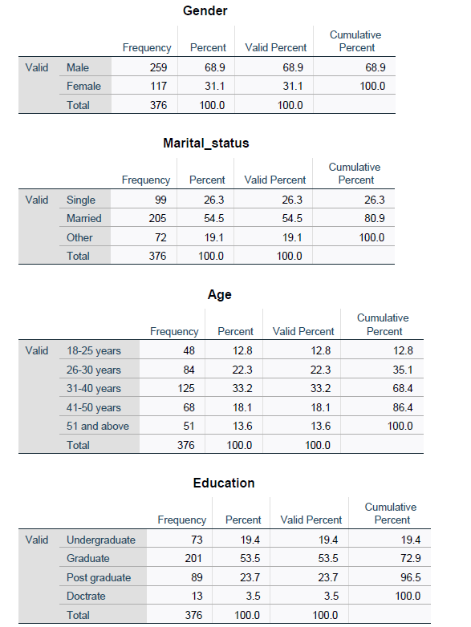

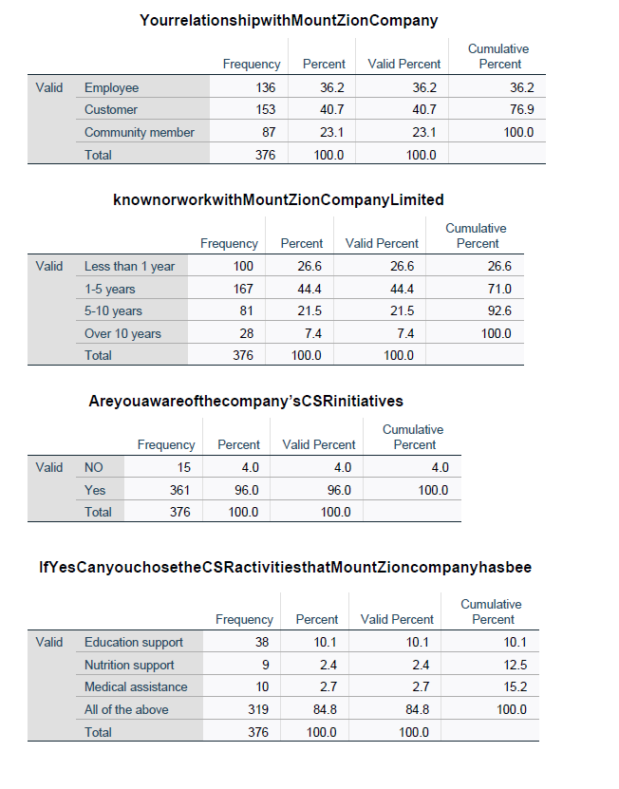
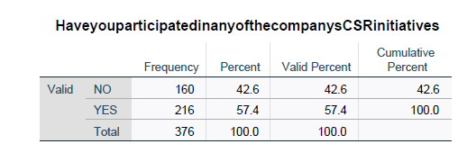

Reliability of all Variables

Reliability (Economic Responsibilities)
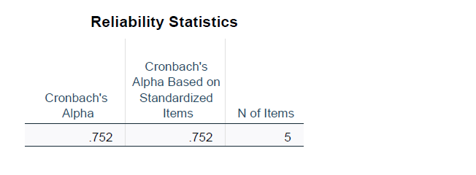
Reliability (Legal Responsibilities)
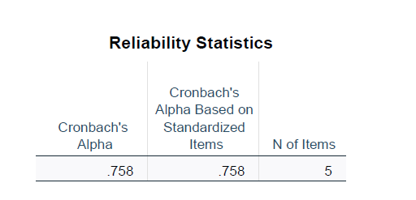

Reliability (Ethic Responsibilities)
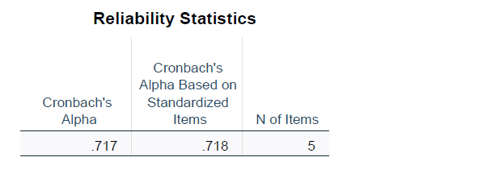

Reliability (Philanthropic Responsibilities)
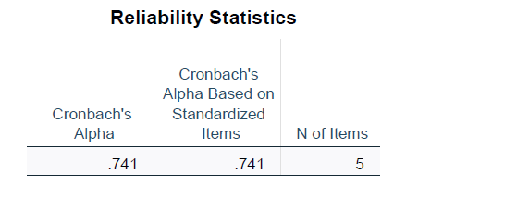
Reliability (Brand Reputation)

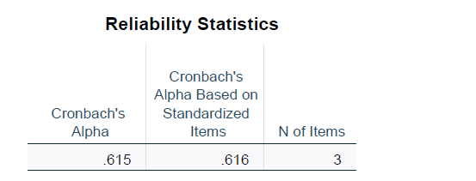

Normality (Skewness & Kurtosis)

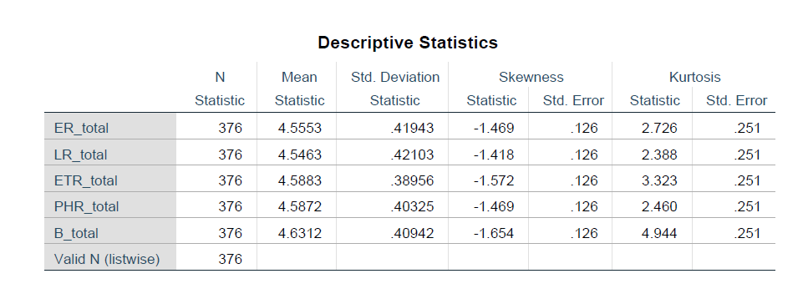

Regression (Multiple Linear regression)

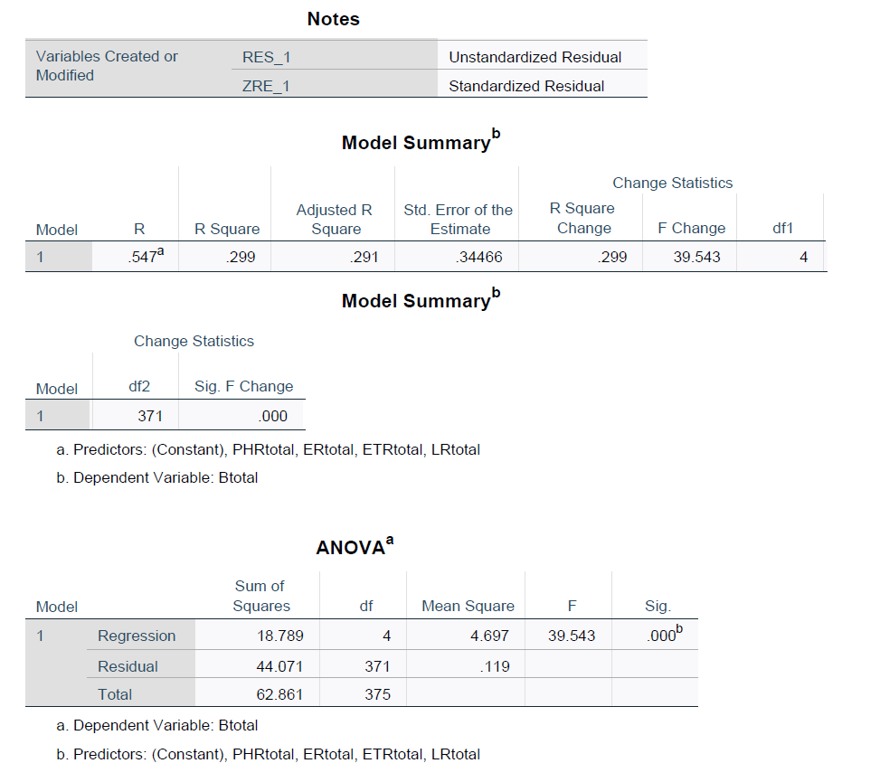
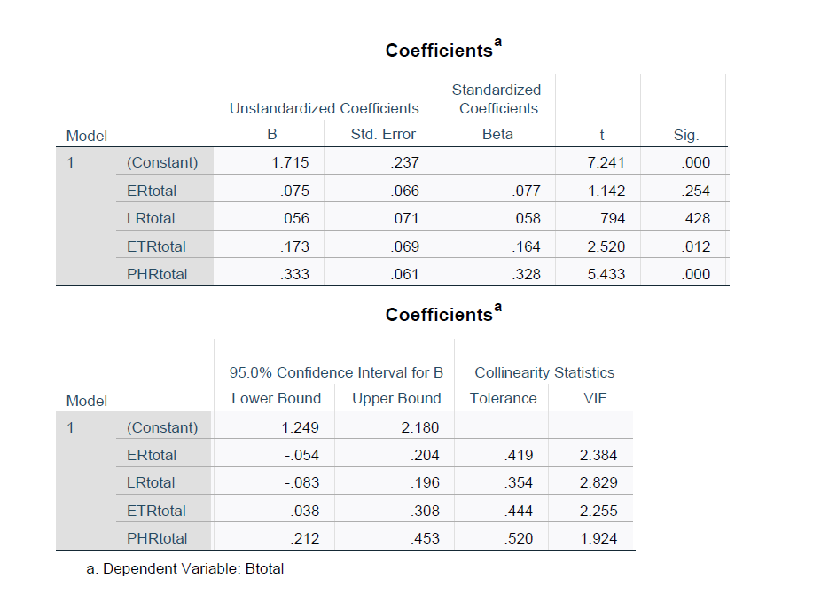
Descriptive output of All Variables

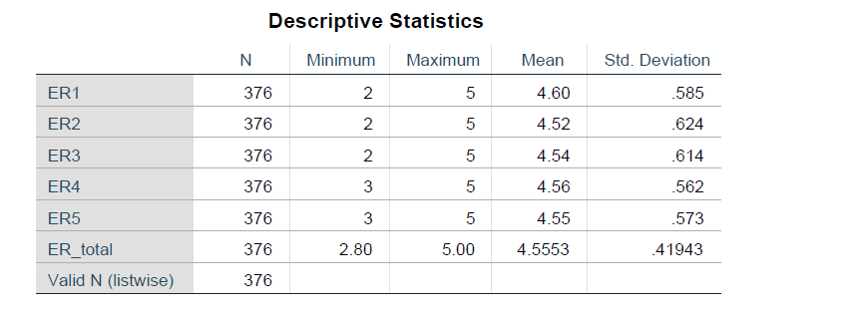

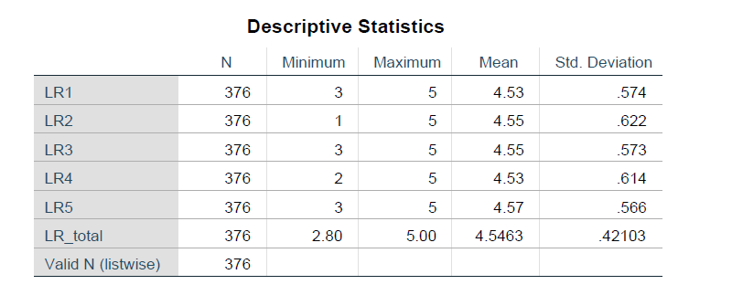
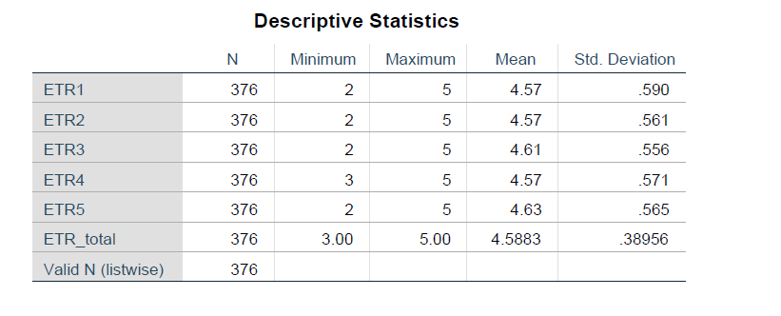
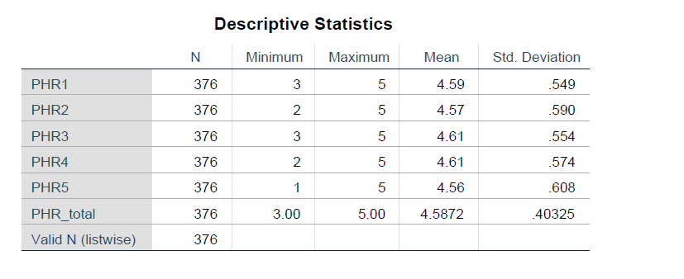
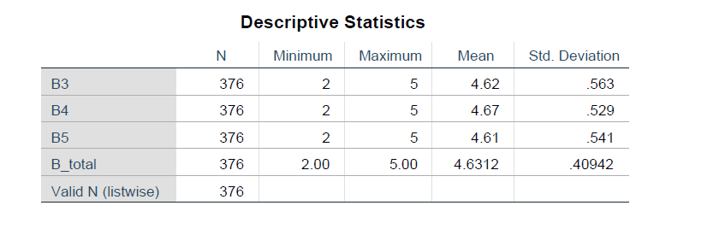

Correlations
